94.587

Fall 2001

Final Project

Traffic Analysis using ATLAS

Lidan Li
#311135

Abstract

This project intends to perform traffic analysis on a selected city section using ATLAS [1]. ATLAS defines a complex traffic model in a simple way. The TSC [3] compiler takes an ATLAS specified city section as input and translates it into executable models that can be used in CD++ [2] tool for further analysis. With this approach, a city section can be easily described and the model can be built and analyzed without writing a single line of source code.

Introduction

The city section defined in this project is the Carleton University Campus of Ottawa, Canada. Step1, the ATLAS specification language is used to define the constructions in the campus. Step 2, these ATLAS definitions (.plan file) are translated into source code by the TSC [3] compiler. Finally, CD++ tool takes the generated source code as input and generate the output file as simulated result that contains the information of the traffic flow in the campus. Based on the original model of the campus, we slightly change the topology of the campus, such as adding the traffic lights in the crossing, adding the railway crossings in the campus, varying the traffic loads etc. in order to compare the traffic performances under different conditions within the campus. By applying this method, we can find an optimal topology of the Carleton University Campus and therefore avoid the traffic jam.

ATLAS constructions

Before simulating the model in the CD++ tool, It is necessary to know how the ATLAS language defines the constructions. Here is a brief explanation.

The constructions defined in the ATLAS language are mapped into DEVS and Cell-DEVS models. Atomic DEVS includes TSCGenerator, TSCConsumer, TSCRailnet, TSCSincrorailnet, TSCTrafficLight, TSCSincrotrafficlight and TSCCounter. TSCGenerator and TSCConsumer provide inputs and outputs to the city section. Rest atomic models provide various functionality of the traffic. All these atomic models construct a high performance discrete-event simulation. Cell-DEVS also describes cell spaces as DEVS models with timing delays, which includes the segments and crossings.

Conceptual model definition for each atomic DEVS and Cell-DEVS in ATLAS [1]:

TSCGenerator: this model is to generate cars during the constant period. It provides the inputs to the city section.

TSCConsumer: this model is to count the number of cars leaving the city section. There are two outputs from this model, one is to calculate the total number of cars leaving, the other is to calculate the number of cars leaving in each time unit. It provides the outputs for the city section.

TSCCounter: this model is connected with each crossing, it counts the number of cars arriving and leaving the crossing.

TSCRailnet: this model is built as the station connected to the railtrack, it can send trains from its output port to the railtrack.

TSCSincrorailnet: this model is to work with the TSCRailnet model, which synchronize the train from the station to the segment.

TSCTrafficlight: this model is in charge of changing the traffic light in the crossing.

TSCSincrotrafficlight: this model is to work with the TSCTrafficlight, which synchronize the traffic light in the crossing.

Segment : this Cell-DEVS represents the cars move in the section between two corners. A set of rules is defined to describe the cars’ moving direction. When the parking or some other traffic constructions are built in the segment, a special rule is defined for these constructions.

Crossing: this Cell-DEVS represents the points where several segments intersect.

Formal specification for TSCGenerator:

No external input, the initial function start the internal function with time zero
δint ( s, e )
{
holdIn (active, Time );
check the lanes in the segment;
}
λ (s)
{
send number 1 to the output port;
}

Formal specification for TSCConsumer:

δext ( s, e, x)
{
quantity = quantity + 1;
}
δint ( s, e )
{
holdIn (active, frecuence);
}
λ (s)
{
send quantity to the port quantityAcum;
send quantity/time to the port quantity;
}

Formal specification for TSCCounter:

δext ( s, e, x)
{
case port
arrive:
arrivedCount++;
solved:
solvedCount++;
}
δint ( s, e )
{
holdIn (active, frecuence );
}
λ (s)
{
send arrivedCount / time to the port throughputA;
send solvedCount / time to the port throughputS;
}

Formal specification for TSCTrafficlight:

δext ( s, e, x)
{
case: port
x_si_luz:
color = msg.value();
holdIn (active, time: zero);
else
holdIn (active, time: zero);
}
δint ( s, e )
{
passivate();
}
λ (s)
{
send color to the port y_t_luz[i];
}

Formal specification for TSCSincrotrafficlight:

No external function, initial function start the internal function with time zero.
δint ( s, e )
{
holdIn (active, time);
tlight = tlight +1;
if (tlight == tlights)
tlight = 0;
}
λ (s)
{
case: tlight
if tlight is match with tlights;
send green light to the output port;
else
send red light to the output port;
}

Formal specification for TSCRailnet:

δext ( s, e, x)
{
train = msg.value();
holdIn( active, time: zero);
}
δint ( s, e )
{
passivate();
}
λ (s)
{
send train to the port y_t_tren_bt[i];
send train to the port y_t_tren_at[i];
}

Formal specification for TSCSincrorailnet:

No external function, initial function start the internal function with time zero.
δint ( s, e )
{
holdIn (active, time);
railnet = railnet +1;
if (railnet == railnets)
railnet = 0;
}
λ (s)
{
case: railnet
if railnet is match with railnets;
send train to the output port;
else
send no train to the output port;
}

Formal specification for cell segment:

TDC_{segment} = < X, Y, I, S, θ, N, d, δ_{int}, δ_{ext}, τ, λ, D >

X: is the set of input external events from the tscgenerator or the crossing;
Y: is the set of output external events to the tsccounter, tscconsumer or the crossing;

I: is model’s modular interface with crossing, tscgenerator, tscconsumer and tsccounter;
η = 3;
N = { (0, -1), (0, 0), (0, 1)};
B = {∅}; nowrapped border, the delay for this cell is transport delay.
τ : a set of rules is defined for the local computing function.

Formal specification for cell crossing:

TDC_{crossing} = < X, Y, I, S, θ, N, d, δ_{int}, δ_{ext}, τ, λ, D >

X: is the set of input external events from the segment;
Y: is the set of output external events to the tsccounter and segment;

I: is model’s modular interface with segment and tsccounter;
η = 3;
N = { (0, -1), (0, 0), (0, 1)};
B = {∅}; nowrapped border, the delay for this cell is transport delay.
τ : a set of rules is defined for the local computing function

TSC Definitions

According to the formal specification of the ATLAS constructions, a TSC (Traffic Simulator Compiler) compiler was built, which can generate code by using a set of templates. These codes can be used in CD++ tools directly as described above.

Here is a simple example to explain how the atomic DEVS and Cell-DEVS coupled model constructed. The following is the ATLAS specification (TSC definition) that describes two segments (roads) and one crossing (intersection) and the corresponding coupled model.

begin segments
t1 = (1,5),(1,1),1,straight,go,40,300,parkNone
t2 = (1,1),(5,1),1,straight,go,40,300,parkNone
end segments

begin crossings
c1 = (1,1),20, withoutTL, withoutHole, 300, 3
end crossings

The following figure is the coupled DEVS model [2] that was resulted from the ATLAS specification. This model can now be used in CD++ for simulation.

C1 counter
Big counter
T1 gen
T2 con
0
1
C1
T1
T2
3
2
1
0
3
2
1
0

City section description:

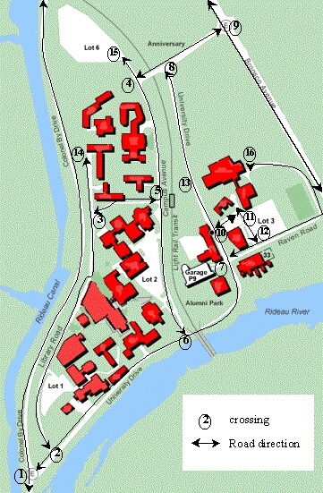
The city section to be described here is the Carleton University Campus. It includes the following main streets: Colonel By drive, Library road, University drive, Campus Avenue, Raven road, Anniversary road, Admin Drive, sunnyside drive and Bronson Avenue. These main streets cross with each other and vary in the number of lanes. Within each of the roads, there are different sections describing different traffic constructions, e.g., different number of lanes, traffic signs, speed limits, parking permissions and potholes. Further more, there is a railway go through the campus; however, it doesn’t cross with any one of the streets because bridges are built. There are four entries/exits allowing traffic enter and leave the campus. They are north/south entries of Bronson Avenue and north/south entries of colonel by drive. The traffic flow in the Bronson is very high as it is a 2 way 3 lane high way. Please refer to the following map for the geographic view of the campus and road positions.

The following is the detailed TSC definition of the Carleton University Campus. The TSC will translate them into DEVS and Cell-DEVS models and generate the MA file to be used under CD++ [2].

begin segments
Colonel_A = (10, 0), (10, 10), 1, straight, go, 40, 300, parkNone
Colonel_B = (10, 10), (17, 190), 1, straight, go, 40, 300, parkNone
Colonel_A1 = (10, 0), (10, 10), 1, straight, back, 40, 300, parkNone
Colonel_B1 = (10, 10), (17, 190), 1, straight, back, 40, 300, parkNone
/* colonel by drive. Colonel A, B is one lane from south to north,
colonel A1, B1 is one lane from north back south. Speed limited at 40 and there is no
parking allowed along the drive. An intersection exists at (10,10) that divide the
road into section A and B */

University_A = (10, 10), (20, 16), 2, straight, go, 40, 300, parkNone
University_B = (20, 16), (71, 61), 1, straight, go, 40, 300, parkNone
University_C = (71, 61), (86, 90), 1, curve, go, 40, 300, parkNone
University_D = (86, 90), (82, 104), 2, straight, go, 40, 300, parkNone
University_E = (82, 104), (74, 120), 2, straight, go, 40, 300, parkNone
University_F = (74, 120), (65, 165), 2, straight, go, 40, 300, parkNone
University_A1 = (10, 10), (20, 16), 2, straight, back, 40, 300, parkNone
University_B1 = (20, 16), (71, 61) , 1, straight, back, 40, 300, parkNone
University_C1 = (71, 61), (86, 90) , 1, curve, back, 40, 300, parkNone
University_D1 = (86, 90), (82, 104), 2, straight, back, 40, 300, parkNone
University_E1 = (82, 104), (74, 120), 2, straight, back, 40, 300, parkNone

University_F1 = (74, 120), (65, 165), 2, straight, back, 40, 300, parkNone
/* University drive. Section A,D,E and F are 2 way and 2 lane. */

Library_A = (20, 16), (35, 107), 1, straight, go, 40, 300, parkNone
Library_B = (35, 107), (62, 113), 1, straight, go, 40, 300, parkNone
Library_C = (35, 107), (35, 130), 1, straight, go, 40, 300, parkNone
Library_A1 = (20, 16), (35, 107), 1, straight, back, 40, 300, parkNone
Library_B1 = (35, 107), (62, 113), 1, straight, back, 40, 300, parkNone
Library_C1 = (35, 107), (35, 130), 1, straight, back, 40, 300, parkNone
/* library road. 2 way 1 lane and no parking */

Campus_A = (71, 61), (62, 113), 1, straight, go, 40, 300, parkNone
Campus_B = (62, 113), (53, 160), 1, straight, go, 40, 300, parkNone
Campus_C = (53, 160), (25, 188), 1, straight, go, 40, 300, parkNone
Campus_A1 = (71, 61), (62, 113), 1, straight, back, 40, 300, parkNone
Campus_B1 = (62, 113), (53, 160), 1, straight, back, 40, 300, parkNone
Campus_C1 = (53, 160), (25, 188), 1, straight, back, 40, 300, parkNone
/* campus avenue. 2 way 1 lane and no parking */

Anniversary_A = (53, 160), (65, 165), 1, straight, go, 40, 300, parkNone
Anniversary_B = (65, 165), (90, 180), 2, straight, go, 40, 300, parkNone
Anniversary_A1 = (53, 160), (65, 165), 1, straight, back, 40, 300, parkNone
Anniversary_B1 = (65, 165), (90, 180), 2, straight, back, 40, 300, parkNone
/* anniversary road. Anniversary_A/A1 is 2 way 1 lane and Anniversary _B/B1 is 2 way 2
lane */

SunnySide_A = (90, 180), (102, 190), 1, straight, go, 40, 300, parkNone
SunnySide_A1 = (90, 180), (102, 190), 1, straight, back, 40, 300, parkNone
/* sunnyside drive. 2 way 1 lane */

Raven_A = (86, 90), (99, 95), 1, straight, go, 40, 300, parkNone
Raven_A1 = (86, 90), (99, 95), 1, straight, back, 40, 300, parkNone
Raven_B = (99, 95), (110, 128), 1, curve, go, 40, 300, parkNone
Raven_B1 = (99, 95), (110, 128), 1, curve, back, 40, 300, parkNone
/* raven road. 2 way 1 lane */

Drive_A = (82, 104), (92, 110), 1, straight, go, 40, 300, parkNone
Drive_A1 = (82, 104), (92, 110), 1, straight, back, 40, 300, parkNone
Drive_B = (92, 110), (99, 95), 1, straight, go, 40, 300, parkNone
Drive_B1 = (92, 110), (99, 95), 2, straight, back, 40, 300, parkNone
/* admin drive. Drive_A/A1 is 2 way 1 lane. Drive_B/B1 is 2 way and B1 is 2 lane */

Bronson_A = (124, 115), (90, 180), 3, straight, go, 60, 300, parkNone
Bronson_B = (90, 180), (80, 190), 3, straight, go, 60, 300, parkNone
Bronson_A1 = (124, 115), (90, 180), 3, straight, back, 60, 300, parkNone
Bronson_B1 = (90, 180), (80, 190), 3, straight, back, 60, 300, parkNone
/* bronson drive. 2 way 3 lane */

end segments

begin crossings

c1 = (10, 10), 20, withoutTL, withoutHole, 300, 3
/* intersection (10,10) of colonel by drive and university drive */
c2 = (20, 16), 20, withoutTL, withoutHole, 300, 3
c3 = (35, 107), 20, withoutTL, withoutHole, 300, 3
c4 = (53, 160), 20, withoutTL, withoutHole, 300, 3
c5 = (62, 113), 20, withoutTL, withoutHole, 300, 3
c6 = (71, 61), 20, withoutTL, withoutHole, 300, 3
c7 = (86, 90), 20, withoutTL, withoutHole, 300, 3
c8 = (65, 165), 20, withoutTL, withoutHole, 300, 3
c9 = (90, 180), 20, withoutTL, withoutHole, 300, 3
c10 = (82, 104), 20, withoutTL, withoutHole, 300, 3
c11 = (92, 110), 20, withoutTL, withoutHole, 300, 3
c12 = (99, 95), 20, withoutTL, withoutHole, 300, 3
c13 = (74, 120), 20, withoutTL, withoutHole, 300, 3
c14 = (35, 130), 20, withoutTL, withoutHole, 300, 3
c15 = (25, 188), 20, withoutTL, withoutHole, 300, 3
c16 = (110, 128), 20, withoutTL, withoutHole, 300, 3

end crossings

The TSC compiler will generate the Cell-DEVS specification according to the above TSC definition. The cell size of segment is determined by the boundaries of the segment in the map. The cell size of crossing is determined by number of input/output segments in a crossing. The following is the partial CD++ source code generated by TSC.

[TOP]
components : BigCounter@TSCCounter
components : Library_B
components : Library_B1
components : Raven_A
components : Raven_A1
components : Anniversary_A
components : Anniversary_A1
components : University_A
components : University_A1
components : Drive_A
components : Drive_A1
components : Anniversary_B
components : Anniversary_B1
components : SunnySide_ACons@TSCConsumer
components : SunnySide_A
components : SunnySide_A1Gen@TSCGenerator
components : SunnySide_A1
…
out : arrived_BigCounter
out : solved_BigCounter
out : qty_Cons_SunnySide_A
out : qty_Cons_Acum_SunnySide_A
…
link : y_c_puedesalir038@Campus_C x_t_puedeentrar1@c15
link : y_t_hayauto0@c15 solved@c15Counter
link : throughputA@c15Counter arrived_c15Counter
link : throughputS@c15Counter solved_c15Counter

[Library_B]
type : cell
width : 27
height : 1
delay : transport
defaultDelayTime : 200
border : nowrapped
neighbors : Library_B(0,-1) Library_B(0,0) Library_B(0,1)
initialvalue : 0
in : x_c_hayauto00
in : x_c_puedeentrar00
out : y_c_haylugar00
in : x_c_haylugar026
out : y_c_hayauto026
out : y_c_puedesalir026
link : x_c_hayauto00 x_c_hayauto@Library_B(0,0)
link : x_c_puedeentrar00 x_c_puedeentrar@Library_B(0,0)
link : y_c_haylugar@Library_B(0,0) y_c_haylugar00
link : x_c_haylugar026 x_c_haylugar@Library_B(0,26)
link : y_c_hayauto@Library_B(0,26) y_c_hayauto026
link : y_c_puedesalir@Library_B(0,26) y_c_puedesalir026
portInTransition : x_c_puedeentrar@Library_B(0,0) segment1-puedeentrar-startcross-rule
portInTransition : x_c_hayauto@Library_B(0,0) segment1-startcross-rule
portInTransition : x_c_haylugar@Library_B(0,26) segment1-endcross-rule
localtransition : segment1-lane-rule
...
[c15-cellOut-rule]
%%%rule : { 0 + send(y_t_puedesalir,0)} 200 { (0,0) = 0 and (0,-1)= 1 and random >= 1/3}
rule : { 3 + send(y_t_puedesalir,0)} 0 { (0,0) = 0 and (0,-1)= 1 and random >= 1/3}
rule : 0 200 { (0,0)= 3 }
rule : 1 200 { (0,0) = 0 and (0,-1) = 1 }
rule : 0 200 { (0,0) = 1 and (0,1) = 0 }
rule : {(0,0)} 200 { t }

Simulation execution results and analysis

Based on the basic model of the Carleton University Campus, many changes have been added to obtain the results under different circumstances.

- Including the non synchronized traffic lights in the two crossings: intersection of colonel by/university Drive and sunnyside/bronson (c1 and c9).

c1 = (10, 10), 20, withTL, withoutHole, 300, 3
c9 = (90, 180), 20, withTL, withoutHole, 300, 3

The simulation is executed in ten minutes. From the figure 1, It is apparent that adding the traffic lights increases the total number of cars in the campus.

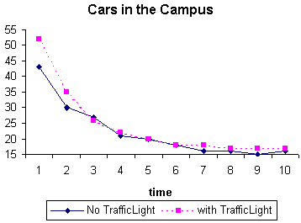Figure 1

In the first minute, due to the non-synchronized traffic lights, the number of vehicles stay in the campus is increased by 10. In the following minutes, it reduced to the normal number but is still a little higher than without the traffic lights. This indicates that although traffic lights are useful in ordering traffic, the non-synchronized lights could actually slow down the vehicles traveling out of the area. Checking the cars go through the crossing C9 in Figure 2, the number of cars arriving and leaving this crossing is reduced comparing with no traffic light previously. From figure 2 we can see that traffic flow in crossing 9 is regulated when the traffic light is added.

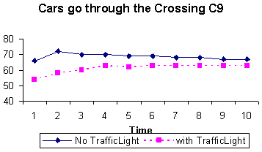Figure 2

From the other point of view, we check the cars leaving the campus from the segment Bronson_B in figure 3. The influence of the traffic light can be seen clearly, the number of cars leaving the segment Bronson_B is reduced when traffic light is added in crossing C9. In this case, the traffic light didn’t solve the campus traffic flow, on the contrary, it results in the high number of cars in the campus due to the fact that it is not synchronized. Because segment Bronson_B is a main traffic road, in order to avoid the traffic jams on this road, the traffic light limit the traffic flow leaving campus through this crossing.

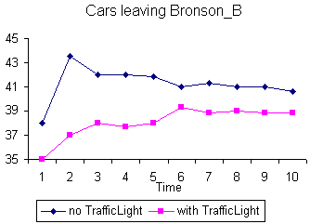Figure 3

- There is a railway go through the campus, but it didn’t affect the local traffic flow because there is bridges built to avoid crossing with roads in the campus. We suppose the railway is crossing with the road in order to test the influence of the railway.

begin railnets
rn = (University_C, 9), (University_C1, 4), (Anniversary_A, 7), (Anniversary_A1, 5), 200
end railnets

This railway has crossings with the segment University_C, University_C1, Anniversary_A, and Anniversary_A1. The first affected crossing is C7. As Figure4 indicates, in the first minute, the number of cars is reduced to 0 due to the closing of the barrier, and no cars arrive crossing C7. In the following minutes, the cars increase largely and reach the maximum number with all cars passing through the railway cross.

Figure 5 describes the number of cars going through crossing C7, C10, C11 and C12 in the first minute. The result shows that in the first minute, no cars went through crossing C10, C11, C12 and C7. This indicates that when a train come through the campus, all the cars are jammed in the current crossing and could not reach nearby crossings.

Since the traffic flow is not very high in the campus, adding the railway didn’t affect the total number of cars in the campus on average over period of time. However, the traffic load did increase dramatically in a short time in the crossings around the railway, which means the railway still has the potential to make the traffic jams.

In general, if a railway cross with the street, it will always induce the traffic jam in the current crossing.

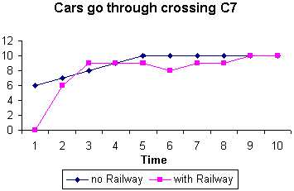Figure 4

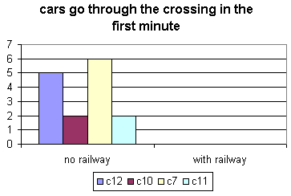Figure 5

- Adding traffic signs in some segments to check the traffic flow changes.

begin ctrElements
in University_B : stop, 0, 200
in University_C : stop, 0, 200
in University_D : stop, 0, 200
in University_E : stop, 0, 200
in Campus_A : stop, 36, 200
in Campus_B : stop, 0, 200
in Campus_C : stop, 0, 200
in Anniversary_A1 : stop, 0, 200

end ctrElements
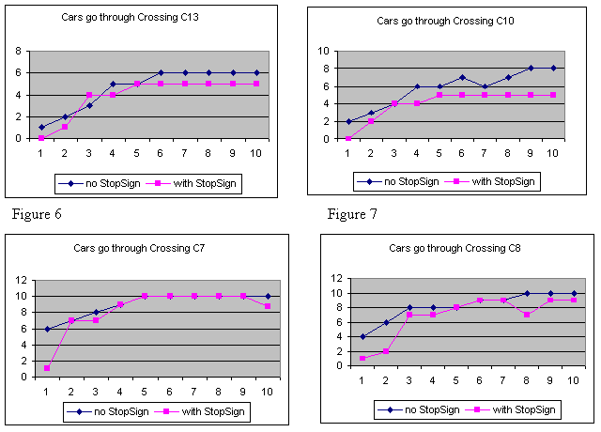Figure 8 Figure 9

Figure 6,7,8 and 9 compares these crossings (C7, C8, C10 and C13) with stop signs and without stop sign. The above figures explain the results obtained at each of the crossings, the number of cars go through these crossings is reduced. Therefore, the stop signs regulated the traffic flow in these crossings. With respect to the total number of cars in the campus in Figure 10, no big difference comparing with the model without stop signs. Only in the last two minutes, the cars stay in the campus increased as the stop signs slows down the traffic leaving the campus and cause the total number of cars increased at some point.
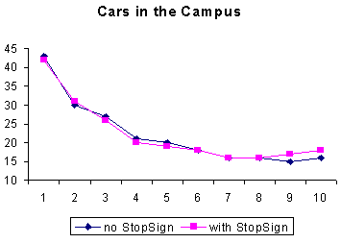Figure 10

- Adding both traffic light and stop sign in these crossings to check the result.
In Figure 11, the total number of cars in the campus is increased by 12. The cars leaving the segment Bronson_B are also reduced due to the fact that less traffic left the campus. The traffic lights limit the number of cars leaving campus.

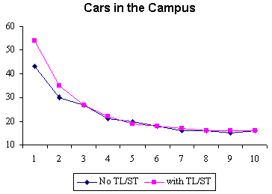Figure 11

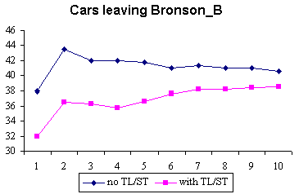Figure 12

- Adding jobsite in the segment Campus

begin jobsites
in Campus_B1 : 1, 25, 1, 200
in Campus_A1 : 1, 12, 1, 200

end jobsites

Use the crossing C5 as a reference point, which is just before the jobsite in Campus_B. In Figure 13, the number of cars increased largely in the first minute due to the fact that people entering and exiting the job site. For such a small crossing, the arrived and solved cars accumulate to 30. In other word, job site could introduce potential traffic jam at its nearby crossings at certain instances. There is also another interesting fact, that is, the traffic flow went below the usual rate after certain point. This is because the job site absorbs/produce traffic flows at one point result less flow at other time since the total number of cars on average are similar. We can imagine this case being people go to work. During the rush hours, the traffic flow is high; however, for the rest of the time, the traffic flow is below average.

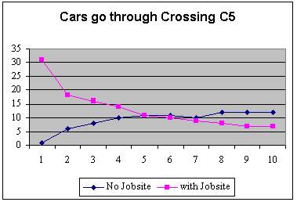Figure 13

- Varying the experimental framework (TSCGenerator) input rates to increase the generated cars.

From Figure 14, during the first minute, the number of vehicles in the campus increased exponentially, after several minutes the number of cars is reduced. During the first few minutes, as the arrival increases all of a sudden, there are jams created in some of the crossings; however, after a while, as the cars started moving around/leaving the campus, the number of cars left in the area decreased. This indicates that the campus can absorb more traffic flow without causing delays than it was in the previous models.

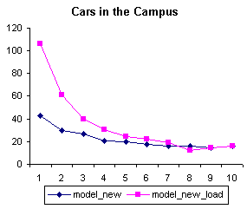 Figure 14

Output for each of the sub-models (Cell-DEVS)

In the ATLAS construction, there are two basic Cell-DEVS sub-models: segment and crossing. Because the Carleton University Campus model is very big, it requires a long time to draw the output result. Here we use a simple example to obtain the output of these two cell sub-models since the cell behavior is the same. For detailed graphic output, please refer to the zip file attached.

begin segments
t1 = (1,5),(1,1),2,straight,go,40,300,parkNone
t2 = (1,1),(5,1),2,straight,go,40,300,parkNone
end segments

begin crossings
c1 = (1,1),20, withoutTL, withoutHole, 300, 3
end crossings

Output for t2:
Line : 240 - Time: 00:00:01:400
0 1 2 3
+------------+
0| 1 0 0 0|
1| 0 0 0 0|
+------------+

Line : 256 - Time: 00:00:01:600
0 1 2 3
+------------+
0| 0 1 0 0|
1| 0 0 0 0|
+------------+

Line : 274 - Time: 00:00:01:800
0 1 2 3
+------------+
0| 0 0 1 0|
1| 0 0 0 0|
+------------+

Line : 295 - Time: 00:00:02:000
0 1 2 3
+------------+
0| 0 0 0 1|
1| 0 0 0 0|
+------------+
…

Conclusion:

In this project, a complex traffic model (Carleton University Campus) is defined by ATLAS [1] specification language. The TSC [3] compiler is used as a tool to translate them into executable files that can be run under the CD++ [2]. The simulated traffic flow is analyzed under different topology of the campus. With this approach, several advantages are obtained in simulating such a complex traffic model. First of all, the high-level specification language describes the model. TSC tool automatically builds the coupled model structure and generates the rules for cell DEVS models. With this approach, the modeler can change the model specification efficiently without rewriting code and therefore saves a lot of time on problem solving. Secondly, by using the ATLAS, although traffic model is a complex simulation, each of the micro-simulation results can be analyzed individually which is difficult to be analyzed by the traditional analytical solutions. Finally, the TSC templates are adaptive. The templates can be modified accordingly to fit different simulation tools without having to change the high-level specification.

The analysis of the campus traffic flow under different circumstances concludes that the TSC approach is useful in analyzing such models. Different traffic signs, traffic lights can be modeled to reflect the real situations easily. This is especially helpful in city traffic planning in order to provide the optimal constructions. These analytical results also prove that the current constructions in the campus works well for traffic controlling and the campus can handle more traffic without introduce traffic jams.

References

[1] Mariana Lo Tartaro, Cesar Torres and Gabriel Wainer. Defining models of urban traffic using the TSC tool. Proceedings of the 2001 Winter Simulation Conference.

[2] Daniel A. Rodriguez and Gabriel A. Wainer. CD++ User’s Guide.

[3] Cesar Torres and Mariana Lo Tartaro. Structure and Functionality of TSC(traffic simulation compiler).

