Barber Shop Simulation

Cell-Devs Model
Sysc5807
Assignment 1

2003-10-19

Prepared
by art gresham
100640035

Filename: /tmp/lo/0000.doc
Part 1. Barber Shop Conceptual Model 3
Representation and English Description 4
Part II Components 5
Atomic 5
CutHair 5
CheckHair 6
Reception 7
Coupled Models 8
Barber 8
BarberShop 8
Part II Testing Strategy 9
Atomic Model Testing 9
Cuthair 9
Checkhair 9
Reception 9
Coupled Model Testing 11
Barber 11
Barbershop 11
Part III Simulation Results 12
Example of Conventions Used 12
Atomic Testing 13
Cuthair, Checkhair, Reception 13
Coupled Testing 14
Barber and Barbershop 14
Extreme Conditions 15
Simultaneous Events 15
Abnormal Transition Times 16
summarizing . . . 17
Appendix 19
Readme.txt 19
Typical .Outputs.txt file 21

Part 1. Barber Shop Conceptual Model
A Cell-Devs Model of a Barber Shop has been created.
The BarberShop Model is a hierarchical implementation of a number of new Atomic Models which have been defined for the Cell-Devs Simulation tool. The model diagram is as follows:
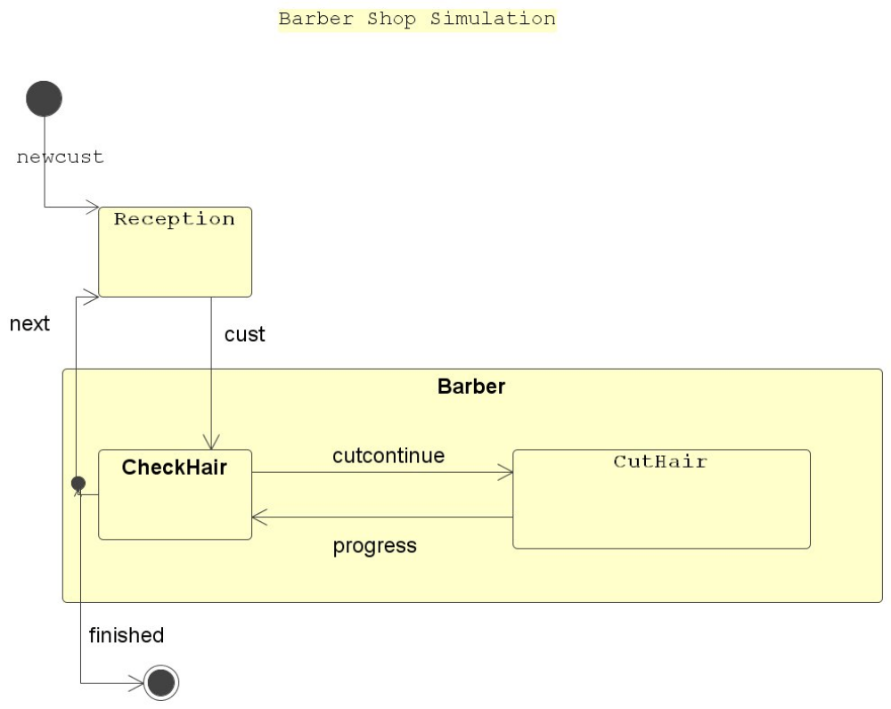

Representation and English Description
The Highest Level Model is BarberShop, which represents a simple retail Barber Shop. Barber Shop is Comprised of:
1) the Atomic Reception, which is a set of chairs for the customers to wait for their haircut in.
Customers arrive and are lined up in queue to wait for the Barber. They will be telling the barber how much hair to cut when they get to him. The first customer of the day, or after all the chairs are empty, is directed directly to the Barber, afterwards the Barber tells the receptionist when he is finished the haircut he is on and ready for a new customer.. The nominal open hours are between 9:00 am and 4:00 pm, and the receptionist turns away anyone arriving outside of those hours. The barber will finish anyone lined up before closing time.
2) the sub-model Barber, which represents the Barber.
Barber is comprised of the Atomic models CheckHair and CutHair. The Barber receives a customer from reception - the customer tells the barber how many millimetres of hair is to be removed. The barber starts work by evaluating the job (checkhair) and signalling cuthair to continue cutting. Cuthair simply represents his arms, hands and scissors. Cuthair reports progress back to checkhair which counts that enough hair has been removed, ( ie 1 millimetre per iteration). When the haircut is complete, the barber signals the receptionist to send another customer.

Part II Components
Atomic
The following are the Atomic Component Model Definitions for BarberShop.
CutHair

Atomic CutHair = {X, S, Y, iTfn, xTfn, ta, lamda}
X = Input Set = {cutcontinue}
S = State = {cutting , passive}
Y=Output ={progress}
iTfn=Internal Transition Function
iTfn(ta) {cutting} -> {passive}
xTfn=External Transition Function
xTfn(cutcontinue) {passive) -> {cutting}
ta=time advance
lamda=output function -> {progress@checkhair}

Devs State Variables

sigma is (transition time (passive= oo, active = predetermined))
phase <element of> {passive, cutting} (initial= passive)
xTfn(e){
assert port = cutcontinue
sigma = cutting-time;
phase = cutting;
lamda = progress@checkhair
}
iTfn(e, sigma){ //assert active
phase = passive ;
sigma = oo ;
}

CheckHair

Atomic CheckHair = {X, S, Y, iTfn, xTfn, ta, lamda}
X = Input Set = {CutHair.progress, cust}
S = State = {Checking , passive}
Y=Output ={cutcontinue, finished}
iTfn=Internal Transition Function
iTfn(e) {Checking} ->passive
xTfn=External Transition Function
xTfn(Customer, passive) ->Checking
xTfn(.progress, Checking) ->Checking
ta=time advance
lamda=output function -> {continue@cuthair, next@reception}

Devs State Variables

sigma (transition time(passive= oo, active = predetermined)
phase (initial= passive) phase <element of> {passive, Checking}
xTfn(Customer, CutHair.progress){
case port
reception.cust { sigma = checktime
cutcount = cust.msg.value()
phase = checking
lamda=cutcontinue@cuthair
}
cuthair.progress{
sigma = Checktime;
phase = Checking;
lamda = cutcontinue@cuthair,next@reception
end-case
}
iTfn(e,){
// assert active
sigma = oo;
phase = passive ;
}
lamda=(if port.progress@cuthair{if cutcount > desired cut{next@reception;} else
if port.reception@cust{cutcontinue@cuthair;}
)
Reception

Atomic Reception = {X, S, Y, iTfn, xTfn, ta, lamda}
X = Input Set = {newcust, finished@checkhair}
S = State = {seating customer , passive}
Y=Output ={cust@checkhair}
iTfn=Internal Transition Function
iTfn(e) {serving customer} ->passive
xTfn=External Transition Function
xTfn ( passive) ->serving customer
ta=time advance
lamda=output function -> {continue@cuthair, next@reception}

Devs State Variables

sigma (transition time(passive= oo, active = predetermined)
phase (initial= passive) phase <element of> {passive, servingCustomer}
xTfn(Customer, CutHair.progress){
case port
newcust { sigma = servingtime
phase = servingCustomer
lamda=internal queue, cust@checkhair
}
checkhair.finished{
sigma = servingtime;
phase = servingCustomer;
lambda= cust@checkhair
}
end-case
}
iTfn(e,){
// assert active
sigma = oo;
phase = passive ;
}
lamda=(if newcust{if only cust{cust@checkhair}else{enqueue}
if finished@checkhair{if queue is not empty{cust@checkhair;}
)
Coupled Models
Barber

Coupled Barber CM= <I,X,Y,D,{Mi},{Ii},{Zij}>
I = interfaces = {in,out,cust,progress,finished,cutcontinue}
X = Input Set = {in}
Y = Output Set = {out}
D = index to components Mi
M1 = {checkhair}
M2 = {cuthair}
I1 = {reception}

Zij = mapping between components
cust@reception -> in@Barber
out@Barber ->next@reception

in@Barber ->cust@checkhair
finished@checkhair -> out@barber

cutcontinue@checkhair cutcontinue@cuthair
progress@cuthair progress@checkhair
finished@checkhair finished

BarberShop

Coupled BarberShop CM= <I,X,Y,D,{Mi},{Ii},{Zij}>
I = interfaces = {in,out }
X = Input Set = {in}
Y = Output Set = {out}
D = index to components Mi
M1 = {reception}
M2 = {Barber}
I1 = {}

Zij = mapping between components
in -> in@Barbershop
out@BarberShop -> out

in@BarberShop ->newcust@reception
out@barber ->out@BarberShop

barber -> mapped as in Barber above
Part II Testing Strategy
All model components will be individually tested, and then test as integrated subcomponents of coupled models. There are 3 regimes of testing to be applied. These are
1) nominal or normal inputs representing realistic run time situation
2) extreme inputs x - preset 0 transition times and simultaneous events
3) extreme inputs z - preset long transition times and simultaneous events

Atomic Model Testing
Cuthair

Cuthair is a timed server - it receives cutcontinue messages, taking the predetermined time to process a cut. When the cut is finished, it outputs progress.
Test inputs are applied for each of the 3 general test regimes described above, and results evaluated.

Checkhair

Checkhair is a counter and type server - it receives both cust arrived messages from reception, and progress messages from cuthair. Checkhair is required to be able to process both concurrently. On progress messages from cuthair, Checkhair will be tested that it correctly counts progress. On cust messages from reception, Checkhair will be tested that it correctly starts cutting hair. Test data for each of the 3 general testing regimes defined above will be applied and evaluated.

Reception

Reception is a FIFO queue. It's queue size is limited, so it has to keep track of total number of entries. It must respond to both newcust messages from the world, and 'finished' messages from checkhair. Reception is required to be able to process both concurrently. Reception will be tested with test data for each of the general testing regimes defined above, and results evaluated.

Coupled Model Testing
Barber

Barber is the coupled checkhair/cuthair components. It receives customers, and informs when cutting is finished. It must be able to start when it receives a customer, finish the cut, and send output when finished. It will be tested with test data for each of the general testing regimes defined above, and results evaluated.

Barbershop

Barbershop is the complete hierarchically coupled system, including Reception, checkhair and cuthair components. It receives customers enqueuing them if the barber is busy and passes queued customers to the barber when he sends a finished message. It must be able to start when it receives a customer, send a 'first customer in queue' to the barber, enqueuing others arriving, and manage open close times for the shop. It will be tested with test data for each of the general testing regimes defined above, and results evaluated.

Part III Simulation Results

Components were developed , unit tested , and integration tested using the test strategy from part II.
Components include reception.cpp and .h, checkhair.cpp and .h, cuthair.cpp and .h .
Inputs are the standard .ma and .ev files for the atomic components, coupled components developed include barber.ma and .ev, and barbershop.ma and .ev
In testing the components, erratic out of sequence inputs were applied to see what would happen. The model code was adjusted to reject erratic inputs. Ie , if the barber has a customer, and receives another customer, he ignores him.

Note: through the course of testing, it became useful and necessary to mark with output comments all edges of the control flow path for external, internal transition functions of all code. These outputs were left active to facilitate interpretation of the test results. Note in the text outputed comments that the last transition time lastchange() was used, not msg.time() .

Further, the batch scripts to run the barbershop simulation have been enhanced to bring all outputs into one '… .outputs.txt ' listing file per simulation test regime and model combination, and a utility to run all included tests - runallbarbershop.bat.
Testing regimes were assigned a naming convention to help sort them out, and combine them.

Example of Conventions Used

barber.bat runs the barber subcomponent using barber.ma and barber.ev .

barber.x.bat runs the barber subcomponent using barber.x.ma and barber.x.ev .
the .x. naming convention is for the extreme conditions no transition times and simultaneous events testing.

barber.z.bat runs the barber subcomponent using barber.z.ma and barber.x.ev . the .z. naming convention is for the extreme conditions long transition times and simultaneous events.

There is a suite of each corresponding to each of the 3 atomic and 2 coupled models for barbershop.

Atomic Testing
Cuthair, Checkhair, Reception

Normal operation.
Events were listed in each of the respective event input .ev files for Cuthair, checkhair and reception. The accompanying message from the input was the desired amount of hair to remove, ie in millimetres.
Under normal circumstances, all 3 performed adequately independently . Complete runtime listings are in the appendices. For example, here is an excerpt from the reception runtime:

"*** reception.ma "
[top]
components : reception@Reception
in : newcust next
out : cust
Link : newcust newcust@reception
Link : next next@reception
Link : cust@reception cust

[reception]
numberofChairs : 8
preparationTime : 00:0:01:100
openingTime : 09:00:00:000
closingTime : 16:00:00:000
. . . screen>
Starting simulation. Stop at time: Infinity. > event inputs:
08:01:00:000 / newcust / 10.00000
09:10:00:000 / newcust / 20.00000
. . .
12:23:00:000 / next / 1.00000
. . . code marks
00:00:00:000rcptn x we are closed - sorry : 0 : 0
08:01:00:000rcptn x queued a newcust request : 1 : 20
08:01:00:000rcptn x activating first cust is coming : 1 : 20
09:10:00:000rcptn o transition : 1 : 20
09:10:00:000rcptn i transition : 0 : 0
09:10:01:100rcptn x queued a newcust request : 1 : 30
09:10:01:100rcptn x activating first cust is coming : 1 : 30
. . . outputs
"*** reception.out "
09:10:01:100 cust 20
09:10:11:100 cust 30
Coupled Testing
Barber and Barbershop

Normal operation.
Events were listed in each of the respective event input .ev files for Barber and Barbershop. Under normal circumstances, all 3 performed adequately independently . Normal circumstances included testing for erratic incoming messages that would typically not occur. Complete runtime listings are in the appendices. For example, here is an excerpt from the Barber runtime outputs.
Note in the text outputed comments that the last transition time lastchange() was used, not msg.time() .
"*** barber.ma "
[top]
components : checkhair@Checkhair cuthair@cuthair

in : cust progress
out : finished cutcontinue

Link : cust cust@checkhair
Link : progress@cuthair progress@checkhair

Link : cutcontinue@checkhair cutcontinue@cuthair
Link : finished@checkhair finished

[checkhair]
preparationTime : 00:00:09:000
Starting simulation. Stop at time: Infinity.
08:03:00:000 / cust / -3.00000
11:03:00:000 / cust / -0.00000
11:03:01:000 / cust / 19.00000
11:03:02:000 / cust / 18.00000
00:00:00:000chkhr x normal receive new customer : 0:0
08:03:00:000chkhr o first cutcontinue ->cuthair : 1:3
08:03:00:000chkhr i transition : : 1:3
00:00:00:000cuthr x ok i'm cutting now : 1
08:03:09:000cuthr o output reporting progress :
08:03:09:000cuthr i internal transition :
Simulation ended!
"*** barber.out "
08:04:09:000 finished 3
Extreme Conditions
All of the Atomic models, and the coupled models too performed MISERABLY under extreme conditions. This included testing with simultaneous events combined with both long and 0 transition times. The key failure was in the checkhair component, and the way it was architected as a counter.
Checkhair used a state variable 'cutcount' for counting how much hair had been cut.
Simultaneous Events
The difficulty with simultaneous events for all of the atomic models was that the external transition function could be triggered sequentially in real time before the output function could run. The external transition function was manipulating state variables such as cutcount, cutmax etc to count total hair cut, and queue size for the receptionist, and these would change 'volatile' before the output function would run. These nasty results were revealed in testing with both the .x. and the .z. extreme test suites. In order to puncture proof the barber shop for extreme conditions, a complete redesign of the receptionist and checkhair components would be required, one which did not use state variables.
A slight improvement to the Receptionist component under simultaneous event conditions was to move the queue unloading function to the output function from its default(as cloned from the QUEUE sample) location in the external transition function.
An example of simultaneous event mishandling from checkhair.x.outputs.txt:
Inputs:
00:00:00:000 / progress / 0.00000
00:00:00:000 / cust / 3.00000
00:00:00:000 / progress / 0.00000
Reported
00:00:00:000chkhr x no cust here for haircut : 1:0
00:00:00:000chkhr x busy and interrupted no new cust : 1:0
00:00:00:000chkhr x no cust here for haircut : 1:0
00:00:00:000chkhr x no cust here for haircut : 1:0
00:00:00:000chkhr x busy and interrupted no new cust : 1:0

Abnormal Transition Times

0 transition times compounded the problems associated with simultaneous events.
The main problem with long transition times was the rejection of incoming messages at the attached components. If checkhair was cutting hair, ie active, it would reject a new customer it had requested. This is not acceptable. In this case, the significance and importance of setting appropriate transition times was identified. This helps a lot. The code however really should be able to handle this, I think. Here is an example of abnormal transition times from reception.z.outputs.txt.
In this case, the first cust in is not dispatched on time before the queue is full, so a customer has to be turned away.
Inputs.
09:00:00:000 / newcust / 30.00000
09:00:00:000 / next / 1.00000
output text:
09:00:00:000rcptn x NEW cust in queue : 8 : 20
09:00:00:000rcptn x we are full - sorry : 8 : 20
09:00:00:000rcptn x activating queued cust is coming : 8 : 20
09:00:00:000rcptn x activating queued cust is coming : 8 : 20

summarizing . . .

this has been an amazing learning experience in real time programming.
There were some glitches in getting started, but once the development environment was stable, things went ok, though slowly.

The key learning has been not to use state variables across function calls.

The key suggestion would be to create a sendoutput that allowed 'tree'ing of an attached comment to the console for aid in debugging.

There would be no expectation of extending the log files contents, but knowing the transition components and functions does NOT reveal the all important edges and states at each edge. Perhaps there is a debugger out there that can animate into and out of these coupled models , as the method and message sequencing is not in the control of the programmer, as with normal COBOL code.

Thank you for the help getting started.

Art

Appendix

Readme.txt

barbershop demo was developed under cygwin on a compaq laptop running windows xp home.
the cd++ was downloaded as cd++_exes_win.zip from the course website
win32 cygwin

1) unzip into directory with cd++ tool - you have to allow overwrite of register.cpp and makefile
2) open a cygwin prompt
3) make
coupled components:

4) barbershop.bat testruns the complete Barbershop coupled devs model using barbershop.ma barbershop.ev
5) barber.bat testruns the Barber subcomponent, also a coupled devs model using barber.ma barber.ev

atomic components:

6) reception.bat testruns the reception Atomic component using reception.ma reception.ev
7) checkhair.bat testruns the checkhair Atomic component using checkhair.ma reception.ev
8) cuthair.bat testruns the cuthair Atomic component using cuthair.ma cuthair.ev

naming conventions - related components have identical name roots
ie there is a barber.bat barber.ma barber.ev
Atomic components: there is reception.cpp, reception.h, checkhair.cpp, checkhair.h, cuthair.cpp, cuthair.h .

OUTPUTS

the .bat files have been configured to organize the output info for easier analysis.
each .bat file runs the simulator with its respective .ev and .ma

the .OUT file, screen output, and diagnostic messages from the code are output to {componentname}.outputs.txt
ie when you run barbershop.bat, you get a barbershop.outputs.txt for convenient viewing.
the last instruction of each .bat file displays the .outputs.txt file to the console using 'less'.
you get around the file in 'less' with the up and down arrows , it's pretty intuitive.
to exist the 'less' viewer, type 'q' for quit.

have fun!

art
sysc5807
Typical .Outputs.txt file
(
"*** cuthair.ma "
[top]
components : cuthair@Cuthair

in : cutcontinue
out : progress

Link : cutcontinue cutcontinue@cuthair
Link : progress@cuthair progress

[cuthair]
preparationTime : 0:0:11:000
"*** cuthair runtime msgs "
N-CD++: A Tool to Implement n-Dimensional Cell-DEVS models
----------------------------------------------------------

Version 2.0-R.45 December-1999
Daniel Rodriguez, Gabriel Wainer, Amir Barylko, Jorge Beyoglonian
Departamento de Computacion. Facultad de Ciencias Exactas y Naturales.
Universidad de Buenos Aires. Argentina.

Loading models from cuthair.ma
Loading events from cuthair.ev
Message log: cuthair.log
Output to: cuthair.out
Tolerance set to: 1e-08
Configuration to show real numbers: Width = 12 - Precision = 5
Quantum: Not used
Evaluate Debug Mode = OFF
Flat Cell Debug Mode = OFF
Debug Cell Rules Mode = OFF
Temporary File created by Preprocessor = /tmp/tb0.0
Printing parser information = OFF

Starting simulation. Stop at time: Infinity.
00:00:00:000 / cutcontinue / -3.00000
00:01:20:000 / cutcontinue / 1.00000
00:02:45:000 / cutcontinue / 3.00000
00:03:20:000 / cutcontinue / 1.00000
00:04:40:000 / cutcontinue / 3.00000
00:05:20:000 / cutcontinue / 1.00000
00:06:40:000 / cutcontinue / 3.00000
00:07:20:000 / cutcontinue / 1.00000
00:08:40:000 / cutcontinue / 3.00000
00:09:20:000 / cutcontinue / 1.00000
00:10:40:000 / cutcontinue / 4.00000
00:11:20:000 / cutcontinue / 5.00000
00:00:00:000cuthr x ok i'm cutting now : -3
00:00:00:000cuthr o output reporting progress :
00:00:00:000cuthr i internal transition :
00:00:11:000cuthr x ok i'm cutting now : 1
00:01:20:000cuthr o output reporting progress :
00:01:20:000cuthr i internal transition :
00:01:31:000cuthr x ok i'm cutting now : 3
00:02:45:000cuthr o output reporting progress :
00:02:45:000cuthr i internal transition :
00:02:56:000cuthr x ok i'm cutting now : 1
00:03:20:000cuthr o output reporting progress :
00:03:20:000cuthr i internal transition :
00:03:31:000cuthr x ok i'm cutting now : 3
00:04:40:000cuthr o output reporting progress :
00:04:40:000cuthr i internal transition :
00:04:51:000cuthr x ok i'm cutting now : 1
00:05:20:000cuthr o output reporting progress :
00:05:20:000cuthr i internal transition :
00:05:31:000cuthr x ok i'm cutting now : 3
00:06:40:000cuthr o output reporting progress :
00:06:40:000cuthr i internal transition :
00:06:51:000cuthr x ok i'm cutting now : 1
00:07:20:000cuthr o output reporting progress :
00:07:20:000cuthr i internal transition :
00:07:31:000cuthr x ok i'm cutting now : 3
00:08:40:000cuthr o output reporting progress :
00:08:40:000cuthr i internal transition :
00:08:51:000cuthr x ok i'm cutting now : 1
00:09:20:000cuthr o output reporting progress :
00:09:20:000cuthr i internal transition :
00:09:31:000cuthr x ok i'm cutting now : 4
00:10:40:000cuthr o output reporting progress :
00:10:40:000cuthr i internal transition :
00:10:51:000cuthr x ok i'm cutting now : 5
00:11:20:000cuthr o output reporting progress :
00:11:20:000cuthr i internal transition :
Simulation ended!
"*** cuthair.out "
00:00:11:000 progress 1
00:01:31:000 progress 1
00:02:56:000 progress 1
00:03:31:000 progress 1
00:04:51:000 progress 1
00:05:31:000 progress 1
00:06:51:000 progress 1
00:07:31:000 progress 1
00:08:51:000 progress 1
00:09:31:000 progress 1
00:10:51:000 progress 1
00:11:31:000 progress 1

