SYSC 5104
METHODOLOGIES FOR DISCRETE EVENT MODELLING AND SIMULATION

Discrete-event Model of the Border Control System using DEVS Formalism

Peter Miebach 100616681
Pradeep Gunaratnam 100322776

October 18, 2012

Part I: Conceptual Model
At the Canadian border, border crossing agents must process each individual that wish to cross into the country in order to determine if they are a threat or not to the country. Traffic will queue up when they enter the system if another vehicle is currently being processed. Through a series of sub systems, the vehicle’s records will be examined and if it fails to pass the primary inspection, a secondary inspection will occur to provide a more in depth inspection. After being inspected, the vehicle will either be allowed to enter the country or be detained. Figure 1 displays the system and interworking components

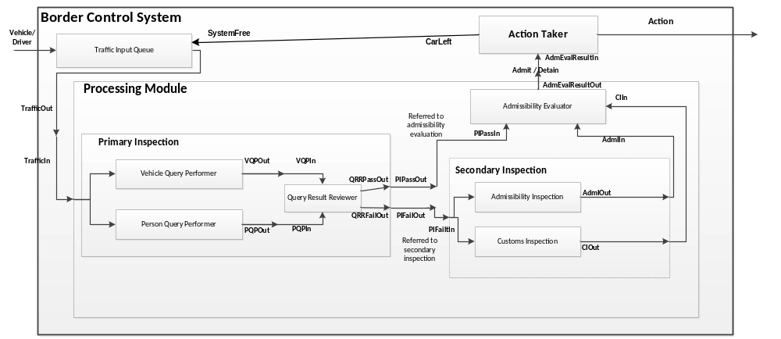
Figure 1: System and interworking components

Brief Description of the behaviour of each Component:
Level 1 (Border Control System):
Traffic Input Queue:
As traffic enters the system, traffic will queue up to be processes if there is already another car currently being processed.
Processing Module:
Contains sub components that will process the traffic that enters the system.
Action Taker:
Depending on the ‘Admissibility Evaluator’, the Action Taker will either admit or detain traffic.

Level 2 (Processing Module):
Primary Inspection:
Contains sub components that will perform a primary check on the traffic.
Secondary Inspection:
Contains sub components that will perform a more thorough check depending on the outcome of the primary inspection.
Admissibility Evaluator:
Will determine if the traffic is qualified to pass into the country or not. If the traffic failed an inspection, then they will not be able to enter the country.

Level 3 (Primary Inspection):
Vehicle Query Performer:
Perform a record check on the vehicle license plate. In the simulation, 95% of vehicles will pass inspection.
Person Query Performer:
Perform a record check on the driver’s license. In the simulation, 95% of people will pass inspection.
Query Result Reviewer:
Determine if further processing is required depending on the outcome of the license checks. If the license check fails, further processing will be required. If both the Vehicle and Person Query Performer succeed, the Query Result Reviewer will forward them to the Admissibility Evaluator.

Level 3 (Secondary Inspection):
Admissibility Inspection:
Performs inspection on vehicle and person to see if they are admissible into the country. This is to prevent from any illegal immigrants, criminals, theft vehicles and unsafe vehicles coming in. In the simulation, 95% of people will pass inspection.
Customs Inspection:
Performs inspection for any contrabands (such as drugs and guns) that the driver might be smuggling with him or in vehicle. In the simulation, 95% of people will pass inspection.

Part II: Model Specification
Referring to Figure 1, the Border Control System can be expressed in terms of atomic and coupled components.

The system breaks down as follows:

Border Control System (coupled)
- Traffic Input Queue (atomic)
- Processing Module (coupled)
  - Primary Inspection (coupled)
    - Vehicle Query Performer (atomic)
    - Person Query Performer (atomic)
    - Query Result Reviewer (atomic)
  - Secondary Inspection (coupled)
    - Admissibility Inspection (atomic)
    - Customs Inspection (atomic)
  - Admissibility Evaluator (atomic)

- Action Taker (atomic)

DEVS formal specification for each of the coupled models:

The DEVS formal specification, CM = <X, Y, D, {Mi}, {Ii}, {Zij}, SELECT >, for each of the couple models is as follows:

Border Control System (coupled):
X = {Vehicle/Driver};
Y = {Action};
D = {Traffic Input Queue, Processing Module, Action Taker};
I(Traffic Input Queue) = Self;
I(Processing Module) = Traffic Input Queue;
I(Action Taker) = Processing Module;
Z (Traffic Input Queue) = Processing Module;
Z(Processing Module) = Action Taker;
Z(Action Taker) = Self;
SELECT: ({Traffic Input Queue, Processing Module, Action Taker}) = Traffic Input Queue;
({Processing Module, Action Taker}) = Processing Module;

Test Strategy:
The Border Control System will be tested using the “black box” testing method. Test cases are
created by adding input traffic to the system at different times. The output is observed to see if the
action is taken.

Input:
00:00:00:00 in 1
00:01:00:00 in 1
00:02:00:00 in 1
00:3:00:00 in 1
.
.
.

00:18:00:00 in 1
00:18:00:00 start 1

Output:
The border control system should output appropriate action output within the expected time. IT should take admin action 95% of the time and detain action 5% of the time.

Processing Module (coupled):
X = {TrafficIn};
Y = {AdmEvalResultOut};
D = {Primary Inspection, Secondary Inspection, Admissibility Evaluator};
I(Primary Inspection) = Self;
I(Secondary Inspection) = Primary Inspection;
I(Admissibility Evaluator) = {Primary Inspection, Secondary Inspection};
Z (Primary Inspection) = {Secondary Inspection, Admissibility Evaluator};
Z(Secondary Inspection) = Admissibility Evaluator;
Z(Admissibility Evaluator) = Self;
SELECT: ({Primary Inspection, Secondary Inspection, Admissibility Evaluator}) = Primary Inspection;
({Primary Inspection, Admissibility Evaluator }) = Primary Inspection;

Test Strategy:
The Processing Module will be tested using the “black box” testing method. Test cases are
created by adding input traffic one by one to the processing module. The output is observed to see if
the AdmEvalResultOut is outputted.

Input:
00:00:00:00 in 1
00:45:00:00 in 1
01:08:00:00 in 1
01:25:00:00 in 1
.
.
.

01:48:00:00 in 1

Output:
The Processing Module should output appropriate AdmEvalResultOut (Admit or Detain) output
within the expected time. It should indicate to take admit 95% of the time and detain 5%.

Primary Inspection (coupled):
X = {TrafficIn};
Y = {QRRPassOut, QRRFailOut};
D = {Vehicle Query Performer, Person Query Performer, Query Result Reviewer};
I(Vehicle Query Performer) = Self;
I(Person Query Performer) = Self;
I(Query Result Reviewer) = {Vehicle Query Performer, Person Query Performer };
Z (Vehicle Query Performer) = Query Result Reviewer;
Z(Person Query Performer) = Query Result Reviewer;
Z(Query Result Reviewer) = Self;
SELECT: ({Vehicle Query Performer, Query Result Reviewer}) = Vehicle Query Performer;
({Person Query Performer, Query Result Reviewer}) = Person Query Performer;

Test Strategy:
The Primary Inspection will be tested using the “black box” testing method. Test cases are
created by adding input traffic one by one to the Primary Inspection module. The output is observed
to see if the QRRPassOut and QRRFailOut is outputted.

Input:
00:00:00:00 in 1
00:45:00:00 in 1
01:08:00:00 in 1
01:25:00:00 in 1
.
.
.

01:48:00:00 in 1

Output:
The Processing Module should output appropriate output within the expected time. It should output
QRRPassout pass 95% of the time and fail it 5%.

Secondary Inspection (coupled):
X = {PIFailIn};
Y = {AdmIOut, CIOut};
D = {Admissibility Inspection, Customs Inspection };
I(Admissibility Inspection) = Self;
I(Customs Inspection) = Self;
Z (Admissibility Inspection) = Self;
Z(Customs Inspection) = Self;
SELECT: ({Admissibility Inspection, Customs Inspection }) = Admissibility Inspection;

Test Strategy:
The Secondary Inspection will be tested using the “black box” testing method. Test cases are
created one by setting PIFailIn to “1” in different time. The output is observed
to see if the AdmIOut and CIOut is outputted.

Input:
00:00:00:00 PIFailIn 1
00:45:00:00 PIFailIn 1
01:08:00:00 PIFailIn 1
01:25:00:00 PIFailIn 1
.
.
.

01:48:00:00 PIFailIn 1

Output:
The Processing Module should output appropriate output within the expected time. It is expected AdmIOut and CIOut will be pass 95% of the time and fail it 5% individually.

DEVS formal specification for each of the atomic models:

The DEVS formal specification, <X, S, Y, δ_{int}, δ_{ext}, λ, ta> for each of the atomic models is as follows:

Traffic Input Queue (atomic)
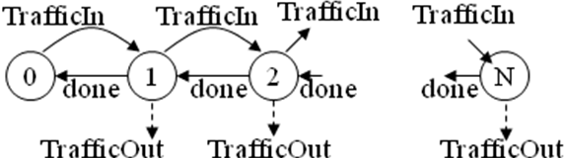
M = <X, Y, S, δ, λ >
X = {TrafficIn, done}
Y = {TrafficOut}
done = TrafficOut
S = {queue.length in [0,N]}
δ : X * S → S
δ(TrafficIn, n) = n+1 for all 0 ≤ n <N
δ(done, n) = n-1 for all 0 < n ≤N
λ : S → Y
λ(n ≠0) = TrafficOut

Test strategy:
The traffic input queue module will be tested using the “black box” testing method. Test cases are created by adding inputs at different times. The queue boundaries will tested. It will be verified that the queue state increments as new traffic arrives and decreases as traffic leaves. When there is no traffic in the system it shows appropriate state.

Vehicle Query Performer (atomic)
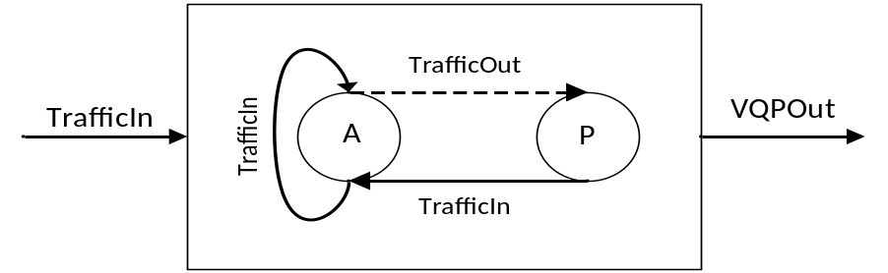

S = {passive, active}
X = {TrafficIn}
Y = {VQPOut}
δint (active) = passive
δext (TrafficIn, passive) = active

δext (TrafficIn, active) = active
λ(active)
{
//95% of input will pass to output
RandNo = Generate random number between 0 and 99;
If RandNo <= 95
VQPOut = 1; //Set VQPOut to pass
Else
VQPOut = 0; //Set VQPOut to fail
}
ta(passive) = INFINITY
ta(active) = random_processing_time between 1 and 2 minutes

Test Strategy:
We would be able to perform the testing by inputting 20 events to the input port at different times.
The time difference between each event is at least 2 minutes (maximum processing time of VQP)
apart so Vehicle Query Performer (VQP) can process the current event before accepting the next
event as it doesn’t have internal Queue. The output is observed to see if VQP passes 95% of the
time.

Input:
00:00:00:00 in 1
00:03:00:00 in 1
00:08:00:00 in 1
00:15:00:00 in 1
.
.
.

01:48:00:00 in 1

Output:
If VQP query is performed successfully, we get twenty outputs with the value of 1 and 0 in different times. The value “1” will be 95% of the time and “0” will be 5% of the time.

Person Query Performer (atomic)
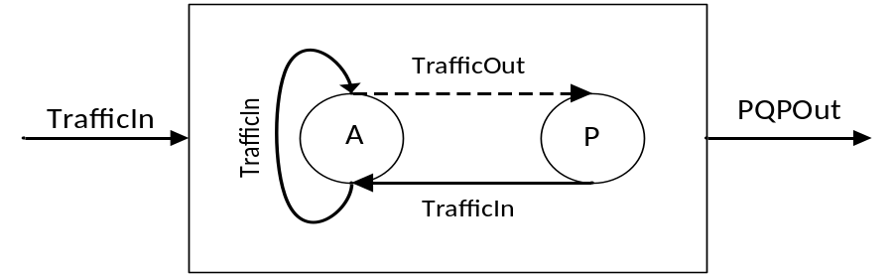
S = {passive, active}
X = {TrafficIn}
Y = {PQPOut}
δint (active) = passive
δext (TrafficIn, passive) = active

δext (TrafficIn, active) = active
λ(active)
{
//95% of input will pass to output
RandNo = Generate random number between 0 and 99;
If RandNo <= 95
PQPOut = 1; //Set PQPOut to pass
Else
PQPOut = 0; //Set PQPOut to fail

}
ta(passive) = INFINITY
ta(active) = random_processing_time 3 and 5 minutes

Test Strategy:
We would be able to perform the testing by inputting 20 events to the input port at different times.
The time difference between each event is at least 5 minutes (maximum processing time of PQP)
apart so Person Query Performer (PQP) can process the current event before accepting the next
event as it doesn’t have internal Queue. The output is observed to see if PQP passes 95% of the
time.

Input:
00:00:00:00 in 1
00:06:00:00 in 1
00:13:00:00 in 1
00:20:00:00 in 1
.
.
.

01:48:00:00 in 1
Output: If PQP query is performed successfully, we get twenty outputs with the value of 1 and 0 in different times. The value “1” will be 95% of the time and “0” will be 5% of the time.

Admissibility Inspection (atomic)
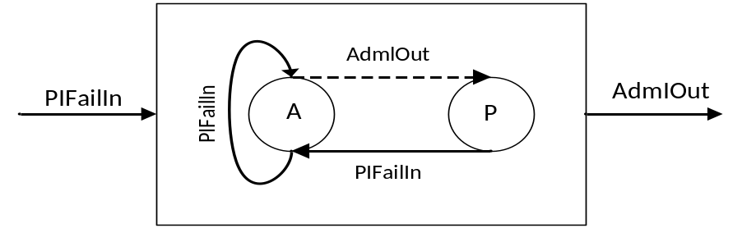
S = {passive, active}
X = {PIFailIn}
Y = {AdmIOut}
δint (active) = passive
δext (PIFailIn, passive) = active
δext (PIFailIn, active) = active
λ(active)
{
//95% of input will pass to output
RandNo = Generate random number between 0 and 99;
If RandNo <= 95
AdmlOut = 1; //Set AdmlOut to pass
Else
AdmlOut = 0; //Set AdmlOut to fail
}
ta(passive) = INFINITY
ta(active) = random_processing_time between 12 and 25 minutes

Test Strategy:
We would be able to perform the testing by inputting 20 events to the input port at different times.
The time difference between each event is at least 25 minutes (maximum processing time of Admissibility Inspection) apart so admissibility Inspection (AI) can process the current event before accepting the next
event as it doesn’t have internal Queue. The output is observed to see if AI passes 95% of the
time.

Input:
00:00:00:00 in 1
00:26:00:00 in 1
00:53:00:00 in 1
00:80:00:00 in 1
.
.
.

01:48:00:00 in 1

Output:
If AI Inspection is performed successfully, we get twenty outputs with the value of 1 and 0 in different times. The value “1” will be 95% of the time and “0” will be 5% of the time.

Customs Inspection (atomic)

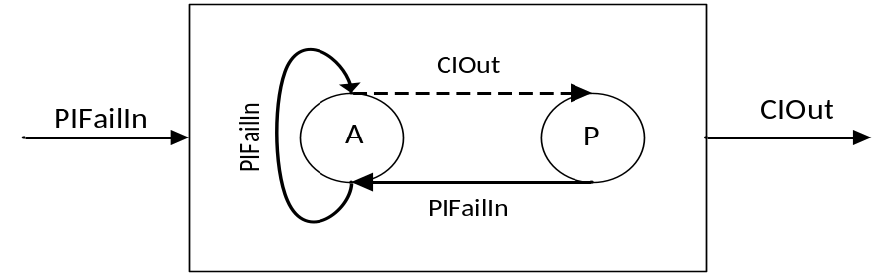
S = {passive, active}
X = {PIFailIn}
Y = {CIOut}
δint (active) = passive
δext (PIFailIn, passive) = active
δext (PIFailIn, active) = active
λ(active)
{
//95% of input will pass to output
RandNo = Generate random number between 0 and 99;
If RandNo <= 95
CIOut = 1; //Set CIOut to pass
Else
CIOut = 0; //Set CIOut to fail
}
ta(passive) = INFINITY
ta(active) = random_processing_time between 30 and 60 minutes
Test Strategy:
We would be able to perform the testing by inputting 20 events to the input port at different times.
The time difference between each event is at least 60 minutes (maximum processing time of Customs Inspection) apart so Customs Inspection (CI) can process the current event before accepting the next event as it doesn’t have internal Queue. The output is observed to see if AI passes 95% of the time.

Input:
00:00:00:00 in 1
01:03:00:00 in 1
02:06:00:00 in 1
03:07:00:00 in 1
.
.
.

21:11:00:00 in 1

Output:
If CI Inspection is performed successfully, we get twenty outputs with the value of 1 and 0 in different times. The value “1” will be 95% of the time and “0” will be 5% of the time.

Query Result Reviewer (atomic)

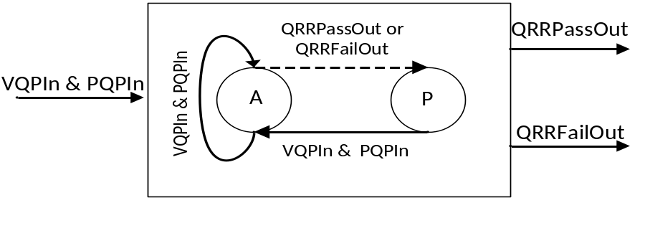
S = {passive, active}
X = {VQPIn, PQPIn}
Y = {QRRPassOut, QRRFailOut}
δint (active) = passive
δext (VQPIn, PQPIn, passive) = active
δext (VQPIn, PQPIn, active) = active
λ(active)
{
IF (VQPIn ==1) && (PQPIn == 1)
QRRPassOut= 1; // Set QRRPassOut to true
QRRFailOut = 0; // Set QRRPassOut to false
Else
QRRPassOut= 0; // Set QRRPassOut to false
QRRFailOut = 1; // Set QRRPassOut to true
}
ta(passive) = INFINITY
ta(active) = randwom_processing_time between 2 and 5 minutes

Test Strategy:
We would be able to perform the testing by inputting VQPIn and PQPIn value pair to the input at
the same time as shown below. We will try different values for VQPIn and PQPIn for each such as
00, 01, 10 and 11 to simulate the pass and fail for each query. The value “1” represents pass whereas “0” denotes fail.The output is observed to see if correct output is given.

Input:
00:00:00:00 pqpin 1
00:00:00:00 vqpin 1

00:06:00:00 pqpin 1
00:06:00:00 vqpin 0

00:15:00:00 pqpin 0
00:15:00:00 vqpin 1

00:21:00:00 pqpin 0
00:21:00:00 vqpin 0

Output:
It should output grrpassout = 1 when both pqpin and vqpin are “1”. For rest of the inputs, it should output qqrfailout = 1.

The output for above input pair should look like as shown below respectively.
00:03:00:000 qrrpassout 1
00:10:00:000 qqrfailout 1
00:17:00:000 qqrfailout 1
00:24:00:000 qqrfailout 1

Admissibility Evaluator (atomic)

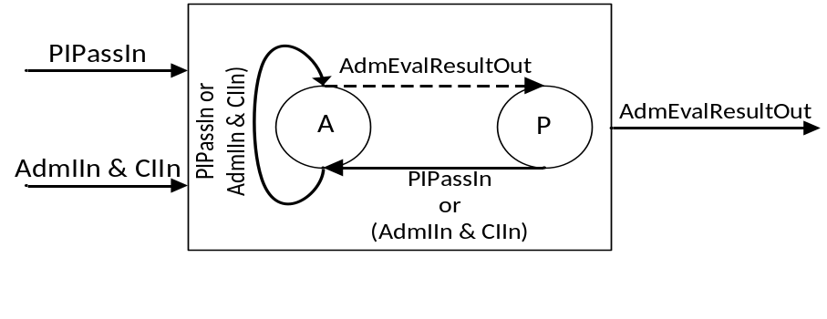
S = {passive, active}
X = {PIPassIn, AdmIIn, CIIn}
Y = {AdmEvalResultOut}
δint (active) = passive
δext (PIPassIn, passive) = active
δext (AdmIIn, CIIn, passive) = active
δext (PIPassIn, active) = active
δext (AdmIIn, CIIn, active) = active
λ(active)
{
IF (PIPassIn ==1) || ((AdmIIn == 1) && (CIIn == 1))
AdminEvalResultOut= 1; // Set AdminEvalResultOut to true
AdminEvalResultOut = 0; // Set AdminEvalResultOut to false
Else
AdminEvalResultOut = 0; // Set AdminEvalResultOut to false
AdminEvalResultOut = 1; // Set AdminEvalResultOut to true
}
ta(passive) = INFINITY
ta(active) = random_processing_time between 2 and 5 minutes

Test Strategy:
We would be able to perform the testing by inputting PIPassIn or Admlln and CIIn value pair to the
input at the same time as shown below. We will try different values for each of the inputs as shown
below.The value “1” represents pass whereas “0” denotes fail.The output is observed to see if
correct output is given.

Input:
00:00:00:00 PIPassIn 1

00:05:00:00 AdmIIn 1
00:05:00:00 CIIn 1

00:10:00:00 AdmIIn 1
00:10:00:00 CIIn 0

00:15:00:00 AdmIIn 0
00:15:00:00 CIIn 1

00:20:00:00 AdmIIn 0
00:20:00:00 CIIn 0

Output:
It should output admevalresultout = 1 when PIPPassIn = “1” or both Admlln and CIIn are “1”. For rest of the inputs, it should output admevalresultout = 0.

The output for above input pair should look like as shown below respectively.
00:04:00:000 admevalresultout 1
00:09:00:000 admevalresultout 1
00:13:00:000 admevalresultout 0
00:17:00:000 admevalresultout 0
00:22:00:000 admevalresultout 0

Action Taker (atomic)

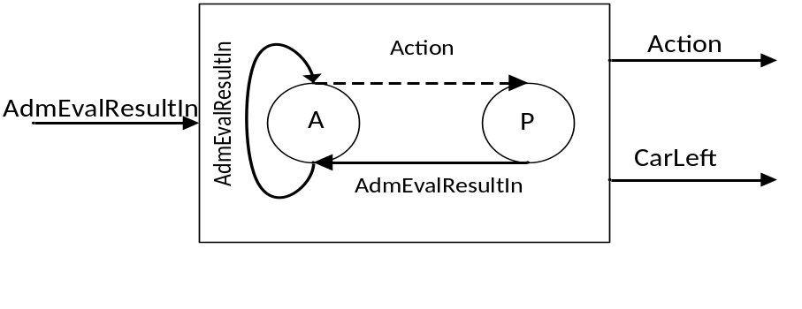
S = {passive, active}
X = {AdmEvalResultIn }
Y = {Action, CarLeft}
δint (active) = passive
δext (AdmEvalResultIn, passive) = active
δext (AdmEvalResultIn, active) = active
λ(active)
{
If (AdmEvalResultIn == 1)
Action = 1; // Set Action to Admin
CarLeft = 1 //Set system is free
Else
Action = 0; Set Action to Detain
CarLeft = 1 // Set System is free
}
ta(passive) = INFINITY
ta(active) = random_processing_time between 2 and 8 minutes

Test Strategy:
We would be able to perform the testing by inputting “0” and “1” for AdmEvalResultIn
as shown below. The value “1” represents admit whereas “0” denotes detain. The output is observed
to see if correct output is given.

Input:
00:00:00:00 in 1
00:10:00:00 in 0

Output:
It should output actionout = 1 and carleftout = 1 when the input valus is admEvalResultIn = “1” otherwise, it should output actionout = 0 and carleftout = 1

The output for above input should look like as shown below respectively.

00:04:00:000 actionout 1
00:04:00:000 carleftout 1

00:13:00:000 actionout 0
00:13:00:000 carleftout 1

Part III: Building and Testing the Model
The atomic models were built using CD++ according to the specification that defined in the Part II above. Then test cases for individual models were develops and tested by following the test cases proposed in the Part II. Then, the atomic models have been built and tested, the couple models were built and tested according to the testing strategy proposed in the previous part. Once the couple model testing completed, the top models for Border Control System was built and tested.

The test cases created to test these models are captured below. The following section also analyzes the results and provide conclusion.

Test Cases and Execution Analysis:
Traffic Input Queue (Atomic model)
The traffic input queue is tested using the “black box” testing method. Test cases are created by adding inputs at different times. The traffic is added to the queue at different time as shown in the input below.
The last digit in the input denotes the each individual. It starts with 1 and then incremented by one to represent every individual. By giving different inputs at different times, the queue boundaries, adding to queue and removing from queue are tested. The following input added three individuals to the queue and then started system and get to ready for processing state. Once the processing started and the system is not processing anyone, one traveller will be removed from the queue and sent to the processing module for processing. When the system completes the processing and takes an action, a system free signal will be Traffic Input Queue by the action taker. The Traffic Input Queue will sense this signal and send another traveller for the processing.

Input:
00:00:00:00 in 1
00:01:00:00 in 2
00:02:00:00 in 3
00:03:00:00 start 1
00:15:00:00 systemFree 1
00:30:00:00 systemFree 1
00:45:00:00 systemFree 1
The output that we received for the above input is listed below. The system was started at minute 3 and at the same time out put was sent from the queue to the processing. Then once the first person is processed, the second person is sent for the processing at minute 15. The system free signal that was sent at minute 15 triggered the queue to send the second person by sensing that system is ready to accept another person for processing.

Output:
00:03:00:000 out 1
00:15:00:000 out 2
00:30:00:000 out 3

This output shows that this module is function as expected. The files TrafficInputQueue.ev and TrafficInputQueueMAOUT.out shows the input and output value respectively.

Vehicle Query Performer (Atomic model):
This atomic model expects one input at a time. It will not accept another input until it completes processing the previous input. This model is implemented to generate random numbers between 0 and 99. If the number is less than 95, a value of “1” is outputted to denote pass. If the number is 95 or above then “0” is outputted to show fail. It also has about 1 to 2 minutes as processing time. The processing time is randomly generated between 1 and 2 minutes. The following input was given.

Input:
00:00:00:00 in 1
00:03:00:00 in 1
00:08:00:00 in 1
00:15:00:00 in 1
00:20:00:00 in 1
00:26:00:00 in 1
00:29:00:00 in 1
00:34:00:00 in 1
00:43:00:00 in 1
00:48:00:00 in 1
01:00:00:00 in 1
01:03:00:00 in 1
01:08:00:00 in 1
01:15:00:00 in 1
01:20:00:00 in 1
01:26:00:00 in 1
01:29:00:00 in 1
01:34:00:00 in 1
01:43:00:00 in 1
01:48:00:00 in 1

The following output is received for the above input.

Output:
00:01:00:000 out 0
00:04:00:000 out 1
00:09:00:000 out 1
00:16:00:000 out 1
00:21:00:000 out 1
00:27:00:000 out 1
00:30:00:000 out 1
00:35:00:000 out 1
00:44:00:000 out 1
00:49:00:000 out 1
01:01:00:000 out 1
01:04:00:000 out 1
01:09:00:000 out 1
01:16:00:000 out 1
01:21:00:000 out 1
01:27:00:000 out 1
01:30:00:000 out 0
01:35:00:000 out 1
01:44:00:000 out 1
01:49:00:000 out 0

The output shows that system is outputting “1” (pass) about 95% of the time as expected. Also, the processing time also seem to be fine. As the number of input increased the accuracy improves. The files VehicleQueryPerformer.ev and VehicleQueryPerformerMAOUT.out shows the input and output value respectively.

Person Query Performer (Atomic model):
Same as the above model, this atomic model expects one input at a time. It will not accept another input until it completes processing the previous input. This model is implemented to generate random numbers between 0 and 99. If the number is less than 95, a value of “1” is outputted to denote pass. If the number is 95 or above then “0” is outputted to show fail. It also has about 3 to 5 minutes as processing time. The processing time is randomly generated between 3 and 5 minutes. The following input was given.

Input:
00:00:00:00 in 1
00:03:00:00 in 1
00:08:00:00 in 1
00:15:00:00 in 1
00:20:00:00 in 1
00:26:00:00 in 1
00:29:00:00 in 1
00:34:00:00 in 1
00:43:00:00 in 1
00:48:00:00 in 1
01:00:00:00 in 1
01:03:00:00 in 1
01:08:00:00 in 1
01:15:00:00 in 1
01:20:00:00 in 1
01:26:00:00 in 1
01:29:00:00 in 1
01:34:00:00 in 1
01:43:00:00 in 1
01:48:00:00 in 1

The following output is received for the above input.

Output:
00:03:00:000 out 1
00:08:00:000 out 1
00:15:00:000 out 1
00:23:00:000 out 1
00:30:00:000 out 1
00:35:00:000 out 1
00:41:00:000 out 1
00:48:00:000 out 1
00:53:00:000 out 1
00:58:00:000 out 1
01:03:00:000 out 1
01:09:00:000 out 1
01:15:00:000 out 1
01:24:00:000 out 1
01:30:00:000 out 1
01:35:00:000 out 1
01:41:00:000 out 1
01:49:00:000 out 1
01:54:00:000 out 1
02:01:00:000 out 1

The output shows that system is outputting “1” (pass) about 95% of the time as expected. Also, the processing time also seem to be fine. As the number of input increased the accuracy improves. The files PersonQueryPerformer.ev and PersonQueryPerformerMAOUT.out shows the input and output value respectively.

Person Query Performer (Atomic model):
Same as the above model, this atomic model expects one input at a time. It will not accept another input until it completes processing the previous input. This model is implemented to generate random numbers between 0 and 99. If the number is less than 95, a value of “1” is outputted to denote pass. If the number is 95 or above then “0” is outputted to show fail. It also has about 3 to 5 minutes as processing time. The processing time is randomly generated between 3 and 5 minutes. The following input was given.

Input:
00:00:00:00 in 1
00:03:00:00 in 1
00:08:00:00 in 1
00:15:00:00 in 1
00:20:00:00 in 1
00:26:00:00 in 1
00:29:00:00 in 1
00:34:00:00 in 1
00:43:00:00 in 1
00:48:00:00 in 1
01:00:00:00 in 1
01:03:00:00 in 1
01:08:00:00 in 1
01:15:00:00 in 1
01:20:00:00 in 1
01:26:00:00 in 1
01:29:00:00 in 1
01:34:00:00 in 1
01:43:00:00 in 1
01:48:00:00 in 1

The following output is received for the above input.

Output:
00:03:00:000 out 1
00:08:00:000 out 1
00:15:00:000 out 1
00:23:00:000 out 1
00:30:00:000 out 1
00:35:00:000 out 1
00:41:00:000 out 1
00:48:00:000 out 1
00:53:00:000 out 1
00:58:00:000 out 1
01:03:00:000 out 1
01:09:00:000 out 1
01:15:00:000 out 1
01:24:00:000 out 1
01:30:00:000 out 1
01:35:00:000 out 1
01:41:00:000 out 1
01:49:00:000 out 1
01:54:00:000 out 1
02:01:00:000 out 1

The output shows that system is outputting “1” (pass) about 95% of the time as expected. Also, the processing time also seem to be fine. As the number of input increased the accuracy improves. The files PersonQueryPerformer.ev and PersonQueryPerformerMAOUT.out shows the input and output value respectively.

Query Result Reviewer (Atomic model):
This atomic model expects two inputs, one from VQP and other one from PQP, at a same time. It will not accept another input until it completes processing the previous input. It is expected this model should AND both inputs and if both of them are “1” then it will out “1” denoting Primary Inspection Passed. For any other input value combination, it should output “0” saying failed. It also has about 2 to 5 minutes as processing time. The processing time is randomly generated between 2 and 5 minutes. The following input was given.

Input:
00:00:00:00 pqpin 1

00:00:00:00 vqpin 1

00:06:00:00 pqpin 1

00:06:00:00 vqpin 0

00:15:00:00 pqpin 0

00:15:00:00 vqpin 1

00:21:00:00 pqpin 0

00:21:00:00 vqpin 0

The following output is received for the above input.

Output:
00:03:00:000 qrrpassout 1
00:09:00:000 qqrfailout 1
00:19:00:000 qqrfailout 1
00:24:00:000 qqrfailout 1

The output shows that system is outputting “1” (pass) for the scenario where both inputs are “1” and it outputs “0” otherwise as expected. Also, the processing time also seem to be fine. As the number of input increased the accuracy improves. The files QueryResultReviewer.ev and QueryResultReviewerMAOUT.out shows the input and output value respectively.

Customs Inspection (Atomic model):
This atomic model expects one input, Primary Inspection Failed input, at a time. It will not accept another input until it completes processing the previous input. This model is implemented to generate random numbers between 0 and 99. If the number is less than 95, a value of “1” is outputted to denote pass. If the number is 95 or above then “0” is outputted to show fail. It also has about 30 to 60 minutes as processing time. The processing time is randomly generated between 30 and 60 minutes. The following input was given.

Input:
00:00:00:00 in 1

01:00:00:00 in 1

02:00:00:00 in 1

03:00:00:00 in 1

04:00:00:00 in 1

05:00:00:00 in 1

06:00:00:00 in 1

07:00:00:00 in 1

08:00:00:00 in 1

09:00:00:00 in 1

10:00:00:00 in 1

11:00:00:00 in 1

12:00:00:00 in 1

13:00:00:00 in 1

14:00:00:00 in 1

15:00:00:00 in 1

16:00:00:00 in 1

17:00:00:00 in 1

18:00:00:00 in 1

19:00:00:00 in 1

The following output is received for the above input.

Output:
00:34:00:000 out 1
01:51:00:000 out 1
02:49:00:000 out 1
03:51:00:000 out 1
04:51:00:000 out 1
05:54:00:000 out 1
06:42:00:000 out 1
07:41:00:000 out 1
08:39:00:000 out 1
09:48:00:000 out 1
10:30:00:000 out 1
11:47:00:000 out 0
12:40:00:000 out 1
13:35:00:000 out 1
14:44:00:000 out 1
15:58:00:000 out 1
16:39:00:000 out 1
17:46:00:000 out 1
18:58:00:000 out 1
19:47:00:000 out 1

The output shows that system is outputting “1” (pass) about 95% of the time as expected. Also, the processing time also seem to be fine. As the number of input increased the accuracy improves. The files CustomInspection.ev and CustomInspectionMAOUT.out shows the input and output value respectively.

Admissibility Evaluator (Atomic model):
This atomic model expects three inputs all together (one from primary inspection pass, admissibility inspection and other Customs Inspection). If the Primary Inspection Pass (PIP) input is sent, then it will ignored the other two input port values. If the primary inspection result is not presented, then it should expects admissibility inspection and customs inspections results at the same time. It should not accept another input until it completes processing the previous input. If only PIP input is passed, it should output “1” to denote “Amit”. Two inputs (Admissibility inspection and custom inspection results ) are passed in, it is expected this model should AND both inputs and if both of them are “1” then it will out “1” denoting Admit since Secondary Inspection Passed. For any other input value combination, it should output “0” saying detain. It also has about 2 to 5 minutes as processing time. The processing time is randomly generated between 2 and 5 minutes. The following input was given.

Input:
00:00:00:00 PIPassIn 1

00:05:00:00 AdmIIn 1

00:05:00:00 CIIn 1

00:10:00:00 AdmIIn 1

00:10:00:00 CIIn 0

00:15:00:00 AdmIIn 0

00:15:00:00 CIIn 1

00:20:00:00 AdmIIn 0

00:20:00:00 CIIn 0

The following output is received for the above input.

Output:
00:02:00:000 admevalresultout 1
00:09:00:000 admevalresultout 1
00:13:00:000 admevalresultout 0
00:18:00:000 admevalresultout 0
00:22:00:000 admevalresultout 0

The output shows that system is outputting “1” (Admit) for the scenario where PIP input is “1” or both admissibility and customs inspection inputs are “1” and it outputs “0” otherwise as expected. Also, the processing time also seem to be fine. As the number of input increased the accuracy improves. The files AdmissibilityEvaluator.ev and AdmissibilityEvaluatorMAOUT.out shows the input and output value respectively.

Action Taker (Atomic model):
This atomic model expects one input ( 1 or 0). If “1” is passed in as input, it senses is as Admit and take the appropriate action by utilizing processing time. Otherwise, it senses it as detail and it detains the traveller. Once the action is taken, it will send car left signal out to the traffic queue so it can send another client for processing. It also has about 2 to 8 minutes as processing time. The processing time is randomly generated between 2 and 8 minutes. The following input was given.

Input:
00:00:00:00 in 1

00:10:00:00 in 0

The following output is received for the above input.

Output:
00:02:00:000 out 1
00:02:00:000 carleft 1
00:13:00:000 out 0
00:13:00:000 carleft 1

The output shows that system is outputting “1” (Admit action taken) and car left (“1” )message sent for the scenario where input is “1” as expected. Otherwise it shows “0” saying detained and “1” for car left. Also, the processing time also seem to be fine. As the number of input increased the accuracy improves. The files ActionTaker.ev and ActionTakerMAOUT.out shows the input and output value respectively.

Primary Inspection (Coupled model):
This coupled model expects one input as a token to activate the module. It will not accept another input until it completes processing the previous input. It is expected this model should output Primary Inspection Pass (“1”) 95% of time and primary inspection failed 5% of the time. It contains three atomic models to perform vehicle query , person query and query review. The person query and vehicle query outputs pass 95% of the time as mentioned in the corresponding atomic model above. The Query Result reviewer takes that input and outputs “1” for pass if both are “1” else “1” for fail. It also has about 6 to 12 minutes as processing time. The following input was given.

Input:
00:00:00:00 in 1

00:12:00:00 in 1

00:24:00:00 in 1

00:36:00:00 in 1

00:48:00:00 in 1

01:00:00:00 in 1

01:12:00:00 in 1

01:24:00:00 in 1

01:36:00:00 in 1

01:48:00:00 in 1

02:00:00:00 in 1

02:12:00:00 in 1

02:24:00:00 in 1

02:36:00:00 in 1

02:48:00:00 in 1

03:00:00:00 in 1

03:12:00:00 in 1

03:24:00:00 in 1

03:36:00:00 in 1

03:48:00:00 in 1

The following output is received for the above input.

Output:
00:06:00:000 pass 1
00:18:00:000 pass 1
00:32:00:000 pass 1
00:42:00:000 pass 1
00:53:00:000 pass 1
01:05:00:000 pass 1
01:20:00:000 pass 1
01:30:00:000 fail 1
01:41:00:000 pass 1
01:54:00:000 pass 1
02:08:00:000 pass 1
02:19:00:000 pass 1
02:31:00:000 pass 1
02:43:00:000 pass 1
02:55:00:000 fail 1
03:06:00:000 pass 1
03:19:00:000 pass 1
03:32:00:000 pass 1
03:43:00:000 pass 1
03:53:00:000 pass 1

The output shows that system is outputting pass “1” (pass) about 95% as expected. Otherwise it outs fail “1” .Also, the processing time also seem to be fine. As the number of input increased the accuracy improves. The files PrimaryInspection.ev and PrimaryInspectionMAOUT.out shows the input and output value respectively.

Secondary Inspection (Coupled model):
This coupled model expects one input “1” as a token to activate the module. It will not accept another input until it completes processing the previous input. It is expected this model should output two values, Admissibility Inspection result and Customs inspection results. If both values are “1” then it is considered, secondary inspection is passed. The Secondary Inspection Pass (“1”) 95% of time and it fails 5% of the time. It also has about 45 to 85 minutes as processing time. The following input was given.

Input:
00:00:00:00 in 1

02:00:00:00 in 1

04:00:00:00 in 1

06:00:00:00 in 1

08:00:00:00 in 1

10:00:00:00 in 1

12:00:00:00 in 1

14:00:00:00 in 1

16:00:00:00 in 1

18:00:00:00 in 1

20:00:00:00 in 1

22:00:00:00 in 1

24:00:00:00 in 1

26:00:00:00 in 1

28:00:00:00 in 1

30:00:00:00 in 1

32:00:00:00 in 1

34:00:00:00 in 1

36:00:00:00 in 1

38:00:00:00 in 1

The following output is received for the above input.

Output:
00:15:00:000 admiout 1
00:39:00:000 ciout 1
02:15:00:000 admiout 1
02:37:00:000 ciout 1
04:18:00:000 admiout 1
04:37:00:000 ciout 1
06:18:00:000 admiout 1
06:30:00:000 ciout 1
08:15:00:000 admiout 1
08:55:00:000 ciout 1
10:24:00:000 admiout 1
10:47:00:000 ciout 1
12:16:00:000 admiout 1
12:45:00:000 ciout 1
14:15:00:000 admiout 1
14:49:00:000 ciout 1
16:19:00:000 admiout 1
16:44:00:000 ciout 1
18:19:00:000 admiout 1
18:57:00:000 ciout 1
20:16:00:000 admiout 1
20:36:00:000 ciout 1
22:23:00:000 admiout 1
22:46:00:000 ciout 1
24:15:00:000 admiout 1
24:34:00:000 ciout 1
26:21:00:000 admiout 1
26:32:00:000 ciout 1
28:21:00:000 admiout 1
28:52:00:000 ciout 1
30:17:00:000 admiout 1
30:51:00:000 ciout 1
32:24:00:000 admiout 1
32:34:00:000 ciout 1
34:22:00:000 admiout 1
34:46:00:000 ciout 1
36:21:00:000 admiout 1
36:38:00:000 ciout 1
38:21:00:000 admiout 1
38:39:00:000 ciout 1

The output shows that system is outputting pass “1” (pass) for both admissibility inspection and custom inspection about 95% as expected. Otherwise it outputs fail “0” which is 5% of the time. Also, the processing time also seem to be fine. As the number of input increased the accuracy improves. The files SecondaryInspection.ev and SecondaryInspectionMAOUT.out shows the input and output value respectively.

Border Control System ( Top Coupled model):
This the top model that consists all the models discussed above. It access any number of traffic inputs at any time. It is implemented to have a queue to queue the travellers and send for processing one by one after previous one is processed. It precepts the system to see if the system is free before send the traffic. It outputs either “1” or “0” indicating admit or detain action is taken respectively. The following input was given.

Input:
00:00:00:00 in 1

00:00:00:00 in 1

00:00:00:00 in 1

00:00:00:00 in 1

00:00:00:00 in 1

00:00:00:00 in 1

00:00:00:00 in 1

00:00:00:00 in 1

00:00:00:00 in 1

00:00:00:00 in 1

00:00:00:00 in 1

00:00:00:00 in 1

00:05:00:00 start 1

00:15:00:00 in 1

00:16:00:00 in 1

00:17:00:00 in 1

00:18:00:00 in 1

00:19:00:00 in 1

00:20:00:00 in 1

00:21:00:00 in 1
The following output is received for the above input.

Output:
00:54:00:000 action 1
01:05:00:000 action 1
01:19:00:000 action 1
01:31:00:000 action 1
01:43:00:000 action 1
01:57:00:000 action 1
02:10:00:000 action 1
02:23:00:000 action 1
02:38:00:000 action 1
02:50:00:000 action 1
03:02:00:000 action 1
03:13:00:000 action 1
03:25:00:000 action 1
03:40:00:000 action 1
03:53:00:000 action 1
04:07:00:000 action 1
04:20:00:000 action 1
04:31:00:000 action 0
04:46:00:000 action 1

The output shows that system is outputting “1” (Admit action taken) and car left (“1” )message sent for the scenario where input is “1” as expected. Otherwise it shows “0” saying detained and “1” for car left. Also, the processing time also seem to be fine. As the number of input increased the accuracy improves. The files BorderCrossing.ev and BorderCrossingMAOUT.out shows the input and output value respectively.

Conclusion:
In overall we obtained working simulation for the proposed border crossing system model. The simulation results fall within the expected range. We did extensive testing to ensure each sub-models were functioning correctly. Once example for improving this system performance is to implement queue in each atomic model so the system can schedule and service each request rather than rejecting the requests while serving the previous one.

