Assignment 1
SYSC 5104

Border Gateway Protocol (BGP)

Submitted by: Mohammad Etemad – 100748481
Submitted to: Prof. Gabriel Wainer

Fall 2014

Carleton University

Introduction

The Border Gateway Protocol (BGP) is a path-vector protocol which is used to exchange routing information between autonomous systems (AS) on the internet. Being a most recent protocol than Exterior Gateway Protocol (EGP), the hosts using this protocol communicate using the Transmission Control Protocol (TCP). To minimize data exchange, the router table information is only sent through the network when a host has detected a change in its routing table’s information. The route selection in the network is calculated by taking into account the information available in the BGP table. BGP can be categorized into two categories: the Internal BGP (iBGP) and the External BGP (EBGP). The iBGP is used to provide information to the routers inside the network whereas the EBGP is used for communication between distinct autonomous systems or domains.

For this course, I would like to model BGP in DEVS. To be able to do so, separate models should be constructed and coupled together. The overall network will be representing the internet itself. The internet consists of different networks. Going another layer down, each network can be modeled by coupling several BGP routers within AS.

The main component of this model will be the BGP router. A BGP router can be modeled using an input buffer, an internal buffer, and a processor. Also, it is essential to have an atomic model for the route generation. The input and output will be in a tabular structure with different variable. The variables (attributes) in a BGP [1] table are as follows. These attributes are used to select the best routing path in the internet:
- Origin
- Next-Hop
- AS-Path
- Weight
- Local Preference
- Multi-Exit-Disc (MED)
- Community
- Atomic Aggregate
- Aggregator
Figure 1 represents a diagram showing the model and its components.
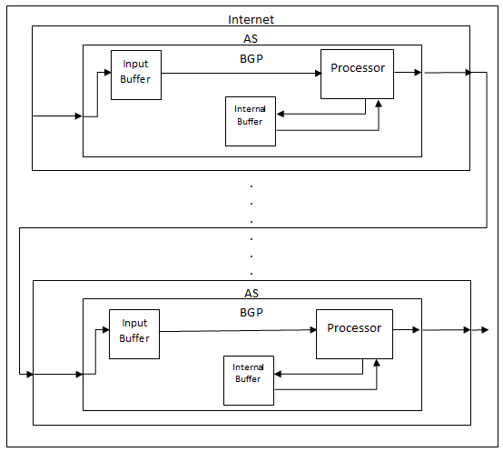 Figure 1. Diagram of the proposed model
A route generator may be needed for the model which will be added later upon necessity.
By coupling the queues and the processor, we will be able to construct a BGP router. After that, by coupling different BGP routers, a network can be formed. A network may also contain a number of local routers, switches and hosts. For simplification purposes, the mentioned elements will not be presented and the BGP router will only be used to represent the whole AS. In the end, the internet can be modeled by coupling different networks.
The figure below is an example of the general routing architecture in the internet. As demonstrated, each AS is an independent network. These networks are connected to one another using BGP (EBGP to be specific) to form the internet.
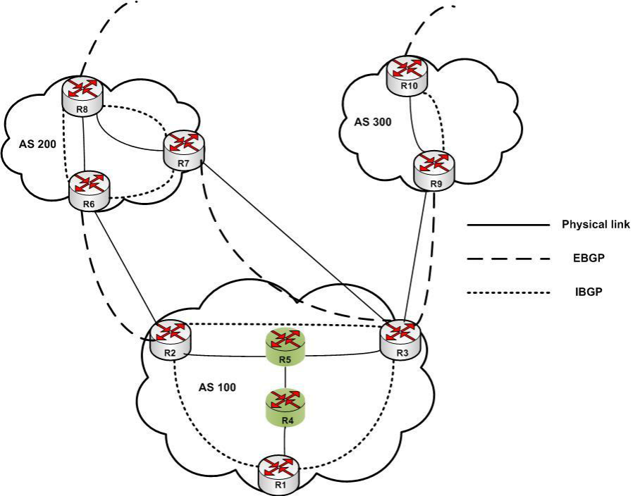
Figure 2. An overall view of the connection between different networks [2]
For this assignment, the BGP model has been simplified to contain an input queue and a processor. The internal buffer shown in figure 1 has been integrated in the BGP processor for simplicity. Later, the buffer will be separated and a route generator will be added. Also, only one BGP has been implemented. Later, the complete proposal will be implemented using DEVS.

Formal Specifications

- Atomic Models:

inputBuffer = <X, Y, S, δ_{int} , δ_{ext}, λ, t_{a} >
X = {In1, reqIn}
Y = {Out1}
S = {Idle, Push, Pop}
δ_{int} (s) =
{
switch (state){
case Idle:
if (Request == 1)
{
state = Pop;
}
else passivate();
break;

case Push:
state = Idle;
break;

case Pop:
if (Request == 1)
{
elements.pop_front();
Qlen--;
}

Request = 0;
state = Idle;
break;
}
return *this;
}

δ_{ext} (s,e,x) =
{
if( msg.port() == In1 ) // Input from In1
{
elements.push_back( msg.value() ) ; //Store Input value in Queue
state = Push;
Qlen++;
holdIn( Atomic::active, ProcessTime);
}
else if (elements.size() > 0)
{
Request = 1;
state = Pop;
holdIn( Atomic::active, ProcessTime);
}
else if (elements.size() == 0)
{ // Here this two condition are True :(msg.port() == Req) & (elements.size() == 0)
Request = 1; // Although Queue is empty but remember that server is waiting for input.
passivate(); // If the queue is empty then passivate.
}

return *this;
}

λ =
{
if (FirstTime || ((state == Pop) && (Request == 1)))
{
sendOutput( msg.time(), Out1, elements.front()); // Send out data from Queue
FirstTime = false;
}
return *this ;
}

BGPProcessor = <X, Y, S, δ_{int} , δ_{ext}, λ, t_{a} >
X = {ProcessorIn1}
Y = {ProcessorOut1, ProcessorOut2}
S = {Idle, RecPack}
δ_{int} (s) =
{

switch (state){
case Idle:
passivate();
break;
case RecPack:
state = Idle;
break;
}
return *this;
}

δ_{ext} (s,e,x) =
{
list<Value>::iterator iter1;
if (msg.port()==ProcessorIn1)
{
InputRoute = msg.value();
holdIn(Atomic::active, ProcessTime);
state = RecPack;
addToList = true;

}
if (BGPelements.size() > 0){
iter1 = BGPelements.begin();
while(iter1 != BGPelements.end()){
if (*iter1 == InputRoute){

AlreadyExists = true;
break;
}
iter1++;
}
}
return *this;
}

λ =
{

if (state == RecPack && addToList == true && AlreadyExists == false){
sendOutput(msg.time(), ProcessorOut1, InputRoute);
sendOutput(msg.time(), ProcessorOut2, 1);
BGPelements.push_back(InputRoute);
addToList = false;
}
if (firstReq == true || AlreadyExists == true){
sendOutput(msg.time(), ProcessorOut2, 1);
firstReq = false;
AlreadyExists = false;
}
return *this ;
}

- Coupled Model:

BGP = <X, Y, D, {M_{d} : d ϵ D}, EIC, EOC, IC, select>
X = {In}
Y = {Out}
D = {BGPProcessor, inputBuffer}
M_{d} = {M_{BGPProcessor}, M_{inputBuffer}}
EIC = {(self, In), (inputBuffer, In1)}
EOC = {(BGPProcessor, ProcessorOut1), (self, Out)}
IC = {(inputBuffer, Out1), (BGPProcessor, ProcessorIn1)}

Execution Results

There is an event file in the submitted folder. This event file consists of some repeated values as follows. For now, the network addresses has been chosen to be 1 bit long. In reality, this is not the case.

Testing inputBuffer:

inputBuffer.ev

00:00:00:015 In 1 → expected output at 00:00:00:025
00:00:00:045 In 3 → expected output at 00:00:00:055
00:00:00:055 In 4 → expected output at 00:00:00:065
00:00:00:075 In 1 → expected output at 00:00:00:085
00:00:00:095 In 5 → expected output at 00:00:00:105
00:00:01:005 In 6 → expected output at 00:00:01:015
00:00:01:025 In 5 → expected output at 00:00:01:035
00:00:01:040 In 5 → expected output at 00:00:01:050
00:00:01:055 In 5 → expected output at 00:00:01:065
00:00:01:070 In 5 → expected output at 00:00:01:080
00:00:01:085 In 5 → expected output at 00:00:01:095
00:00:02:000 In 9 → expected output at 00:00:02:010

inputBufferOUT.out

00:00:00:025 out 1
00:00:00:055 out 3
00:00:00:065 out 4
00:00:00:085 out 1
00:00:00:105 out 5
00:00:01:015 out 6
00:00:01:035 out 5
00:00:01:050 out 5
00:00:01:065 out 5
00:00:01:080 out 5
00:00:01:095 out 5
00:00:02:010 out 9

After integrating the BGP processor, we expect the duplicate addresses not to be advertised as follows:

inputBuffer.ev

00:00:00:015 In 1 → expected output at 00:00:00:025
00:00:00:045 In 3 → expected output at 00:00:00:055
00:00:00:055 In 4 → expected output at 00:00:00:065
00:00:00:075 In 1 → should be eliminated
00:00:00:095 In 5 → expected output at 00:00:00:105
00:00:01:005 In 6 → expected output at 00:00:01:015
00:00:01:025 In 5 → should be eliminated
00:00:01:040 In 5 → should be eliminated
00:00:01:055 In 5 → should be eliminated
00:00:01:070 In 5 → should be eliminated
00:00:01:085 In 5 → should be eliminated
00:00:02:000 In 9 → expected output at 00:00:02:010

We expect the values to show in the output, but if an address has already been advertised in the BGP routing table, the processor should not advertise the value again. As demonstrated below, the repeated inputs are eliminated and all inputs are delayed by 10 ms:

BGPOUT.out

00:00:00:025 out 1
00:00:00:055 out 3
00:00:00:065 out 4
00:00:00:105 out 5
00:00:01:015 out 6
00:00:02:010 out 9

These series of tests insure that the output of the system is as expected and the model is working correctly.

References

[1] Hares, Susan, Yakov Rekhter, and Tony Li, "A Border Gateway Protocol 4 (BGP-4)," RFC 4271, January 2006.
[2] B. U. Kazi, “Policy Dispute in BGP: Analysis, Detection and Proposed Solution,” M.Sc. thesis, Elec. and Comp. Eng., Ryerson Univ., Toronto, ON, 2012.

