SYSC 5104 Assignment 2

Pattern Differentiation of Glandular Cancerous Cells and Normal Cells

From: Richard Ying Fang
100225723
To: Professor Gabriel A. Wainer

Date: November 19, 2007
Table of Content
Cell-DEVS Conceptual Model Description (Part I) 3
Rule number 7: 4
Rule number 9: 4
Model Formal Specifications for Pattern Differentiation (Part II): 5
Rule Number 7: 5
Rule Number 9: 6
Model Execution Result (Part III) 6
For Rule Number 7 model: 6
For Rule 9 model: 8
Conclusion: 10

Cell-DEVS Conceptual Model Description (Part I):
The goal of this study was to construct a system that could generate and modify Feature Detector (FD) for specific pattern recognition in cancerous cells research.

The fitness of an FD was determined by how well we could use it to separate cancerous cells from normal cells.

- Two dimensional (20 x 20) matrix is used
- he adjacent neighbors are defined as following (5 total including (0,0), (1,0), (-1, 0), (0,1), (0, -1) )

North
i,j+1
West
i-1,j

South
i,j-1
East
i+1,j
Self
(i,j)

- State { 0, 1}
- Rules:
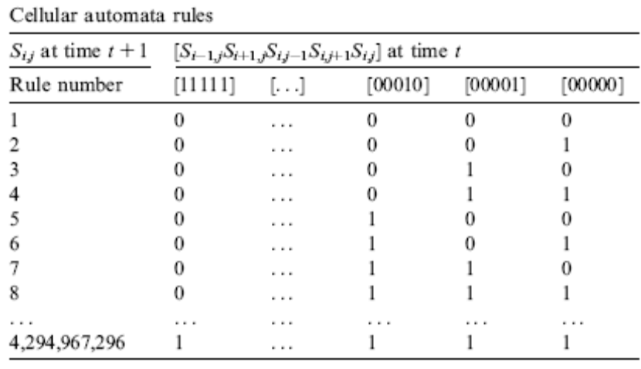

In this assignment, small (two) subsets of the rules are chosen randomly from the above table of rules .
Instead of randomly chosen by the computer, we are going to randomly chose by the student (implementer). This is to avoid to input and store such a big database (with 4G of items).

Rule number 7:
- When self’s current state value is 0, all my neighbors are 0, self will remain 0
- When self’s current state value is 1, and all my neighbors are 0, self will change to 1.
- When self’s current state value is 0, and North neighbors is 1, East and West neighbors are 0, self will change from 0 to 1.
4) For all other combination of state, self will change to (or still remains) to be 0.

Rule number 9:
- When self’s current state value is 1, and only North neighbor’s value is 1, self maintain state value of 1
- In all other case, self state change (or maintain) to be 0.

These two rules will be used to generate two simulation results. And results will be compared to identify which rule is better (in finding the FD).

Model Formal Specifications for Pattern Differentiation (Part II):

Cell-DEVS coupled model is defined as following:
M_{A} = < I_{A}, X_{A}, Y_{A}, Xlist_{A}, Ylist_{A}, η_{A}, N_{A}, {m_{A}, n_{A}}, C_{A}, B_{A}, Z_{A}, select_{A}>

In this case, there are no input external events and output external events, so
Xlist_{A} = { ∅ };
Ylist_{A} = { ∅ }.
η_{A} = 5; the neighbor size is 5.
I_{A} = < P^{x}, P^{y}>, P^{x} = { ∅ }; P^{y} = { ∅ }; model’s modular interface with external events is null, because there are no input and output external events.
N_{A} = { (0,0), (-1,0), (0,-1), (1, 0), (0,1) };
X_{A} = Y_{A} = {0, 1};
m_{A} = 20; n_{A} = 20; this defines the cellular model is a two dimensional model, the row is 20 and the column is 20.
B_{A} = {nowrapped}; this indicates that the model has non-toroidal border.
C_{A} = {C_{Aij} / i ∈ [0,19], j ∈ [0,19]} and transport delay is used for each cell.
Z_{A} :

P_{ij} ^{Y}₁ → P_{i,j-1} ^{X}₁ P_{i,j+1} ^{Y}₁ → P_{ij} ^{X}₁
P_{ij} ^{Y}₂ → P_{i+1,j-1} ^{X}₂ P_{i-1,j+1} ^{Y}₂ → P_{ij} ^{X}₂
P_{ij} ^{Y}₃ → P_{i+1,j} ^{X}₃ P_{i-1,j} ^{Y}₃ → P_{ij} ^{X}₃
P_{ij} ^{Y}₄ → P_{i+1,j+1} ^{X}₄ P_{i-1,j-1} ^{Y}₄ → P_{ij} ^{X}₄
P_{ij} ^{Y}₅ → P_{ij} ^{X}₅ P_{ij} ^{Y}₅ → P_{ij} ^{X}₅

Rule Number 7:
1) if (0,0) == (0,1) == (1,0) == (0,-1) == (-1,0) == 0
then (0,0) = 0;

2) if (0,0) == 1; (0,1) == (1,0) == (0,-1) == (-1,0) == 0
then (0,0)=1;

3) if (0,0) == 0; (0,1) ==1; (1,0) == (0,-1) == (-1,0) == 0
then (0,0)=1;

4) Otherwise (0,0) =0

Rule Number 9:
- if (0,0) == 1; (0,1) == 1; (1,0) == (0,-1) == (-1,0) == 0 then (0,0) = 1;
- Otherwise, (0,0) == 0;

///////
Rule | Result | Input values
Rule Number 7 | 0 | (0,0) = 0 AND (0,1) = 0 AND (1,0) = 0 AND (0,-1) = 0 AND (-1,0) = 0
Rule Number 7 | 1 | (0,0) = 1 AND (0,1) = 0 AND (1,0) = 0 AND (0,-1) = 0 AND (-1,0) = 0
Rule Number 7 | 1 | (0,0) = 0 AND (0,1) = 1 AND (1,0) = 0 AND (0,-1) = 0 AND (-1,0) = 0
Rule Number 7 | 0 | Otherwise
Rule Number 9 | 1 | (0,0) = 1 AND (0,1) = 1 AND (1,0) = 0 AND (0,-1) = 0 AND (-1,0) = 0
Rule Number 9 | 0 | Otherwise

select_{A} = { (1,0), (0,-1), (0,0), (0,1), (-1,0) };

Model Execution Result (Part III)

For Rule Number 7 model:
It is executed based on the following initial value.

0 0 0 0 0 0 0 0 0 1 0 0 0 0 0 0 0 0 0 0 0
1 0 0 0 0 0 0 0 1 0 1 0 0 0 0 0 0 0 0 0 0
2 0 0 0 1 1 1 1 0 0 0 1 0 0 0 0 0 0 0 0 0
3 0 0 0 1 1 1 0 0 0 0 0 1 0 0 0 0 0 0 0 0
4 0 0 0 1 1 0 0 0 0 0 0 0 1 0 0 0 0 0 0 0
5 0 0 0 1 1 0 0 0 0 0 0 0 0 1 0 0 0 0 0 0
6 0 0 1 0 0 0 0 0 0 0 0 0 0 0 1 0 0 0 0 0
7 0 1 0 0 0 0 0 0 0 0 0 0 0 0 0 1 0 0 0 0
8 1 0 0 0 0 0 0 0 0 0 0 0 0 0 0 0 1 0 0 0
9 0 1 0 0 0 0 0 0 0 0 0 0 0 0 0 0 0 1 0 0
10 0 0 1 0 0 0 0 0 0 0 0 0 0 0 0 0 0 0 1 0
11 0 0 0 1 0 0 0 0 0 0 0 0 0 0 0 0 0 0 0 1
12 0 0 0 0 1 0 0 0 0 0 0 0 0 0 0 0 0 0 1 0
13 0 0 0 0 0 1 0 0 0 0 0 0 0 0 0 0 0 1 0 0
14 0 0 0 0 0 0 1 0 0 0 0 0 0 0 0 0 1 0 0 0
15 0 0 0 0 0 0 0 1 0 0 0 0 0 0 0 1 0 0 0 0
16 0 0 0 0 0 0 0 0 1 0 0 0 0 0 1 0 0 0 0 0
17 0 0 0 0 0 0 0 0 0 1 0 0 0 1 0 0 0 0 0 0
18 0 0 0 0 0 0 0 0 0 0 1 0 1 0 0 0 0 0 0 0
19 0 0 0 0 0 0 0 0 0 0 0 1 0 0 0 0 0 0 0 0

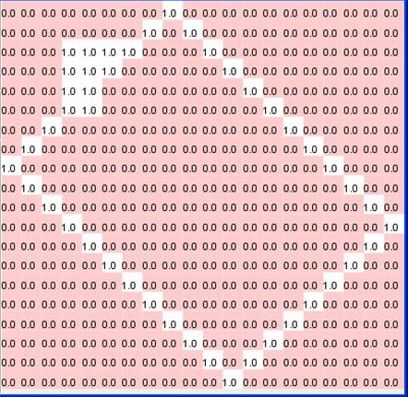

The result:
After 27th iteration of execution is shown as following:

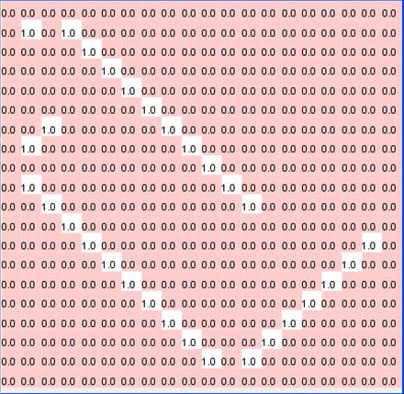

For Rule 9 model:
It is executed based on the following initial value.

0 0 0 0 0 0 0 0 0 1 0 0 0 0 0 0 0 0 0 0 0
1 0 0 0 0 0 0 0 1 0 1 0 0 0 0 0 0 0 0 0 0
2 0 0 0 1 1 1 1 0 0 0 1 0 0 0 0 0 0 0 0 0
3 0 0 0 1 1 1 0 0 0 0 0 1 0 0 0 0 0 0 0 0
4 0 0 0 1 1 0 0 0 0 0 0 0 1 0 0 0 0 0 0 0
5 0 0 0 1 1 0 0 0 0 0 0 0 0 1 0 0 0 0 0 0
6 0 0 1 0 0 0 0 0 0 0 0 0 0 0 1 0 0 0 0 0
7 0 1 0 0 0 0 0 0 0 0 0 0 0 0 0 1 0 0 0 0
8 1 0 0 0 0 0 0 0 0 0 0 0 0 0 0 0 1 0 0 0
9 0 1 0 0 0 0 0 0 0 0 0 0 0 0 0 0 0 1 0 0
10 0 0 1 0 0 0 0 0 0 0 0 0 0 0 0 0 0 0 1 0
11 0 0 0 1 0 0 0 0 0 0 0 0 0 0 0 0 0 0 0 1
12 0 0 0 0 1 0 0 0 0 0 0 0 0 0 0 0 0 0 1 0
13 0 0 0 0 0 1 0 0 0 0 0 0 0 0 0 0 0 1 0 0
14 0 0 0 0 0 0 1 0 0 0 0 0 0 0 0 0 1 0 0 0
15 0 0 0 0 0 0 0 1 0 0 0 0 0 0 0 1 0 0 0 0
16 0 0 0 0 0 0 0 0 1 0 0 0 0 0 1 0 0 0 0 0
17 0 0 0 0 0 0 0 0 0 1 0 0 0 1 0 0 0 0 0 0
18 0 0 0 0 0 0 0 0 0 0 1 0 1 0 0 0 0 0 0 0
19 0 0 0 0 0 0 0 0 0 0 0 1 0 0 0 0 0 0 0 0

The result:

After 2rd Iteration, the result is as following:
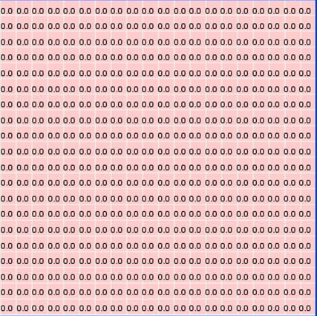

Note:
Please refer to the readme.txt file included in the zip file for instructions of how to execute the program(s).

Conclusion:
In between Rule 7 and Rule 9, Rule 7 is better in finding the Feature Defect (FD) for cancer cell.
Reference:
1) “Pattern differentiation of glandular cancerous cells and normal cells with cellular automata and evolutionary learning"; by Jong-Chen Chen a,*, Chun-Ming Yeh a, Jeh-En Tzeng; from Expert Systems with Applications 34 (2008) 337–346

