SYSC 5104: Assignment #2
Classification using Cell-DEVS

Michael Floyd
100294876
November 23, 2009
Motivation:

This assignment will aim to use Cell-DEVS as a tool for classification. The following paper will be used as the basis of my assignment:

Tom Fawcett. Data mining with cellular automata. SIGKDD Explorations 10(1): 32-39 (2008)

This paper describes how cellular automata can be used to train an instance-based classifier. Initially, an n-dimensional grid is created with each cell in the grid representing a discretized region of the input-space. Initially, a set of training instances are selected and the cells they would occupy are given the associated class value. Since the paper only deals with binary classification, each cell can therefore have a value of 0 (undefined), 1 (class 1) or 2 (class 2). Each cell has a von Neumann neighbourhood and is updated based on majority voting from its neighbours. The update rule (n4_V1_nonstable) is shown:

n4_V1_nonstable = 0 : class 1 neighbours + class 2 neighbours = 0
1 : class 1 neighbours > class 2 neighbours
2 : class 2 neighbours > class 1 neighbours
rand({1,2}) : class 1 neighbours = class 2 neighbours

The class labels will therefore propagate out from the training instances. After a certain number of generations, the automata can be stopped and the grid can be used to classify novel input problems.

Using a cellular approach to classification removes the need to have a global knowledge of the training data. In traditional classifiers, a training sample is either used to train the classifier or, in the case of instance-based classifiers, knowledge about other instances is used during classification. With cellular automata, only knowledge of the cell and its immediate neighbours is available. One example where such a classification approach might be applicable would be in a combat scenario. In a war, an area of land (like a town) would only know certainly if it was occupied by one of the armies. Otherwise, if would have to make assumptions about what force occupied it by observing if any neighbouring regions were under control.

Modified Design:

Once the Fawcett’s cellular automata approach has converged on a classification of the data region it becomes difficult to change the classification with new training instances, so it would be unsuitable for online learning. For example, if a classification boundary was incorrect a new training point added to the grid might be surrounded by labels for the other class and therefore be converted to that other class. This is especially problematic for imbalanced data sets (when instance of class 1 are far more common than instances of class 2).

To solve this I would use a more finely-grained range of cell states: known_class_1 = 3, likely_class_1 = 2, boundary_class_1 = 1, undefined = 0, known_class_2 = 6, likely_class_2 = 5, boundary_class_2 = 4. The update function is shown below:

modified_vote = 3 : state = 3
6 : state = 6
0 : class 1 neighbours + class 2 neighbours=0
2 : class 2 neigh=0 AND class 1 neigh>0
4 : class 2 neigh>0 AND class 1 neigh=0
1 : class 1 neighbours>class 2 neighbours
3 : class 2 neighbours>class 1 neighbours
rand({1,2}) : class 1 neighbors = class 2 neighbors

This is, in fact, a version of Fawcett’s approach that uses fuzzy class membership.

Conceptual Models:

The specific details of the Cell-DEVS model for each approach is shown in Table 1. The complete implementation of these models, using CD++, can be found in the accompanying .ma files. It should be noted that the original model is contained in the models beginning with “classification_fawcett” and the improved model in the models beginning with “classification_floyd”.

 | X=Y=S | N | D | τ | Border | λ
Original | {0,3,6} | von Neumann | transport | n4_V1_nonstable | unwrapped | S
Improved | {0,1,2,3,4,5,6} | von Neumann | transport | modified_vote | unwrapped | S
Table 1: Cell-DEVS model

Evaluation:

The evaluation of these models was performed in three stages. The two models were compared on the following tasks:

- A 2D classification task with a linear boundary.
- A 2D classification task with an parabolic boundary.
- A 2D classification task with a linear boundary and online learning.

In each of these tasks the grid of cells represents a region where both the x-axis and y-axis go from 0 to 4 and each cell represents an increment of 0.05. A training sample of 300 cells were chosen at random for each task and given their class value. The remaining cells were given an initial state of undefined. These values were chosen to mirror the experiments performed in Fawcett’s paper. Both models, Fawcett and Floyd, were given the same training samples.

Linear:

Both classification models were used on a region where class 1 and class 2 can be separated linearly. The CD++ models are named classification_fawcett.ma and classification_floyd.ma.

Looking at the resulting classification, both approaches produce a nearly linear classification boundary. It should also be noted that both approaches produce identical boundaries. The only difference is that all cells are either class 1 or class 2 using the Fawcett model, whereas in the improved model they can be definitely of a particular class (training instances only), likely of a particular class or on the boundary of a particular class.

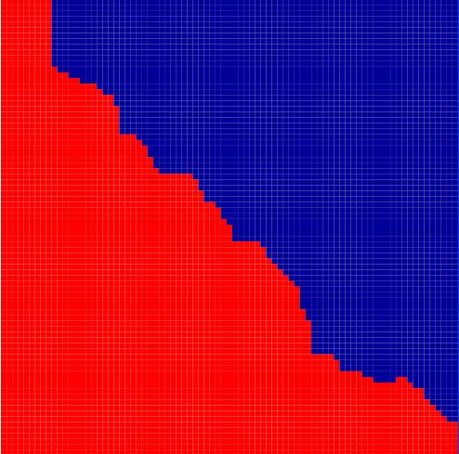
Figure 1: Linear classification using Fawcett approach

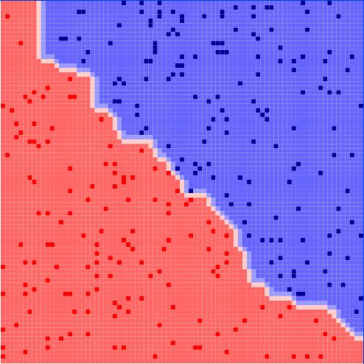
Figure 2: Linear classification using Floyd approach

Parabolic:

In this test, the boundary between classes was parabolic. The CD++ models are named classification_fawcett_para.ma and classification_floyd_para.ma.

As with the linear tests, there was no difference in the classification by the two models. Both were able to do a good job producing a roughly parabolic classification boundary.

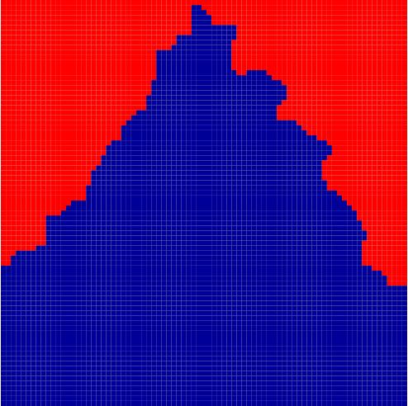
Figure 3: Parabolic classification using Fawcett approach

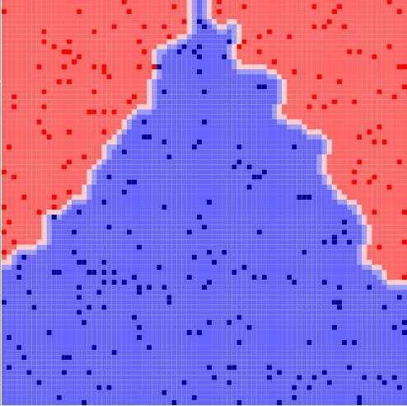
Figure 4: Parabolic classification using Floyd approach

Online Learning:

As we were able to observe from the linear classifier task, there was a region in the top left corner that was incorrectly classified. It would be useful to be able to fix this training error without having to completely retrain the model. In order to test the ability of these models to perform online learning, each model is fully trained (with the same training instances from the linear classification task) and then provided with correct classifications to several misclassified cells. Ideally, the model should be able to improve using this information.

In these tests, five cells which were originally misclassified are given their correct classification after the models are fully trained. In order to make this easy to visually identify, all five cells used are in the top-left corner of the region. These tests can be run using classification_fawcett_online.ma and classification_floyd_online.ma CD++ models.

As was expected, the Fawcett approach was completely unable to benefit from online learning. The cells which are given the new data quickly revert to their previous incorrect classification. However, using the improved approach you can clearly see there is now a distinct blue region in the top-left corner of the region. The classification boundary is now closer to the true boundary, making this a definite improvement over the Fawcett approach.

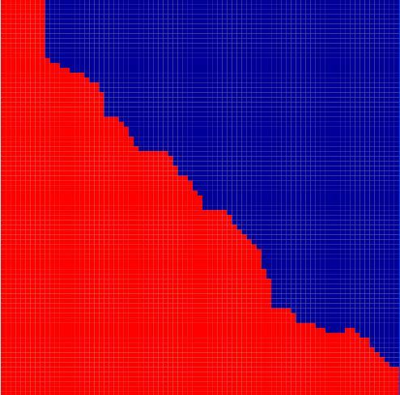
Figure 5: Linear classification with online learning using Fawcett approach

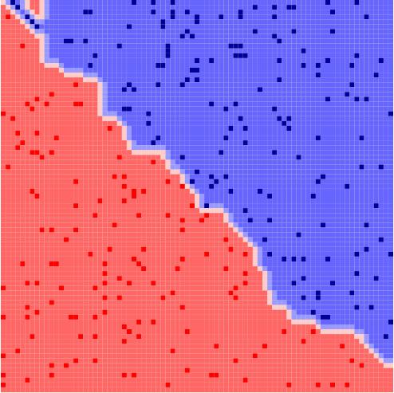
Figure 6: Linear classification with online learning using Floyd approach

Conclusions:

The main conclusions of this assignment are that the cellular automata approach to classification discussed in this document is a clear improvement over the approach proposed by Fawcett. The improved approach produces identical classification boundaries to Fawcett, but is far superior in situations where new training instances are added using online learning. Since online learning is important in any machine learning task, it is clearly advantageous to use this approach when training a classifier using cellular automata.

This assignment did not perform an extensive experimental evaluation of a cellular automata classifier but was instead a demonstration of how a cellular automata classifier can allow for online learning. Further work in this area would likely involve experimenting on multi-class problems (as opposed to two-class), severely imbalanced data sets and data with more than two features. Using real-life data sets would demonstrate the need for parallel DEVS, since many data sets have ten or more features and the number of cells needed in exponentially related to the number of features.

