Static Collision Avoidance for a Point Mass UAV or Robot Using Cell DEVS

SYSC-5807
Assignment 2

Rami Youssef
SN# 100204490

Nov 12, 2003

Part I

Robots or Unmanned Aerial Vehicles encounter some static and dynamic obstacles when they traverse a specific area or follow some path. Therefore, it is necessary for the robot or the UAV to be able to avoid such obstacles and continue its mission.

This assignment deals with avoiding only static obstacles as shown in the following diagram.

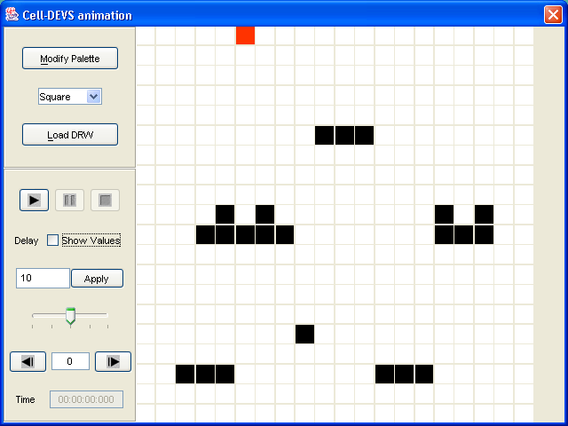

The red square represents the UAV or the robot, and the black squares represent various static obstacles. The robot mission is to cross the area top to bottom while avoiding all encountered obstacles.

Part II

The formal specifications for the cell-devs model can be written as follows. Some of them are set to defaults or not used.

CD = <X, Y, I, S, Θ, N, d, δ_{int} , δ_{ext} , τ, λ, D>

X = {} : set of inputs external events
Y= {} : set of outputs
I =
neighborhood size : 6
number of ports: 0

S: state Value {0,1,9}
Θ:
s = {0,1,9}
phase = {active,passive}

N = {} set of input events
D= 100 ms (cell delay)
δ_{int} : internal transition function
δ_{ext} : External transition function
τ : local computing function
D : duration function

The model was built using the previous specifications and was tested thoroughly. It behaved as expected. Different tests can be conducted, by changing the starting position of the robot and by changing the positions of the static obstacles. That can be done at the initialization part of the MA file. No matter where we started our robot, it was still able to cross to the bottom of the page avoiding all obstacles. However, the case where we have a very large horizontal obstacle wasn’t tested, as it is an unrealistic case to the assumed model.

Attached with a report are some printouts of various execution printouts showing the behavior of the model.

The model was also tested for multiple robots running at the same time, and the results were verified for a specific set of scenarios based on a condition that there is an appropriate separation between the robots, so they don’t interfere with one another. Attached are some printouts of such a scenario.

