

94.587

ADVANCED TOPICS ON COMPUTER SYSTEMS: METHODOLOGICAL ASPECTS OF MODELLING AND SIMULATION

Term Project
Testing Performance of Parallel Cell-DEVS Models

Wanjun Sun (258556)
wsun@sce.carleton.ca

1. Introduction
Parallel simulation is an effective method to achieve speedups in model execution. In this project, we run some existing and newly created models in parallel mode. After that we analyze the performance using the testing data.

My work mainly consists of following parts: modeling the city area section model explained in the course and paper (www.sce.carleton.ca/faculty/wainer/papers/97-007.ps). Then I run some of the existing models (life game and airport, etc.) and this area section model in both standalone and parallel mode in various scenarios to obtain test data based on which we can carry out the performance analysis later. Moreover, because the tool we used is not a fully developed commercial software, we need to find out the problems when doing the work and record them so that they can be taken into consideration in future version and people can make better use of the tool.

2. Implementation of City Area Section Model:
The city area section is a model explained in the course. All models’ formal specifications and conceptual descriptions are introduced in detail in online paper 97-007.ps. We do not elaborate them here again. When I work on the models I found some minor errors regarding the model specifications and rules. Therefore, we make some modifications so that the models can work properly. Here we include the sketch of the final coupled model systems as well as neighborhood and rules definition of each Cell-DEVS model to show the structure and working mechanisms of the models.
c

A: Residential Neighborhood
Cell-DEVS

C: Highway
Cell-DEVS

D: Ferry Boat
E: Factory
B: Commercial Neighborhood
Cell-DEVS
Fig. 1 Model Structure
a b
c
a b
2.1 Model A: Residential Neighborhood

Fig. 2: Model A (Residential) - Cell’s Neighborhood and Rules
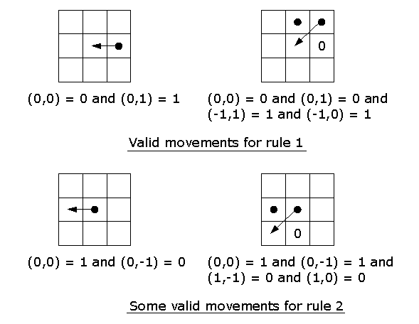
Cell’s Neighborhood
Following is the .ma file that describes the Residential Neighborhood model.

% residential.ma
% Model A: Smog in the Residential Neighborhood (Cell-DEVS)
[top]
components : residential
in : in_factory in_highway
link : in_factory in_factory@residential
link : in_highway in_highway@residential
[residential]
type : cell
dim : (9, 10)
delay : inertial
defaultDelayTime : 500
border : nowrapped
% select is decided by the sequence of the cells
neighbors : residential(-1,1) residential(-1,0) residential(0,1)
neighbors : residential(-1,-1) residential(0,0) residential(1,1)
neighbors : residential(0,-1) residential(1,0) residential(1,-1)
initialvalue : 0
initialrowvalue : 0 0000000000
initialrowvalue : 1 0000010000
initialrowvalue : 2 0100111000
initialrowvalue : 3 0000010000
initialrowvalue : 4 0000100000
initialrowvalue : 5 0010001000
initialrowvalue : 6 0000100000
initialrowvalue : 7 0000000000
initialrowvalue : 8 0000000100
in : in_factory in_highway
link : in_factory in_factory@residential(0,9)
link : in_highway in_highway@residential(1,9)
portInTransition : in_factory@residential(0,9) got-exhaust-air-rule
portInTransition : in_highway@residential(1,9) got-exhaust-air-rule
localtransition : diffussingRule
[got-exhaust-air-rule]
rule : { portValue(thisPort) } 500 {t}
% following rules are same as [diffussingRule]
…
[diffussingRule]
rule : 1 500 { ((0,0) = 0 and (0,1) = 1) or
((0,0) = 0 and (0,1) = 0 and (-1,1) = 1 and (-1,0) = 1)
}
rule : 0 500 { (truecount = 1) or
((0,0) = 1 and (0,-1) = 0) or
((0,0) = 1 and (0,-1) = 1 and (1,-1) = 0 and (1,0) = 0)
}
rule : {(0,0)} 500 {t}

By following the verification procedures (manual simulation) we practiced in assignment 2, we can easily verify the model rules. Here we don’t elaborate on this part.

2.2 Model B: Commercial Neighborhood

Fig. 3: Model B (Commercial) - Cell’s Neighborhood and Rules
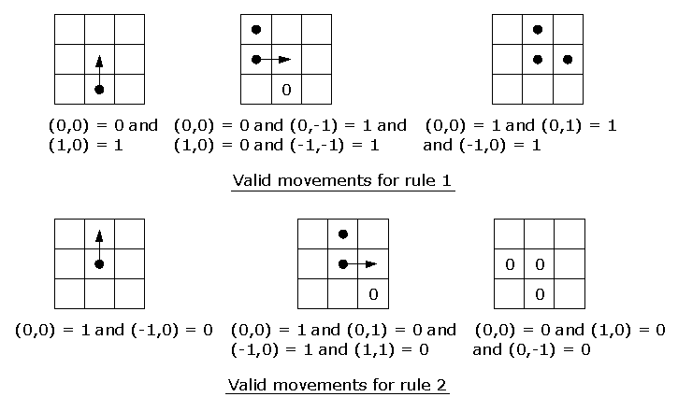
Cell’s Neighborhood
Following is the .ma file that describes the Commercial Neighborhood model.

% commercial.ma
% Model B: Traffic in the Commercial Neighborhood (Cell-DEVS)
[top]
components : commercial
in : in_highway in_ferry
out : out_highway out_ferry
link : in_highway in_highway@commercial
link : in_ferry in_ferry@commercial
link : out_highway@commercial out_highway
link : out_ferry@commercial out_ferry
[commercial]
type : cell
dim : (4, 9)
delay : transport
defaultDelayTime : 100
border : wrapped
%select is decided by the sequence of the following cells
neighbors : commercial(1,-1) commercial(0,-1) commercial(1,0)
neighbors : commercial(-1,-1) commercial(0,0) commercial(1,1)
neighbors : commercial(-1,0) commercial(0,1) commercial(-1,1)
initialvalue : 0
initialrowvalue : 0 010000100
initialrowvalue : 1 111000000
initialrowvalue : 2 011000000
initialrowvalue : 3 000000000
in : in_highway in_ferry
out : out_highway out_ferry
link : in_highway in_highway@commercial(0,1)
link : in_ferry in_ferry@commercial(0,6)
link : out_highway@commercial(0,2) out_highway
link : out_ferry@commercial(0,8) out_ferry
portInTransition : in_highway@commercial(0,1) car-moving-in-commerial-rule
portInTransition : in_ferry@commercial(0,6) car-moving-in-commerial-rule
localtransition : movingRuleB
zone : generateOut_highway { (0,2) }
zone : generateOut_ferry { (0,8) }
[car-moving-in-commerial-rule]
rule : { portValue(thisPort) } 100 {t}
% following rules are same as [movingRuleB]
…
[generateOut_highway]
rule : { (0,0) - 1 + send( out_highway , 1 )} 100 { (0,0) = 1 }
% following rules are same as [movingRuleB]
…
[generateOut_ferry]
rule : { (0,0) - 1 + send( out_ferry , 1 )} 100 { (0,0) = 1 }
% following rules are same as [movingRuleB]
…
[movingRuleB]
rule : 1 100 { ((0,0) = 0 and (1,0) = 1) or % I have no car and one is coming from bottom
((0,0) = 0 and (0,-1) = 1 and (1,0) = 0 and (-1,-1) = 1) or
% I have no car and one is coming from left
((0,0) = 1 and (0,1) = 1 and (-1,0) = 1) % blocked by right and top car
}
rule : 0 100 { ((0,0) = 1 and (-1,0) = 0) or % car goes up
((0,0) = 1 and (0,1) = 0 and (-1,0) = 1 and (1,1) = 0) or % car goes right
((0,0) = 0 and (1,0) = 0 and (0,-1) = 0)
% no car and no car coming from bottom and left
}
rule : {(0,0)} 100 {t}

Fig. 4: Model C (Highway) – Cell’s Neighborhood and Rules
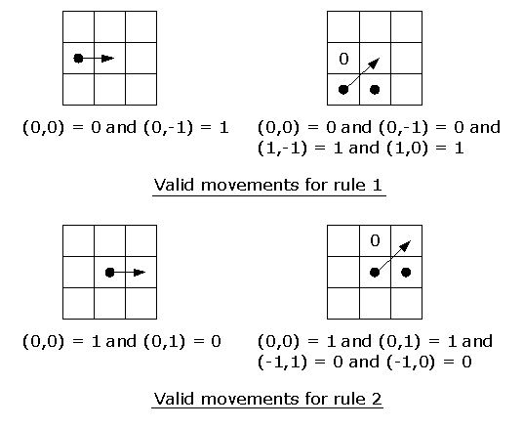
Cell’s Neighborhood
2.3 Model C: Highway
Following is the .ma file that describes the Highway model.

% highway.ma
% Model C: Highway (Cell_DEVS)
[top]
components : highway
in : in_ferry in_commercial in_factory
out : out_ferry out_commercial out_factory out_residential
link : in_ferry in_ferry@highway
link : in_commercial in_commercial@highway
link : in_factory in_factory@highway
link : out_ferry@highway out_ferry
link : out_commercial@highway out_commercial
link : out_factory@highway out_factory
link : out_residential@highway out_residential
[highway]
type : cell
dim : (4, 15)
delay : transport
defaultDelayTime : 50
border : wrapped
% the sequence of the cells decides the select function
neighbors : highway(0,1) highway(-1,1) highway(1,1)
neighbors : highway(0,0) highway(-1,0) highway(1,0)
neighbors : highway(-1,-1) highway(0,-1) highway(1,-1)
initialvalue : 0
initialrowvalue : 0 000000110000000
initialrowvalue : 1 000000000001000
initialrowvalue : 2 010000001100000
initialrowvalue : 3 000000001110000
in : in_ferry in_commercial in_factory
out : out_ferry out_commercial out_factory out_residential
link : in_ferry in_ferry@highway(2,0)
link : in_commercial in_commercial@highway(3,4)
link : in_factory in_factory@highway(3,13)
link : out_ferry@highway(3,0) out_ferry
link : out_commercial@highway(3,3) out_commercial
link : out_factory@highway(3,14) out_factory
link : out_residential@highway(0,9) out_residential
portInTransition : in_ferry@highway(2,0) car-moving-in-highway-rule
portInTransition : in_commercial@highway(3,4) car-moving-in-highway-rule
portInTransition : in_factory@highway(3,13) car-moving-in-highway-rule
localtransition : movingRuleC
zone : generateOut_ferry { (3,0) }
zone : generateOut_commercial { (3,3) }
zone : generateOut_factory { (3,14) }
zone : generateOut_residential { (0,9) }
[car-moving-in-highway-rule]
rule : { portValue(thisPort) } 50 {t}
% following rules are same as [movingRuleC]
…
[generateOut_ferry]
rule : { (0,0) - 1 + send( out_ferry , 1 )} 50 { (0,0) = 1 }
% following rules are same as [movingRuleC]
…
[generateOut_commercial]
rule : { (0,0) - 1 + send( out_commercial , 1 )} 50 { (0,0) = 1 }
% following rules are same as [movingRuleC]
…
[generateOut_factory]
rule : { (0,0) - 1 + send( out_factory , 1 )} 50 { (0,0) = 1 }
% following rules are same as [movingRuleC]
…
[generateOut_residential]
rule : { (0,0) + send( out_residential , 1 )} 50 { (0,0) = 1 } % send smog not car to residential
% following rules are same as [movingRuleC]
…
[movingRuleC]
rule : 1 50 { ((0,0) = 0 and (0,-1) = 1) or
((0,0) = 0 and (0,-1) = 0 and (1,-1) = 1 and (1,0) = 1)
}
rule : 0 50 { ((0,0) = 1 and (0,1) = 0) or
((0,0) = 1 and (0,1) = 1 and (-1,1) = 0 and (-1,0) = 0)
}
rule : {(0,0)} 50 {t}

2.4 Model D: Ferry and Model E: Factory

There are two DEVS model: Ferry and Factory. They are created based on the queue example. Here we give only the Ferry model (ferry.h and ferry.cpp):

/*******************************************************************
* DESCRIPTION: Atomic Model Ferry
*******************************************************************/
#ifndef __FERRY_H
#define __FERRY_H
#include <list>
#include "atomic.h" // class Atomic
class Ferry : public Atomic
{
public:
Ferry( const string &name = "Ferry" ); //Default constructor
virtual string className() const ;
protected:
Model &initFunction();
Model &externalFunction( const ExternalMessage & );
Model &internalFunction( const InternalMessage & );
Model &outputFunction( const InternalMessage & );
private:
const Port &in;
const Port &done;
Port &out;
Time Load_time;
typedef list<Value> ElementList ;
ElementList elements ;
}; // class Ferry
// ** inline ** //
inline string Ferry::className() const
{
return "Ferry" ;
}
#endif //__FERRY_H
-----------------------------------------------------------------------------------------------------------

// ferry.cpp
/*******************************************************************
* DESCRIPTION: Atomic Model Ferry
*******************************************************************/
/** include files **/
#include "ferry.h" // class Ferry
#include "message.h" // class ExternalMessage, InternalMessage
#include "mainsimu.h" // MainSimulator::Instance().getParameter( ... )
extern "C"
{
#include "randlib.h" // used by ignpoi() to create random number
}
/** public functions **/
/*******************************************************************
* Function Name: Ferry
********************************************************************/
Ferry::Ferry( const string &name )
: Atomic( name )
, in( addInputPort( "in" ) )
, done( addInputPort( "done" ) )
, out( addOutputPort( "out" ) )
{
}
/*******************************************************************
* Function Name: initFunction
********************************************************************/
Model &Ferry::initFunction()
{
elements.erase( elements.begin(), elements.end() ) ;
return *this ;
}
/*******************************************************************
* Function Name: externalFunction
********************************************************************/
Model &Ferry::externalFunction( const ExternalMessage &msg )
{
if( msg.port() == in )
{
elements.push_back( 1 ) ;
if( elements.size() == 1 )
{
Load_time = Time::Time(0, ignpoi(15), 0, 0);
holdIn( active, Load_time );
}
}
if( msg.port() == done )
{
elements.pop_front() ;
if( !elements.empty() )
{
Load_time = Time::Time(0, ignpoi(15), 0, 0);
holdIn( active, Load_time );
}
}
return *this;
}
/*******************************************************************
* Function Name: internalFunction
********************************************************************/
Model &Ferry::internalFunction( const InternalMessage & )
{
passivate();
return *this ;
}
/*******************************************************************
* Function Name: outputFunction
********************************************************************/
Model &Ferry::outputFunction( const InternalMessage &msg )
{
sendOutput( msg.time(), out, elements.front() ) ;
return *this ;
}

2.5 The final Coupled Model – The Area Section

Following is the .ma file that describes the final coupled model - The Area Section.

%---------------------------------------------------------------------------------
% area-section.ma
%---------------------------------------------------------------------------------
[top]
components : commercial residential highway ferry@Ferry factory@Factory
link : out_residential@highway in_highway@residential
link : out@factory in_factory@residential
link : out_factory@highway in@factory
link : out@factory in_factory@highway
link : out_commercial@highway in_highway@commercial
link : out_highway@commercial in_commercial@highway
link : out_ferry@commercial in@ferry
link : out@ferry in_ferry@commercial
link : out_ferry@highway in@ferry
link : out@ferry in_ferry@highway
link : out@ferry done@ferry
link : out@factory done@factory
%---------------------------------------------------------------------------------
[commercial]
type : cell
dim : (4, 9)
delay : transport
defaultDelayTime : 100
border : wrapped
%select is decided by the sequence of the following cells
neighbors : commercial(1,-1) commercial(0,-1) commercial(1,0)
neighbors : commercial(-1,-1) commercial(0,0) commercial(1,1)
neighbors : commercial(-1,0) commercial(0,1) commercial(-1,1)
initialvalue : 0
initialrowvalue : 0 010000100
initialrowvalue : 1 111000000
initialrowvalue : 2 011000000
initialrowvalue : 3 000000000
in : in_highway in_ferry
out : out_highway out_ferry
link : in_highway in_highway@commercial(0,1)
link : in_ferry in_ferry@commercial(0,6)
link : out_highway@commercial(0,2) out_highway
link : out_ferry@commercial(0,8) out_ferry
portInTransition : in_highway@commercial(0,1) car-moving-in-commerial-rule
portInTransition : in_ferry@commercial(0,6) car-moving-in-commerial-rule
localtransition : movingRuleB
zone : generateOut_highway { (0,2) }
zone : generateOut_ferry { (0,8) }
[car-moving-in-commerial-rule]
rule : { portValue(thisPort) } 100 {t}
% following rules are same as [movingRuleB]
…
[generateOut_highway]
rule : { (0,0) - 1 + send( out_highway , 1 )} 100 { (0,0) = 1 }
% following rules are same as [movingRuleB]
…
[generateOut_ferry]
rule : { (0,0) - 1 + send( out_ferry , 1 )} 100 { (0,0) = 1 }
% following rules are same as [movingRuleB]
…
[movingRuleB]
rule : 1 100 { ((0,0) = 0 and (1,0) = 1) or
((0,0) = 0 and (0,-1) = 1 and (1,0) = 0 and (-1,-1) = 1) or
((0,0) = 1 and (0,1) = 1 and (-1,0) = 1)
}
rule : 0 100 { ((0,0) = 1 and (-1,0) = 0) or
((0,0) = 1 and (0,1) = 0 and (-1,0) = 1 and (1,1) = 0) or
((0,0) = 0 and (1,0) = 0 and (0,-1) = 0)
}
rule : {(0,0)} 100 {t}
%---------------------------------------------------------------------------------
[highway]
type : cell
dim : (4, 15)
delay : transport
defaultDelayTime : 50
border : wrapped
% the sequence of the cells decides the select function
neighbors : highway(0,1) highway(-1,1) highway(1,1)
neighbors : highway(0,0) highway(-1,0) highway(1,0)
neighbors : highway(-1,-1) highway(0,-1) highway(1,-1)
initialvalue : 0
initialrowvalue : 0 000000110000000
initialrowvalue : 1 000000000001000
initialrowvalue : 2 010000001100000
initialrowvalue : 3 000000001110000
in : in_ferry in_commercial in_factory
out : out_ferry out_commercial out_factory out_residential
link : in_ferry in_ferry@highway(2,0)
link : in_commercial in_commercial@highway(3,4)
link : in_factory in_factory@highway(3,13)
link : out_ferry@highway(3,0) out_ferry
link : out_commercial@highway(3,3) out_commercial
link : out_factory@highway(3,14) out_factory
link : out_residential@highway(0,9) out_residential
portInTransition : in_ferry@highway(2,0) car-moving-in-highway-rule
portInTransition : in_commercial@highway(3,4) car-moving-in-highway-rule
portInTransition : in_factory@highway(3,13) car-moving-in-highway-rule
localtransition : movingRuleC
zone : generateOut_ferry { (3,0) }
zone : generateOut_commercial { (3,3) }
zone : generateOut_factory { (3,14) }
zone : generateOut_residential { (0,9) }
[car-moving-in-highway-rule]
rule : { portValue(thisPort) } 50 {t}
% following rules are same as [movingRuleC]
…
[generateOut_ferry]
rule : { (0,0) - 1 + send( out_ferry , 1 )} 50 { (0,0) = 1 }
% following rules are same as [movingRuleC]
…
[generateOut_commercial]
rule : { (0,0) - 1 + send( out_commercial , 1 )} 50 { (0,0) = 1 }
% following rules are same as [movingRuleC]
…
[generateOut_factory]
rule : { (0,0) - 1 + send( out_factory , 1 )} 50 { (0,0) = 1 }
% following rules are same as [movingRuleC]
…
[generateOut_residential]
rule : { (0,0) + send( out_residential , 1 )} 50 { (0,0) = 1 } % send smog not car to residential
% following rules are same as [movingRuleC]
…
[movingRuleC]
rule : 1 50 { ((0,0) = 0 and (0,-1) = 1) or
((0,0) = 0 and (0,-1) = 0 and (1,-1) = 1 and (1,0) = 1)
}
rule : 0 50 { ((0,0) = 1 and (0,1) = 0) or
((0,0) = 1 and (0,1) = 1 and (-1,1) = 0 and (-1,0) = 0)
}
rule : {(0,0)} 50 {t}
%---------------------------------------------------------------------------------
[residential]
type : cell
dim : (9, 10)
delay : inertial
defaultDelayTime : 500
border : nowrapped
% select is decided by the sequence of the cells
neighbors : residential(-1,1) residential(-1,0) residential(0,1)
neighbors : residential(-1,-1) residential(0,0) residential(1,1)
neighbors : residential(0,-1) residential(1,0) residential(1,-1)
initialvalue : 0
initialrowvalue : 0 0000000000
initialrowvalue : 1 0000010000
initialrowvalue : 2 0100111000
initialrowvalue : 3 0000010000
initialrowvalue : 4 0000100000
initialrowvalue : 5 0010001000
initialrowvalue : 6 0000100000
initialrowvalue : 7 0000000000
initialrowvalue : 8 0000000100
in : in_factory in_highway
link : in_factory in_factory@residential(0,9)
link : in_highway in_highway@residential(1,9)
portInTransition : in_factory@residential(0,9) got-exhaust-air-rule
portInTransition : in_highway@residential(1,9) got-exhaust-air-rule
localtransition : diffussingRule
[got-exhaust-air-rule]
rule : { portValue(thisPort) } 500 {t}
% following rules are same as [diffussingRule]
…
[diffussingRule]
rule : 1 500 { ((0,0) = 0 and (0,1) = 1) or
((0,0) = 0 and (0,1) = 0 and (-1,1) = 1 and (-1,0) = 1)
}
rule : 0 500 { (truecount = 1) or
((0,0) = 1 and (0,-1) = 0) or
((0,0) = 1 and (0,-1) = 1 and (1,-1) = 0 and (1,0) = 0)
}
rule : {(0,0)} 500 {t}
%---------------------------------------------------------------------------------
[factory]
%---------------------------------------------------------------------------------
[ferry]
%---------------------------------------------------------------------------------
select : ferry factory highway commercial residential

2.6 Important Notes

When testing every individual model by checking the output file generated from log file, we need to comment the output port related rules to get the correct cell values. After the testing, we can uncomment these rules. For instance, in "highway.ma" there is a rule related with output port "out_ferry" (the first rule of [generateOut_ferry]):

[generateOut_ferry]
rule : { (0,0) - 1 + send( out_ferry , 1 ) } 100 { (0,0) = 1 }
% following rules are same as [movingRuleC]
rule : 1 50 { ((0,0) = 0 and (0,-1) = 1) or
((0,0) = 0 and (0,-1) = 0 and (1,-1) = 1 and (1,0) = 1)
}
rule : 0 50 { ((0,0) = 1 and (0,1) = 0) or
((0,0) = 1 and (0,1) = 1 and (-1,1) = 0 and (-1,0) = 0)
}
rule : {(0,0)} 50 {t}
Following are parts of the output results in two cases:

Case A: First rule commented: Case B: First rule not commented:

Line : 142 - Time: 00:00:00:000 Line : 142 - Time: 00:00:00:000
0 1 2 3 4 5 6 7 8 91011121314 0 1 2 3 4 5 6 7 8 91011121314
+------------------------------+ +------------------------------+
0| 1 1 | 0| 1 1 |
1| 1 | 1| 1 |
2| 1 1 1 | 2| 1 1 1 |
3| 1 1 1 | 3| 1 1 1 |
+------------------------------+ +------------------------------+

Line : 284 - Time: 00:00:00:050 Line : 284 - Time: 00:00:00:050
0 1 2 3 4 5 6 7 8 91011121314 0 1 2 3 4 5 6 7 8 91011121314
+------------------------------+ +------------------------------+
0| 1 | 0| 1 |
1| 1 1 | 1| 1 1 |
2| 1 1 | 2| 1 1 |
3| 1 1 1 1 | 3| 1 1 1 1 |
+------------------------------+ +------------------------------+

Line : 434 - Time: 00:00:00:100 Line : 436 - Time: 00:00:00:100
0 1 2 3 4 5 6 7 8 91011121314 0 1 2 3 4 5 6 7 8 91011121314
+------------------------------+ +------------------------------+
0| 1 | 0| 1 |
1| 1 1 | 1| 1 1 |
2| 1 1 1 1 | 2| 1 1 1 1 |
3| 1 1 | 3| 1 1 |
+------------------------------+ +------------------------------+

Line : 584 - Time: 00:00:00:150 Line : 588 - Time: 00:00:00:150
0 1 2 3 4 5 6 7 8 91011121314 0 1 2 3 4 5 6 7 8 91011121314
+------------------------------+ +------------------------------+
0| 1 | 0| 1 1 |
1| 1 1 1| 1| 1 1 1|
2| 1 1 1 | 2| 1 1 1 |
3| 1 1 | 3| 1 1 |
+------------------------------+ +------------------------------+

Line : 734 - Time: 00:00:00:200 Line : 748 - Time: 00:00:00:200
0 1 2 3 4 5 6 7 8 91011121314 0 1 2 3 4 5 6 7 8 91011121314
+------------------------------+ +------------------------------+
0| 1 | 0| 1 1 |
1| 1 1 1 | 1| 1 1 1 |
2| 1 1 1 | 2| 1 1 1 |
3| 1 1| 3| 1 1 1|
+------------------------------+ +------------------------------+

Line : 884 - Time: 00:00:00:250 Line : 916 - Time: 00:00:00:250
0 1 2 3 4 5 6 7 8 91011121314 0 1 2 3 4 5 6 7 8 91011121314
+------------------------------+ +------------------------------+
0| 1 | 0| 1 1 1 |
1| 1 1 1 | 1| 1 1 1 |
2| 1 1 1| 2| 1 1 1|
3| 1 1 | 3| 1 1 1 1|
+------------------------------+ +------------------------------+

We can see that at Time: 00:00:00:100, value of cell(0,9) becomes 1. Note cell(0,9) is a output port. From then on, in case B the value of cell(0,9) remains 1 and keep generating more 1s according to the rules. Same thing happens for other output ports: cell(3,0), cell(3,3), cell(3,14). This is certainly not the true case. We can see that case A represents the true case all the time (with no extra car generated).

- Installation of Parallel CD++ Toolkit

The parallel simulation package we are using is "cd++-3.0.3.tar.gz". Unzip the package and it will create a folder named “cd++”. Since we also use standalone mode to run and test the models and the standalone simulation tool’s folder is already called “cd++”, we change this parallel simulation folder name to “pcd++”. Then some files need to be modified before the tool can be compiled.

In Makefile.common (under “pcd++”), change following directory settings:

export MAINDIR=/home/587-015/pcd++
export MPIDIR=/usr/local/mpich

To let the C++ programs run in parallel mode, following changes need to be made in *.h and *.cpp files:

#include "mainsimu.h" #include "parsimu.h"
active AtomicState::active
MainSimulator ParallelMainSimulator
Time VTime
outputFunction(const InternalMessage &msg) outputFunction(const CollectMessage &msg )

In “register.cpp”, add the models as what queue model did. In “makefile”, make following changes:

/home/atroccol/tesis/cd++ /home/587-015/pcd++

and then run "make depend". After this step, all the directory setting inconsistencies are fixed. Now it’s ready to compile the tools. Run "make" and after a considerably long time a new "cd++" is created. That is the tool we use to do the parallel simulation.

The process is quite straightforward now, but it took us lots of time to figure out the tricks because the tools seem to be under development and therefore the manual doesn’t include detailed information about installation and compilation.

4. Testing of Existing DEVS and Cell-DEVS Models

In the testing, we use following script to run the simulation tool. Here we take the airport model for example:

time -o airport2b.time -a /usr/local/mpich/bin/mpirun -np 2 ../../pcd++/cd++ -mAEROPUER.MA -Pairport2b.par -t00:00:05:000 -eaeropuer.ev -oairport2b.out -l>airport2b.log

We use Linux system command “time” to record the time every simulation cycle takes. The time will be recorded in the files with the extension “.time” and in append mode, so we can run the simulation several times and record all the time it takes.

4.1 Testing of DEVS Models and Performance Analysis

We run two DEVS models to do the testing: airport and the Enginebody Subfactory model I created in assignment 1. For some unknown reason, Airport mode can only run with a short running time (at most -t00:01:00:000 which coincides with the external event time), otherwise the system gives following error message:

[wsun@localhost airport]$ ./run1
Exception AssertException thrown!
Description: Invalid assertion
Thrown in:
File: msgbag.cpp - Method: add - Line: 38
Description:
count == 0 || (count != 0 && msg->time() == msgtime )
[wsun@localhost airport]$

4.1.1 Airport Model Parallel Testing

We constructed many partition settings with which we carry out the testing. Following are the partition files we used and the testing data obtained.

<airport1.par> 1 processor
0 : torre cola_aterrizaje cola_despegue pista Hangar selector Deposito1 Deposito2 Deposito3 Deposito4 4_to_1

<airport2a.par> 2 processors – partition setting a
0 : torre cola_aterrizaje cola_despegue pista Hangar
1 : selector Deposito1 Deposito2 Deposito3 Deposito4 4_to_1

<airport2b.par> 2 processors – partition setting b
0 : torre cola_aterrizaje cola_despegue pista Hangar selector Deposito1 Deposito2 Deposito3 Deposito4
1 : 4_to_1

<airport3a.par> 3 processors – partition setting a
0 : torre cola_aterrizaje cola_despegue pista Hangar
1 : selector Deposito1 Deposito2
2 : Deposito3 Deposito4 4_to_1

<airport3b.par> 3 processors – partition setting b
0 : torre
1 : cola_aterrizaje cola_despegue pista Hangar selector Deposito1 Deposito2
2 : Deposito3 Deposito4 4_to_1

<airport3c.par> 3 processors – partition setting c
0 : torre selector Deposito1 Deposito2
1 : cola_aterrizaje cola_despegue pista Hangar
2 : Deposito3 Deposito4 4_to_1

<airport3d.par> 3 processors – partition setting d
0 : torre selector Deposito1 Deposito2 cola_aterrizaje
1 : pista Hangar
2 : Deposito3 Deposito4 4_to_1 cola_despegue

<airport4a.par> 4 processors – partition setting a
0 : torre cola_aterrizaje cola_despegue
1 : pista Hangar selector
2 : Deposito1 Deposito2 Deposito3
3 : Deposito4 4_to_1

<airport4b.par> 4 processors – partition setting b
0 : torre cola_aterrizaje cola_despegue pista Hangar selector Deposito1 Deposito2
1 : Deposito3
2 : Deposito4
3 : 4_to_1

<airport4c.par> 4 processors – partition setting c
0 : torre
1 : pista Hangar selector
2 : Deposito1 Deposito2 Deposito3 Deposito4
3 : 4_to_1 cola_aterrizaje cola_despegue

<airport4d.par> 4 processors – partition setting d
0 : torre
1 : pista Hangar selector cola_aterrizaje cola_despegue
2 : Deposito1 Deposito2 Deposito3 Deposito4
3 : 4_to_1

 | Airport Model
Partition Settings | Test1 | Test2 | Test3 | Average
1 | 0.59 | 0.51 | 0.51 | 0.54
2a | 0.86 | 0.84 | 0.85 | 0.85
2b | 0.83 | 0.83 | 0.83 | 0.83
3a | 1.24 | 1.11 | 1.09 | 1.15
3b | 1.15 | 1.11 | 1.09 | 1.12
3c | 1.12 | 1.09 | 1.09 | 1.10
3d | 1.13 | 1.09 | 1.06 | 1.09
4a | 1.31 | 1.38 | 1.43 | 1.37
4b | 1.37 | 1.34 | 1.34 | 1.35
4c | 1.36 | 1.35 | 1.33 | 1.35
4d | 1.36 | 1.35 | 1.38 | 1.36

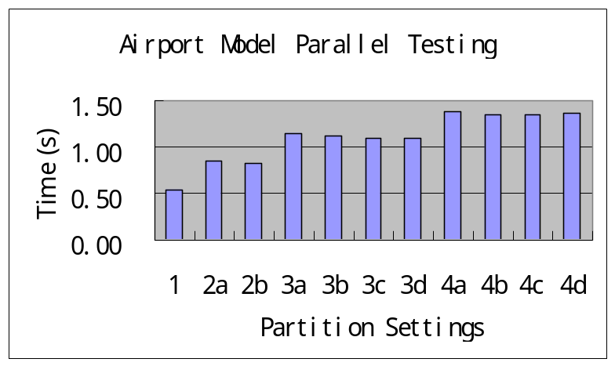
For some unknown reason, we got error message when running simulation with some partition settings. Sometimes these partition settings can be handled without generating error messages. Following is the error message we got:

[587-015@AA0507-PC08 airport]$ ./run3a
CommManager 1CommManager 2CommManager received terminate message :
sequence: 4618052569784557144 senderLP: 2 destLP: 1 type: TERMINATEMSG
error : unknown message type found...
received terminate message :
sequence: 1 senderLP: 2 destLP: 2 type: TERMINATEMSG
error : unknown message type found...
0 received terminate message :
sequence: 4618052569784557144 senderLP: 2 destLP: 0 type: TERMINATEMSG
error : unknown message type found...
[587-015@AA0507-PC08 airport]$

4.1.2 Engine Subfactory Model Parallel Testing

Following are the partition files we used and the testing data obtained.

<CM-EngineFact1.par> 1 processor
0 : piston engineBody engineAss

<CM-EngineFact2a.par> 2 processors – partition setting a
0 : piston
1 : engineBody engineAss

<CM-EngineFact2b.par> 2 processors – partition setting b
0 : engineAss
1 : piston engineBody

<CM-EngineFact2c.par> 2 processors – partition setting c
0 : piston engineBody engineAss
1 :

<CM-EngineFact2d.par> 2 processors – partition setting d
0 :
1 : piston engineBody engineAss

<CM-EngineFact3a.par> 3 processors – partition setting a
0 : piston
1 : engineBody
2 : engineAss

<CM-EngineFact3b.par> 3 processors – partition setting b
0 : piston engineBody
1 :
2 : engineAss

 | Engine SubFactory Model
Partition Settings | Test1 | Test2 | Test3 | Average
1 | 2.04 | 2.05 | 2.10 | 2.06
2a | 2.28 | 2.29 | 2.30 | 2.29
2b | 2.18 | 2.16 | 2.15 | 2.16
2c | 2.16 | 2.35 | 2.39 | 2.30
2d | 2.04 | 2.05 | 2.03 | 2.04
3a | 3.57 | 3.51 | 3.54 | 3.54
3b | 1.05 | 1.05 | 1.09 | 1.06

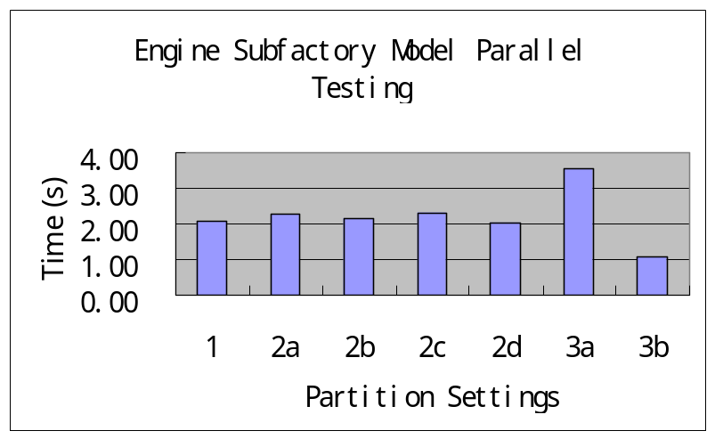

We got similar error message as airport model when running simulation with partition setting 3b.

4.1.3 Performance Analysis

We can see from the testing data that for airport model, using more processor to do the simulation leads to longer simulation time. The reason could be that the model we used is a simple one and the time consumption in handling the message transmission between processors (the overhead) overwhelms the time saving by using more processors in parallel mode. This can also be easily seen from model Engine Subfactory Model partition setting 3a where each atomic model runs on a individual processor and the simulation requires a lot of message transmissions.

4.2 Testing of Cell-DEVS Models

4.2.1 Life Game Model Parallel Testing

We run Life game to test the Cell-DEVS model simulation in parallel mode. Following are the partition files we used and the testing data obtained.

<life1.par> 1 processor
0 : life(0,0)..(19,19)

< life2a.par> 2 processors – partition setting a
0 : life(0,0)..(19,9)
1 : life(0,10)..(19,19)

< life2b.par> 2 processors – partition setting b
0 : life(0,0)..(9,19)
1 : life(10,0)..(19,19)

< life2c.par> 2 processors – partition setting c
0 : life(0,0)..(2,19)
1 : life(3,0)..(19,19)

< life3a.par> 3 processors – partition setting a
0 : life(0,0)..(19,6)
1 : life(0,7)..(19,12)
2 : life(0,13)..(19,19)

< life3b.par> 3 processors – partition setting b
0 : life(0,0)..(6,19)
1 : life(7,0)..(12,19)
2 : life(13,0)..(19,19)

< life3c.par> 3 processors – partition setting c
0 : life(0,0)..(9,9)
1 : life(10,0)..(19,9)
2 : life(0,10)..(19,19)

< life3d.par> 3 processors – partition setting d
0 : life(0,0)..(9,9)
1 : life(0,10)..(9,19)
2 : life(10,0)..(19,19)

< life4a.par> 4 processors – partition setting a
0 : life(0,0)..(9,9)
1 : life(0,10)..(9,19)
2 : life(10,0)..(19,9)
3 : life(10,10)..(19,19)

< life4b.par> 4 processors – partition setting b
0 : life(0,0)..(19,4)
1 : life(0,5)..(19,9)
2 : life(0,10)..(19,14)
3 : life(0,15)..(19,19)

< life4c.par> 4 processors – partition setting c
0 : life(0,0)..(4,19)
1 : life(5,0)..(9,19)
2 : life(10,0)..(14,19)
3 : life(15,0)..(19,19)

< life4d.par> 4 processors – partition setting d
0 : life(0,0)..(2,1)
1 : life(0,2)..(2,19)
2 : life(3,0)..(19,1)
3 : life(3,2)..(19,19)

 | Life Game Model
Partition Settings | Test1 | Test2 | Test3 | Average
1 | 55.95 | 55.96 | 56.03 | 55.98
2a | 35.70 | 35.95 | 36.23 | 35.96
2b | 33.78 | 33.65 | 33.68 | 33.70
2c | 21.61 | 21.61 | 21.60 | 21.61
3a | 31.83 | 31.11 | 31.20 | 31.38
3b | 28.14 | 28.11 | 28.11 | 28.12
3c | 23.55 | 23.49 | 23.48 | 23.51
3d | 23.22 | 23.14 | 23.15 | 23.17
4a | 25.10 | 24.61 | 24.55 | 24.75
4b | 27.51 | 27.41 | 27.41 | 27.44
4c | 24.20 | 24.27 | 24.14 | 24.20
4d | 21.47 | 21.28 | 21.11 | 21.29
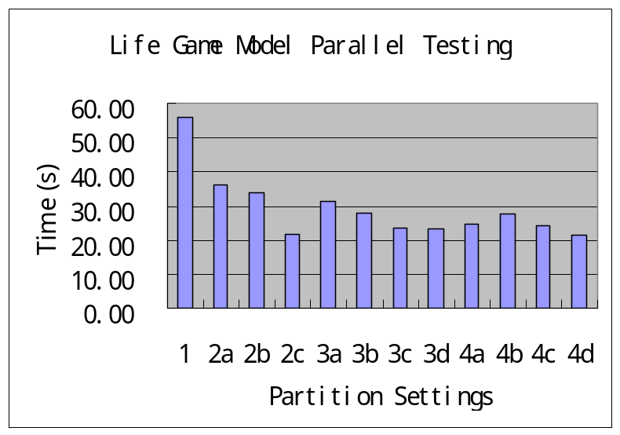
4.2.2 Performance Analysis

We can see that using more processor leads to the decrease of simulation time. The parallel simulation pays off. The heavy workloads were handled in parallel mode on different processors therefore improve the performance. We note that the performance is also affected by the partition settings.

- Testing of Area Section Model and Performance Analysis

We got similar problem as we had with airport model when running the area section model in longer running time, therefore the following test are based on running time: -t00:00:00:500. Following are the partition files we used and the testing data obtained.

<area-section1.par> 1 processor
0 : commercial(0,0)..(3,8) residential(0,0)..(8,9) highway(0,0)..(3,14) ferry factory

< area-section2a.par> 2 processors – partition setting a
0 : commercial(0,0)..(3,8) residential(0,0)..(8,9) highway(0,0)..(3,14)
1 : ferry factory

< area-section2b.par> 2 processors – partition setting b
0 : commercial(0,0)..(3,8) residential(0,0)..(8,9)
1 : highway(0,0)..(3,14) ferry factory

< area-section2c.par> 2 processors – partition setting c
0 : commercial(0,0)..(3,8) residential(0,0)..(8,9) factory
1 : highway(0,0)..(3,14) ferry

< area-section2d.par> 2 processors – partition setting d
0 : highway(0,0)..(3,14)
1 : ferry factory commercial(0,0)..(3,8) residential(0,0)..(8,9)

< area-section3a.par> 3 processors – partition setting a
0 : commercial(0,0)..(3,8) residential(0,0)..(8,9) highway(0,0)..(3,14)
1 : factory
2 : ferry

< area-section3b.par> 3 processors – partition setting b
0 : highway(0,0)..(3,14)
1 : factory commercial(0,0)..(3,8)
2 : ferry residential(0,0)..(8,9)

< area-section3c.par> 3 processors – partition setting c
0 : highway(0,0)..(3,14)
1 : commercial(0,0)..(3,8) residential(0,0)..(8,9)
2 : ferry factory

< area-section3d.par> 3 processors – partition setting d
0 : factory
1 : highway(0,0)..(3,14)
2 : ferry residential(0,0)..(8,9) commercial(0,0)..(3,8)

< area-section4a.par> 4 processors – partition setting a
0 : factory
1 : ferry
2 : residential(0,0)..(8,9) commercial(0,0)..(3,8)
3 : highway(0,0)..(3,14)

< area-section4b.par> 4 processors – partition setting b
0 : factory ferry
1 : commercial(0,0)..(3,8)
2 : residential(0,0)..(8,9)
3 : highway(0,0)..(3,14)

< area-section4c.par> 4 processors – partition setting c
0 : ferry
1 : commercial(0,0)..(3,8) factory
2 : residential(0,0)..(8,9)
3 : highway(0,0)..(3,14)

< area-section4d.par> 4 processors – partition setting d
0 : ferry
1 : commercial(0,0)..(3,8)
2 : residential(0,0)..(8,9)
3 : highway(0,0)..(3,14) factory

5.1 Testing Under Workload 1

Workload:
Initial Values for Cell-Spaces models

Commercial Highway Residential

010000100 000000110000000 0000000000
111000000 000000000001000 0000010000
011000000 010000001100000 0100111000
000000000 000000001110000 0000010000
0000100000
0010001000
0000100000
0000000000
0000000100

Loading time for Ferry and Factory models: 15

 | Area Section Model – Workload 1
Partition Settings | Test1 | Test2 | Test3 | Average
1 | 11.15 | 10.91 | 10.89 | 10.98
2a | 11.25 | 10.93 | 10.92 | 11.03
2b | 6.43 | 6.24 | 6.24 | 6.30
2c | 6.09 | 5.93 | 5.95 | 5.99
2d | 6.04 | 5.88 | 5.86 | 5.93
3a | 9.06 | 8.88 | 8.88 | 8.94
3b | 5.95 | 5.98 | 5.92 | 5.95
3c | 5.93 | 5.88 | 5.93 | 5.91
3d | 3.39 | 3.40 | 3.39 | 3.39
4a | 3.76 | 3.78 | 3.74 | 3.76
4b | 3.51 | 3.49 | 3.48 | 3.49
4c | 3.51 | 3.48 | 3.51 | 3.50
4d | 3.48 | 3.45 | 3.44 | 3.46
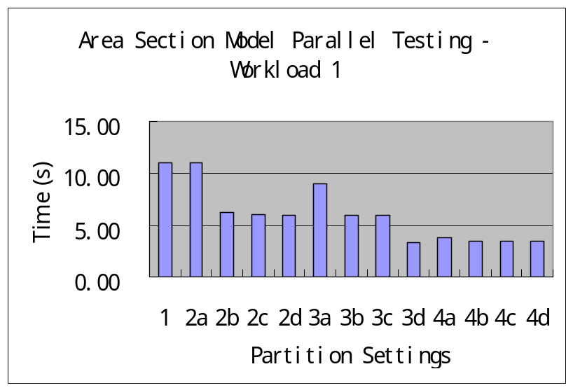

5.2 Testing Under Workload 2

Workload:
Initial Values for Cell-Spaces models

Commercial Highway Residential

011101110 000110110110100 0101110110
111010010 000110101001010 0111010010
011011001 010111101101010 0101111010
011101111 010101001110010 0010110101
0011100101
0010101010
0101101001
0010100100
0111010100

Loading time for Ferry and Factory models: 15 (no change)

 | Area Section Model - Workload 2
Partition Settings | Test1 | Test2 | Test3 | Average
1 | 12.29 | 12.31 | 12.30 | 12.30
2a | 13.24 | 12.23 | 12.25 | 12.57
2b | 7.13 | 7.10 | 7.11 | 7.11
2c | 7.07 | 7.11 | 7.08 | 7.09
2d | 9.45 | 9.47 | 9.24 | 9.39
3a | 13.26 | 13.16 | 13.19 | 13.20
3b | 9.64 | 9.62 | 9.59 | 9.62
3c | 9.56 | 9.58 | 9.58 | 9.57
3d | 4.97 | 5.06 | 4.97 | 5.00
4a | 5.99 | 5.38 | 5.41 | 5.59
4b | 5.04 | 5.06 | 5.06 | 5.05
4c | 5.06 | 5.04 | 5.04 | 5.05
4d | 5.03 | 5.01 | 5.04 | 5.03
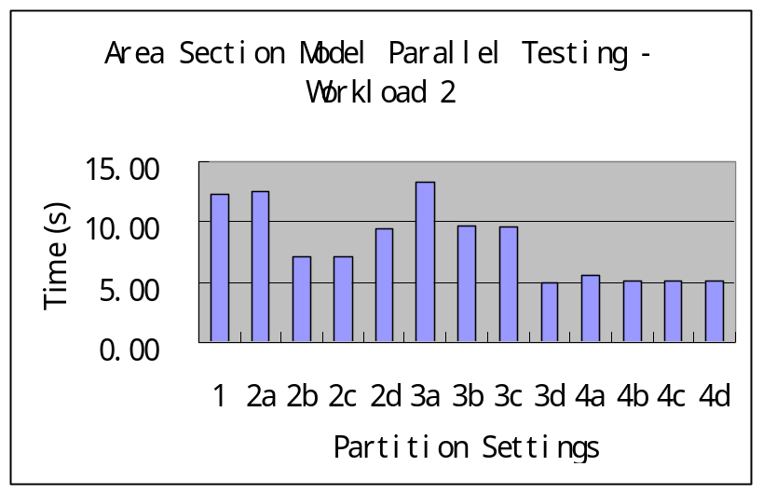

5.3 Testing Under Workload 3

Workload:
Initial Values for Cell-Spaces models (no change from Workload 2, not listed here.)
Loading time for Ferry and Factory models: 5

 | Area Section Model - Workload 3
Partition Settings | Test1 | Test2 | Test3 | Average
1 | 11.69 | 11.38 | 11.34 | 11.47
2a | 12.87 | 12.29 | 12.27 | 12.48
2b | 6.74 | 6.78 | 6.76 | 6.76
2c | 6.75 | 6.74 | 6.77 | 6.75
2d | 8.96 | 9.03 | 8.97 | 8.99
3a | 13.35 | 12.85 | 12.81 | 13.00
3b | 10.15 | 9.51 | 9.47 | 9.71
3c | 9.46 | 9.44 | 9.40 | 9.43
3d | 4.99 | 4.94 | 4.96 | 4.96
4a | 5.93 | 5.38 | 5.39 | 5.57
4b | 5.04 | 5.04 | 5.06 | 5.05
4c | 5.03 | 5.07 | 5.05 | 5.05
4d | 5.06 | 5.03 | 5.05 | 5.05
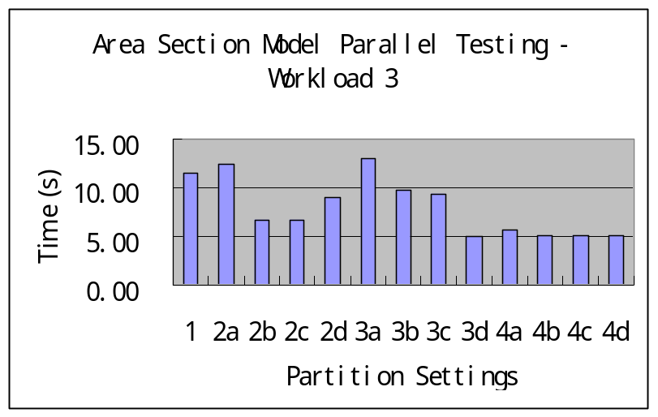

  - Performance Analysis

From the testing data we know that running complex model in parallel mode can improve the performance. This becomes more evident when the model’s complexity is increasing and/or the workload is becoming heavier. We also note that the partition settings can significantly affect the performance of parallel simulation. For instance, in partition 3a all the coupled Cell models are assigned to the same processor, which means that processor will handle lots of computation while other processors have little job to do but waiting during the simulation cycle. This situation should be avoided in practical applications.

- Conclusion

We can see from the testing results that using more processors to do the simulation in parallel mode does not necessarily lead to improved performance. When the model is very simple and requires little resource to run the simulation, the message transmission between processors may take more time to handle, therefore offset the time saved by using parallel simulation. Nevertheless, when the model is complex enough, parallel simulation can definitely improve the performance of simulation by handling jobs in parallel mode, which reduce the simulation time significantly. Furthermore, the partition settings can affect the performance as well. When a processor is assigned much heavier workload than others or a large amount message transmission are necessary between different processors, the overhead will offset the time saving by using parallel simulation. So partition settings should also be taken into account in practical applications.

Appendix

Time spent on each part of the project:
- Time taken to learn the tools: 32 h (including time taken to prepare the package, try every way to figure out the correct way to get the tools compiled without error and modify related files to make the examples work without errors, etc.)
- Time taken to write the application (the models): 22 h (including time taken to understand the problem, code the models, test each model individually, find errors in original specifications and make appropriate changes to them to make the model work properly, etc.)
- Time taken to do the testing 21 h (including time taken to write the scripts, construct the partition files, do the testing in various scenarios, etc.)
- Time taken to write the report: 14 h (Including time taken to draw the graphs, process testing data, analyze the results, etc.)

References:
[1] Gabriel A. Wainer. CD++ (Parallel Version) User’s Guide. 2001
[2] Gabriel A. Wainer; Norbert Giambiasi. Specification, modeling and simulation of timed Cell-DEVS spaces. (www.sce.carleton.ca/faculty/wainer/papers/97-007.ps)
[3] 94.587 Course Notes - Advanced Topics on Computer Systems: Methodological Aspects of Modeling and Simulation.

