Overview: Cruise Control System (CCS) {Refined…}

System description:

CCS is a real-time event driven system that is used to automatically maintain the speed of a vehicle over varying terrain. The CCS supports button controls, gas pedal and break interfaces for the user to interact with the system. The CCS inputs from the user interfaces and the speed sensor readings. The CCS generates an output to indicate whether the gas throttle should be pressed, released or stopped. The CCS functions in five modes of operations, which are Inactive, Idle, Active, Stand-by and On-break. Details of these states are given later in the report. When the CCS is activated and in control, it controls the speed of the vehicle and maintains it at a preferred rate. Depending on the input, at times the CCS enters On-break or Stand-by states and hands over the control to the manual maneuvering as will be discussed later.

On, Off, Set, Acc, Dec and Resume buttons are supported in the CCS. Pressing “on/off” button activates/deactivates the system and the “set” button sets the current speed and the system maintains the set speed. Applying the break pedal relinquishes the automated speed control of the system, and leads it to On-break state, until the “resume/set” button is pressed. When the gas pedal is pressed the system switches to “stand by” mode of operation, and waits until the vehicle reaches the pre-set speed. Once the pre-set speed is reached, the CCS becomes active again and takes control. The maintenance speed of the vehicle could be increased or decreased by pressing the “accelerator” or “decelerator” buttons respectively. Holding down the Acc/Dec button would periodically increase/decrease the speed of the vehicle till released.

ON button press would change the CCS from Inactive to Idle state, where the System is ready to receive inputs. OFF button press would shut down CCS and leave it in Inactive state. Applying the break and gas pedal would change the CCS state from Idle to On-break and Stand-by respectively. Set and Resume button presses or reaching the initial speed again would bring the CCS back to the Active state. Detailed information is illustrated in the State graph illustration later in the report.

CCS, the top-level module, is a composite of atomic Input/Output modules and structural Processing Module (PM). PM is further decomposed into Break (BRC), Gas Pedal (PC), Button (BUC) controllers and CCS controller (CCSC) components. BUC is structural and the others are atomic models exhibiting different behaviors. BUC is further decomposed into three atomic models, which are ON/OFF controller, Set, Resume modules and a structural model, namely the Speed controller (SC). SC is composed of AccQueue, DecQueue, Increase and Decrease atomic models. The CCS behavior and output are results of four external inputs, which are button, break, gas pedal and speed sensor readings. The output indicates whether to press, release or stop the gas throttle. Refer to the attached CCS overview model figure.

Button Input Module (BIM): Serves the purpose of identifying the button input to be processed. The BIM receives the input button press and identifies the specific button and sends it to the corresponding input port of the BUC via its output port.

Processing Module (PM): PM is composed of BUC, CCSC, BRC and PC. Inputs six different button inputs with break, gas pedal and speed sensor reading from the top level CCS. PM also outputs three outputs to the Output Module. PM directs the button inputs to the BUC, break input to BRC, gas pedal input to PC and speed sensor reading to CCSC modules. PM also takes the responsibility of transferring the output of the BUC, BRC, PC as the input to the CCSC.

Button Controller (BUC): BUC is a structural model composed of three atomic models, ON/OFF controller, Set, Resume components, and a structural model, Speed Controller. BUC serves the purpose of relaying the button inputs to the corresponding module and generating six outputs to the CCSC.

ONOFF Controller: This atomic model inputs ON and OFF button presses and indicates whether the CCS is activated or deactivated. This component is designed to ignore repeated button presses of the same state. For example, when the CCS is activated, other ON button presses would be ignored. Only the first press would be accounted for and the others would be ignored. The same applies for OFF. This component generates turnedON/turnedOFF outputs to the CCSC.

Set Component: Once the CCS is activated, this atomic model inputs the “Set” button press and sets the current speed as the maintained speed. Regardless of whether the break is applied or the gas pedal is pressed, pressing the Set button would again bring the CCS back to active state. This component generates “Set speed” output to the CCSC.

Resume Component: This atomic model is used to restore configurations once the system is in the On-break state. The CCS has to be activated for this component to function. Resume button press restores the initial speed settings and brings the system to active state. Generates “Resume CCS” output to indicate the CCSC to resume CCS control.

Speed Controller (SC): This structural model inputs the Acc/Dec button presses from the BUC and generates Increase/Decrease outputs to the CCSC. SC is composed of AccQueue, DecQueue, Increase and Decrease atomic models. The queues are used to facilitate the CCS for the Acc/Dec button presses. Pressing on the Acc/Dec button continuously would generate frequent input events, which may not be recognized by the Increase/Decrease components due to its processing time delay. Hence frequent arrivals of the Acc/Dec inputs are initially stored in their corresponding queues and processed by the Increase/Decrease modules one after the other. The CD++ source files of the DEVS model for “Queue” design and implementation are downloaded from the professor’s web site.

AccQueue/DecQueue Components: Enqueues the Acc/Dec button presses and dequeues them, once requested, in the received order to the Increase/Decrease modules respectively. The queues are of limited size and it is presumed that the initial size of the Queue is sufficient to accommodate the acceleration/deceleration needs.

Increase/Decrease Components: These atomic models would input Acc/Dec button presses from the queues and process them. Once finished, these would generate the Increase/Decrease output and indicate the queues that they have processed the event and are ready for the next.

Break Controller (BC): The CCS receives the break input and supplies it to the PM and it in turn relays it to the BC. BC inputs the break and informs the CCSC of the break input. Upon the break input the CCS hands over the control to manual maneuvering and reaches the On-break. The CCS resumes its control only when the Resume/Set button is pressed.

Gas Pedal Controller (PC): The CCS receives the Gas Pedal input and supplies it to the PM and it in turn relays it to the PC. The gas pedal input is informed to the CCSC. Upon the pedal input the CCS hands over the control to manual maneuvering and reaches the Stand-by state. The CCS automatically resumes control once the vehicle reaches the initial speed. (It must be noted that applying the Gas pedal would only increase the speed from the current speed, and hence must be reduced again.)

Cruise Control System Controller (CCSC): This atomic model inputs from the BUC, BRC, PC and speed sensor. CCSC component behaves as the main controller of the CCS and changes the system states, based on the current state, input and the expected behavior. The CCSC component generates three outputs to indicate whether to increase, decrease or stop the gas supply to the Output Module.

Output Module (OM): This atomic model inputs Increase, Decrease and Stop signals from the CCSC and generates one output. The output signal of OM carries one of these values 1, -1, 0 to indicate release, press and stop gas throttle.
Initial Cruise Control System Overview Model
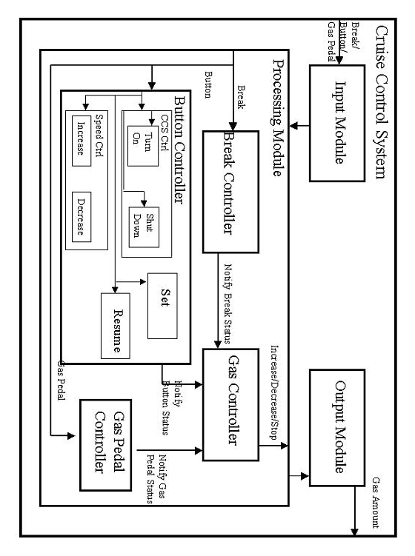
Cruise Control System Overview Diagram (Refined)
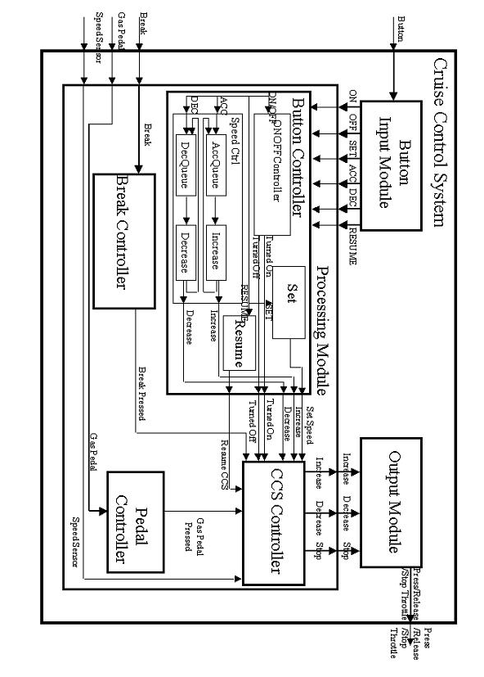
Modifications to Initial Model:

- Initial “Input Module”, which was given the responsibility of processing all external inputs, has been renamed to “Button Input Module” with the responsibility of only processing the button inputs. This module identifies one of the six possible button inputs and outputs it to the appropriate port, where the “Button Controller” receives it as an input.

- The “Gas Controller” component has been replaced by the “CCS Controller”, which exhibits the main controller behavior and changes CCS’s state depending on the current state, input and the expected output.

- “Speed Controller” component has two added queues, each associated with the Increase and Decrease modules to enhance the functionality of identifying all frequent ACC/DEC inputs.

- Break input is directly fed into the Break component.

- Gas Pedal input is directly fed into the Pedal Controller component.

- Speed sensor reading is fed into the CCS Controller component.

- Output Module is fed in with three inputs at three different ports, rather than one input as indicated earlier. Where the Output Module processing identifies the input and generates the corresponding output to indicate the gas throttle positioning. In the initial model the Output Module generated output to indicate whether to increase, decrease or stop the gas supply.

Formal Specifications:

Button
Atomic Models’ Formal Specification:

- Button Input Module
Button
idle
δ
int
ta -
-e
active

There are 2 states: idle and active. When a button is pressed in the idle state, the transition is taken to the active state. There it waits ta-e periods processing the activity and returns to the idle state through internal transition. When the process is in active state, another Button received is handled in the active state as well.

X = {ButtonPress}
Y = {ON, OFF, SET, ACC, DEC, RESUME}
S = {idle, active}

δ_{ext} : δ_{ext}(idle, ButtonPress) = active
δ_{int} : δ_{int}(active, ta(PROC_TIME)) = active

λ(active) = ON
λ(active) = OFF
λ(active) = SET
λ(active) = ACC
λ(active) = DEC
λ(active) = RESUME

ta(active) = PROC_TIME
ta(idle) = ∞

- Processing Module
  - Button Controller
    - ONOFF Controller

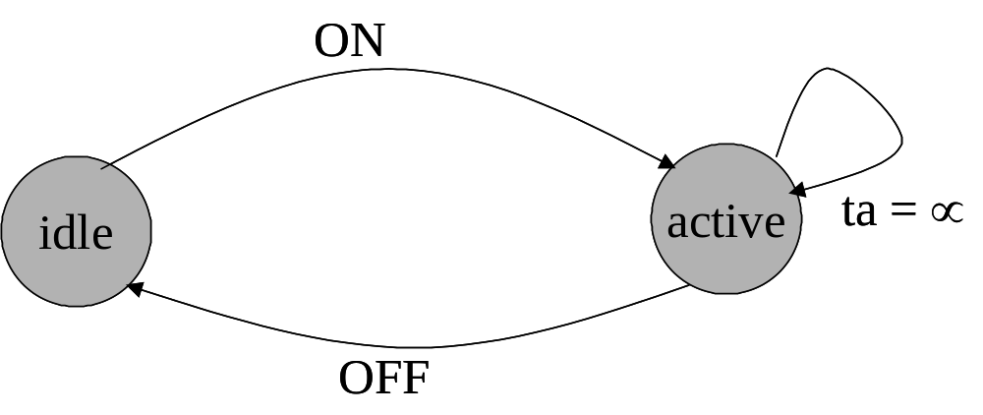
ta = ∞

There are 2 states here as well. From the idle state, the ON button will move the state to the active states. After activating the system, it will stay in the state until it receives OFF button signal.

X = {ON, OFF}
Y = {TurnON, TurnOFF}
S = { Idle, Active}

δ_{ext} : δ_{ext}(Idle, ON) = Active
δ_{ext} : δ_{ext}(Active, OFF) = Idle

δ_{int} : δ_{int}(Active, ta(Active)) = Active
δ_{int} : δ_{int}(Idle, ta(Idle)) = Idle

λ(Active) = TurnOFF
λ(Idle) = TurnON

ta(Idle) = ∞
ta(Active) = ∞

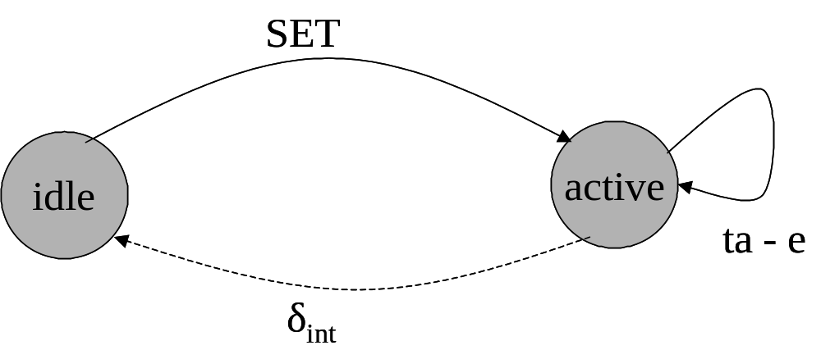
    - Set Module
SET

There are 2 states: idle and active. When a SET button is pressed in the idle state, the transition is taken to the active state. There it waits ta-e periods processing the activity and returns to the idle state through internal transition.

X = {Set}
Y = {SetSpeed}
S = { Idle, Active}

δ_{ext} : δ_{ext}(Idle, Set) = Active
δ_{ext} : δ_{ext}(Active, Set) = Active
δ_{int} : δ_{int}(Active, ta(Active)) = Idle

λ(Active) = SetSpeed

ta(Active) = PROC_TIME
ta(Idle) = ∞

    - Resume Module
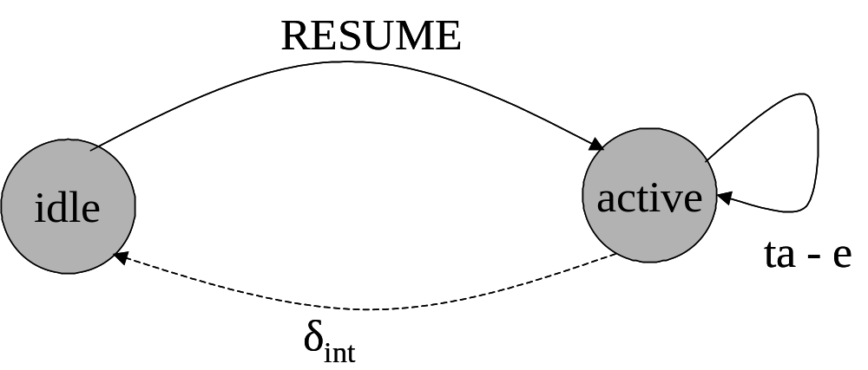

There are 2 states: idle and active. When a RESUME button is pressed in the idle state, the transition is taken to the active state. There it waits ta-e periods processing the activity and returns to the idle state through internal transition. There’s only one resume button press and the rest will be ignored.

X = {Resume}
Y = {ResumeCCS}
S = { Idle, Active}

δ_{ext} : δ_{ext}(Idle, Resume) = Active
δ_{int} : δ_{int}(Active, ta(Active)) = Idle

λ(Active) = ResumeCCS

ta(Active) = PROC_TIME
ta(Idle) = ∞

    - Speed Controller
      - Increase

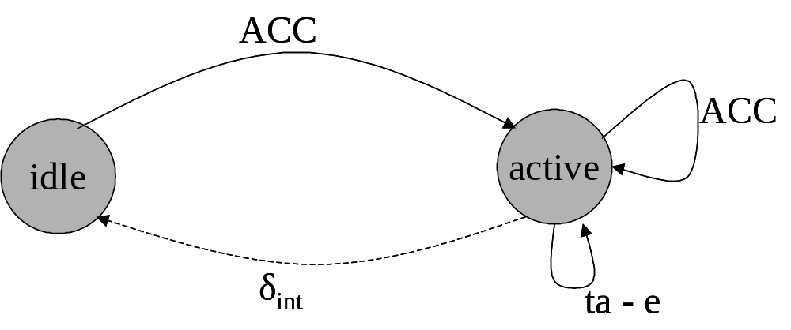

There are 2 states: idle and active. When a ACC button is pressed in the idle state, the transition is taken to the active state. There it waits ta-e periods processing the activity and returns to the idle state through internal transition. If more ACC buttons are pressed, then the system will stay in the active state processing the request, before returning to the idle state.

X = {Acc}
Y = {Increase}
S = { Idle, Active}

δ_{ext} : δ_{ext}(Idle, Acc) = Active
δ_{ext} : δ_{ext}(Active, Acc) = Active
δ_{int} : δ_{int}(Active, ta(Active)) = Idle

λ(Active) = Increase

ta(Active) = PROC_TIME
ta(Idle) = ∞

      - Decrease

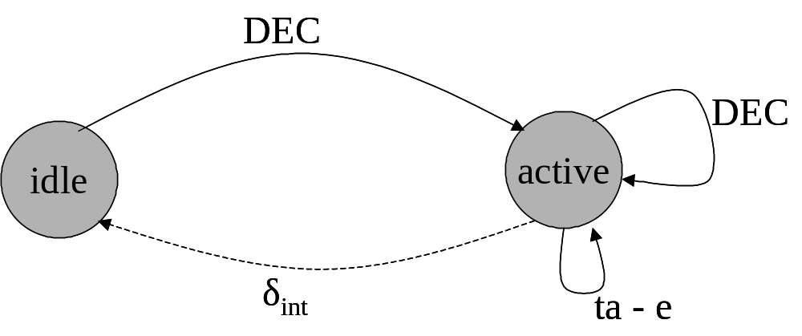

There are 2 states: idle and active. When a DEC button is pressed in the idle state, the transition is taken to the active state. There it waits ta-e periods processing the activity and returns to the idle state through internal transition. If more DEC buttons are pressed, then the system will stay in the active state processing the request, before returning to the idle state.

X = {Dec}
Y = {Decrease}
S = { Idle, Active}

δ_{ext} : δ_{ext}(Idle, Dec) = Active
δ_{ext} : δ_{ext}(Active, Dec) = Active
δ_{int} : δ_{int}(Active, ta(Active)) = Idle

λ(Active) = Decrease

ta(Active) = PROC_TIME
ta(Idle) = ∞

      - AccQueue & DecQueue

The formal specification is not provided for these components since they are not our work.

  - Break Controller

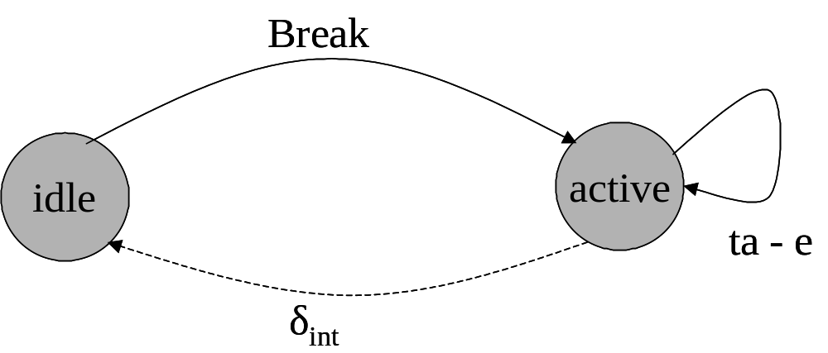
There are 2 states: idle and active. When break is pressed in the idle state, the transition is taken to the active state. There it waits ta-e periods processing the activity and returns to the idle state through internal transition. Only one break can be pressed, others are ignored.

X = {BreakPress}
Y = {BreakPressed}
S = {idle, active}

δ_{ext} : δ_{ext}(idle, BreakPress) = Busy
δ_{int} : δ_{int}(active) = Ready

λ(active) = BreakPressed

ta(active) = PROC_TIME
ta(active) = ∞

  - Pedal Controller

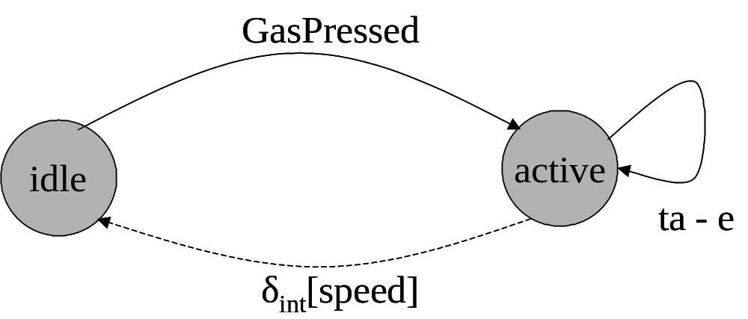

Similarly, there are 2 states involved here as well. When the system is in CCS, then the state is in idle. A Gas Pressed signal would move to active were it process it and returns to the idle state.

X = {GPedalPress}
Y = {GPedalPressed}
S = { Ready, Busy}

δ_{ext} : δ_{ext}(Ready, GPedalPress) = Busy
δ_{int} : δ_{int}(Busy) = Ready

λ(Busy) = GPedalPressed

ta(Busy) = PROC_TIME
ta(Ready) = ∞

  - Cruise Control System Controller

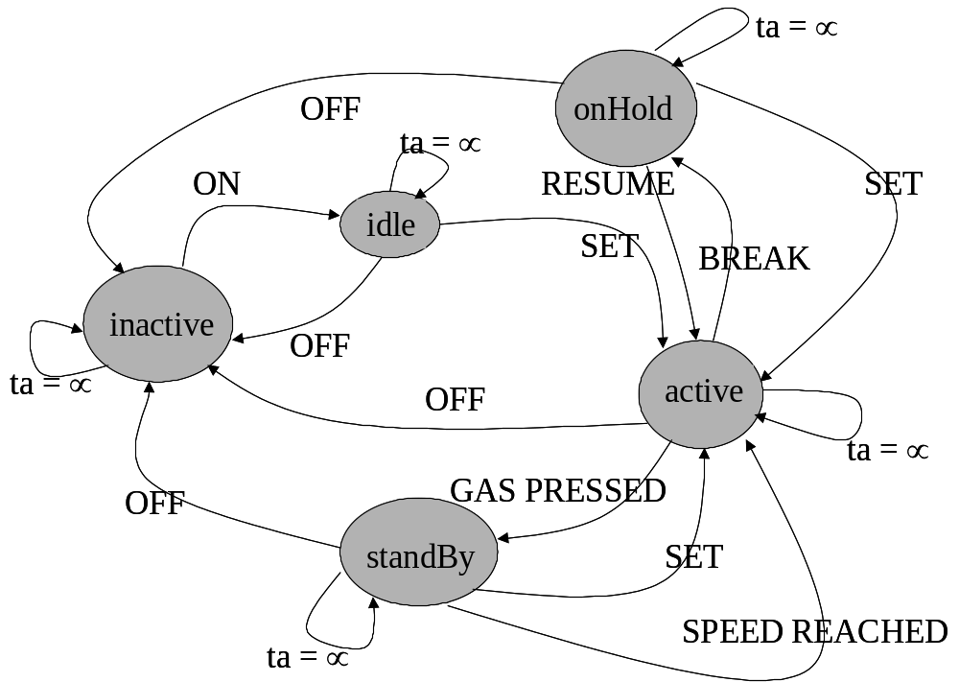

- inActive: CCS is turned off and currently CCS can accept only ON signal form processing module. Once CCS received an ON signal, the new state of the system will be idle.
- idle: CCS is idle and it waits for SET button, however this state will also respond to OFF button. New state for OFF button will be inActive and SET button will be active. If the new state is active then current speed of the automotive is captured as the set speed.
- active: staying in this state indicates that automotives speed is currently controlled by CCS system. The active module in is in this module forever waiting for external input
- standby: When the CCS is active, a gas press can move the system into this state to give the user manual control of the speed. From here, once the vehicle returns to the sent speed, then the CCS takes over.
- onHold: this is the state where a break pressed will move the system into from active state. From this state it is possible to return to the active state by pressing the RESUME button.

X = {Increase, Decrease, TurnedOFF, TurnedON, ResumeCCS, SetSpeed, BreakPressed, GPedalPressed, SpeedSensor}
Y = {Increase, Decrease, Stop}
S = { Inactive, Idle, Active, Stand-by, On-break}

δ_{ext} : δ_{ext}(Inactive, TurnedON) = Idle
δ_{ext} : δ_{ext}(Idle, TurnedOFF) = Inactive
δ_{ext} : δ_{ext}(Idle, Set) = Active
δ_{ext} : δ_{ext}(Active, Break) = On-break
δ_{ext} : δ_{ext}(Active, GPedalPress) = Stand-by
δ_{ext} : δ_{ext}(Active, TurnOFF) = Inactive
δ_{ext} : δ_{ext}(Active, Increase) = Active
δ_{ext} : δ_{ext}(Active, Decrease) = Active
δ_{ext} : δ_{ext}(Active, SpeedSensor) = Active
δ_{ext} : δ_{ext}(On-break, ResumeCCS) = Active
δ_{ext} : δ_{ext}(On-break, TurnOFF) = Inactive
δ_{ext} : δ_{ext}(Stand-by, TurnOFF) = Inactive
δ_{ext} : δ_{ext}(Stand-by, SpeedSensor) = {Active, Stand-by}

δ_{int} : δ_{int}(Busy) = Ready

λ(Active) = {Increase, Decrease, Stop}

ta(inactive) = ∞
ta(idle) = ∞

- Output Module

X = {Increase, Decrease, Stop}
Y = {Press, Release, Close}
S = { Idle, IncGas, DecGas, StopGas}

δ_{ext} : δ_{ext}(Ready, Increase) = IncGas
δ_{ext} : δ_{ext}(Ready, Decrease) = DecGas
δ_{ext} : δ_{ext}(Ready, Stop) = StopGas

δ_{int} : δ_{int}(IncGas) = Idle
δ_{int} : δ_{int}(DecGas) = Idle
δ_{int} : δ_{int}(StopGas) = Idle

λ(IncGas) = Release
λ(DecGas) = Press
λ(StopGas) = Close

ta(Idle) = ∞
ta(IncGas) = INC_TIME
ta(DecGas) = DEC_TIME
ta(StopGas) = STOP_TIME

Structural Models’ Formal Specification:

Cruise Control System

CCS = <X, Y, {ButtonInputModule, ProcessingModule, OutputModule}, {I_{i}}, {Z_{ij}}, Select>

X = {Button, Break, GasPedal, SpeedSensor}
Y = {ThrottlePress, ThrottleRelease, ThrottleClose}

I (ButtonInputModule) = ProcessingModule
I (ProcessingModule) = OutputModule
I (OutputModule) = Self

Z (ButtonInputModule) = ProcessingModule
Z (ProcessingModule) = OutputModule
Z (OutputModule) = Self

Select = ({ButtonInputModule, ProcessingModule, OutputModule}) = ProcessingModule
({ButtonInputModule, OutputModule}) = ButtonInputModule

EIC = {(CCS.ButtonInput, ButtonInputModule.input), (CCS.BreakInput, ProcessingModule.BreakInput), (CCS.GasPedalInput, ProcessingModule.GasPedalInput), (CCS.SpeedSensorInput, ProcessingModule.SpeedInput)}

EOC = {(OutputModule.ThrottlePressInput, CCS.ThrottlePressOutput), OutputModule.ThrottleReleaseOutput, CCS.ThrottleReleaseOutput), (OutputModule.ThrottleCloseOutput, CCS.ThrottleStopOutput)}

IC = {(BIM.OnOut, PM.OnIn), (BIM.OffOut, PM.OffIn), (BIM.SetOut, PM.SetIn), (BIM.AccOut, PM.AccIn), (BIM.DecOut, PM.DecIn), (BIM.ResumeOut, PM.ResumeIn), (PM.IncreaseOut, Out.ResumeIn), (PM.DecreaseOut, OM.DecreaseIn), (PM.StopOut, OM.StopIn)}

Processing Module

ProcessingModule = < X, Y, {ButtonController, BreakController, PedalController, CCSController}, EIC, EOC, IC, Select>

X = < ON, OFF, SET, ACC, DEC, Resume, Break, GasPedal, SpeedSensor>
Y = < Increase, Decrease, Stop>

EIC = {(PM.ONInput, BUC.ONInput), (PM.OFFInput, BUC.OFFInput), (PM.SETInput, BUC.SETInput), (PM.ACCInput, BUC.ACCInput), (PM.DECInput, BUC.DECInput), (PM.ResumeInput, BUC.ResumeInput), (PM.BreakInput, BRC.Input), (PM.GasPedalinput, PC.GasInput), (PM.SpeedInput, CCSC.SpeedInput)}

EOC = {(CCSC.IncreaseOutput, PM.IncreaseOutput), (CCSC.DecreaseOutput, PM.DecreaseOutput), (CCSC.StopOutput, PM.StopOutput)}

IC = {(BUC.TurnedONOutput, CCSC.TurnedONInput), (BUC.TurnedOFFOutput, CCSC.TurnedOFFInput), (BUC.DecreaseOutput, CCSC.DecreaseInput), (BUC.IncreaseOutput, CCSC.IncreaseInput), (BUC.SetSpeedOutput, CCSC.SetSpeedInput), (BUC.ResumeOutput, CCSC.ResumeInput), (BRC.BreakPressedOutput, CCSC.BreakPressedInput), (PC.GassPedalPressedOutput, CCSC.GassPedalPressedInput)}

Select = { BUC, BRC, PC, CCSC } = BRK
= {BUC, PC, CCSC } = BUC
= {PC, CCSC} = CCSC

Button Controller

ButtonController = <X, Y, {ONOFFController (OOC), Set, Resume, SpeedController(SC)}, EIC, EOC, IC, Select>

X = { ON, OFF, SET, ACC, DEC, Resume }
Y = { TurnedON, Increase, Decrease, TurnedOFF, SetSpeed, ResumeCCS }

EIC = {(BUC.ONInput, OOC.ONInput), (BUC.OFFInput, OOC.OFFInput), (BUC.SETInput, Set.Input), (BUC.ACCInput, SC.ACCInput), (BUC.DECInput, SC.DECInput), (BUC.ResumeInput, Resume.Input)}

EOC = {(OOC.TurnedONOutput, BUC.TurnedONOutput), (OOC.TurnedOFFOutput, BUC.TurnedOFFOutput), (Set.Output, BUC.SetSpeedOutput), (Resume.Output, BUC.ResumeCCSOutput), (SC.IncreaseOutput, BUC.IncreaseOutput), (SC.DecreaseOutput, BUC.DecreaseOutput)}

IC = φ

Select = { OOC, SC, Set, Resume } = OOC
= { SC, Set, Resume } = Set
= { SC, Resume } = SC

Speed Control

SpeedControl = <X, Y, {Increase, Decrease}, EIC, EOC, IC, Select>

X = { ACC, DEC }
Y = { Increase, Decrease }
EIC = {(SC.ACCInput, Increase.Input), (SC.DECInput, Decrease.Input)}
EOC = {(Increase.Output, SC.IncreaseOutput), (Decrease.Output, SC.DecreaseOutput)}
IC = φ
Select = {Increase, Decrease} = Decrease
Testing Strategy

Overview:

The Cruise Control System (CCS) is composed of a hierarchical architecture to implement its functionality. It is composed of different levels, where the atomic models and couple models are interacting. The participating atomic models are: Increase, Decrease, Set, Resume, ONOFFController, ButtonInputModule, BreakController, OutputModule, PedalController and CCSController. Moving up the structure, Increase and Decrease atomic models are coupled into the SpeedController. Then the SpeedController, ONOFFController, Set, and Resume are coupled into the ButtonController. One stage up would be the ProcessingModule coupling ButtonController, PedalController, CCSController and BreakController. The big CruiseControlSystem couples the ProcessingModule, ButtonInputModule and the OutputModule. The layout is as outlined in the CCS Overview Diagram. This testing strategy will focus to show the requirements to test each of the atomic models as well as the couple models.

Increase

Purpose:
This atomic model is to be used for handling the button input to increase the speed of the system. The button involved in this testing would be the ACC button of the model.

Execution:
Press the ACC button to increase the speed.

Expected Results:
The model will not react to this input if the CCS is not turned on. And in the case where the system is activated, then each input though the button should be processed to increase the speed by 1km.

Decrease

Purpose:
This atomic model is to be used for handling the button input to decrease the speed of the system. The button involved in this testing would be the DEC button of the model.

Execution:
Press the DEC button to increase the speed.

Expected Results:
The model will not react to this input if the CCS is not turned on. And in the case where the system is activated, then each input though the button should be processed to decrease the speed by 1km.

Set

Purpose:
This model is to be used for handling the button input to set the current speed of the vehicle as the operating speed of the CCS model. The SET button will be used to set this speed.

Execution:
Press SET button to set the speed for the CCS model

Expected Results:
The CCS must be activated for the speed to be set and if not, then the input will be ignored. Further, each of the button press must be handled to keep track with user’s requirement of the system speed.

Resume

Purpose:
This atomic model is used to bring the system back to a previously operating speed. The system was active and it was running on Cruise Control and when the break is pressed, the operating speed would be remembered. Hitting this button would bring the vehicle back to the recorded speed.

Execution:
Press RESUME button to bring the vehicle back to previous speed

Expected Results:
If the system was just activated and hitting this button would ignore this press. But if the vehicle was already running on CCS and somehow brought out, then this button press would have some meaning. The system would bring the vehicle back to previous speed.

ONOFFController

Purpose:
The ONOFFController model is used to activate and deactivate the CCS system of a vehicle.

Execution:
Hit the ON button to activate the Cruise Control System and OFF button to turn off the system.

Expected Results:
The system would be turned on with the ON button, but no speed will be set. Pressing the ON button again will yield no output. Similarly, the OFF button will turn the system OFF and repeated presses are ignored.

ButtonInputModule

Purpose:
The purpose of this atomic model is to handle the any button press and subdivide it as individual buttons.

Execution:
Press any button

Expected Results:
Any button press will be processed, and one of six individual output will be delivered at a time. Possible six outputs will be: ON, OFF, ACC, DEC, RESUME and RESUME.

BreakController

Purpose:
This atomic model is responsible for handling the break press when the vehicle is running on the Cruise Control System.

Execution:
The break pedal is pressed while the vehicle is running under Cruise Control System.

Expected Results:
When the vehicle is set on the CCS, a break press would cancel the set speed and give manual control. During this cancellation process, the speed must be remembered by the system to be used by RESUME button execution.

OutputModule

Purpose:
The model is responsible for handling the ProcessingModule outputs and interprets in terms of Gas Supply for the vehicle.

Execution:
No direct execution is possible by the user; rather the button press, break, or gas pedal press executes it. Inputs should be simulated in each of these ports to test the functionality of the module as a stand-alone module.

Expected Results:
The model will get the inputs of ProcessingModule, and convert it to one of throttle press, throttle release, or throttle close.

PedalController

Purpose:
This atomic model is used to handle the manual gas pedal input by the user when the vehicle is still functioning under Cruise Control System.

Executions:
SET the Cruise Control System at a certain speed. Then manually press the gas pedal for a while, and then release it.

Expected Result:
When the gas pedal is pressed manually, the CCS will control to manual operation of the speed, but will remember the speed. When the user releases the manual control of the gas, then the CCS will take over at the remembered speed.

CCSController

Purpose:
This atomic model is the main decision making module. It takes inputs from the Button Controller, Break Controller, Pedal Controller and an external Speed Sensor Input and process to let the Output Module know of how to handle the gas supply to the vehicle.

Executions:
No direction execution, rather through the other modules. Direct inputs must be given to test the functionality during the incremental development phase.

Expected Results:
Depending on the inputs and at the state the CCSController is in, the Output Module will be informed to either increase/decrease/stop the gas flow to the vehicle.

SpeedController

Purpose:
This couple model is handling the INCREASE and DECREASE button press of the user. The queue is re-used here stored each of the button press.

Execution:
Press either the INCREASE or DECREASE button.

Expected Results:
If the CCS is running on a vehicle, then the Speed Controller will give the appropriate output to the CCSController. The output will be either the increase signal or the decrease signal.

ButtonController

Purpose:
This couple model couples all the button functionality and delivers six outputs to the CCSController.

Execution:
Any of the buttons could be pressed. Individual inputs should be tested with appropriate scenarios.

Expected Results:
The output from this model is either to Set Speed, Increase, Decrease, Turned On, Turned Off, and Resume CCS.

ProcessingModule

Purpose:
This couple model couples most of the CCS components and process the inputs to give the gas flow to the vehicle.

Execution:
This model should receive one of the six inputs from the Button Input Module, as well as inputs from Break, Gas Pedal and Speed Sensor.

Expected Results:
The inputs will be processed and the output will be of the form (Increase/Decrease/Stop) to the Output Module.

CruiseControlSystem

Purpose:
Operate a vehicle in an automatic speed controlled environment

Execution:
Press any button, break or gas pedal

Expected Output:
Depending on the state of the system, the output will be Press/Release/Close the gas throttle to the vehicle.

Execution Result Analysis for Module (Top): CruiseControlSystem (CCS)

Content of CruiseControlSystem.ev is as fallows

Input ID (explanation purpose)
00:00:10:000 testInButton 1 1
00:00:11:000 testInSpeedSensor 100 2
00:00:14:000 testInSpeedSensor 110 3
00:00:20:000 testInButton 3 4
00:00:21:000 testInSpeedSensor 114 5
00:00:24:000 testInSpeedSensor 108 6
00:00:27:000 testInSpeedSensor 118 7
00:00:30:000 testInButton 4 8
00:00:31:000 testInSpeedSensor 120 9
00:00:34:000 testInSpeedSensor 106 10
00:00:37:000 testInSpeedSensor 111 11
00:00:40:000 testInButton 4 12
00:00:41:000 testInSpeedSensor 115 13
00:00:45:000 testInBreak 1 14
00:00:45:500 testInSpeedSensor 80 15
00:00:46:000 testInButton 6 16
00:00:48:000 testInSpeedSensor 110 17
00:00:50:000 testInButton 5 18
00:00:51:000 testInSpeedSensor 120 19
00:00:55:000 testInSpeedSensor 106 20
00:00:58:000 testInSpeedSensor 118 21
00:01:00:000 testInButton 5 22
00:01:03:000 testInSpeedSensor 115 23
00:01:05:000 testInGasPedal 1 24
00:01:08:000 testInSpeedSensor 118 25
00:01:10:000 testInButton 5 26
00:01:11:000 testInSpeedSensor 120 27
00:01:11:000 testInSpeedSensor 112 28
00:01:11:000 testInSpeedSensor 113 29
00:01:20:000 testInButton 6 30
00:01:21:000 testInSpeedSensor 110 31
00:01:30:000 testInButton 2 32

Content of CruiseControlSystem.out is as fallows
Output ID (explanation purpose)
00:00:21:025 testthrottle –1 1
00:00:24:020 testthrottle 1 2
00:00:27:025 testthrottle –1 3
00:00:30:060 testthrottle –1 4
00:00:31:025 testthrottle –1 5
00:00:34:020 testthrottle 1 6
00:00:40:055 testthrottle 1 7
00:00:41:025 testthrottle –1 8
00:00:45:040 testthrottle 0 9
00:00:46:040 testthrottle 1 10
00:00:48:020 testthrottle 1 11
00:00:50:055 testthrottle 1 12
00:00:51:025 testthrottle –1 13
00:00:55:020 testthrottle 1 14
00:00:58:025 testthrottle –1 15
00:01:00:060 testthrottle –1 16
00:01:03:025 testthrottle –1 17
00:01:05:040 testthrottle 0 18
00:01:30:055 testthrottle 0 19

Result Analysis:

Expected Input signals:
- Speed sensor reading from hardware
- Button input from button hardware (expected values 1-6)
- Break pressed signal from break
- Gas pedal pressed signal from Gas Pedal

Expected Output signals:
- Throttle control (expected values –1, 0, 1)
-1: decrease gasoline
0: stop gasoline control
1: increase gasoline

This is the top, which controls the automotives speed based on above inputs

Input Id 1: Indicates that an ON button had been pressed. However, CCS would not produce any out put for this input since CCS is not jet active.

Input Id (2-3): Speed sensor readings, since CCS is not jet active no output was produced. However, internally current speed variable is updated.

Input Id 4: Indicates that an SET button had been pressed. As the response to this button CCS state had been modified to active and now on CCS will control the automotives speed at 110Km. However, no output is needed until a new speed is received form speed senor because at this point current speed and set speed were equal

Input Id 5: Speed sensor reading indicates that new speed of the automotive was 114 Km. Since the CCS should maintain 110 Km, an output –1 (PRESED by 1 unit) was produced to maintain the set speed 110Km. This was the first output at 00:00:21:025 on testthrottle port with the value –1. This time indicates the input time and processing time.

Input Id 6: Speed sensor reading indicates that new speed of the automotive was 108 Km. Since the CCS should maintain 110 Km, an output 1 (RELESED by 1 unit) was produced to maintain the set speed 110Km. This was output Id 2 at 00:00:24:020 on testthrottle port with the value 1.

Input Id 7: Speed sensor reading indicates that new speed of the automotive was 118 Km. Since the CCS should maintain 110 Km, an output –1 (PRESED by 1 unit) was produced to maintain the set speed 110Km. This was the output Id 3 at 00:00:27:025 on testthrottle port with the value –1. This time indicates the input time and processing time.

Input Id 8: Indicates that an ACC button (id 4) had been pressed. It indicates that user wants to increase the set speed by 1Km. As the response to this button, an output (output ID 4) was produced at 00:00:30:060 to increase the automotive speed. Internally set speed is incremented by 1km (new set speed =111 Km).

Input Id 9: Speed sensor reading indicates that new speed of the automotive was 120 Km. Since the CCS should maintain 111 Km, an output –1 (PRESED by 1 unit) was produced to maintain the set speed 111Km. This was the output Id 5 at 00:00:31:025 on testthrottle port with the value –1. This time indicates the input time and processing time.

Input Id 10: Speed sensor reading indicates that new speed of the automotive was 106 Km. Since the CCS should maintain 111 Km, an output (RELESED by 1 unit) was produced to maintain the set speed 111Km. This was output Id 6 at 00:00:34:020 on testthrottle port with the value 1.

Input Id 11: Speed sensor reading indicates that new speed of the automotive was 111 Km. Since the CCS should maintain 111 Km and current speed was equal to set speed there was no output produced

Input Id 12: Indicates that an ACC button (id 4) had been pressed. It indicates that user wants to increase the set speed by 1Km. As the response to this button, an output (output ID 7) was produced at 00:00:40:055 to increase the automotive speed. Internally set speed is incremented by 1km (new set speed =112 Km).

InputId 13: Speed sensor reading indicates that new speed of the automotive was 115 Km. Since the CCS should maintain 112 Km, an output –1 (PRESED by 1 unit) was produced to maintain the set speed 112 Km. This was the output Id 8 at 00:00:41:025 on testthrottle port with the value –1. This time indicates the input time and processing time.

InputId 14: This signal indicates that user had pressed the break pedal and as response to it CCS should release it control. There for an output 0 was produced to release it control. This was output Id 9 at 00:00:45:040. Although CCSController will not involve (onBreak state) the automotive speed controlling until a RESUME signal is received, it preserved the set speed value as 112Km.

InputId 15: This was a speed sensor reading and since CCS was not controlling the speed of the automotive there was no output produced for these inputs. However, current speed value would be modified and new current speed value at this point will be 80 Km.

InputId 16: It indicates that user had pressed the RESUME button; hence the previous set speed should be maintained (CCS took control of the automotives speed). Since the CCS should maintain 112 Km, an output 1 (RELESED by 1 unit) was produced to maintain the set speed 112 Km. This was the output Id 10 at 00:00:46:040 on testthrottle port with the value 1. This time indicates the input time and processing time.

Input 17: Speed sensor reading indicates that new speed of the automotive was 110 Km. Since the CCS should maintain 112 Km, an output 1 (RELESED by 1 unit) was produced to maintain the set speed 112 Km. This was the output Id 11 at 00:00:48:020 on testthrottle port with the value 1. This time indicates the input time and processing time.

Input 18: Indicates that a DEC button (id 5) had been pressed. It indicates that user wants to decrease the set speed by 1Km. Set speed value was modified to 111 Km. As the response to this button, an output (output ID 12) was produced at 00:00:50:055 to increase the automotive speed.

Input 19: Speed sensor reading indicates that new speed of the automotive was 120 Km. Since the CCS should maintain 111Km, an output –1 (PRESED by 1 unit) was produced to maintain the set speed 111 Km. This was the output Id 13 at 00:00:51:025 on testthrottle port with the value –1. This time indicates the input time and processing time.

Input Id 20: Speed sensor reading indicates that new speed of the automotive was 106 Km. Since the CCS should maintain 111 Km, an output 1 (RELESED by 1 unit) was produced to maintain the set speed 111 Km. This was the output Id 14 at 00:00:55:020 on testthrottle port with the value 1. This time indicates the input time and processing time.

Input 21: Speed sensor reading indicates that new speed of the automotive was 118 Km. Since the CCS should maintain 111Km, an output –1 (PRESED by 1 unit) was produced to maintain the set speed 111 Km. This was the output Id 15 at 00:00:58:025 on testthrottle port with the value –1. This time indicates the input time and processing time.

Input 22: Indicates that a DEC button (id 5) had been pressed. It indicates that user wants to decrease the set speed by 1Km. Set speed value was modified to 110 Km. As the response to this button, an output (output ID 16) was produced at 00:01:00:060 to decrease the automotive speed.

Input 23: Speed sensor reading indicates that new speed of the automotive was 115 Km. Since the CCS should maintain 110 Km, an output 1 (RELESED by 1 unit) was produced to maintain the set speed 110 Km. This was the output Id 17 at 00:01:03:025 on testthrottle port with the value -1. This time indicates the input time and processing time.

Input Id 24: This indicates that user had pressed the gasoline pedal and as response to that CCS should release it control and wait (standby) until the new speed is less or equal to set speed. Since CCS need to release it control, a stop throttle (0) signal was produced (output Id 18) at 00:01:05:040. Although CCSC will not involve (standby state) the automotive speed controlling until automotive reached back the set speed or less, it preserved the set speed value as 110Km and update the new speed to speed sensor readings.

Input Id 25-30 (inclusive): This inputs will not be accounted by CCS since the current state is standby and it not reached the set speed value (110 Km).

Input Id 31: Speed sensor reading indicates that current speed is 110Km. Since set speed was 110Km, CCSController should gain the control of the automotive. There will not be any response since set speed and current speed are same (110 Km).

Input Id 32: This signal indicates that user had pressed the OFF button, and as response to it CCS should release it control. There for a stop gasoline signal was produced (output Id 19) at 00:01:30:055. CCSController will not involve the automotive speed controlling until an ON signal is received form user.

Above discussion indicates the correctness of this module.
Execution Result Analysis for Module: CCSController

Note: processing time for this module is set to 10 ms.

Content of CCSController.ev is as fallows

Input ID (explanation purpose)
00:00:20:00 testIn_SPEED 180 1
00:00:40:00 testIn_SPEED 190 2
00:00:60:00 testIn_SPEED 70 3
00:00:80:00 testIn_SPEED 100 4
00:00:100:00 testIn_SPEED 120 5
00:00:102:00 testIn_TURNEDON 1 6
00:00:120:00 testIn_SPEED 121 7
00:00:140:00 testIn_SPEED 118 8
00:00:160:00 testIn_SPEED 115 9
00:00:168:00 testIn_SET 1 10
00:00:180:00 testIn_SPEED 121 11
00:00:200:00 testIn_SPEED 118 12
00:00:220:00 testIn_SPEED 115 13
00:00:225:00 testIn_INC 1 14
00:00:240:00 testIn_SPEED 121 15
00:00:260:00 testIn_SPEED 118 16
00:00:280:00 testIn_SPEED 115 17
00:00:285:00 testIn_DEC 1 18
00:00:300:00 testIn_SPEED 121 19
00:00:320:00 testIn_SPEED 118 20
00:00:340:00 testIn_SPEED 115 21
00:00:360:00 testIn_BREAK 1 22
00:00:380:00 testIn_SPEED 121 23
00:00:400:00 testIn_SPEED 118 24
00:00:420:00 testIn_SPEED 115 25
00:00:425:00 testIn_RESUME 1 26
00:00:460:00 testIn_SPEED 121 27
00:00:480:00 testIn_SPEED 118 28
00:00:500:00 testIn_SPEED 115 29
00:00:512:00 testIn_GAS 1 30
00:00:520:00 testIn_SPEED 125 31
00:00:540:00 testIn_SPEED 150 32
00:00:560:00 testIn_SPEED 141 33
00:00:580:00 testIn_SPEED 138 34
00:00:600:00 testIn_SPEED 125 35
00:00:620:00 testIn_SPEED 121 36
00:00:640:00 testIn_SPEED 118 37
00:00:660:00 testIn_SPEED 112 38
00:00:680:00 testIn_TURNEDOFF 1 39
00:00:700:00 testIn_SPEED 118 40
00:00:720:00 testIn_SPEED 115 41

Content of CCSController.out is as fallows
Output ID (explanation purpose)
00:03:00:010 testout_dec 1 1
00:03:20:010 testout_dec 1 2
00:03:45:010 testout_inc 1 3
00:04:00:010 testout_dec 1 4
00:04:20:010 testout_dec 1 5
00:04:40:010 testout_inc 1 6
00:05:00:010 testout_dec 1 7
00:05:20:010 testout_dec 1 8
00:06:00:010 testout_stop 1 9
00:07:40:010 testout_dec 1 10
00:08:00:010 testout_dec 1 11
00:08:32:010 testout_stop 1 12
00:11:00:010 testout_inc 1 13
00:11:20:010 testout_stop 1 14

Result Analysis:

Expected Input signals:
- Speed sensor reading from hardware
- 6 types of button inputs from ButtonController module
- Break pressed signal from BreakController module
- Gas pedal pressed signal from GasPedalController module

Expected Output signals:
- Increase Gasoline signal to OutputModule
- Decrease Gasoline signal to OutputModule
- Stop Gasoline signal to OutputModule

This module makes the decision based on the input signal (may be value) and current state of the CCS System.

First five inputs (1-5) of the CCSController was just speed sensor readings (automotives speed in Km), since the CCS was not jet turned on there was no output produced for this inputs.

Input Id 6: Indicates that a turnedON signal was fed into CCSController at 00:00:102:00, as respond to this signal CCSController’s new state was idle and it wait for SET signal.

InputId 7-9: These were just speed sensor readings (automotives speed in Km), since the CCS was not jet set to any maintainable speed, there was no output produced for this inputs. However, the current speed is updated internally and in this case current speed is set to 115 Km (inpuId 9).

InputId 10: Indicates that user had pressed the set button, as the respond to this signal CCSController had set the current speed (115 Km) as the set speed (115 Km) and tried to maintain this (115 Km) speed. But, no output was produced for this input because CCSController did not need to modify the automotives speed jet.

Input Id 11: Speed sensor reading indicates that new speed of the automotive was 121 Km. Since the CCSController should maintain 115 Km, an output (DECREASE by 1Km) was produced to maintain the set speed 115Km. This was the first output at 00:03:00:010 on testOut_dec port (this time indicates the input time and processing time).

Input Id 12: Speed sensor reading indicates that new speed of the automotive was 118 Km. Since the CCSController should maintain 115 Km, an output (DECREASE by 1Km) was produced to maintain the set speed 115Km. This was output Id 2 at 00:03:20:010 on testOut_dec port (this time indicates the input time and processing time).

InputId 13: Speed sensor reading indicates that new speed of the automotive was 115 Km. Since the CCSController should maintain 115 Km, there were no output produced by CCSController.

InputId 14: It indicates that user wants to increase the set speed by 1Km. As the response to this signal, an output (output ID 3) was produced at 00:03:45:010 to increase the automotive speed. Internally set speed is incremented by 1km (new set speed =116Km).

InputId 15: Speed sensor reading indicates that new speed of the automotive was 121 Km. Since the CCSController should maintain 116 Km, an output (DECREASE by 1Km) was produced to maintain the set speed 116Km. This was output Id 4 at 00:04:00:010 on testOut_dec port (this time indicates the input time and processing time).

InputId 16: Speed sensor reading indicates that new speed of the automotive was 118 Km. Since the CCSController should maintain 116 Km, an output (DECREASE by 1Km) was produced to maintain the set speed 116Km. This was output Id 5 at 00:04:20:010 on testOut_dec port (this time indicates the input time and processing time).

InputId 17: Speed sensor reading indicates that new speed of the automotive was 115 Km. Since the CCSController should maintain 116 Km, an output (INCREASE by 1Km) was produced to maintain the set speed 116Km. This was output Id 6 at 00:04:40:010 on testOut_inc port (this time indicates the input time and processing time).

InputId 18: It indicates that user wants to decrease the set speed by 1Km. Internally set speed is decremented by 1km (new set speed =115Km). Since the last speed sensor input was 115Km and new set speed also 115Km there was no out put produced for this input.

InputId 19: Speed sensor reading indicates that new speed of the automotive was 121 Km. Since the CCSController should maintain 115 Km, an output (DECREASE by 1Km) was produced to maintain the set speed 115Km. This was output Id 7 at 00:05:00:010 on testOut_dec port (this time indicates the input time and processing time).

Input 20: Speed sensor reading indicates that new speed of the automotive was 118 Km. Since the CCSController should maintain 115 Km, an output (DECREASE by 1Km) was produced to maintain the set speed 115Km. This was output Id 8 at 00:05:20:010 on testOut_dec port (this time indicates the input time and processing time).

Input Id 21: Speed sensor reading indicates that new speed of the automotive was 115 Km. Since the CCSController should maintain 115 Km, there were no output produced by CCSController.

InputId 22: This signal indicates that user had pressed the break pedal and as response to break CCSController should release it control. There for a stop gasoline signal was produced (output Id 9) at 00:06:00:010. Although CCSController will not involve (onBreak state) the automotive speed controlling until a RESUME signal is received, it preserved the set speed value as 115Km.

Input Id 23-25: These were speed sensor readings and since CCSController was not controlling the speed of the automotive there was no output produced for these inputs. However, current speed value would be modified and new current speed value at this point will be 115 Km (Input Id 25).

Input Id 26: It indicates that user had pressed the RESUME button; hence the previous set speed should be maintained (CCSContoller took control of the automotives speed). At this point current speed value and set speed value were same, hence no output were produced for this input.

Input Id 27: Speed sensor reading indicates that new speed of the automotive was 121 Km. Since the CCSController should maintain 115 Km, an output (DECREASE by 1Km) was produced to maintain the set speed 115Km. This was output Id 10 at 00:07:40:010 on testOut_dec port (this time indicates the input time and processing time).

Input Id 28: Speed sensor reading indicates that new speed of the automotive was 118 Km. Since the CCSController should maintain 115 Km, an output (DECREASE by 1Km) was produced to maintain the set speed 115Km. This was output Id 11 at 00:08:00:010 on testOut_dec port (this time indicates the input time and processing time).

Input Id 29: Speed sensor reading indicates that new speed of the automotive was 115 Km. Since the CCSController should maintain 115 Km, there were no output produced by CCSController.

Input Id 30: This signal indicates that user had pressed the gasoline pedal and as response to that CCSController should release it control and wait (standby) until the new speed is less or equal to set speed. Since CCSContoller need to release it control, a stop gasoline signal was produced (output Id 12) at 00:08:32:010. Although CCSController will not involve (standby state) the automotive speed controlling until automotive reached back the set speed or less, it preserved the set speed value as 115Km and update the new speed to speed sensor readings.

Input Id 31-37: Speed sensor reading indicates that new speed of the automotive was grater than the set speed 115 Km. Since the CCSController was in standby mode and it wait for current speed to reached or less than set speed 115 Km, there were no output produced by CCSController.

Input Id 38: Speed sensor reading indicates that current speed is 112Km. Since set speed was 115Km, CCSController should gain the control of the automotive. As the respond to this input (id=13) an output was produced at 00:11:00:010 to increase the automotives speed by 1Km.

Input Id 40: This signal indicates that user had pressed the OFF button, and as response to it CCSController should release it control. There for a stop gasoline signal was produced (output Id 14) at 00:11:20:010. CCSController will not involve the automotive speed controlling until a ON signal is received form user.

Above discussion indicates the correctness of this module.

Execution Result Analysis for Module: ProcessingModule

Content of ProcessingModule.ev is as fallows
Input Id (Explanation purpose only)
00:00:10:000 testInOn 1 1
00:00:11:000 testInSpeed 100 2
00:00:20:000 testInSet 1 3
00:00:21:000 testInSpeed 110 4
00:00:30:000 testInAcc 1 5
00:00:31:000 testInSpeed 120 6
00:00:40:000 testInAcc 1 7
00:00:41:000 testInSpeed 115 8
00:00:45:000 testInBreak 1 9
00:00:45:500 testInSpeed 80 10
00:00:46:000 testInResume 1 11
00:00:48:000 testInSpeed 110 12
00:00:50:000 testInDec 1 13
00:00:51:000 testInSpeed 120 14
00:01:00:000 testInDec 1 15
00:01:03:000 testInSpeed 115 16
00:01:05:000 testInGas 1 17
00:01:08:000 testInSpeed 110 18
00:01:10:000 testInDec 1 19
00:01:11:000 testInSpeed 110 20
00:01:20:000 testInResume 1 21
00:01:21:000 testInSpeed 110 22
00:01:30:000 testInOff 1 23

Content of ProcessingModule.out is fallows
Output Id(Explanation purpose only)
00:00:21:015 testoutdec 1 1
00:00:30:040 testoutdec 1 2
00:00:31:015 testoutdec 1 3
00:00:40:040 testoutdec 1 4
00:00:41:015 testoutdec 1 5
00:00:45:025 testoutstop 1 6
00:00:46:025 testoutinc 1 7
00:00:48:015 testoutdec 1 8
00:00:50:040 testoutdec 1 9
00:00:51:015 testoutdec 1 10
00:01:00:040 testoutdec 1 11
00:01:03:015 testoutdec 1 12
00:01:05:025 testoutstop 1 13

Result Analysis:

Expected Input signals:
ON, OFF, SET, ACC, DEC and RESUME signal form ButtonInputModule

Expected Output signals:
INC,DEC and STOP

Input Id 1: Initially the CCS is turned on and the initial speed-reading is fed into CCS. These will not result in any output, since the CCS has not reached the active state and thus no change in the Throttle position.
Input Id 2: Current speed is set to 100Km, and no output produced since CCS is not active.
Input Id 3: Once set is pressed, the current speed of 100Km is set as the set-speed. Generated no output.
Input Id 4: The input of speed reading, 110Km, resulted in the output to decrease the automotive speed by 1Km. Which is indicated in Output 1.
Input Id 5: Set speed is increased by 1Km (new set-speed 101Km). Output is to decrease the speed since the current speed is 110Km (indicated in Output Id 2).
Input Id 6: Output is generated to decrement the speed since the current speed is 120Km (>101Km). Indicated in Output Id 3.
Input Id 7: Set speed is increased by 1Km (new set-speed 102Km). Output is to decrease the speed since the current speed is 120Km (indicated in Output Id 4).
Input Id 8: The input speed reading of 115Km, resulted in the output to decrease the automotive speed by 1Km. Which is indicated in Output 5.
Input Id 9: Break input is applied, hence the CCS reaches On-break state and will not be in speed control till the Resume button is pressed. Output for this event is the release of Throttle control indicated by Output Id 6.
Input Id 10: No affect, but current speed is set to 80Km.
Input Id 11: CCS resumes control and generate output to increase the speed indicated by output Id 7.
Input Id 12: Since the current speed is 110Km and the set speed is 102Km, output is generated to decrement the speed indicated in output Id 8.
Input Id 13: Set speed is decremented by 1Km and the new set speed is 101Km. output is generated to decrement the speed since the current speed is 110Km indicated in output Id 9.
Input Id 14: Current speed is 120Km and thus output to decrement speed indicated in output Id 10.
Input Id 15: Set speed is decremented by 1Km and the new set speed is 100Km. output is generated to decrement the speed since the current speed is 120Km indicated in output Id 11.
Input Id 16: Current speed is 110Km and thus output to decrement speed indicated in output Id 12.
Input Id 17: Gas pedal is pressed and thus the CCS reaches standby state and thus output generated to stop the control of the throttle indicated in output id 13.
Input Id 18: Current speed of 110Km is greater than the set speed and thus no output generated.
Input Id 19: No actions since CCS is still on standby state
Input Id 20 Current speed of 110Km is greater than the set speed and thus no output generated.
Input Id 21: Resume input doesn’t result in any output since the CCS is still in standby state. Hence the only way to resume control of the CCS is to reach back the original set speed of 102Km.
Input Id 22: Current speed of 110Km is greater than the set speed and thus no output generated.
Input Id 23: System is turned off, and yet there was no output generated since the CCS has already closed the throttle.

Execution Result Analysis for Module: ButtonController

Note: processing time for this module is set to 15 ms.

Content of ButtonController.ev is as fallows

00:00:10:000 testInOn 1
00:00:20:000 testInSet 1
00:00:30:000 testInAcc 1
00:00:40:000 testInAcc 1
00:00:50:000 testInDec 1
00:01:00:000 testInDec 1
00:01:10:000 testInDec 1
00:01:20:000 testInResume 1
00:01:30:000 testInOff 1

Content of ButtonController.out is fallows

00:00:10:015 testoutturnon 1
00:00:20:010 testoutset 1
00:00:30:025 testoutinc 1
00:00:40:025 testoutinc 1
00:00:50:025 testoutdec 1
00:01:00:025 testoutdec 1
00:01:10:025 testoutdec 1
00:01:20:010 testoutresume 1
00:01:30:015 testoutturnoff 1

Result Analysis:

Expected Input signals:

ON, OFF, SET, ACC, DEC and RESUME signal form ButtonInputModule

Expected Output signals:

ON, OFF, SET, INC, DEC and RESUME signal to CCSController

As it discussed in the test case description, for each button input @testIn ports this module should respond with an out put @testOut port once the processing time elapsed.
By closely examine the result (output) with input, it can be noted that every input produces an output after 10ms of processing time.
This behavior indicates the correctness of expected behavior of the “ButtonController" module.
Execution Result Analysis for Module: ButtonInputModule

Note: processing time for this module is set to 15 ms.

Content of ButtonInputModule.ev is as fallows
00:00:10:00 testIn 5
00:00:30:00 testIn 6
00:00:50:00 testIn 3
00:00:70:00 testIn 1
00:00:190:00 testIn 4
00:00:200:00 testIn 2

Content of ButtonInputModule.out is as fallows
00:00:10:015 testout_dec 1
00:00:30:015 testout_resume 1
00:00:50:015 testout_set 1
00:01:10:015 testout_on 1
00:03:10:015 testout_acc 1
00:03:20:015 testout_off 1

Result Analysis:

Expected Input signals:
Button pressed signal from hardware

Expected Output signals:
ON, OFF, SET, ACC, DEC and RESUME signal to ProcessingModule

As it discussed in the test case description, for each button input @testIn port this module should identify the type of input button based on the input value. Once it identified module should produce a specific output based on the input value after processing time. This module make the decision based on the value passed in input port and its mapping is provided below

Input value Meaning

1 ON button
2 OFF button
3 SET button
4 ACC button
5 DEC button
6 RESUME button

The *.EV file indicates that first input value is 5, which means DEC button has been pressed at 00:00:10:00. Hence, there should be an output at “testOut_dec” after processing time elapsed. This can be noted on the out put file that indicate an output is produced at 00:00:10:10 on “testOut_dec” port. By closely examine the result with input, it can be noted that every button input produce an specific button signal at specific port once 15 ms of processing time elapsed.
This behavior indicates the correctness of the expected behavior of the “ButtonInputModule" module.
Execution Result Analysis for Module: BreakController

Note: processing time for this module is set to 10 ms.

Content of “BreakController.ev” is as fallows

00:00:10:00 testIn 1
00:00:30:00 testIn 1
00:00:50:00 testIn 1

Content of “BreakController.out” is as fallows

00:00:10:010 testout 1
00:00:30:010 testout 1
00:00:50:010 testout 1

Result Analysis:

Expected Input signals:
Break pressed signal from hardware
Expected Output signals:
Break pressed signal to CCSController module

As it discussed in the test case description, for each break input @testIn port this module should respond with an out put @testOut port after the processing time. By closely examine the result with input, it can be noted that every input produces an output after 10 ms of processing time.
This behavior indicates the correctness of the expected behavior of the "BreakController" module.

Execution Result Analysis for Module: Increase

Note: processing time for this module is set to 10 ms.

Content of Increase.ev is as follows
00:00:10:00 testIn 1
00:00:30:00 testIn 1
00:00:30:05 testIn 1
00:00:50:00 testIn 1

Content of Increase.out is follows
00:00:10:010 testout 1
00:00:30:010 testout 1
00:00:50:010 testout 1

Result Analysis:

Expected Input signals:
Acc

Expected Output signals:
Increase

As seen here, the Increase module takes 10ms of processing time and informs the CCSC to increase the speed by one unit. Close observation reveals the fact that, frequent ACC requests (repeated request to increase speed within the processing time of 10ms) are being ignored. For example, the request at 30:05 has been ignored. Which is a design flaw.

Such design flaw has been corrected by adding a queue in front of the Increase module. Therefore, all the requests would enter the queue first and then will be served sequentially. Albeit the delay time in the queue, it is ensured that none of the requests will be ignored. This assures the correctness of the module.

Execution Result Analysis for Module: Decrease

Note: processing time for this module is set to 10 ms.

Content of Decrease.ev is as follows
00:00:10:00 testIn 1
00:00:30:00 testIn 1
00:00:30:05 testIn 1
00:00:50:00 testIn 1

Content of Decrease.out is follows
00:00:10:010 testout 1
00:00:30:010 testout 1
00:00:50:010 testout 1

Result Analysis:

Expected Input signals:
Dec
Expected Output signals:

Decrease

The same analysis as Increase Module applies here. Therefore, the Decrease module is facilitated by a queue as well to ensure correctness.

Execution Result Analysis for Module: ONOFFController

Note: processing time for this module is set to 10 ms.

Content of ONOFFController.ev is as follows
00:00:10:000 testONIn 1
00:00:20:000 testOFFIn 1
00:00:30:000 testONIn 1
00:00:40:000 testONIn 1
00:00:50:000 testOFFIn 1
00:01:00:000 testONIn 1
00:01:00:005 testOFFIn 1
00:01:10:000 testONIn 1

Content of ONOFFController.out is follows
00:00:10:010 testonout 1
00:00:20:010 testoffout 1
00:00:30:010 testonout 1
00:00:50:010 testoffout 1
00:01:00:010 testonout 1

Result Analysis:

Expected Input signals:
ON, OFF

Expected Output signals:
TurnON, TurnOFF

The correctness of the ONOFFController is illustrated in this test case. The ON request generated at 40 Sec. has been ignored since the CCS was turned on already. The same applies for the OFF request. This module presumes that the user requests would not be generated within 10ms time frame. Thus any requests generated within the time frame of 10ms will not be accounted for and will be ignored. This is illustrated by an OFF request generated at 01:00:05. The CCS has ignored this request. Which is a design error, which can be resolved by adding a queue, as done in the Increase/Decrease modules. Then again the ON request at 01:10:000 is again ignored, since the CCS is already in ON state.

Execution Result Analysis for Module: OutputModule

Note: processing time for this module is set to 10 ms for Increase, 15ms for Decrease and 20ms for Stop.

Content of OutputModule.ev is as follows
00:00:10:00 testInc 1
00:00:20:00 testDec 1
00:00:30:00 testStp 1
00:00:40:00 testDec 1
00:00:50:00 testStp 1
00:01:00:00 testInc 1

Content of OutputModule.out is follows
00:00:10:010 testthrottle 1
00:00:20:015 testthrottle -1
00:00:30:020 testthrottle 0
00:00:40:015 testthrottle -1
00:00:50:020 testthrottle 0
00:01:00:010 testthrottle 1

Result Analysis:

Expected Input signals:
Increase, Decrease, Stop

Expected Output signals:

ThrottlePosition

The Output module generates an output according to the received input, which indicates the throttle position. The output carries values 1, -1 and 0, which in turn indicate press, release and stop throttle position. For example, the first input makes a request to Increase the gas and the corresponding output is illustrated with a value of 1 to release the throttle. The same logic follows.

Execution Result Analysis for Module: PedalController

Note: processing time for this module is set to 10 ms.

Content of PedalController.ev is as follows
00:00:10:00 testIn 1
00:00:30:00 testIn 1
00:00:50:00 testIn 1

Content of PedalController.out is follows
00:00:10:010 testout 1
00:00:30:010 testout 1
00:00:50:010 testout 1

Result Analysis:

Expected Input signals:
GasPedal

Expected Output signals:

GasPedalPressed

This module simply receives the input and generates a soft signal to the CCSC to indicate that the Gas pedal has been pressed. The CCSC receives the input and performs the corresponding action.

Execution Result Analysis for Module: Resume

Note: processing time for this module is set to 10 ms.

Content of Resume.ev is as follows
00:00:10:00 testIn 1
00:00:30:00 testIn 1
00:00:30:05 testIn 1
00:00:50:00 testIn 1

Content of Resume.out is follows
00:00:10:010 testout 1
00:00:30:010 testout 1
00:00:50:010 testout 1

Result Analysis:

Expected Input signals:
Resume

Expected Output signals:
ResumeCCS

This module simply receives the resume button press and generates a signal to the CCSC indicating that the resume request has arrived for the CCS.

Execution Result Analysis for Module: Set

Note: processing time for this module is set to 10 ms.

Content of Set.ev is as follows
00:00:10:00 testIn 1
00:00:30:00 testIn 1
00:00:30:05 testIn 1
00:00:50:00 testIn 1

Content of Set.out is follows
00:00:10:010 testout 1
00:00:30:010 testout 1
00:00:50:010 testout 1

Result Analysis:

Expected Input signals:
Set

Expected Output signals:

SetSpeed

This module simply receives the set button press and generates a signal to the CCSC indicating that the set speed request has arrived for the CCS. This signal would bring the CCS to active state regardless of its current state, as long as the system is activated and the Gas pedal press has not led the system into Standby state.

Execution Result Analysis for Module: SpeedController

Note: processing time for this module is set to 25 ms.

Content of SpeedController.ev is as follows
00:00:10:000 testAccIn 1
00:00:20:000 testAccIn 1
00:00:30:000 testAccIn 1
00:00:30:005 testAccIn 1
00:00:30:008 testAccIn 1
00:00:30:010 testAccIn 1
00:00:30:015 testAccIn 1
00:00:40:000 testAccIn 1
00:00:40:005 testAccIn 1
00:00:50:000 testDecIn 1
00:00:50:005 testDecIn 1
00:01:00:005 testDecIn 1

Content of SpeedController.out is follows
00:00:10:025 testincout 1
00:00:20:025 testincout 1
00:00:30:025 testincout 1
00:00:30:050 testincout 1
00:00:30:075 testincout 1
00:00:30:100 testincout 1
00:00:30:125 testincout 1
00:00:40:025 testincout 1
00:00:40:050 testincout 1
00:00:50:025 testdecout 1
00:00:50:050 testdecout 1
00:01:00:030 testdecout 1

Result Analysis:

Expected Input signals:
ACC, DEC

Expected Output signals:
Increase, Decrease

The SpeedController module receives the ACC/DEC inputs and generates the Increase/Decrease outputs correspondingly. The design flaw of ignoring frequent ACC/DEC requests observed in the Increase/Decrease modules has been corrected here by queuing the inputs prior to processing. For example, the requests generated at 30:05, 30:08, 30:10 and so on have been processed and not ignored by the SpeedController module. Therefore, this test run confirms the correctness of this module.

Future Work:
- BIM: Pressing on the Acc/Dec buttons will not send in repeated inputs to PM.
- ONOFF controller ignores inputs generated during the processing time of the module. Hence, there exists a possibility for an OFF button press to be ignored, if pressed during the processing of another event.
- Periodic speed sensor readings to the CCSC component.

