SYSC 5104 Methodologies for Discrete-Event Modeling and Simulation

(Fall 2004)



Assignment 2

Reversible Cellular Automata as

Cryptography

Alex Campbell
Student #: 100632604
Email: alexc@sce.carleton.ca
Date: November 10, 2004
Part 1:

Rule 30 was first considered as a possible stream cipher for use in cryptography. Rule 30 is implemented as follows:

Table 1. Rule 30
Neighbor pattern | 111 | 110 | 101 | 100 | 011 | 010 | 001 | 000
New state | 0 | 0 | 0 | 1 | 1 | 1 | 1 | 0

The bottom line in the above table has the bits 00011110, which is the binary representation of the number 30, so that it is called the "rule 30". This can be implemented as a 2-dimensional Cell-DEVS problem, and can be visualized like this sample:
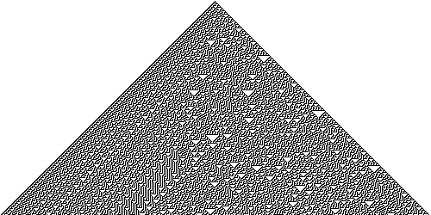

Figure 1. Implementation of Rule 30

I propose to implement a more advanced method discussed in the attached paper. A cell-DEVs model will be used to encrypt a binary message. Two possible methods to be used seperatly or together are Rule 90 and 150.

Table 2. Rule 90
Neighbor pattern | 111 | 110 | 101 | 100 | 011 | 010 | 001 | 000
New state | 0 | 1 | 0 | 1 | 1 | 0 | 1 | 0

Table 3. Rule 150
Neighbor pattern | 111 | 110 | 101 | 100 | 011 | 010 | 001 | 000
New state | 1 | 0 | 0 | 1 | 0 | 1 | 1 | 0

For Part 2, Rule 90 will be used as the cellular enrypter. Using the rules in reverse, decryption will also be implemented.

Part 2: Cell-DEVS of Rule 90 Encryption and Decryption

Formal specification for the Encryption Cell-DEVS model:

Workspace size: 20x20.

Neighbors:
(0,0)

Possible Cell Values:

0 - A binary data bit (zero) to be encoded, until 20 lines have been encoded.
1 - A binary data bit (one) to be encoded, until 20 lines have been encoded.
2 - A cell that is ready to take the value (0 or 1) that results in encrypting its neighborhood values.
3 - A cell that must not be encrypted, but rather become a zero, as the encrypted message needs to be padded in zeros (see examples).

Cell Rules (in order):

All rules have delay 100.

Cell = 1 if ( 0, 0) = 1
Cell = 0 if ( 0, 0) = 3
Cell = 2 if (-1,-1) = 2 or (-1, 1) = 2
Cell = 1 if ( 0, 0) = 2 and (-1,-1) = 1 and (-1, 1) = 1
Cell = 1 if ( 0, 0) = 2 and (-1,-1) = 0 and (-1, 1) = 0
Cell = 0 if t=t

Formal specification for the Decryption Cell-DEVS model:

Workspace size: 20x20.

Neighbors:

(0,0)

Possible Cell Values:

0 - A binary data bit (zero) to be decoded, until 20 lines have been decoded.
1 - A binary data bit (one) to be decoded, until 20 lines have been decoded.
2 - A cell that is ready to take the value (0 or 1) that results in decrypting its neighborhood values.

Cell Rules (in order):

All rules have delay 100.

Cell = 1 if (0,0) = 1
Cell = 0 if (0,0) = 0
Cell = 1 if (0,0) = 2 and (-1,-1) = 0 and (0,-2) = 0
Cell = 0 if (0,0) = 2 and (-1,-1) = 0 and (0,-2) = 1
Cell = 0 if (0,0) = 2 and (-1,-1) = 1 and (0,-2) = 0
Cell = 1 if (0,0) = 2 and (-1,-1) = 1 and (0,-2) = 1
Cell = 1 if (0,0) = 2 and (-1, 1) = 0 and (0, 2) = 0
Cell = 0 if (0,0) = 2 and (-1, 1) = 0 and (0, 2) = 1
Cell = 0 if (0,0) = 2 and (-1, 1) = 1 and (0, 2) = 0
Cell = 1 if (0,0) = 2 and (-1, 1) = 1 and (0, 2) = 1
Cell = 2 if t=t

Simulating and Studying the Encryption Cell-DEVS model:

Encryption Test: Encrypt, using 20 iterations (rows), the message 101100111000111101

Simulation Initialization:
Drawlog .drw file: | CD++ Modeler Cell-DEVS Animation:
+--------------------+  0| 1 11 111 1111 1 |  1|32222222222222222223|  2| |  3| |  4| |  5| |  6| |  7| |  8| |  9| |  10| |  11| |  12| |  13| |  14| |  15| |  16| |  17| |  18| |  19| |  +--------------------+ | 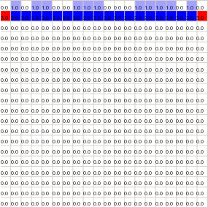

Simulation Result (Simulation Completes after 20 Steps):
Drawlog .drw file: |  | CD++ Modeler Cell-DEVS Animation:
+--------------------+  0| 1 11 111 1111 1 |  1| 11 1 1 11 11 |  2| 111 1 1 1 |  3| 11 1 11 1 11 1 1 |  4| 11 11 1111 |  5| 111 11 11 |  6| 1 11 1111 |  7| 1 11 11 111 |  8| 1 111 1 |  9| 11 1 11111111 1 |  10| 11 111111 11 |  11| 11 1 1111 1 |  12| 11 1 11 11 11 |  13| 11 11 1 1 1 |  14| 1 11 1 1 1 1 |  15| 11 1 1 1111 111 |  16| 1111 1 11 1 |  17| 1 11 11 11 1 |  18| 1 1 111 11 |  19| 1 11 1 1 1 1 |  +--------------------+ | 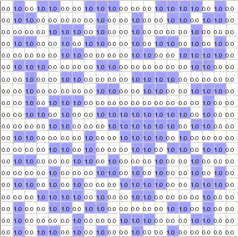
Result: 101100111000111101 encrypts 20 iterations to become: 101101010010010000.
Simulating and Studying the Decryption Cell-DEVS model:

Decryption Test: Decrypt, using 20 iterations (rows), the encoded message that resulted from the above encryption process. (101100111000111101→101101010010010000)

Simulation Initialization:
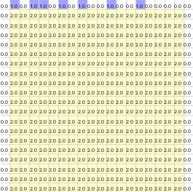

One Iteration of Decoding Process:
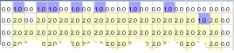
Solved cell
Solved cell
Nine Iterations of Decoding Process:
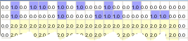
Solved Entire Row

Fully Decoded, 171 Iterations and no more rows available:
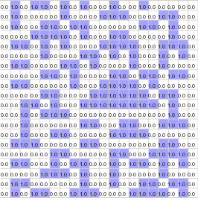
Same Message
Observations from Studies:

The two Cell-DEVS models operated correctly and terminated upon full encryption/decryption. A binary number of length 18 was fully encoded, and then decoded using the two models. In all tests the decoded number always equaled the original number from before encryption.

To perform 20 sequential encryptions on the original binary number of length 18, only 20 time steps were needed. The decryption process was much more challenging, due to problem solving and dependant solutions. Because of this, to fully decode the message back to its original value, 171 time steps were needed. The animation is very interesting. By observing the process, it is clear that the decoding process requires the zero padding to determine a first solution on a new row, then the rest of the row and grow from that value.

