SYSC 5104 Methodologies for Discrete-Event

Modeling and Simulation

(Fall 2004)

Final Project

Discrete Event Multiple Model Control of a Time Varying Plant



Alexander Scott Campbell
Student #: 100632604
Email: alexc@sce.carleton.ca
Date: December 10, 2004

Section 1 – Introduction

Conventional adaptive control using a single identification model, is efficient when the initial parameter estimation error is small, and plant parameters are slowly varying over time. The use of multiple models becomes appropriate, when either of these conditions are not satisfied, such as in the case of a subsystem failure or a change in the operating environment. Typically, a finite number of models are evaluated by an index-of-performance, where, at any instant, the most suitable model’s parameterized controller is applied to the plant. An arrangement using multiple fixed models is shown in Figure 1. This approach proves beneficial for maintaining control of a plant when there is parameter jumps. Additional discussion of multiple model control for continuous or discrete time systems is provided in Reference [1].
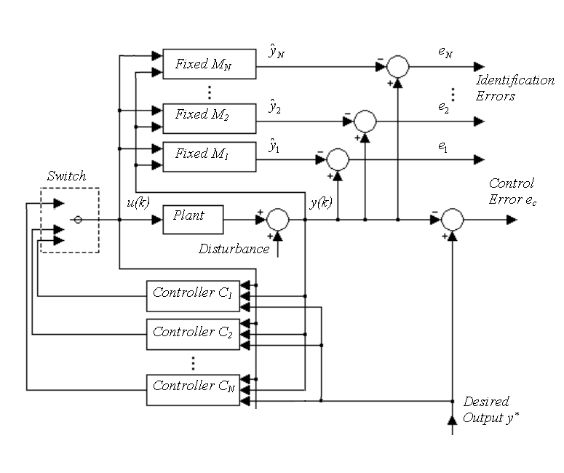
Figure 1. Typical arrangement of multiple fixed models for control of an unknown plant.

Multiple model control demands a union of high-level decision making with mathematically complex algorithms. Implementing such, using discrete-event math is where much of this paper’s design is focused. Once the theory and testing was performed, was an implementation in CD++ modeling language attempted.

Research has been performed in the area of discrete event control systems. Of interest to this paper are Reference [2, 3], where the author defines a hybrid method, Quantized State Control. Also, Lyapunov stability is proven for control of a time varying system.

The goal of the controller in this paper is to have the plant’s output match the reference signal y_{r}, with zero control error. The reference signal is originally a real signal, which must be discretized using quantized DEVS with hysteresis. When performing mathematical calculations of the plant and controller states, interpolation of state, in-between event arrivals, was necessary. Discussions of the many methods implemented are provided in Sections 2, 3, and 4.

Section 2 - Conceptual model definitions

2.1 Conceptual Model of the Plant

The plant behaves as the 2nd order discrete time plant, defined using the difference equation

The piecewise constant parameter vector is defined

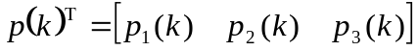.

Because it is defined using discrete event notation, it requires additional inputs, described using interpolation, to calculate a new output. It produces the new plant output once the trigger is enabled. The plantState input {1,2, 3} determines what set of parameters the plant should operate on (thus, it has time-varying properties). The possible parameter states are contained within the plant’s variables.

s₁
gen.
y_{p}
s₂
wait
variables:
int generateOutput,
int pState,
array plantState1Params
array plantState2Params
array plantState3Params

u_{control}

y_{p}(k-1)

y_{p}(k-2)

trigger

plantState
Plant
y_{p}(k)

Figure 2. Conceptual model of the plant.

2.2 Conceptual Model of a Plant Identification Model

Three Models are used to identify the plant states. Each plant identifying model creates an output:

A second output is the modeling error:

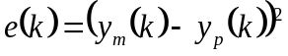

This error is used by the controller, to determine which parameters are best for controlling the system.

s₁
gen.
y_{m}
s₂
wait
variables:
int haveU
int haveYp
int haveYpd
int haveypdd
array modelParams

u_{control}
y_{p}(t)
y_{p}(k-1)
y_{p}(k-2)

Model
y_{m}

e_{m}

Figure 3. Conceptual model of a plant-identifying model.

2.3 Conceptual Model of a Unit Delay Function

This model performs the simple task of delaying a signal’s propagation. It is used in the multiple model controller to force the plant-identifying models to update after a plant update.

s₁
have an input
s₂
wait
variables:
double theSignal
int haveSignal

input

unitDelay
output

Figure 4. Conceptual model a unit delay.

2.4 Conceptual Model of State Interpolation Method

This model performs the task receiving consecutive events, and interpolating points in between them. The two points of interest are shown in Figure 5.

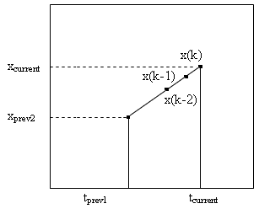
Figure 5. Interpolation strategy

s₁
gen.
output
s₂
wait
variables:
double oldEventX
double oldEventTime
double slope
int waitingForData

eventX
eventT
interpLast
x(k-1)

x(k-2)

Figure 6. Conceptual model of the interpolation method

2.5 Conceptual Model of the Controller

The goal of the controller is to have the plant’s output match the reference signal y_{r}, with zero control error. This controller must analyze the available modeling errors (from the separately implemented models) to decide which is the smallest and most suitable. The parameters associated with the best-fit model are used to generate a control signal for the system. These required parameters are already known within the controller and do not need to be sent to it. The certainly equivalence principle is used to calculate the control signal according as

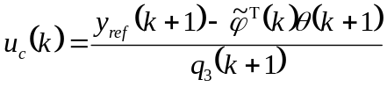,

where,

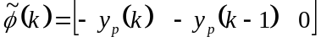

.

s₄

wait
variables:
int haveYr
int haveYpd
int haveypdd
int bestModel
array model1Params
array model2Params
array model3Params

y_{ref}
y_{p}(k-1)

y_{p}(k-2)

e_{m1}
e_{m2}
e_{m3}

genControl
u_{c} (k)

modelSelect
s₃
generate u_{c}
using model3
params
s₁
generate u_{c}
using model1
params
s₂
generate u_{c}
using model2
params

Figure 7. Conceptual model of the controller.

2.6 Conceptual Coupled Model of the Multiple Model Controller

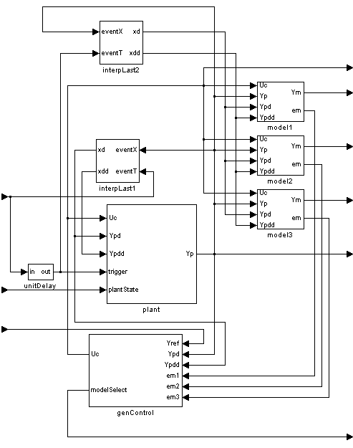
OUTPUT FILE:

u_{c}

y_{m1}

y_{m2}

y_{m3}

y_{p}

modelSelect

EVENT FILE:

Event Arrival Time
(for Y_{ref)}
Plant
State
Changes (forced)
Quantized Y_{ref}
Arrival

Figure 8. Conceptual coupled model of multiple model controller.

Section 3 - Formal model specifications and testing strategies

3.1 Atomic Model Plant:

X = {Uin Ypdin Ypddin Trigger plantState}
Y = {Ypout}
S = {createOutput pState}
Vars = {p11 p12 p13 p21 p22 p23 p31 p32 p33 U Ypd Ypdd Yp scrap}

Internal Transition Function:
passivate

External Transition Function:
if (msg.port() == Uin) {
U = msg.value();
holdIn( active, Time( 0.1) ) ;
}
if (msg.port() == Ypdin) {
Ypd = msg.value();
holdIn( active, Time( 0.1) ) ;
}
if (msg.port() == Ypddin) {
Ypdd = msg.value();
holdIn( active, Time( 0.1) ) ;
}
if (msg.port() == Trigger) {
if (createOutput == 0) {
createOutput = 1;
scrap = msg.value();
holdIn( active, Time( 0.1) ) ;
}
}
if (msg.port() == plantState) {
pState = msg.value();
holdIn( active, Time( 0.1) ) ;
}
Output Function:
if (createOutput == 1) {
createOutput = 0;
if (pState == 1) { Yp = p11*Ypd+p12*Ypdd+p13*U;}
if (pState == 2) { Yp = p21*Ypd+p22*Ypdd+p23*U;}
if (pState == 3) { Yp = p31*Ypd+p32*Ypdd+p33*U;}
send output Yp to Port Ypout
}

Testing Strategy:
- Input a string of inputs [Uin Ypdin Ypddin] taken from the Matlab Prototype. Also in the event file, manually add a Trigger input.
- Compare output [Ypout] to the Matlab Plant.

3.2 Atomic Model Model1 (Model2 and Model3 are identical)

X = {Uin Ypin Ypdin Ypddin}
Y = {Ymout Eout}
S = {haveU haveYp haveYpd haveYpdd}
Vars = {p1 p2 p3 U Ym Yp Ypd Ypdd E}

Internal Transition Function:
passivate

External Transition Function:
if (msg.port() == Uin && haveU == 0){
haveU = 1;
U = msg.value();
holdIn( active, Time( 0.1) ) ;
}
if (msg.port() == Ypin && haveYp == 0) {
haveYp = 1;
Yp = msg.value();
holdIn( active, Time( 0.1) ) ;
}
if (msg.port() == Ypdin && haveYpd == 0) {
haveYpd = 1;
Ypd = msg.value();
holdIn( active, Time( 0.1) ) ;
}
if (msg.port() == Ypddin && haveYpdd == 0) {
haveYpdd = 1;
Ypdd =msg.value();
holdIn( active, Time( 0.1) ) ;
}
Output Function:
if (haveU == 1 && haveYp == 1 && haveYpd == 1 &&haveYpdd == 1) {
haveU = 0;
haveYp = 0;
haveYpd = 0;
haveYpdd = 0;
Ym = p1*Ypd+p2*Ypdd+p3*U;
E = (Yp-Ym)*(Yp-Ym);
send output Ym to Port Ymout
send output E to Port Eout
}

Testing Strategy:
- Input a string of inputs [Uin Ypin Ypdin Ypddin] taken from the Matlab Prototype.
- Compare outputs [Ymout Eout] to tests using the Matlab Model1.

3.3 Atomic Model UnitDelay

X = {theIn}
Y = {theOut}
S = {haveSignal}
Vars = {theSignal}

Internal Transition Function:
passivate

External Transition Function:
if (msg.port() == theIn && haveSignal == 0) {
haveSignal = 1;
theSignal = msg.value();
holdIn( active, Time( 0.5) ) ;
}
Output Function:
if (haveSignal == 1) { //have the new event
haveSignal = 0;
send output theSignal to Port theOut
}

Testing Strategy:
- Input string of [theIn] inputs, observe that outputs [theOut] arrive exactly 0.5 later in time.
- Do not expect buffer-like behavior, only one element is accepted within a 0.5 time period.

3.4 Atomic Model InterpLast

X = {evXin xTin}
Y = {xdout xddout}
S = {waitingforData haveNewEvent haveNewEventTime}
Vars = {evX oldEvX xT oldxT slopeX xtd xtdd}

Internal Transition Function:
passivate

External Transition Function:
if (msg.port() == evXin && haveNewEvent == 0) {
haveNewEvent = 1;
oldEvX = evX;
evX = msg.value();
holdIn( active, Time( 0.001) ) ;
}
if (msg.port() == xTin && haveNewEvent == 1) {
haveNewEventT = 1;
oldxT = xT;
xT = msg.value();
holdIn( active, Time( 0.001) ) ;
}
Output Function:
if (haveNewEvent == 1 && haveNewEventT == 1) { //have the new event time haveNewEvent = 0;
haveNewEventT = 0;
slopeX = (evX-oldEvX)/(xT-oldxT);
xtd = evX - slopeX;
xtdd = evX - 2*slopeX;
send output xtd to Port xdout
send output xtdd to Port xddout
}
}

Testing Strategy:
- Input a string of inputs [evXin xTin] taken from the Matlab Prototype’s Quantized reference signal.
- Compare outputs [xdout xddout]to the Matlab function interpLast, or plot the results and observe they exist on a line connecting the two real events of interest.

3.5 Atomic Model GenControl

X = {Yrin Ypin Ypdin Em1in Em2in Em3in}
Y = {Uout, modelSelect}
S = {haveYr haveYp haveYpd}
Vars = {q11 q12 q13 q21 q22 q23 q31 q32 q33 Yr Yp Ypd U em1 em2 em3 bestModel}

Internal Transition Function:
passivate

External Transition Function:
if (msg.port() == Yrin && haveYr == 0) {
haveYr = 1;
Yr = msg.value();
holdIn( active, Time( 0.001) ) ;
}
if (msg.port() == Ypin && haveYp == 0){
haveYp = 1;
Yp = msg.value();
holdIn( active, Time( 0.001) ) ;
}
if (msg.port() == Ypdin && haveYpd == 0) {
haveYpd = 1;
Ypd = msg.value();
holdIn( active, Time( 0.001) ) ;
}
if (msg.port() == Em1in) {
em1 = msg.value();
holdIn( active, Time( 0.001) ) ;
}
if (msg.port() == Em2in) {
em2 = msg.value();
holdIn( active, Time( 0.001) ) ;
}
if (msg.port() == Em3in) {
em3 = msg.value();
holdIn( active, Time( 0.001) ) ;
}
Output Function:
if (haveYr == 1 && haveYp == 1 && haveYpd == 1) {
haveYr = 0;
haveYp = 0;
haveYpd = 0;
bestModel = 2; // initial guess
U = (Yr-q21*Yp-q22*Ypd)/q23; // calc U as if Model 2 was best
// em1 = -2; // this can be used to force switching to stop permanently
if (em1 < em2 && em1 < em3) { // Model 1 is best
bestModel = 1;
U = (Yr-q11*Yp-q12*Ypd)/q13;
if (em3 < em2 && em3 < em1) { // Model 3 is best
bestModel = 3;
U = (Yr-q31*Yp-q32*Ypd)/q33;
}
send output U to Port Uout
send output bestModel to Port modelSelect
}

Testing Strategy:
- Input a string of inputs [Yrin Ypin Ypdin] while forcing [Em1in] < [Em2in & Em3in].
- Compare output [Uout] to the output of the Matlab Controller using same inputs.
- Repeat, while switching the minimum modeling errors [Em1in Em2in Em3in].
- Boserve/Ensure that the output [modelSelect] represents 1, 2, or 3, depending on the modeling errors input.
- If the three different models have significantly different parameters, the control signal should appear different in size and shape for a each new set operating parameters.

3.6 Coupled Model ControlSystem

X = {Yrin xTin plantState }
Y = {Ypout modelSelect observeU }

Overall Testing Strategy:
  - Use an event file, exported from Matlab, containing Time- Stamped Reference Signal Arrival Events as inputs to [Yrin xTin].
  - Do not force any plant state changes using port [plantState] (it is automatically in plant state)
  - Compare output [Ypout] to the output of the Matlab simulation under identical circumstances. Also, in comparison to the input reference signal [Yrin], it should be near identical.
  - Observe/Ensure that output [modelSelect] remains at 1, if it temporarily switches this is due to other models having near identical performance. If it permanently switching to 2 or 3, but overall system control is not jeopardized, then perhaps all the models are very similar.
  - Simulate using the same Quantized Reference Signal Event File, but add manual parameter jumps ([plantState] = 1, 2, or 3)
  - Observe/Ensure that output [modelSelect] is quick to match the input [plantState]. Short transients of system instability or large control error is acceptable the controller switch is being performed.
  - Compare output [Ypout] to the output of the Matlab simulation under identical circumstances. Also, in comparison to the input reference signal [Yrin], it should be near identical.
  - Further Experiments are covered in Section 5.

Section 4 – Discrete Event Control Strategy Prototyping using Matlab®

Multiple model control demands a union of high-level decision making with mathematically complex algorithms. Implementing such, using discrete-events, and CD++ modeling language, requires additional design and testing. The initial problem posed is “how does one perform multiple model control, or adaptive control, when the discrete event system must model a real-time physical system?” Some of the tools used in this paper:
- Quantized discretization
- Interpolation of states
- Triggering updates
- Unit delays, to propagate updates

It was decided that Matlab® should be used to design the interpolation and test the interpolation approach to performing discrete event control. As a starting point, the method of quantum discretization was implemented. The desired plant output, existing as reference signal, was declared in discrete time:

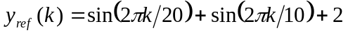

Using this signal as an operand, quantized DEVS with hysteresis (= 0.1, n = 2) was applied. Given the signal being quantized is (0,2), the normalized quantum size can be considered 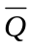= 0.05. This first task was implemented in the script quantize.m. The result of quantize.m is a discrete time signal, which also has discrete event changes. To remove the discrete time component, Quant2Event.m is used. The result of this process is a list of event changes, plus a list of event times. This list of events and event times was used for all tests performed in Matlab® and CD++.

Calculating the output of the 2nd order plant, at the time of a new event arrival, requires knowledge of the previous two virtual discrete time plant outputs. As discussed earlier, this requires interpolation between events. This method was implemented in the script interpLast.m, which can be found in the index.

A discrete event controller was implemented in Matlab®, using recursive least squares to perform parameter estimation of an unknown 2nd order plant. Because of the matrix manipulation required, the recursive least squares method was never implemented in CD++. However, a multiple model control scheme was implemented in CD++. With proper model placement, multiple model control can offer near perfect control of plant in simulations containing parameter jumps.

Below are results of testing the Matlab® approach to discrete event control with a time-invariant plant (master file DEVController.m).

4.1 Discretization Results
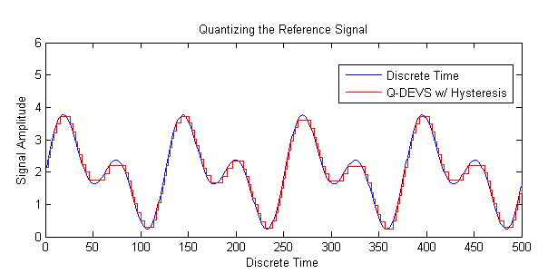
Figure 9. Discretization of reference signal (n = 2, Q = 0.10).

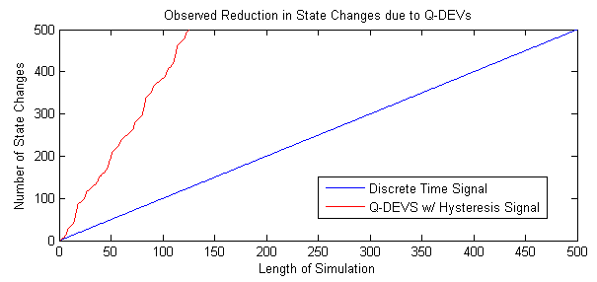
Figure 10. Reduction in state changes due to discretization (n = 2, Q = 0.10).
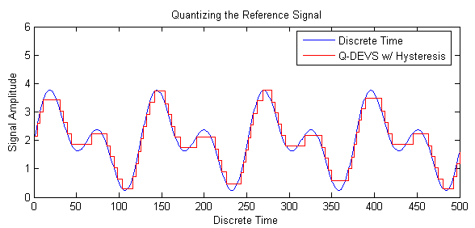
Figure 11. Discretization of reference signal (n = 2, Q = 0.18).

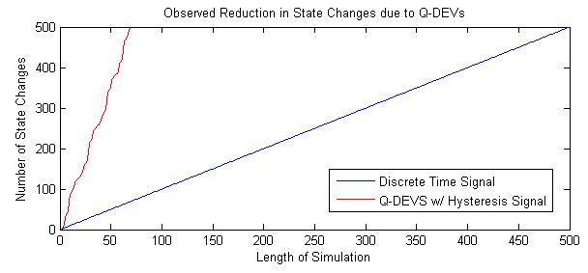
Figure 12. Reduction in state changes due to discretization (n = 2, Q = 0.18).
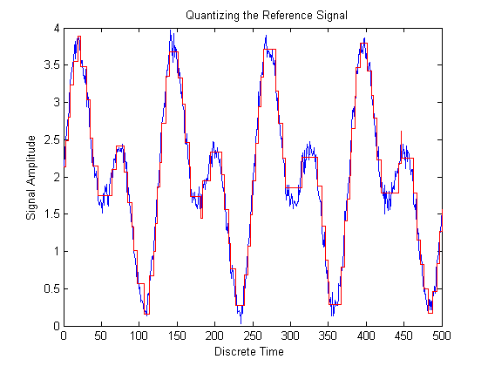
Figure 13. Discretization of a stochastic signal (n = 2, Q = 0.15).

4.2 Interpolation Results
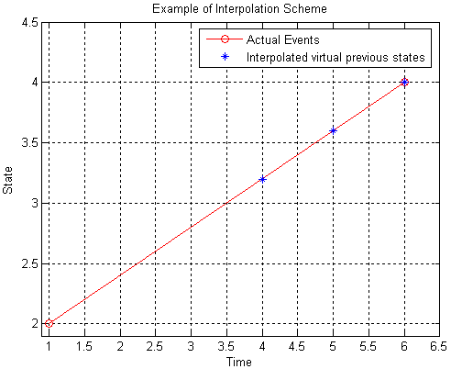
Figure 14. Interpolation between events.

4.3 Discrete Event Simulation Results
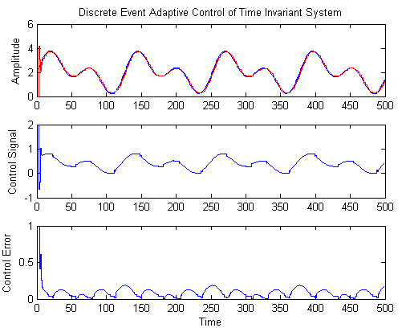
Figure 15. Adaptive control using Q = 0.02

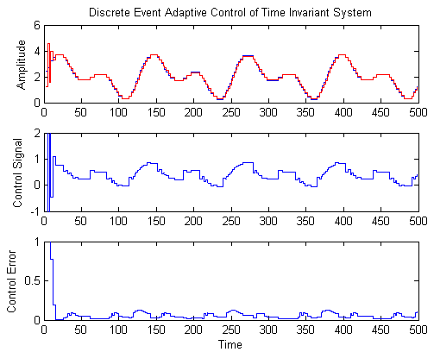
Figure 16. Adaptive control using Q = 0.1
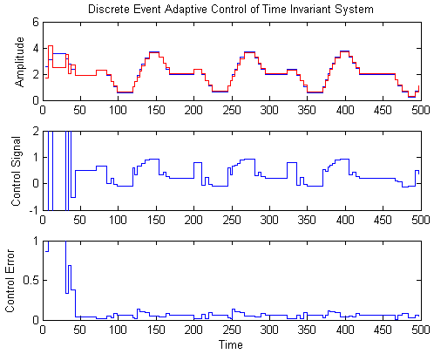
Figure 17. Adaptive control using Q = 0.2

The above three Matlab® simulations where performed using plant parameter values

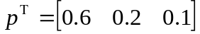,

and initial parameter estimates

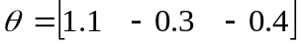.

In observing the produced figures, is clear that the control error remains roughly the same, no matter what quantum size is used when performing discretization of the reference signal. Also, the recursive least squares adaptive algorithm was able to converge to the actual plant parameter values much faster when the quantum size was smaller. This is inherent, as an adaptive algorithm require persistent excitation for optimal performance.

Section 5 – Discrete Event Control Results Using CD++

5.1 Event Files

The event file accesses the following ports of ControlSystem.ma (found in index):
- Yrin
- XTin
- plantState
The resulting simulation produces outputs on the following ports:
- Ypout
- ModelSelect
- observeU

The plant has the following plant states:

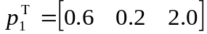
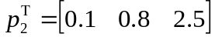
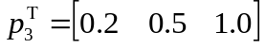

The models and controller have the following parameter estimates:

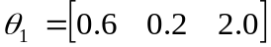
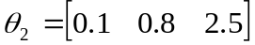
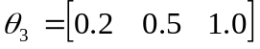

The most critical component to the event file is the reference signal events (Yrin) and event arrival times (Xtin). The creation of this foundation event file is discussed in Section 4.1 In addition, the plantState events must be set by the user, in order to simulate changes in parameter behaviours. The goal is to cycle through all plant states during the 500 second duration of the reference signal. The event file (controlSystem.ev) includes the following behaviours for the plant:

00:00:01:000 plantState 1
00:00:01:000 xTin 3
00:00:37:500 plantState 2
00:00:37:000 xTin 142
00:01:19:500 plantState 3
00:01:20:000 xTin 313
00:01:52:500 plantState 1
00:01:53:000 xTin 461

5.2 CD++ Simulation of Time Varying Plant with no Model Switching

In the initial simulation, controlSytem.ev was used, but the controller was fixed, having the parameters associated with Model 1. In this case a single model controller is applied to a plant with multiple consecutive parameter jumps. The results where obtained in controlSystem.out, and exported into Matlab® for analysis. The Matlab® variables were saved and included with this report, as file CDPlusSim1Data.mat. Figure 18 shows the plotting of this data, performed using script CDPlusPlotSim1Data.m.

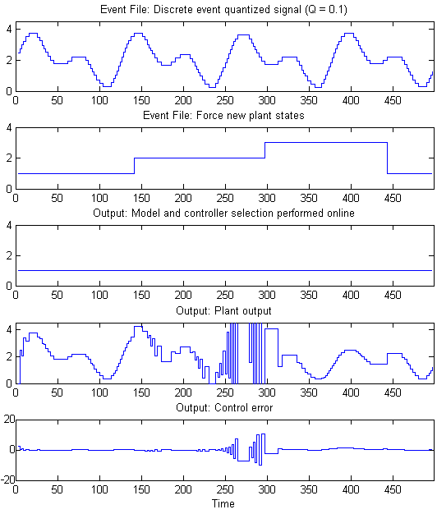
Figure 18. CD++ simulation containing parameter jumps, using a fixed controller.

Using the fixed parameter controller, stable control was achievable for plant states P₁ and P₃. At plant state P₃, the closed loop system became, eventually yielding unbounded plant outputs.

5.3 CD++ Simulation of Time Varying Plant with Multiple Model Switching

In this simulation, controlSytem.ev was again used as the input event file. The controller was allowed to determine which parameters to use, according to the modeling errors reported by the three models. The results where obtained in controlSystem.out, and exported into Matlab® for analysis. The Matlab® variables were saved and included with this report, as file CDPlusSim2Data.mat. Figure 19 shows the plotting of this data, performed using script CDPlusPlotSim2Data.m.

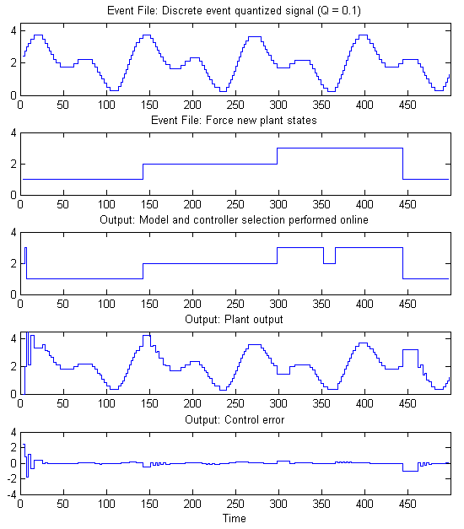
Figure 19. CD++ simulation containing parameter jumps, using a fixed controller.

This simulation result displays the advantages of multiple model control. Because a perfectly parameterized controller was designed a priori, the controller was able to select it, by observing the performance of its associated model. For this deterministic scenario, control error only existed at the time period coinciding with each jump in plant parameters. During simulation initialization, the instantaneous error of each model was zero, requiring several reference signal arrival events and corresponding triggered plant outputs to identifies which controller was most suitable. During operation, only at time 355 did a false model switch occur. The source of the false switch was again due to two models having almost zero modeling error. For switching in the presence of uncertainties, such as in the stochastic case, more advanced switching method can be implements. A more effective switching method would analyze a whole window of modeling errors, or utilize a forgetting factor.

Section 6 – Conclusion

The benefit of performing control using the multiple model approach was explained and demonstrated in this paper. The design problem was researched and discussed, before being implemented in two phases. In the first phase, Matlab® was used to test the proposed methods of discretization, interpolation, unit delays, and triggered subsystems. The front-end discretization provided a drastic reduction in data volume. Using true discrete event inputs and updates, adaptive control of a time-invariant plant was demonstrated. In the second phase, CD++ was used to fully implement a discrete event controller. Three plant identification models were implemented to identify jumps in plant parameters and select controllers accordingly. Simulations, using CD++, showed that the properties of continuous and discrete time multiple model controllers could be employed using discrete event systems with CD++.

References

- K. S. Narendra, O. A. Driollet, M. Feiler, and K. George, "Adaptive control using multiple models, switching and tuning," Int. J. Adapt. Control Signal Process., vol. 17, 2003, pp. 87–102.
- E. Kofman, "Quantized-State Control. A Method for Discrete Event Control of Continuous Systems," Latin American Applied Research (LAAR Journal), 2003, 33(4). pp 399-406.
- E. Kofman, "Discrete Event Control of Time Varying Plants," Technical Report LSD0303, LSD, Universidad Nacional de Rosario, 2003,

