94.587 Term Project

Modeling and Simulation of Diffusion Limited Aggregation with Cell-DEVS

Changshuang Lin
(#100275796)
clin@sce.carleton.ca

Due Date: Dec. 1, 2003

Table of Contents

1. Introduction 3
2. Modeling Rules 3
3. Formal Specification 4
4. Implementation 5
5. Testing 6
6. Execution Results 8
7. Conclusions 13
Reference 13

- Introduction

Diffusion Limited Aggregation (DLA) occurs when diffusing particles stick to and progressively enlarge an initial seed represented by a fixed object. The seed typically grows in an irregular shape resembling frost on a window [1]. Diffusion is a random motion with respect to the direction. There are two kinds of particles in a grid: fixed and mobile. A mobile particle has same probability of walking toward each direction. When a mobile particle moves and meets a fixed particle, it becomes fixed and sticks with the fixed particle. In other words, they form aggregates. A mobile particle disappears and becomes invisible if it strays too far from the center. The process continues until all mobile particles have either disappeared or have become fixed. Some illustrations of DLA can be found in [2].

- Modeling Rules
Initially a certain percentage of the cells (e. g. 25%) are occupied by mobile particles. This percentage is also called concentration percentage. There exist at least one or more fixed particles (the seeds) at the initial stage. The system evolves with the following rules.
- A particle can move in four directions: up (1), right (2), down (3) and left (4), as shown in Figure 1.
1

2
4

3

Figure 1: Moving Directions of a Particle

- A particle becomes fixed if its adjacent cell contains fixed particles. A cell has four adjacent cells: up, down, left or right.
- An empty cell will be occupied if there is at least one mobile particle that intends to move in and there is no fixed particle adjacent to the mobile particle.
- In the case that there are more than one particle that intend to move toward a same empty cell, the particle with the highest number representing the moving direction (see Figure 1) succeeds.
- A mobile particle that can’t move will stay in that cell and select a new direction randomly for the next move.
- A mobile particle disappears if it strays too far from the center.

- Formal Specification
The formal specification for the coupled Cell-DEVS model corresponding to the file DLA.ma is described as follows.

M=<I,X,Y,Xlist,Ylist,η, N,{m,n}, C, B, Z, select>
Xlist=Φ
Ylist=Φ
η=25
I=<P^{X},P^{y}>,with P^{X}={Φ},P^{y}={Φ};
N={ (-3,0), (-2,-1), (-2,0), (-2,1), (-1,-2), (-1,-1), (-1,0), (-1,1), (-1,2), (0,-3), (0,-2),
(0,-1), (0,0), (0,1), (0,2), (0,3), (1,-2), (1,-1), (1,0), (1,1), (1,2), (2,-1), (2,0),
(2,1), (3,0) };
X={-1, 0,1,2,3,4,5};
Y={0,1,2,3,4,5}
m=21; n=21;
B={Φ};
C={Cij/iε[1,21], jε[1,21]}
Z:
P_{ij}^{X}₁ → P_{i-1,j+1}^{Y}₁ P_{i+1,j-1}^{Y}₁ → P_{ij}^{X}₁
P_{ij}^{X}₁ → P_{i,j+1}^{Y}₁ P_{i,j-1}^{Y}₂ → P_{ij}^{X}₂
P_{ij}^{X}₁ → P_{i+1,j+1}^{Y}₁ P_{i-1,j-1}^{Y}₁ → P_{ij}^{X}₃
P_{ij}^{X}₁ → P_{i+1,j}^{Y}₁ P_{i-1,j}^{Y}₁ → P_{ij}^{X}₄
P_{ij}^{X}₁ → P_{ij}^{Y}₁ P_{ij}^{Y}₁ → P_{ij}^{X}₅
P_{ij}^{X}₁ → P_{i,j+3}^{Y}₁ P_{i,j-3}^{Y}₁ → P_{ij}^{X}₁
P_{ij}^{X}₁ → P_{i,j+2}^{Y}₁ P_{i,j-2}^{Y}₂ → P_{ij}^{X}₂
P_{ij}^{X}₁ → P_{i,j-21}^{Y}₁ P_{i,j+2}^{Y}₁ → P_{ij}^{X}₃
P_{ij}^{X}₁ → P_{i,j-3}^{Y}₁ P_{i,j+3}^{Y}₁ → P_{ij}^{X}₄
P_{ij}^{X}₁ → P_{i+1,j+2}^{Y}₁ P_{i-1,j-2}^{Y}₁ → P_{ij}^{X}₅
P_{ij-3}^{X}₁ → P_{i+1,j+1}^{Y}₁ P_{i-1,j-1}^{Y}₁ → P_{ij}^{X}₁
P_{ij}^{X}₁ → P_{i+1,j-1}^{Y}₁ P_{i-1,j+1}^{Y}₂ → P_{ij}^{X}₂
P_{ij}^{X}₁ → P_{i+1,j-2}^{Y}₁ P_{i-1,j+2}^{Y}₁ → P_{ij}^{X}₃
P_{ij}^{X}₁ → P_{i+2,j+1}^{Y}₁ P_{i-2,j-1}^{Y}₁ → P_{ij}^{X}₄
P_{ij}^{X}₁ → P_{i+2,j}^{Y}₁ P_{i-2,j}^{Y}₁ → P_{ij}^{X}₅
P_{ij-3}^{X}₁ → P_{i+2,j-1}^{Y}₁ P_{i-2,j+1}^{Y}₁ → P_{ij}^{X}₁
P_{ij}^{X}₁ → P_{i+3,,j}^{Y}₁ P_{i-3,j}^{Y}₂ → P_{ij}^{X}₂
P_{ij}^{X}₁ → P_{i-1,j+2}^{Y}₁ P_{i+1,j-2}^{Y}₁ → P_{ij}^{X}₃
P_{ij}^{X}₁ → P_{i-1,j+1}^{Y}₁ P_{i+1,j-1}^{Y}₁ → P_{ij}^{X}₄
P_{ij}^{X}₁ → P_{i-1,j-1}^{Y}₁ P_{i+1,j+1}^{Y}₁ → P_{ij}^{X}₅
P_{ij-3}^{X}₁ → P_{i-1,j-2}^{Y}₁ P_{i+1,j+2}^{Y}₁ → P_{ij}^{X}₁
P_{ij}^{X}₁ → P_{i-2,j+1}^{Y}₁ P_{i+2,j-1}^{Y}₂ → P_{ij}^{X}₂
P_{ij}^{X}₁ → P_{i-2,j}^{Y}₁ P_{i+2,j}^{Y}₁ → P_{ij}^{X}₃
P_{ij}^{X}₁ → P_{i-2,j-1}^{Y}₁ P_{i+2,j+1}^{Y}₁ → P_{ij}^{X}₄
P_{ij}^{X}₁ → P_{i-3,j}^{Y}₁ P_{i+3,j}^{Y}₁ → P_{ij}^{X}₅
select ={ (-3,0), (-2,-1), (-2,0), (-2,1), (-1,-2), (-1,-1), (-1,0), (-1,1), (-1,2), (0,-3),
(0,-2), (0,-1), (0,0), (0,1), (0,2), (0,3), (1,-2), (1,-1), (1,0), (1,1), (1,2), (2,-1),
(2,0), (2,1), (3,0) };

- Implementation

As shown in the formal specification, the DLA model is implemented as a 2D Cell-DEVS. The following rule is used to check to see if a mobile particle strays too far away from the center:

rule : 0 100 { ( (cellpos(0) - 10) * (cellpos(0) - 10) + (cellpos(1) - 10 ) * (cellpos(1) - 10) ) > 81 }

The cell with a value of 0 indicates that it is empty one, and a value of 1 to 4 indicates that it contains a mobile particle with the specified moving direction. A cell with a value of 5 indicates that it contains a seed, i.e. a fixed particle. When a cell is empty, it checks to see if there is any mobile particle that wants to move in that cell. Such mobile particle can move in if and only if it does not have any adjacent cell containing a fixed particle.

rule : {round(uniform(1,4))} 100 { (0,0) = 0 and
( ( (0,-1)=2 and (-1, -1) !=5 and (1,-1) !=5 and (0,-2) !=5 ) or
( (-1,0)=3 and (-1,-1) !=5 and (-2,0) !=5 and (-1,1) !=5 ) or
( (0,1)=4 and (1,1) !=5 and (0,2) !=5 and (1,1) !=5 ) or
( (1,0)=1 and (1,1) !=5 and (2,0) !=5 and (1,-1) !=5 )
) }

In the case there are move than one particle that wants to move in a same empty cell, only the particle with the highest moving direction number succeeds. Following examples illustrate the resolution of moving conflict for a particle that is attempting to move a cell up. In this example, the mobile particle with moving direction 1 (up) can move in an empty cell above if there is no other mobile particle that attempts to move in.

% direction = 1 (up)
% stay and change direction when nowhere to move
rule : {round(uniform(1,4))} 100 { (0,0)=1 and (-1,0)!=0 }
rule : {round(uniform(1,4))} 100 { (0,0)=1 and (-1,0)=0 and
(
( (-2,0)=3 and (-2,-1) != 5 and (-3,0) !=5 and (-2,1) !=5 ) or
( (-1,-1)=2 and (-1,-2) !=5 and (-2,-1)!=5 and (0,-1)!=5 ) or
( (-1,1)=4 and (-2,1) !=5 and (-1,2) !=5 and (0,1) !=5 )
) }

% move otherwise
rule : 0 100 {(0,0)=1 and (-1,0)=0 and t}

Whenever a mobile particle is in a cell with any fixed particle adjacent to it, it becomes fixed.

% the particle becomes fixed if an adjacent cell contains fixed paticle
rule : 5 100 { (0,0) > 0 and (0,0)<5 and
( (-1, 0) = 5 or (0, -1) = 5 or (0, 1) = 5 or (1, 0) = 5 ) }

Initially a 3-D Cell-DEVS was developed for this project, and the moving conflict was resolved with use of random numbers in the third plane. However, given that conflict can be resolved with the use of moving direction numbers, and that the execution of 3-D simulation is slow, 2-D Cell-DEVS is created instead as presented above.

- Testing

For this project, one of the several model files called DLA_test.ma has been written in order to test the correctness of the modeling. This model file is used to test the model with respect to the move of particles in the different situations. The grid is initialized to be in Figure 2.

0 1 2 3 4 5 6 7 8 9 10 11 12 13 14
+---------------------------------------------------------------------------+
0| 0 0 0 0 0 0 0 0 0 0 0 0 0 0 0|
1| 0 0 0 0 0 0 0 0 0 0 0 0 0 0 0|
2| 0 0 0 0 0 0 0 0 0 0 0 0 0 0 0|
3| 0 0 0 0 0 3 0 0 0 0 0 0 0 0 0|
4| 0 0 0 0 2 0 4 5 0 0 0 0 0 0 0|
5| 0 0 0 0 0 1 0 0 0 0 0 0 0 0 0|
6| 0 0 0 0 0 0 0 0 0 0 0 0 0 0 0|
7| 0 0 0 0 0 0 0 0 0 0 0 0 0 0 0|
8| 0 0 0 0 0 0 0 0 0 0 0 0 0 0 0|
9| 0 0 0 0 0 0 0 0 0 3 0 0 0 0 0|
10| 0 0 0 0 0 0 0 0 2 0 4 0 0 0 0|
11| 0 0 0 0 0 0 0 0 0 1 0 0 0 0 0|
12| 0 0 0 4 0 1 2 0 0 0 0 0 0 0 0|
13| 0 0 0 0 0 0 3 0 0 0 0 0 0 0 0|
14| 0 0 0 0 0 0 0 0 0 0 0 0 0 0 0|
+---------------------------------------------------------------------------+

Figure 2: The grid at time 00:00:00:000

After the delay, the grid changes to be the one shown in Figure 3.

0 1 2 3 4 5 6 7 8 9 10 11 12 13 14
+---------------------------------------------------------------------------+
0| 0 0 0 0 0 0 0 0 0 0 0 0 0 0 0|
1| 0 0 0 0 0 0 0 0 0 0 0 0 0 0 0|
2| 0 0 0 0 0 0 0 0 0 0 0 0 0 0 0|
3| 0 0 0 0 0 0 0 0 0 0 0 0 0 0 0|
4| 0 0 0 0 3 4 5 5 0 0 0 0 0 0 0|
5| 0 0 0 0 0 4 0 0 0 0 0 0 0 0 0|
6| 0 0 0 0 0 0 0 0 0 0 0 0 0 0 0|
7| 0 0 0 0 0 0 0 0 0 0 0 0 0 0 0|
8| 0 0 0 0 0 0 0 0 0 0 0 0 0 0 0|
9| 0 0 0 0 0 0 0 0 0 4 0 0 0 0 0|
10| 0 0 0 0 0 0 0 0 3 3 0 0 0 0 0|
11| 0 0 0 0 0 1 0 0 0 3 0 0 0 0 0|
12| 0 0 1 0 0 0 0 2 0 0 0 0 0 0 0|
13| 0 0 0 0 0 0 0 0 0 0 0 0 0 0 0|
14| 0 0 0 0 0 0 2 0 0 0 0 0 0 0 0|
+---------------------------------------------------------------------------+
Figure 3: The grid at time 00:00:00:100

Note that, in Figure 3 at time 00:00:00:100, the particle in cell (3, 5) moves down into the empty cell while the particle in cell (4, 6) becomes fixed. These two figures show that every mobile particle moves in compliant with the specification, and the model is defined correctly.

- Execution Results

Several model files have been written in order to see the running process of DLA with different number of seeds and different percentages of concentration.

DLA.ma
For this model, grid sizes are set to be 21 x 21. There is one seed in the center and the percentage of concentration is 30%.

DLA_two_seeds.ma
This model is the same as the DLA.ma except that it has two seeds.

DLA_big1.ma
The grid size is set to be 71 x 71. There is one seed in the center and the percentage of concentration is 30%. It takes around 30 minutes to complete the simulation.

DLA_big2.ma
This model is the same as the DLA_big1.ma except that it has two seeds.

DLA_big3.ma
This model is the same as the DLA_big1.ma except that it has 40% of concentration percentage.

The scripts to run each model file are provided. Some execution results by running the scripts are shown in Figure 4 to Figure 7.

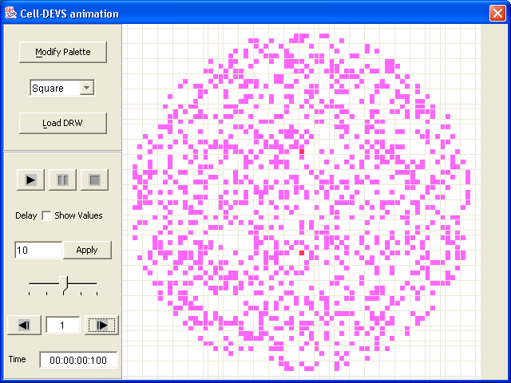

Figure 4: Initial Execution Result of Running DLA_big2.ma
(Two seeds and 30% concentration)

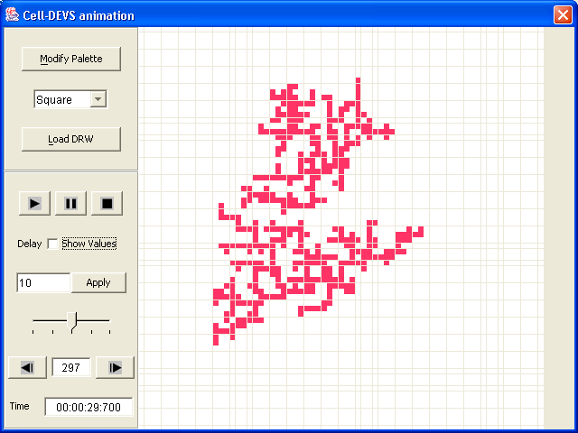

Figure 5: Final Execution Result of Running DLA_big2.ma
(Two seeds and 30% concentration)

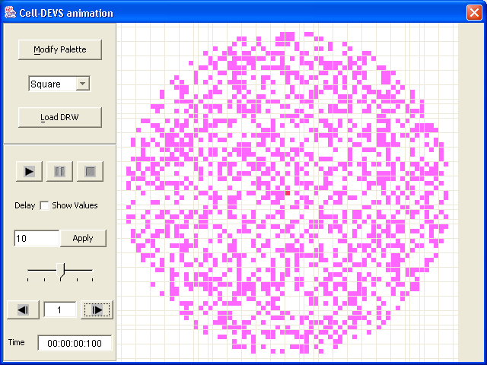

Figure 6: Initial Execution Result of Running DLA_big3.ma
(One seed and 40% concentration)

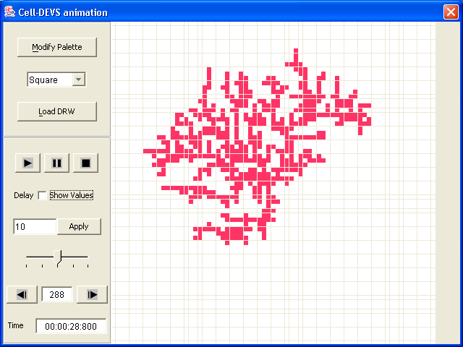

Figure 7: Final Execution Result of Running DLA_big3.ma
(One seed and 40% concentration)

- Conclusions

For this term project, a model to simulate the process of diffusion-limited aggregation with Cell-DEVS has been defined. Diffusion-limited aggregation is an example of fractal growth model. Core activities of this project include understanding of DLA, writing of the formal specification and the model files, as well as the testing of the simulation. An implementation of this term project has provided me with a very rich experience on the simulation and modeling with Cell-DEVS.

Reference
[1] T. Toffoli and N. Margolus, Cellular Automata Machines: a New Environment for Modeling, MIT Press, London, England, 1978
[2] Five Cellular Automata: Diffusion-Limited Aggregation, available from http://hermetic.nofadz.com/pca/da.htm

