SYSC-5807 METHODOLOGICAL ASPECTS OF MODELLING AND SIMULATION

Term Project

Xiuping Wu Student#: 100258863

xpwu@sce.carleton.ca

December 1st, 2003

Systems and Computer Engineering, Carleton University

Driven Diffusion Modeling Using Cell-DEVS

Introduction
This project models the random motion of two species of particles that exist in a system when an external field presents which may drive one species of particles move along the field direction while the other species move against that direction [1]. This kind of model can simulate the behavior for certain kinds of materials such as superionic conductors, fast ion conductors and solid electrolytes. These two species of particles are differentiated by their attribute of positive charge or negative charge. The particle space contains approximately the same amount of positive and negative particles so that the total charge of the system is zero. The external field biases the movement of each species in opposite directions and an order-disorder transition occurs as a function of density. This project is going to use Cell-DEVS model to simulate the system and will study how the density of the particle space affect the behavior of the system.
Initially, the space is occupied by the two randomly distributed particles A and B and each particle has a randomly chosen direction to face. These directions are North, East, South or West. The density of the occupied space is denoted as P. In the case of an external electrical field appearance (assuming the field points to the north-east), the preferable moving direction of particle A is North or East while the preferable moving direction of particle B is South or West. The probability of A and B hops along that preferable direction is a, and the probability of hopping against the direction is (1-a).

2. The Rules
The rules for a particle of either type to move are as follows:
- The cells only move towards the direction that they are facing now. The adjacent cell mentioned below refers to the neighboring cell that the particle is facing now.
- If the adjacent cell is occupied, then the particle remains in its current place and randomly chooses a direction to face.
- If the adjacent cell is empty but faced by one or more particles, then the particle remains in its current place and randomly chooses a direction to face.
- If the adjacent cell is empty and faced by no other particles, then the particle moves to the adjacent cell and chooses randomly a direction to face.
Rules for a particle to randomly choose a direction to face are as follows:
For particle A, the probability of choosing north, east, south or west to face are (a/2), (a/2), (1-a)/2 and (1-a)/2 respectively.
For particle B, the probability of choosing north, east, south or west to face are (1-a)/2, (1-a)/2, (a/2) and (a/2) respectively.
The rules for updating cells are as follows:
- If the cell is empty and faced by no particles, then it remains empty.
- If the cell is empty and faced by exactly one particle, then the cell will be occupied.
- If the cell is empty and faced by two or more particles, then the cell remains empty.
- If the cell is occupied and the inside particle faces an empty cell that is not faced by other particles, then this cell will be vacated.

3. Parameters
The probability a mentioned above is selected the value of 0.9.
The values in a cell are defined as follows:
11/21
13/23
12/22
14/24
0 - an empty cell
11 - a cell occupied by a north-facing particle A
12 - a cell occupied by an east-facing particle A
13 - a cell occupied by a south-facing particle A
14 - a cell occupied by a west-facing particle A
21 - a cell occupied by a north-facing particle B
22 - a cell occupied by an east-facing particle B
23 - a cell occupied by a south-facing particle B
24 - a cell occupied by a west-facing particle B

4. Cell-DEVS model specification
The particles neighborhood is illustrated in the following Figure 1.

Figure 1 Neighborhood

M=<I,X,Y,Xlist,Ylist,η, N,{m,n}, C, B, Z, select>
Xlist=Φ
Ylist=Φ
η=13
I=<P^{X}, P^{y}>, with P^{X}=Φ, P^{y}=Φ;
N={(-1,-1), (-1,0),(-1,1), (0,-1), (0,0), (0,1), (1,-1), (1,0), (1,1), (2,0), (-2,0), (0,-2), (0,2) }
X={x | x ε N₀⁺};
Y={y | y ε N₀⁺};
m=30; n=30;
B={ (Cij | i =1, 30; j ε[1, 30]), (Cij | j=1, 30; i ε[1, 30]) };
C={Cij / iε[1, 30], jε[1, 30]}
Z:
P_{ij}^{Y1}→P_{i,j-1}^{X1} P_{i,j+1}^{Y1}→Pij^{X1}
P_{ij}^{Y2}→P_{i+1,j}^{X2} P_{i-1,j}^{Y2}→P_{ij}^{X2}
P_{ij}^{Y3}→P_{i,j+1}^{X3} P_{i,j-1}^{Y3}→Pij^{X3}
P_{ij}^{Y4}→P_{i-1,j}^{X4} P_{i+1,j}^{Y4}→P_{ij}^{X4}
P_{ij}^{Y5}→P_{ij}^{X5} P_{ij}^{Y5}→P_{ij}^{X5}
P_{ij}^{Y6}→P_{i+1,j+1}^{X6} P_{i-1,j-1}^{Y6}→P_{ij}^{X6}
P_{ij}^{Y7}→P_{i-1,j-1}^{X7} P_{i+1,j+1}^{Y7}→P_{ij}^{X7}
P_{ij}^{Y8}→P_{i+1,j-1}^{X8} P_{i-1,j+1}^{Y8}→P_{ij}^{X8}
P_{ij}^{Y9}→P_{i-1,j+1}^{X9} P_{i+1,j-1}^{Y9}→P_{ij}^{X9}
P_{ij}^{Y10}→P_{i-2,j}^{X10} P_{i+2,j}^{Y10}→P_{ij}^{X10}
P_{ij}^{Y11}→P_{i+2,j}^{X11} P_{i-2,j}^{Y11}→P_{ij}^{X11}
P_{ij}^{Y12}→P_{i,j+2}^{X12} P_{i,j-2}^{Y12}→P_{ij}^{X12}
P_{ij}^{Y13}→P_{i,j-2}^{X12} P_{i,j+2}^{Y12}→P_{ij}^{X12}
Select={ (-1,-1), (-1,0),(-1,1), (0,-1), (0,0), (0,1), (1,-1), (1,0), (1,1),(2,0), (-2,0), (0,2),
(0,-2)}

5. Final Results
A Java program has been written to produce the initial values in the cell space. This program takes the density value, the size of the space and the .val file name as parameters. It will randomly generate two kinds of particles that are randomly distributed in the space according to the given density value. The particles that have values from 11-14 are A particles and those with values from 21-24 are B particles. The last digit 1-4 represents the different directions that they are facing. The simulation results are shown below:

Results analysis:
Below are parts of the results from the test case which uses the model specification DrivenDiffusion.ma and the initial values in DrivenDiffusion.val. The complete results are in draw file diffusion.drw.

Line : 539 - Time: 00:00:00:000

0 1 2 3 4 5 6 7
+------------------------------------------------------------------
0| 13.000 0.000 0.000 0.000 0.000 0.000 0.000 0.000
1| 0.000 0.000 0.000 0.000 0.000 0.000 0.000 0.000
2| 0.000 0.000 0.000 22.000 0.000 0.000 0.000 0.000
3| 0.000 0.000 0.000 12.000 0.000 0.000 0.000 23.000
4| 0.000 0.000 0.000 0.000 0.000 14.000 0.000 0.000
5| 0.000 0.000 0.000 0.000 13.000 0.000 21.000 0.000
6| 0.000 0.000 0.000 0.000 0.000 11.000 0.000 0.000
7| 0.000 0.000 0.000 0.000 11.000 0.000 24.000 0.000
8| 0.000 0.000 0.000 12.000 0.000 0.000 0.000 0.000
9| 0.000 0.000 0.000 0.000 0.000 24.000 0.000 0.000
10| 0.000 0.000 0.000 0.000 0.000 0.000 0.000 0.000
11| 0.000 0.000 0.000 0.000 0.000 0.000 0.000 0.000

Line : 776 - Time: 00:00:00:100
0 1 2 3 4 5 6 7
+--------------------------------------------------------------------
0| 0.000 0.000 0.000 0.000 0.000 0.000 0.000 0.000
1| 0.000 0.000 0.000 0.000 0.000 0.000 0.000 0.000
2| 0.000 0.000 0.000 22.000 0.000 0.000 0.000 0.000
3| 0.000 0.000 0.000 0.000 0.000 11.000 23.000 0.000
4| 0.000 0.000 0.000 13.000 0.000 0.000 0.000 0.000
5| 0.000 0.000 0.000 11.000 0.000 0.000 0.000 23.000
6| 0.000 0.000 0.000 0.000 0.000 12.000 0.000 0.000
7| 0.000 0.000 0.000 0.000 0.000 12.000 24.000 0.000
8| 0.000 0.000 0.000 0.000 0.000 23.000 0.000 0.000
9| 0.000 0.000 0.000 11.000 0.000 0.000 0.000 0.000
10| 0.000 0.000 0.000 0.000 0.000 0.000 0.000 0.000
11| 0.000 0.000 0.000 0.000 0.000 0.000 0.000 0.000

We can see that the cells have been updated according to the rules exactly.

Since the model is used to study how the system behavior are affected by the density of particles that are distributed in the space, several test cases have been designed and the results along with their analysis are presented below.

Case 1: Cell Space with Low Density of 10%
In this case, about 10% of the cell space is occupied by the randomly distributed two kinds of particles. The initial state of the cell space is shown in the following Figure 1. The figures in this section are all drawn by the cdModeler. The blue ones (from light blue to dark blue which represent different directions) represent particle A while red ones (from light red to dark red which represent different directions) represent particle B.
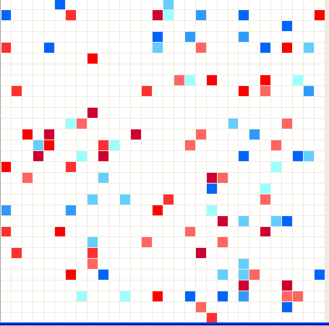
Figure 1 Initial State of low density 10%

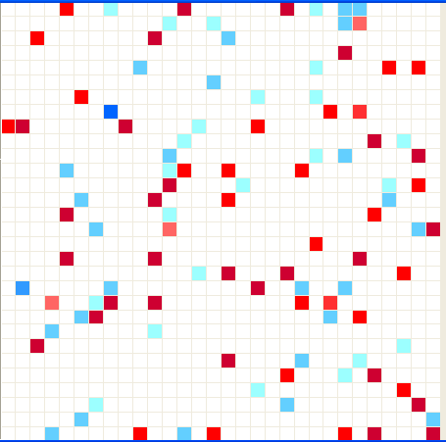
Figure 2 The cell space with low density of10% after 100 time steps
Figure 2 shows the cell space after stimulating the model for 100 time steps. We can see the particles are still randomly distributed in the whole space. The cell space remains disordered over the simulated time steps. The distributions of particles A and B are pretty homogeneous which indicates pretty high current in the system.

Case 2: Cell Space with Density of 20%
In this case, the initial cell space has the density of 20%. This is shown in Figure 3 below.

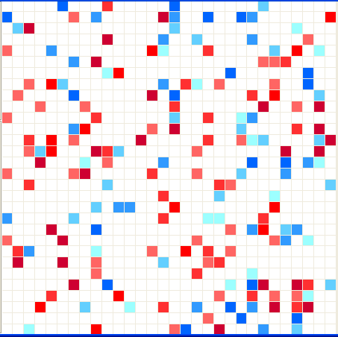

Figure 3 Initial cell space with density of 20%

After stimulating the model for 100 time steps, the cell space is illustrated in Figure 4 below.

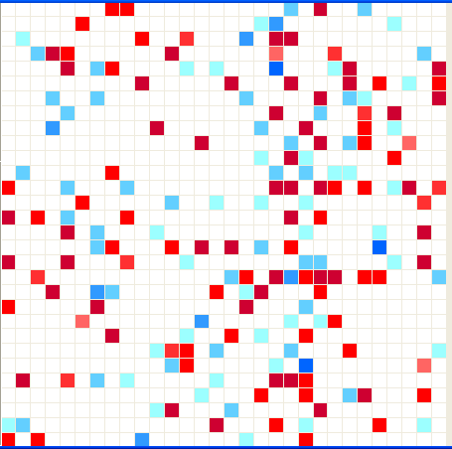

Figure 4 Cell space with density of 20% after 100 time steps
The whole space distribution is very similar to case 1 which has density of 10%.
Case 3: Cell Space with Density of 40%
In this case, the density of the whole space is pretty high. The initial cell space is illustrated in Figure 5 below.

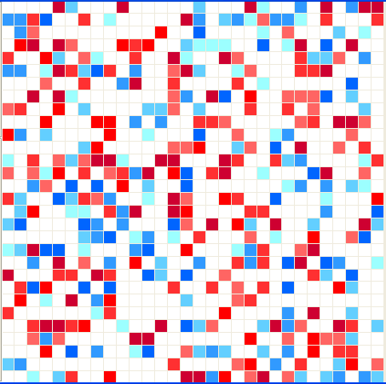
Figure 5 Initial Cell Space with density of 40%

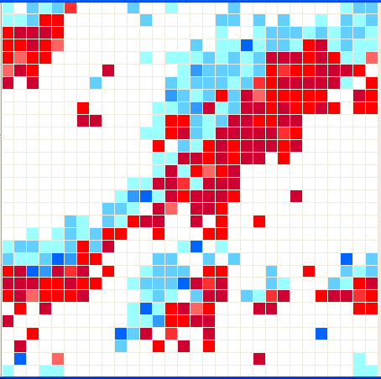
Figure 6 Cell space with density of 40% after 100 time steps
From the results at 100 time step as shown in Figure 6, we can see that the distribution of the two particles is now pretty ordered. It exhibits striped, banded structure. Within each strip, there exist two sub-strips with each having approximately the same amount of particles. This indicates the inhomogeneities of the distribution of two particles and thus results in reduced current in the system.
The following two cases with high density of 50% and 70% respectively indicate the same behavior.
Case 4: Cell Space with Density of 50%
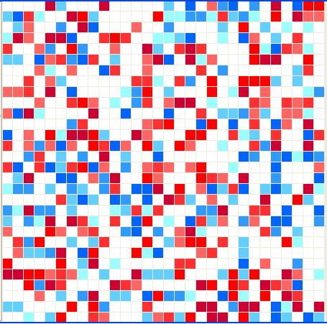

Figure 7 Initial Cell Space at density of 50%

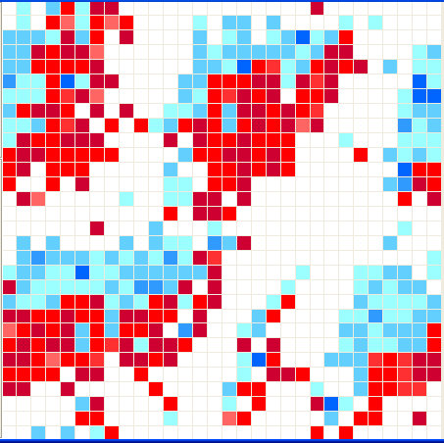

Figure 8: Cell Space at density of 50% after 100 time steps

Case 5: Cell Space with Density of 70%

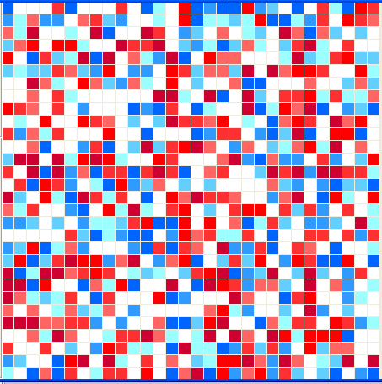

Figure 9: The Initial Cell Space with density of 70%

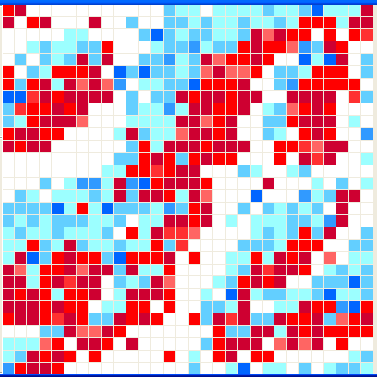

Figure 10: Cell Space with density of 70% after 100 time steps

6. Bonus Part
A partition file has been created for using the parallel simulator. The results and the model specification files are under the directory “bonus”. The driven.log is the log file generated after simulating the model for 300 milliseconds.
Suggestions:
In the partition definition, it would be more helpful if there is a note saying “follow the format strictly, no extra space allowed.”
References:
[1] R. J. Gaylord, K. Nishidate, “Modeling Nature”, Springer-Verlag New York, Inc., 1996

