Assignment # 2

Edge Detection and Noise Filter

(Part 1, 2 and Bonus Part)

By

Muhammad Asif

masif@sce.carleton.ca

Student Id: 100629549

Course: SYSC 5807

Part 1

Image Processing and Cellular Automata

Cellular automata can be successfully applied in image processing. There are many applications where cellular automata can be applied like image enhancement, noise removal, edge detection and segmentation.

Edge Detection
Edge detection in an image is one of the fundamental processes of image processing. In this assignment, I am planning to use cellular automata for edge or border detection in a two dimensional image. There are various standard image detection techniques like Sobel’s edge detector.
Each pixel of the image can be assumed as a cell. Each pixel will be compared to its neighborhood. If there is difference of values above a threshold (0 and 1 in case of binary data), then that pixel is marked as edge (1) and if that difference is not more than a threshold, then it is marked as non-edge (0).

Here is the original image.



After edge detection, it should look like this
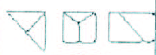

For binary data, we can assume it like this way.

 |  |  |  |  |  |  |  | 1
 |  |  |  |  |  |  | 1 | 1
 |  |  |  |  |  | 1 | 1 | 1
 |  |  |  |  | 1 | 1 | 1 | 1
 |  |  |  | 1 | 1 | 1 | 1 | 1
 |  |  | 1 | 1 | 1 | 1 | 1 | 1
 |  | 1 | 1 | 1 | 1 | 1 | 1 | 1

And after applying edge detection using cellular automata, ideally it should look like this.
 |  |  |  |  |  |  |  | 1
 |  |  |  |  |  |  | 1 | 1
 |  |  |  |  |  | 1 |  | 1
 |  |  |  |  | 1 |  |  | 1
 |  |  |  | 1 |  |  |  | 1
 |  |  | 1 |  |  |  |  | 1
 |  | 1 | 1 | 1 | 1 | 1 | 1 | 1

References:

http://www.christhomas.co.uk/dissert/dissertation.htm

http://www.nd.edu/~mtns/papers/17761_4.pdf

Part 2

Modification in Part 1
I have assumed to analyze the image in binary format in CELL DEVS. After analyzing this, I come to conclusion that edge detection is very simple to do. So I added one more fundamental aspect of image processing i.e Noise Removal Filter. Idea of this filter is to removal the noise from image along with edge detection.

Neighborhood
For image processing, it is a general practice to assume neighborhood of 3x3, either working in cellular automata or not. So I have assumed to consider neighborhood of 3x3 for my assignment.

Algorithm
Generally, the computation involved in noise removal filter and edge detection is same, and they only differ in thresholds. Actually, good edge detection techniques also included noise removal property in them like Sobel Edge detector or Laplacian Edge Detector.

As I am working on edge detection and noise removal at the same time, so I assumed that if in the neighbor hood, there are more than 2 pixels which have same value, then it is a valid image data.
trueCount () > 2
For edge detection, I have to differentiate between pixel which is at the boundary and the pixel which is local inside of image. As we know, shapes can have corners as well, so keeping in mind that I come up with following rules.

trueCount () <= 7 and (0,0) = 1 → boundary pixel
trueCount () > 7 and (0,0) = 1 → not boundary pixel

Combining rules of edge detection and noise removal filter, I come up with following rules.
rule : 0 100 { (0,0) = 1 and trueCount > 7 }
rule : 1 100 { (0,0) = 1 and trueCount <= 7 and trueCount >2 }
rule : 0 100 { t }

DEVS Formulism

External Coupling Definition

M = < X, Y, D, {Mi}, {Ii}, {Zij}, select>

I have no external coupling with any outside world. So I am not defining this portion of formalism.

Atomic Cell Devs Model

CD = < X, Y, I, S, θ, N, d, δ_{int}, δ_{ext}, τ, λ, D >

X
Cell sees its entire neighbor as input to evaluate its next state.

Y
There is no output from a cell. Each cell represents a pixel of image, and it evaluates its future state according to neighbor.

S = {Real}
Since I am using binary images. So the possible states of the cell are 1 and 0.

N = There is no input values for this model.

I = <n,u,P^{x}, P^{y} > = {none}
θ = (s,phase,σqueue, σ)
The state changed from 1 to 0 after a transport delay and vice versa.

δ_{int} , δ_{ext} , τ, λ, D = There is no such functions. Please refer to edge.ma file for these values.

Couple Cell-DEVS

GCC = < XList, YList, I, X, Y, n, N, {e,f }, C, B, Z, select >

XList = { (m,n,) where m and n belongs to N, 0 <= m <= 30, 0 <= n <= 30}
YList = { none }

I = <P^{x}, P^{y}> = {none}

N = { (-1,0), (0,-1), (0,0), (0,1), (1,0), (1,0),(-1.-1) , (1,-1),(1-,1)}

X = {none}
Y = {none}
n = 9
e = 30 (used 20 for single examples)
f = 30 (used 20 for single examples)
C = { C_{ij}/ i ε [0,30], j ε [0,30]}, where C_{ij} = < I_{ij}, X_{ij}, Y_{ij}, S_{ij}, N_{ij}, d_{ij},
δ_{intij}, δ_{extij}, τ_{ij}, λ_{ij}, D_{ij}> is an atomic component.

B = {none} (wrapped)

Z = There is no coupling in my case.
Select = there is no priority in this case

Testing and Animation on Modeler

After building model, I have tested it for following scenarios one by one and then I combine all in one VAL file.

Rectangle
Rectangle is the simplest shape. I create a sold rectangle and then test the model. Edges are detected perfectly and noise is removed in steps.
Here are results on Modeler.
At 00:00:00:000
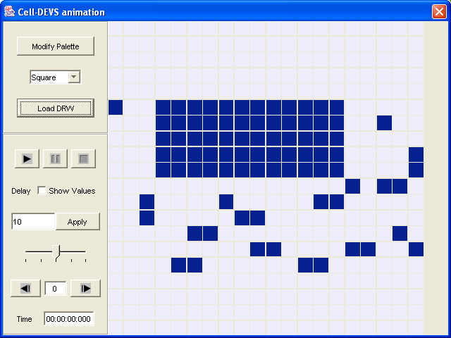

At 00:00:00:100
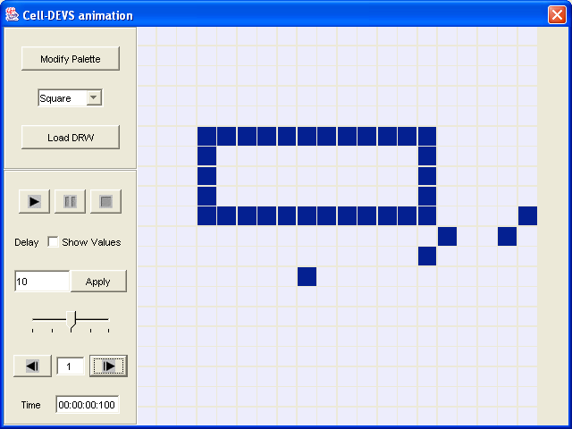

At 00:00:00:200
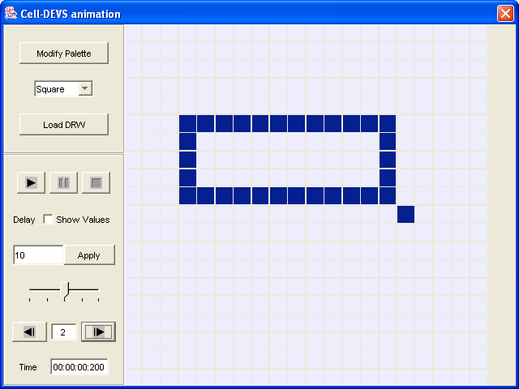

At 00:00:00:300
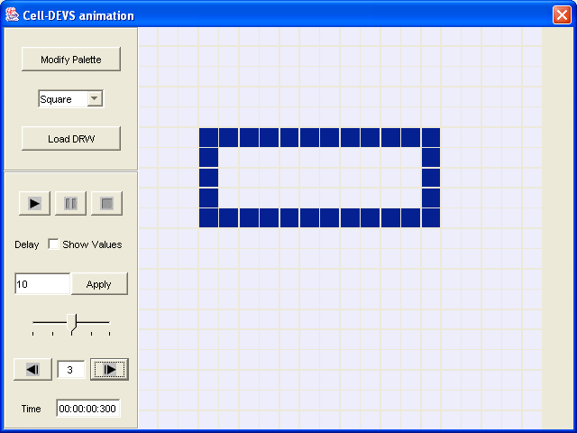

Triangle
Results of triangle case are here. Model works pretty well for it as well.
At 00:00:00:000
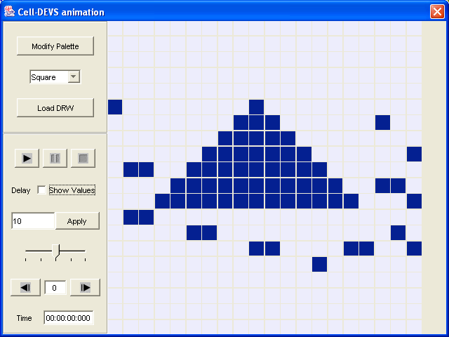
At 00:00:00:100
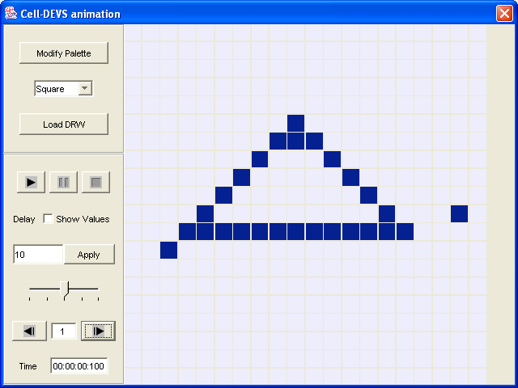

At00:00:00:200
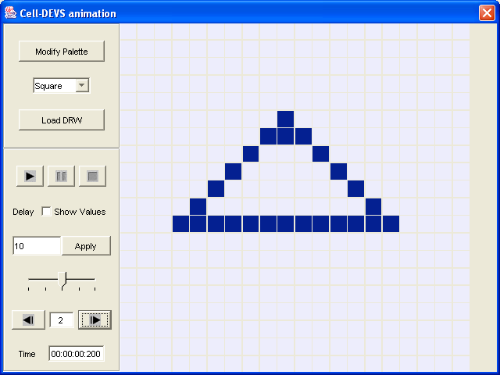

Parallelogram
Applying model simulation to a parallelogram results following animations.
At 00:00:00:000
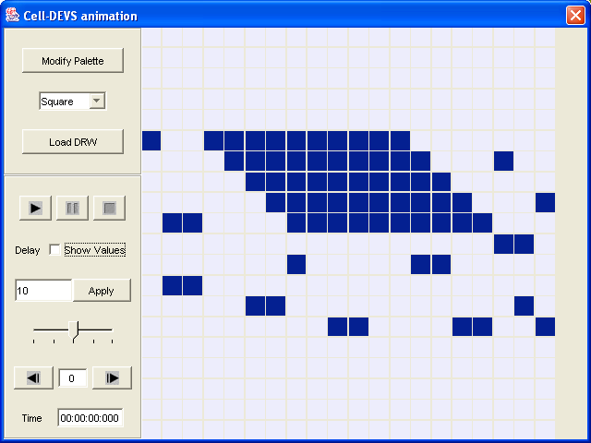
At 00:00:00:100

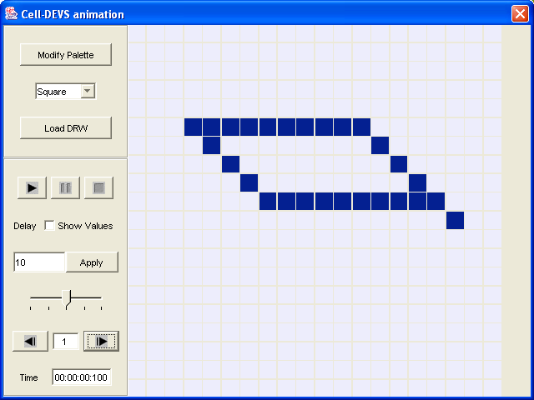
At 00:00:00:200

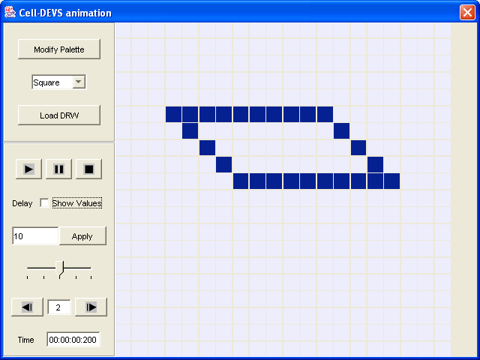
Alphabet Letter “T”
At 00:00:00:000
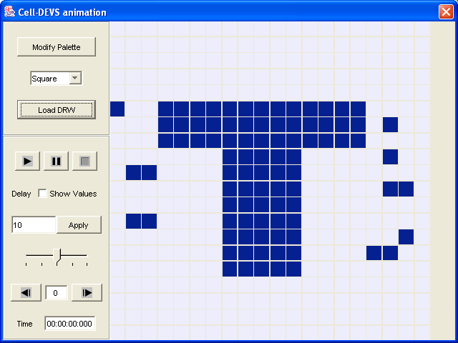
At 00:00:00:100.
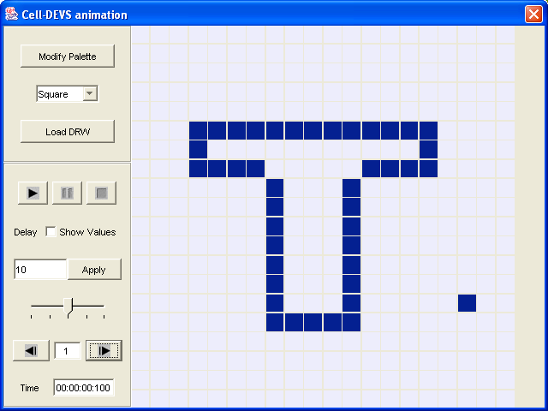

At 00:00:00:200
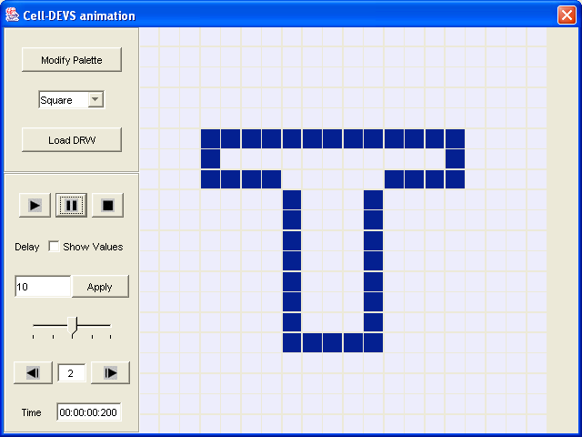
Complex Shape
I take a complex shape and test it for this model.
At 00:00:00:000
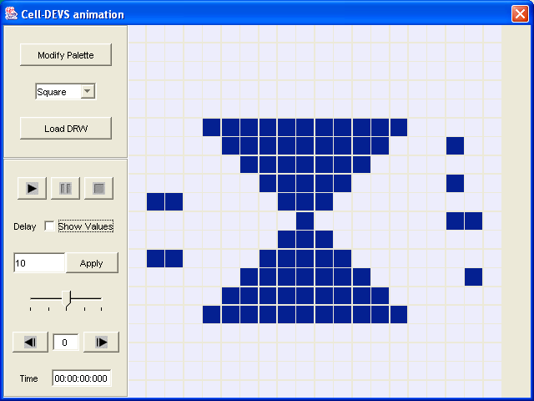
At 00:00:00:100

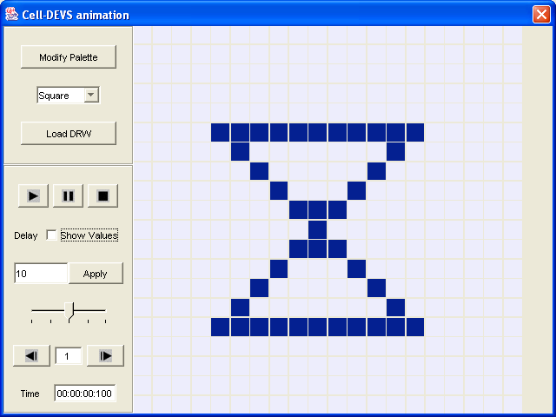

Combining All Scenario
At the end, I combine all these scenarios in one input date file (VAL file) and finalize my pal file. I set background (0 values to light grey).

The purposes of this exercise is also to facilitate Prof. to test all scenarios in one go and use this final version for simulation on VRML tool.

Here is input shown on Modeler.
At 00:00:00:000
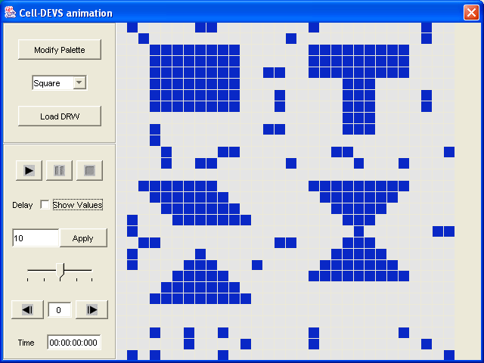
At 00:00:00:100
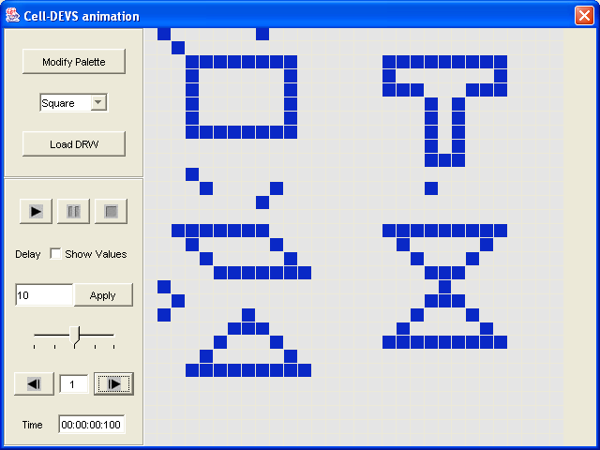

At 00:00:00:200

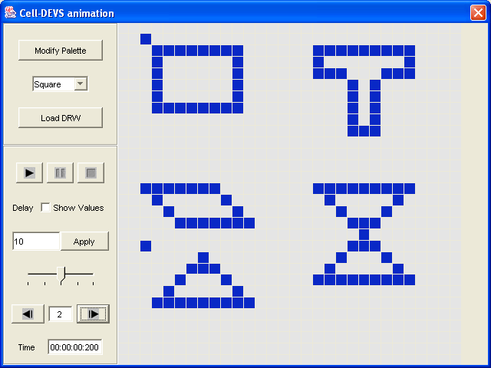
At 00:00:00:300
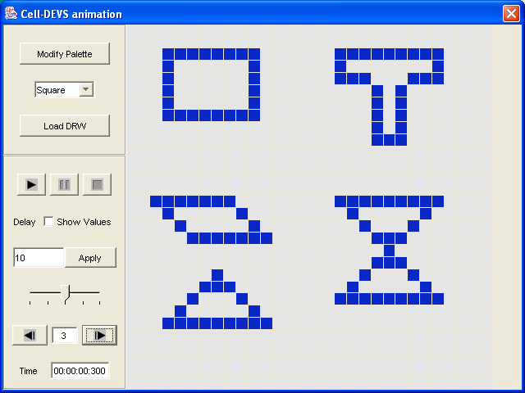

Interesting Conclusion
Behavior of Noise filter is interesting in cellular automata and better than in classical approaches of image processing. In classical approaches, we analyze image pixels only once for noise removal and get results after one iteration. Here in cellular automata, we iterate this up till our rules of noise removal are not able to find any further noise in the image.

Bonus part

I am using combined image input for analysis of model in VRML GUI.

Observation
One observation is that, VRML gui is giving error on pal file created by Modeler. When I dig out the problem, I found that I have not set colors for all intervals. VRML GUI requires setting of color for all intervals. When I did it, then there is no error.

Below are the screen shots of analysis done in VRML GUI.

After loading edge.drw file

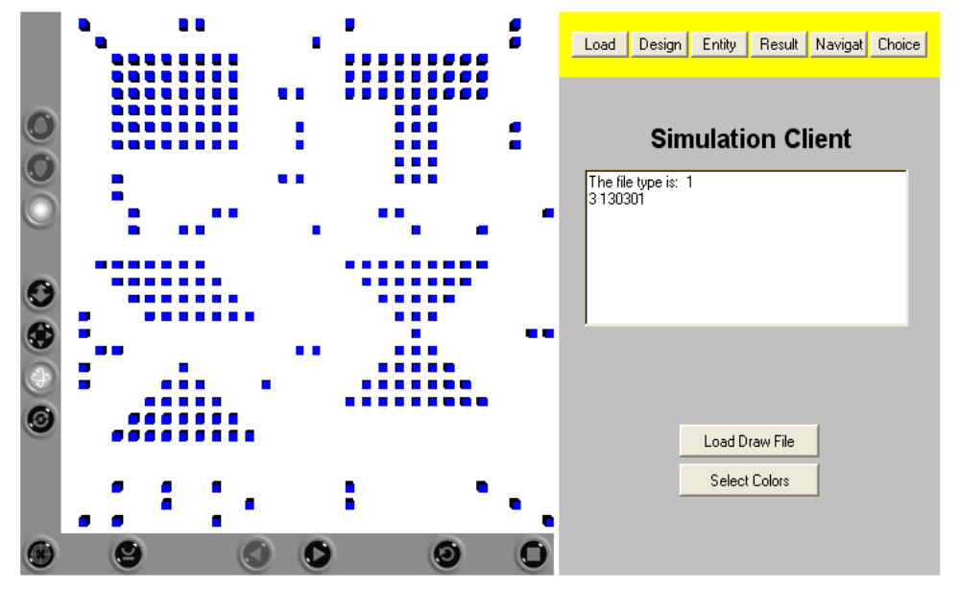

Then I go to navigate part of tool
At 00:00:00:000
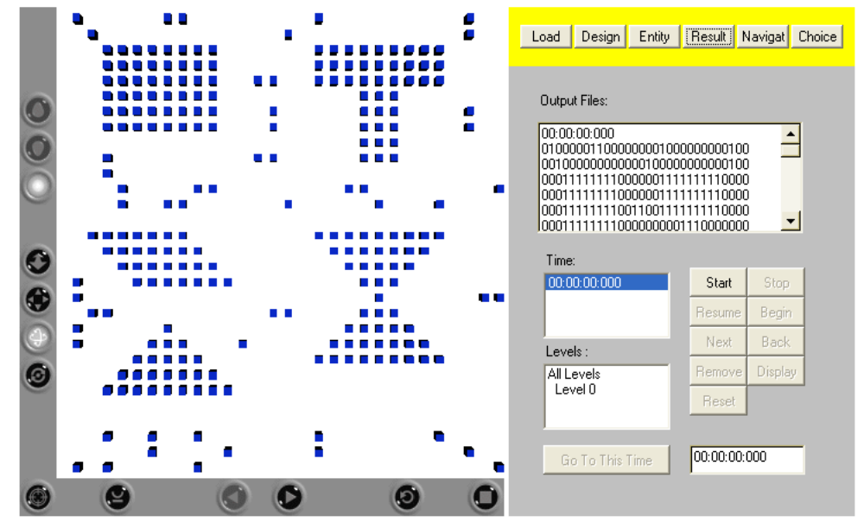
At 00:00:00:100
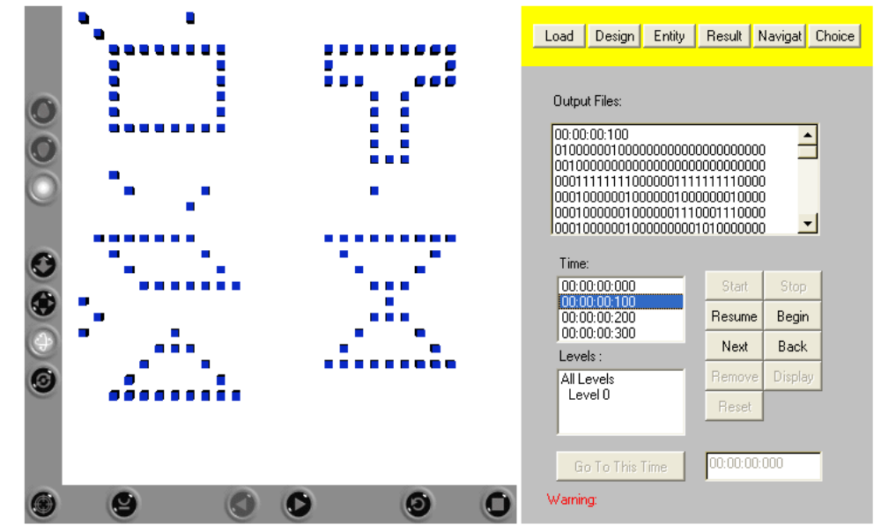
At 00:00:00:200
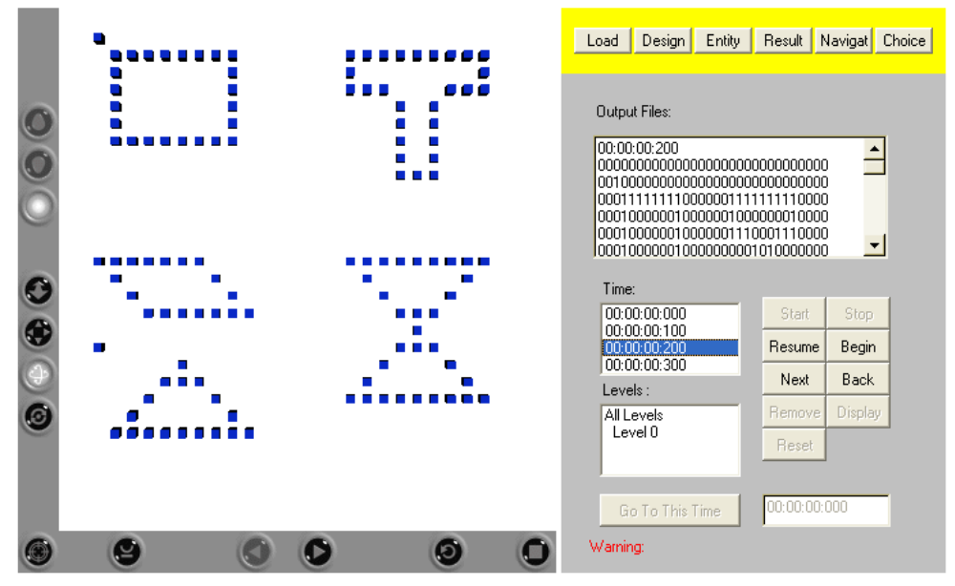
At 00:00:00:300

Entity view is like this

Another view at the end

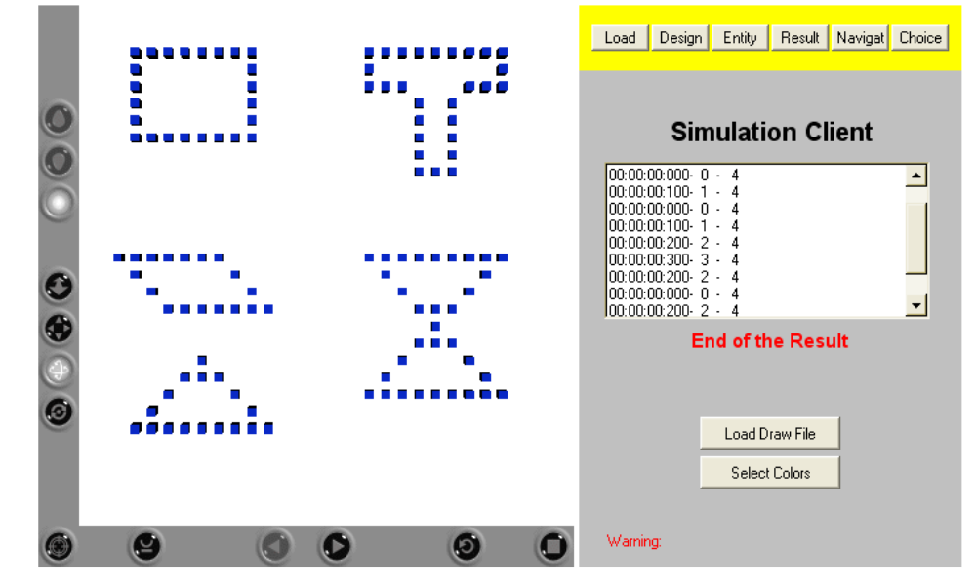

Using the Roll button, I flipped all the stuff, and images are like this

