Introduction
The simplest form of enzyme kinetics is expressed in the following equation:

1

Here an enzyme E and a substrate S combine to form a complex. While bound to the enzyme, the substrate may be transformed into product P, i.e., the enzyme acts as a catalyst. Interactions between an enzyme and a substrate don’t necessarily produce a product though; hence the first reaction is reversible as denoted by . In this model it is assumed that once a product forms it is permanent.

Modelling Using Cell-DEVS
The Cell-DEVS model was created using a 20×20 matrix representing the container for the various chemical species. Initially it holds only E and S as depicted in Figure 1.

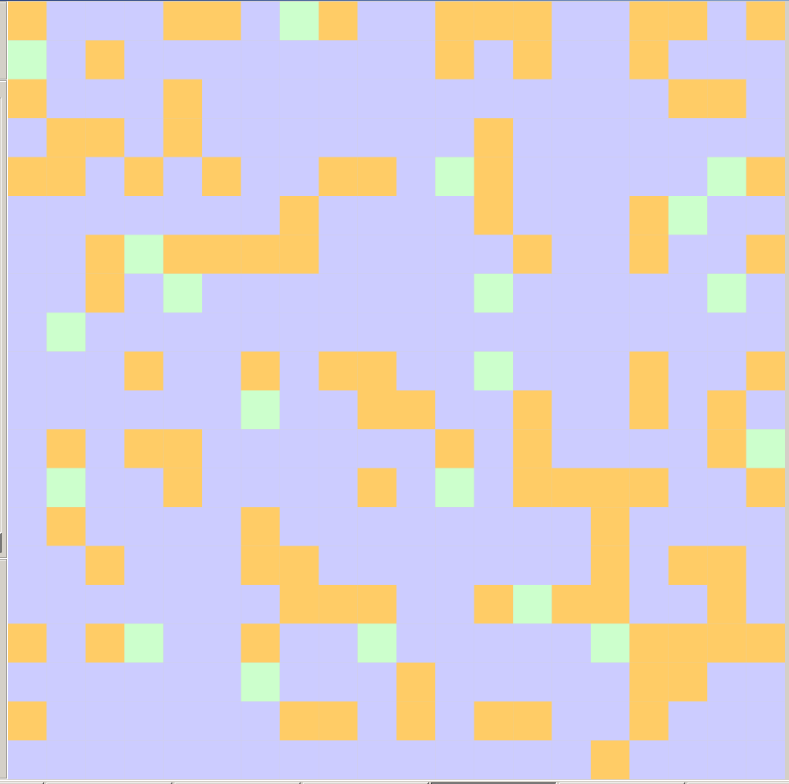
Figure 1 Initial Distribution of Enzymes (Green) and Substrates (Orange) in a 20×20 Container

The container was considered to have no borders in keeping with the theme of a well-mixed container. This idea was used by Kier et al. (1996).
The Cell-DEVS model contains two layers. The first layer holds the state of each cell; the second layer holds random numbers drawn from U(0,1) used to make decisions about particle trajectories. Each cell has an extended von Neumann neighborhood as shown in Figure 2.
(0,0)
(1,1)
(-1,-1)
(-1,1)
(1,-1)
Figure 2 Extended von Neumann Neighborhood With Enumeration of Selected Cells

Enumeration of the cells in the neighborhood is increasing in a ‘down and to the right’ fashion, with the central cell being labeled cell(0,0).

Cells in the first layer (layer 0) can have 14 states:
-1 an error has occurred, this is the default state assigned if all other rules have failed
0 fluid (water) that provides no resistance to particle motion; consider it as empty space
2# enzyme
3# substrate
4# product

where # can be

1 moving from the east
2 moving from the north
3 moving from the west
4 moving from the south

Cells in the second layer are real values drawn from a U(0,1) distribution.

The model uses a transport delay with a default delay time of 100 ms.

The initial states were creating using a MatLab® (Mathworks, Natick MA) script. They are stored in the file EnzymeKinetics20by20.val. For this simulation, the random numbers in the second layer do not change. This is implemented using the rule

rule : { (0,0,0) } 100 { cellPos(2) = 1 }

i.e., for all cells in the second layer, they are assigned their current value.

The rules for each cell in the first layer depend on its state and on the states of selected cells in the neighborhood to see if any particles are adjacent and moving toward that cell. Particles move only north, south east or west; never diagonally. An example for a water cell (state 0) is shown in Figure 3 in which the relevant cells are shaded.
0
21
21
33
31
Figure 3 Example of a Water Cell With an Approaching Enzyme and an Approaching Substrate

1. shading signifies neighboring cells that are relevant in deciding the future state of the water cell
2. the enzyme in cell(0,1,0) and the substrate in cell(0,-1,0) are approaching (red shading)

The rule for this cell is of the form

% You are a water and there are two approaching particles, from the east and west.
rule : { 10*trunc((0,1,0)/10)+1 } 100 { (0,0,0) = 0 and remainder((0,1,0),10) = 1 and remainder((0,-1,0),10) = 3 and (0,1,1) < (0,-1,1) }
rule : { 10*trunc((0,-1,0)/10)+3 } 100 { (0,0,0) = 0 and remainder((0,1,0),10) = 1 and remainder((0,-1,0),10) = 3 and (0,-1,1) < (0,1,1) }

The first rule states that if cell(0,0,0) is a water cell and the cell to the immediate east is a particle moving west, and the cell to the immediate west is a particle moving east, then find out which of the two particle cells has the lesser value stored in the random number layer. The ‘winning’ cell is the one that is transformed into a water cell, while its state is transferred the current cell; the appearance is that the particle moves into the water cell and leaves a water cell behind. The second rule accounts for the opposite case. The 10*trunc((0,-1,0)/10)+1 construct is used to handle all particle types at once, i.e., a type 21, type 31 and type 41 cells are treated the same.

The second major rule category is when cell(0,0,0) is a particle and the cell in front of it, i.e., in the direction that it is moving, is a water cell. The situation and relevant cells are illustrated in Figure 4.

21
0
22
33
21
Figure 4 Example of a Particle Cell When the Cell in Front of It is a Water Cell

1. shading signifies neighboring cells that are relevant in deciding the future state of the particle cell at (0,0,0)
2. the enzyme in cell(0,-2,0) and the substrate in cell(-1,-1,0) are approaching (red shading)

The rule pertaining to Figure 4 would be:

% You are a west moving particle and the cell in front of you is water and there are two other approaching particles to the water, from the north and west.
rule : 0 100 { (remainder((0,0,0),10) = 1 and (0,-1,0) = 0) and remainder((-1,-1,0),10) = 2 and remainder((0,-2,0),10) = 3 and ( (0,0,1) < (-1,-1,1) and (0,0,1) < (0,-2,1) ) }
rule : { round( uniform(10*trunc((0,0,0)/10)+0.5000001,10*trunc((0,0,0)/10)+4.4999999) ) } 100 { (remainder((0,0,0),10) = 1 and (0,-1,0) = 0) and remainder((-1,-1,0),10) = 2 and remainder((0,-2,0),10) = 3 and ( (0,0,1) > (-1,-1,1) or ( 0,0,1) > (0,-2,1) ) }

The logic of the decision is the same as for Figure 3: if the current cell was the water cell, it would have to look at the random values corresponding to the three approaching particles. However, the current cell is one of those approaching particles, so it has to check to see which particle is going to ‘move’ into the water cell. So it has to compare its corresponding random value with that corresponding to the cell two ahead and with the random value corresponding to the cell one over and up one. So there are three random numbers to be compared. The least value ‘wins’. If the least value corresponds to the current cell, it becomes a water cell so the state value is 0, otherwise it stays the same type, but its direction can change. The change in direction is evaluated using the term
round( uniform(10*trunc((0,0,0)/10)+0.5000001,10*trunc((0,0,0)/10)+4.4999999) )
10*trunc((0,0,0)/10) gives 20 for enzymes, 30 for substrates and 40 for products. Say the value is 20, then the state is found by drawing from a U(20.5000001,24.4999999) range and rounding the value so it is equally likely to be 21, 22, 23, or 24.

The third type of rule is when cell(0,0,0) is a particle and the cell in front is also a particle. In this case only the two state values are important as illustrated in Figure 5.
31
24

Figure 5 Example of a Particle Cell Hitting Another Particle

1. shading signifies neighboring cells that are relevant in deciding the future state of the particle cell at (0,0,0)

In this case the current cell, here with state value 31, will stay occupied with a particle. Two things can happen though: (i) it can change direction and (ii) if the interaction is a substrate colliding with an enzyme, as is the case in Figure 5, then the substrate can be transformed into a product with probability 0.1. This is achieved by drawing a random number from U(0,1) and comparing it to 0.1.
% You are a west moving particle and there is a particle in front of you.
rule : { round( uniform(20.5000001,24.4999999) ) } 100 { ((0,0,0) = 21 and (0,-1,0) != 0) }
rule : { round( uniform(40.5000001,44.4999999) ) } 100 { ((0,0,0) = 31 and trunc((0,-1,0)/10) = 2 and random < 0.1) }
rule : { round( uniform(30.5000001,34.4999999) ) } 100 { ((0,0,0) = 31 and (0,-1,0) != 0) }
rule : { round( uniform(40.5000001,44.4999999) ) } 100 { ((0,0,0) = 41 and (0,-1,0) != 0) }

Comments Regarding the Rules

There are some weaknesses, or at least points to consider, in the present rule set.

1. There is a remote possibility of cycling because the random numbers in the second layer are fixed. This implies the same decision is always made for identical interactions at any cell. A better way would be to reset the second layer each time step.
2. There is a better way than the setup I use in some cases which has
rule : if random number 1 < random number 2 then do one thing
rule: if random number 2 < random number 1 then do something else
The random number 2< random number 1 condition is not required. There may be a way to do everything with one rule.
3. For the third major rule type (particle approaching another particle), if a particle is an immediate neighbor and is heading toward a cell which has a departing particle, it cannot move into the vacated cell. To allow this requires expanding the neighborhood to look at all of the possibilities of the neighbor. Whether this is a problem is debatable, but the concept is worth considering.
4. When a particle bumps into another one its direction is changed randomly, including keeping moving in the same direction. A more sophisticated rule would be to force a change of direction when a particle is in this situation.

Running the Simulation
As the simulation runs, substrate gets converted to product. 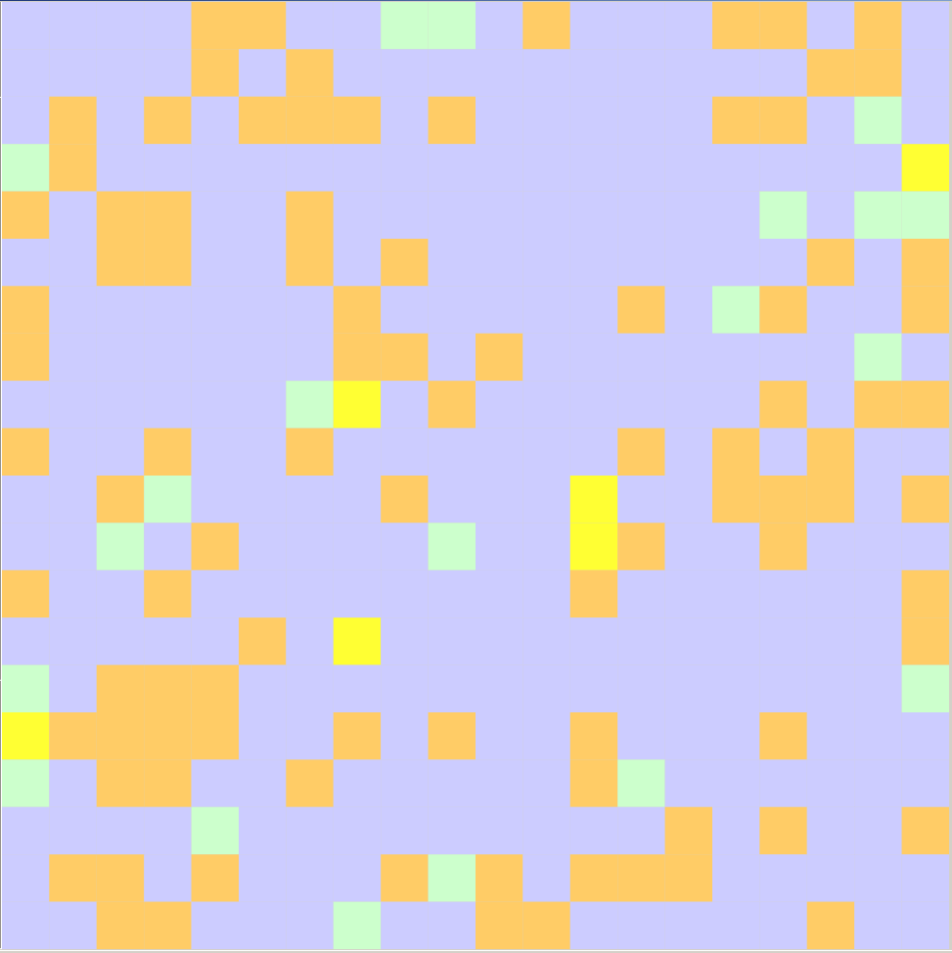
Figure 6 Conversion to Product (Yellow) After One Second

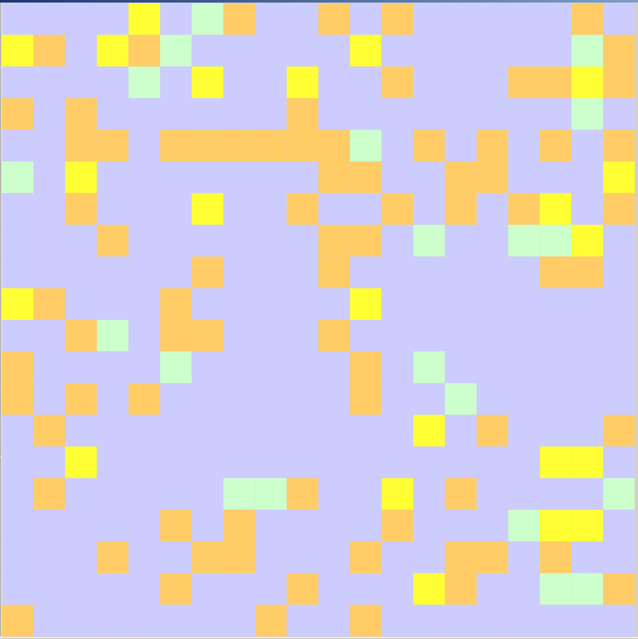

Figure 7 Conversion to Product After Five Seconds

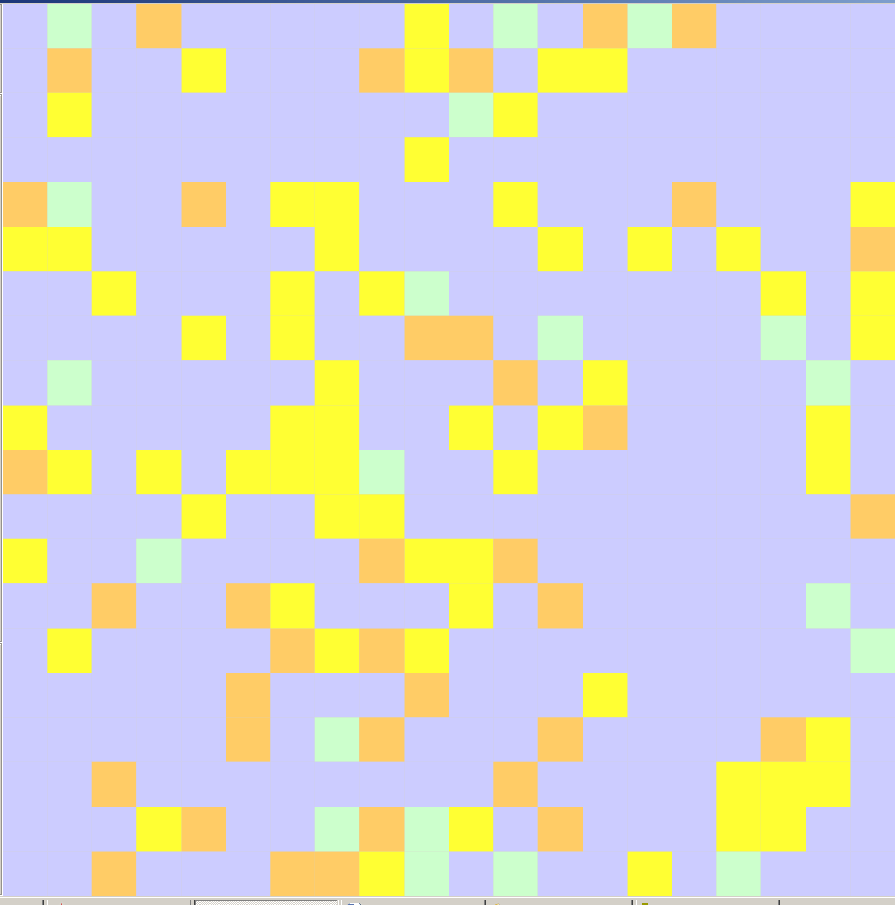
Figure 8 Conversion to Product After Twenty Seconds

Initially there are 20 enzymes and 100 substrates. After 1 second there are 6 P, after 5 seconds there are 22 and after 20 seconds there are ~60. The number of enzymes at the end of the simulation is still 20 as required. You can see that the conversion rate is decreasing with time as expected.

Discussion

In typical kinetic modeling, a system of differential equations is written for the system, e.g.,
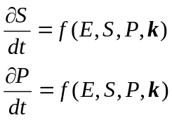 2
where k is a vector of parameters called rate constants. Data are collected and nonlinear regression is used to estimate the rate constants. The rate constants are related to the frequency of successful interactions between the reactants, in this case that means they are related to the frequency that a substrate bumps into an enzyme and the random number drawn is less than 0.1.
The differential equation formulation assumes that the concentrations of the reactants are continuous variables. When concentrations are on the order of moles/liter then this assumption is valid. When concentrations become very small as may be the case in cell modeling, one can use stochastic simulation algorithms (SSA) (see Gillespie (2007) for a review). For these simulations there is a transformation of the rate constants so they are suitable for the stochastic nature of the algorithm.
What would be interesting would be to try to relate the cutoff for determining a successful interaction that forms a P, here it is 0.1, to the rate constants for the reaction. The relationship would be specific to the set of rules used. The key steps would be to
1. set the cutoff value for a successful interaction
2. run a simulation and collect concentration versus time data (number of S and P vs time)
3. fit a nonlinear regression using equation 2 to get the rate constants
4. compare the rate constants to the cutoff value in (1)

One could do a similar analysis using a stochastic simulation algorithm to ‘solve’ the differential equations. Of course, every time you run an SSA you get different profiles because of its stochastic nature so fitting it to data is not so simple, but the profiles don’t vary too much unless you have only a very few particles.

Possible modifications/enhancements to the present simulation would include
1. implementing the ideas in the discussion of the rules
2. adding boundaries of various configurations
3. providing zones of attraction around enzymes so that nearby substrates have an increased
probability of moving toward the enzyme compared to totally random movement
4. allowing the particles to move along diagonals
5. allowing 3-dimensional movement.

Summary

This type of simulation provides a starting point for practical simulations of more complex chemical kinetic systems. If your physical system is truly well-mixed then the differential equation models are applicable, but if your system has spatial gradients, as is the case in cell models, the Cell-DEVS model can account for this. This would require finding a relationship between the parameters in the Cell-DEVS model and the concentration profiles for real systems. This may not be directly possible for some systems, e.g., measuring concentration vs time profiles in living cells. This would necessitate measuring other properties and inferring cell biochemistry, or applying relationships determined from other (physically larger so that measurements can be made) systems to cells.

Acknowledgement

The Bouncing Ball model from the example CD++ Models Web page was particularly useful in getting started.

References
Gillespie, DT (2007) Stochastic Simulation of Chemical Kinetics. Annu. Rev. Phys. Chem. 58, 35–55

Kier, LB, Cheng C-K, Testa, B & Carrupt, P-A (1996) A cellular automata model of enzyme kinetics. J. Molecular Graphics 14, 227-231

