Carleton University
Department of Systems and Computer Engineering

ADVANCED TOPICS ON COMPUTER SYSTEMS: METHODOLOGICAL ASPECTS OF MODELLING AND SIMULATION

Assignment 1

Mokhtar Amalou
Student No. 100630576

SYSTEM:
ENTERPRISE PROCESS FOR PROVISIONING data network SERVICES (EPSP)

PART I, II, III

October 20, 2003
Table of Content (TOC)
1. System Identification 3
2. Objectives 3
3. System Description 3
3.1 Customer Service (CS) Sub Model 4
3.2 Service Design (SD) Sub Model 4
3.3 Service Implementation (SI) Sub Model 4
3.4 Service Activation (SA) Sub Model 5
4. Model Structures 6
5. Model Variables 7
6. Coupling Scheme 7
7. Formal Specifications 7
7.1 Coupled Models 7
7.2 Atomic Models 10
7.2.1 Service Queue Pseudocode 10
7.2.2 Service Request Processor Pseudocode 11
7.2.3 Service Processor Pseudocode 12
8. Testing Strategy and Test Cases 12

List of Figures
Figure 1: Flow Chart of Enterprise Process for Provisioning Data Network Services 3
Figure 2: EPSP Model Structure 6
Figure 3: EPSP Model Structure with Atomic & Coupled Models 6
Figure 4: EPSP Coupling Scheme 7

PART I: Conceptual Model Description

System Identification
Our system is a simple enterprise process for provisioning data network services (ATM, FR, DSL, ISDN, Leased Line, DDN, X.25, etc.)
This process is typically used in telecommunications services providers such as Bell Canada to systematically perform the operations related to Customer Service, design, implementation, testing and activation stages. The figure (1) illustrates the operational flow chart description for this process.
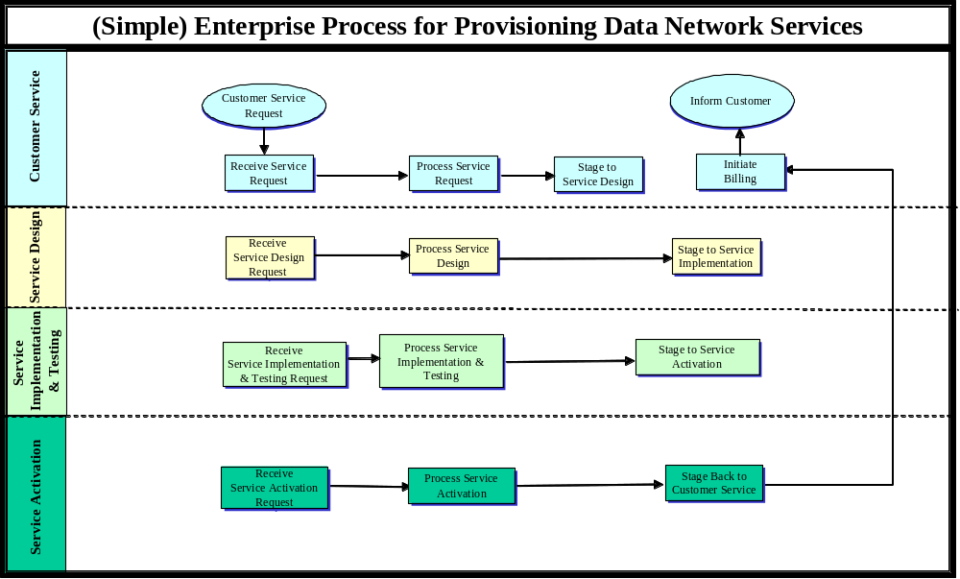

Figure 1: Flow Chart of Enterprise Process for Provisioning Data Network Services

Objectives
The objective of this project is on one hand to model the system in order to gain a better understanding of its operations workflow and on the other hand to simulate the system in order to analyze its characteristics. The most important characteristic of interest to us is the process cycle time, ie: how long it takes to provision a data service?
The objective of a telecom operations organization is to reduce as much as possible the process cycle time by optimizing the enterprise processes (reorganizing/removing/merging process operations) in order to fulfill the objective set by the telecom business organization. For example, the business organization may set the objective to handle 1000 customer requests per day (8 hours) for new data network services. The enterprise process used by the operations organization (may) or (may not) be capable of handling 1000 request per day. Modeling and simulation of this process will provide a definite answer about the process strengths and weaknesses.

System Description
The TOP model of our system is the Provisioning Process. It is naturally decomposed into five sub models (level 2):
- Customer Service: is responsible for interfacing with the customers, receiving customer requests for new services, completing the requests with additional information and informing customers of service ready for utilization.
- Service Design: is responsible for designing the network architecture (nodes, interfaces, routes) to support the service.
- Service Implementation & Testing: is responsible for the implementation (also called cross-connections) and the end-to-end testing activities of the service.
- Service Activation: is responsible for activating the network components supporting the service and making sure that the service is working accordingly.

Customer Service (CS) Sub Model
The CS sub Model is initiated by receipt of a customer request containing a Customer Request Description (CRD) for a new data service to install. It concludes when the service description request is completed with additional information and forwarded to the design sub model. The following is the internal scenario of the SD sub-Model.
- A customer request is received for a new data service. The request is added into the customer_request_queue according to the first in first out regulation.
- After some time, the request is taken for processing. The processing means completing customer requirements with additional information. A profile is required for each customer. The profile includes parameters such as speed or bit rate, window size, features, class, and protocol parameters. Some of the parameters are contained in customer information and provided on the service request. Other parameters must be determined via internal resources.
- After Some time, the request is completed with additional information and becomes the Customer Service Description (CSD).
- After Some time, the CSDD is forwarded to Service Design Sub Model.

Service Design (SD) Sub Model
The SD sub Model is initiated by receipt of a Customer Service Description (CSD) describing requirements to design a new data network service. It concludes when the new service is designed according to the requirements and forwarded to the implementation sub model. The following is the internal scenario of the SD sub-Model.
- The CSD request is received. It is added into the service_design_queue according to the first in first out regulation.
- The analysis stage starts with a step to qualify the request. Such as, local loop length that impacts specific transmission parameters is not permitted for DSL service or the facilities necessary for the service are not currently available on or nearby the customer site. In these situations, the request is denied and the customer is informed accordingly. However, in our model, we simplify the process by considering only valid requests.
- Once the request for a new data service is accepted, a high level design is created, which defines the network components involved (switches, circuits, ports, etc.).
- When the design is completed, physical resources are reserved (on hold) for the implementation of the service. A Service Design Description (SDD) is created.
- After Some time, the SDD is forwarded to Service Implementation & Testing Sub Model.

Service Implementation (SI) Sub Model
The SI sub Model is initiated by receipt of a Service Design Description (SDD) describing the design of a new data network service. It concludes when the new data service is implemented and tested. The following is the internal scenario of the SI sub-Model:
- The SDD request is received. It is added into the service_implementation_queue according to the first in first out regulation.
- The SIT sub-model analyzes the SDD. Physical cross connections are performed between the ports on the exchange and ports on the facility nodes used for inter exchange transport. The Service Implementation Description (SID) is created which describe the implementation details.
- The SIT will coordinate an end to end test on the network components supporting the service as described in the SID. Testing plan (including test cases, test schedule, etc.) is prepared. The testing staff performs the actual test set up and run test cases. Testing continues until all the test cases are executed successfully.
- After Some time, the SID is forwarded to Service Activation Sub Model.

Service Activation (SA) Sub Model
The SA sub Model is initiated by receipt of a Service Implementation Description (SID) describing the implementation of the requested data network service. It concludes when the new data service is activated and billing is initiated. The following is the internal scenario of the SA sub-Model:
- The SDD request is received. It is added into the service_activation_queue according to the first in first out regulation.
- For each data service customer, unique information describing the type and grade of service as well as service parameters must be applied to the data exchanges involved. The SA Sub Model will apply the service specific parameters identified on the Customer Service.
- The SA Sub Model will access the exchange components and activate the commands that achieve this new Activation.
- The SA Sub Model will perform verification to ensure that the equipments are configured to provide the desired service. Verification failures are followed by problem resolution activities until the desired results are achieved.
- At the completion of all activation, the SA Sub Model will stage back to the CS sub model in order to initiate the billing and informs the customer that the service is ready for utilization.

Model Structures
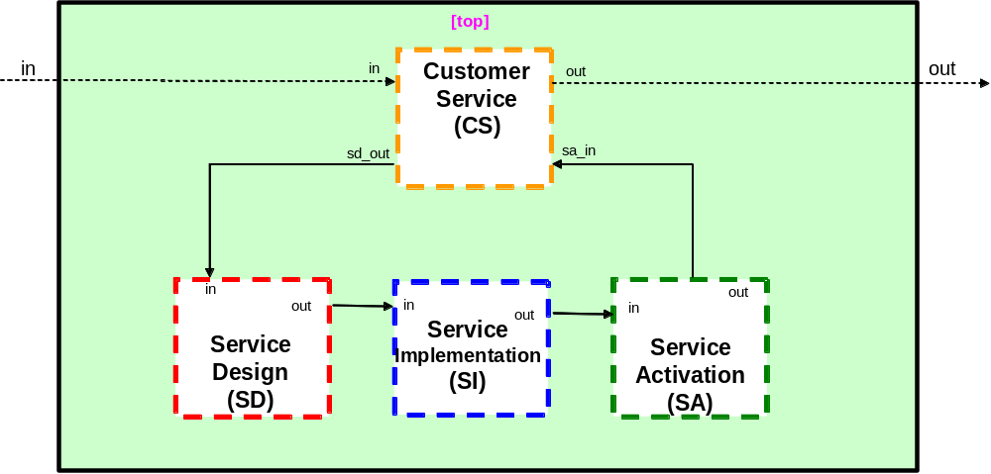

Figure 2: EPSP Model Structure
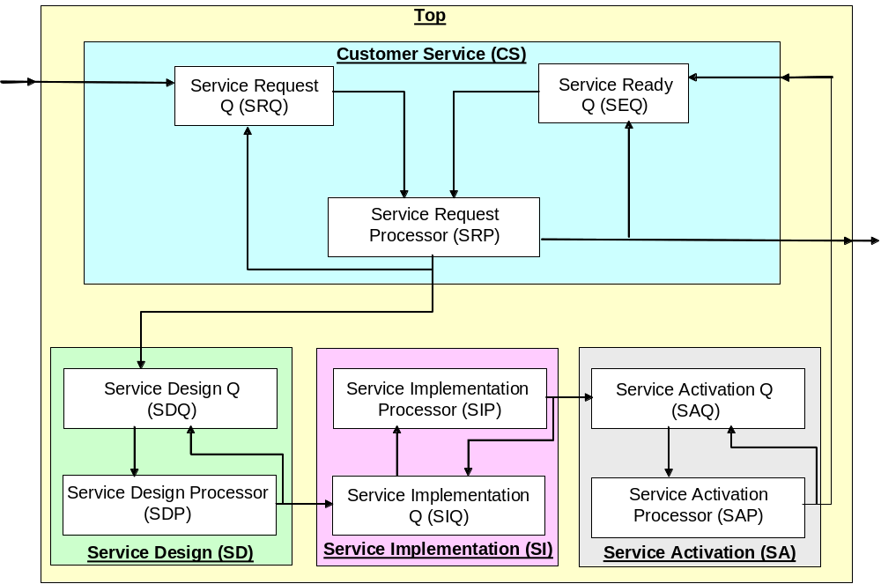

Figure 3: EPSP Model Structure with Atomic & Coupled Models

Model Variables
The following sub models are of type “queue” and have the same state variables:
- SRQ, SEQ, SDQ, SIQ, SAQ
Variables: phase, sigma, service_id, service_queue, preparation_time;
The following sub models are of type “processor” and have the same state variables:
- SRP, SDP, SIP, SAP
Variables: phase, sigma, service_id, processing time.
Note that the service “processors” do not contain the details of the processing itself since this is beyond the scope of this study. We are focusing on the process workflow only. Please read the assumptions in the following section (#5.1)

PART II: Formal Descriptions

Coupling Scheme
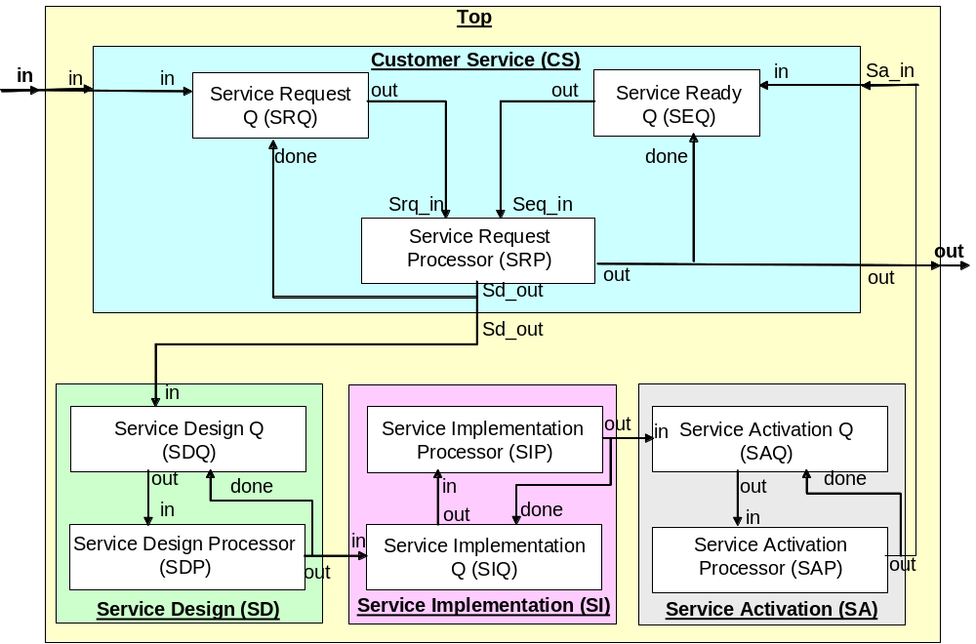

Figure 4: EPSP Coupling Scheme

Formal Specifications

Coupled Models
[top]
Components: CustomerService
Components: ServiceDesign
Components: ServiceImplementation
Components: ServiceActivation
in : in
out: out
Link: in in@CustomerService
Link: out@CustomerService out
Link: sd_out@CustomerService in@ServiceDesign
Link: out@ServiceDesign in@ServiceImplementation
Link: out@ServiceImplementation in@ServiceAactivation
Link: out@ServiceActivation sa_in@CustomerService

[CustomerService]
Components: srq@ServiceRequestQ
Components: seq@ServiceReadyQ
Components: srp@ServiceRequestProcessor

in : in sa_in
out : out sd_out

Link: in in@srq
Link: out@srq srq_in@srp
Link: sa_in in@seq
Link: out@seq seq_in@srp
Link: out@srp out
Link: sd_out@srp done@srq
Link: out@srp done@seq

[ServiceDesign]
Components: sdq@ServiceDesignQ
Components: sdp@ServiceDesignProcessor
in : in
out : out

Link: in in@sdq
Link: out@sdq in@sdp
Link: out@sdp out
Link: out@sdp done@sdq

[ServiceImplementation]
components : siq@ServiceImplementationQ
components : sip@ServiceImplementationProcessor

in : in
out : out

Link: in in@siq
Link: out@siq in@sip
Link: out@sip out
Link: out@sip done@siq

[ServiceActivation]
Components: saq@ServiceActivationQ
Components: sap@ServiceActivationProcessor

in : in
out : out

Link: in in@saq
Link: out@saq in@sap
Link: out@sap out
Link: out@sap done@saq

Atomic Models
The following models have all the same formal specification with minor adaptations during CD++ coding. It is derived from the Queue formal specification
SRQ, SEQ, SDQ, SIQ, SAQ.

Service Queue Pseudocode
SRQ = <X, S, Y, δint, δext,λ, ta >
- X = {in, done}
- Y = {out}
- S = {phase, sigma, service_id, service_queue}
- ta = preparation_time;

δext (s, e, x )
{
Case port
in:
Case phase
Idle: //start processing the service request
service_id = x;
sigma = preparation_time;
Phase = Busy
Busy:
add (x, service_queue); //add the request into srq queue
sigma = sigma – e;
done:
If empty (service_queue)
Phase = Idle;
Sigma = infinity
Else
service_id = get (service_queue);
sigma = preparation_time;
phase = busy;
End if
}
δint ( s, e )
{
Phase = Idle;
sigma = infinity;
}
λ (s)
{
Send service_id to the port out
}

Service Request Processor Pseudocode
The following is the formal specification for the Service Request Processor atomic model (SRP) which belongs to the Customer Service Coupled model.
SRQ = <X, S, Y, δint, δext,λ, ta >
- X = {srq_in, seq_in}
- Y = {sd_out, out}
- S = {phase, sigma, service_id}
δext (s, e, x )
{
if port = srq_in
servicestatus = newservice;
else
servicestatus = oldservice;
endif;
service_id = x;
sigma = processing_time;
Phase = Busy;
}
δint ( s, e )
{
Phase = Idle;
sigma = infinity;
}
λ (s)
{ if servicestatus = newservice
Send service_id to the port sd_out //the service request should go to the design
Else
Send service_id to the port out //the service request has been activated and billing started
}

Service Processor Pseudocode
The following models have all the same formal specification with minor adaptations during CD++ coding.
SDP, SIP, SAP.

SRQ = <X, S, Y, δint, δext,λ, ta >
- X = {in}
- Y = {out}
- S = {phase, sigma, service_id}
- ta = processing_time;

δext (s, e, x )
{
service_id = x;
sigma = processing_time;
Phase = Busy
}
δint ( s, e )
{
Phase = Idle;
sigma = infinity;
}
λ (s)
{
Send service_id to the port out
}

Testing Strategy and Test Cases
We have three groups of atomic models:
- Service-Queuing models: SRQ, SRQ, SDQ, SIQ, SAQ
- Service-Processing models: SAP, SIP, and SAP.
- Service-Request Processor: SRP.
The models in each group above can use the same set of input data to test them because they have similar structure and behavior.
We design input data that cover most cases to test each model respectively. We run the model and compare the output file and log file with what we get by simulating manually.

PART III: IMPLEMENTATION
Results:
- Successfully complied all the models and generated a simulator in Cygwin env.
- Successfully tested all the atomic models
- Failed to test the coupled model. I can’t understand the reason!
Testing Structure:
Model | .ma | .ev | Log | Out
Epsp  (epsp.bat) | Epsp | Epsp | Epsp | Epsp
Customer Service  (epsp-CS.bat) | Epsp-CS-only | Epsp-CS-test | EpspCSlog | epspCSout
Service Design  (epsp-SD.bat) | Epsp-SD-only | Epsp-SD-test | epspSDlog | epspSDout
Service Implementation  (epsp-SI.bat) | Epsp-SI-only | Epsp-SD-test | epspSIlog | epspSIout
Service Activation  (epsp-SA.bat) | Epsp-SA-only | Epsp-SA-test | epspSAlog | epspSAlog

Discussion
Description of service-queuing based models:
I developed the service-queuing atomic models using the Queue example that comes with cd++ package. Our Model is simple because of the following assumptions:
- All the customer requests are accepted
- There are no operational failures in design, implementation, testing and activation stages
- Each sub-model handles only one job at a time (no parallelism). This means that a sub-model can be busy handling the request or idle waiting for a new request.
Description of service-processing based models:
These models are a bit different from the above models. They process the service request depending on the stage (Design, Implementation, and Activation). For example, the SDP is responsible for designing the service, whereas SIP is responsible for implementing the service.
The model internals are dependant on factors that are important but difficult to model. Those factors are, for instance: Number of People involved performing a task (Design, Implementation, Testing and Activation), tools used to support the activities, pure manual activities that are performed without any tool support, etc. Each of these factors should be weighted with its impact (positive or negative) on the overall activity lead-time.
In other words, we can roughly formalize the lead-time of an activity such as:
Lead-time (activity) = Type-of-service {MLT * (1 – [T1 (#workers) + T2 (#tools)])}
MLT is the maximum lead-time, which is the based on the worst-case scenario (1 worker, 0 tools and all tasks are manuals) for a given type of service.
T1 (#workers): is a function that receives as an input the number of workers and returns a fraction of time which is the lead-time decrease with respect to the MLT.
T2 (#tools): is a function that receives as an input the numbers of tools and returns a fraction of time that means the lead-time decrease with respect to the MLT.
Example:
For the Service Design Activity:
Service-type: ATM
MLT = 5 days (i.e. 1 worker, 0 tools and 10 manual tasks) to design an ATM service over the network.
# Workers: 3 → T1 (3) = 0.2, i.e. three employees will reduce by 20% the overall lead-time
#Tools: 2 → T2 (2) = 0.3, i.e. two automatic tools will reduce by 30% the overall lead-time
T1 and T2 functions are not linear functions.
Thereby: Lead-time (service-design) = 5 (1-05) = 2.5 days
By increasing the number of workers and using 2 automatic tools, we have decreased the lead-time for the service-design activity by 2.5 days.
However, the fact that we don’t have the definition of functions T1 and T2, we cannot model them and thus simulate the overall process lead-time since the purpose of the simulation is to create variations in the values of these factors and determine their optimal settings.
Conclusion:
As you can read from the system description, this system is an operational business process used in the telecom management environment.
I spent a lot of time trying to model specific aspects of this system as described above. However, I have not given enough time for the implementation part of the model.
I find that DEVS formalism is quite suitable to model business process and the CD++ tool is a powerful tool.
As a first experience with the DEVS and the CD++, it is positive. I would expect to gain more hands-on expertise in the future.

