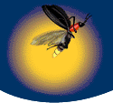

SYSC 5807

METHODOLOGICAL ASPECTS OF
MODELING AND SIMULATION

Assignment #2

“FireFly Habitat”

by

Christopher S. Smith
101828

Abstract:

In the wet areas of South East Asia, one of the most magnificent natural spectacles can be seen when thousands of fireflies gather in the early evenings and put on their synchronous flashing light shows. This paper outlines a simulation of this effect using the Cell-DEVS modeling system.

Department of Systems and Computer Engineering

CARLETON UNIVERSITY

CONTENTS

1.0 | Introduction |  |  | 3
2.0 | A Little Bit About FireFlies |  |  | 4
 | 2.1 | Habitat and Range
 | 2.2 | Natural History and Behavior
 | 2.3 | Mimicry
 | 2.4 | How do fireflies produce light?
 | 2.5 | Why do fireflies glow?
3.0 | The Model |  |  | 6
 | 3.1 | The FireFly Cell
 | 3.2 | The Coupled Model
 | 3.3 | The Rules
4.0 | Testing |  |  | 9
 | 4.1 | Expected Results
 | 4.2 | Actual Results
5.0 | Conclusions |  |  | 10
6.0 | References |  |  | 11

Appendix A: Bonus Section – VRML Tool

Appendix B: Original Researched Paper

1.0 INTRODUCTION

“One of the most spectacular examples of coupled oscillators in nature can be seen along the tidal rivers of Malaysia, Thailand and New Guinea, where thousands of male fireflies gather together in trees at night and flash on and off in unison in an attempt to attract the females that cruise overhead. When the males arrive at dusk, their flickerings are uncoordinated. As the night deepens, pockets of synchrony begin to emerge and grow. Eventually whole trees pulsate in a silent, hypnotic concert that continues for hours.” ³

In their paper, On Fireflies, Cellular Systems and Evolware, ³ Teuscher and Capcarrere attempt to produce an accurate simulation of the above phenomenon. Their simulation is limited to a two dimensional cellular array. The transition rule they use for individual cells or fireflies is; if there is a firefly flashing in the immediate vicinity, or local neighbourhood, of the primary firefly, the primary firefly synchronizes with that firefly. This behaviour continues until all cells, or fireflies are synchronized.

The method used by Teuscher and Capcarrere is a mathematical FPGA-based method of cellular automata simulation called Evolware. It appears to be somewhat more complicated that Cell-DEVS.

In this project, I will go beyond what Teuscher and Capcarrere have done, extending the simulation into the third dimension. I will confirm their results using Cell-DEVS and show that Cell-DEVS simulates the behaviour of the fireflies better and easier.

2.0 A LITTLE BIT ABOUT FIREFLIES

Fireflies are not really "flies" as entomologists know them, but are beetles in the family Lampyridae. "Flies" have one pair of wings (like houseflies) while all other winged insects, like fireflies, have two pairs of wings, or, four wings in all.

Most known firefly species are bioluminescent as adults. However, all known firefly larvae are bioluminescent, as are firefly eggs. Thus, the ability to glow as an adult insect is not the characteristic that defines this group of beetles, but, rather the bioluminescence of the larvae.
Also not all bioluminescent beetles are fireflies.

2.1 Habitat and Range

Most firefly larvae are found in rotting wood or other forest litter or on the edges of streams and ponds at night. Some Asian species are fully aquatic and live underwater, feeding on aquatic snails. The larvae of several tropical firefly species in the genus Pyractomena are strictly arboreal, feed on arboreal snails and pupate while hanging under living.

Adult fireflies are found in the same general habitats as their larvae. Generally speaking, the highest number of firefly species are found in warm, humid areas of the world. Some species, however, are found in very arid regions of the world. In these arid regions, larvae and adults can be readily found following rains. The greatest number of firefly species are found in tropical Asia and Central and South America.

Some species of firefly are found in the United States and Canada but rarely west of about the middle of Kansas or Manitoba and seldom north of southern Ontario.

2.2 Natural History and Behavior

Firefly Larvae are predaceous and have been observed feeding mostly on earthworms, snails and slugs. Multiple larvae have also been observed attacking large prey items, such as large earthworms.

Adult fireflies also have long sickle-shaped mandible mouth parts suggestive of predation. Although it is widely known that fireflies of a few species mimic the mates of other species in order to attract and devour them, observations of adults feeding on other prey items are practically non-existent. It is likely however, that adults might feed on plant nectar in order to sustain their energy requirements in the adult stage, which can last several months or longer.

2.3 Mimicry

Aggressive mimicry is a phenomenon where one organism (a mimic) tricks another organism (the dupe) into thinking it is another (the model), with the result being a negative outcome for the dupe, as well as the model. In the case of aggressive mimicry in fireflies, mated females that belong to a few species in the genus Photuris mimic the female responses of other fireflies in the same area in order to attract males of the mimicked species. When these males are tricked (or duped) into landing near these mimics to mate, they are pounced upon and eaten. Recent evidence also suggests that these female mimics are not only acquiring food but also defensive chemicals from their prey, which they themselves do not produce in large quantities.

2.4 How do fireflies produce light?

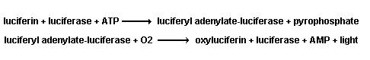
Fireflies produce light via a chemical reaction consisting of Luciferin (a substrate) combined with Luciferase (an enzyme), ATP (adenosine triphosphate) and oxygen. ATP is the basic energy molecule of all living organisms. When these components are added, light is produced. The following describes the reaction:
These reactions take a small time to propagate, perhaps 0.5 seconds. ¹ After a discharge there is a small recharge period required before the firefly can discharge again. Cycles for different species range from one second to ten seconds. ¹

There are several theories on how fireflies control the "on" and "off" of their photic organs. However, the exact mechanism(s) has yet to be worked out. The Oxygen Control Theory" is based on the firefly turning on and off its light by controlling the oxygen supply to the photic organ for use in the chemical reaction. The "Neural Activation Theory" hypothesizes that fireflies have neural control of structures called "tracheal end cells" which, upon stimulation, may release a messenger molecule in the photic organ which initiates the activation of the chemical reaction. Regardless of how fireflies control the "on" and "off" of their bioluminescence, the production of light in the above manner is very efficient, with very little heat being given off as wasted energy.

2.5 Why do fireflies glow?

All known firefly larvae have photic organs and produce light. The most generally accepted hypothesis is firefly larvae use their luminescence as a warning signal (aposematism) that communicates to potential predators that they taste bad because they have defensive chemicals in their bodies. These larvae increase both the intensity and frequency of their glow when disturbed.

Not all firefly species are bioluminescent as adults. Of the species that are, one or both sexes use species specific flash patterns to attract members of the opposite. These bioluminescent signals can take the form of anything from a continuous glow, to discrete single flashes and multi-pulsed flashes.

In most species of North American fireflies, during a certain time of night, males fly about flashing their species specific flash pattern. Females of the same species tend to be perched on vegetation, usually near the ground, and if a flashing male catches a female's fancy, she will respond at a fixed time delay after the last male's flash. A short flash dialogue may ensue between the male and female as the male locates her position and descends to mate.

Aspects of male flash patterns are also thought to be affected by sexual selection. ²
Female fireflies have been shown to prefer certain characteristics of a male's photic signal (such as increased flash rate) and respond preferentially to males that possess these "sexy" signal components. After all, not flashing would allow more energy to be used in mating and, thus, more offspring and, thus, the depletion of the flashing behaviour.

One of the most spectacular aspects about the flashing behaviour is the synchronized flashing that some south-east asian fireflies exhibit. Thousands of fireflies begin to gather in the early evening hours flashing at different random rates. Within hours, their flashing has become completely synchronized. How they do this is not know. It is simulatable, however. This is what this paper is about. ³
3.0 THE MODEL

3.1 The FireFly Cell

Each cell represents a single firefly within its one square metre local environment. It is assumed that his location is fixed relative to his neighbours. As a group, the fireflies move about together.

The following state diagram illustrates the simulated behaviour of each firefly:
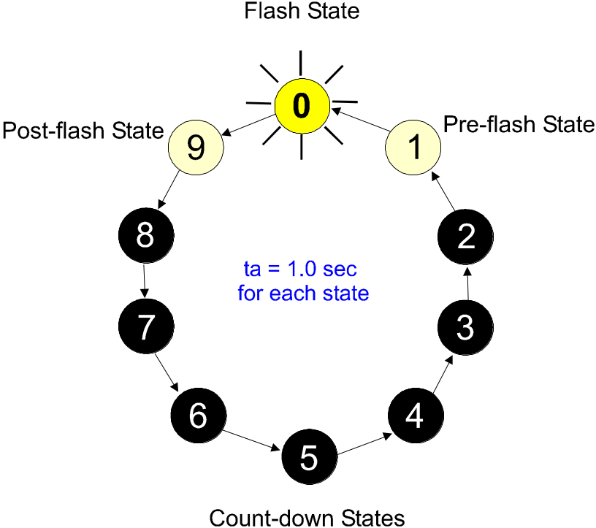

Figure 1: State Definition of FireFly Cell

As each state has a delay time of one second, the total cycle time is ten seconds. Each cell will cycle through the 10 states – state 0 will be the “ON” or flash state, state 1 the pre-flash state where the firefly’s flash actually starts. After the flash, the firefly goes through the post-flash state where its bioluminescence dies away. All other states are dark.

The definition of ten separate states allows for ten separate flash cycles. Each individual firefly, while having a ten second cycle, starts its cycle at a different one second interval.

Each Firefly (or Cell) is able to ‘see’ all immediately adjacent fireflies/cells.

3.2 The Coupled Model

The coupled model is model of the habitat in which the fireflies live. It represents a 10 by 10 by 10 cube that is wrapped on the edges to represent the next similar cube.

The formal definition of the coupled model is shown below:

[top]
components : habitat

[habitat]
type : cell
dim : (10,10,10)
delay : transport
defaultDelayTime : 1000
border : wrapped

neighbors : habitat(-1,-1,-1) habitat(-1,-1,1) habitat(-1,-1,0)
neighbors : habitat(1,-1,-1) habitat(1,-1,1) habitat(1,-1,0)
neighbors : habitat(-1,1,-1) habitat(-1,1,1) habitat(-1,1,0)
neighbors : habitat(1,1,-1) habitat(1,1,1) habitat(1,1,0)
neighbors : habitat(1,0,-1) habitat(1,0,1) habitat(1,0,0)
neighbors : habitat(-1,0,-1) habitat(-1,0,1) habitat(-1,0,0)
neighbors : habitat(0,1,-1) habitat(0,1,1) habitat(0,1,0)
neighbors : habitat(0,-1,-1) habitat(0,-1,1) habitat(0,-1,0)
neighbors : habitat(0,0,-1) habitat(0,0,1) habitat(0,0,0)

initialvalue : 0
initialMapValue : habitat.map
localtransition : habitat_rule

[habitat_rule]

rule : 9 1000 { (0,0,0) = 0 }
rule : 8 1000 { (0,0,0) = 9 and statecount(0) = 0 }
rule : 9 1000 { (0,0,0) = 9 and statecount(0) > 0 }
rule : 7 1000 { (0,0,0) = 8 and statecount(0) = 0 }
rule : 9 1000 { (0,0,0) = 8 and statecount(0) > 0 }
rule : 6 1000 { (0,0,0) = 7 and statecount(0) = 0 }
rule : 9 1000 { (0,0,0) = 7 and statecount(0) > 0 }
rule : 5 1000 { (0,0,0) = 6 and statecount(0) = 0 }
rule : 9 1000 { (0,0,0) = 6 and statecount(0) > 0 }
rule : 4 1000 { (0,0,0) = 5 and statecount(0) = 0 }
rule : 9 1000 { (0,0,0) = 5 and statecount(0) > 0 }
rule : 3 1000 { (0,0,0) = 4 and statecount(0) = 0 }
rule : 9 1000 { (0,0,0) = 4 and statecount(0) > 0 }
rule : 2 1000 { (0,0,0) = 3 and statecount(0) = 0 }
rule : 9 1000 { (0,0,0) = 3 and statecount(0) > 0 }
rule : 1 1000 { (0,0,0) = 2 and statecount(0) = 0 }
rule : 9 1000 { (0,0,0) = 2 and statecount(0) > 0 }
rule : 0 1000 { (0,0,0) = 1 }

3.3 The Rules

rule : 9 1000 { (0,0,0) = 0 }

After the firefly completes its ‘flash’ (state 0) cycle, it enters the post-flash state or state 9.

rule : 8 1000 { (0,0,0) = 9 and statecount(0) = 0 }
rule : 9 1000 { (0,0,0) = 9 and statecount(0) > 0 }

After timing out in state 9, the firefly enters state 8 if no firefly in its immediate neighbourhood is flashing. If one is, then the firefly stays in state 9 – synchronizing it with the flashing firefly.

rule : 7 1000 { (0,0,0) = 8 and statecount(0) = 0 }
rule : 9 1000 { (0,0,0) = 8 and statecount(0) > 0 }

Similar to above, the firefly in state 8 goes to state 7 unless there is a flashing firefly in its immediate vicinity. In this case it returns to state 9, thus, synchronizing with the flashing firefly.

rule : 6 1000 { (0,0,0) = 7 and statecount(0) = 0 }
rule : 9 1000 { (0,0,0) = 7 and statecount(0) > 0 }
rule : 5 1000 { (0,0,0) = 6 and statecount(0) = 0 }
rule : 9 1000 { (0,0,0) = 6 and statecount(0) > 0 }
rule : 4 1000 { (0,0,0) = 5 and statecount(0) = 0 }
rule : 9 1000 { (0,0,0) = 5 and statecount(0) > 0 }
rule : 3 1000 { (0,0,0) = 4 and statecount(0) = 0 }
rule : 9 1000 { (0,0,0) = 4 and statecount(0) > 0 }
rule : 2 1000 { (0,0,0) = 3 and statecount(0) = 0 }
rule : 9 1000 { (0,0,0) = 3 and statecount(0) > 0 }
rule : 1 1000 { (0,0,0) = 2 and statecount(0) = 0 }
rule : 9 1000 { (0,0,0) = 2 and statecount(0) > 0 }

For the states 7, 6, 5, 4, 3 and 2, the same behaviour takes place as in the state 8. If there is a flashing firefly in the immediate vicinity, the next state of the firefly is state 9.

rule : 0 1000 { (0,0,0) = 1 }

If the firefly is in the pre-flash state (or state 1) the next state is always state 0 or flash state.

4.0 TESTING

4.1 Expected Results

The following is, for a 3X3X3 version of this simulation, what is to be expected. All cell values should be the same and they should count down from 9 to 0 every ten seconds. This represents a simulated version of the firefly synchronously flashing ‘on’ for one second and ‘off’ for nine.

Line : xxxxxx - Time: 00:01:54:000
012 012 012
+---+ +---+ +---+
0|111| 0|111| 0|111|
1|111| 1|111| 1|111|
2|111| 2|111| 2|111|
+---+ +---+ +---+
Line : xxxxxx - Time: 00:01:55:000
012 012 012
+---+ +---+ +---+
0|000| 0|000| 0|000|
1|000| 1|000| 1|000|
2|000| 2|000| 2|000|
+---+ +---+ +---+
Line : xxxxxx - Time: 00:01:56:000
012 012 012
+---+ +---+ +---+
0|999| 0|999| 0|999|
1|999| 1|999| 1|999|
2|999| 2|999| 2|999|
+---+ +---+ +---+

4.2 Actual Results

It was at this point that it was discovered that the simulation would not reduce to the perfect all ‘on’ and all ‘off ‘states. One single firefly remained ‘off’ when all others were ‘on’, as shown below:

Line : 462170 - Time: 00:01:35:000
0123456789 0123456789 0123456789
+----------+ +----------+ +----------+
0| | 0| | 0| |
1| | 1| | 1| |
2| | 2| | 2| |
3| | 3| | 3| |
4| | 4| | 4| |
5| | 5| | 5| |
6| | 6| | 6| |
7| | 7| 1 | 7| |
8| | 8| | 8| |
9| | 9| | 9| |
+----------+ +----------+ +----------+
Now this situation is not unusual in nature but errs from the original premise of the exercise. A simple correction to the model is given here: If the neighbourhood of the firefly was extended slightly, i.e., the firefly can see slightly beyond only his nearest neighbours, the simulation synchronizes quite readily. The addition of this extended neighbourhood can be justified by observing that the firefly should be able to see further directly ahead of himself. In .ma language, the extension is achieved with the following code:

neighbors : habitat(-2,0,0)

With this alteration the simulation reduces to the desired synchronized ‘ON’ – ‘OFF’ behaviour.

The habitat.drw file is included on the accompanying disk.

5.0 CONCLUSIONS

In this project I went beyond what Teuscher and Capcarrere did, extending their simulation into the third dimension. While I ran into a small problem using the exact rules they did, I can justify the changes I made to the rules based on what is seen in nature. I confirm their results using the Cell-DEVS system. I also show that Cell-DEVS simulates the behaviour of the fireflies better and easier. The 2D and 3D visual aids make the simulation that much more realistic and demonstrable.

6.0 REFERENCES

1 | North American Fireflies of the Genus Photoris  Herbert Spencer Barber  Smithsonian Institute  Washington, D.C.  1951  pages 3 and 6
2 | Reproductive Behavior of Insects  W.J. Bailey and J. Ridsdill-Smith  Chapman and Hall  London, England  1991  pages 43 and 44
3 | On Fireflies, Cellular Systems and Evolware  Christof Teuscher and Mathieu S. Capcarrere  Evolvable Systems: From Biology to Hardware  5th International Conference ICES 2003  Trondhein, Norway  March 2003  Springer-Verlag  Berlin, Germany  2003  (attached as Appendix B)

Appendix A: Bonus Section – VRML Tool

The following are screen captures of the 3D simulation at different times. They illustrate the progression from random flashing to synchronized flashing. The yellow cubes represent the flashing stage while the black cubes, obviously, represent the ‘off’ stages.

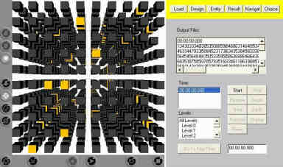  This is the initial, random distribution. | 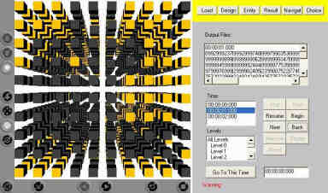  This is the distribution after one second.
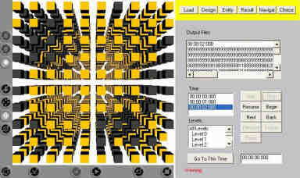  This is the distribution after two seconds. | 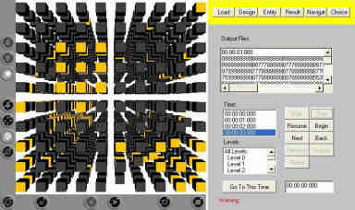  This is the distribution after three seconds.
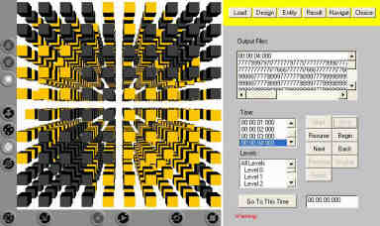  This is the distribution after four seconds. | 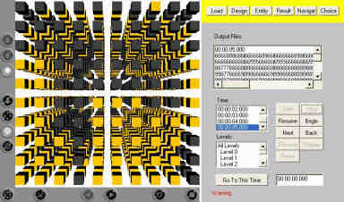  This is the distribution after five seconds.
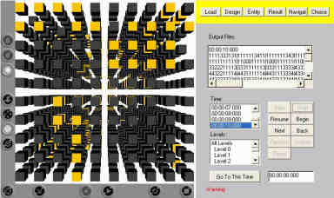  This is the distribution after ten seconds. | 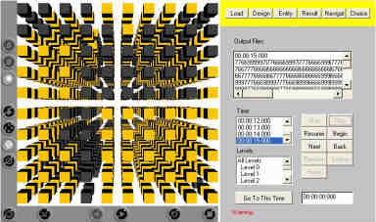  This is the distribution after 15 seconds.

The following eight captures illustrate that the flies are starting to synchronize.

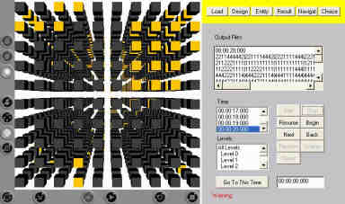  This is the distribution after 20 seconds. | 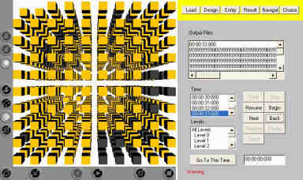  This is the distribution after 33 seconds.
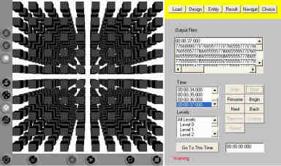  This is the distribution after 37 seconds. | 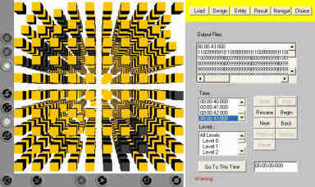  This is the distribution after 43 seconds.
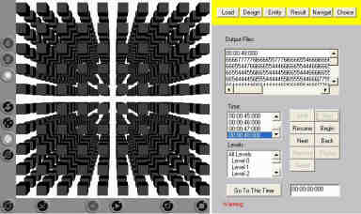  This is the distribution after 48 seconds. | 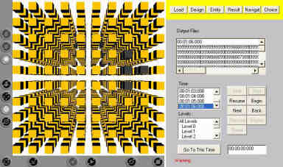  This is the distribution after 66 seconds.
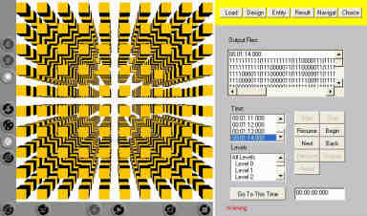  This is the distribution after 74 seconds. | 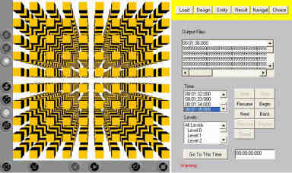  This is the distribution after 95 seconds.

These last three captures show that by this time the fireflies have completely synchronized their flashing cycles. All ‘off’, All ‘on’ and All ‘off’ again.

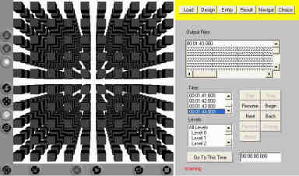  This is the distribution after 104 seconds. | 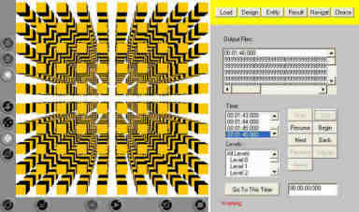  This is the distribution after 106 seconds.
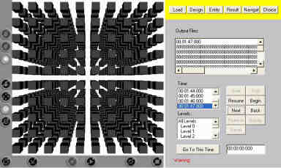
This is the distribution after 107 seconds.

Appendix B: Original Researched Paper

