Assignment #2

Khurram Shahzad
khurramsaifi@yahoo.com
Student Id: 100293224

Course: SYSC 5807

First Option
Fission Process

Description

A method of breakage of radioactive atoms by means of a process of self-division into two parts. Each of part then becomes a separate and different atom.

An example of Radioactive element is Uranium atoms. In a fission reaction, the nucleus of a uranium atom fused, splits into two non-radioactive elements and releasing neutrons. When a free neutron is absorbed by a nearby uranium atom, that radioactive atom fused, splits into two non radioactive elements and releases more neutrons which strike other atoms. Thus, a chain reaction occurs, and the fission process becomes self-sustaining.

In cellular automata paradigm; when a neutron (as an input) hit the certain radioactive elements (cells). Then the radioactive element (cells) fuses and release energy and also releases 3 or so neutrons. Theses released neutron particle hit other radioactive atoms and fuse them and release further neutrons. And this process becomes a chain process. This process results a lot of energy. For simplicity we assume that a radioactive element fuses into one non-radioactive element.

A brief description of some of the functionality of a fission process is following:
- Radioactive element is ready for fission process
- A neutron hits the radioactive element; fuses it (or radioactive element becomes not any more radioactive element) and release energy and other neutrons
- These neutrons absorbed by the other radioactive element and do the same process
- This process continues in a chain process
In Figures it can be shown like this.

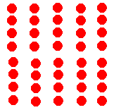

Radio Active Element in Red
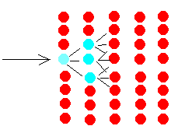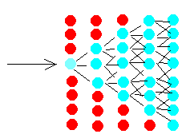
few atoms are not radioactive(light blue) most of atoms are not radioactive(light blue)

References

http://lectureonline.cl.msu.edu/~mmp/applist/chain/chain.htm
http://www.ba.infn.it/~zito/museo/des80.html

Cell-DEVS Model:

CD = < X, Y, I, S, θ, N, d, δint, δext, τ, λ, D >

- X Set of input External Events
- Y Set of output External Events
- I = < n, m, Px, Py > is the model’s modular interface, with

- n neighboring cells
9 total neighbors in this cell space for each cell
neighbors : life(-1,-1) life(-1,0) life(-1,1)
neighbors : life(0,-1) life(0,0) life(0,1)
neighbors : life(1,-1) life(1,0) life(1,1)

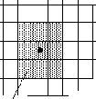
Fig: cell’s neighbors

- S Possible state
{0,1,2,3,4,5,9}

0 means nothing

Neutron
1 neutron in lower right diagonal direction
2 neutrons in right direction
3 neutrons in upper right diagonal direction

Fused Radio Active Element
4 fused radio active element
5 fused radio active element

Radioactive element
9 radio active element

- delay of the cell 100ms

Rules for Reaction Cell-DEVS Model

Here are the rules for the Reaction Cell DEVS

rule : 5 100 { (0,0) = 9 and (-1,-1) = 1 }
rule : 5 100 { (0,0) = 9 and (1,-1) = 3 }

rule : 9 100 { (0,0) = 9 and (0,-1) = 0 }

rule : 5 100 { (0,0) = 9 and (0,-1) = 2 }

rule : 4 100 { (0,0) = 5 and statecount(3) = 1 and statecount(2) = 1 and statecount(1) = 1 }
rule : 5 100 { (0,0) = 5 }
rule : 4 100 { (0,0) = 4 }

rule : 2 100 { (0,0) = 0 and (0,-1) = 5 }
rule : 3 100 { (0,0) = 0 and (1,-1) = 5 }
rule : 1 100 { (0,0) = 0 and (-1,-1) = 5}

rule : 1 100 { (0,0) = 0 and (-1,-1) = 1 }
rule : 2 100 { (0,0) = 0 and (0,-1) = 2 }
rule : 3 100 { (0,0) = 0 and (1,-1) = 3 }

rule : 0 100 { t }

Graphical Output Results

Step by step output is shown

A neutron is running towards radioactive elements
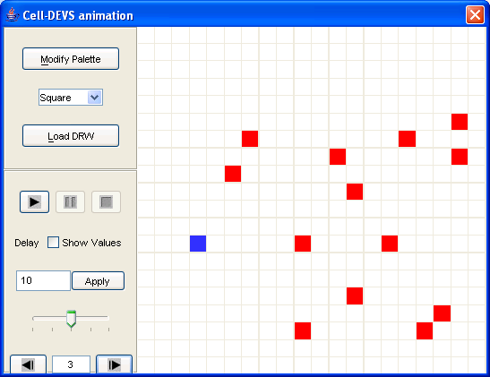

A radio active element fused and emits three neutron
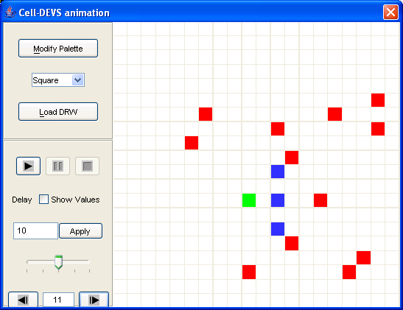

Tow other radio active elements got fused
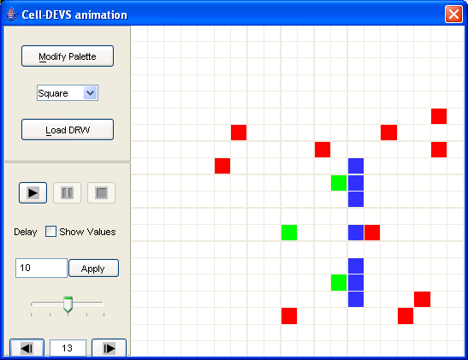

Bonus Part

Step by step output is shown

A neutron is running towards radioactive elements

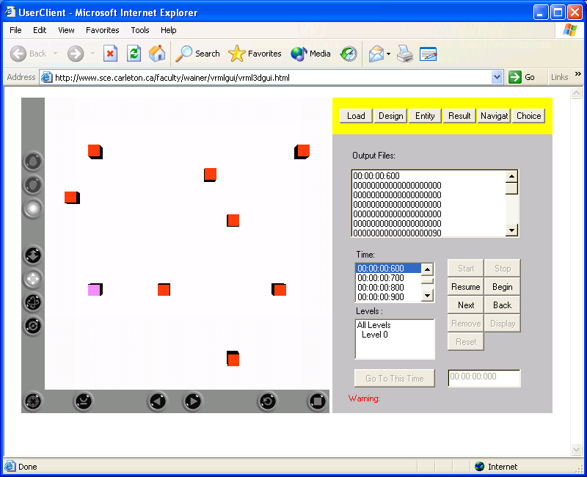

A radio active element fused and emits three neutron
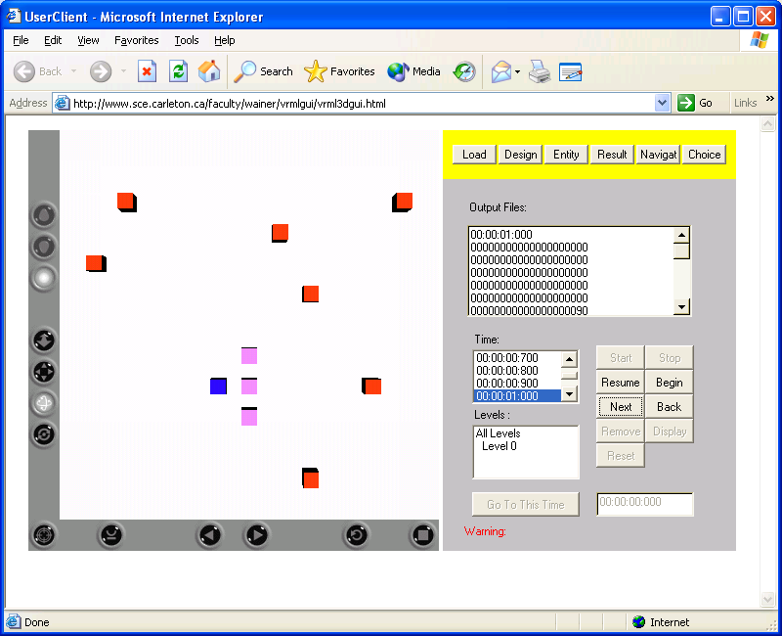

Tow other radio active elements got fused
