94.587 Advanced Topics on Computer Systems: Methodological Aspects of Modeling and Simulation (2002 Fall)

Term Project: Update of a Library of Finite State Machines (Moore Machines) Using CD++

Tao Zheng 258050

Carleton University

1. Introduction:
This term project is aimed to update a library of Finite State Machines (FSM) developed previously [1]. By updating this library, the Finite State Machines (Moore Machines) could be created in a simpler manner and a better behavior is provided.

2. Finite State Machine Characteristics:
The Finite State Machines are formally defined as follows in [2]:
FSM = < S, X, Y, f, g >
where X: finite input set
Y: finite output set
S: finite state set
f: next state function
f: X * S -> S
g: output function
g: S -> Y : Moore machine
g: X * S -> Y: Mealy machine
Every Finite State Machine is supposed to have an initial state.
This term project focuses on the Moore machines, i.e. the output depends on the state only.

3. Atomic Model MooreState
3.1 Formal Specification of MooreState
Every Finite State Machine consists of a number of states with transition functions. If we can define the behavior of a generic state as an atomic model, a Finite State Machine could be created easily and formally by generating a coupled DEVS model which consists of a number of those atomic models.
Figure 1.1 shows the atomic model named MooreState which is implemented in this project. This atomic model represents the behavior of a generic state in Moore machines.
In this approach, all the states in a FSM are encoded as integers. A unique global stateCode is assigned to each state in a Finite State Machine. The phase indicates whether this state is active or passive. Only one state is active at a time in
eventIn
transitionIn
errorOut
transitionOut
stateOut

events[ ]
stateCode
phase
stateValue
nextActiveState
errorCode
isEvent

Figure 1 Atomic Model of MooreState

one Finite State Machine. The events of a FSM are encoded as integers as well. The eventIn receives encoded numbers representing external events. If a state receives a legal event listed in events[ ] when it is active, the stateOut port sends out the current stateValue, and the transitionOut port sends out the nextActiveState signal to all the transitionIn ports in the FSM announcing which state is active in the next step. A state becomes active if the encoded number received from transitionIn port is same as its stateCode. An errorCode would be sent out from the errorOut port if an error occurs in the state.
The formal DEVS specification <S, X, Y, δint, δext, λ, ta> for the atomic model MooreState is illustrated as follows:
State Variables:
events[ ]; //the legal events of the state and the associated nextActiveState which are parsed from the .ma file
stateCode; //the unique state code of the state parsed from the .ma file. 0 represents the initial state in a FSM
phase; //the phase of the state (active or passive).
stateValue; //the assigned output of the state parsed from .ma file.
nextActiveState; //the state code of the next active state
errorCode; //the error code if an error occurs. 0: no error; negative number: an error.
isEvent; //true: an event is received. false: a transition signal is received

X = {eventIn, transitionIn }
Y = {stateOut, transitionOut, errorOut}
S = {{events[ ], stateCode, phase, stateValue, nextActiveState, errorCode, isEvent}}

δext (events[ ], stateCode, phase, stateValue, nextActiveState, errorCode, isEvent, e, x)
{ case phase
active:
if x is from eventIn
if x is legal
get the nextActiveState from events[ ];
errorCode = 0;
else
errorCode = -999;
isEvent = true;
holdIn(active, 0); //trigger an immediate internal event for output
else
; //do nothing
passive:
if x is from transitionIn
if x equals stateCode
isEvent = false;
errorCode = 0;
holdIn (passive, 0);
//trigger an immediate internal event for output
else
; //do nothing
else
; //do nothing
}

δint (events[ ], stateCode, phase, stateValue, nextActiveState, errorCode, isEvent, e, x)
{ if (errorCode == 0) //no error
{ if (isEvent) //always enter the passive phase after receiving an event
passivate();
else //a new state is activated by the input from the transition
holdIn(active, Infinity);
}
else //don’t change the phase if an error occurs
{ if (state() == passive)
passivate();
else
holdIn(active, Time::Inf);
}
}

λ(errorCode != 0)
{ send errorCode to the port errorOutput //error
}
λ(errorCode == 0)
{ if (isEvent) // announce the next active state
send nextActiveState to the port transitionOutput
else // indicate the current state
send stateValue to the port stateOutput
}

3.2 Testing of the Atomic Model MooreState
An example moorestate.ma file with added comments is listed as follows:
[top]
components : moorestate@MooreState
out : stateOut
out : transitionOut
out : errorOut
in : transitionIn
in : eventIn
Link : eventIn eventIn@moorestate
Link : transitionIn transitionIn@moorestate
Link : stateOut@moorestate stateOut
Link : transitionOut@moorestate transitionOut
Link : errorOut@moorestate errorOut
Link : transitionOut@moorestate transitionIn@moorestate
[moorestate]
StateCode : 0 //the current state has the stateCode 0 (initial state)
StateValue : 1 //the current state has the stateValue 1
NumberOfTransitions : 2 //two legal transitions are defined in the current state
Transition01 : 0->1 //if event 0 is received, the state with stateCode 1 is active next
Transition02 : 1->0 //if event 1 is received, the state with stateCode 0 is active next

All the items listed in the [moorestate] part are required for the states in a FSM. The number of Transition items depends on the item NumberOfTransitions. If the number of defined transitions is more than NumberOfTransitions, some of the defined transitions listed last will be ignored.
An event file which includes some of the possible scenarios (moorestate.ev) is created as follows:

00:00:02:00 eventIn 1
00:00:05:00 eventIn 1
00:00:10:00 eventIn 0
00:00:15:00 eventIn 1
00:00:20:00 eventIn 2
00:00:25:00 transitionIn 0
00:00:30:00 eventIn 1
00:00:33:00 eventIn 2
00:00:35:00 eventIn 1
00:00:40:00 eventIn 0

According to the moorestate.ma, the current state is the initial state, and it is set as active initially. It should response to the first 3 events. The two events with bold fonts should not generate any outputs after the event 0 at time 00:00:10:000, because the current state is not active anymore. At time 00:00:25:000, the current state is active again by receiving 0 from transitionIn. The event with bold and italic fonts is an illegal event for the current state. An error messaged should be generated. However, the current state retains its phase after this illegal event. The output file moorestate.out shows the expected results:

00:00:02:000 transitionout 0
00:00:02:000 stateout 1
00:00:05:000 transitionout 0
00:00:05:000 stateout 1
00:00:10:000 transitionout 1
00:00:25:000 stateout 1
00:00:30:000 transitionout 0
00:00:30:000 stateout 1
00:00:33:000 errorout -999
00:00:35:000 transitionout 0
00:00:35:000 stateout 1
00:00:40:000 transitionout 1

4. Finite State Machines Using the Atomic Model MooreState
After testing the atomic model MooreState, several Finite State Machine models are created as coupled DEVS models by connecting a number of MooreStates.
There are several basic rules to create a Finite State Machine by connecting the MooreStates:
- All the transitionOut and transitionIn ports should be connected together inside the FSM. I.e. in the view of a FSM, these ports don’t communicate with the external environment and they are not visible to the outside world.
- All the eventIn ports of MooreStates should be connected to an input port of a FSM.
- All the errorOut ports of MooreStates are connected together as an output port of a FSM
- Each stateOut port of MooreState could either be connected to an individual output port of a FSM or connected together as one output port of a FSM
- All the states in a FSM are encoded as integer numbers (stateCode) during simulation. The state with the stateCode 0 is the initial state in the FSM
- All the legal events for this FSM are also encoded as integer numbers during simulation.

4.1 Simple Moore Machine
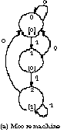A simple Moore machine (shown at right) is introduced in [3]. This finite state machine sends out value 1 whenever its input string has at least two 1's in sequence. Otherwise, value 0 is sent out. Three states are defined in this FSM.
The conceptual model of this FSM is shown in Figure 2.

errorOut
errorOut
errorOut

S0

S1

S2
transitionIn
transitionOut
transitionIn
transitionOut
transitionIn
transitionOut
eventIn
eventIn
eventIn
in
stateOut
stateOut
stateOut
s0
s1
s2
error

Figure 2 The Conceptual Model of a Simple Moore Machine

The formal specifications <X, Y, D, {M_{i}}, {I_{i}}, {Z_{ij}}, SELECT > for this coupled model are defined as follows:

X = {in};
Y = {s0, s1, s2, error};
D = {S0, S1, S2};
I(S0) = {S0, S1, S2, self};
I(S1) = {S0, S1, S2, self};
I(S2) = {S0, S1, S2, self};
Z(S0) = S0; Z(S0) = S1; Z(S0) = S1; Z(S0) = self;
Z(S1) = S0; Z(S1) = S1; Z(S1) = S1; Z(S1) = self;
Z(S2) = S0; Z(S2) = S1; Z(S2) = S1; Z(S2) = self;
SELECT: S0 > S1 > S2
where S0, S1 and S2 are the instances of atomic model MooreState

This FSM has the following event code table and state code table:
Event Code Table:
Event Event Code
Input 0 0
Input 1 1

State Code Table:
State State Code
S0 0
S1 1
S2 2

4.2 Vender Machine
A vender machine example (shown below) is introduced in [4]. This vender machine accepts 5, 10 cents coins and sells candy bars worth 15 or 20 cents.

The simplified conceptual model of this FSM is shown in Figure 3 (For simplicity, transitionIn ports, transitionOut ports and the connections among them are not shown any more in the later part. The rules of dealing with those transition ports are explained in the basic rules and demonstrated in the example of a simple Moore machine.)
The formal specifications <X, Y, D, {M_{i}}, {I_{i}}, {Z_{ij}}, SELECT > for this coupled model are defined as follows:
X = {in};
Y = {zero, five, ten, fifteen, twenty, error};
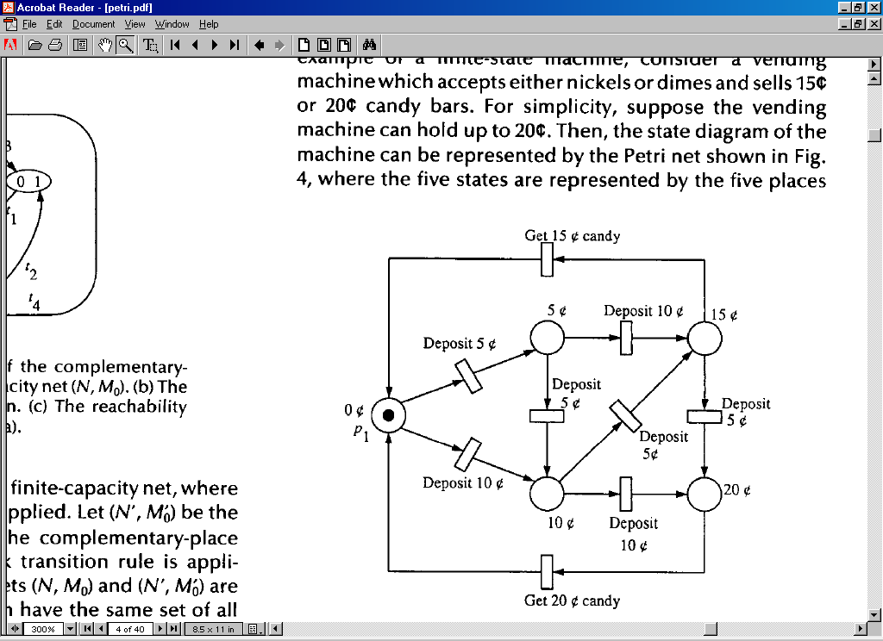
D = {Zero, Five, Ten, Fifteen, Twenty};
I(Zero) = I(Five) = I(Ten) = I(Fifteen)
= I(Twenty)
= {Zero, Five, Ten, Fifteen, Twenty, self};
Z(Zero) = Zero, Z(Zero) = Five,
Z(Zero) = Ten, Z(Zero) = Fifteen,
Z(Zero) = Twenty, Z(Zero) = self;
Z(Five) = Zero, Z(Five) = Five,
Z(Five) = Ten, Z(Five) = Fifteen,
Z(Five) = Twenty, Z(Five) = self;
Z(Ten) = Zero, Z(Ten) = Five,
Z(Ten) = Ten, Z(Ten) = Fifteen,
Z(Ten) = Twenty, Z(Ten) = self;
Z(Fifteen) = Zero, Z(Fifteen) = Five,
Z(Fifteen) = Ten, Z(Fifteen) = Fifteen,
Z(Fifteen) = Twenty, Z(Fifteen) = self;

zero
stateOut
twenty
stateOut
fifteen
stateOut
five
stateOut
ten
stateOut
error
eventInin
eventInin
eventInin
eventInin
eventInin
in
Zero
Five
Ten
Fifteen
Twenty

Figure 3 The Simplified Conceptual Model of a Vender Machine
Z(Twenty) = Zero, Z(Twenty) = Ten,
Z(Twenty) = Ten, Z(Twenty) = Fifteen,
Z(Twenty) = Twenty, Z(Twenty) = self;
SELECT:
Zero > Five > Ten > Fifteen > Twenty
where Zero, Five and Ten, Fifteen and Twenty are the instances of atomic model MooreState
The vender machine has the following event code table and state code table:
Event Code Table:
Event Event Code
Deposit 5¢ 0
Deposit 10¢ 1
Get 15¢ Candy 2
Get 20¢ Candy 3
State Code Table:
State State Code
Zero 0
Five 1
Ten 2
Fifteen 3
Twenty 4

  - ATM
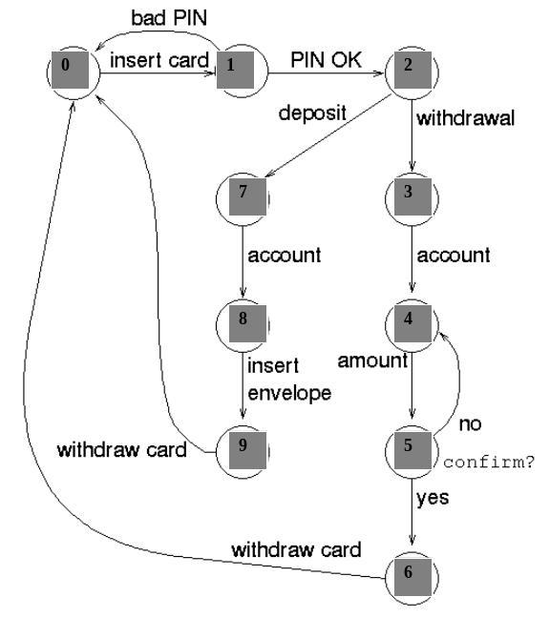A simple automated teller machine (ATM) (shown below) is introduced in [5]. In this model, each transition is labeled with an input coming from the user (such as insert card) or a central database (such as PIN OK versus bad PIN). The simplified conceptual model is shown in Figure 4 (transitionIn an transitionOut ports and the connections among them are not shown).
The formal specifications <X, Y, D, {M_{i}}, {I_{i}}, {Z_{ij}}, SELECT > for this coupled model are defined as follows:
X = {in};
Y = { idle, checkingpin, selectingtransaction, withdrawing, inputingamount, confirming, withdrawaldone, depositing, insertingmoney, depositdone, error};
eventInin
eventInin
eventInin
eventInin
eventInin
in
eventInin
eventInin
eventInin
eventInin
eventInin
selectingtransaction
stateOut
depositdone
stateOut
withdrawing
stateOut
insertingmoney
stateOut
depositing
stateOut
withdrawaldone
stateOut
confirming
stateOut
inputingamount
stateOut
checkingpin
stateOut
idle
stateOut
error
Idle
Checkingpin
Depositdone
Insertingmoney
Depositing
Withdrawaldone
Confirming
Withdrawing
Selectingtransaction
Inputingamount

Figure 4 The Simplified Conceptual Model of ATM

D = { Idle, Checkingpin, Selectingtransaction, Withdrawing, Inputingamount, Confirming, Withdrawaldone, Depositing, Insertingmoney, Depositdone };
I(Idle) = I(Checkingpin) = I(Selectingtransaction) = I(Withdrawing)
= I(Inputingamount) = I(Confirming) = I(Withdrawaldone) = I(Depositing)
= I(Insertingmoney) = I(Depositdone)
= { Idle, Checkingpin, Selectingtransaction, Withdrawing, Inputingamount, Confirming, Withdrawaldone, Depositing, Insertingmoney, Depositdone, self};
Z(Idle) = Idle, Z(Idle) = Checkingpin, Z(Idle) = Selectingtransaction,
Z(Idle) = Withdrawing, Z(Idle) = Inputingamount, Z(Idle) = Confirming,
Z(Idle) = Withdrawaldone, Z(Idle) = Insertingmoney, Z(Idle) = Deposting,
Z(Idle) = Depositdone, Z(Idle) = self
……
……
SELECT:
Idle > Checkingpin > Selectingtransaction > Withdrawing, > Inputingamount
> Confirming > Withdrawaldone > Depositing > Insertingmoney > Depositdone
where Idle, Checkingpin, Selectingtransaction, Withdrawing, Inputingamount, Confirming, Withdrawaldone, Depositing, Insertingmoney and Depositdone are the instances of atomic model MooreState
The ATM model has the following event code table and state code table:
Event Code Table:
Event Event Code
insert card 0
bad-PIN 1
PIN-OK 2
withdrawal 3
account 4
amount 5
confirm-no 6
confirm-yes 7
withdraw-card 8
deposit 9
insert-envelop 10

State Code Table:
State State Code
Idle 0
Checkingpin 1
Selectingtransaction 2
Withdrawing 3
Inputingamount 4
Confirming 5
Withdrawaldone 6
Depositing 7
Insertingmoney 8
Depositdone 9

  - Telephony System
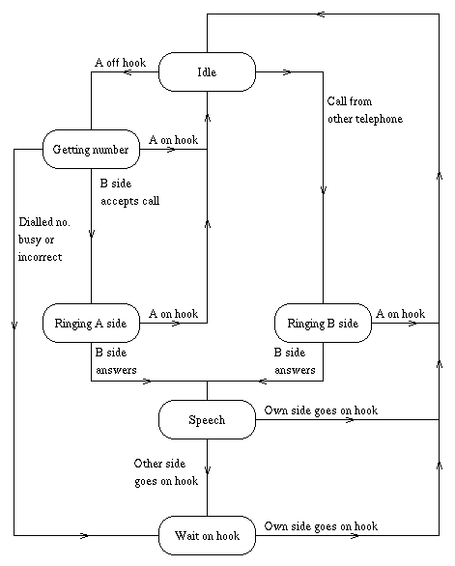
The Finite State Machines are used to model telephony systems as well. A simple "Plain Ordinary Telephony Service" (POTS) is described as a FSM model in [6] (shown at right). Figure 5 shows the simplified conceptual model of this FSM (transitionIn an transitionOut ports and the connections among them are not shown).
For simplicity, the formal specification of the telephony model is not listed.
The formal specifications <X, Y, D, {M_{i}}, {I_{i}}, {Z_{ij}}, SELECT > for this coupled model are defined as follows:
X = {in};
Y = { idle, gettingnumber, ringingaside, ringingbside, speech, waitonhok, error };
D = { Idle, GettingNumber, RingingASide, RingingBSide, Speech, WaitOnhook, error };
eventInin
eventInin
eventInin
eventInin
eventInin
eventInin
waitonhook
stateOut
idle
stateOut
speech
stateOut
ringingbside
stateOut
gettingnumber
stateOut
ringingaside
stateOut
in
error
Idle
Getting Number
Ringing A Side
Ringing B Side
Speech
Wait
Onhook

Figure 5 The Conceptual Model of Telephony System

I(Idle) = I(GettingNumber) = I(RingingASide) = I(RingingBSide)
= I(Speech) = I(WaitOnhook)
= { Idle, GettingNumber, RingingASide, RingingBSide, Speech, WaitOnhook, self}
Z(Idle) = Idle, Z(Idle) = GettingNumber, Z(Idle) = RingingASide,
Z(Idle) = RingingBSide, Z(Idle) = Speeck, Z(Idle) = WaitOnhook, Z(Idle) = self
……
……
SELECT:
Idle > GettingNumber > RingingASide > RingingBSide > Speech > WaitOnhook
where Idle, GettingNumber, RingingASide, RingingBSide, Speech and WaitOnhook are the instances of atomic model MooreState

This telephony model has the following event code table and state code table:
Event Code Table:
Event Event Code
A offhook 0
B side accepts call 1
B side answers 2
B goes on hook 3
A goes on hook 4
Call from other telephone 5
Dial number busy or incorrect 6

State Code Table:
State State Code
Idle 0
Getting number 1
Ringing A side 2
Ringing B side 3
Speech 4
Wait onhook 5

  - Simulation Results Analysis and Comparison
The first 3 FSM models are also implemented and tested in [1]. In order to compare the results of the approach in [1] and the results of this approach, the event code table and state code table of this approach match those of the implementation in [1]. The .ev files in [1] are also used to test the FSM models implemented in this approach.
4.5.1 Comparison with a Previous Implementation
After simulation results comparison and checking, some flaws are found in the previous implementation.
1. There are some errors in the vender machine model implemented in [1]. It misses a transition from state Ten to state Fifteen, and the transition from state Ten to state Twenty is supposed as a dime-click transition instead of a nickel-click transition. Thus a new .ev file is generated to test the vender machine model in this project.
2. The implementation in [1] is not a Moore machine implementation. The following is part of the output file of ATM model implemented in [1]:
00:00:00:012 idle 0
00:00:00:022 checkin 0
00:00:00:032 sel-transact 2
00:00:00:042 sel-wd-ac 3
00:00:00:052 in-amount 4
00:00:00:062 confirm 5
00:00:00:072 in-amount 6
00:00:00:082 confirm 5
00:00:00:092 dispensing 7
00:00:00:102 idle 8
At time 00:00:00:012 and time 00:00:102, the ATM is at state Idle. However, the outputs at these two times are different. They are supposed to have the same output if the FSM is a Moore machine. After checking the .ev file and .out file of the ATM model in [1], it is found that the output in that implementation is actually the received event of that state at that time. The related part of the .ev file is listed as follows:
00:00:00:10 in 0
00:00:00:20 in 0
00:00:00:30 in 2
00:00:00:40 in 3
00:00:00:50 in 4
00:00:00:60 in 5
00:00:00:70 in 6
00:00:00:80 in 5
00:00:00:90 in 7
00:00:00:100 in 8
This doesn’t make many senses.
3. Further more, in the ATM model, event 0 represents event “insert card”. At time 00:00:00:10 and time 00:00:00:20, there are two consecutive “insert card” events. No errors are reported in [1].
The simulation results of this approach figures out the problems mentioned above and works well.

4.5.2 Testing of the FSM models
Simple Moore machine model
The input of this simple Moore machine model is a sequence of 0s and 1s. The output is supposed as 1 if more than two consecutive 1s are received. Otherwise, 0 is sent as output. The simplemooremachine.ev is listed as follows. The events with bold fonts in the .ev file expect 1 as the output. (This file is same as the .ev file from the implementation in [1])
00:00:00:10 in 0
00:00:00:20 in 1
00:00:00:30 in 1
00:00:00:40 in 1
00:00:00:50 in 0
00:00:00:60 in 0
00:00:00:70 in 1
00:00:00:80 in 0
00:00:00:90 in 0
00:00:00:100 in 0
00:00:00:110 in 1
00:00:00:120 in 0
00:00:00:130 in 1
00:00:00:140 in 1
00:00:00:150 in 0

The simplemooremachine.out gives the expected results:
00:00:00:010 s0 0
00:00:00:020 s1 0
00:00:00:030 s2 1
00:00:00:040 s2 1
00:00:00:050 s0 0
00:00:00:060 s0 0
00:00:00:070 s1 0
00:00:00:080 s0 0
00:00:00:090 s0 0
00:00:00:100 s0 0
00:00:00:110 s1 0
00:00:00:120 s0 0
00:00:00:130 s1 0
00:00:00:140 s2 1
00:00:00:150 s0 0

Vender machine model
The vendermachine.ev simulates the scenarios of buying one 15¢ candy and two 20¢ candies:
00:00:00:10 in 0
00:00:00:20 in 0
00:00:00:30 in 0
00:00:00:40 in 2
00:00:00:50 in 0
00:00:00:60 in 0
00:00:00:70 in 1
00:00:00:80 in 3
00:00:00:90 in 1
00:00:00:110 in 1
00:00:00:130 in 3

The simulation results in vendermachine.out are expected.
00:00:00:010 five 5
00:00:00:020 ten 10
00:00:00:030 fifteen 15
00:00:00:040 zero 0
00:00:00:050 five 5
00:00:00:060 ten 10
00:00:00:070 twenty 20
00:00:00:080 zero 0
00:00:00:090 ten 10
00:00:00:110 twenty 20
00:00:00:130 zero 0

ATM model
The atm.ev simulates a withdrawal transaction and deposit transaction. Between these two transactions, the PIN is checked several times due to the wrong PIN input. (This .ev file is as the .ev file from the implementation in [1].)
00:00:00:10 in 0
00:00:00:20 in 0
00:00:00:30 in 2
00:00:00:40 in 3
00:00:00:50 in 4
00:00:00:60 in 5
00:00:00:70 in 6
00:00:00:80 in 5
00:00:00:90 in 7
00:00:00:100 in 8
00:00:00:110 in 0
00:00:00:120 in 1
00:00:00:130 in 0
00:00:00:140 in 1
00:00:00:150 in 0
00:00:00:160 in 2
00:00:00:170 in 9
00:00:00:180 in 4
00:00:00:190 in 10
00:00:00:200 in 8

An unspecified reception of this model which is not indicated in the previous implementation is indicated in this implementation.
00:00:00:010 checkingpin 1
00:00:00:020 error -999
00:00:00:030 selectingtransaction 2
00:00:00:040 withdrawing 3
00:00:00:050 inputingamount 4
00:00:00:060 confirming 5
00:00:00:070 inputingamount 4
00:00:00:080 confirming 5
00:00:00:090 withdrawaldone 6
00:00:00:100 idle 0
00:00:00:110 checkingpin 1
00:00:00:120 idle 0
00:00:00:130 checkingpin 1
00:00:00:140 idle 0
00:00:00:150 checkingpin 1
00:00:00:160 selectingtransaction 2
00:00:00:170 depositing 7
00:00:00:180 insertingmoney 8
00:00:00:190 depositdone 9
00:00:00:200 idle 0

Telephony model
The telephony.ev file consists of the following scenarios:
A makes a call to B, B accepts the call, A, B talks and B onhooks first;
A receives a call from B, A, B talks and B onhooks first
A dials a wrong number or the line is busy, A onhooks ;
A offhooks, then A onhooks immediately.
00:00:00:10 in 0
00:00:00:20 in 1
00:00:00:30 in 2
00:00:00:40 in 3
00:00:00:50 in 4
00:00:00:60 in 5
00:00:00:65 in 2
00:00:00:70 in 3
00:00:00:80 in 4
00:00:00:90 in 0
00:00:00:110 in 6
00:00:00:120 in 4
00:00:00:130 in 0
00:00:00:140 in 4

The output (telephony.out) gives the expected results.
00:00:00:010 gettingnumber 1
00:00:00:020 ringingaside 2
00:00:00:030 speech 4
00:00:00:040 waitonhook 5
00:00:00:050 idle 0
00:00:00:060 ringingbside 3
00:00:00:065 speech 4
00:00:00:070 waitonhook 5
00:00:00:080 idle 0
00:00:00:090 gettingnumber 1
00:00:00:110 waitonhook 5
00:00:00:120 idle 0
00:00:00:130 gettingnumber 1
00:00:00:140 idle 0

5. Conclusion
This term project implements an atomic DEVS model called MooreState representing the generic state behavior of the Finite State Machines (Moore machines). By connecting a number of these generic states, Finite State Machines could be created easily and formally. By comparing with a previous implementation, this implementation provides a better behavior. The representations of the state transition functions are also straightforward and easier to understand. The simulation results of the FSM models provide the confidence of using this implementation.

6. Possible Bug Report
In the implementation of MooreState, an array is required to store the information of the next state function of that state. When I tried to use the static array in moorestate.h, the CD++ always dumps cores during simulation. However, the simulation works well without modifying the model if I use the dynamic array instead of static array. It takes me a long time to figure it out. It looks like that the CD++ might have a bug dealing with static arrays.

References:
[1] http://www.sce.carleton.ca/faculty/wainer/wbgraf/samples/fsm.zip
[2] http://www.sce.carleton.ca/courses/94587/materials/slides/Lecture3.ppt
[3] http://www2.ele.ufes.br/~ailson/digital2/cld/chapter8/chapter08.doc4.html
[4] http://www.cse.sc.edu/~gquan/Course790/Lecture6-7.ppt
[5] http://www.csc.ncsu.edu/eos/users/e/efg/210/s99/course_locker/www/Notes/fsm/
[6] http://www.erlang.org/doc/r8b/doc/design_principles/fsm.html

