Visualization Set Up Instructions

The following set up procedure should be followed to carry out the visualization of the C++ Cell-DEVS football ground simulation:

1. Install Blender from http://download.blender.org/release/Blender2.43/blender-2.43-windows.exe
2. Install Python version 2.4 from http://www.python.org/ftp/python/2.4.4/python-2.4.4.msi
3. Place **IsisFootballGround.blend** in C:\Program Files\Blender Foundation\Blender\.blender
4. Place **IsisFootballGround.py** in C:\Program Files\Blender Foundation\Blender\.blender\scripts.
5. Place **IsisFootballGround.ma**, **IsisFootballGround.val**, and **IsisFootballGround.log** in   
   C:\Program Files\Blender Foundation\Blender\.blender
6. Open **IsisFootballGround.blend**. This can be done by double clicking on the file in the C:\Program Files\Blender Foundation\Blender\.blender folder; OR
7. Load the **CD++ Simulations** script. See the following screen capture.

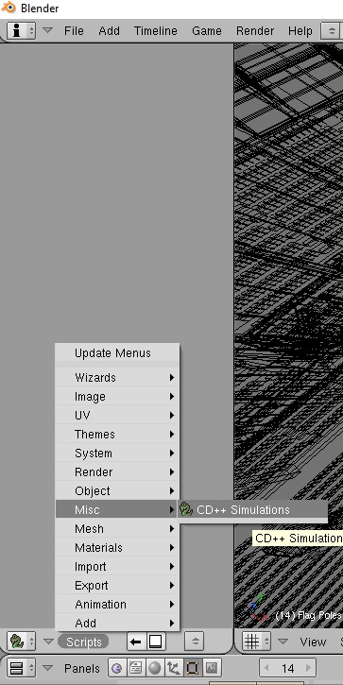

1. In the script GUI, select **IsisFootballGround.ma** and **IsisFootballGround.log** by browsing the .blender folder, if they are not already selected. See the following screen capture.

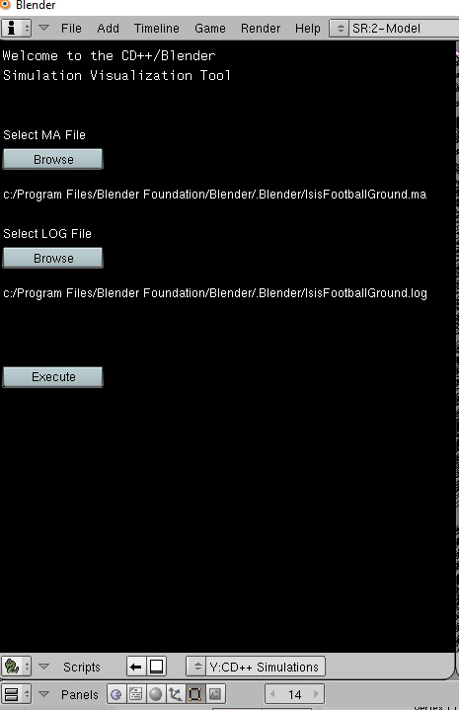

1. Hit the Execute button in the script GUI

---------------------------------

Brief description of the contents

---------------------------------

IsisFootballGround.blend : the .blend file where the visualization is carried out

IsisFootballGround.ma : the .ma file which is used to code the rules

IsisFootballGround.log : the log file generated for the .ma file

IsisFootballGround.pal: the .pal file storing the palette used to visualize with different colours

Isisfootballground.py : the python script file

IsisFootballGround.val : the .val file which sets up the initial stage

SYSC 5104-Final Report .pdf : the final project report