SYSC 5807

Cell-DEVS Gossip Model

David Tudino
100280642

November 12th, 2003

Table of Contents
1 Cellular Automata Model 3
2 Conceptual Model 3
3 Cell-DEVS Model 4
4 Formal Specification 4
5 Testing Strategies 5
5.1 Moore Neighborhood Results 6
5.2 Neumann Neighborhood Results 8
6 Model Modifications 10
7 Bonus! 10

Cellular Automata Model

The Cellular Automata model that will be modeled in Cell-DEVS is the Gossip model.
A model description can be found at the following URL: http://www.uni-koblenz.de/~kgt/Learn/Textbook/node74.html (printed copy provided).
The Gossip model is used to model the spread of information or gossip amongst a group of people from a single person. As in real life, the gossip spreads to interested parties from someone who has already heard the gossip. Once someone learns the gossip, they will not need to hear it again.

Conceptual Model

The conceptual gossip model is show in Figure 1.
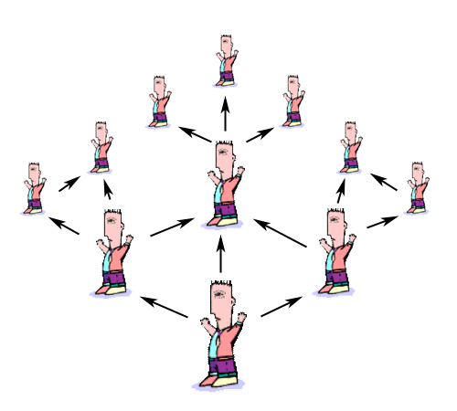
Figure 1: Conceptual Cell-DEVS Gossip

The gossip model represents the flow of information from a single source to a group of people. Any person who knows of the gossip can potentially spread the gossip to his neighbour. Once some one knows the gossip, he doesn’t need to hear it again, and so the information flows outward from the originating source. As well, just because someone’s friend knows the gossip, there is a chance that it will not be spread.

Cell-DEVS Model

The Cell-DEVS model will be based on two, two-dimensional square grids. The bottom layer grid will represent the people, who will be active or dead, indicating whether or not they have the gossip. The second layer will be used to hold the probabilities of spreading the gossip. The cell neighborhood can be either a Moore or Neumann neighborhood.

Each cell in the inverse neighborhood has a random chance of being told the gossip from a cell that knows it. This prevents the model from evolving the same way in every execution. This random number is obtained from the layer above.

There are three rules for cells in this model:
- if a cell is passive, and there are any cells in its inverse neighborhood which are active, the cell may become active
- if a cell is active, it will remain active
- there is a very small chance that a cell that has the gossip will forget it

Formal Specification

The formal specification of a Cell-DEVS model is given by
GCC = <Xlist, Ylist, I, X, Y, η, N, {f, c}, C, B, Z, select>

The gossip model has two levels. The bottom level represents the people, and the second level contains random numbers that are used to determine if the gossip will spread or not.
The model definitions here use the Neumann Neighborhood, although a Moore Neighborhood can be used as well.

The bottom, or people layer of the coupled Cell-DEVS model is defined by:
Xlist = { };
Ylist = { } ;
X = Y = { 0, 1 };

I = <P^{X} , P^{Y}>, with P^{X} = { }; P^{Y} = { };
η = 5;
N = { (-1,0,0) , (0,-1,0) , (0,0,0) , (0,1,0) , (1,0,0) };
f = c = 10;
C = { Cij / i ε [ 1,10] , j ε [1,10] };
B = { }; (wrapped)
Z :
Pij Y1 → Pi,j-1 X1  Pij Y2 → Pi+1,j X2  Pij Y3 → Pi,j+1 X3  Pij Y4 → Pi-1,j X4  Pij Y5 → Pij X5 | Pi,j+1 Y1 → Pij X1  Pi-1,j Y2 → Pij X2  Pi,j-1 Y3 → Pij X3  Pi+1,j Y4 → Pij X4  Pij Y5 → Pij X5

Select = { (-1,0,0) , (0,-1,0) , (0,0,0) , (0,1,0) , (1,0,0) };

The second layer, the random variable layer, is similar in its definition.
Xlist = { };
Ylist = { } ;
X = Y = { random }; (between 0 and 1)

I = <P^{X} , P^{Y}>, with P^{X} = { }; P^{Y} = { };
η = 5;
N = { (-1,0,1) , (0,-1,1) , (0,0,1) , (0,1,1) , (1,0,1) };
f = c = 10;
C = { Cij / i ε [ 1,10] , j ε [1,10] };
B = { }; (wrapped)
Z :
Pij Y1 → Pi,j-1 X1  Pij Y2 → Pi+1,j X2  Pij Y3 → Pi,j+1 X3  Pij Y4 → Pi-1,j X4  Pij Y5 → Pij X5 | Pi,j+1 Y1 → Pij X1  Pi-1,j Y2 → Pij X2  Pi,j-1 Y3 → Pij X3  Pi+1,j Y4 → Pij X4  Pij Y5 → Pij X5

Select = { (-1,0,1) , (0,-1,1) , (0,0,1) , (0,1,1) , (1,0,1) };

Testing Strategies

The gossip model was tested using varying probabilities for both passing on the gossip and forgetting it. As well, the model was testing using both Moor and Neumann neighborhoods. In all test cases, the initial gossip holder was roughly in the middle of the cell space.

The tests run were with probabilities of the gossip being spread at 25%, 50% and 75%.
In all these cases the forgetting probability was 10%. The model was also tested with a probability of 50% and forgetting probability of 5%.

The initial state in all test cases is shown in Figure 2. All the diagrams shown will be the cdModeler output. The black bar in the middle is the division between the two layers. In some cases, there appears to be zero values in the middle of the second layer in later states. I believe this is due to rounding as the model execution and the draw file indicate that there are in fact values there.

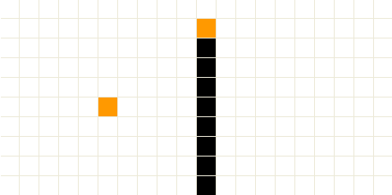
Figure 2: Gossip Model Initial State

Moore Neighborhood Results

For brevity, I will only show the results after 15 second of execution. In most cases, this is sufficient for the gossip to have spread over most of the graph.

Figure 3 shows the final result of the model with a 10% chance of forgetting and a 75% chance of passing the gossip.

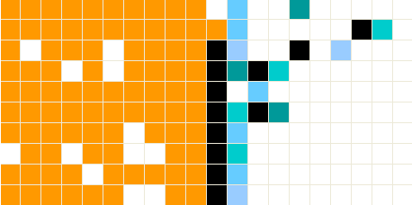
Figure 3: Moore Neighborhood and 75% Chance of spread

Figure 4 shows the final result of the model with a 10% chance of forgetting the gossip and a 50% chance of spreading it.
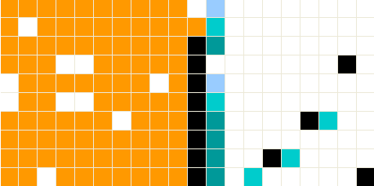
Figure 4: Moore Neighborhood and 50% Chance of spread

Figure 5 will show the model with a 50% chance of spreading the gossip and now a 5% chance of forgetting the gossip. Apparently the change in probability of forgetting the gossip has little effect on the rest of the model. So long as the probability of passing the gossip is greater than forgetting it, any cells that forget will quickly learn it again.

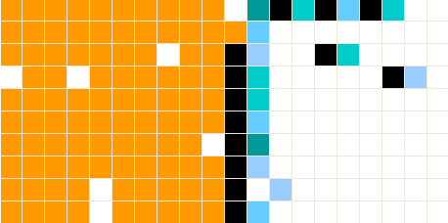
Figure 5: Moore Neighborhood with a 5% Chance of Forgetting

Lastly, Figure 6 shows the results of the Moore Neighborhood and a 25% chance of spreading the gossip.

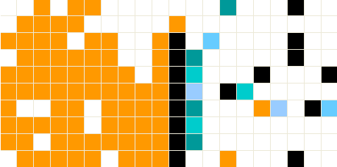
Figure 6: Moore Neighborhood and 25% Chance of spread

From these results it becomes apparent that the model will eventually spread to fill the graph under all conditions. Some variations may take a bit longer than others, however. As the specification states, the model will spread outward from the source fairly evenly.

Neumann Neighborhood Results

In these test cases, the model will be run with a Neumann neighborhood. Again the results displayed will be after 15 seconds of execution.

Figure 7 shows the final result of the model with a 10% chance of forgetting and a 75% chance of passing the gossip.

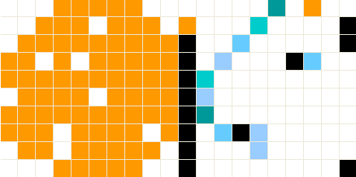
Figure 7: Neumann Neighborhood with 75% Chance of spreading

Figure 8 shows the final result of the model with a 10% chance of forgetting the gossip and a 50% chance of spreading it.

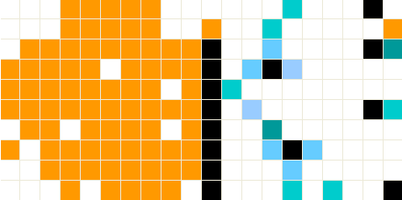
Figure 8: Neumann Neighborhood with 50% Chance of spreading

Figure 9 will show the model with a 50% chance of spreading the gossip and now a 5% chance of forgetting the gossip. Again it seems that this has only a small effect on the overall results of the model.

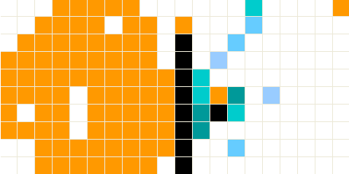
Figure 9: Neumann Neighborhood with 5% Chance of forgetting

Finally, Figure 10 shows the results of the Moore Neighborhood and a 25% chance of spreading the gossip.

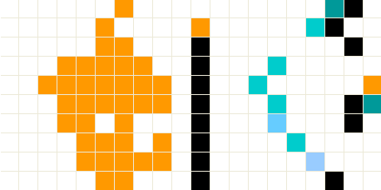
Figure 10: Neumann Neighborhood with 25% Chance of spreading

As in the Moor neighborhood execution, the model appears to spread outward for all the probability levels tested. With less chance of spreading the gossip, the model will spread slower, which is consistent with the Moore execution and the original specification. As can be seen here, the spread pattern looks slightly different, but this is only obvious due to the rather short run time and the low chance of spreading.

Model Modifications

Some modifications were made to the model from the model that was submitted initially. The most noteworthy addition was of the rule to forget the gossip, which was left out of the original Cell-DEVS model.

Bonus!

The gossip model was viewable in the VRML GUI. Figures 11 and 12 show the GUI and the results of a Moore and Neumann neighborhood.

Some issues I found with the VRML tool were that there was a requirement for spaces between values in the drawlog file. The program would seem to freeze when a draw file without spaces was opened. It would go as far as loading something a grid with red squares in all the possible spaces, but then it wouldn’t allow me to select any colors or run the model.

The color selection window also has issues regarding the set color button. It seems that after each time it is pressed it would automatically set focus to the next color box in the list of color ranges. So if a color was selection, but then I wanted to change that color and press set color again, it would set the new color in the next box.
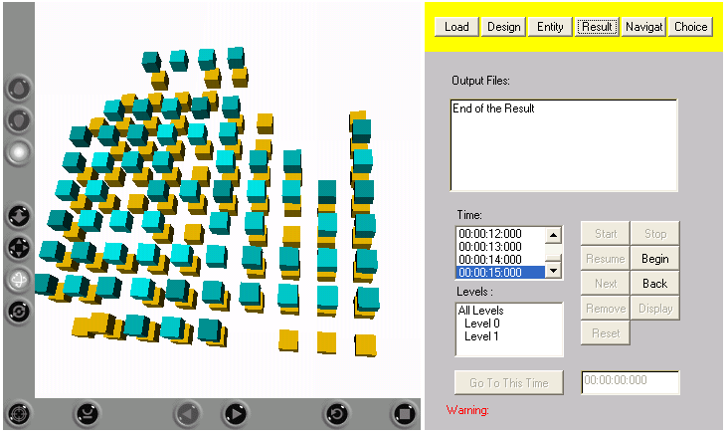
Figure 11: Gossip Model in VRML GUI with Moore Neighborhood

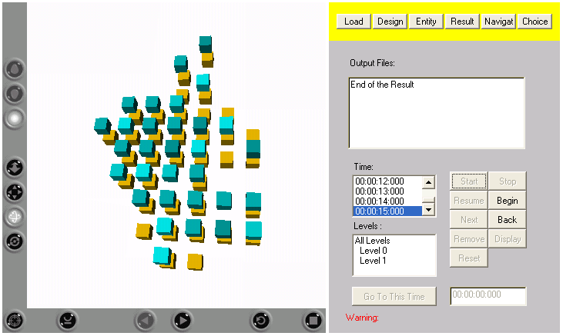
Figure 12: Gossip Model in VRML GUI with Neumann Neighborhood

