CARLETON UNIVERSITY

Department of Systems and Computer Engineering

SYSC-5807 METHODOLOGICAL ASPECTS OF MODELLING & SIMULATION .

Assignment 1

“A DEVS MODEL SIMULATION
OF A
CANADIAN FORCES
CC-130
(HERCULES)
AIRCRAFT
LOADS MONITORING SYSTEM”

Christopher S. Smith

101828
CARLETON UNIVERSITY
Department of Systems and Computer Engineering

SYSC-5807 METHODOLOGICAL ASPECTS OF MODELLING & SIMULATION .

Assignment 1 – Proposal
Christopher S. Smith
101828
spectre7@sympatico.ca

Between 1997 and 2000, I worked for British Aerospace Electronic Systems – Canada (BAE). One of my projects while there was to design an ‘Operational Loads Monitoring System’ (LMS) for the Canadian Force’s CC-130 Hercules aircraft. The idea, very much similar to a Flight Data Recorder (FDR), was to record structural and dynamic loads on a solid state recording device and use this data, at a later date, to schedule aircraft maintenance.

Prior to the implementation of this system, the Canadian Airforce scheduled maintenance on its CC-130s based on flight hours. The problem with this basis was that an aircraft, like the Hercules, experiences much more stress and strain on a relatively short search and rescue mission in the Arctic, for example, than on a longer trans-Atlantic flight. The LMS was designed to improve this scheduling.

The system works as follows: After inserting the solid state recording cartridge (FLASH) into the recording device a series of parameters including; date, time and aircraft number are manually input through a key pad. No data is recorded until the ‘Weight-Off-Wheels’ (‘WOW’) signal is asserted – this means the front wheel of the aircraft has left the ground. At this time, a header is written to the data cartridge and data recording begins. Data – wing loads, engine RPMs, vertical & lateral accelerations, elevator/aileron/flap positions and more – are recorded when there is a change in any one them by a predefined threshold value. This, obviously, requires a buffer or queue in which unchanged values are not recorded. Actual values are recorded on the memory cartridge one second after they are received.

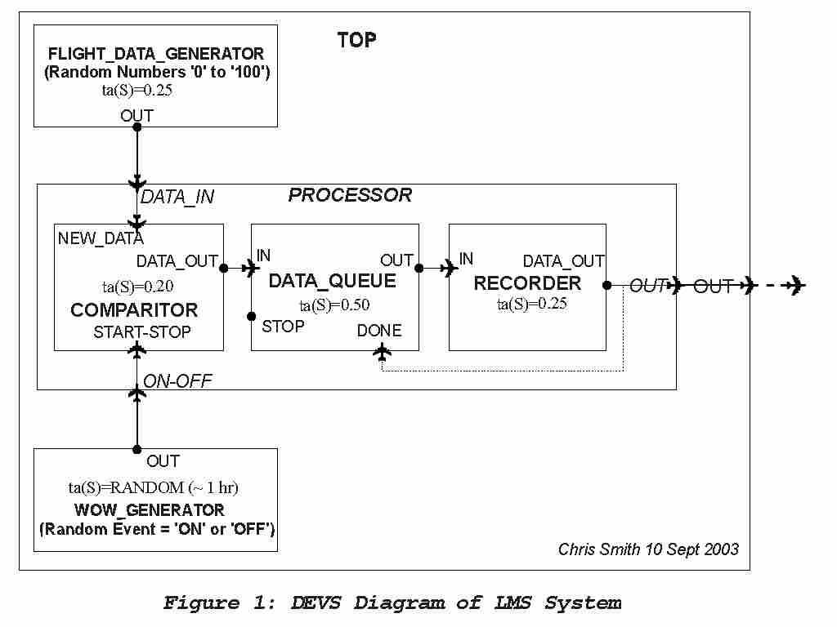
Upon aircraft landing, the WOW signal is withdrawn and no new data is collected. Recording stops when the queue is empty. The model is shown in the following figure ...
CARLETON UNIVERSITY
Department of Systems and Computer Engineering

SYSC-5807 METHODOLOGICAL ASPECTS OF MODELLING & SIMULATION .

Figure 1, above, shows the DEVS diagram of the entire LMS system. The individual, atomic components are specified below. The first two, the Flight Data Generator and the WOW Generator are external to the actual system and provide simulated inputs. The actual LMS system is simulated by the ‘Processor’ coupled model.

Flight Data Generator

The flight data generator simulates the data that would be collected from the aircraft sub-systems such as wing loads, engine RPMs, vertical & lateral accelerations, and elevator/aileron/flap positions. In real life the data would be long strings of numbers and characters perhaps hundreds of items long. For our simulation, we will use simple natural numbers between 1 and 100.
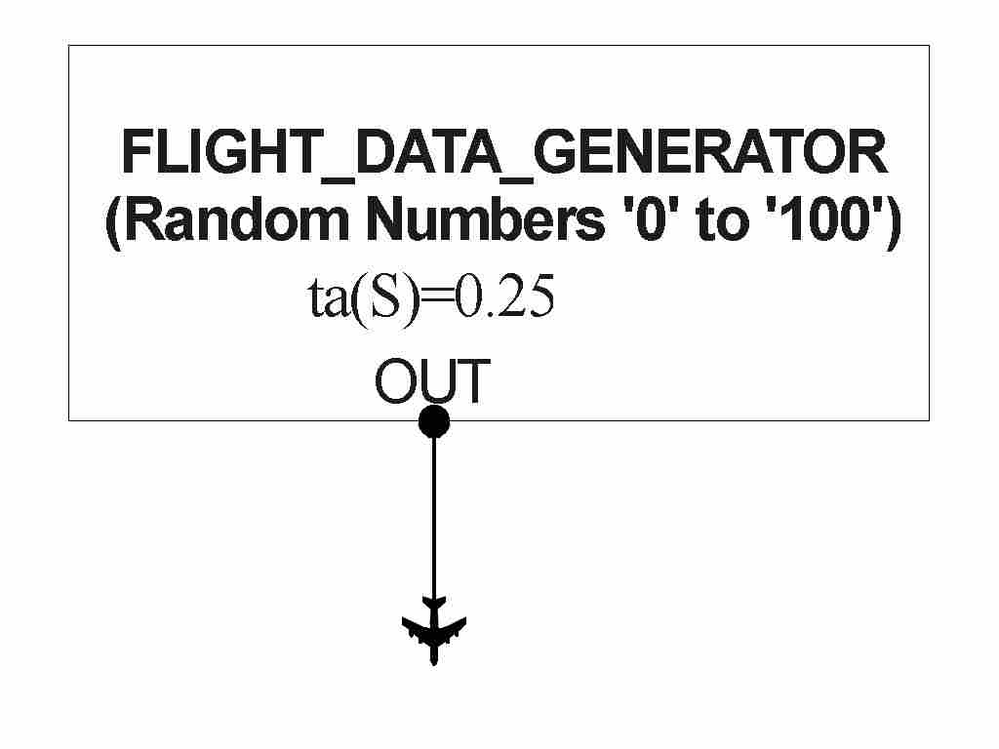

Figure 2 : DEVS Diagram of Atomic Component

The specification is as follows:

DEVS_{atomic} = < X, S, Y, δ_{int}, δ_{ext}, ta, λ >

X = φ

Y = OUT

S = < ACTIVE >

δ_{int} = delay for ta

δ_{ext} = φ

ta = 0.25 seconds

λ = 1+rand() % 100 - a random number between 1 and 100

The .cpp and .h code for the flight data generator is attached in Appendix A.

WOW Generator

The WOW generator simulates the “Weight-Off-Wheels” signal that identifies when the aircraft has left the ground (recording starts) and when it lands (recording ceases). We will use an instantiation of the existing ‘Generator’ class. A mean value of one hour will simulate approximately one hour before take-off and approximately one hour of flight-time.

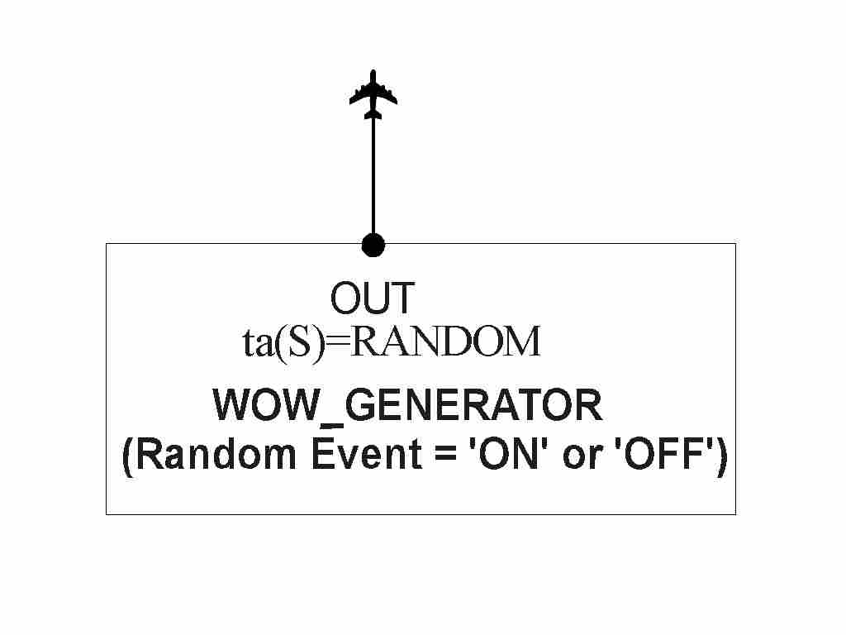
Figure 3 : DEVS Diagram of Atomic Component

Comparitor

The Comparitor module compares subsequent data with prior data and passes the later data only if it is different from the prior data by some threshold. This is done to eliminate redundant recording. In the case of our simulation the threshold is set as 1. Also, this module only passes data to the next module when the WOW signal is active.

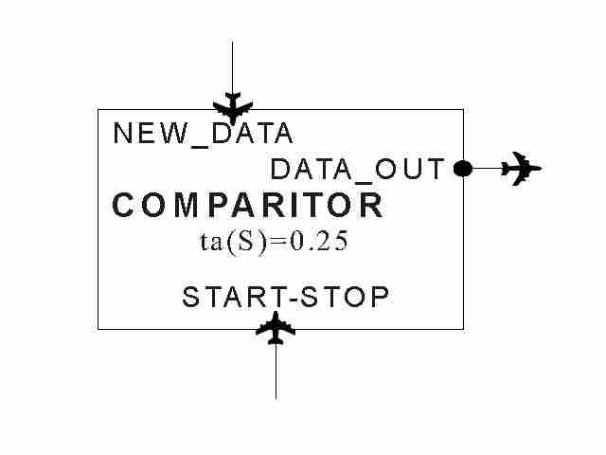

Figure 4 : DEVS Diagram of Atomic Component

The specification is as follows:

DEVS_{atomic} = < X, S, Y, δ_{int}, δ_{ext}, ta, λ >

X = < NEW_DATA , START_STOP >

Y = DATA_OUT

S = < ACTIVE , PASSIVE >

δ_{int} = passivate

δ_{ext} = if (START_STOP is Active)
if (NEW_DATA == previous value(NEW_DATA) +/- threshold) passivate
else hold active for ta
else do nothing

ta = 0.20 seconds

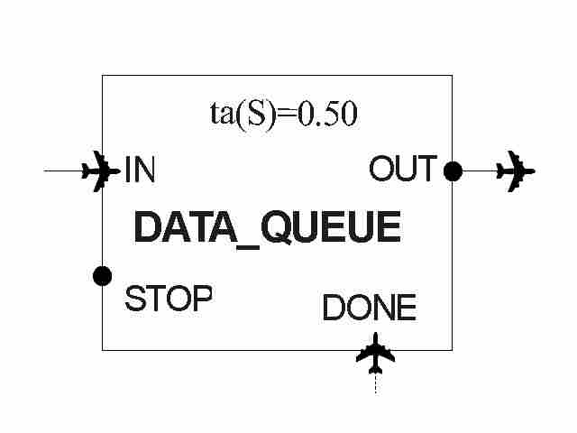
λ = send(NEW_DATA to DATA_OUT)

The .cpp and .h code for the comparitor is attached in Appendix A.

DATA QUEUE

The Data_Queue acts as a buffer between the fairly rapid left side of the model and the slower right side. It is an instantiation of the existing ‘queue’ class.

Figure 5 : DEVS Diagram of Atomic Component

RECORDER

The Recorder module is responsible for writing to the recording hardware. Typically this takes somewhat more time that other operations. This is why in our simulation there is a 0.5 second delay in this module.

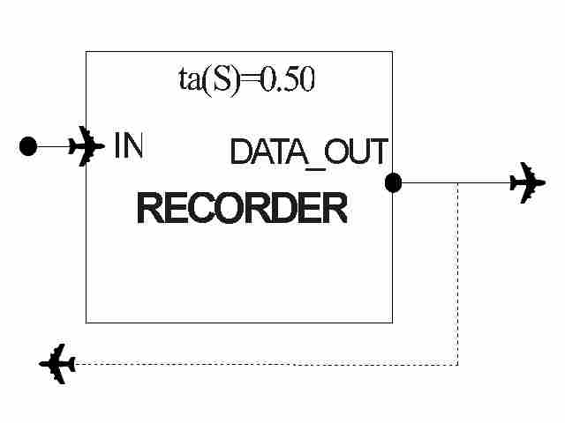

Figure 6 : DEVS Diagram of Atomic Component

The specification is as follows:

DEVS_{atomic} = < X, S, Y, δ_{int}, δ_{ext}, ta, λ >

X = IN

Y = DATA_OUT

S = < ACTIVE , PASSIVE >

δ_{int} = passivate

δ_{ext} = receive DATA on IN
delay for ta

ta = 0.20 seconds

λ = send(DATA to DATA_OUT)

The .cpp and .h code for the recorder is attached in Appendix A.

PROCESSOR COUPLED MODEL

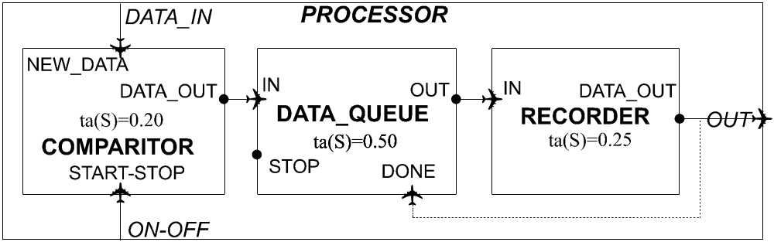

Figure 7 : DEVS Diagram of ‘PROCESSOR’ Coupled Component

After instantiation and testing of the Comparitor, Data_Queue and Recorder modules, they are bound together by use of the following .ma file. The ‘Processor’ coupled model is then tested as an integral unit. Testing details and results are recorded in Appendix B.

[top]
components : data_queue@Queue
components : comparitor@Comparitor
components : recorder@Recorder

out : out
in : data_in
in : WOW_in

Link : data_in new_data@comparitor
Link : WOW_in start_stop@comparitor

Link : data_out@comparitor in@data_queue
Link : out@data_queue in@recorder

Link : data_out@recorder done@data_queue
Link : data_out@recorder out

[comparitor]
preparation : 00:00:00:200

[data_queue]
preparation : 00:00:00:500

[recorder]
preparation : 00:00:00:500

Similarly, testing details of the Flight Data Generator and WOW Generator are contained in Appendix B. The final step was to combine all components using the .ma file below:

[top]
components : WOW_generator@Generator
components : flight_data_generator@Flight_Data_Generator
components : processor

out : out

Link : out@WOW_generator on_off@processor
Link : out@flight_data_generator data_in@processor
Link : out@processor out

[processor]
components : data_queue@Queue
components : comparitor@Comparitor
components : recorder@Recorder

out : out
in : data_in
in : on_off

Link : data_in new_data@comparitor
Link : on_off start_stop@comparitor
Link : data_out@comparitor in@data_queue

Link : out@data_queue in@recorder
Link : data_out@recorder done@data_queue
Link : data_out@recorder out

[comparitor]
preparation : 00:00:00:200

[data_queue]
preparation : 00:00:00:500

[recorder]
preparation : 00:00:00:500

[flight_data_generator]
preparation : 00:00:00:250

[WOW_generator]
distribution : normal
mean : 3600000
deviation : 600000
APPENDIX A:

CODE

comparitor.h

/*******************************************************************
*
* DESCRIPTION: Atomic Model Comparitor
* AUTHOR: Chris Smith
* DATE: 22/10/2003
*
*******************************************************************/

#ifndef __COMPARITOR_H
#define __COMPARITOR_H

#include <list>
#include "atomic.h" // class Atomic
#include "model.h" // class Model

class Comparitor : public Atomic
{
public:
Comparitor( const string &name = "Comparitor" ); //Default constructor
virtual string className() const ;

protected:
Model &initFunction();
Model &externalFunction( const ExternalMessage & );
Model &internalFunction( const InternalMessage & );
Model &outputFunction( const InternalMessage & );

private:

const Port &new_data; // where data comes in
const Port &start_stop; // where WOW comes in
Port &data_out; // where data to record is sent out
Time preparationTime ;
int threshold ; // new data must be +/- threshold than last data
int received_data ; // data value just received
int old_data ; // last data value received
int WOW ; // aircraft is waiting on ground

}; // class Comparitor

// ** inline ** //
inline
string Comparitor::className() const
{
return "Comparitor" ;
}

#endif //__COMPARITOR_H
comparitor.cpp

/*******************************************************************
*
* DESCRIPTION: Atomic Model Comparitor
* AUTHOR: Chris Smith
* DATE: 22/10/2003
*
*******************************************************************/

/** include files **/

#include "comparitor.h" // class Comparitor
#include "message.h" // class ExternalMessage, InternalMessage
#include "mainsimu.h" // MainSimulator::Instance().getParameter( ... )

/** public functions **/

/*******************************************************************
* Function Name: Comparitor
* Description:
********************************************************************/
Comparitor::Comparitor( const string &name )
: Atomic( name )
, new_data( addInputPort( "new_data" ) )
, start_stop( addInputPort( "start_stop" ) )
, data_out( addOutputPort( "data_out" ) )
, preparationTime( 0, 0, 1, 0 )
{
string time( MainSimulator::Instance().getParameter( description(),
"preparation" ) ) ;

if( time != "" ) preparationTime = time ;
}

/*******************************************************************
* Function Name: initFunction
* Description: Resetea la lista
* Precondition: El tiempo del proximo evento interno es Infinito
********************************************************************/
Model &Comparitor::initFunction()
{
threshold = 1;
received_data = -1;
old_data = -1;
WOW = 0;
return *this ;
}

/*******************************************************************
* Function Name: externalFunction
* Description:
********************************************************************/
Model &Comparitor::externalFunction( const ExternalMessage &msg )
{
if(( msg.port() == new_data ) && WOW) // receiving data and in air
{
received_data = msg.value();
if(( received_data == old_data + threshold)
|| ( received_data == old_data) // new data same as old data
|| ( received_data == old_data - threshold))
{
passivate(); // go to sleep
}
else
{
old_data = msg.value(); // new data is different
holdIn( active, preparationTime ); // wait one sec for processing
}
} // if(( msg.port() == new_data ) && WOW )

if( msg.port() == start_stop )
{
if( msg.value() == 1 ) // can start processing
{
WOW = 1; // aircraft is flying
passivate(); // go to sleep
}
else
{
WOW = 0; // aircraft is on ground
passivate(); // go to sleep
}
} // if( msg.port() == start_stop )

return *this;
}

/*******************************************************************
* Function Name: internalFunction
* Description:
********************************************************************/
Model &Comparitor::internalFunction( const InternalMessage & )
{
passivate(); // go to sleep
return *this ;
}

/*******************************************************************
* Function Name: outputFunction
* Description:
********************************************************************/
Model &Comparitor::outputFunction( const InternalMessage &msg )
{
if(WOW)
{
sendOutput( msg.time(), data_out, received_data ) ;
// send data and time to out port
}
return *this ;
}

recorder.h

/*******************************************************************
*
* DESCRIPTION: Atomic Model Recorder
* AUTHOR: Chris Smith
* DATE: 22/10/2003
*
*******************************************************************/

#ifndef __RECORDER_H
#define __RECORDER_H

#include <list>
#include "atomic.h" // class Atomic

class Recorder : public Atomic
{
public:
Recorder( const string &name = "Recorder" ); //Default constructor
virtual string className() const ;

protected:
Model &initFunction();
Model &externalFunction( const ExternalMessage & );
Model &internalFunction( const InternalMessage & );
Model &outputFunction( const InternalMessage & );

private:
const Port &in ;
Port &data_out ; // where data is sent out
Time preparationTime ;
int item ;

}; // class Recorder

inline
string Recorder::className() const
{
return "Recorder" ;
}
#endif //__RECORDER_H
recorder.cpp

/*******************************************************************
*
* DESCRIPTION: Atomic Model Recorder
* AUTHOR: Chris Smith
* DATE: 22/10/2003
*
*******************************************************************/

/** include files **/

#include "Recorder.h" // class Recorder
#include "message.h" // class ExternalMessage, InternalMessage
#include "mainsimu.h" // MainSimulator::Instance().getParameter( ... )

#include <cstdlib> // library containing Random Number Generator

/** public functions **/

/*******************************************************************
* Function Name: Recorder
* Description:
********************************************************************/
Recorder::Recorder( const string &name )
: Atomic( name )
, in( addInputPort ( "in" ) )
, data_out( addOutputPort( "data_out" ) )
, preparationTime( 0, 0, 0.5, 0 )
{
string time( MainSimulator::Instance().getParameter( description(),
"preparation" ) ) ;
if( time != "" ) preparationTime = time ;
}

/*******************************************************************
* Function Name: initFunction
* Description: Resetea la lista
* Precondition: El tiempo del proximo evento interno es Infinito
********************************************************************/
Model &Recorder::initFunction()
{
//cout << " *** I am in the init function *** " ;
item = -1 ;
return *this ;
}

/*******************************************************************
* Function Name: externalFunction
* Description:
********************************************************************/
Model &Recorder::externalFunction( const ExternalMessage &msg )
{
//cout << " *** I am in the external function *** " ;
holdIn( active, preparationTime );
// wait prep-time
item = msg.value() ;
// this is the item to output
return *this;
}

/*******************************************************************
* Function Name: internalFunction
* Description:
********************************************************************/
Model &Recorder::internalFunction( const InternalMessage & )
{
//cout << " *** I am in the internal function *** " ;
passivate();
// go to sleep
return *this ;
}

/*******************************************************************
* Function Name: outputFunction
* Description:
********************************************************************/
Model &Recorder::outputFunction( const InternalMessage &msg )
{
//cout << " *** I am in the output function *** " ;
sendOutput(msg.time(), data_out, item );
// send data and time to out port
return *this ;
}

flight_data_generator.h

/*******************************************************************
*
* DESCRIPTION: Atomic Model Flight_Data_Generator
* AUTHOR: Chris Smith
* DATE: 22/10/2003
*
*******************************************************************/

#ifndef __FLIGHT_DATA_GENERATOR_H
#define __FLIGHT_DATA_GENERATOR_H

#include <list>
#include "atomic.h" // class Atomic

#include <cstdlib> // library containing Random Number Generato

class Flight_Data_Generator : public Atomic
{
public:
Flight_Data_Generator( const string &name = "Flight_Data_Generator" );
//Default constructor

virtual string className() const ;

protected:
Model &initFunction();
Model &externalFunction( const ExternalMessage & );
Model &internalFunction( const InternalMessage & );
Model &outputFunction( const InternalMessage & );

private:
Port &out; // where data is sent out
Time preparationTime ; // time it takes to complete action

int generated_number ; // this is the random generated number

}; // class Flight_Data_Generator

// ** inline ** //
inline
string Flight_Data_Generator::className() const
{
return "Flight_Data_Generator" ;
}

#endif //__FLIGHT_DATA_GENERATOR_H

flight_data_generator.cpp

/*******************************************************************
*
* DESCRIPTION: Atomic Model Flight_Data_Generator
* AUTHOR: Chris Smith
* DATE: 22/10/2003
*
*******************************************************************/

/** include files **/

#include "Flight_Data_Generator.h" // class Flight_Data_Generator
#include "message.h" // class ExternalMessage, InternalMessage
#include "mainsimu.h" // MainSimulator::Instance().getParameter( ... )

#include <cstdlib> // library containing Random Number Generator

/** public functions **/

/*******************************************************************
* Function Name: Flight_Data_Generator
* Description:
********************************************************************/
Flight_Data_Generator::Flight_Data_Generator( const string &name )
: Atomic( name )
, out( addOutputPort( "out" ) )
, preparationTime( 0, 0, 1, 0 )
{
string time( MainSimulator::Instance().getParameter( description(),
"preparation" ) ) ;

if( time != "" ) preparationTime = time ;
}

/*******************************************************************
* Function Name: initFunction
* Description: Resetea la lista
* Precondition: El tiempo del proximo evento interno es Infinito
********************************************************************/
Model &Flight_Data_Generator::initFunction()
{
//cout << " *** I am in the init function *** " ;
holdIn( active, Time::Zero ) ;
generated_number = -1 ;
return *this;
}

/*******************************************************************
* Function Name: externalFunction
* Description:
********************************************************************/
Model &Flight_Data_Generator::externalFunction( const ExternalMessage &msg )
{
//cout << " *** I am in the external function *** " ;
return *this ;
}

/*******************************************************************
* Function Name: internalFunction
* Description:
********************************************************************/
Model &Flight_Data_Generator::internalFunction( const InternalMessage & )
{
//cout << " *** I am in the internal function *** " ;
holdIn( active, preparationTime ) ;
return *this ;
}

/*******************************************************************
* Function Name: outputFunction
* Description:
********************************************************************/
Model &Flight_Data_Generator::outputFunction( const InternalMessage &msg )
{
//cout << " *** I am in the output function *** " ;
generated_number = (1+rand() % 100) ;
/* yields random numbers between 1 and 100 */
sendOutput(msg.time(), out, generated_number );
/* send data and time to out port */
return *this ;
}

register.cpp

/*******************************************************************
*
* DESCRIPTION: Simulator::registerNewAtomics()
* AUTHOR: Chris Smith
* DATE: 22/10/2003
*
*******************************************************************/

#include "modeladm.h"
#include "mainsimu.h"
#include "flight_data_generator.h" // class Flight_Data_Generator
#include "recorder.h" // class Recorder
#include "comparitor.h" // class Comparitor
#include "queue.h" // class Queue
#include "generat.h" // class Generator
#include "cpu.h" // class CPU
#include "transduc.h" // class Transducer
#include "trafico.h" // class Trafico

void MainSimulator::registerNewAtomics()
{
SingleModelAdm::Instance().registerAtomic(
NewAtomicFunction<Flight_Data_Generator>() , "Flight_Data_Generator" ) ;
SingleModelAdm::Instance().registerAtomic( NewAtomicFunction<Recorder>() ,
"Recorder" ) ;
SingleModelAdm::Instance().registerAtomic( NewAtomicFunction<Comparitor>() ,
"Comparitor" ) ;
SingleModelAdm::Instance().registerAtomic( NewAtomicFunction<Queue>() , "Queue"
) ;
SingleModelAdm::Instance().registerAtomic( NewAtomicFunction<Generator>() ,
"Generator" ) ;
SingleModelAdm::Instance().registerAtomic( NewAtomicFunction<CPU>() , "CPU" ) ;
SingleModelAdm::Instance().registerAtomic( NewAtomicFunction<Transducer>() ,
"Transducer" ) ;
SingleModelAdm::Instance().registerAtomic( NewAtomicFunction<Trafico>() ,
"Trafico" ) ;
}
makefile

.SUFFIXES : .cpp .o .c .y

CPP=/usr/local/gcc-2.95.3/bin/g++
CC=/usr/local/gcc-2.95.3/bin/gcc
AR=ar
YACPP=yacc

DEFINES_CPP=

#============================================================================
# Optimized Code - Requires more virtual memory.
OPTCPPFLAGS=-O3
#----------------------
# Not optimized
#OPTCPPFLAGS=
#============================================================================

# gcc < 2.8.x
#DEFINES_CPP=-D_G_NO_EXTERN_TEMPLATES
#CPPFLAGS=-fhandle-exceptions

#============================================================================
# gcc 2.8.x (y superiores):
# -------------------------
# Ver warnings:
CPPFLAGS += -Wall
# Ignorar warnings:
#CPPFLAGS += -w

# Include information for GDB:
#CPPFLAGS += -g

# !!!!!!!!!!!!!!!!!!!!!!!!!!!!!!!!!!!!!!!!!!!!!!!!!!!!!!!!!!!!!!!!!!!!!!!!!!!!
# The next flag must be actived ONLY if we are compiling under Windows 95 !!!!
# !!!!!!!!!!!!!!!!!!!!!!!!!!!!!!!!!!!!!!!!!!!!!!!!!!!!!!!!!!!!!!!!!!!!!!!!!!!!
#CPPFLAGS += -D__WINDOWS__
#============================================================================

DEFINES_C=

# If we are compiling for Unix
INCLUDES_CPP=-I/usr/local/gcc-2.95.3/include
# or if we are compiling for Windows 95
#INCLUDES_CPP=

INCLUDES_C=
CFLAGS=
DEBUGFLAGS=
LDFLAGS += -L. -g

# if we are compiling for Windows 95, comment the last two lines

EXAMPLESOBJS=comparitor.o flight_data_generator.o recorder.o queue.o main.o generat.o cpu.o transduc.o trafico.o distri.o com.o linpack.o debug.o register.o
LIBNAME=simu
LIBS=-lsimu
ALLOBJS=${EXAMPLESOBJS} ${SIMOBJS}
INIOBJS=initest.o ini.o
ALLSRCS=${ALLOBJS:.o=.cpp} gram.y

all: simu

libs: libsimu.a

simu: ${ALLOBJS} libsimu.a
/usr/local/gcc-2.95.3/bin/g++ ${LDFLAGS} -o $@ ${EXAMPLESOBJS} ${LIBS}

initest: ${INIOBJS}
${CPP} ${LDFLAGS} -o $@ ${INIOBJS}

drawlog: drawlog.o libsimu.a
g++ ${LDFLAGS} -o $@ drawlog.o ${LIBS}

makerand: makerand.o libsimu.a
g++ ${LDFLAGS} -o $@ makerand.o ${LIBS}

toMap: toMap.o libsimu.a
g++ ${LDFLAGS} -o $@ toMap.o ${LIBS}

toCDPP: toCDPP.o libsimu.a
g++ ${LDFLAGS} -o $@ toCDPP.o ${LIBS}

randEvent: randEvent.o libsimu.a
g++ ${LDFLAGS} -o $@ randEvent.o ${EXAMPLESOBJS} ${LIBS}

exptest: synnode.o
g++ ${LDFLAGS} -o $@ synnode.o

parser: parser.o gram.o
g++ ${LDFLAGS} -o $@ parser.o gram.o

libsimu.a: ${SIMOBJS}
${AR} crs lib${LIBNAME}.a ${SIMOBJS}

clean:
- rm -f *.o *.a simu core drawlog initest exptest parser makerand toMap

depend:
makedepend -Y ${ALLSRCS}

backup:
tar -cvf simu.tar *.cpp *.h *.c *.y makefile* *.ma *.ev *.vpj *.bat *.txt *.val *.inc *.map; gzip simu.tar; mv simu.tar.gz simu.tgz

########################
# Without Optimization

comparitor.o: comparitor.cpp
${CPP} -c ${INCLUDES_CPP} ${DEFINES_CPP} ${DEBUGFLAGS} ${CPPFLAGS} $<
flight_data_generator.o: flight_data_generator.cpp
${CPP} -c ${INCLUDES_CPP} ${DEFINES_CPP} ${DEBUGFLAGS} ${CPPFLAGS} $<

recorder.o: recorder.cpp
${CPP} -c ${INCLUDES_CPP} ${DEFINES_CPP} ${DEBUGFLAGS} ${CPPFLAGS} $<

generat.o: generat.cpp
${CPP} -c ${INCLUDES_CPP} ${DEFINES_CPP} ${DEBUGFLAGS} ${CPPFLAGS} $<

queue.o: queue.cpp
${CPP} -c ${INCLUDES_CPP} ${DEFINES_CPP} ${DEBUGFLAGS} ${CPPFLAGS} $<

cpu.o: cpu.cpp
${CPP} -c ${INCLUDES_CPP} ${DEFINES_CPP} ${DEBUGFLAGS} ${CPPFLAGS} $<

transduc.o: transduc.cpp
${CPP} -c ${INCLUDES_CPP} ${DEFINES_CPP} ${DEBUGFLAGS} ${CPPFLAGS} $<

trafico.o: trafico.cpp
${CPP} -c ${INCLUDES_CPP} ${DEFINES_CPP} ${DEBUGFLAGS} ${CPPFLAGS} $<

register.o: register.cpp
${CPP} -c ${INCLUDES_CPP} ${DEFINES_CPP} ${DEBUGFLAGS} ${CPPFLAGS} $<

msgadm.o: msgadm.cpp
${CPP} -c ${INCLUDES_CPP} ${DEFINES_CPP} ${DEBUGFLAGS} ${CPPFLAGS} $<

root.o: root.cpp
${CPP} -c ${INCLUDES_CPP} ${DEFINES_CPP} ${DEBUGFLAGS} ${CPPFLAGS} $<

parser.o: parser.cpp
${CPP} -c ${INCLUDES_CPP} ${DEFINES_CPP} ${DEBUGFLAGS} ${CPPFLAGS} $<

main.o: main.cpp
${CPP} -c ${INCLUDES_CPP} ${DEFINES_CPP} ${DEBUGFLAGS} ${CPPFLAGS} $<

drawlog.o: drawlog.cpp
${CPP} -c ${INCLUDES_CPP} ${DEFINES_CPP} ${DEBUGFLAGS} ${CPPFLAGS} $<

toMap.o: toMap.cpp
${CPP} -c ${INCLUDES_CPP} ${DEFINES_CPP} ${DEBUGFLAGS} ${CPPFLAGS} $<

toCDPP.o: toCDPP.cpp
${CPP} -c ${INCLUDES_CPP} ${DEFINES_CPP} ${DEBUGFLAGS} ${CPPFLAGS} $<

makerand.o: makerand.cpp
${CPP} -c ${INCLUDES_CPP} ${DEFINES_CPP} ${DEBUGFLAGS} ${CPPFLAGS} $<

mainsimu.o: mainsimu.cpp
${CPP} -c ${INCLUDES_CPP} ${DEFINES_CPP} ${DEBUGFLAGS} ${CPPFLAGS} $<

# Uncomment these lines only for Windows
#macroexp.o: macroexp.cpp
# ${CPP} -c ${INCLUDES_CPP} ${DEFINES_CPP} ${DEBUGFLAGS} ${CPPFLAGS} $<
#
#flatcoup.o: flatcoup.cpp
# ${CPP} -c ${INCLUDES_CPP} ${DEFINES_CPP} ${DEBUGFLAGS} ${CPPFLAGS} $<
########################

.cpp.o:
${CPP} -c ${INCLUDES_CPP} ${DEFINES_CPP} ${DEBUGFLAGS} ${CPPFLAGS} ${OPTCPPFLAGS} $<

.c.o:
${CC} -c ${INCLUDES_C} ${DEFINES_C} ${DEBUGFLAGS} ${CFLAGS} ${OPTCPPFLAGS} $<

.y.o:
bison -d -v -o gram.c gram.y
${CPP} -c ${INCLUDES_CPP} ${DEFINES_CPP} ${DEBUGFLAGS} ${CPPFLAGS} ${OPTCPPFLAGS} ${@:.o=.c}
rm $*.c

# DO NOT DELETE

queue.o: queue.h atomic.h model.h port.h modelid.h time.h portlist.h real.h
queue.o: undefd.h impresion.h tbool.h except.h stringp.h value.h evaldeb.h
queue.o: cellpos.h ntupla.h procadm.h process.h message.h strutil.h
queue.o: mainsimu.h root.h event.h ini.h loader.h ltranadm.h
main.o: stdaload.h loader.h time.h evaldeb.h macroexp.h except.h stringp.h
main.o: netload.h mainsimu.h root.h event.h real.h undefd.h impresion.h
main.o: tbool.h value.h port.h modelid.h process.h procadm.h ini.h ltranadm.h
main.o: cellpos.h ntupla.h portlist.h model.h
generat.o: generat.h atomic.h model.h port.h modelid.h time.h portlist.h
generat.o: real.h undefd.h impresion.h tbool.h except.h stringp.h value.h
generat.o: evaldeb.h cellpos.h ntupla.h procadm.h process.h message.h
generat.o: strutil.h mainsimu.h root.h event.h ini.h loader.h ltranadm.h
generat.o: distri.h
cpu.o: cpu.h atomic.h model.h port.h modelid.h time.h portlist.h real.h
cpu.o: undefd.h impresion.h tbool.h except.h stringp.h value.h evaldeb.h
cpu.o: cellpos.h ntupla.h procadm.h process.h message.h strutil.h distri.h
cpu.o: mainsimu.h root.h event.h ini.h loader.h ltranadm.h
transduc.o: transduc.h atomic.h model.h port.h modelid.h time.h portlist.h
transduc.o: real.h undefd.h impresion.h tbool.h except.h stringp.h value.h
transduc.o: evaldeb.h cellpos.h ntupla.h procadm.h process.h message.h
transduc.o: strutil.h mainsimu.h root.h event.h ini.h loader.h ltranadm.h
trafico.o: time.h trafico.h atomic.h model.h port.h modelid.h portlist.h
trafico.o: real.h undefd.h impresion.h tbool.h except.h stringp.h value.h
trafico.o: evaldeb.h cellpos.h ntupla.h procadm.h process.h message.h
trafico.o: strutil.h
distri.o: time.h distri.h except.h stringp.h strutil.h real.h undefd.h
distri.o: impresion.h tbool.h value.h evaldeb.h
debug.o: debug.h tdcell.h atomcell.h portlist.h real.h undefd.h impresion.h
debug.o: tbool.h except.h stringp.h value.h evaldeb.h port.h modelid.h
debug.o: cellpos.h ntupla.h atomic.h model.h time.h procadm.h process.h
debug.o: neighval.h mylist.h coupcell.h coupled.h ltranadm.h cellstate.h
register.o: modeladm.h mainsimu.h root.h event.h time.h real.h undefd.h
register.o: impresion.h tbool.h except.h stringp.h value.h evaldeb.h port.h
register.o: modelid.h process.h procadm.h ini.h loader.h ltranadm.h cellpos.h
register.o: ntupla.h portlist.h model.h queue.h atomic.h generat.h cpu.h
register.o: transduc.h message.h strutil.h trafico.h
gram.o: synnode.h tbool.h except.h stringp.h real.h undefd.h impresion.h
gram.o: value.h evaldeb.h realfunc.h ltranadm.h cellpos.h ntupla.h portlist.h
gram.o: port.h modelid.h time.h model.h procadm.h process.h parser.h
recorder.o: recorder.h atomic.h model.h port.h modelid.h time.h portlist.h real.h
recorder.o: undefd.h impresion.h tbool.h except.h stringp.h value.h evaldeb.h
recorder.o: cellpos.h ntupla.h procadm.h process.h message.h strutil.h
recorder.o: mainsimu.h root.h event.h ini.h loader.h ltranadm.h
flight_data_generator.o: flight_data_generator.h atomic.h model.h port.h modelid.h time.h portlist.h real.h
flight_data_generator.o: undefd.h impresion.h tbool.h except.h stringp.h value.h evaldeb.h
flight_data_generator.o: cellpos.h ntupla.h procadm.h process.h message.h strutil.h
flight_data_generator.o: mainsimu.h root.h event.h ini.h loader.h ltranadm.h
comparitor.o: comparitor.h atomic.h model.h port.h modelid.h time.h portlist.h real.h
comparitor.o: undefd.h impresion.h tbool.h except.h stringp.h value.h evaldeb.h
comparitor.o: cellpos.h ntupla.h procadm.h process.h message.h strutil.h
comparitor.o: mainsimu.h root.h event.h ini.h loader.h ltranadm.h
APPENDIX B:

Testing

Testing is accomplished in three phases;

(1) Individual, atomic modules are tested using event drivers (.ev files) where possible,

(2) The ‘Processor’ coupled module is tested using event drivers, and

(3) The Flight Data Generator and WOW Generator are used to drive the ‘Processor’ module
in a simplified fashion.

After this a full scale run of the simulation is performed.

Flight Data Generator

Designed with no external input, this module is self perpetuating. For testing only, the output is a random number between 1 and 100 generated at 0.1 second intervals. A time limit of one second is put on this test.

The .bat file that runs this test follows;

./simu -t00:00:01:000 -mFDG.ma -lFDG.log -oFDG.out

The .ma file is

[top]
components : flight_data_generator@Flight_Data_Generator
out : out
Link : out@flight_data_generator out

[flight_data_generator]
preparation : 00:00:00:100

The following is the results (the .log file) of this test:

Mensaje I / 00:00:00:000 / Root(00) para top(01)
Mensaje I / 00:00:00:000 / top(01) para flight_data_generator(02)
Mensaje D / 00:00:00:000 / flight_data_generator(02) / 00:00:00:000 para top(01)
Mensaje D / 00:00:00:000 / top(01) / 00:00:00:000 para Root(00)
Mensaje * / 00:00:00:000 / Root(00) para top(01)
Mensaje * / 00:00:00:000 / top(01) para flight_data_generator(02)
Mensaje Y / 00:00:00:000 / flight_data_generator(02) / out / 19.00000 para top(01)
Mensaje D / 00:00:00:000 / flight_data_generator(02) / 00:00:00:100 para top(01)
Mensaje Y / 00:00:00:000 / top(01) / out / 19.00000 para Root(00)
Mensaje D / 00:00:00:000 / top(01) / 00:00:00:100 para Root(00)
Mensaje * / 00:00:00:100 / Root(00) para top(01)
Mensaje * / 00:00:00:100 / top(01) para flight_data_generator(02)
Mensaje Y / 00:00:00:100 / flight_data_generator(02) / out / 5.00000 para top(01)
Mensaje D / 00:00:00:100 / flight_data_generator(02) / 00:00:00:100 para top(01)
Mensaje Y / 00:00:00:100 / top(01) / out / 5.00000 para Root(00)
Mensaje D / 00:00:00:100 / top(01) / 00:00:00:100 para Root(00)
Mensaje * / 00:00:00:200 / Root(00) para top(01)
Mensaje * / 00:00:00:200 / top(01) para flight_data_generator(02)
Mensaje Y / 00:00:00:200 / flight_data_generator(02) / out / 78.00000 para top(01)
Mensaje D / 00:00:00:200 / flight_data_generator(02) / 00:00:00:100 para top(01)
Mensaje Y / 00:00:00:200 / top(01) / out / 78.00000 para Root(00)
Mensaje D / 00:00:00:200 / top(01) / 00:00:00:100 para Root(00)
Mensaje * / 00:00:00:300 / Root(00) para top(01)
Mensaje * / 00:00:00:300 / top(01) para flight_data_generator(02)
Mensaje Y / 00:00:00:300 / flight_data_generator(02) / out / 2.00000 para top(01)
Mensaje D / 00:00:00:300 / flight_data_generator(02) / 00:00:00:100 para top(01)
Mensaje Y / 00:00:00:300 / top(01) / out / 2.00000 para Root(00)
Mensaje D / 00:00:00:300 / top(01) / 00:00:00:100 para Root(00)
Mensaje * / 00:00:00:400 / Root(00) para top(01)
Mensaje * / 00:00:00:400 / top(01) para flight_data_generator(02)
Mensaje Y / 00:00:00:400 / flight_data_generator(02) / out / 35.00000 para top(01)
Mensaje D / 00:00:00:400 / flight_data_generator(02) / 00:00:00:100 para top(01)
Mensaje Y / 00:00:00:400 / top(01) / out / 35.00000 para Root(00)
Mensaje D / 00:00:00:400 / top(01) / 00:00:00:100 para Root(00)
Mensaje * / 00:00:00:500 / Root(00) para top(01)
Mensaje * / 00:00:00:500 / top(01) para flight_data_generator(02)
Mensaje Y / 00:00:00:500 / flight_data_generator(02) / out / 70.00000 para top(01)
Mensaje D / 00:00:00:500 / flight_data_generator(02) / 00:00:00:100 para top(01)
Mensaje Y / 00:00:00:500 / top(01) / out / 70.00000 para Root(00)
Mensaje D / 00:00:00:500 / top(01) / 00:00:00:100 para Root(00)
Mensaje * / 00:00:00:600 / Root(00) para top(01)
Mensaje * / 00:00:00:600 / top(01) para flight_data_generator(02)
Mensaje Y / 00:00:00:600 / flight_data_generator(02) / out / 3.00000 para top(01)
Mensaje D / 00:00:00:600 / flight_data_generator(02) / 00:00:00:100 para top(01)
Mensaje Y / 00:00:00:600 / top(01) / out / 3.00000 para Root(00)
Mensaje D / 00:00:00:600 / top(01) / 00:00:00:100 para Root(00)
Mensaje * / 00:00:00:700 / Root(00) para top(01)
Mensaje * / 00:00:00:700 / top(01) para flight_data_generator(02)
Mensaje Y / 00:00:00:700 / flight_data_generator(02) / out / 99.00000 para top(01)
Mensaje D / 00:00:00:700 / flight_data_generator(02) / 00:00:00:100 para top(01)
Mensaje Y / 00:00:00:700 / top(01) / out / 99.00000 para Root(00)
Mensaje D / 00:00:00:700 / top(01) / 00:00:00:100 para Root(00)
Mensaje * / 00:00:00:800 / Root(00) para top(01)
Mensaje * / 00:00:00:800 / top(01) para flight_data_generator(02)
Mensaje Y / 00:00:00:800 / flight_data_generator(02) / out / 83.00000 para top(01)
Mensaje D / 00:00:00:800 / flight_data_generator(02) / 00:00:00:100 para top(01)
Mensaje Y / 00:00:00:800 / top(01) / out / 83.00000 para Root(00)
Mensaje D / 00:00:00:800 / top(01) / 00:00:00:100 para Root(00)
Mensaje * / 00:00:00:900 / Root(00) para top(01)
Mensaje * / 00:00:00:900 / top(01) para flight_data_generator(02)
Mensaje Y / 00:00:00:900 / flight_data_generator(02) / out / 33.00000 para top(01)
Mensaje D / 00:00:00:900 / flight_data_generator(02) / 00:00:00:100 para top(01)
Mensaje Y / 00:00:00:900 / top(01) / out / 33.00000 para Root(00)
Mensaje D / 00:00:00:900 / top(01) / 00:00:00:100 para Root(00)
Mensaje * / 00:00:01:000 / Root(00) para top(01)
Mensaje * / 00:00:01:000 / top(01) para flight_data_generator(02)
Mensaje Y / 00:00:01:000 / flight_data_generator(02) / out / 71.00000 para top(01)
Mensaje D / 00:00:01:000 / flight_data_generator(02) / 00:00:00:100 para top(01)
Mensaje Y / 00:00:01:000 / top(01) / out / 71.00000 para Root(00)
Mensaje D / 00:00:01:000 / top(01) / 00:00:00:100 para Root(00)

The results indicate that the module does in fact produce random numbers between 1 and 100 at a rate of one per one tenth second.

WOW Generator

Similarly to the previous module this module is designed with no external input and is self perpetuating. For testing only, the output of this module is a “0” followed by a “1” approximately 60 seconds later. A “2” follows approximately 60 seconds later, again. These values simulate the aircraft on the ground, leaving the ground and returning, again, to the ground, respectively. A time limit of three minutes is put on this test.

The .bat file that runs this test is;

./simu -t00:03:00:000 -mWOW_gen.ma -lWOW_gen.log -oWOW_gen.out

The .ma file is

[top]
components : WOW_generator@Generator
out : out
Link : out@WOW_generator out

[WOW_generator]
distribution : normal
mean : 60 <- produces approx. 60 second intervals
deviation : 1 <- limits the differences to approx. 1 second

The following is the results (the .log file) of this test:

Mensaje I / 00:00:00:000 / Root(00) para top(01)
Mensaje I / 00:00:00:000 / top(01) para wow_generator(02)
Mensaje D / 00:00:00:000 / wow_generator(02) / 00:00:00:000 para top(01)
Mensaje D / 00:00:00:000 / top(01) / 00:00:00:000 para Root(00)
Mensaje * / 00:00:00:000 / Root(00) para top(01)
Mensaje * / 00:00:00:000 / top(01) para wow_generator(02)
Mensaje Y / 00:00:00:000 / wow_generator(02) / out / 0.00000 para top(01)
Mensaje D / 00:00:00:000 / wow_generator(02) / 00:00:59:987 para top(01)
Mensaje Y / 00:00:00:000 / top(01) / out / 0.00000 para Root(00)
Mensaje D / 00:00:00:000 / top(01) / 00:00:59:987 para Root(00)
Mensaje * / 00:00:59:987 / Root(00) para top(01)
Mensaje * / 00:00:59:987 / top(01) para wow_generator(02)
Mensaje Y / 00:00:59:987 / wow_generator(02) / out / 1.00000 para top(01)
Mensaje D / 00:00:59:987 / wow_generator(02) / 00:00:58:796 para top(01)
Mensaje Y / 00:00:59:987 / top(01) / out / 1.00000 para Root(00)
Mensaje D / 00:00:59:987 / top(01) / 00:00:58:796 para Root(00)
Mensaje * / 00:01:58:783 / Root(00) para top(01)
Mensaje * / 00:01:58:783 / top(01) para wow_generator(02)
Mensaje Y / 00:01:58:783 / wow_generator(02) / out / 2.00000 para top(01)
Mensaje D / 00:01:58:783 / wow_generator(02) / 00:00:58:957 para top(01)
Mensaje Y / 00:01:58:783 / top(01) / out / 2.00000 para Root(00)
Mensaje D / 00:01:58:783 / top(01) / 00:00:58:957 para Root(00)
Mensaje * / 00:02:57:740 / Root(00) para top(01)
Mensaje * / 00:02:57:740 / top(01) para wow_generator(02)
Mensaje Y / 00:02:57:740 / wow_generator(02) / out / 3.00000 para top(01)
Mensaje D / 00:02:57:740 / wow_generator(02) / 00:02:00:035 para top(01)
Mensaje Y / 00:02:57:740 / top(01) / out / 3.00000 para Root(00)
Mensaje D / 00:02:57:740 / top(01) / 00:02:00:035 para Root(00)

The results indicate that the module does work as expected.

Comparitor

There are two separate tests for this module; the first to ensure that the module passes values through to the next module only when the WOW signal is active (when the Start-Stop input is “1”). The second test tests to ensure that no redundant values, within the threshold, are passed.

The two batch files are:

./simu -mcomparitor.ma -ecomparitor.ev -lcomparitor.log -ocomparitor.out

and

./simu -mcomparitor.ma -ecomparitor-2.ev -lcomparitor-2.log -ocomparitor-2.out

respectively.

The .ma file for both is:

[top]
components : comparitor@Comparitor
out : out
in : in1
in : in2
Link : in1 new_data@comparitor
Link : in2 start_stop@comparitor
Link : data_out@comparitor out

[comparitor]
preparation : 00:00:00:050

The two event files are shown below; that on the left for the first test, that on the right for the second. (P) indicates that value should be passed to the outport.

00:00:00:000 in2 0 <- aircraft is on ground -> 00:00:00:000 in2 0
00:00:00:100 in1 1 00:00:00:100 in1 1
00:00:00:500 in1 3 00:00:00:500 in1 3
00:00:00:800 in1 5 00:00:00:600 in1 3
00:00:01:500 in2 1 <- aircraft is in air 00:00:00:800 in1 5
00:00:01:600 in1 7 (P) aircraft is in air -> 00:00:01:500 in2 1
00:00:01:700 in1 9 (P) 00:00:01:600 in1 7 (P)
00:00:01:800 in1 0 (P) 00:00:01:700 in1 7
00:00:02:000 in2 2 <- aircraft is on ground 00:00:01:800 in1 8
00:00:02:200 in1 2 00:00:01:900 in1 8
00:00:02:300 in1 4 00:00:02:000 in1 9 (P)
00:00:02:400 in1 6 00:00:02:100 in1 9
00:00:03:000 in2 3 00:00:02:600 in1 5 (P)
00:00:02:800 in1 0 (P)
aircraft is on ground -> 00:00:03:000 in2 2
00:00:03:200 in1 2
00:00:03:300 in1 4
The following is the .log file for the first test ...

Mensaje I / 00:00:00:000 / Root(00) para top(01)
Mensaje I / 00:00:00:000 / top(01) para comparitor(02)
Mensaje D / 00:00:00:000 / comparitor(02) / ... para top(01)
Mensaje D / 00:00:00:000 / top(01) / ... para Root(00)
Mensaje X / 00:00:00:000 / Root(00) / in2 / 0.00000 para top(01)
Mensaje X / 00:00:00:000 / top(01) / start_stop / 0.00000 para comparitor(02)
Mensaje D / 00:00:00:000 / comparitor(02) / ... para top(01)
Mensaje D / 00:00:00:000 / top(01) / ... para Root(00)
Mensaje X / 00:00:00:100 / Root(00) / in1 / 1.00000 para top(01)
Mensaje X / 00:00:00:100 / top(01) / new_data / 1.00000 para comparitor(02)
Mensaje D / 00:00:00:100 / comparitor(02) / ... para top(01)
Mensaje D / 00:00:00:100 / top(01) / ... para Root(00)
Mensaje X / 00:00:00:500 / Root(00) / in1 / 3.00000 para top(01)
Mensaje X / 00:00:00:500 / top(01) / new_data / 3.00000 para comparitor(02)
Mensaje D / 00:00:00:500 / comparitor(02) / ... para top(01)
Mensaje D / 00:00:00:500 / top(01) / ... para Root(00)
Mensaje X / 00:00:00:800 / Root(00) / in1 / 5.00000 para top(01)
Mensaje X / 00:00:00:800 / top(01) / new_data / 5.00000 para comparitor(02)
Mensaje D / 00:00:00:800 / comparitor(02) / ... para top(01)
Mensaje D / 00:00:00:800 / top(01) / ... para Root(00)
***IN AIR***
Mensaje X / 00:00:01:500 / Root(00) / in2 / 1.00000 para top(01)
Mensaje X / 00:00:01:500 / top(01) / start_stop / 1.00000 para comparitor(02)
Mensaje D / 00:00:01:500 / comparitor(02) / ... para top(01)
Mensaje D / 00:00:01:500 / top(01) / ... para Root(00)
Mensaje X / 00:00:01:600 / Root(00) / in1 / 7.00000 para top(01)
Mensaje X / 00:00:01:600 / top(01) / new_data / 7.00000 para comparitor(02)
Mensaje D / 00:00:01:600 / comparitor(02) / 00:00:00:050 para top(01)
Mensaje D / 00:00:01:600 / top(01) / 00:00:00:050 para Root(00)
Mensaje * / 00:00:01:650 / Root(00) para top(01)
Mensaje * / 00:00:01:650 / top(01) para comparitor(02)
Mensaje Y / 00:00:01:650 / comparitor(02) / data_out / 7.00000 para top(01)
Mensaje D / 00:00:01:650 / comparitor(02) / ... para top(01)
Mensaje Y / 00:00:01:650 / top(01) / out / 7.00000 para Root(00)
Mensaje D / 00:00:01:650 / top(01) / ... para Root(00)
Mensaje X / 00:00:01:700 / Root(00) / in1 / 9.00000 para top(01)
Mensaje X / 00:00:01:700 / top(01) / new_data / 9.00000 para comparitor(02)
Mensaje D / 00:00:01:700 / comparitor(02) / 00:00:00:050 para top(01)
Mensaje D / 00:00:01:700 / top(01) / 00:00:00:050 para Root(00)
Mensaje * / 00:00:01:750 / Root(00) para top(01)
Mensaje * / 00:00:01:750 / top(01) para comparitor(02)
Mensaje Y / 00:00:01:750 / comparitor(02) / data_out / 9.00000 para top(01)
Mensaje D / 00:00:01:750 / comparitor(02) / ... para top(01)
Mensaje Y / 00:00:01:750 / top(01) / out / 9.00000 para Root(00)
Mensaje D / 00:00:01:750 / top(01) / ... para Root(00)
Mensaje X / 00:00:01:800 / Root(00) / in1 / 0.00000 para top(01)
Mensaje X / 00:00:01:800 / top(01) / new_data / 0.00000 para comparitor(02)
Mensaje D / 00:00:01:800 / comparitor(02) / 00:00:00:050 para top(01)
Mensaje D / 00:00:01:800 / top(01) / 00:00:00:050 para Root(00)
Mensaje * / 00:00:01:850 / Root(00) para top(01)
Mensaje * / 00:00:01:850 / top(01) para comparitor(02)
Mensaje Y / 00:00:01:850 / comparitor(02) / data_out / 0.00000 para top(01)
Mensaje D / 00:00:01:850 / comparitor(02) / ... para top(01)
Mensaje Y / 00:00:01:850 / top(01) / out / 0.00000 para Root(00)
Mensaje D / 00:00:01:850 / top(01) / ... para Root(00)
***ON GROUND***
Mensaje X / 00:00:02:000 / Root(00) / in2 / 2.00000 para top(01)
Mensaje X / 00:00:02:000 / top(01) / start_stop / 2.00000 para comparitor(02)
Mensaje D / 00:00:02:000 / comparitor(02) / ... para top(01)
Mensaje D / 00:00:02:000 / top(01) / ... para Root(00)
Mensaje X / 00:00:02:200 / Root(00) / in1 / 2.00000 para top(01)
Mensaje X / 00:00:02:200 / top(01) / new_data / 2.00000 para comparitor(02)
Mensaje D / 00:00:02:200 / comparitor(02) / ... para top(01)
Mensaje D / 00:00:02:200 / top(01) / ... para Root(00)
Mensaje X / 00:00:02:300 / Root(00) / in1 / 4.00000 para top(01)
Mensaje X / 00:00:02:300 / top(01) / new_data / 4.00000 para comparitor(02)
Mensaje D / 00:00:02:300 / comparitor(02) / ... para top(01)
Mensaje D / 00:00:02:300 / top(01) / ... para Root(00)
Mensaje X / 00:00:02:400 / Root(00) / in1 / 6.00000 para top(01)
Mensaje X / 00:00:02:400 / top(01) / new_data / 6.00000 para comparitor(02)
Mensaje D / 00:00:02:400 / comparitor(02) / ... para top(01)
Mensaje D / 00:00:02:400 / top(01) / ... para Root(00)
Mensaje X / 00:00:03:000 / Root(00) / in2 / 3.00000 para top(01)
Mensaje X / 00:00:03:000 / top(01) / start_stop / 3.00000 para comparitor(02)
Mensaje D / 00:00:03:000 / comparitor(02) / ... para top(01)
Mensaje D / 00:00:03:000 / top(01) / ... para Root(00)

These results show the module passes values through to the next module only when the WOW signal is active.

The following is the .log file for the second test ...

Mensaje I / 00:00:00:000 / Root(00) para top(01)
Mensaje I / 00:00:00:000 / top(01) para comparitor(02)
Mensaje D / 00:00:00:000 / comparitor(02) / ... para top(01)
Mensaje D / 00:00:00:000 / top(01) / ... para Root(00)
Mensaje X / 00:00:00:000 / Root(00) / in2 / 0.00000 para top(01)
Mensaje X / 00:00:00:000 / top(01) / start_stop / 0.00000 para comparitor(02)
Mensaje D / 00:00:00:000 / comparitor(02) / ... para top(01)
Mensaje D / 00:00:00:000 / top(01) / ... para Root(00)
Mensaje X / 00:00:00:100 / Root(00) / in1 / 1.00000 para top(01)
Mensaje X / 00:00:00:100 / top(01) / new_data / 1.00000 para comparitor(02)
Mensaje D / 00:00:00:100 / comparitor(02) / ... para top(01)
Mensaje D / 00:00:00:100 / top(01) / ... para Root(00)
Mensaje X / 00:00:00:500 / Root(00) / in1 / 3.00000 para top(01)
Mensaje X / 00:00:00:500 / top(01) / new_data / 3.00000 para comparitor(02)
Mensaje D / 00:00:00:500 / comparitor(02) / ... para top(01)
Mensaje D / 00:00:00:500 / top(01) / ... para Root(00)
Mensaje X / 00:00:00:600 / Root(00) / in1 / 3.00000 para top(01)
Mensaje X / 00:00:00:600 / top(01) / new_data / 3.00000 para comparitor(02)
Mensaje D / 00:00:00:600 / comparitor(02) / ... para top(01)
Mensaje D / 00:00:00:600 / top(01) / ... para Root(00)
Mensaje X / 00:00:00:800 / Root(00) / in1 / 5.00000 para top(01)
Mensaje X / 00:00:00:800 / top(01) / new_data / 5.00000 para comparitor(02)
Mensaje D / 00:00:00:800 / comparitor(02) / ... para top(01)
Mensaje D / 00:00:00:800 / top(01) / ... para Root(00)
***IN AIR***
Mensaje X / 00:00:01:500 / Root(00) / in2 / 1.00000 para top(01)
Mensaje X / 00:00:01:500 / top(01) / start_stop / 1.00000 para comparitor(02)
Mensaje D / 00:00:01:500 / comparitor(02) / ... para top(01)
Mensaje D / 00:00:01:500 / top(01) / ... para Root(00)
Mensaje X / 00:00:01:600 / Root(00) / in1 / 7.00000 para top(01)
Mensaje X / 00:00:01:600 / top(01) / new_data / 7.00000 para comparitor(02)
Mensaje D / 00:00:01:600 / comparitor(02) / 00:00:00:050 para top(01)
Mensaje D / 00:00:01:600 / top(01) / 00:00:00:050 para Root(00)
Mensaje * / 00:00:01:650 / Root(00) para top(01)
Mensaje * / 00:00:01:650 / top(01) para comparitor(02)
Mensaje Y / 00:00:01:650 / comparitor(02) / data_out / 7.00000 para top(01)
Mensaje D / 00:00:01:650 / comparitor(02) / ... para top(01)
Mensaje Y / 00:00:01:650 / top(01) / out / 7.00000 para Root(00)
Mensaje D / 00:00:01:650 / top(01) / ... para Root(00)
Mensaje X / 00:00:01:700 / Root(00) / in1 / 7.00000 para top(01)
Mensaje X / 00:00:01:700 / top(01) / new_data / 7.00000 para comparitor(02)
Mensaje D / 00:00:01:700 / comparitor(02) / ... para top(01)
Mensaje D / 00:00:01:700 / top(01) / ... para Root(00)
Mensaje X / 00:00:01:800 / Root(00) / in1 / 8.00000 para top(01)
Mensaje X / 00:00:01:800 / top(01) / new_data / 8.00000 para comparitor(02)
Mensaje D / 00:00:01:800 / comparitor(02) / ... para top(01)
Mensaje D / 00:00:01:800 / top(01) / ... para Root(00)
Mensaje X / 00:00:01:900 / Root(00) / in1 / 8.00000 para top(01)
Mensaje X / 00:00:01:900 / top(01) / new_data / 8.00000 para comparitor(02)
Mensaje D / 00:00:01:900 / comparitor(02) / ... para top(01)
Mensaje D / 00:00:01:900 / top(01) / ... para Root(00)
Mensaje X / 00:00:02:000 / Root(00) / in1 / 9.00000 para top(01)
Mensaje X / 00:00:02:000 / top(01) / new_data / 9.00000 para comparitor(02)
Mensaje D / 00:00:02:000 / comparitor(02) / 00:00:00:050 para top(01)
Mensaje D / 00:00:02:000 / top(01) / 00:00:00:050 para Root(00)
Mensaje * / 00:00:02:050 / Root(00) para top(01)
Mensaje * / 00:00:02:050 / top(01) para comparitor(02)
Mensaje Y / 00:00:02:050 / comparitor(02) / data_out / 9.00000 para top(01)
Mensaje D / 00:00:02:050 / comparitor(02) / ... para top(01)
Mensaje Y / 00:00:02:050 / top(01) / out / 9.00000 para Root(00)
Mensaje D / 00:00:02:050 / top(01) / ... para Root(00)
Mensaje X / 00:00:02:100 / Root(00) / in1 / 9.00000 para top(01)
Mensaje X / 00:00:02:100 / top(01) / new_data / 9.00000 para comparitor(02)
Mensaje D / 00:00:02:100 / comparitor(02) / ... para top(01)
Mensaje D / 00:00:02:100 / top(01) / ... para Root(00)
Mensaje X / 00:00:02:600 / Root(00) / in1 / 5.00000 para top(01)
Mensaje X / 00:00:02:600 / top(01) / new_data / 5.00000 para comparitor(02)
Mensaje D / 00:00:02:600 / comparitor(02) / 00:00:00:050 para top(01)
Mensaje D / 00:00:02:600 / top(01) / 00:00:00:050 para Root(00)
Mensaje * / 00:00:02:650 / Root(00) para top(01)
Mensaje * / 00:00:02:650 / top(01) para comparitor(02)
Mensaje Y / 00:00:02:650 / comparitor(02) / data_out / 5.00000 para top(01)
Mensaje D / 00:00:02:650 / comparitor(02) / ... para top(01)
Mensaje Y / 00:00:02:650 / top(01) / out / 5.00000 para Root(00)
Mensaje D / 00:00:02:650 / top(01) / ... para Root(00)
Mensaje X / 00:00:02:800 / Root(00) / in1 / 0.00000 para top(01)
Mensaje X / 00:00:02:800 / top(01) / new_data / 0.00000 para comparitor(02)
Mensaje D / 00:00:02:800 / comparitor(02) / 00:00:00:050 para top(01)
Mensaje D / 00:00:02:800 / top(01) / 00:00:00:050 para Root(00)
Mensaje * / 00:00:02:850 / Root(00) para top(01)
Mensaje * / 00:00:02:850 / top(01) para comparitor(02)
Mensaje Y / 00:00:02:850 / comparitor(02) / data_out / 0.00000 para top(01)
Mensaje D / 00:00:02:850 / comparitor(02) / ... para top(01)
Mensaje Y / 00:00:02:850 / top(01) / out / 0.00000 para Root(00)
Mensaje D / 00:00:02:850 / top(01) / ... para Root(00)
***ON GROUND***
Mensaje X / 00:00:03:000 / Root(00) / in2 / 2.00000 para top(01)
Mensaje X / 00:00:03:000 / top(01) / start_stop / 2.00000 para comparitor(02)
Mensaje D / 00:00:03:000 / comparitor(02) / ... para top(01)
Mensaje D / 00:00:03:000 / top(01) / ... para Root(00)
Mensaje X / 00:00:03:200 / Root(00) / in1 / 2.00000 para top(01)
Mensaje X / 00:00:03:200 / top(01) / new_data / 2.00000 para comparitor(02)
Mensaje D / 00:00:03:200 / comparitor(02) / ... para top(01)
Mensaje D / 00:00:03:200 / top(01) / ... para Root(00)
Mensaje X / 00:00:03:300 / Root(00) / in1 / 4.00000 para top(01)
Mensaje X / 00:00:03:300 / top(01) / new_data / 4.00000 para comparitor(02)
Mensaje D / 00:00:03:300 / comparitor(02) / ... para top(01)
Mensaje D / 00:00:03:300 / top(01) / ... para Root(00)
Mensaje X / 00:00:03:400 / Root(00) / in1 / 6.00000 para top(01)
Mensaje X / 00:00:03:400 / top(01) / new_data / 6.00000 para comparitor(02)
Mensaje D / 00:00:03:400 / comparitor(02) / ... para top(01)
Mensaje D / 00:00:03:400 / top(01) / ... para Root(00)
Mensaje X / 00:00:03:600 / Root(00) / in1 / 4.00000 para top(01)
Mensaje X / 00:00:03:600 / top(01) / new_data / 4.00000 para comparitor(02)
Mensaje D / 00:00:03:600 / comparitor(02) / ... para top(01)
Mensaje D / 00:00:03:600 / top(01) / ... para Root(00)
Mensaje X / 00:00:04:000 / Root(00) / in2 / 3.00000 para top(01)
Mensaje X / 00:00:04:000 / top(01) / start_stop / 3.00000 para comparitor(02)
Mensaje D / 00:00:04:000 / comparitor(02) / ... para top(01)
Mensaje D / 00:00:04:000 / top(01) / ... para Root(00)

These results show the module does not pass redundant values, within the threshold.

DATA QUEUE

The testing of the Data Queue is quite simply. Events are fed into the IN port. For the test to be successful, the same values should be observed at the OUT port, ta time units later. To that end:
The batch file, .ma file and .ev file are shown below.

./simu -mdata_queue.ma -edata_queue.ev -ldata_queue.log -odata_queue.out

[top]
components : data_queue@Queue
out : out
in : in
Link : in in@data_queue
Link : out@data_queue done@data_queue
Link : out@data_queue out

[data_queue]
preparation : 00:00:01:000

00:00:00:10 in 1
00:00:00:50 in 3
00:00:01:00 in 5
00:00:01:50 in 7
The following .log file is produced ...

Mensaje I / 00:00:00:000 / Root(00) para top(01)
Mensaje I / 00:00:00:000 / top(01) para data_queue(02)
Mensaje D / 00:00:00:000 / data_queue(02) / ... para top(01)
Mensaje D / 00:00:00:000 / top(01) / ... para Root(00)
Mensaje X / 00:00:00:010 / Root(00) / in / 1.00000 para top(01)
Mensaje X / 00:00:00:010 / top(01) / in / 1.00000 para data_queue(02)
Mensaje D / 00:00:00:010 / data_queue(02) / 00:00:01:000 para top(01)
Mensaje D / 00:00:00:010 / top(01) / 00:00:01:000 para Root(00)
Mensaje X / 00:00:00:050 / Root(00) / in / 3.00000 para top(01)
Mensaje X / 00:00:00:050 / top(01) / in / 3.00000 para data_queue(02)
Mensaje D / 00:00:00:050 / data_queue(02) / 00:00:00:960 para top(01)
Mensaje D / 00:00:00:050 / top(01) / 00:00:00:960 para Root(00)
Mensaje X / 00:00:01:000 / Root(00) / in / 5.00000 para top(01)
Mensaje X / 00:00:01:000 / top(01) / in / 5.00000 para data_queue(02)
Mensaje D / 00:00:01:000 / data_queue(02) / 00:00:00:010 para top(01)
Mensaje D / 00:00:01:000 / top(01) / 00:00:00:010 para Root(00)
Mensaje * / 00:00:01:010 / Root(00) para top(01)
Mensaje * / 00:00:01:010 / top(01) para data_queue(02)
Mensaje Y / 00:00:01:010 / data_queue(02) / out / 1.00000 para top(01)
Mensaje D / 00:00:01:010 / data_queue(02) / ... para top(01)
Mensaje Y / 00:00:01:010 / top(01) / out / 1.00000 para Root(00)
Mensaje X / 00:00:01:010 / top(01) / done / 1.00000 para data_queue(02)
Mensaje D / 00:00:01:010 / data_queue(02) / 00:00:01:000 para top(01)
Mensaje D / 00:00:01:010 / top(01) / 00:00:01:000 para Root(00)
Mensaje X / 00:00:01:050 / Root(00) / in / 7.00000 para top(01)
Mensaje X / 00:00:01:050 / top(01) / in / 7.00000 para data_queue(02)
Mensaje D / 00:00:01:050 / data_queue(02) / 00:00:00:960 para top(01)
Mensaje D / 00:00:01:050 / top(01) / 00:00:00:960 para Root(00)
Mensaje * / 00:00:02:010 / Root(00) para top(01)
Mensaje * / 00:00:02:010 / top(01) para data_queue(02)
Mensaje Y / 00:00:02:010 / data_queue(02) / out / 3.00000 para top(01)
Mensaje D / 00:00:02:010 / data_queue(02) / ... para top(01)
Mensaje Y / 00:00:02:010 / top(01) / out / 3.00000 para Root(00)
Mensaje X / 00:00:02:010 / top(01) / done / 3.00000 para data_queue(02)
Mensaje D / 00:00:02:010 / data_queue(02) / 00:00:01:000 para top(01)
Mensaje D / 00:00:02:010 / top(01) / 00:00:01:000 para Root(00)
Mensaje * / 00:00:03:010 / Root(00) para top(01)
Mensaje * / 00:00:03:010 / top(01) para data_queue(02)
Mensaje Y / 00:00:03:010 / data_queue(02) / out / 5.00000 para top(01)
Mensaje D / 00:00:03:010 / data_queue(02) / ... para top(01)
Mensaje Y / 00:00:03:010 / top(01) / out / 5.00000 para Root(00)
Mensaje X / 00:00:03:010 / top(01) / done / 5.00000 para data_queue(02)
Mensaje D / 00:00:03:010 / data_queue(02) / 00:00:01:000 para top(01)
Mensaje D / 00:00:03:010 / top(01) / 00:00:01:000 para Root(00)
Mensaje * / 00:00:04:010 / Root(00) para top(01)
Mensaje * / 00:00:04:010 / top(01) para data_queue(02)
Mensaje Y / 00:00:04:010 / data_queue(02) / out / 7.00000 para top(01)
Mensaje D / 00:00:04:010 / data_queue(02) / ... para top(01)
Mensaje Y / 00:00:04:010 / top(01) / out / 7.00000 para Root(00)
Mensaje X / 00:00:04:010 / top(01) / done / 7.00000 para data_queue(02)
Mensaje D / 00:00:04:010 / data_queue(02) / ... para top(01)
Mensaje D / 00:00:04:010 / top(01) / ... para Root(00)

RECORDER

Testing of the Recorder module is virtually identical to that of the Data Queue. Events are fed into the IN port. For the test to be successful, the same values should be observed at the DATA_OUT port, ta time units later. The batch file, .ma file and .ev file are shown below:

./simu -mrecorder.ma -erecorder.ev -lrecorder.log -orecorder.out

[top]
components : recorder@Recorder
out : out
in : in
Link : in in@recorder
Link : data_out@recorder out

[recorder]
preparation : 00:00:00:500

00:00:01:000 in 1
00:00:02:000 in 2
00:00:03:000 in 3
00:00:04:000 in 4

And the resulting .log file...

Mensaje I / 00:00:00:000 / Root(00) para top(01)
Mensaje I / 00:00:00:000 / top(01) para recorder(02)
Mensaje D / 00:00:00:000 / recorder(02) / ... para top(01)
Mensaje D / 00:00:00:000 / top(01) / ... para Root(00)
Mensaje X / 00:00:01:000 / Root(00) / in / 1.00000 para top(01)
Mensaje X / 00:00:01:000 / top(01) / in / 1.00000 para recorder(02)
Mensaje D / 00:00:01:000 / recorder(02) / 00:00:00:500 para top(01)
Mensaje D / 00:00:01:000 / top(01) / 00:00:00:500 para Root(00)
Mensaje * / 00:00:01:500 / Root(00) para top(01)
Mensaje * / 00:00:01:500 / top(01) para recorder(02)
Mensaje Y / 00:00:01:500 / recorder(02) / data_out / 1.00000 para top(01)
Mensaje D / 00:00:01:500 / recorder(02) / ... para top(01)
Mensaje Y / 00:00:01:500 / top(01) / out / 1.00000 para Root(00)
Mensaje D / 00:00:01:500 / top(01) / ... para Root(00)
Mensaje X / 00:00:02:000 / Root(00) / in / 2.00000 para top(01)
Mensaje X / 00:00:02:000 / top(01) / in / 2.00000 para recorder(02)
Mensaje D / 00:00:02:000 / recorder(02) / 00:00:00:500 para top(01)
Mensaje D / 00:00:02:000 / top(01) / 00:00:00:500 para Root(00)
Mensaje * / 00:00:02:500 / Root(00) para top(01)
Mensaje * / 00:00:02:500 / top(01) para recorder(02)
Mensaje Y / 00:00:02:500 / recorder(02) / data_out / 2.00000 para top(01)
Mensaje D / 00:00:02:500 / recorder(02) / ... para top(01)
Mensaje Y / 00:00:02:500 / top(01) / out / 2.00000 para Root(00)
Mensaje D / 00:00:02:500 / top(01) / ... para Root(00)
Mensaje X / 00:00:03:000 / Root(00) / in / 3.00000 para top(01)
Mensaje X / 00:00:03:000 / top(01) / in / 3.00000 para recorder(02)
Mensaje D / 00:00:03:000 / recorder(02) / 00:00:00:500 para top(01)
Mensaje D / 00:00:03:000 / top(01) / 00:00:00:500 para Root(00)
Mensaje * / 00:00:03:500 / Root(00) para top(01)
Mensaje * / 00:00:03:500 / top(01) para recorder(02)
Mensaje Y / 00:00:03:500 / recorder(02) / data_out / 3.00000 para top(01)
Mensaje D / 00:00:03:500 / recorder(02) / ... para top(01)
Mensaje Y / 00:00:03:500 / top(01) / out / 3.00000 para Root(00)
Mensaje D / 00:00:03:500 / top(01) / ... para Root(00)
Mensaje X / 00:00:04:000 / Root(00) / in / 4.00000 para top(01)
Mensaje X / 00:00:04:000 / top(01) / in / 4.00000 para recorder(02)
Mensaje D / 00:00:04:000 / recorder(02) / 00:00:00:500 para top(01)
Mensaje D / 00:00:04:000 / top(01) / 00:00:00:500 para Root(00)
Mensaje * / 00:00:04:500 / Root(00) para top(01)
Mensaje * / 00:00:04:500 / top(01) para recorder(02)
Mensaje Y / 00:00:04:500 / recorder(02) / data_out / 4.00000 para top(01)
Mensaje D / 00:00:04:500 / recorder(02) / ... para top(01)
Mensaje Y / 00:00:04:500 / top(01) / out / 4.00000 para Root(00)
Mensaje D / 00:00:04:500 / top(01) / ... para Root(00)

PROCESSOR COUPLED MODEL

The testing of the Processor model follows that of the Comparitor module. There are two separate tests for this model; the first to ensure that the model passes values through to the end only when the WOW signal is active (when the Start-Stop input is “1”). The second test tests to ensure that no redundant values, within the threshold, are passed.

The two batch files are:

./simu -t00:03:00:000 -mprocessor.ma -eprocessor-1.ev -lprocessor-1.log -oprocessor-1.out

and

./simu -t00:03:00:000 -mprocessor.ma -eprocessor-2.ev -lprocessor-2.log -oprocessor-2.out

The .ma file is:

[top]
components : data_queue@Queue
components : comparitor@Comparitor
components : recorder@Recorder

out : out
in : data_in
in : WOW_in

Link : data_in new_data@comparitor
Link : WOW_in start_stop@comparitor

Link : data_out@comparitor in@data_queue
Link : out@data_queue in@recorder

Link : data_out@recorder done@data_queue
Link : data_out@recorder out

[comparitor]
preparation : 00:00:00:200

[data_queue]
preparation : 00:00:00:500

[recorder]
preparation : 00:00:00:500

and the .ev files are:

00:00:00:100 WOW_in 0 <- aircraft on ground
00:00:00:350 data_in 1
00:00:00:600 WOW_in 1 <- aircraft in air
00:00:00:850 data_in 3
00:00:01:100 data_in 5
00:00:01:350 WOW_in 2 <- aircraft on ground
00:00:01:600 data_in 9

and

00:00:00:000 WOW_in 0 <- aircraft on ground
00:00:00:250 data_in 1
00:00:01:000 WOW_in 1 <- aircraft in air
00:00:01:100 data_in 3
00:00:01:350 data_in 5
00:00:01:600 data_in 7
00:00:01:850 data_in 7 <- redundant data
00:00:02:100 data_in 9
00:00:02:350 data_in 11
00:00:02:600 data_in 12 <- redundant data
00:00:03:850 data_in 13
00:00:03:100 data_in 15
00:00:03:350 data_in 17
00:00:03:500 WOW_in 2 <- aircraft on ground
00:00:03:750 data_in 19

and the results are for test one ...

Mensaje I / 00:00:00:000 / Root(00) para top(01)
Mensaje I / 00:00:00:000 / top(01) para data_queue(02)
Mensaje I / 00:00:00:000 / top(01) para comparitor(03)
Mensaje I / 00:00:00:000 / top(01) para recorder(04)
Mensaje D / 00:00:00:000 / data_queue(02) / ... para top(01)
Mensaje D / 00:00:00:000 / comparitor(03) / ... para top(01)
Mensaje D / 00:00:00:000 / recorder(04) / ... para top(01)
Mensaje D / 00:00:00:000 / top(01) / ... para Root(00)

Mensaje X / 00:00:00:100 / Root(00) / wow_in / 0.00000 para top(01)
Mensaje X / 00:00:00:100 / top(01) / start_stop / 0.00000 para comparitor(03)
Mensaje D / 00:00:00:100 / comparitor(03) / ... para top(01)
Mensaje D / 00:00:00:100 / top(01) / ... para Root(00)
Mensaje X / 00:00:00:350 / Root(00) / data_in / 1.00000 para top(01)
Mensaje X / 00:00:00:350 / top(01) / new_data / 1.00000 para comparitor(03)
Mensaje D / 00:00:00:350 / comparitor(03) / ... para top(01)
Mensaje D / 00:00:00:350 / top(01) / ... para Root(00)

Mensaje X / 00:00:00:600 / Root(00) / wow_in / 1.00000 para top(01)
Mensaje X / 00:00:00:600 / top(01) / start_stop / 1.00000 para comparitor(03)
Mensaje D / 00:00:00:600 / comparitor(03) / ... para top(01)
Mensaje D / 00:00:00:600 / top(01) / ... para Root(00)
Mensaje X / 00:00:00:850 / Root(00) / data_in / 3.00000 para top(01)
Mensaje X / 00:00:00:850 / top(01) / new_data / 3.00000 para comparitor(03)
Mensaje D / 00:00:00:850 / comparitor(03) / 00:00:00:200 para top(01)
Mensaje D / 00:00:00:850 / top(01) / 00:00:00:200 para Root(00)
Mensaje * / 00:00:01:050 / Root(00) para top(01)
Mensaje * / 00:00:01:050 / top(01) para comparitor(03)
Mensaje Y / 00:00:01:050 / comparitor(03) / data_out / 3.00000 para top(01)
Mensaje D / 00:00:01:050 / comparitor(03) / ... para top(01)
Mensaje X / 00:00:01:050 / top(01) / in / 3.00000 para data_queue(02)
Mensaje D / 00:00:01:050 / data_queue(02) / 00:00:00:500 para top(01)
Mensaje D / 00:00:01:050 / top(01) / 00:00:00:500 para Root(00)
Mensaje X / 00:00:01:100 / Root(00) / data_in / 5.00000 para top(01)
Mensaje X / 00:00:01:100 / top(01) / new_data / 5.00000 para comparitor(03)
Mensaje D / 00:00:01:100 / comparitor(03) / 00:00:00:200 para top(01)
Mensaje D / 00:00:01:100 / top(01) / 00:00:00:200 para Root(00)
Mensaje * / 00:00:01:300 / Root(00) para top(01)
Mensaje * / 00:00:01:300 / top(01) para comparitor(03)
Mensaje Y / 00:00:01:300 / comparitor(03) / data_out / 5.00000 para top(01)
Mensaje D / 00:00:01:300 / comparitor(03) / ... para top(01)
Mensaje X / 00:00:01:300 / top(01) / in / 5.00000 para data_queue(02)
Mensaje D / 00:00:01:300 / data_queue(02) / 00:00:00:250 para top(01)
Mensaje D / 00:00:01:300 / top(01) / 00:00:00:250 para Root(00)

Mensaje X / 00:00:01:350 / Root(00) / wow_in / 2.00000 para top(01)
Mensaje X / 00:00:01:350 / top(01) / start_stop / 2.00000 para comparitor(03)
Mensaje D / 00:00:01:350 / comparitor(03) / ... para top(01)
Mensaje D / 00:00:01:350 / top(01) / 00:00:00:200 para Root(00)
Mensaje * / 00:00:01:550 / Root(00) para top(01)
Mensaje * / 00:00:01:550 / top(01) para data_queue(02)
Mensaje Y / 00:00:01:550 / data_queue(02) / out / 3.00000 para top(01)
Mensaje D / 00:00:01:550 / data_queue(02) / ... para top(01)
Mensaje X / 00:00:01:550 / top(01) / in / 3.00000 para recorder(04)
Mensaje D / 00:00:01:550 / recorder(04) / 00:00:00:500 para top(01)
Mensaje D / 00:00:01:550 / top(01) / 00:00:00:500 para Root(00)
Mensaje X / 00:00:01:600 / Root(00) / data_in / 9.00000 para top(01)
Mensaje X / 00:00:01:600 / top(01) / new_data / 9.00000 para comparitor(03)
Mensaje D / 00:00:01:600 / comparitor(03) / ... para top(01)
Mensaje D / 00:00:01:600 / top(01) / 00:00:00:450 para Root(00)
Mensaje * / 00:00:02:050 / Root(00) para top(01)
Mensaje * / 00:00:02:050 / top(01) para recorder(04)
Mensaje Y / 00:00:02:050 / recorder(04) / data_out / 3.00000 para top(01)
Mensaje D / 00:00:02:050 / recorder(04) / ... para top(01)
Mensaje Y / 00:00:02:050 / top(01) / out / 3.00000 para Root(00)
Mensaje X / 00:00:02:050 / top(01) / done / 3.00000 para data_queue(02)
Mensaje D / 00:00:02:050 / data_queue(02) / 00:00:00:500 para top(01)
Mensaje D / 00:00:02:050 / top(01) / 00:00:00:500 para Root(00)
Mensaje * / 00:00:02:550 / Root(00) para top(01)
Mensaje * / 00:00:02:550 / top(01) para data_queue(02)
Mensaje Y / 00:00:02:550 / data_queue(02) / out / 5.00000 para top(01)
Mensaje D / 00:00:02:550 / data_queue(02) / ... para top(01)
Mensaje X / 00:00:02:550 / top(01) / in / 5.00000 para recorder(04)
Mensaje D / 00:00:02:550 / recorder(04) / 00:00:00:500 para top(01)
Mensaje D / 00:00:02:550 / top(01) / 00:00:00:500 para Root(00)
Mensaje * / 00:00:03:050 / Root(00) para top(01)
Mensaje * / 00:00:03:050 / top(01) para recorder(04)
Mensaje Y / 00:00:03:050 / recorder(04) / data_out / 5.00000 para top(01)
Mensaje D / 00:00:03:050 / recorder(04) / ... para top(01)
Mensaje Y / 00:00:03:050 / top(01) / out / 5.00000 para Root(00)
Mensaje X / 00:00:03:050 / top(01) / done / 5.00000 para data_queue(02)
Mensaje D / 00:00:03:050 / data_queue(02) / ... para top(01)
Mensaje D / 00:00:03:050 / top(01) / ... para Root(00)

and for test two ...

Mensaje I / 00:00:00:000 / Root(00) para top(01)
Mensaje I / 00:00:00:000 / top(01) para data_queue(02)
Mensaje I / 00:00:00:000 / top(01) para comparitor(03)
Mensaje I / 00:00:00:000 / top(01) para recorder(04)
Mensaje D / 00:00:00:000 / data_queue(02) / ... para top(01)
Mensaje D / 00:00:00:000 / comparitor(03) / ... para top(01)
Mensaje D / 00:00:00:000 / recorder(04) / ... para top(01)
Mensaje D / 00:00:00:000 / top(01) / ... para Root(00)

Mensaje X / 00:00:00:000 / Root(00) / wow_in / 0.00000 para top(01)
Mensaje X / 00:00:00:000 / top(01) / start_stop / 0.00000 para comparitor(03)
Mensaje D / 00:00:00:000 / comparitor(03) / ... para top(01)
Mensaje D / 00:00:00:000 / top(01) / ... para Root(00)
Mensaje X / 00:00:00:250 / Root(00) / data_in / 1.00000 para top(01)
Mensaje X / 00:00:00:250 / top(01) / new_data / 1.00000 para comparitor(03)
Mensaje D / 00:00:00:250 / comparitor(03) / ... para top(01)
Mensaje D / 00:00:00:250 / top(01) / ... para Root(00)

Mensaje X / 00:00:01:000 / Root(00) / wow_in / 1.00000 para top(01)
Mensaje X / 00:00:01:000 / top(01) / start_stop / 1.00000 para comparitor(03)
Mensaje D / 00:00:01:000 / comparitor(03) / ... para top(01)
Mensaje D / 00:00:01:000 / top(01) / ... para Root(00)
Mensaje X / 00:00:01:100 / Root(00) / data_in / 3.00000 para top(01)
Mensaje X / 00:00:01:100 / top(01) / new_data / 3.00000 para comparitor(03)
Mensaje D / 00:00:01:100 / comparitor(03) / 00:00:00:200 para top(01)
Mensaje D / 00:00:01:100 / top(01) / 00:00:00:200 para Root(00)
Mensaje * / 00:00:01:300 / Root(00) para top(01)
Mensaje * / 00:00:01:300 / top(01) para comparitor(03)
Mensaje Y / 00:00:01:300 / comparitor(03) / data_out / 3.00000 para top(01)
Mensaje D / 00:00:01:300 / comparitor(03) / ... para top(01)
Mensaje X / 00:00:01:300 / top(01) / in / 3.00000 para data_queue(02)
Mensaje D / 00:00:01:300 / data_queue(02) / 00:00:00:500 para top(01)
Mensaje D / 00:00:01:300 / top(01) / 00:00:00:500 para Root(00)
Mensaje X / 00:00:01:350 / Root(00) / data_in / 5.00000 para top(01)
Mensaje X / 00:00:01:350 / top(01) / new_data / 5.00000 para comparitor(03)
Mensaje D / 00:00:01:350 / comparitor(03) / 00:00:00:200 para top(01)
Mensaje D / 00:00:01:350 / top(01) / 00:00:00:200 para Root(00)
Mensaje * / 00:00:01:550 / Root(00) para top(01)
Mensaje * / 00:00:01:550 / top(01) para comparitor(03)
Mensaje Y / 00:00:01:550 / comparitor(03) / data_out / 5.00000 para top(01)
Mensaje D / 00:00:01:550 / comparitor(03) / ... para top(01)
Mensaje X / 00:00:01:550 / top(01) / in / 5.00000 para data_queue(02)
Mensaje D / 00:00:01:550 / data_queue(02) / 00:00:00:250 para top(01)
Mensaje D / 00:00:01:550 / top(01) / 00:00:00:250 para Root(00)
Mensaje X / 00:00:01:600 / Root(00) / data_in / 7.00000 para top(01)
Mensaje X / 00:00:01:600 / top(01) / new_data / 7.00000 para comparitor(03)
Mensaje D / 00:00:01:600 / comparitor(03) / 00:00:00:200 para top(01)
Mensaje D / 00:00:01:600 / top(01) / 00:00:00:200 para Root(00)
Mensaje * / 00:00:01:800 / Root(00) para top(01)
Mensaje * / 00:00:01:800 / top(01) para data_queue(02)
Mensaje Y / 00:00:01:800 / data_queue(02) / out / 3.00000 para top(01)
Mensaje D / 00:00:01:800 / data_queue(02) / ... para top(01)
Mensaje X / 00:00:01:800 / top(01) / in / 3.00000 para recorder(04)
Mensaje D / 00:00:01:800 / recorder(04) / 00:00:00:500 para top(01)
Mensaje D / 00:00:01:800 / top(01) / 00:00:00:000 para Root(00)
Mensaje * / 00:00:01:800 / Root(00) para top(01)
Mensaje * / 00:00:01:800 / top(01) para comparitor(03)
Mensaje Y / 00:00:01:800 / comparitor(03) / data_out / 7.00000 para top(01)
Mensaje D / 00:00:01:800 / comparitor(03) / ... para top(01)
Mensaje X / 00:00:01:800 / top(01) / in / 7.00000 para data_queue(02)
Mensaje D / 00:00:01:800 / data_queue(02) / ... para top(01)
Mensaje D / 00:00:01:800 / top(01) / 00:00:00:500 para Root(00)
Mensaje X / 00:00:01:850 / Root(00) / data_in / 7.00000 para top(01)
Mensaje X / 00:00:01:850 / top(01) / new_data / 7.00000 para comparitor(03)
Mensaje D / 00:00:01:850 / comparitor(03) / ... para top(01)
Mensaje D / 00:00:01:850 / top(01) / 00:00:00:450 para Root(00)
Mensaje X / 00:00:02:100 / Root(00) / data_in / 9.00000 para top(01)
Mensaje X / 00:00:02:100 / top(01) / new_data / 9.00000 para comparitor(03)
Mensaje D / 00:00:02:100 / comparitor(03) / 00:00:00:200 para top(01)
Mensaje D / 00:00:02:100 / top(01) / 00:00:00:200 para Root(00)
Mensaje * / 00:00:02:300 / Root(00) para top(01)
Mensaje * / 00:00:02:300 / top(01) para comparitor(03)
Mensaje Y / 00:00:02:300 / comparitor(03) / data_out / 9.00000 para top(01)
Mensaje D / 00:00:02:300 / comparitor(03) / ... para top(01)
Mensaje X / 00:00:02:300 / top(01) / in / 9.00000 para data_queue(02)
Mensaje D / 00:00:02:300 / data_queue(02) / ... para top(01)
Mensaje D / 00:00:02:300 / top(01) / 00:00:00:000 para Root(00)
Mensaje * / 00:00:02:300 / Root(00) para top(01)
Mensaje * / 00:00:02:300 / top(01) para recorder(04)
Mensaje Y / 00:00:02:300 / recorder(04) / data_out / 3.00000 para top(01)
Mensaje D / 00:00:02:300 / recorder(04) / ... para top(01)
Mensaje Y / 00:00:02:300 / top(01) / out / 3.00000 para Root(00)
Mensaje X / 00:00:02:300 / top(01) / done / 3.00000 para data_queue(02)
Mensaje D / 00:00:02:300 / data_queue(02) / 00:00:00:500 para top(01)
Mensaje D / 00:00:02:300 / top(01) / 00:00:00:500 para Root(00)
Mensaje X / 00:00:02:350 / Root(00) / data_in / 11.00000 para top(01)
Mensaje X / 00:00:02:350 / top(01) / new_data / 11.00000 para comparitor(03)
Mensaje D / 00:00:02:350 / comparitor(03) / 00:00:00:200 para top(01)
Mensaje D / 00:00:02:350 / top(01) / 00:00:00:200 para Root(00)
Mensaje * / 00:00:02:550 / Root(00) para top(01)
Mensaje * / 00:00:02:550 / top(01) para comparitor(03)
Mensaje Y / 00:00:02:550 / comparitor(03) / data_out / 11.00000 para top(01)
Mensaje D / 00:00:02:550 / comparitor(03) / ... para top(01)
Mensaje X / 00:00:02:550 / top(01) / in / 11.00000 para data_queue(02)
Mensaje D / 00:00:02:550 / data_queue(02) / 00:00:00:250 para top(01)
Mensaje D / 00:00:02:550 / top(01) / 00:00:00:250 para Root(00)
Mensaje X / 00:00:02:600 / Root(00) / data_in / 12.00000 para top(01)
Mensaje X / 00:00:02:600 / top(01) / new_data / 12.00000 para comparitor(03)
Mensaje D / 00:00:02:600 / comparitor(03) / ... para top(01)
Mensaje D / 00:00:02:600 / top(01) / 00:00:00:200 para Root(00)
Mensaje * / 00:00:02:800 / Root(00) para top(01)
Mensaje * / 00:00:02:800 / top(01) para data_queue(02)
Mensaje Y / 00:00:02:800 / data_queue(02) / out / 5.00000 para top(01)
Mensaje D / 00:00:02:800 / data_queue(02) / ... para top(01)
Mensaje X / 00:00:02:800 / top(01) / in / 5.00000 para recorder(04)
Mensaje D / 00:00:02:800 / recorder(04) / 00:00:00:500 para top(01)
Mensaje D / 00:00:02:800 / top(01) / 00:00:00:500 para Root(00)
Mensaje X / 00:00:03:100 / Root(00) / data_in / 15.00000 para top(01)
Mensaje X / 00:00:03:100 / top(01) / new_data / 15.00000 para comparitor(03)
Mensaje D / 00:00:03:100 / comparitor(03) / 00:00:00:200 para top(01)
Mensaje D / 00:00:03:100 / top(01) / 00:00:00:200 para Root(00)
Mensaje * / 00:00:03:300 / Root(00) para top(01)
Mensaje * / 00:00:03:300 / top(01) para comparitor(03)
Mensaje Y / 00:00:03:300 / comparitor(03) / data_out / 15.00000 para top(01)
Mensaje D / 00:00:03:300 / comparitor(03) / ... para top(01)
Mensaje X / 00:00:03:300 / top(01) / in / 15.00000 para data_queue(02)
Mensaje D / 00:00:03:300 / data_queue(02) / ... para top(01)
Mensaje D / 00:00:03:300 / top(01) / 00:00:00:000 para Root(00)
Mensaje * / 00:00:03:300 / Root(00) para top(01)
Mensaje * / 00:00:03:300 / top(01) para recorder(04)
Mensaje Y / 00:00:03:300 / recorder(04) / data_out / 5.00000 para top(01)
Mensaje D / 00:00:03:300 / recorder(04) / ... para top(01)
Mensaje Y / 00:00:03:300 / top(01) / out / 5.00000 para Root(00)
Mensaje X / 00:00:03:300 / top(01) / done / 5.00000 para data_queue(02)
Mensaje D / 00:00:03:300 / data_queue(02) / 00:00:00:500 para top(01)
Mensaje D / 00:00:03:300 / top(01) / 00:00:00:500 para Root(00)
Mensaje X / 00:00:03:350 / Root(00) / data_in / 17.00000 para top(01)
Mensaje X / 00:00:03:350 / top(01) / new_data / 17.00000 para comparitor(03)
Mensaje D / 00:00:03:350 / comparitor(03) / 00:00:00:200 para top(01)
Mensaje D / 00:00:03:350 / top(01) / 00:00:00:200 para Root(00)

Mensaje X / 00:00:03:500 / Root(00) / wow_in / 2.00000 para top(01)
Mensaje X / 00:00:03:500 / top(01) / start_stop / 2.00000 para comparitor(03)
Mensaje D / 00:00:03:500 / comparitor(03) / ... para top(01)
Mensaje D / 00:00:03:500 / top(01) / 00:00:00:300 para Root(00)
Mensaje X / 00:00:03:750 / Root(00) / data_in / 19.00000 para top(01)
Mensaje X / 00:00:03:750 / top(01) / new_data / 19.00000 para comparitor(03)
Mensaje D / 00:00:03:750 / comparitor(03) / ... para top(01)
Mensaje D / 00:00:03:750 / top(01) / 00:00:00:050 para Root(00)
Mensaje * / 00:00:03:800 / Root(00) para top(01)
Mensaje * / 00:00:03:800 / top(01) para data_queue(02)
Mensaje Y / 00:00:03:800 / data_queue(02) / out / 7.00000 para top(01)
Mensaje D / 00:00:03:800 / data_queue(02) / ... para top(01)
Mensaje X / 00:00:03:800 / top(01) / in / 7.00000 para recorder(04)
Mensaje D / 00:00:03:800 / recorder(04) / 00:00:00:500 para top(01)
Mensaje D / 00:00:03:800 / top(01) / 00:00:00:500 para Root(00)
Mensaje X / 00:00:03:850 / Root(00) / data_in / 13.00000 para top(01)
Mensaje X / 00:00:03:850 / top(01) / new_data / 13.00000 para comparitor(03)
Mensaje D / 00:00:03:850 / comparitor(03) / ... para top(01)
Mensaje D / 00:00:03:850 / top(01) / 00:00:00:450 para Root(00)
Mensaje * / 00:00:04:300 / Root(00) para top(01)
Mensaje * / 00:00:04:300 / top(01) para recorder(04)
Mensaje Y / 00:00:04:300 / recorder(04) / data_out / 7.00000 para top(01)
Mensaje D / 00:00:04:300 / recorder(04) / ... para top(01)
Mensaje Y / 00:00:04:300 / top(01) / out / 7.00000 para Root(00)
Mensaje X / 00:00:04:300 / top(01) / done / 7.00000 para data_queue(02)
Mensaje D / 00:00:04:300 / data_queue(02) / 00:00:00:500 para top(01)
Mensaje D / 00:00:04:300 / top(01) / 00:00:00:500 para Root(00)
Mensaje * / 00:00:04:800 / Root(00) para top(01)
Mensaje * / 00:00:04:800 / top(01) para data_queue(02)
Mensaje Y / 00:00:04:800 / data_queue(02) / out / 9.00000 para top(01)
Mensaje D / 00:00:04:800 / data_queue(02) / ... para top(01)
Mensaje X / 00:00:04:800 / top(01) / in / 9.00000 para recorder(04)
Mensaje D / 00:00:04:800 / recorder(04) / 00:00:00:500 para top(01)
Mensaje D / 00:00:04:800 / top(01) / 00:00:00:500 para Root(00)
Mensaje * / 00:00:05:300 / Root(00) para top(01)
Mensaje * / 00:00:05:300 / top(01) para recorder(04)
Mensaje Y / 00:00:05:300 / recorder(04) / data_out / 9.00000 para top(01)
Mensaje D / 00:00:05:300 / recorder(04) / ... para top(01)
Mensaje Y / 00:00:05:300 / top(01) / out / 9.00000 para Root(00)
Mensaje X / 00:00:05:300 / top(01) / done / 9.00000 para data_queue(02)
Mensaje D / 00:00:05:300 / data_queue(02) / 00:00:00:500 para top(01)
Mensaje D / 00:00:05:300 / top(01) / 00:00:00:500 para Root(00)
Mensaje * / 00:00:05:800 / Root(00) para top(01)
Mensaje * / 00:00:05:800 / top(01) para data_queue(02)
Mensaje Y / 00:00:05:800 / data_queue(02) / out / 11.00000 para top(01)
Mensaje D / 00:00:05:800 / data_queue(02) / ... para top(01)
Mensaje X / 00:00:05:800 / top(01) / in / 11.00000 para recorder(04)
Mensaje D / 00:00:05:800 / recorder(04) / 00:00:00:500 para top(01)
Mensaje D / 00:00:05:800 / top(01) / 00:00:00:500 para Root(00)
Mensaje * / 00:00:06:300 / Root(00) para top(01)
Mensaje * / 00:00:06:300 / top(01) para recorder(04)
Mensaje Y / 00:00:06:300 / recorder(04) / data_out / 11.00000 para top(01)
Mensaje D / 00:00:06:300 / recorder(04) / ... para top(01)
Mensaje Y / 00:00:06:300 / top(01) / out / 11.00000 para Root(00)
Mensaje X / 00:00:06:300 / top(01) / done / 11.00000 para data_queue(02)
Mensaje D / 00:00:06:300 / data_queue(02) / 00:00:00:500 para top(01)
Mensaje D / 00:00:06:300 / top(01) / 00:00:00:500 para Root(00)
Mensaje * / 00:00:06:800 / Root(00) para top(01)
Mensaje * / 00:00:06:800 / top(01) para data_queue(02)
Mensaje Y / 00:00:06:800 / data_queue(02) / out / 15.00000 para top(01)
Mensaje D / 00:00:06:800 / data_queue(02) / ... para top(01)
Mensaje X / 00:00:06:800 / top(01) / in / 15.00000 para recorder(04)
Mensaje D / 00:00:06:800 / recorder(04) / 00:00:00:500 para top(01)
Mensaje D / 00:00:06:800 / top(01) / 00:00:00:500 para Root(00)
Mensaje * / 00:00:07:300 / Root(00) para top(01)
Mensaje * / 00:00:07:300 / top(01) para recorder(04)
Mensaje Y / 00:00:07:300 / recorder(04) / data_out / 15.00000 para top(01)
Mensaje D / 00:00:07:300 / recorder(04) / ... para top(01)
Mensaje Y / 00:00:07:300 / top(01) / out / 15.00000 para Root(00)
Mensaje X / 00:00:07:300 / top(01) / done / 15.00000 para data_queue(02)
Mensaje D / 00:00:07:300 / data_queue(02) / ... para top(01)
Mensaje D / 00:00:07:300 / top(01) / ... para Root(00)

Final Simulation

The final simulation meant integrating the Processor coupled model with the two data generators, flight data generator and WOW generator. This simulation requires no external inputs. All modules will eventually become passive except the data generators. It is, therefore, necessary to put a time limit on the simulation. A limit of two hours is appropriate. This limit is impossed in the batch file which is shown here:

./simu -t02:00:00:000 -mlms_simulator.ma -elms_simulator.ev -llms_simulator.log
-olms_simulator.out

The following .ma file shows the interconnections of this coupled model. The WOW generator is setup to provide an approximate one hour flight.

[top]
components : WOW_generator@Generator
components : flight_data_generator@Flight_Data_Generator
components : processor

out : out

Link : out@WOW_generator on_off@processor
Link : out@flight_data_generator data_in@processor
Link : out@processor out

[processor]
components : data_queue@Queue
components : comparitor@Comparitor
components : recorder@Recorder

out : out
in : data_in
in : on_off

Link : data_in new_data@comparitor
Link : on_off start_stop@comparitor
Link : data_out@comparitor in@data_queue
Link : out@data_queue in@recorder
Link : data_out@recorder done@data_queue
Link : data_out@recorder out

[comparitor]
preparation : 00:00:00:200

[data_queue]
preparation : 00:00:00:500

[recorder]
preparation : 00:00:00:250

[flight_data_generator]
preparation : 00:00:00:250

[WOW_generator]
distribution : normal
mean : 3600000
deviation : 600000

The produced log file is far too long to be included in this report but can be seen in the code provided with this simulation or the simulation can be re-run to see it a fresh.

