Methodologies for Discrete Event Modeling and Simulation

Assignment1: Hero Battle Simulator

Liang Qingzhong

7354542

University of Ottawa
Part 1:
The purpose of this simulation is to determine the victor of a battle between two game characters (two hero) based on the attribute of characters (attack, health point…). Each one accompany with a creep (something like a soldier), which will attack enemy.
These are the rules:
- When a hero saw that his enemy creep can kill by one attack, he will attack the enemy creep immediately. Otherwise, the hero has some probability to attack the enemy hero or the enemy creep, or just do nothing.
- Normally, creep will just attack the other creep. But when a hero attacking the enemy hero, the enemy creep will attack the hero. And when the hero stop attack the enemy hero, the enemy creep will continue to attack the other creep.
- Creep will attack hero when its enemy creep is dead.
The Battle Model consists of two main kind of components: the Hero Model (Enemy Hero Model) and the Creep Model (Enemy Creep Model). Hero model is composed of two atomic models: a Decision Model (attack or do nothing), and an Attack Model (normal attack or skill attack). Creep model has one atomic models: AttackDecision Model (decide to attack who and attack).
Figure 1: Battle Model Structure
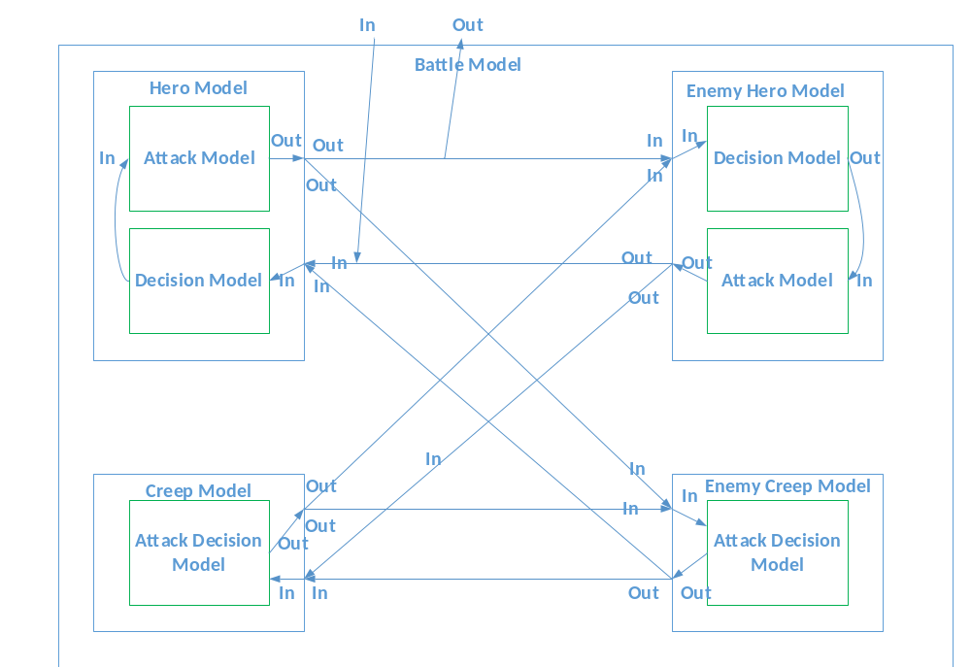
Hero model has two states: alive and dead. It have a Decision Model (based on the character model’s own decision making criteria), which determines if the character’s next action will be to attack or do nothing. The Decision Model has two states, passive and decision. The Decision Model remains passive until it receives input, and then activates to make a decision based on that input.
If the Hero’s Decision Model determined that they should attack/take last hit, then the Attack Model determines which attack to use, who to attack and performs an attack. If the model determined that do nothing, then attack model would output do nothing. The Attack Model has two states: passive and active.
The creep ‘s Attack-Decision Model has two state: passive and active. It determines who to attack when it receives input.

Part 2:
As illustrated in Figure 1, the hero battle simulator has one input and one output. The BattleIn input indicates the original health point of the enemy creep. This input is passed to the hero’s decision model, and the battle then begins. The BattleOut port outputs the result of this battle (win, lose). The hero battle simulator is comprised of two kinds of coupled models, one is hero model, which is then broken down into two atomic models (decision, attack). And the other one is creep model, which has just one atomic model (attack-decision model)

  - Formal Specifications of Atomic Models
The formal specifications of the six atomic models in this simulation, according the specifications <X, S, Y, δint, δext, ta, λ > are as follows:
    - Creep Attack-Decision Model (CreepModel)
S = {passive, active}
X = {heroIn,creepIn}
Y = {heroOut,creepOut}
δint (active) = passive
δext(in, passive) = active
δext(in, active) = active
λ(active)
{
If “I am dead”:
I do not send anything.
Else:
If input is “damage to creep”
Remove damage from dragon hit points
If creep is now dead, send message to tell enemy (hero and creep) that I am dead (by outputting 0)

If input is ”damage to hero”
Send “damage to hero” to the enemy hero.
Else
Send “damage to creep” to the enemy creep.

Send the “health point” to the enemy hero.
}

ta(passive) = INFINITY
ta(active) = 0
    - Hero Decision Model (HDecision)
S = {passive, active}
X = {heroIn,creepIn}
Y = {attackOut}
δint (active) = passive
δext(in, passive) = active
δext(in, active) = active
λ(active)
{
If input is “enemy hero dead”
Send “enemy hero dead” to Attack Model
If input is “enemy creep dead”
Record enemy creep is dead
Send “attack hero” to Attack Model
If input is damage data
Remove damage from knight hit points
If hp <= 0
Send “dead” to Attack Model
Else:
AttackFunction

If input is “health point” && health point is lower than my attack
Send “attack creep” to Attack Model
Else
AttackFunction

}

AttackFunction :
If enemy creep is alive
60% chance of do nothing
Send “do nothing” to Attack Model
40% chance of choosing attack
70% chance of attack creep
Send “attack creep” to Attack Model
30% chance of attack hero
Send “attack hero” to Attack Model
Else
Send “attack hero” to Attack Model

ta(passive) = INFINITY
ta(active) = 0
    - Hero Attack Model (HAttack)
S = {passive, active}
X = {in}
Y = {outHero,outCreep,outResult}
δint (active) = passive
δext(in, passive) = active
δext(in, active) = active
λ(active)
{
70% chance of choosing normal attack
Prepare time = 1.5

30% chance of choosing skill attack
Prepare time = 1.5
Damage = damage * 2

If input data is “enemy hero dead”
Send “win” to outResult, end simulation
If input data is “dead”
Send “enemy hero dead” to enemy hero and creep
Send “lose” to outResult, end simulation
If input data is “attack hero”
Send “damage to hero” to enemy hero and creep
If input data is “attack creep”
Send “damage to creep” to enemy creep
Send “do nothing” to enemy hero
If input data is “do nothing”
Send “do nothing” to enemy hero and creep

}

ta(passive) = INFINITY
ta(active) = preparation Time

  - Formal Specifications of Coupled Models
The formal specifications of the three coupled models in this simulation, according to specifications <X, Y, D, EIC, EOC, IC, SELECT> are as follows:
    - Hero Model
X = {heroIn, creepIn}
Y = {heroOut, creepOut, resultOut}
D = {HDecision, HAttack}
EIC = {(Hero.heroIn, HDecision.heroIn), (Hero.creepIn, HDecision.creepIn)}
IOC = {(HAttack.heroOut, Hero.heroOut), (HAttack.creepOut, Hero.creepOut), ((HAttack. resultOut, Hero. resultOut))}
IC = {(HDecision.out, HAttack.in)}
SELECT = ({HDecision, HAttack }) = HDecision

    - Battle Model
X = battleIn
Y = battleOut
D = {Hero, EnemyHero, Creep, EnemyCreep}
EIC = {(Battle.battleIn, Hero.creepIn)}
IOC = {(Hero.resultOut, Battle.battleOut)}
IC = {(Hero.heroOut, EnemyHero.heroIn), (Hero.creepOut, EnemyCreep.HeroIn),
(EnemyHero.heroOut, Hero.heroIn), (EnemyHero.creepOut, Creep.HeroIn),
(Creep.heroOut, EnemyHero.heroIn), (Creep.creepOut, EnemyCreep.creepIn),
(EnemyCreep.heroOut, Hero.heroIn), (EnemyCreep.creepOut, Creep.creepIn)}

SELECT = ({Hero, EnemyHero}) = Hero
({Hero, EnemyCreep}) = Hero
({EnemyHero, Creep}) = EnemyHero
({Hero, EnemyHero, EnemyCreep}) = Hero
({EnemyHero, Creep, EnemyCreep }) = EnemyHero
({Hero, EnemyHero, Creep, EnemyCreep }) = Hero

  - MessageType Definition
- These messages are used between hero and creep model:
Damage: 1000xxx
Show hero’s damage to the creep: 2000xxx
Show creep‘s health point: 3000xxx
Do nothing 4000xxx
Dead: 9000xxx
- These messages are used between hero decision and hero attack model:
Enemy Hero Dead: 1000xxx
Attack Hero: 2000xxx
Attack Creep: 3000xxx
Do nothing 4000xxx
Hero Dead: 5000xxx

  - Testing Strategies
All models in this simulation will be tested individually using the black box testing method. This means that for each test a model file (.ma) and an event file (.ev) will be manually created to test the model. The event file will contain input event timing and values, and the running of the simulation using the event and model files will produce an output file (.out) and log. The log details everything that occurs during the simulation, and the output file includes the time and values outputted by the model being simulated.
Part 3:
This section details the test cases for each model in the simulation.

  - Testing Creep Model (CreepModel)
There are five main behaviour that CreepModel could interact with an incoming value.
- If input value is “enemy hero attack my hero”, output attack hero (“damage” to hero).
- If input value is “enemy creep is dead”, record it and output attack hero (“damage” to hero).
- If input value is “damage”, and I am not dead with this damage, then output attack creep. But if I am dead, I tell enemy hero and creep that I am dead, output “dead”.
- Other input, output attack creep (“damage” to other creep).
- If “I am dead”, when I receive input, I do nothing.

These event case values have been designed to test each of these possible functionalities.
Input:
00:00:10:00 heroIn 1000015 //receive damage from hero
00:00:10:00 creepIn 1000015 //receive damage from creep
00:00:30:00 heroIn 2000025 // enemy hero attack my hero
00:00:30:00 creepIn 1000015
00:00:50:00 creepIn 9000000 // enemy creep is dead
00:01:10:00 heroIn 2000050
00:01:30:00 heroIn 1000050 // I am dead, I just have 100 hp
00:01:30:00 creepIn 1000050 // I am dead, I just have 100 hp
00:01:40:00 heroIn 1000150

Output:
00:00:11:500 creepout 1.00002e+06 //(4)attack creep
00:00:31:500 heroout 1.00002e+06 //(1)attack hero
00:00:51:500 heroout 1.00002e+06 //(2)attack hero
00:01:11:500 heroout 1.00002e+06 //(2)attack hero
00:01:31:500 creepout 9e+06 //(3)tell it that I am dead
00:01:31:500 heroout 9e+06 //tell it that I am dead
//(5)no response to message at 01:40:00

  - Testing Hero Decision Model (HDecision)
There are five main behaviour that HDecision could interact with an incoming value.
- If input value is “enemy hero dead”, Send “enemy hero dead” to Attack Model
- If input value is “enemy creep dead”, record it and attack hero. Record enemy creep is dead. Send “attack hero” to Attack Model
- If input value is “damage”, and I am not dead, use AttackFunction. But if I am dead, I tell enemy hero that I am dead, and send “dead” to Attack Model
- If “health point” && health point is lower than my attack, send “attack creep” to Attack Model. Else use AttackFuntion.
- Other input, AttackFuntion.
AttackFunction: refer to the model. There are three possible output, “do nothing”,”attack creep”,”attack hero”. (In the source code, it can be all possible output)
These event case values have been designed to test each of these possible functionalities.
Input:
00:00:30:00 creepIn 3000100 //Show creep’s hp to hero
00:00:30:00 heroIn 4000050 // do nothing
00:00:50:00 creepIn 1000020 // enemy creep attack hero
00:00:50:00 heroIn 1000010 // enemy hero attack hero
00:01:10:00 creepIn 1000010
00:01:10:00 heroIn 1000010
00:01:20:00 creepIn 3000020
00:01:20:00 heroIn 1000010
00:02:10:00 creepIn 9000000 // enemy creep is dead
00:02:20:00 heroIn 9000000 // enemy hero is dead
00:02:30:00 heroIn 1000100 // enemy hero attack

Output:
00:00:30:000 attackout 4.00005e+06 //(4)not satisfy the condition use attack function
00:00:50:000 attackout 2.00005e+06 //(5)use attack function
00:01:10:000 attackout 4.00005e+06 //
00:01:20:000 attackout 3.00005e+06 //(4)attack creep to take the last hit
00:02:10:000 attackout 2.00005e+06 //(2)
00:02:20:000 attackout 1.00005e+06 //(1)“enemy hero is dead”
00:02:30:000 attackout 5.00005e+06 //(3)“I am dead”

  - Testing Hero Attack Model (HAttack)
There are five main behaviour that HAttack could interact with an incoming value.
- If input value is “enemy hero dead”, Send “win” to result.
- If input value is “hero dead”, send “enemy hero dead” to enemy hero, send “lose” to result
- If input value is “attack hero”, send “damage” to enemy hero and send “attack hero” to enemy creep.
- If input value is “attack creep”, send “damage” to enemy creep and send “do nothing” to enemy hero.
- If input value is “do nothing”, send “do nothing” to enemy hero and creep.

These event case values have been designed to test each of these possible functionalities.
Input:
00:00:10:00 in 1000050
00:00:30:00 in 2000050
00:00:50:00 in 3000050
00:01:10:00 in 4000050
00:01:20:00 in 5000050

Output:
00:00:11:500 resultout 1 //win
00:00:31:500 heroout 1.0001e+06 //attack enemy hero
00:00:31:500 creepout 2.0001e+06 //show enemy creep that I am attacking enemy hero
00:00:51:500 creepout 1.0001e+06 //attack enemy creep
00:00:51:500 heroout 4e+06 // do nothing
00:01:11:500 creepout 4e+06 // do nothing
00:01:11:500 heroout 4e+06 // do nothing
00:01:21:500 resultout 2 //lose
00:01:21:500 heroout 9e+06 // tell enemy hero that I am dead

  - Hero Model
As defined above, the hero coupled model is composed of the atomic models HDecision and HAttack. The hero model can receive five kinds of input, which define at the Message Definition. The hero model also have five kinds of output and a special output for battle result.
These event case values have been designed to test each of these possible functionalities.
Input:
00:00:30:00 creepIn 3000100 //Show creep’s hp to hero
00:00:30:00 heroIn 4000050 // do nothing
00:00:50:00 creepIn 1000020 // enemy creep attack hero
00:00:50:00 heroIn 1000010 // enemy hero attack hero
00:01:10:00 creepIn 1000010
00:01:10:00 heroIn 1000010
00:01:20:00 creepIn 3000020 //Show creep’s hp to hero
00:01:20:00 heroIn 1000010
00:02:10:00 creepIn 9000000 // enemy creep is dead
00:02:20:00 heroIn 9000000 // enemy hero is dead
00:02:30:00 heroIn 1000100 // enemy hero attack

Output:
00:00:31:500 creepout 4e+06 //do nothing
00:00:31:500 heroout 4e+06 //do nothing
00:00:51:500 creepout 1.0001e+06
00:00:51:500 heroout 4e+06
00:01:11:500 creepout 1.00005e+06
00:01:11:500 heroout 4e+06
00:01:21:500 creepout 1.00005e+06 // take the last hit
00:01:21:500 heroout 4e+06
00:02:11:500 heroout 1.00005e+06 //attack enemy hero
00:02:11:500 creepout 2.00005e+06 //show enemy creep that I am attacking enemy hero
00:02:21:500 resultout 1 // win
00:02:31:500 resultout 2 // lose
00:02:31:500 heroout 9e+06 // I am dead

  - Battle Model
The simulation is started by a “creep health point” input to the hero. Then the four model will interact with each other automatically. At last, “resultout” will get the battle result, “win” or “lose”;
These event case values have been designed to test each of these possible functionalities.
Input:
00:00:01:00 in 3000100

Output:
00:00:05:500 resultout 2 //lose

This is the battle detail:


