**Cell-DEVS model of the Hydrophobic Effect**

**Department of Systems and Computer Engineering**

**Assignment 1 Report for SYSC 5104: Methodologies for Discrete-Event Modelling and Simulation**

**Fall 2011**

**Instructor: Prof. Gabriel Wainer**

November 19, 2011

*Author:*

*K. Waqas Muhi - 100629922*

**Original Proposal**

**SYSC 5104 – Assignment 2 proposal**

Name: Kanwar Waqas Muhi  
Student ID: 100629922

Water and the dissolution of different substances within it is an interesting topic which has been investigated and researched quite a bit in recent times. This is primarily due to the “complex systems it forms when solutes enter its embrace” [1] and also because when “solution ingredients interact or transact, there emerges in the system a set of properties not clearly recognizable as additive contributions from the ingredients”.

Kier, Cheng, and Testa looked at a number of biochemical phenomena related to water and solutions in [1] and presented their modeling based on cellular automata principles. The model that is proposed to be looked at in this assignment is what is known as the “Hydrophobic effect”. The Hydrophobic effect refers to the “observed tendency of nonpolar substances to aggregate in aqueous solutions and exclude water molecules” [2]. An example of this would be oil mixed with water.

This assignment would look at a Cell-DEVS representation of this effect with a view to explore the differences between the interaction of water and other substances whose tendency to associate with water varies – from low to high. The expectation is that those substances whose tendency to associate is high will more readily dissolve in water and show a uniform distribution. On the other hand, those substances whose tendency to associate is low should show large concentrations of that substance within the solution.

**Introduction**

This assignment looks at a Cell-DEVS representation of the “Hydrophobic Effect”. As explained in the proposal, water forms complex systems with different solutes and the Hydrophobic Effect refers to the “observed tendency of nonpolar substances to aggregate in aqueous solutions and exclude water molecules” [2].

The reference paper actually used for the assignment is [3] which is the full version of the research discussed in [1] by the same authors. It should be noted however, that the model designed and experimented with in this assignment is a simplified version of what is presented in [3]. Morever, contrary to the original intent proposed, the assignment only looks at solutes whose tendency to associate with water is low thus showing large concentrations of that substance within the solution. Time constraints and the compex nature of the model in [3] led to these simplifications.

**Modeling Rules**The modeling rules designed for the assignment are based on the theory behind the Hydrophobic Effect and what was presented in [3]. Initially, 69% of the cells are occupied with water and solute molecules. Water molecules are represented by a value of 1 while solute molecules are represented by a value of 2. The rest of the grid consists of vacant cells and is represented by a value of 0.

Out of the 69%, 10% are allocated to solute molecules while the remaining 59% is allocated with water. A Von Neumann neighbourhood is used with 55x55 cell dimensions and wrapped borders. Transport delays are used. The rules state that:

* If a cell is vacant and has 3 or more water molecules in its neighbourhood, it changes to a water molecule.
* If a cell is vacant and has 1 or more solute molecules in its neighbourhood, it changes to a solute molecule.
* A cell remains vacant if none of the above two conditions apply.
* If a cell is occupied with a water molecule with more than 2 solute molecules in its neighbourhood, then it changes to a solute molecule.
* If a cell is occupied with a water molecule with less than 2 solute molecules in its neighbourhood, then it remains a water molecule.
* If a cell is occupied with a solute molecule and has more than or equal to 3 water molecules, it changes to a water molecule.
* If a cell is occupied with a solute molecule and has less than 3 water molecules, then it remains a solute molecule.
* In any other case, the cell remains vacant.

**Formal Specification**

The formal specification of the Cell-DEVS model corresponding to the file hydrophobic.ma is given below.

M=<I,X,Y,Xlist,Ylist,η, N,{m,n}, C, B, Z, select>

Xlist=Φ

Ylist=Φ

η=5

I=<PX,Py>,with PX={Φ},Py={Φ};

N={(-1,0), (0,-1), (0,0), (0,1) (1,0)};

X={-1, 0,1,2};

Y={0,1,2}

m=55; n=55;

B={Φ};

C={Cij/iε[1,55], jε[1,55]}

Z:

Pij Y1 🡪 Pi,j-1 X1 Pi,j+1 Y1 🡪 Pij X1

Pij Y2 🡪 Pi+1,j X2 Pi-1,j Y2 🡪Pij X2

Pij Y3 🡪 Pi,j+1 X3 Pi,j-1 Y3 🡪Pij X3

Pij Y4 🡪 Pi-1,j X4 Pi+1,j Y4 🡪 Pij X4

Pij Y5 🡪 Pij X5 Pij Y5 🡪 Pij X5

select={ (-1,0), (0,1), (0,0), (0,-1), (1, 0) };

**Implementation**

As shown in the formal specification, the Hydrophobic Effect model is implemented as a 2D Cell-DEVS. There are basically 3 sets of rules as mentioned previously. The first set of rules governs the case when a cell is empty. This is shown below:

%Rules in case cell is vacant

rule : 1 100 {(0,0) = 0 and statecount(1)>=3}

rule : 2 100 {(0,0) = 0 and statecount(2)>=1}

rule : 0 100 {(0,0) = 0 and statecount(2)<1 and statecount(1)<3}

Since water molecules dominate over solute molecules, these rules are geared towards a vacant space being taken up a solute molecule more readily than a water molecule.

The second set of rules governs the case of a cell being occupied by a water molecule and is shown below:

%Rules in case cell is occupied with water molecule

rule : 2 100 {(0,0) = 1 and statecount(2)>2}

rule : 1 100 {(0,0) = 1 and statecount(2)<2}

As shown, the above set of rules give an equal chance to the water molecule being taken over by a solute molecule or staying as it is depending on how many solute molecules are present in its neighbourhood.

The final set of rules governs the behaviour of a solute molecule and is shown below:

%Rules in case cell is occupied with solute molecule

rule : 1 100 {(0,0) = 2 and statecount(1)>=3}

rule : 2 100 {(0,0) = 2 and statecount(1)<3}

This set of rules favours the solute molecule remaining as it is rather than being taken over by a water molecule. This is what closely resembles the Hydrophobic Effect and gives us small concentrations of solute molecules amongst the water molecules.

**Testing and Results**

The model file, hydrophobic.ma, was used for the testing and results were collected accordingly. It was observed that the model reaches a steady state at a certain point after which no more activity takes place. The initial state of the model is shown in Figure 1:

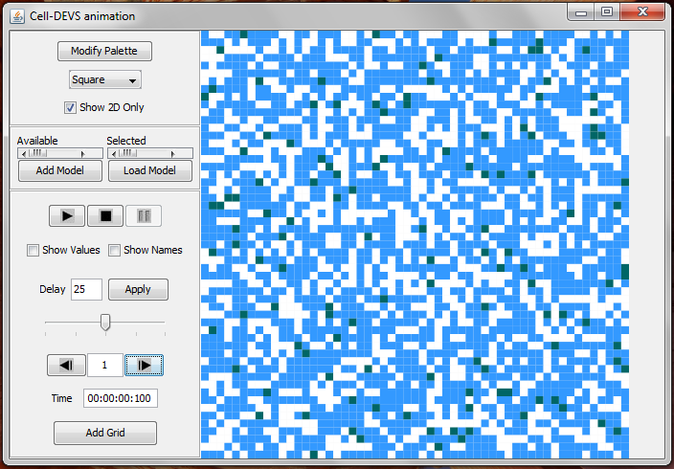

**Figure 1: Initial state of the model**

The blue cells are the water molecules, the grey are the solute molecules, and the white represent vacant spaces. As intended, there are significantly more water molecules than solute molecules and the latter are scattered at random positions in the grid.

Figure 2 shows how the model looks like after 10 time units.

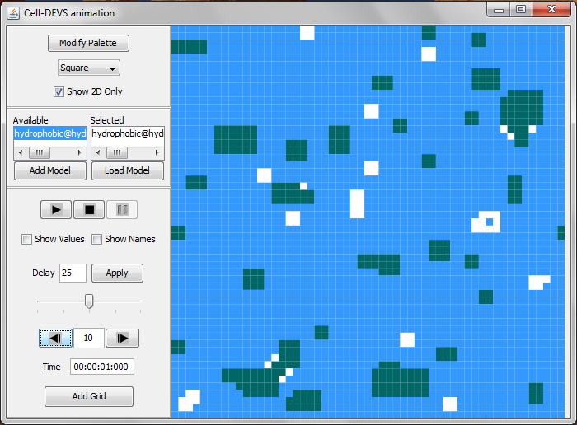

**Figure 2: State of the model after 10 time units**

It can be seen here that solute molecules have started to form small concentrations at various places in the grid. This very closely resembles the behaviour of non-polar solutes in water which tend to aggregate together and exclude water molecules from their concentrations.

Figures 3 and 4 show states of the model after 25 and 45 time units. Both show continuing aggregation of the solute molecules from Figure 2.

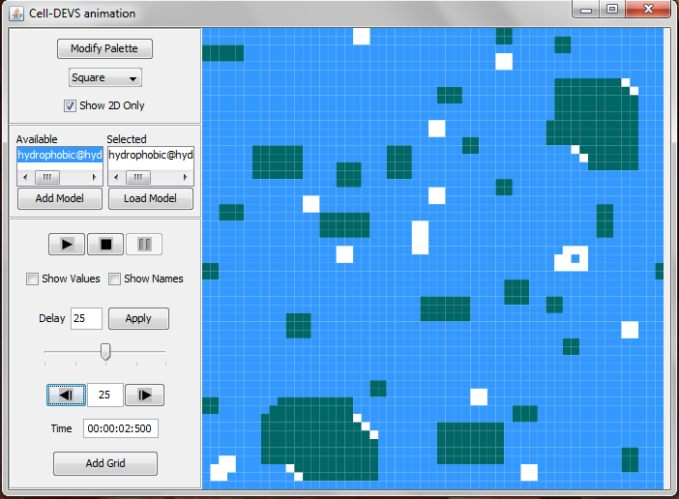

**Figure 3: State of the model after 25 time units**

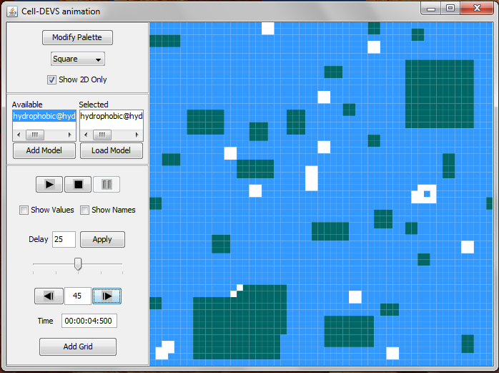

**Figure 4: State of the model after 45 time units**

The model reaches its final state after 60 time units. At this point, a number of solute concentrations have been formed in the solution with water molecules having been excluded. This state very closely resembles the Hydrophobic Effect modeled in [3] although not exactly similar or accurate because our model was a simplified version. The steady state is shown in Figure 5.

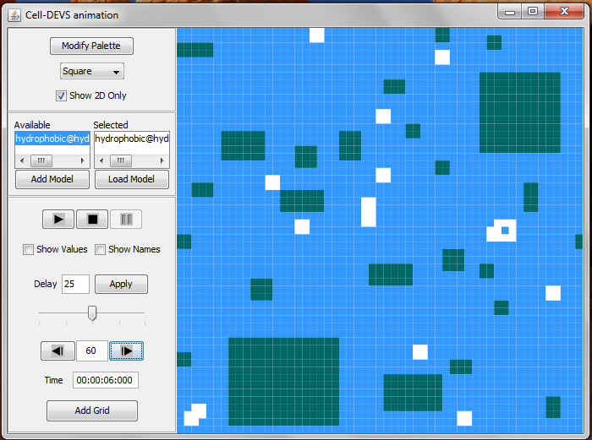

**Figure 5: Final state of the model achieved after 60 time units**

**Conclusions**

A simplified version of the Hydrophobic Effect model presented in [3] was modelled in this assignment. The model did show similar properties although not exactly the same results. 69% of the cells used in the grid were initialized with water (59%) and solute (10%) molecules. A grid of 55x55 cells was used with transport delays along with a Von Neumann neighbourhood for the cells.

It was observed that starting from a random distribution of solute molecules, a final state is reached where we see small concentrations of solute molecules aggregated at various points in the solution having excluded water molecules. This very closely resembles the behaviour of non-polar solutes in aqueous solutions. Time constraints prevented us from from modeling the behaviour of more polar solutes but the results achieved were satisfactory overall.

**References**

[1] L. Kier, C. Cheng, and B.Testa, “Cellular automata models of biochemical phenomena,” *Future Generation Computer Systems* 16 – 273-289, 1999.

[2] Wikipedia, “Hydrophobic effect,” [Online]. Available: <http://en.wikipedia.org/wiki/Hydrophobic_effect> [Accessed: November 5, 2011].

[3] L. Kier, C. Cheng, B.Testa, and P. Carrupt, “A Cellular Automata Model of the Hydrophobic Effect,” *Pharmaceutical Research,* volume 12, no. 4, 1995*.*