SYSC 5807 Assignment #2 Kevin Lam
November 11, 2002 215552

Part I: Original Conceptual Model

I propose to use a Cellular-DEVS model to implement a maze-solving algorithm using cellular automata.

In February 1993 I read an article in Doctor Dobb’s Journal entitled “Cellular Automata For Solving Mazes” authored by Basem A. Nayfeh. I was intrigued by this quick and efficient solution to finding a path through a given maze without the use of backtracking.

The concept is simple: a maze is defined as an array of cells, with a value representing “1” if the cell is a wall, and “0” if the cell is a hallway (a free cell). The following diagram represents a simple maze in a 10x10 cellular array:

1 | 1 | 1 | 1 | 1 | 1 | 1 | 1 | 1 | 1
0 | 0 | 1 | 0 | 0 | 0 | 0 | 0 | 0 | 1
1 | 0 | 1 | 0 | 1 | 1 | 1 | 1 | 0 | 1
1 | 0 | 1 | 0 | 0 | 0 | 0 | 1 | 0 | 1
1 | 0 | 1 | 0 | 1 | 1 | 0 | 1 | 0 | 1
1 | 0 | 0 | 0 | 1 | 0 | 0 | 1 | 0 | 1
1 | 0 | 1 | 1 | 1 | 1 | 0 | 1 | 1 | 1
1 | 0 | 1 | 0 | 0 | 0 | 0 | 0 | 0 | 1
1 | 0 | 1 | 0 | 1 | 0 | 1 | 1 | 0 | 1
1 | 1 | 1 | 0 | 1 | 1 | 1 | 1 | 1 | 1
 | N
W |  | E
 | S
A cell’s neighborhood consists of itself, plus the four squares immediately to its north, south, east, or west.

In the cellular maze-solving algorithm, the rules are:

- A wall cell always remains a wall cell
- A free cell becomes a wall cell if its neighborhood includes three or more wall cells
- A free cell remains a free cell if its neighborhood includes less than three walls cells.

When this set of rules is processed, the algorithm effectively blocks off every dead-end path in the maze. Every free cell that is accessible from only one direction (i.e. three wall cells around it) must be a dead end and therefore cannot be part of the solution. Therefore it is turned into a wall cell. This repeats until the system remains in a steady state; the result is that all cells in the array are wall cells except for those representing the solution(s) to the maze. If there is no solution, the entire array of cells will be wall cells.

In this model the system is closed, and there are no inputs or outputs required.
Part II: Formal Specification

a. Cell-DEVS Atomic Model Specification

The following is the formal specification for the Cell-DEVS maze-solving model:

CD = < X, Y, I, S, θ, N, d, δ_{int}, δ_{ext}, τ, λ, D >

X = Ø

Y = Ø

S = { 0, 1 }

N = neighborhood = { (-1, 0), (0, -1), (0, 1), (1, 0), (0,0) }

d = 100 ms

τ: N→S is defined by the rules described in the previous section, i.e.:
S = 1 if cell(0,0) = 1
S = 1 if cell(0,0) = 0 and truecount ≥ 3
S = 0 if cell(0,0) = 0 and truecount <3

b. Cell-DEVS Coupled Model Specification

The model specification from part (a) above gives rise to the following model definition:

[top]
components : maze

[maze]
type : cell
dim : (20, 20)
delay : transport
defaultDelayTime : 100
border : nowrapped
neighbors : maze(-1,0)
neighbors : maze(0,-1) maze(0,0) maze(0,1)
neighbors : maze(1,0)

localtransition : maze-rule

[maze-rule]
rule : 1 100 { (0,0) = 0 and (truecount = 3 or truecount = 4) }
rule : 0 100 { (0,0) = 0 and truecount < 3 }
rule : 1 100 { t }

The model definition also defines the initial maze by specifying the states of the maze cells as 1’s or 0’s. For example, the following is a definition of a maze which can be solved using the Cell-DEVS model:

initialrowvalue : 0 11111111111111111111
initialrowvalue : 1 00000101101100000011
initialrowvalue : 2 11110101101111111011
initialrowvalue : 3 10010100000000011011
initialrowvalue : 4 10110101101111011011
initialrowvalue : 5 10110101101111011011
initialrowvalue : 6 10010100101000000011
initialrowvalue : 7 10110111101011110111
initialrowvalue : 8 10110000101111010111
initialrowvalue : 9 10110110101011010011
initialrowvalue : 10 10110110101011011011
initialrowvalue : 11 10000110001011011011
initialrowvalue : 12 11010111111011011011
initialrowvalue : 13 11010000000011011111
initialrowvalue : 14 11011111111111010001
initialrowvalue : 15 11011000000111010101
initialrowvalue : 16 11011010110000010101
initialrowvalue : 17 11011011111111110101
initialrowvalue : 18 10001000000000000101
initialrowvalue : 19 11111111110111111111

c. Implementation and Testing

The model definitions given above were implemented in three separate test cases, each case representing a different maze to be solved. Each case was implemented as a separate model file (called maze1.ma, maze2.ma, and maze3.ma).

Model 1: A maze with exactly one solution

The first model to be simulated was a maze with one solution path. The maze definition is shown in part (b) above, in the “initialrowvalue” lines of the .ma file. When the model was executed, the rules correctly blocked off all non-solution paths in the maze, leaving the maze cells in a steady-state representing the solution to the maze. The following diagram illustrates the initial cell state and the final steady state of the maze cells, as visualized in the Graflog tool:

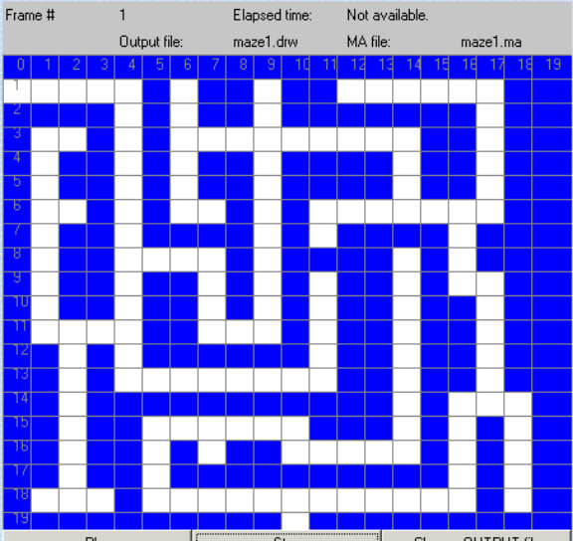 | 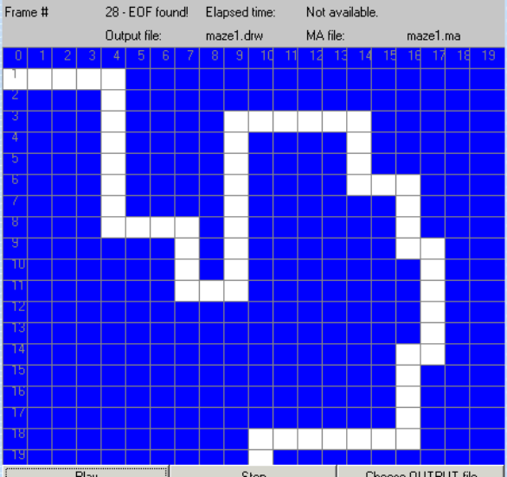
Model 2: A maze with no solutions

Next, a model was simulated in which the maze had no solution. The model attributes (size, timing, and cellular automata rules) were not changed, but the initial values of the cell space were changed as follows:

initialrowvalue : 0 11111111111111111111
initialrowvalue : 1 00000101101100000011
initialrowvalue : 2 11110101101111111011
initialrowvalue : 3 10010100000000011011
initialrowvalue : 4 10110101101111011011
initialrowvalue : 5 10110101101111011011
initialrowvalue : 6 10010100101000000011
initialrowvalue : 7 10110111101011110111
initialrowvalue : 8 10110000101111010111
initialrowvalue : 9 10110110101011010011
initialrowvalue : 10 10110110101011011011
initialrowvalue : 11 10000110001011011011
initialrowvalue : 12 11010111111011011011
initialrowvalue : 13 11010000000011011111
initialrowvalue : 14 11011111111111010001
initialrowvalue : 15 11011000000111010101
initialrowvalue : 16 11011010110000010101
initialrowvalue : 17 11011011111111110101
initialrowvalue : 18 10001000000000000101
initialrowvalue : 19 11111111110111111111

When this model was executed, the result was that the entire cell space was in the same state (1’s). This behaviour is correct, as it indicates that all non-solution paths (in this case, all paths) were turned into wall cells. The following diagram illustrates the initial cell state and the final steady, as visualized in the Graflog tool:

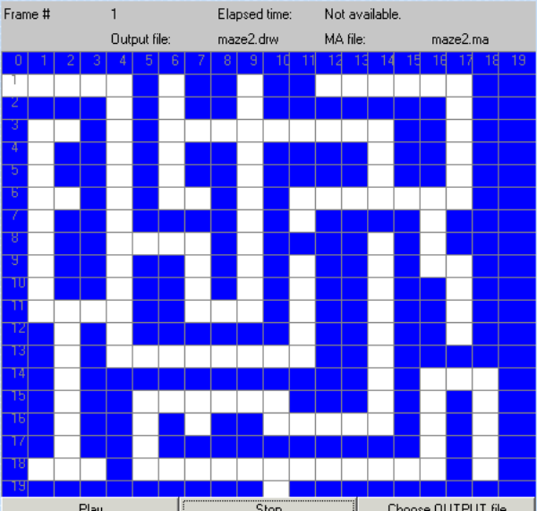 | 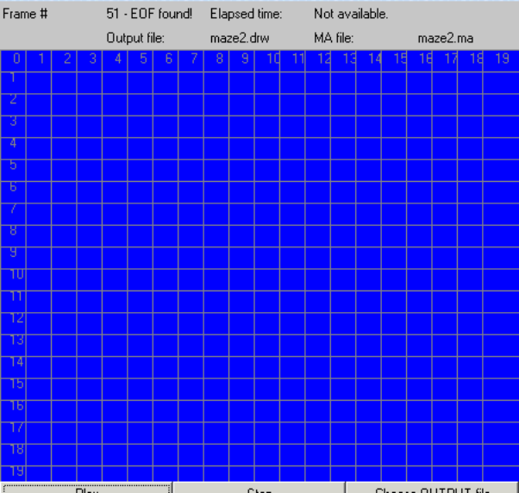

Model 3: A maze with multiple solution paths

Finally, a model was simulated in which the maze had several solutions (variations on the original solution path). Again the model attributes were not changed, but the initial values of the cell space were changed to the following:

initialrowvalue : 0 11111111111111111111
initialrowvalue : 1 00000101101100000011
initialrowvalue : 2 11110101101111111011
initialrowvalue : 3 10010100000000011011
initialrowvalue : 4 10110101101111011011
initialrowvalue : 5 10110101101111011011
initialrowvalue : 6 10010100101000000011
initialrowvalue : 7 10110111101011110111
initialrowvalue : 8 10110000101000010111
initialrowvalue : 9 10110110101011010011
initialrowvalue : 10 10110110101011011011
initialrowvalue : 11 10000110001011011011
initialrowvalue : 12 11010111111011011011
initialrowvalue : 13 11010000000011011011
initialrowvalue : 14 11011111111111010001
initialrowvalue : 15 11011000000111010101
initialrowvalue : 16 11011010110000010101
initialrowvalue : 17 11011010111111110101
initialrowvalue : 18 10001000000000000101
initialrowvalue : 19 11111111110111111111

Again the output correctly isolates all the cells which can be possibly part of the solution path, turning all other cells into wall cells. The following is the input and output from Graflog:

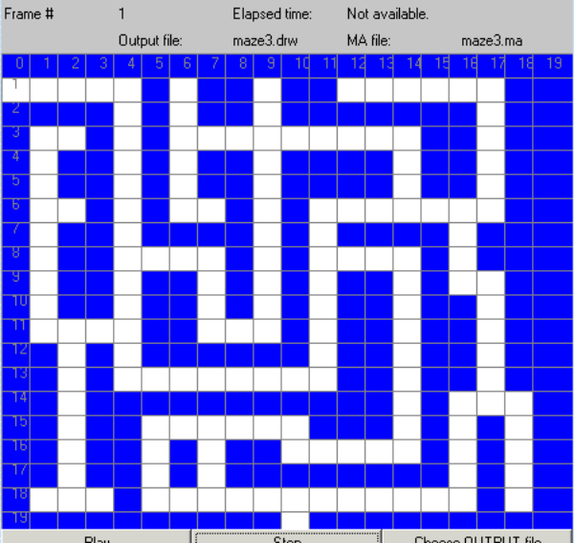 | 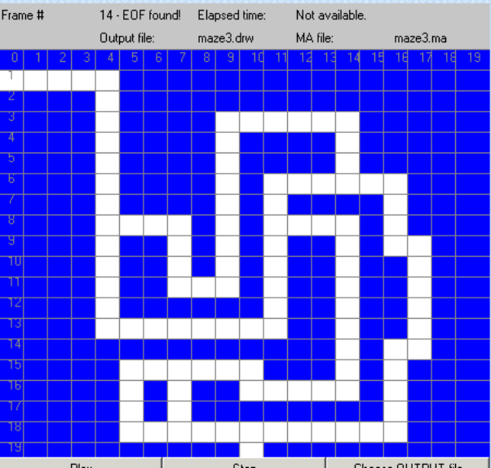

Note that in this case, the solution state of the system does not necessarily provide a clear path through the maze. It would be still be possible for a “traveler” following the path to get lost by following a loop or accidentally doubling back on itself and returning to the beginning of the maze.
Part III: Conclusions

The Cellular-DEVS models included with this report and described herein correctly simulate the behaviour of the maze-solving algorithm proposed by Nayfeh in his 1993 article. The maze, as modeled as a cell space, can easily solve itself by removing all non-essential paths and converting them into walls of the maze. This algorithm has a tremendous advantage over traditional maze solving algorithms in that it can reach a solution in a linear time (as opposed to backtracking and traveling over many dead end paths). In addition, when this model executes, all dead end paths are being pruned simultaneously.

The downside to this algorithm is that it does require a full knowledge of the maze prior to solving it (it cannot operate on cells of which the value is unknown) and the model does not provide a complete solution in the case where there is not one distinct solution path. If there exist several paths, the algorithm only provides a partial solution which removes all dead end paths.

The logic behind the algorithm is very simple and can be scaled to larger spaces without difficulty. It would be interesting, in further studies, to determine if this algorithm would scale to 3-dimensional spaces (or even n-dimensional ones) or whether the algorithm would still be valid for different neighbor sets (i.e. a hexagonal or triangular neighborhood).

This assignment was also successful in demonstrating the use of the CD++ tool in simulating a cellular automata model, and using the associated tools (drawlog, graflog) to visualize the outputs.

