SYSC 5807
Methodologies of Modeling and Simulation
Fall 2003
Instructor: Prof. Gabriel A. Wainer

Assignment # 2
MOBILE AD-HOC NODES

Prepared by: Bengu Balya
Student Number: 350 638
Email: b_balya@hotmail.com

1. PART-1: MOBILE AD-HOC NODES
Ad-Hoc networks are characterized by, several wireless mobile nodes communicating with each other without an infrastructure. Because there is no infrastructure, each mobile node may act as a router for another node. So the packet generated from one of the mobile nodes, will be routed to the neighboring mobile node and routed from this node to the next, until it reaches to the destination.
In order to choose to which neighboring node the packet will be routed, the distance from this node to the base station will be used. Here “distance” means not the physical distance but how many counts away the base station is.
Each node will keep this distance information and update it regularly, by being aware of its neighbors’ distances. For example, let us assume that, node-X has two neighbors, node-Y and node-Z, which has a distance from base station by 1 and 3 hops respectively. So node-X is 4 hops away from base station if it chooses the path through node-Z, or 2 hops away if it chooses the path through node-Y. Node-X should choose always the shortest path, which is node-Y.
In this assignment, the part of the protocol, that is, each node to determine its shortest path (hope count) to the base station, will be modeled. The structure of the model will be as follows:
- Base station will be positioned at the middle of the cell system and will always have a hop count state of “0”.
- 20*20 cells will be used.
- 6 closest cells around the node will form the neighborhood to be aware of.
- It is assumed that if a node is 1-5 hops away from the base station, that node is allowed to reach to the base station.
- If a node is 6 or more hops away from the base station, that node is not allowed to communicate with the base station. Because it will use too much network resources. That’s why, the nodes, that are more than 6 hops away from the base station, will all be considered as if they have no neighbors. Initially all cells will have an initial state of 6.
- So first the nodes which are in the neighborhood of base station will update their states to “1”. And then the nodes in the neighborhood of these nodes will update their states to “2” and so on.
In order to model the mobility of nodes, the “Bouncing Ball” example will be used. Because the “Bouncing Ball” example does not consider collision avoidance, first this example will be modified to add this feature. Mainly, because there will be several mobile nodes moving around and there should be a mechanism to avoid them collapsing in each other.
The main focus of the project is to implement the hop count plane successfully. Depending on the complexity of the first part, mobility feature may be added also as the second plane. But the successful integration is not guaranteed within the coverage of this assignment.
As a final goal, the following rules are planned to implement:
Mobility Plane Rules:
“Bouncing Ball” example rules will be valid. Also as an addition:
Collision Rule: If there is more than one node aiming to the same cell, the one with the highest priority will move. The priority will be determined by the direction of the movement. Whoever has the highest direction number, as shown in the figure below, will have priority.
4
2

1
3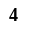

HopCount Plane Rules:
Hop Count Rule - 1: If a cell is occupied (plane 0 value not equals to 0), then check the cell neighbors to see if the base station is within the neighborhood of the cell. If so, set hop count value of the cell to 1 (at plane 1).
Hop Count Rule - 2: If a cell is occupied (at plane 0), and the cell dos not have a hop count value of 1 (that is base station is not in the neighborhood), then check cell neighbors to see if there is any other mobile node. If there is any, then choose the one with smallest hop count value (at plane 1), increment the value by one, and set this value as the new hop count value of the cell.
Hop Count Rule – 3: If a cell is occupied (at plane 0), and the cell does not have any neighbors then set the hop count value of the cell to 6.
Hop Count Rule – 4: If a cell is not occupied (at plane 0), then set the hop count value of the cell to 7.

PART-2:
Simulation tool does not allow initializing each plane separately by using only one command (Initializing each cell one by one is not considered as a practical and effective initialization method, since there are 400 cells at each plane). So the following changes are done to initial specifications (Part-1).
- Base station will have a hop count state of “99” instead of “0”.
- All cells at plane 0 and which are not occupied will have an initial state of “0”.
- All cells at plane 1 (other than base station) will have an initial state of “0” instead of “6”.
- Cells, which are 1,2,3,4,5,6 hop counts away from the base station will have state values of 10,20,30,40,50 and 60 respectively. (The reason using two digit values instead of one digit is that, there are more than 10 different states in total in both planes. Also statecount() function takes into account of all neighboring cells from both planes).
- The collision rule (as explained in Part-1) will not be implemented because it is found to be too complex to be implemented within the coverage of this assignment.
The assignment consists of two independent parts. First part is implemented for only static nodes. The second part is implemented by using both mobile and static nodes, and may be incomplete. The second part should be considered as a preliminary work before the course project.
Case 1: Only static nodes exist.
Simulation runs until all static nodes find out their hop count state values. Because there is no change after, simulation stops. Different scenarios can be observed by changing the number and position of static nodes. Because there is no mobile node, the plane 1 rules will be as follows:
Rule-1: If the cell is occupied by a base station or not occupied at all, do not change the state at plane 1.
Rule-2: If the cell is occupied by a static cell then, check if the base station is in the neighborhood. If so set state to 10. Otherwise, check if there are other nodes in the neighborhood. If so, find the one with lowest value, increment by 10 and set as the new state. Otherwise set state to 60.
Case 2: Both static and mobile nodes exist.
The system is dynamic and depending on the number and direction of mobile nodes, different scenarios can be observed. There is no collision rule implemented between two mobile nodes. So, as far as there is no collision, simulation will run correctly. The collision rule between mobile and static nodes is implemented as follows.
Collision Rule Between Mobile and Static Nodes: If the cell, which is in the moving direction of the mobile node, is not empty, then reverse the direction of the mobile node.
Collision Rule Between Mobile Nodes: Not implemented.
Also the plane 1 rules are expanded as follows:
Rule-1: If a cell is occupied by a static node at plane 0; then check, if there is a base station in the neighborhood. If there is a base station then set the state to 10. Otherwise, check if there are other nodes. If there are any, find the one with lowest state value, increment it by ten and set this value as the next state. Otherwise, set state to 60.
Rule-2: If the current state is 0, and there are no nodes planning to move to this cell at plane 0, state will remain as 0.
Rule-3: If the cell is occupied by a base station, state will be always 99.
Rule-4: If the cell is occupied by a mobile node, and if the next cell in the direction of the mobile node is empty, then set the next state as 0.
Rule-5: If the cell is empty and there is a node planning to move to this cell at plane 0, then check the neighborhood. If the base station is in the neighborhood, set state to 10. Otherwise, check the neighborhood to find the node with lowest state, increment it by10 and set as the next state. Otherwise set the next state to 60.
Rule-6: If the cell is occupied by a mobile node, and if the next cell in the direction of the mobile node is not empty, then check if the base station is in the neighborhood. If so, set state to 10. Otherwise check the neighborhood for a node with the lowest state value. If so, increment the value by ten and set as the state value. Otherwise, set state to 60.
Formal Specifications for Case-1:
Atomic Models:
(1) Plane 0

CD=<X, Y, I, S, θ, N, d, δint, δext,τ, λ, D>
X=Y=S={0,8,9};
d = transport delay, 100msec
τ = ( mover_and_hope-rule as in the staticadhocnode.MA file)
I, θ, δint, δext, λ, D will be according to Cell DEVS definitions.

(1) Plane 1

CD=<X, Y, I, S, θ, N, d, δint, δext,τ, λ, D>
X={0,1,2,3,4,5,6,8,9}
Y=S={0,1,2,3,4,5,6,9};
d = transport delay, 100msec
τ = ( mover_and_hope-rule as in the “staticadhocnode.MA” file)
I, θ, δint, δext, λ, D will be according to Cell DEVS definitions.
Coupled Models:
(1) Plane 0

M=<I,X,Y,Xlist,Ylist,η, N,{m,n,t}, C, B, Z, select>
Xlist=Φ
Ylist=Φ
η=18
I=<P^{X},P^{Y},with P^{X}={Φ},P^{Y}={Φ};
N={ (-1,-1,0),(-1,0,0),(-1,1,0),(0,-1,0),(0,0,0),(0,1,0),(1,-1,0),(1,0,0),(1,1,0),
(-1,-1,1),(-1,0,1),(-1,1,1),(0,-1,1),(0,0,1),(0,1,1),(1,-1,1),(1,0,1),(1,1,1) }
X=Y={0,8,9};
m=20; n=20;t=2
B={ Cij / Cij ε C /\ (i=1 V i=20) /\ ( j=1 V j=20) };
C={Cij/iε[1,20], jε[1,20]}
Z: for plane 0:
P_{i}j^{Y1}→ P_{i,j}^{X1} P_{ij}^{X1}←P_{ij}^{Y1}
Select ={(-1,-1,0),(-1,0,0),(-1,1,0),(0,-1,0),(0,0,0),(0,1,0),(1,-1,0),(1,0,0),(1,1,0), (-1,-1,1),(-1,0,1),(-1,1,1),(0,-1,1),(0,0,1),(0,1,1),(1,-1,1),(1,0,1),(1,1,1) }

(2) Plane 1

M=<I,X,Y,Xlist,Ylist,η, N,{m,n,t}, C, B, Z, select>
Xlist=Φ
Ylist=Φ
η=18
I=<P^{X},P^{Y}>,with P^{X}={Φ},P^{Y}={Φ};
N={ (-1,-1,0),(-1,0,0),(-1,1,0),(0,-1,0),(0,0,0),(0,1,0),(1,-1,0),(1,0,0),(1,1,0),
(-1,-1,-1),(-1,0,-1),(-1,1,-1),(0,-1,-1),(0,0,-1),(0,1,-1),(1,-1,-1),(1,0,-1),(1,1,-1) }
X=Y={0,1,2,3,4,5,6,9};
m=20; n=20; t=2
B={ Cij / Cij ε C /\ (i=1 V i=20) /\ ( j=1 V j=20) };
C={Cij/iε[1,20], jε[1,20]}
Z: (as according to the neighboring cell definition), for plane 1:
P_{ij}^{Y1}→P_{i-1,j-1}^{X1} P_{ij}^{X1}←P_{i+1,j+1}^{Y1}
P_{i}j^{Y2}→P_{i-1,j}^{X2} P_{ij}^{X2}←P_{i+1,j}^{Y2}
Pij^{Y3}→ P_{i-1,j+1}^{X3} P_{ij}^{X3}←P_{i+1,j-1}^{Y3}
Pij^{Y4}→P_{i,j-1}^{X4} P_{ij}^{X4}←P_{ij+1}^{Y4}
P_{i}j^{Y5}→ P_{i,j}^{X5} P_{ij}^{X5}←P_{ij}^{Y5}
P_{ij}^{Y6}→P_{i,j+1}^{X6} P_{ij}^{X6}← P_{i,j-1}^{Y6}
P_{i}j^{Y7}→P_{i+1,j-1}^{X7} P_{ij}^{X7}←P_{i-1,j+1}^{Y7}
Pij^{Y8}→ P_{i+1,j}^{X8} P_{ij}^{X8}← P_{i-1,j}^{Y8}
Pij^{Y9}→P_{i+1,j+1}^{X9} P_{ij}^{X9}←P_{i-1,j-1}^{Y9}

Select ={(-1,-1,0),(-1,0,0),(-1,1,0),(0,-1,0),(0,0,0),(0,1,0),(1,-1,0),(1,0,0),(1,1,0), (-1,-1,-1),(-1,0,-1),(-1,1,-1),(0,-1,-1),(0,0,-1),(0,1,-1),(1,-1,-1),(1,0,-1),(1,1,-1) }

For the model’s specification, please refer to the file – Mobilenode.MA

Value:
0----------an empty cell (plane 0 & plane 1)
8----------a cell occupied by a static node (plane 0)
9----------a cell occupied by a base station (plane 0 and plane 1)
1----------a cell occupied by a node and 1 hop away from the base station (plane 1)
2----------a cell occupied by a node and 2 hops away from the base station (plane 1)
3----------a cell occupied by a node and 3 hops away from the base station (plane 1)
4----------a cell occupied by a node and 4 hops away from the base station (plane 1)
5----------a cell occupied by a node and 5 hops away from the base station (plane 1)
6----------a cell occupied by a node and can not reach to the base station (plane 1)

Formal Specifications for Case-2:
Atomic Models:
(1) Plane 0

Inner Cell Atomic Model:
CD=<X, Y, I, S, θ, N, d, δint, δext,τ, λ, D>
X=Y=S={0,1,2,3,4,5,6};
d = transport delay, 500msec
τ = ( mover_and_hope-rule as defined in the staticadhocnode.MA file)
I, θ, δint, δext, λ, D will be according to Cell DEVS definitions.

Top Atomic Model:
CD=<X, Y, I, S, θ, N, d, δint, δext,τ, λ, D>
X={0,1,2,3,4,5};
Y={0,1,3,5};
S={0,1,3,5};
d = transport delay, 500msec
τ = ( top-rule as defined in the staticadhocnode.MA file)
I, θ, δint, δext, λ, D will be according to Cell DEVS definitions.

Bottom Atomic Model:
CD=<X, Y, I, S, θ, N, d, δint, δext,τ, λ, D>
X={0,1,2,3,4,5,6};
Y={0,2,4,5};
S={0,2,4,5};
d = transport delay, 500msec
τ = ( bottom-rule as defined in the staticadhocnode.MA file)
I, θ, δint, δext, λ, D will be according to Cell DEVS definitions.

Left Atomic Model
CD=<X, Y, I, S, θ, N, d, δint, δext,τ, λ, D>
X={0,1,2,3,4,5,6};
Y={0,1,2,5};
S={0,1,2,5};
d = transport delay, 500msec
τ = ( left-rule as defined in the staticadhocnode.MA file)
I, θ, δint, δext, λ, D will be according to Cell DEVS definitions.

Right Atomic Model
CD=<X, Y, I, S, θ, N, d, δint, δext,τ, λ, D>
X={0,1,2,3,4,5,6};
Y={0,3,4,5};
S={0,3,4,5};
d = transport delay, 500msec
τ = ( right-rule as defined in the staticadhocnode.MA file)
I, θ, δint, δext, λ, D will be according to Cell DEVS definitions.

CornerUL Atomic Model
CD=<X, Y, I, S, θ, N, d, δint, δext,τ, λ, D>
X={0,1,4,5};
Y={0,1,5};
S={0,1,5};
d = transport delay, 500msec
τ = ( cornerUL-rule as defined in the staticadhocnode.MA file)
I, θ, δint, δext, λ, D will be according to Cell DEVS definitions.

CornerUR Atomic Model
CD=<X, Y, I, S, θ, N, d, δint, δext,τ, λ, D>
X={0,2,3,5};
Y={0,3,5};
S={0,3,5};
d = transport delay, 500msec
τ = ( cornerUR-rule as defined in the staticadhocnode.MA file)
I, θ, δint, δext, λ, D will be according to Cell DEVS definitions.

CornerDL Atomic Model
CD=<X, Y, I, S, θ, N, d, δint, δext,τ, λ, D>
X={0,2,3,5};
Y={0,2,5};
S={0,2,5};
d = transport delay, 500msec
τ = ( cornerDL-rule as defined in the staticadhocnode.MA file)
I, θ, δint, δext, λ, D will be according to Cell DEVS definitions.

CornerDR Atomic Model
CD=<X, Y, I, S, θ, N, d, δint, δext,τ, λ, D>
X={0,1,4,5};
Y={0,4,5};
S={0,4,5};
d = transport delay, 500msec
τ = ( cornerDR-rule as defined in the staticadhocnode.MA file)
I, θ, δint, δext, λ, D will be according to Cell DEVS definitions.

(1) Plane 1

CD=<X, Y, I, S, θ, N, d, δint, δext,τ, λ, D>
X={0,1,2,3,4,5,6,10,20,30,40,50,60,99};
Y={0,10,20,30,40,50,60,99};
S={0,10,20,30,40,50,60,99};
d = transport delay, 500msec
τ = ( mover_and_hope-rule as in the “staticadhocnode.MA” file)
I, θ, δint, δext, λ, D will be according to Cell DEVS definitions.
Formal Specifications for Case-2 Coupled Model:
(1) Plane 0

M=<I,X,Y,Xlist,Ylist,η, N,{m,n,t}, C, B, Z, select>
Xlist=Φ
Ylist=Φ
η=18
I=<P^{X},P^{Y}>,with P^{X}={Φ},P^{Y}={Φ};
N={(-1,-1,0),(-1,0,0),(-1,1,0),(0,-1,0),(0,0,0),(0,1,0),(1,-1,0),(1,0,0),(1,1,0),
(-1,-1,1),(-1,0,1),(-1,1,1),(0,-1,1),(0,0,1),(0,1,1),(1,-1,1),(1,0,1),(1,1,1) }
X=Y={0,1,2,3,4,5,6};
m=20; n=20;t=2
B={ Cij / Cij ε C /\ (i=1 V i=20) /\ ( j=1 V j=20) };
C={Cij/iε[1,20], jε[1,20]}
Z: (as according to the neighboring cell definition), for plane 0:
P_{ij}^{Y1}→P_{i-1,j-1}^{X1} P_{ij}^{X1}←P_{i+1,j+1}^{Y1}
Pij^{Y2}→ P_{i-1,j+1}^{X2} P_{ij}^{X2}←P_{i+1,j-1}^{Y2}
P_{i}j^{Y3}→ P_{i,j}^{X3} P_{ij}^{X3}←P_{ij}^{Y3}
P_{i}j^{Y4}→P_{i+1,j-1}^{X4} P_{ij}^{X4}←P_{i-1,j+1}^{Y4}
Pij^{Y5}→P_{i+1,j+1}^{X5} P_{ij}^{X5}←P_{i-1,j-1}^{Y5}
Select ={(-1,-1,0),(-1,0,0),(-1,1,0),(0,-1,0),(0,0,0),(0,1,0),(1,-1,0),(1,0,0),(1,1,0), (-1,-1,1),(-1,0,1),(-1,1,1),(0,-1,1),(0,0,1),(0,1,1),(1,-1,1),(1,0,1),(1,1,1) }

(2) Plane 1

M=<I,X,Y,Xlist,Ylist,η, N,{m,n,t}, C, B, Z, select>
Xlist=Φ
Ylist=Φ
η=18
I=<P^{X},P^{y}>,with P^{X}={Φ},P^{y}={Φ};
N={(-1,-1,0),(-1,0,0),(-1,1,0),(0,-1,0),(0,0,0),(0,1,0),(1,-1,0),(1,0,0),(1,1,0), (-1,-1,-1),(-1,0,-1),(-1,1,-1),(0,-1,-1),(0,0,-1),(0,1,-1),(1,-1,-1),(1,0,-1),(1,1,-1) }
X=Y={0,10,20,30,40,50,60,99};
m=20; n=20;t=2
={ Cij / Cij ε C /\ (i=1 V i=20) /\ ( j=1 V j=20) };
C={Cij/iε[1,20], jε[1,20]}
Z: (as according to the neighboring cell definition), for plane 1:
P_{ij}^{Y1}→P_{i-1,j-1}^{X1} P_{ij}^{X1}←P_{i+1,j+1}^{Y1}
P_{i}j^{Y2}→P_{i-1,j}^{X2} P_{ij}^{X2}←P_{i+1,j}^{Y2}
Pij^{Y3}→ P_{i-1,j+1}^{X3} P_{ij}^{X3}←P_{i+1,j-1}^{Y3}
Pij^{Y4}→P_{i,j-1}^{X4} P_{ij}^{X4}←P_{ij+1}^{Y4}
P_{i}j^{Y5}→ P_{i,j}^{X5} P_{ij}^{X5}←P_{ij}^{Y5}
P_{ij}^{Y6}→P_{i,j+1}^{X6} P_{ij}^{X6}← P_{i,j-1}^{Y6}
P_{i}j^{Y7}→P_{i+1,j-1}^{X7} P_{ij}^{X7}←P_{i-1,j+1}^{Y7}
Pij^{Y8}→ P_{i+1,j}^{X8} P_{ij}^{X8}← P_{i-1,j}^{Y8}
Pij^{Y9}→P_{i+1,j+1}^{X9} P_{ij}^{X9}←P_{i-1,j-1}^{Y9}

Select ={(-1,-1,0),(-1,0,0),(-1,1,0),(0,-1,0),(0,0,0),(0,1,0),(1,-1,0),(1,0,0),(1,1,0), (-1,-1,-1),(-1,0,-1),(-1,1,-1),(0,-1,-1),(0,0,-1),(0,1,-1),(1,-1,-1),(1,0,-1),(1,1,-1) }

For the model’s specification, please refer to the file – Mobilenode.MA
Value:
0----------an empty cell (plane 0 & plane 1)
1----------a cell occupied by a node, which moves in south-east direction (plane 0)
2----------a cell occupied by a node, which moves in north-east direction (plane 0)
3----------a cell occupied by a node, which moves in south-west direction (plane 0)
4----------a cell occupied by a node, which moves in north-west direction (plane 0)
5----------a cell occupied by a static node (plane 0)
6----------a cell occupied by a base station (plane 0)
10--------a cell occupied by a node and 1 hop away from the base station (plane 1)
20--------a cell occupied by a node and 2 hops away from the base station (plane 1)
30--------a cell occupied by a node and 3 hops away from the base station (plane 1)
40--------a cell occupied by a node and 4 hops away from the base station (plane 1)
50--------a cell occupied by a node and 5 hops away from the base station (plane 1)
60--------a cell occupied by a node and can not reach to the base station (plane 1)
99--------a cell occupied by a base station (plane1)
Model Specification of Case 1:
[top]
components : staticadhocnode

[staticadhocnode]
type : cell
dim : (20, 20, 2)
delay : transport
defaultDelayTime : 0
border : nowrapped
neighbors : staticadhocnode(-1,-1,0) staticadhocnode(-1,0,0) staticadhocnode(-1,1,0)
neighbors : staticadhocnode(0,-1,0) staticadhocnode(0,0,0) staticadhocnode(0,1,0)
neighbors : staticadhocnode(1,-1,0) staticadhocnode(1,0,0) staticadhocnode(1,1,0)
neighbors : staticadhocnode(-1,-1,-1) staticadhocnode(-1,0,-1) staticadhocnode(-1,1,-1)
neighbors : staticadhocnode(0,-1,-1) staticadhocnode(0,0,-1) staticadhocnode(0,1,-1)
neighbors : staticadhocnode(1,-1,-1) staticadhocnode(1,0,-1) staticadhocnode(1,1,-1)

initialvalue : 0
initialCellsValue : staticadhocnode.val
localtransition : mover_and_hop-rule

[mover_and_hop-rule]

rule : 8 100 { cellpos(2) = 0 and (0,0,0) = 8 }
rule : 9 100 { cellpos(2) = 0 and (0,0,0) = 9 }
rule : 0 100 { cellpos(2) = 0 and t }

rule : 1 100 { cellpos(2) = 1 and (0,0,-1) = 8 and statecount(9) > 0 }
rule : 2 100 { cellpos(2) = 1 and (0,0,-1) = 8 and ( ( (0,0,0) != 1 and statecount(1) > 0 ) or statecount(1) > 1 ) and statecount(9) =0 }
rule : 3 100 { cellpos(2) = 1 and (0,0,-1) = 8 and ( ( (0,0,0) != 2 and statecount(2) > 0 ) or statecount(2) > 1 ) and statecount(1) = 0 and statecount(9) =0 }
rule : 4 100 { cellpos(2) = 1 and (0,0,-1) = 8 and ( ( (0,0,0) != 3 and statecount(3) > 0 ) or statecount(3) > 1 ) and statecount(2) = 0 and statecount(1) = 0 and statecount(9) =0 }
rule : 5 100 { cellpos(2) = 1 and (0,0,-1) = 8 and ( ( (0,0,0) != 4 and statecount(4) > 0 ) or statecount(4) > 1 ) and statecount(3) = 0 and statecount(2) = 0 and statecount(1) = 0 and statecount(9) =0 }
rule : 6 100 { cellpos(2) = 1 and (0,0,-1) = 8 and statecount(4) = 0 and statecount(3) = 0 and statecount(2) = 0 and statecount(1) = 0 and statecount(9) =0 }
rule : 6 100 { cellpos(2) = 1 and (0,0,-1) = 8 and t }

rule : 0 100 { cellpos(2) = 1 and (0,0,-1) = 0 }
rule : 9 100 { cellpos(2) = 1 and (0,0,-1) = 9 }

# NOTES
#
# 0 = empty cell
# 8 = Static Node
# 9 = Base Station
# 1 = 1 hop away from the base station
# 2 = 2 hops away from the base station
# 3 = 3 hops away from the base station
# 4 = 4 hops away from the base station
# 5 = 5 hops away from the base station
# 6 = Can not reach to the base station
Model Specification of Case 2:
[top]
components : mobileadhocnode

[mobileadhocnode]
type : cell
dim : (20, 20, 2)
delay : transport
defaultDelayTime : 0
border : nowrapped
neighbors : mobileadhocnode(-1,-1,0) mobileadhocnode(-1,0,0) mobileadhocnode(-1,1,0)
neighbors : mobileadhocnode(0,-1,0) mobileadhocnode(0,0,0) mobileadhocnode(0,1,0)
neighbors : mobileadhocnode(1,-1,0) mobileadhocnode(1,0,0) mobileadhocnode(1,1,0)
neighbors : mobileadhocnode(-1,-1,-1) mobileadhocnode(-1,0,-1) mobileadhocnode(-1,1,-1)
neighbors : mobileadhocnode(0,-1,-1) mobileadhocnode(0,0,-1) mobileadhocnode(0,1,-1)
neighbors : mobileadhocnode(1,-1,-1) mobileadhocnode(1,0,-1) mobileadhocnode(1,1,-1)

initialvalue : 0
initialCellsValue : mobileadhocnode.val
localtransition : mover_and_hop-rule

zone : cornerUL-rule { (0,0,0) }
zone : cornerUR-rule { (0,19,0) }
zone : cornerDL-rule { (19,0,0) }
zone : cornerDR-rule { (19,19,0) }
zone : top-rule { (0,1,0)..(0,18,0) }
zone : bottom-rule { (19,1,0)..(19,18,0) }
zone : left-rule { (1,0,0)..(18,0,0) }
zone : right-rule { (1,19,0)..(18,19,0) }

[mover_and_hop-rule]

rule : 1 500 { cellpos(2) = 0 and (0,0,0) = 4 and (-1,-1,0) != 0 }
rule : 4 500 { cellpos(2) = 0 and (0,0,0) = 1 and (1,1,0) != 0 }
rule : 3 500 { cellpos(2) = 0 and (0,0,0) = 2 and (-1,1,0) != 0 }
rule : 2 500 { cellpos(2) = 0 and (0,0,0) = 3 and (1,-1,0) != 0 }

rule : 5 500 { cellpos(2) = 0 and (0,0,0) = 5 }
rule : 6 500 { cellpos(2) = 0 and (0,0,0) = 6 }
rule : 4 500 { cellpos(2) = 0 and (0,0,0) = 0 and (1,1,0) = 4 }
rule : 3 500 { cellpos(2) = 0 and (0,0,0) = 0 and (-1,1,0) = 3 }
rule : 2 500 { cellpos(2) = 0 and (0,0,0) = 0 and (1,-1,0) = 2 }
rule : 1 500 { cellpos(2) = 0 and (0,0,0) = 0 and (-1,-1,0) = 1 }
rule : 0 500 { cellpos(2) = 0 and t }

rule : 10 500 { cellpos(2) = 1 and (0,0,-1) = 5 and statecount(99) > 0 }
rule : 20 500 { cellpos(2) = 1 and (0,0,-1) = 5 and ( ( (0,0,0) != 10 and statecount(10) > 0 ) or statecount(10) > 1 ) }
rule : 30 500 { cellpos(2) = 1 and (0,0,-1) = 5 and ( ( (0,0,0) != 20 and statecount(20) > 0 ) or statecount(20) > 1 ) }
rule : 40 500 { cellpos(2) = 1 and (0,0,-1) = 5 and ( ( (0,0,0) != 30 and statecount(30) > 0 ) or statecount(30) > 1 ) }
rule : 50 500 { cellpos(2) = 1 and (0,0,-1) = 5 and ( ( (0,0,0) != 40 and statecount(40) > 0 ) or statecount(40) > 1 ) }
rule : 60 500 { cellpos(2) = 1 and (0,0,-1) = 5 and t }

rule : 0 500 { cellpos(2) = 1 and (0,0,-1) = 0 and (1,1,-1) != 4 and (-1,1,-1) != 3 and (1,-1,-1) != 2 and (-1,-1,-1) != 1 }
rule : 0 500 { cellpos(2) = 1 and (0,0,-1) = 1 and (1,1,-1) = 0 }
rule : 0 500 { cellpos(2) = 1 and (0,0,-1) = 2 and (-1,1,-1) = 0 }
rule : 0 500 { cellpos(2) = 1 and (0,0,-1) = 3 and (1,-1,-1) = 0 }
rule : 0 500 { cellpos(2) = 1 and (0,0,-1) = 4 and (-1,-1,-1) = 0 }
rule : 99 500 { cellpos(2) = 1 and (0,0,-1) = 6 }

rule : 10 500 { cellpos(2) = 1 and (0,0,-1) = 0 and (1,1,-1) = 4 and statecount(99) > 0 }
rule : 20 500 { cellpos(2) = 1 and (0,0,-1) = 0 and (1,1,-1) = 4 and ( ( (1,1,0) != 10 and statecount(10) > 0 ) or statecount(10) > 1 ) }
rule : 30 500 { cellpos(2) = 1 and (0,0,-1) = 0 and (1,1,-1) = 4 and ( ( (1,1,0) != 20 and statecount(20) > 0 ) or statecount(20) > 1 ) }
rule : 40 500 { cellpos(2) = 1 and (0,0,-1) = 0 and (1,1,-1) = 4 and ( ( (1,1,0) != 30 and statecount(30) > 0 ) or statecount(30) > 1 ) }
rule : 50 500 { cellpos(2) = 1 and (0,0,-1) = 0 and (1,1,-1) = 4 and ( ( (1,1,0) != 40 and statecount(40) > 0 ) or statecount(40) > 1 ) }
rule : 60 500 { cellpos(2) = 1 and (0,0,-1) = 0 and (1,1,-1) = 4 and t }

rule : 10 500 { cellpos(2) = 1 and (0,0,-1) = 0 and (-1,1,-1) = 3 and statecount(99) > 0 }
rule : 20 500 { cellpos(2) = 1 and (0,0,-1) = 0 and (-1,1,-1) = 3 and ( ( (-1,1,0) != 10 and statecount(10) > 0 ) or statecount(10) > 1 ) }
rule : 30 500 { cellpos(2) = 1 and (0,0,-1) = 0 and (-1,1,-1) = 3 and ( ( (-1,1,0) != 20 and statecount(20) > 0 ) or statecount(20) > 1 ) }
rule : 40 500 { cellpos(2) = 1 and (0,0,-1) = 0 and (-1,1,-1) = 3 and ( ( (-1,1,0) != 30 and statecount(30) > 0 ) or statecount(30) > 1 ) }
rule : 50 500 { cellpos(2) = 1 and (0,0,-1) = 0 and (-1,1,-1) = 3 and ( ( (-1,1,0) != 40 and statecount(40) > 0 ) or statecount(40) > 1 ) }
rule : 60 500 { cellpos(2) = 1 and (0,0,-1) = 0 and (-1,1,-1) = 3 and t }

rule : 10 500 { cellpos(2) = 1 and (0,0,-1) = 0 and (1,-1,-1) = 2 and statecount(99) > 0 }
rule : 20 500 { cellpos(2) = 1 and (0,0,-1) = 0 and (1,-1,-1) = 2 and ( ( (1,-1,0) != 10 and statecount(10) > 0 ) or statecount(10) > 1 ) }
rule : 30 500 { cellpos(2) = 1 and (0,0,-1) = 0 and (1,-1,-1) = 2 and ( ( (1,-1,0) != 20 and statecount(20) > 0 ) or statecount(20) > 1 ) }
rule : 40 500 { cellpos(2) = 1 and (0,0,-1) = 0 and (1,-1,-1) = 2 and ( ( (1,-1,0) != 30 and statecount(30) > 0 ) or statecount(30) > 1 ) }
rule : 50 500 { cellpos(2) = 1 and (0,0,-1) = 0 and (1,-1,-1) = 2 and ( ( (1,-1,0) != 40 and statecount(40) > 0 ) or statecount(40) > 1 ) }
rule : 60 500 { cellpos(2) = 1 and (0,0,-1) = 0 and (1,-1,-1) = 2 and t }

rule : 10 500 { cellpos(2) = 1 and (0,0,-1) = 0 and (-1,-1,-1) = 1 and statecount(99) > 0 }
rule : 20 500 { cellpos(2) = 1 and (0,0,-1) = 0 and (-1,-1,-1) = 1 and ( ( (-1,-1,0) != 10 and statecount(10) > 0 ) or statecount(10) > 1 ) }
rule : 30 500 { cellpos(2) = 1 and (0,0,-1) = 0 and (-1,-1,-1) = 1 and ( ( (-1,-1,0) != 20 and statecount(20) > 0 ) or statecount(20) > 1 ) }
rule : 40 500 { cellpos(2) = 1 and (0,0,-1) = 0 and (-1,-1,-1) = 1 and ( ( (-1,-1,0) != 30 and statecount(30) > 0 ) or statecount(30) > 1 ) }
rule : 50 500 { cellpos(2) = 1 and (0,0,-1) = 0 and (-1,-1,-1) = 1 and ( ( (-1,-1,0) != 40 and statecount(40) > 0 ) or statecount(40) > 1 ) }
rule : 60 500 { cellpos(2) = 1 and (0,0,-1) = 0 and (-1,-1,-1) = 1 and t }

rule : 10 500 { cellpos(2) = 1 and (0,0,-1) = 1 and (1,1,-1) != 0 and statecount(99) > 0 }
rule : 20 500 { cellpos(2) = 1 and (0,0,-1) = 1 and (1,1,-1) != 0 and ( ( (0,0,0) != 10 and statecount(10) > 0 ) or statecount(10) > 1 ) }
rule : 30 500 { cellpos(2) = 1 and (0,0,-1) = 1 and (1,1,-1) != 0 and ( ( (0,0,0) != 20 and statecount(20) > 0 ) or statecount(20) > 1 ) }
rule : 40 500 { cellpos(2) = 1 and (0,0,-1) = 1 and (1,1,-1) != 0 and ( ( (0,0,0) != 30 and statecount(30) > 0 ) or statecount(30) > 1 ) }
rule : 50 500 { cellpos(2) = 1 and (0,0,-1) = 1 and (1,1,-1) != 0 and ( ( (0,0,0) != 40 and statecount(40) > 0 ) or statecount(40) > 1 ) }
rule : 60 500 { cellpos(2) = 1 and (0,0,-1) = 1 and (1,1,-1) != 0 and t }

rule : 10 500 { cellpos(2) = 1 and (0,0,-1) = 2 and (-1,1,-1) != 0 and statecount(99) > 0 }
rule : 20 500 { cellpos(2) = 1 and (0,0,-1) = 2 and (-1,1,-1) != 0 and ( ( (0,0,0) != 10 and statecount(10) > 0 ) or statecount(10) > 1 ) }
rule : 30 500 { cellpos(2) = 1 and (0,0,-1) = 2 and (-1,1,-1) != 0 and ( ( (0,0,0) != 20 and statecount(20) > 0 ) or statecount(20) > 1 ) }
rule : 40 500 { cellpos(2) = 1 and (0,0,-1) = 2 and (-1,1,-1) != 0 and ( ( (0,0,0) != 30 and statecount(30) > 0 ) or statecount(30) > 1 ) }
rule : 50 500 { cellpos(2) = 1 and (0,0,-1) = 2 and (-1,1,-1) != 0 and ( ( (0,0,0) != 40 and statecount(40) > 0 ) or statecount(40) > 1 ) }
rule : 60 500 { cellpos(2) = 1 and (0,0,-1) = 2 and (-1,1,-1) != 0 and t }

rule : 10 500 { cellpos(2) = 1 and (0,0,-1) = 3 and (1,-1,-1) != 0 and statecount(99) > 0 }
rule : 20 500 { cellpos(2) = 1 and (0,0,-1) = 3 and (1,-1,-1) != 0 and ( ( (0,0,0) != 10 and statecount(10) > 0 ) or statecount(10) > 1 ) }
rule : 30 500 { cellpos(2) = 1 and (0,0,-1) = 3 and (1,-1,-1) != 0 and ( ( (0,0,0) != 20 and statecount(20) > 0 ) or statecount(20) > 1 ) }
rule : 40 500 { cellpos(2) = 1 and (0,0,-1) = 3 and (1,-1,-1) != 0 and ( ( (0,0,0) != 30 and statecount(30) > 0 ) or statecount(30) > 1 ) }
rule : 50 500 { cellpos(2) = 1 and (0,0,-1) = 3 and (1,-1,-1) != 0 and ( ( (0,0,0) != 40 and statecount(40) > 0 ) or statecount(40) > 1 ) }
rule : 60 500 { cellpos(2) = 1 and (0,0,-1) = 3 and (1,-1,-1) != 0 and t }

rule : 10 500 { cellpos(2) = 1 and (0,0,-1) = 4 and (-1,-1,-1) != 0 and statecount(99) > 0 }
rule : 20 500 { cellpos(2) = 1 and (0,0,-1) = 4 and (-1,-1,-1) != 0 and ( ( (0,0,0) != 10 and statecount(10) > 0 ) or statecount(10) > 1 ) }
rule : 30 500 { cellpos(2) = 1 and (0,0,-1) = 4 and (-1,-1,-1) != 0 and ( ( (0,0,0) != 20 and statecount(20) > 0 ) or statecount(20) > 1 ) }
rule : 40 500 { cellpos(2) = 1 and (0,0,-1) = 4 and (-1,-1,-1) != 0 and ( ( (0,0,0) != 30 and statecount(30) > 0 ) or statecount(30) > 1 ) }
rule : 50 500 { cellpos(2) = 1 and (0,0,-1) = 4 and (-1,-1,-1) != 0 and ( ( (0,0,0) != 40 and statecount(40) > 0 ) or statecount(40) > 1 ) }
rule : 60 500 { cellpos(2) = 1 and (0,0,-1) = 4 and (-1,-1,-1) != 0 and t }

[top-rule]
rule : 3 500 { (0,0,0) = 0 and (1,1,0) = 4 }
rule : 1 500 { (0,0,0) = 0 and (1,-1,0) = 2 }
rule : 5 500 { (0,0,0) = 5 }
rule : 0 500 { t }

[bottom-rule]
rule : 4 500 { (0,0,0) = 0 and (-1,1,0) = 3 }
rule : 2 500 { (0,0,0) = 0 and (-1,-1,0) = 1 }
rule : 5 500 { (0,0,0) = 5 }
rule : 0 500 { (0,0,0) != 5 and t }

[left-rule]
rule : 1 500 { (0,0,0) = 0 and (-1,1,0) = 3 }
rule : 2 500 { (0,0,0) = 0 and (1,1,0) = 4 }
rule : 5 500 { (0,0,0) = 5 }
rule : 0 500 { (0,0,0) != 5 and t }

[right-rule]
rule : 3 500 { (0,0,0) = 0 and (-1,-1,0) = 1 }
rule : 4 500 { (0,0,0) = 0 and (1,-1,0) = 2 }
rule : 5 500 { (0,0,0) = 5 }
rule : 0 500 { (0,0,0) != 5 and t }

[cornerUL-rule]
rule : 1 500 { (0,0,0) = 0 and (1,1,0) = 4 }
rule : 5 500 { (0,0,0) = 5 }
rule : 0 500 { (0,0,0) != 5 and t }

[cornerUR-rule]
rule : 3 500 { (0,0,0) = 0 and (1,-1,0) = 2 }
rule : 5 500 { (0,0,0) = 5 }
rule : 0 500 { (0,0,0) != 5 and t }

[cornerDL-rule]
rule : 2 500 { (0,0,0) = 0 and (-1,1,0) = 3 }
rule : 5 500 { (0,0,0) = 5 }
rule : 0 500 { (0,0,0) != 5 and t }

[cornerDR-rule]
rule : 4 500 { (0,0,0) = 0 and (-1,-1,0) = 1 }
rule : 5 500 { (0,0,0) = 5 }
rule : 0 500 { (0,0,0) != 5 and t }

# NOTES
# Movement of mobile nodes:
#
# 0 = empty cell
# 1 = Moves in south-east direction
# 2 = Moves in north-east direction
# 3 = Moves in south-west direction
# 4 = Moves in north-west direction
# 5 = Static Node
# 6 = Base Station
# 10 = 1 hop away from the base station
# 20 = 2 hops away from the base station
# 30 = 3 hops away from the base station
# 40 = 4 hops away from the base station
# 50 = 5 hops away from the base station
# 60 = Can not reach to the base station
# 99 = Base station (plane 1)

FINAL REPORT.
The following problems are encountered with Modeller GUI program:
- When the width of characters in the DRAW.BAT file is set as “ –w2”, Modeller program couldn’t run. It is found out that this is related with the number of digits of the state values, which are 2 digits in mobile ad hoc nodes case. Although the .DRW file is clearly visible enough with width of the characters set to 2; in order to be able to run the Modeller, the width of the characters are set to 3.
- After setting width of the characters to three, the Modeller can run correctly. But it cuts the last 4 columns of the second plane. This can be clearly seen from the Modeller sample outputs, which are given in Appendix-A, case2.
The following problems are encountered with VRML 3D GUI Program.
- Mobile ad hoc nodes model uses more than 10 states, which means that it requires more than 10 colors for 3D GUI environment. But, VRML 3D GUI program does not permit using more than 10 colors. So the 3D GUI sample outputs can only be obtained for the static ad hoc nodes case, which uses less than 10 colors. The sample results are given in Appendix-B.
The following problems are encountered with CD++ Simulation Program.
- When two planes exist with rules, which have different time delay functions; the simulator confuses the timings of these rules. Further investigation and proof of the problem couldn’t be provided within this report because of time limitations. In this assignment, all rules use the same delay timing, therefore this problem does not occur.
- “round(uniform(x,y))” function should generate numbers between x and y in a random way. But it is found out that it does not generate numbers randomly but always follows the same number generation pattern for a particular condition. So it is decided not to use this function at all. If plane 0 rules are changed as to generate random direction in the case of collision avoidance between mobile and static nodes, instead of just reversing the direction of the mobile node; then this problem can be observed. That is for each run of the simulator, the output .DRW file will be the same. That is mobile nodes behave in a deterministic way when they meet with static nodes, instead of a random way.
- Another observation for the above scenario (mobile node can not move because the next cell is not empty) is that; if the cell generates the same random direction value as before, simulator will bring this cell to sleep mode. But actually, simulator should continue to generate random direction values, until the mobile node continues to move again. The validation of this statement could not be further investigated, because of the problem encountered with “round(uniform(x,y))” function as explained above. In this assignment random number generator function is not used at all.
CASE-1 TEST RESULTS.
Only static nodes are used. It is expected the static nodes to find out how many hops away the base station is. So first the static nodes in the neighborhood of the base station will update their states to 1. Then the nodes in the neighborhood of nodes with state 1, will update their states to 2 and so on. When preparing the layout of static nodes, loops are done between static node and base station, in order to observe if the static node can choose the path with lowest number of hop counts. The test layout in “staticadhocnode.VAL” file, with 55 static nodes, is as follows.

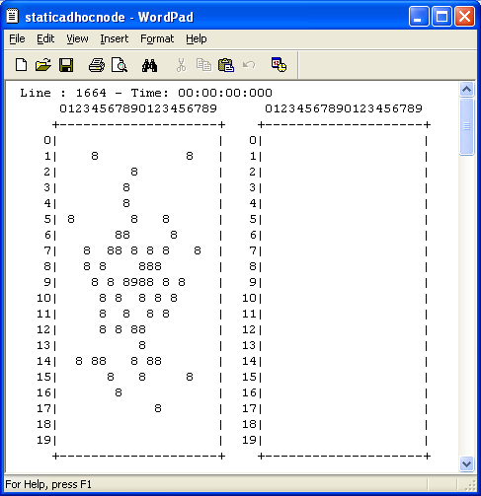

It can be seen that after the first run, only the cells which are occupied by a static node and in the neighborhood of the base station will update their states to 1.

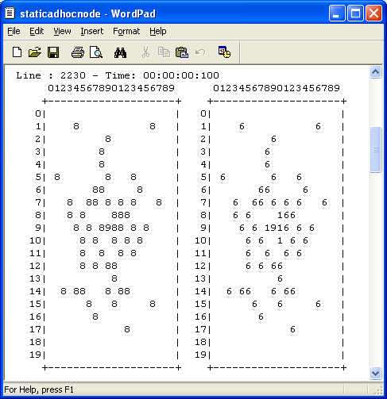
After 5’th iteration there will be no runs because all the cells up to 5 hops away from the base station have already updated their sates to 5. Also all the cells which 6 or more hops states away from the base station will remain the same.
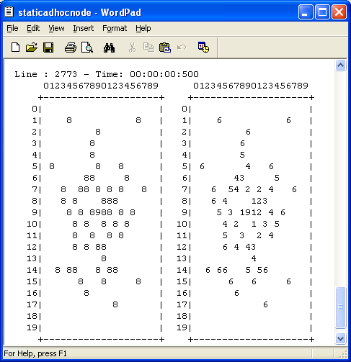
As an example of loops generated, the cell at (6,8) can be observed. It has three neighbors with states 4,4 and 2. And this cell chooses the path through lowest hop counts (which is 2) and updates its state value to 3.
When cells are initialized with values other than acceptable state values, which are 0,1,2,3,4,5,6 and 9 in this case; the simulator recognized that and gave an error message.
Another observation is that, most of the cells are not within the coverage area. So, if a larger neighborhood would be chosen, then coverage area would have been larger, which might be a more realistic case for a real world.
Although it is not within the specifications, two base stations are used just for curiosity, as shown in the figure below. And it is observed that, the model behaves correctly. Here especially the nodes between two base stations are not confused and calculated their states according to which base station is closer.

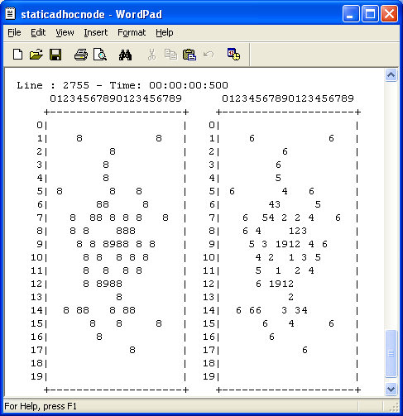

In order to check the performance of the edge cells, a base station is located close to the edge cells (According to the specifications base station will be one and at the center. This is just for trial purposes.). The result is shown in the figure below.

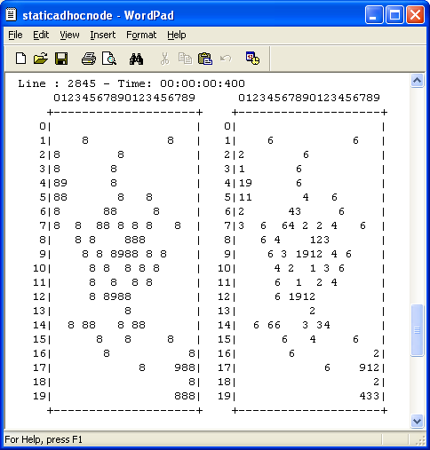
A base station is located at the edge cells in the .VAL file. But it is not recognized by the model as expected, because the model is implemented as such that base station can be located only at the inner cells.
CASE-2 TEST RESULTS.
The performance of the model with mobile nodes is not guaranteed in the specifications. So there is no need to perform tests within the coverage of this assignment. Still tests are performed and explained below as an extra effort.
Both static and mobile nodes are used. It is expected each static or mobile node to find out how many hops away the base station is. So first the nodes in the neighborhood of the base station will update their states to 10. Then the nodes in the neighborhood of nodes with state 10, will update their states to 20 and so on. As mobile nodes moves especially close to the base station and surrounding static nodes, it is possible to see, how mobile node changes its state.
The test layout in “staticadhocnode.VAL” file, with 23 static and three mobile nodes, is shown in the figure below. Mobile nodes have directions 1,1 and 3 initially.

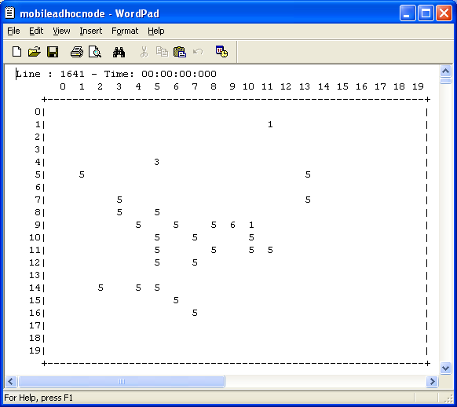

A sample view is given below when mobile node approaches close to the base station and surrounding nodes. The corresponding plane 2 views for the following iterations are observed as follows, which are as expected.

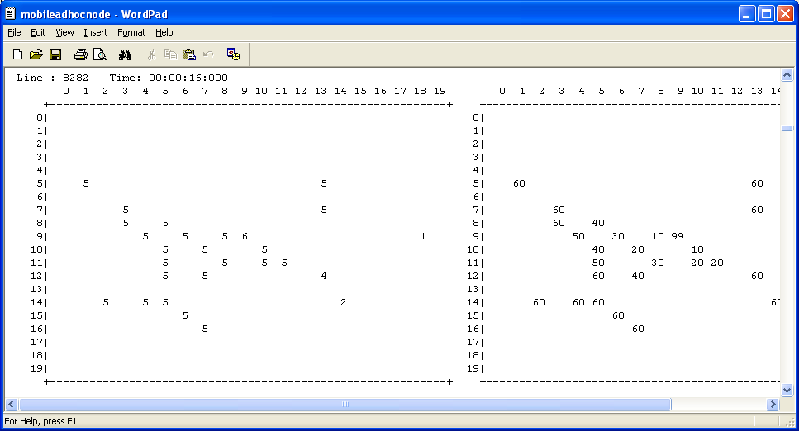

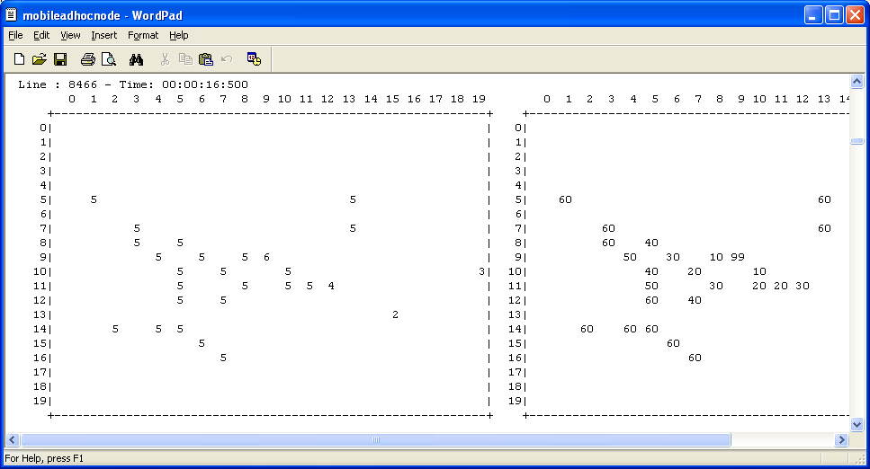

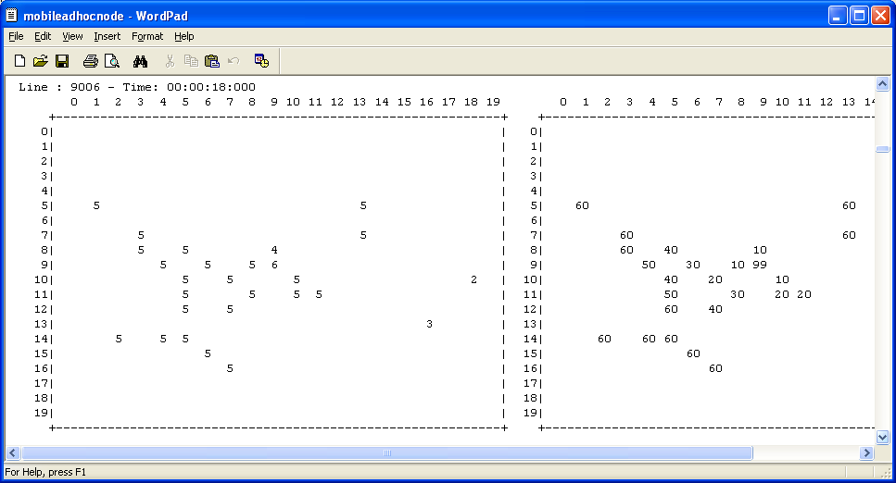

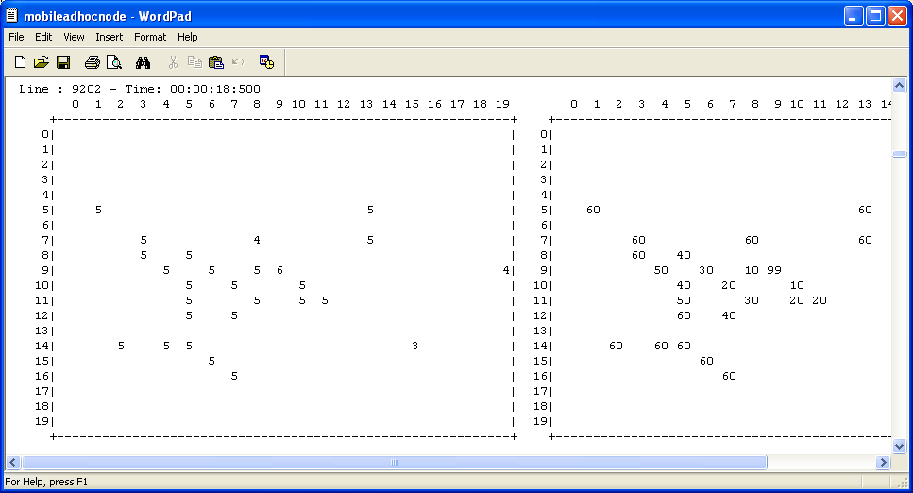

APPENDIX A
MODELLER OUTPUTS FOR CASE1 AND CASE2

APPENDIX B
VRML GUI OUTPUTS FOR CASE1

