SYSC 5807
Methodologies of Modeling and Simulation
Fall 2003
Instructor: Prof. Gabriel A. Wainer

Project Report
MOBILE AD-HOC NODES

Prepared by: Bengu Balya
Student Number: 350 638
Email: b_balya@hotmail.com

TABLE OF CONTENTS.
LIST OF FIGURES. 3
1. INTRODUCTION. 4
2. AN OVERVIEW OF AD HOC NETWORKS. 5
2. CONCEPTUAL MODEL DEFINITION. 6
2.1 MOBILITY PLANE: 7
2.2 HOP COUNT PLANE: 9
2.3 COVERAGE PLANE: 11
3. FORMAL SPECIFICATION. 12
3.1 FORMAL SPECIFICATIONS FOR ATOMIC MODELS. 12
3.1 FORMAL SPECIFICATIONS FOR COUPLED MODELS. 14
4. Model Specification File: 18
5. SIMULATION AND TEST RESULTS. 25
5.1 PLANE-0: MOBILITY PLANE. 25
5.2 PLANE-1: HOP COUNT PLANE. 32
5.3 PLANE-2: COVERAGE PLANE. 40
5. ANALYSIS OF TEST RESULTS. 45
6. CONCLUSIONS. 46
APPENDIX-A: SAMPLE MODELLER OUTPUTS 47

LIST OF FIGURES.

Figure 1: Direction of mobile nodes in mobility plane. 7
Figure 2: Directions of mobile nodes at mobility plane. 25
Figure 3: Initial layout of nodes and base stations at mobility plane. 26
Figure 4: Test results after first move of mobile nodes at Time:00:00:01:000. 27
Figure 5: Test results after second move of mobile nodes at Time:00:00:02:000. 28
Figure 6: Test results after third move of mobile nodes at Time:00:00:03:000. 29
Figure-7: Initial layout for CA of mobile nodes at corner cells at Time:00:00:00:000. 30
Figure-8 Test results after first move of mobile nodes at Time:00:00:01:000. 30
Figure-9: Test results after second move of mobile nodes at Time:00:00:02:000. 31
Figure-10: Initial layout of nodes and base stations at mobility plane. 32
Figure-11: Simulation Output at Time:00:00:01:000. 33
Figure-12: Simulation Outputs at Time:00:00:02:000. 33
Figure-13: Simulation Outputs at Time:00:00:03:000. 34
Figure-14: Simulation Outputs at Time:00:00:04:000. 34
Figure-15: Simulation Outputs at Time:00:00:05:000. 35
Figure-16: Simulation Outputs at Time:00:00:06:000. 36
Figure-17: Simulation Outputs at Time:00:00:07:000. 36
Figure-18: Simulation Outputs at Time:00:00:08:000. 37
Figure-19: Simulation Outputs at Time:00:00:09:000. 37
Figure-20: Simulation Outputs at Time:00:00:22:000. 38
Figure-21: Simulation Outputs at Time:00:00:23:000. 39
Figure-22: Simulation Outputs at Time:00:00:01:000. 40
Figure-23: Simulation Outputs at Time:00:00:02:000. 41
Figure-24: Simulation Outputs at Time:00:00:03:000. 41
Figure-25: Simulation Outputs at Time:00:00:04:000. 42
Figure-26: Simulation Outputs at Time:00:00:05:000. 42
Figure-27: Simulation Outputs at Time:00:00:06:000. 43
Figure-28: Simulation Outputs at Time:00:00:60:000. 44
Figure-29: Simulation Outputs at Time:00:00:61:000. 44
Figure-A1: Modeler Display at Time:00:00:03:000. 47
Figure-A2: Modeler Display at Time:00:00:04:000. 47
Figure-A3: Modeler Display at Time:00:00:05:000. 48
Figure-A4: Modeler Display at Time:00:01:14:000. 48
Figure-A5: Modeler Display at Time:00:01:15:000. 49
Figure-A6: Modeler Display at Time:00:01:24:000. 49

1. INTRODUCTION.
In the literature, it was not seen much cellular automata applications on Ad-Hoc Networks, other than one using cellular automata and genetic algorithms for location management of mobile computing networks [1].
So, the study that will be presented in this project is the first application of its kind using CELL DEVS modeling.
Ad-hoc networks are networks without an infrastructure. That means there are no routers, switches etc. On the other hand, each ad-hoc node can act as a router and forward data from one neighboring node to another.
This project aims, each ad-hoc node to be able to determine its distance from the base station. Here distance means, how many hop counts away the base station is. Also, as the bonus part of this project, coverage plane is implemented.
Coverage may be a quite important information for network engineers to determine where to place the extra base stations, so that, more ad hoc nodes will be able to reach to the gateway.
Ad hoc nodes can be static or mobile. So in this project, both static and mobile nodes exist. In order to implement mobility, collision avoidance techniques are implemented in the model. User traffic or network traffic are not in the coverage of this study.
Details of conceptual and formal definitions and test and simulation results are explained and presented in the following sections.

[1] R. Subrata, A. Zomaya, “Evolving Cellular Automata for Location Management in Mobile Computing Networks”, IEEE Transactions on Parallel and Distributed Systems, Vol.14, No.1, 2003.

2. AN OVERVIEW OF AD HOC NETWORKS.
As people wants to reach internet everywhere, such as, while traveling or sitting in a café etc, ad-hoc network technology will be widely accepted and used as a solution.
Ad-Hoc networks are characterized by, several wireless mobile or static nodes communicating with each other without an infrastructure. That means, you can throw these nodes from a plane, for example, to a desert or forest without any infrastructure, and they will self configure themselves, automatically detect their neighboring nodes and start talking with each other.
Because there is no infrastructure, each mobile node may act as a router for another node. So the packet generated from one of the mobile nodes, will be routed to the neighboring mobile node and routed from this node to the next, until it reaches to the destination.
In ad hoc networks, base station is used as a gateway to internet, PSTN (Public Switched Telephone Network) or other wireless networks. So all external traffic will be forwarded through base station. That means each node should know if it could reach to the base station and also should be aware of the shortest path. Here “shortest path” means not the physical distance but how many hop counts away the base station is. In order to choose to which neighboring node the packet will be routed, the distance from each neighboring node to the base station will be used.
Each node will keep this distance information and update it regularly, by being aware of its neighbors’ distances. For example, let us assume that, node-X has two neighbors, node-Y and node-Z, which has a distance from base station by 1 and 3 hops respectively. So node-X is 4 hops away from base station if it chooses the path through node-Z, or 2 hops away if it chooses the path through node-Y. Node-X should choose always the shortest path, which is node-Y.
Any node that is in the neighborhood of another node that can reach to the base station, can also reach to the base station. This fact can be used to implement the coverage area concept. All cells that are occupied by the nodes that can reach to the base station and all the cells in the neighborhood of these nodes will be in the coverage area. In other words, any mobile ad-hoc node that moves in one of the empty cells in the coverage area, can reach to the base station.
On the other hand, ad-hoc nodes are using the battery and transmission power of the other nodes that the data is forwarded on. As the number of nodes on path increases so is the total power consumption. Therefore, it will be wise to put a limit on the total number of hop counts. In this project this limit is chosen to be 5 hops. So the mobile or static nodes that are 6 or more hops away from the base station, will not be able to reach to the base station and also will not be in the coverage area.

2. CONCEPTUAL MODEL DEFINITION.
There exist both static and mobile nodes in the model, and also one or more base stations. There is no upper or lower limit for the number nodes, although a natural upper bound will be the total number of cells.
Model will consist of 3 planes, as one plane per variable. The first plane will implement the physical location or movement of the nodes. The second plane will be determining the hop count value of each node. Third plane shows the coverage area. As a general view of the model:
- Base stations can be located anywhere and will always have a value of “6” both in plane#1 and plane#2.
- 20*20 cell structure will be used.
- 24 closest cells around the node will form the neighborhood to be aware of.
- It is assumed that if a node is 1-5 hops away from the base station, that node is allowed to reach to the base station.
- If a node is 6 or more hops away from the base station, that node is not allowed to communicate with the base station.
- Initially all cells will have an initial value of 0 at all planes, other than the ones which are occupied. Those cells that are initially occupied will be initialized in the “.val” file.
The main focus of the project was to implement the hop count plane successfully. But as the bonus part of the project, coverage plane is also modeled.
The conceptual rules of each model will be explained in the following sections.

2.1 MOBILITY PLANE:
The movement of the mobile nodes will be diagonal as in case of “Bouncing Ball” example, which is designed for only one moving ball. So all the rules are redeveloped from the beginning by taking into account that there can be more than one mobile node. Mobile nodes will bounce when they reach to the edges of the plane. For all edges and corners of plane#1, zones are defined to be able to implement different rules at the edges.
Because the “Bouncing Ball” example does not consider collision avoidance, first this example will be modified to add this feature. Mainly, because there will be several mobile nodes moving around and there should be a mechanism to avoid them to collapse with each other or with static nodes.
The values of the mobility plane cells will be as follows:
5: Static Node.
6: Base Station.
1: Mobile node moving in south-east direction.
2: Mobile node moving in north-east direction.
3: Mobile node moving in south-west direction.
4: Mobile node moving in north-west direction.
4
3
1
2

Figure 1: Direction of mobile nodes in mobility plane.
Collision Rule Between Mobile and Static Nodes: If the cell, which is in the moving direction of the mobile node, is not empty, then reverse the direction of the mobile node. Otherwise, assign the direction value of the mobile node to the new cell.
Collision Rule Between Mobile Nodes: If the cell, which is in the moving direction of the mobile node, is empty, then check if there is any other mobile node approaching to the same cell from other directions and trying to occupy the cell at the same time. If there is any, then reverse the direction of the mobile node. Otherwise, assign the direction value of the mobile node to the new cell.

2.2 HOP COUNT PLANE:
Hop count plane will be located on top of mobility plane. Cells, which are occupied at mobility plane and 1,2,3,4,5,6 hops away from the base station at hop count plane, will have values of 10,20,30,40,50 and 60 respectively. The reason for using two digit values instead of one digit is that, there are more than 10 different states in total in both planes. And statecount() function takes into account of all neighboring cells from both planes.
The possible values of the cells are as follows:
0: A cell, which is not occupied at mobility plane.
6: A cell, which is occupied by a base station at mobility plane.
10: A cell, which is occupied by a static or mobile node at mobility plane and which is in the neighborhood of the base station.
20: A cell, which is occupied by a static or mobile node at mobility plane and which has a neighbor with value 10, but not one with value 6.
30: A cell, which is occupied by a static or mobile node at mobility plane and which has a neighbor with value 20, but not one with values 6 or 10.
40: A cell, which is occupied by a static or mobile node at mobility plane and which has a neighbor with value 30, but not one with values 6, 10 or 20.
50: A cell, which is occupied by a static or mobile node at mobility plane and which has a neighbor with value 40, but not one with values 6, 10, 20 or 30.
60: A cell, which is occupied by a static or mobile node at mobility plane and which has a neighbor with value 50, but not one with values 6, 10, 20, 30 or 40; or has no node in its neighbor at all.

Hop count plane rules are as follows:
HopCount-1: If the current cell value is 0, and there are no nodes planning to move to this cell at mobility plane, or if there are more than one nodes trying to move to this cell, then value will not change.
HopCount-2: If a cell is occupied by a base station at mobility plane then the cell value at plane#1 will not change.
HopCount-3: If a cell is occupied by a static node at plane#0 then check, if there is a base station in the neighborhood. If there is any then set the value to 10. Otherwise, check if there are other nodes. If there are any, find the one with lowest hop count value, increment it by ten and set this value. Otherwise, set value to 60.
HopCount-4: If a cell is occupied by a mobile node at plane#0 and if the next cell in the direction of the mobile node is empty, and there are no other mobile nodes trying to move to the next cell at plane#0, then set the value of this cell as 0.
HopCount-5: If a cell is occupied by a mobile node at plane#0 and if the next cell in the direction of the mobile node is not empty, or there are other mobile nodes trying to move to the next cell at plane#0, then check, if there is a base station in the neighborhood. If there is any then set the value to 10. Otherwise, check if there are other nodes. If there are any, find the one with lowest hop count value, increment it by ten and set this value. Otherwise, set the next value to 60.
HopCount-6: If the cell is empty and there is only one node planning to move to this cell at plane 0, then check the neighborhood. If the base station is in the neighborhood, set value to 10. Otherwise, check the neighborhood to find the node with lowest value, increment it by10 and set the value. Otherwise set the next value 60.
According to CELL DEVS and our model structure, output of mobility plane cells together with outputs of hop-count plane cells will be input of hop-count plane cells. For example, when a mobile node moves to a new cell, then this will be input to the hop-count plane cell, and this cell will calculate its hop count value to set after delay time. But, after delay time, this mobile node maybe will move again, and whatever we have set at hop count plane will not be valid. This problem exists only with mobile nodes. We do expect the node to know right away about its new value without delay time at hop count plane.
In order to solve the problem that is described above, a trick is applied to hop count plane rules. Hop count plane rules that are listed above will be valid but when they check the mobility plane cell values, they will not use the current values of the cell but the predicted next step value. By this trick, the problem is solved as will be seen from simulation outputs.

2.3 COVERAGE PLANE:
Coverage plane shows if a cell can reach to the base station or vise versa, by making less than 6 hops. The cell may be currently occupied by a static or mobile node, or empty. Coverage plane rules are as follows:
Coverage-1: If there is a base station in the neighborhood, set value to 7.
Coverage-2: If there is a node with value 10 in the neighborhood, set value to 1.
Coverage-3: If there is a node with value 20 in the neighborhood, set value to 1.
Coverage-4: If there is a node with value 30 in the neighborhood, set value to 1.
Coverage-5: If there is a node with value 40 in the neighborhood, set value to 1.
Coverage-6: For all other cases set value to 0.

3. FORMAL SPECIFICATION.

3.1 FORMAL SPECIFICATIONS FOR ATOMIC MODELS.

(1) Plane 0

Inner Cell Atomic Model:
CD=<X, Y, I, S, θ, N, d, δint, δext,τ, λ, D>
X=Y=S={0,1,2,3,4,5,6};
d = transport delay, 1000 msec
τ = ( mover_and_hope-rule as defined in the mobilenode.MA file)
I,θ, δint, δext, λ, D will be according to Cell DEVS definitions.

Top Atomic Model:
CD=<X, Y, I, S, θ, N, d, δint, δext,τ, λ, D>
X={0,2,4,5,6};
Y={0,1,2,3,4,5,6};
S={0,1,3,5,6};
d = transport delay, 1000 msec
τ = ( top-rule as defined in the mobilenode.MA file)
I,θ, δint, δext, λ, D will be according to Cell DEVS definitions.

Bottom Atomic Model:
CD=<X, Y, I, S, θ, N, d, δint, δext,τ, λ, D>
X={0,1,2,3,4,5,6};
Y={0,2,4,5,6};
S={0,2,4,5,6};
d = transport delay, 1000 msec
τ = ( bottom-rule as defined in the mobilenode.MA file)
I,θ, δint, δext, λ, D will be according to Cell DEVS definitions.

Left Atomic Model
CD=<X, Y, I, S, θ, N, d, δint, δext,τ, λ, D>
X={0,1,2,3,4,5,6};
Y={0,1,2,5,6};
S={0,1,2,5,6};
d = transport delay, 1000 msec
τ = ( left-rule as defined in the mobilenode.MA file)
I,θ, δint, δext, λ, D will be according to Cell DEVS definitions.

Right Atomic Model
CD=<X, Y, I, S, θ, N, d, δint, δext,τ, λ, D>
X={0,1,2,3,4,5,6};
Y={0,3,4,5,6};
S={0,3,4,5,6};
d = transport delay, 1000 msec
τ = ( right-rule as defined in the mobilenode.MA file)
I,θ, δint, δext, λ, D will be according to Cell DEVS definitions.

CornerUL Atomic Model
CD=<X, Y, I, S, θ, N, d, δint, δext,τ, λ, D>
X={0,1,2,3,4,5,6};
Y={0,1,5,6};
S={0,1,5,6};
d = transport delay, 1000 msec
τ = ( cornerUL-rule as defined in the mobilenode.MA file)
I,θ, δint, δext, λ, D will be according to Cell DEVS definitions.

CornerUR Atomic Model
CD=<X, Y, I, S, θ, N, d, δint, δext,τ, λ, D>
X={0,1,2,3,4,5,6};
Y={0,3,5,6};
S={0,3,5,6};
d = transport delay, 1000 msec
τ = ( cornerUR-rule as defined in the mobilenode.MA file)
I,θ, δint, δext, λ, D will be according to Cell DEVS definitions.

CornerDL Atomic Model
CD=<X, Y, I, S, θ, N, d, δint, δext,τ, λ, D>
X={0,1,2,3,4,5,6};
Y={0,2,5,6};
S={0,2,5,6};
d = transport delay, 1000 msec
τ = ( cornerDL-rule as defined in the mobilenode.MA file)
I,θ, δint, δext, λ, D will be according to Cell DEVS definitions.

CornerDR Atomic Model
CD=<X, Y, I, S, θ, N, d, δint, δext,τ, λ, D>
X={0,1,2,3,4,5,6};
Y={0,4,5,6};
S={0,4,5,6};
d = transport delay, 1000 msec
τ = ( cornerDR-rule as defined in the mobilenode.MA file)
I,θ, δint, δext, λ, D will be according to Cell DEVS definitions.

(2) Plane 1

CD=<X, Y, I, S, θ, N, d, δint, δext,τ, λ, D>
X={0,1,2,3,4,5,6,10,20,30,40,50,60};
Y={0,10,20,30,40,50,60,6};
S={0,10,20,30,40,50,60,6};
d = transport delay, 1000 msec
τ = ( mover_and_hope-rule as in the “mobilenode.MA” file)
I,θ, δint, δext, λ, D will be according to Cell DEVS definitions.

(3) Plane 2

CD=<X, Y, I, S, θ, N, d, δint, δext,τ, λ, D>
X={0,7,10,20,30,40,50,60,6};
Y={0,7};
S={0,7};
d = transport delay, 1000 msec
τ = ( mover_and_hope-rule as in the “mobilenode.MA” file)
I,θ, δint, δext, λ, D will be according to Cell DEVS definitions.

3.1 FORMAL SPECIFICATIONS FOR COUPLED MODELS.
(1) Plane 0

M=<I,X,Y,Xlist,Ylist,η, N,{m,n,t}, C, B, Z, select>
Xlist=Φ
Ylist=Φ
η=50
I=<P^{X},P^{Y}>,with P^{X}={Φ},P^{Y}={Φ};
N={ (-2,-2,0),(-2,-1,0),(-2,0,0),(-2,1,0),(-2,2,0),(-1,-2,0),(-1,-1,0),(-1,0,0),(-1,1,0),(-1,2,0),(0,-2,0),(0,-1,0),(0,0,0),(0,1,0),(0,2,0),(1,-2,0),(1,-1,0),(1,0,0),(1,1,0),(1,2,0),(2,-2,0),(2,-1,0),(2,0,0),(2,1,0),(2,2,0),(-2,-2,1),(-2,-1, 1),(-2,0, 1),(-2,1, 1),(-2,2, 1),(-1,-2, 1),(-1,-1, 1),(-1,0, 1),(-1,1, 1),(-1,2, 1),(0,-2, 1),(0,-1, 1),(0,0, 1),(0,1, 1),(0,2, 1),(1,-2, 1),(1,-1, 1),(1,0, 1),(1,1, 1),(1,2, 1),(2,-2, 1),(2,-1, 1),(2,0, 1),(2,1, 1),(2,2, 1) }

X=Y={0,1,2,3,4,5,6};
m=20; n=20; t=3
B={ Cij / Cij ε C /\ (i=1 V i=20) /\ ( j=1 V j=20) };
C={Cij/iε[1,20], jε[1,20]}
Z: (as according to the neighboring cell definition), for plane 0:
P_{ij}^{Y1}→P_{i-1,j-1}^{X1} P_{ij}^{X1}←P_{i+1,j+1}^{Y1}
Pij^{Y2}→ P_{i-1,j+1}^{X2} P_{ij}^{X2}←P_{i+1,j-1}^{Y2}
P_{i}j^{Y3}→ P_{i,j}^{X3} P_{ij}^{X3}←P_{ij}^{Y3}
P_{i}j^{Y4}→P_{i+1,j-1}^{X4} P_{ij}^{X4}←P_{i-1,j+1}^{Y4}
Pij^{Y5}→P_{i+1,j+1}^{X5} P_{ij}^{X5}←P_{i-1,j-1}^{Y5}
Select = {(-2,-2,0), (-2,-1,0), (-2,0,0), (-2,1,0), (-2,2,0), (-1,-2,0), (-1,-1,0), (-1,0,0), (-1,1,0), (-1,2,0), (0,-2,0), (0,-1,0), (0,0,0), (0,1,0), (0,2,0), (1,-2,0), (1,-1,0), (1,0,0), (1,1,0), (1,2,0), (2,-2,0), (2,-1,0), (2,0,0), (2,1,0), (2,2,0), (-2,-2,1), (-2,-1,1), (-2,0,1), (-2,1, 1), (-2,2,1), (-1,-2,1), (-1,-1,1), (-1,0, 1), (-1,1, 1), (-1,2, 1), (0,-2, 1), (0,-1, 1), (0,0, 1), (0,1, 1), (0,2, 1), (1,-2, 1), (1,-1, 1), (1,0, 1), (1,1, 1), (1,2, 1), (2,-2, 1), (2,-1, 1), (2,0, 1), (2,1, 1), (2,2, 1)}

(2) Plane 1

M=<I,X,Y,Xlist,Ylist,η, N,{m,n,t}, C, B, Z, select>
Xlist=Φ
Ylist=Φ
η=50
I=<P^{X},P^{y}>,with P^{X}={Φ},P^{y}={Φ};
N={ (-2,-2,0),(-2,-1,0),(-2,0,0),(-2,1,0),(-2,2,0),(-1,-2,0),(-1,-1,0),(-1,0,0),(-1,1,0),(-1,2,0),(0,-2,0),(0,-1,0),(0,0,0),(0,1,0),(0,2,0),(1,-2,0),(1,-1,0),(1,0,0),(1,1,0),(1,2,0),(2,-2,0),(2,-1,0),(2,0,0),(2,1,0),(2,2,0),(-2,-2,1),(-2,-1, 1),(-2,0, 1),(-2,1, 1),(-2,2, 1),(-1,-2, 1),(-1,-1, 1),(-1,0, 1),(-1,1, 1),(-1,2, 1),(0,-2, 1),(0,-1, 1),(0,0, 1),(0,1, 1),(0,2, 1),(1,-2, 1),(1,-1, 1),(1,0, 1),(1,1, 1),(1,2, 1),(2,-2, 1),(2,-1, 1),(2,0, 1),(2,1, 1),(2,2, 1) }

X=={0,1,2,3,4,5,6,10,20,30,40,50,60};
Y={0,10,20,30,40,50,60,6};
m=20; n=20; t=3
={ Cij / Cij ε C /\ (i=1 V i=20) /\ ( j=1 V j=20) };
C={Cij/iε[1,20], jε[1,20]}
Z: (as according to the neighboring cell definition), for plane 1:
P_{ij}^{Y1}→P_{i-1,j-1}^{X1} P_{ij}^{X1}←P_{i+1,j+1}^{Y1}
P_{i}j^{Y2}→P_{i-1,j}^{X2} P_{ij}^{X2}←P_{i+1,j}^{Y2}
Pij^{Y3}→ P_{i-1,j+1}^{X3} P_{ij}^{X3}←P_{i+1,j-1}^{Y3}
Pij^{Y4}→P_{i,j-1}^{X4} P_{ij}^{X4}←P_{ij+1}^{Y4}
P_{i}j^{Y5}→ P_{i,j}^{X5} P_{ij}^{X5}←P_{ij}^{Y5}
P_{ij}^{Y6}→P_{i,j+1}^{X6} P_{ij}^{X6}← P_{i,j-1}^{Y6}
P_{i}j^{Y7}→P_{i+1,j-1}^{X7} P_{ij}^{X7}←P_{i-1,j+1}^{Y7}
Pij^{Y8}→ P_{i+1,j}^{X8} P_{ij}^{X8}← P_{i-1,j}^{Y8}
Pij^{Y9}→P_{i+1,j+1}^{X9} P_{ij}^{X9}←P_{i-1,j-1}^{Y9}

Select = {(-2,-2,0), (-2,-1,0), (-2,0,0), (-2,1,0), (-2,2,0), (-1,-2,0), (-1,-1,0), (-1,0,0), (-1,1,0), (-1,2,0), (0,-2,0), (0,-1,0), (0,0,0), (0,1,0), (0,2,0), (1,-2,0), (1,-1,0), (1,0,0), (1,1,0), (1,2,0), (2,-2,0), (2,-1,0), (2,0,0), (2,1,0), (2,2,0), (-2,-2,1), (-2,-1,1), (-2,0,1), (-2,1, 1), (-2,2,1), (-1,-2,1), (-1,-1,1), (-1,0, 1), (-1,1, 1), (-1,2, 1), (0,-2, 1), (0,-1, 1), (0,0, 1), (0,1, 1), (0,2, 1), (1,-2, 1), (1,-1, 1), (1,0, 1), (1,1, 1), (1,2, 1), (2,-2, 1), (2,-1, 1), (2,0, 1), (2,1, 1), (2,2, 1)}

(3) Plane 2

M=<I,X,Y,Xlist,Ylist,η, N,{m,n,t}, C, B, Z, select>
Xlist=Φ
Ylist=Φ
η=50
I=<P^{X},P^{y}>,with P^{X}={Φ},P^{y}={Φ};
N={ (-2,-2,0),(-2,-1,0),(-2,0,0),(-2,1,0),(-2,2,0),(-1,-2,0),(-1,-1,0),(-1,0,0),(-1,1,0),(-1,2,0),(0,-2,0),(0,-1,0),(0,0,0),(0,1,0),(0,2,0),(1,-2,0),(1,-1,0),(1,0,0),(1,1,0),(1,2,0),(2,-2,0),(2,-1,0),(2,0,0),(2,1,0),(2,2,0),(-2,-2,-1),(-2,-1,-1),(-2,0,-1),(-2,1,-1),(-2,2,-1),(-1,-2,-1),(-1,-1,-1),(-1,0,-1),(-1,1,-1),(-1,2,-1),(0,-2,-1),(0,-1,-1),(0,0,-1),(0,1,-1),(0,2,-1),(1,-2,-1),(1,-1,-1),(1,0,-1),(1,1,-1),(1,2,-1),(2,-2,-1),(2,-1,-1),(2,0,-1),(2,1,-1),(2,2,
-1) }

X={0,7,10,20,30,40,50,60,6};
Y={0,7};
m=20; n=20; t=3
={ Cij / Cij ε C /\ (i=1 V i=20) /\ ( j=1 V j=20) };
C={Cij/iε[1,20], jε[1,20]}
Z: (as according to the neighboring cell definition), for plane 2:
P_{ij}^{Y1}→P_{i-1,j-1}^{X1} P_{ij}^{X1}←P_{i+1,j+1}^{Y1}
P_{i}j^{Y2}→P_{i-1,j}^{X2} P_{ij}^{X2}←P_{i+1,j}^{Y2}
Pij^{Y3}→ P_{i-1,j+1}^{X3} P_{ij}^{X3}←P_{i+1,j-1}^{Y3}
Pij^{Y4}→P_{i,j-1}^{X4} P_{ij}^{X4}←P_{ij+1}^{Y4}
P_{i}j^{Y5}→ P_{i,j}^{X5} P_{ij}^{X5}←P_{ij}^{Y5}
P_{ij}^{Y6}→P_{i,j+1}^{X6} P_{ij}^{X6}← P_{i,j-1}^{Y6}
P_{i}j^{Y7}→P_{i+1,j-1}^{X7} P_{ij}^{X7}←P_{i-1,j+1}^{Y7}
Pij^{Y8}→ P_{i+1,j}^{X8} P_{ij}^{X8}← P_{i-1,j}^{Y8}
Pij^{Y9}→P_{i+1,j+1}^{X9} P_{ij}^{X9}←P_{i-1,j-1}^{Y9}

Select = {(-2,-2,0), (-2,-1,0), (-2,0,0), (-2,1,0), (-2,2,0), (-1,-2,0), (-1,-1,0), (-1,0,0), (-1,1,0), (-1,2,0), (0,-2,0), (0,-1,0), (0,0,0), (0,1,0), (0,2,0), (1,-2,0), (1,-1,0), (1,0,0), (1,1,0), (1,2,0), (2,-2,0), (2,-1,0), (2,0,0), (2,1,0), (2,2,0), (-2,-2,1), (-2,-1,1), (-2,0,1), (-2,1, 1), (-2,2,1), (-1,-2,1), (-1,-1,1), (-1,0, 1), (-1,1, 1), (-1,2, 1), (0,-2, 1), (0,-1, 1), (0,0, 1), (0,1, 1), (0,2, 1), (1,-2, 1), (1,-1, 1), (1,0, 1), (1,1, 1), (1,2, 1), (2,-2, 1), (2,-1, 1), (2,0, 1), (2,1, 1), (2,2, 1)}

For the model’s specification, please refer to the file – Mobilenode.MA

4. Model Specification File:

[top]
components : mobilenode

[mobilenode]
type : cell
dim : (20, 20, 3 )
delay : transport
defaultDelayTime : 0
border : nowrapped
neighbors : mobilenode(-2,-2,0) mobilenode(-2,-1,0) mobilenode(-2,0,0) mobilenode(-2,1,0) mobilenode(-2,2,0)
neighbors : mobilenode(-1,-2,0) mobilenode(-1,-1,0) mobilenode(-1,0,0) mobilenode(-1,1,0) mobilenode(-1,2,0)
neighbors : mobilenode(0,-2,0) mobilenode(0,-1,0) mobilenode(0,0,0) mobilenode(0,1,0) mobilenode(0,2,0)
neighbors : mobilenode(1,-2,0) mobilenode(1,-1,0) mobilenode(1,0,0) mobilenode(1,1,0) mobilenode(1,2,0)
neighbors : mobilenode(2,-2,0) mobilenode(2,-1,0) mobilenode(2,0,0) mobilenode(2,1,0) mobilenode(2,2,0)

neighbors : mobilenode(-2,-2,-1) mobilenode(-2,-1,-1) mobilenode(-2,0,-1) mobilenode(-2,1,-1) mobilenode(-2,2,-1)
neighbors : mobilenode(-1,-2,-1) mobilenode(-1,-1,-1) mobilenode(-1,0,-1) mobilenode(-1,1,-1) mobilenode(-1,2,-1)
neighbors : mobilenode(0,-2,-1) mobilenode(0,-1,-1) mobilenode(0,0,-1) mobilenode(0,1,-1) mobilenode(0,2,-1)
neighbors : mobilenode(1,-2,-1) mobilenode(1,-1,-1) mobilenode(1,0,-1) mobilenode(1,1,-1) mobilenode(1,2,-1)
neighbors : mobilenode(2,-2,-1) mobilenode(2,-1,-1) mobilenode(2,0,-1) mobilenode(2,1,-1) mobilenode(2,2,-1)

initialvalue : 0
initialCellsValue : mobilenode.val
localtransition : mover_and_hop-rule

zone : cornerUL-rule { (0,0,0) }
zone : cornerUR-rule { (0,19,0) }
zone : cornerDL-rule { (19,0,0) }
zone : cornerDR-rule { (19,19,0) }
zone : top-rule { (0,1,0)..(0,18,0) }
zone : bottom-rule { (19,1,0)..(19,18,0) }
zone : left-rule { (1,0,0)..(18,0,0) }
zone : right-rule { (1,19,0)..(18,19,0) }

[mover_and_hop-rule]

rule : 1 1000 { cellpos(2) = 0 and (0,0,0) = 4 and ( (-1,-1,0) != 0 or (-2,-2,0) = 1 or (-2,0,0) = 3 or (0,-2,0) = 2 ) }
rule : 4 1000 { cellpos(2) = 0 and (0,0,0) = 1 and ( (1,1,0) != 0 or (0,2,0) = 3 or (2,2,0) = 4 or (2,0,0) = 2 ) }
rule : 3 1000 { cellpos(2) = 0 and (0,0,0) = 2 and ( (-1,1,0) != 0 or (-2,0,0) = 1 or (-2,2,0) = 3 or (0,2,0) = 4 ) }
rule : 2 1000 { cellpos(2) = 0 and (0,0,0) = 3 and ( (1,-1,0) != 0 or (2,-2,0) = 2 or (2,0,0) = 4 or (0,-2,0) = 1 ) }

rule : 5 1000 { cellpos(2) = 0 and (0,0,0) = 5 }
rule : 6 1000 { cellpos(2) = 0 and (0,0,0) = 6 }

rule : 4 1000 { cellpos(2) = 0 and (0,0,0) = 0 and (1,1,0) = 4 and (-1,-1,0) != 1 and (-1,1,0) != 3 and (1,-1,0) != 2 }
rule : 3 1000 { cellpos(2) = 0 and (0,0,0) = 0 and (-1,1,0) = 3 and (1,1,0) != 4 and (-1,-1,0) != 1 and (1,-1,0) != 2 }
rule : 2 1000 { cellpos(2) = 0 and (0,0,0) = 0 and (1,-1,0) = 2 and (-1,1,0) != 3 and (1,1,0) != 4 and (-1,-1,0) != 1 }
rule : 1 1000 { cellpos(2) = 0 and (0,0,0) = 0 and (-1,-1,0) = 1 and (1,-1,0) != 2 and (-1,1,0) != 3 and (1,1,0) != 4 }

rule : 0 1000 { cellpos(2) = 0 and t }

rule : 10 1000 { cellpos(2) = 1 and (0,0,-1) = 5 and statecount(6) > 0 }
rule : 20 1000 { cellpos(2) = 1 and (0,0,-1) = 5 and ( ( (0,0,0) != 10 and statecount(10) > 0 ) or statecount(10) > 1 ) }
rule : 30 1000 { cellpos(2) = 1 and (0,0,-1) = 5 and ( ( (0,0,0) != 20 and statecount(20) > 0 ) or statecount(20) > 1 ) }
rule : 40 1000 { cellpos(2) = 1 and (0,0,-1) = 5 and ( ( (0,0,0) != 30 and statecount(30) > 0 ) or statecount(30) > 1 ) }
rule : 50 1000 { cellpos(2) = 1 and (0,0,-1) = 5 and ( ( (0,0,0) != 40 and statecount(40) > 0 ) or statecount(40) > 1 ) }
rule : 60 1000 { cellpos(2) = 1 and (0,0,-1) = 5 and t }

rule : 0 1000 { cellpos(2) = 1 and (0,0,-1) = 0 and (1,1,-1) != 4 and (-1,1,-1) != 3 and (1,-1,-1) != 2 and (-1,-1,-1) != 1 }
rule : 0 1000 { cellpos(2) = 1 and (0,0,-1) = 1 and (1,1,-1) = 0 and (0,2,-1) != 3 and (2,2,-1) != 4 and (2,0,-1) != 2 }
rule : 0 1000 { cellpos(2) = 1 and (0,0,-1) = 2 and (-1,1,-1) = 0 and (-2,0,-1) != 1 and (-2,2,-1) != 3 and (0,2,-1) != 4 }
rule : 0 1000 { cellpos(2) = 1 and (0,0,-1) = 3 and (1,-1,-1) = 0 and (2,-2,-1) != 2 and (2,0,-1) != 4 and (0,-2,-1) != 1 }
rule : 0 1000 { cellpos(2) = 1 and (0,0,-1) = 4 and (-1,-1,-1) = 0 and (-2,-2,-1) != 1 and (-2,0,-1) != 3 and (0,-2,-1) != 2 }
rule : 6 1000 { cellpos(2) = 1 and (0,0,-1) = 6 }

rule : 10 1000 { cellpos(2) = 1 and (0,0,-1) = 0 and ( (1,1,-1) = 4 and (-1,-1,-1) != 1 and (-1,1,-1) != 3 and (1,-1,-1) != 2 ) and statecount(6) > 0 }
rule : 20 1000 { cellpos(2) = 1 and (0,0,-1) = 0 and ( (1,1,-1) = 4 and (-1,-1,-1) != 1 and (-1,1,-1) != 3 and (1,-1,-1) != 2 ) and ( ( (1,1,0) != 10 and statecount(10) > 0 ) or statecount(10) > 1 ) }
rule : 30 1000 { cellpos(2) = 1 and (0,0,-1) = 0 and ( (1,1,-1) = 4 and (-1,-1,-1) != 1 and (-1,1,-1) != 3 and (1,-1,-1) != 2 ) and ( ( (1,1,0) != 20 and statecount(20) > 0 ) or statecount(20) > 1 ) }
rule : 40 1000 { cellpos(2) = 1 and (0,0,-1) = 0 and ( (1,1,-1) = 4 and (-1,-1,-1) != 1 and (-1,1,-1) != 3 and (1,-1,-1) != 2 ) and ( ( (1,1,0) != 30 and statecount(30) > 0 ) or statecount(30) > 1 ) }
rule : 50 1000 { cellpos(2) = 1 and (0,0,-1) = 0 and ( (1,1,-1) = 4 and (-1,-1,-1) != 1 and (-1,1,-1) != 3 and (1,-1,-1) != 2 ) and ( ( (1,1,0) != 40 and statecount(40) > 0 ) or statecount(40) > 1 ) }
rule : 60 1000 { cellpos(2) = 1 and (0,0,-1) = 0 and ( (1,1,-1) = 4 and (-1,-1,-1) != 1 and (-1,1,-1) != 3 and (1,-1,-1) != 2 ) and t }

rule : 10 1000 { cellpos(2) = 1 and (0,0,-1) = 0 and ( (-1,1,-1) = 3 and (1,1,-1) != 4 and (-1,-1,-1) != 1 and (1,-1,-1) != 2 ) and statecount(6) > 0 }
rule : 20 1000 { cellpos(2) = 1 and (0,0,-1) = 0 and ( (-1,1,-1) = 3 and (1,1,-1) != 4 and (-1,-1,-1) != 1 and (1,-1,-1) != 2 ) and ( ( (-1,1,0) != 10 and statecount(10) > 0 ) or statecount(10) > 1 ) }
rule : 30 1000 { cellpos(2) = 1 and (0,0,-1) = 0 and ( (-1,1,-1) = 3 and (1,1,-1) != 4 and (-1,-1,-1) != 1 and (1,-1,-1) != 2 ) and ( ( (-1,1,0) != 20 and statecount(20) > 0 ) or statecount(20) > 1 ) }
rule : 40 1000 { cellpos(2) = 1 and (0,0,-1) = 0 and ( (-1,1,-1) = 3 and (1,1,-1) != 4 and (-1,-1,-1) != 1 and (1,-1,-1) != 2 ) and ( ( (-1,1,0) != 30 and statecount(30) > 0 ) or statecount(30) > 1 ) }
rule : 50 1000 { cellpos(2) = 1 and (0,0,-1) = 0 and ( (-1,1,-1) = 3 and (1,1,-1) != 4 and (-1,-1,-1) != 1 and (1,-1,-1) != 2 ) and ( ( (-1,1,0) != 40 and statecount(40) > 0 ) or statecount(40) > 1 ) }
rule : 60 1000 { cellpos(2) = 1 and (0,0,-1) = 0 and ( (-1,1,-1) = 3 and (1,1,-1) != 4 and (-1,-1,-1) != 1 and (1,-1,-1) != 2 ) and t }

rule : 10 1000 { cellpos(2) = 1 and (0,0,-1) = 0 and ( (1,-1,-1) = 2 and (-1,1,-1) != 3 and (1,1,-1) != 4 and (-1,-1,-1) != 1 ) and statecount(6) > 0 }
rule : 20 1000 { cellpos(2) = 1 and (0,0,-1) = 0 and ( (1,-1,-1) = 2 and (-1,1,-1) != 3 and (1,1,-1) != 4 and (-1,-1,-1) != 1 ) and ( ( (1,-1,0) != 10 and statecount(10) > 0 ) or statecount(10) > 1 ) }
rule : 30 1000 { cellpos(2) = 1 and (0,0,-1) = 0 and ( (1,-1,-1) = 2 and (-1,1,-1) != 3 and (1,1,-1) != 4 and (-1,-1,-1) != 1 ) and ( ( (1,-1,0) != 20 and statecount(20) > 0 ) or statecount(20) > 1 ) }
rule : 40 1000 { cellpos(2) = 1 and (0,0,-1) = 0 and ( (1,-1,-1) = 2 and (-1,1,-1) != 3 and (1,1,-1) != 4 and (-1,-1,-1) != 1 ) and ( ( (1,-1,0) != 30 and statecount(30) > 0 ) or statecount(30) > 1 ) }
rule : 50 1000 { cellpos(2) = 1 and (0,0,-1) = 0 and ( (1,-1,-1) = 2 and (-1,1,-1) != 3 and (1,1,-1) != 4 and (-1,-1,-1) != 1 ) and ( ( (1,-1,0) != 40 and statecount(40) > 0 ) or statecount(40) > 1 ) }
rule : 60 1000 { cellpos(2) = 1 and (0,0,-1) = 0 and ( (1,-1,-1) = 2 and (-1,1,-1) != 3 and (1,1,-1) != 4 and (-1,-1,-1) != 1 ) and t }

rule : 10 1000 { cellpos(2) = 1 and (0,0,-1) = 0 and ( (-1,-1,-1) = 1 and (1,-1,-1) != 2 and (-1,1,-1) != 3 and (1,1,-1) != 4 ) and statecount(6) > 0 }
rule : 20 1000 { cellpos(2) = 1 and (0,0,-1) = 0 and ( (-1,-1,-1) = 1 and (1,-1,-1) != 2 and (-1,1,-1) != 3 and (1,1,-1) != 4 ) and ( ( (-1,-1,0) != 10 and statecount(10) > 0 ) or statecount(10) > 1 ) }
rule : 30 1000 { cellpos(2) = 1 and (0,0,-1) = 0 and ( (-1,-1,-1) = 1 and (1,-1,-1) != 2 and (-1,1,-1) != 3 and (1,1,-1) != 4 ) and ( ( (-1,-1,0) != 20 and statecount(20) > 0 ) or statecount(20) > 1 ) }
rule : 40 1000 { cellpos(2) = 1 and (0,0,-1) = 0 and ( (-1,-1,-1) = 1 and (1,-1,-1) != 2 and (-1,1,-1) != 3 and (1,1,-1) != 4 ) and ( ( (-1,-1,0) != 30 and statecount(30) > 0 ) or statecount(30) > 1 ) }
rule : 50 1000 { cellpos(2) = 1 and (0,0,-1) = 0 and ( (-1,-1,-1) = 1 and (1,-1,-1) != 2 and (-1,1,-1) != 3 and (1,1,-1) != 4 ) and ( ( (-1,-1,0) != 40 and statecount(40) > 0 ) or statecount(40) > 1 ) }
rule : 60 1000 { cellpos(2) = 1 and (0,0,-1) = 0 and ( (-1,-1,-1) = 1 and (1,-1,-1) != 2 and (-1,1,-1) != 3 and (1,1,-1) != 4 ) and t }

rule : 0 1000 { cellpos(2) = 1 and (0,0,-1) = 0 and t }

rule : 10 1000 { cellpos(2) = 1 and (0,0,-1) = 1 and ( (1,1,-1) != 0 or (0,2,-1) = 3 or (2,2,-1) = 4 or (2,0,-1) = 2 ) and statecount(6) > 0 }
rule : 20 1000 { cellpos(2) = 1 and (0,0,-1) = 1 and ( (1,1,-1) != 0 or (0,2,-1) = 3 or (2,2,-1) = 4 or (2,0,-1) = 2 ) and ( ( (0,0,0) != 10 and statecount(10) > 0 ) or statecount(10) > 1 ) }
rule : 30 1000 { cellpos(2) = 1 and (0,0,-1) = 1 and ( (1,1,-1) != 0 or (0,2,-1) = 3 or (2,2,-1) = 4 or (2,0,-1) = 2 ) and ( ( (0,0,0) != 20 and statecount(20) > 0 ) or statecount(20) > 1 ) }
rule : 40 1000 { cellpos(2) = 1 and (0,0,-1) = 1 and ( (1,1,-1) != 0 or (0,2,-1) = 3 or (2,2,-1) = 4 or (2,0,-1) = 2 ) and ( ( (0,0,0) != 30 and statecount(30) > 0 ) or statecount(30) > 1 ) }
rule : 50 1000 { cellpos(2) = 1 and (0,0,-1) = 1 and ( (1,1,-1) != 0 or (0,2,-1) = 3 or (2,2,-1) = 4 or (2,0,-1) = 2 ) and ( ( (0,0,0) != 40 and statecount(40) > 0 ) or statecount(40) > 1 ) }
rule : 60 1000 { cellpos(2) = 1 and (0,0,-1) = 1 and ( (1,1,-1) != 0 or (0,2,-1) = 3 or (2,2,-1) = 4 or (2,0,-1) = 2 ) and t }

rule : 10 1000 { cellpos(2) = 1 and (0,0,-1) = 2 and ( (-1,1,-1) != 0 or (-2,0,-1) = 1 or (-2,2,-1) = 3 or (0,2,-1) = 4 ) and statecount(6) > 0 }
rule : 20 1000 { cellpos(2) = 1 and (0,0,-1) = 2 and ( (-1,1,-1) != 0 or (-2,0,-1) = 1 or (-2,2,-1) = 3 or (0,2,-1) = 4 ) and ( ( (0,0,0) != 10 and statecount(10) > 0 ) or statecount(10) > 1 ) }
rule : 30 1000 { cellpos(2) = 1 and (0,0,-1) = 2 and ( (-1,1,-1) != 0 or (-2,0,-1) = 1 or (-2,2,-1) = 3 or (0,2,-1) = 4 ) and ( ( (0,0,0) != 20 and statecount(20) > 0 ) or statecount(20) > 1 ) }
rule : 40 1000 { cellpos(2) = 1 and (0,0,-1) = 2 and ( (-1,1,-1) != 0 or (-2,0,-1) = 1 or (-2,2,-1) = 3 or (0,2,-1) = 4 ) and ( ( (0,0,0) != 30 and statecount(30) > 0 ) or statecount(30) > 1 ) }
rule : 50 1000 { cellpos(2) = 1 and (0,0,-1) = 2 and ( (-1,1,-1) != 0 or (-2,0,-1) = 1 or (-2,2,-1) = 3 or (0,2,-1) = 4 ) and ( ( (0,0,0) != 40 and statecount(40) > 0 ) or statecount(40) > 1 ) }
rule : 60 1000 { cellpos(2) = 1 and (0,0,-1) = 2 and ( (-1,1,-1) != 0 or (-2,0,-1) = 1 or (-2,2,-1) = 3 or (0,2,-1) = 4 ) and t }

rule : 10 1000 { cellpos(2) = 1 and (0,0,-1) = 3 and ( (1,-1,-1) != 0 or (2,-2,-1) = 2 or (2,0,-1) = 4 or (0,-2,-1) = 1 ) and statecount(6) > 0 }
rule : 20 1000 { cellpos(2) = 1 and (0,0,-1) = 3 and ( (1,-1,-1) != 0 or (2,-2,-1) = 2 or (2,0,-1) = 4 or (0,-2,-1) = 1 ) and ( ( (0,0,0) != 10 and statecount(10) > 0 ) or statecount(10) > 1 ) }
rule : 30 1000 { cellpos(2) = 1 and (0,0,-1) = 3 and ( (1,-1,-1) != 0 or (2,-2,-1) = 2 or (2,0,-1) = 4 or (0,-2,-1) = 1 ) and ( ( (0,0,0) != 20 and statecount(20) > 0 ) or statecount(20) > 1 ) }
rule : 40 1000 { cellpos(2) = 1 and (0,0,-1) = 3 and ( (1,-1,-1) != 0 or (2,-2,-1) = 2 or (2,0,-1) = 4 or (0,-2,-1) = 1 ) and ( ( (0,0,0) != 30 and statecount(30) > 0 ) or statecount(30) > 1 ) }
rule : 50 1000 { cellpos(2) = 1 and (0,0,-1) = 3 and ( (1,-1,-1) != 0 or (2,-2,-1) = 2 or (2,0,-1) = 4 or (0,-2,-1) = 1 ) and ( ( (0,0,0) != 40 and statecount(40) > 0 ) or statecount(40) > 1 ) }
rule : 60 1000 { cellpos(2) = 1 and (0,0,-1) = 3 and ( (1,-1,-1) != 0 or (2,-2,-1) = 2 or (2,0,-1) = 4 or (0,-2,-1) = 1 ) and t }

rule : 10 1000 { cellpos(2) = 1 and (0,0,-1) = 4 and ( (-1,-1,-1) != 0 or (-2,-2,-1) = 1 or (-2,0,-1) = 3 or (0,-2,-1) = 2 ) and statecount(6) > 0 }
rule : 20 1000 { cellpos(2) = 1 and (0,0,-1) = 4 and ( (-1,-1,-1) != 0 or (-2,-2,-1) = 1 or (-2,0,-1) = 3 or (0,-2,-1) = 2 ) and ( ( (0,0,0) != 10 and statecount(10) > 0 ) or statecount(10) > 1 ) }
rule : 30 1000 { cellpos(2) = 1 and (0,0,-1) = 4 and ( (-1,-1,-1) != 0 or (-2,-2,-1) = 1 or (-2,0,-1) = 3 or (0,-2,-1) = 2 ) and ( ( (0,0,0) != 20 and statecount(20) > 0 ) or statecount(20) > 1 ) }
rule : 40 1000 { cellpos(2) = 1 and (0,0,-1) = 4 and ( (-1,-1,-1) != 0 or (-2,-2,-1) = 1 or (-2,0,-1) = 3 or (0,-2,-1) = 2 ) and ( ( (0,0,0) != 30 and statecount(30) > 0 ) or statecount(30) > 1 ) }
rule : 50 1000 { cellpos(2) = 1 and (0,0,-1) = 4 and ( (-1,-1,-1) != 0 or (-2,-2,-1) = 1 or (-2,0,-1) = 3 or (0,-2,-1) = 2 ) and ( ( (0,0,0) != 40 and statecount(40) > 0 ) or statecount(40) > 1 ) }
rule : 60 1000 { cellpos(2) = 1 and (0,0,-1) = 4 and ( (-1,-1,-1) != 0 or (-2,-2,-1) = 1 or (-2,0,-1) = 3 or (0,-2,-1) = 2 ) and t }

rule : 7 1000 { cellpos(2) = 2 and statecount(6) > 0 }
rule : 7 1000 { cellpos(2) = 2 and statecount(10) > 0 }
rule : 7 1000 { cellpos(2) = 2 and statecount(20) > 0 }
rule : 7 1000 { cellpos(2) = 2 and statecount(30) > 0 }
rule : 7 1000 { cellpos(2) = 2 and statecount(40) > 0 }
rule : 0 1000 { cellpos(2) = 2 and statecount(40) = 0 and statecount(30) = 0 and statecount(20) = 0 and statecount(10) = 0 and statecount(6) = 0 }

[top-rule]
rule : 3 1000 { cellpos(2) = 0 and (0,0,0) = 0 and (1,1,0) = 4 and (1,-1,0) != 2 }
rule : 1 1000 { cellpos(2) = 0 and (0,0,0) = 0 and (1,-1,0) = 2 and (1,1,0) != 4 }
rule : 5 1000 { cellpos(2) = 0 and (0,0,0) = 5 }
rule : 6 1000 { cellpos(2) = 0 and (0,0,0) = 6 }
rule : 3 1000 { cellpos(2) = 0 and (0,0,0) = 1 and ( (1,1,0) != 0 or (2,0,0) = 2 or (0,2,0) = 3 or (2,2,0) = 4 ) }
rule : 1 1000 { cellpos(2) = 0 and (0,0,0) = 3 and ( (1,-1,0) != 0 or (2,0,0) = 4 or (0,-2,0) = 1 or (2,-2,0) = 2 ) }
rule : 0 1000 { cellpos(2) = 0 and t }

[bottom-rule]
rule : 4 1000 { cellpos(2) = 0 and (0,0,0) = 0 and (-1,1,0) = 3 and (-1,-1,0) != 1 }
rule : 2 1000 { cellpos(2) = 0 and (0,0,0) = 0 and (-1,-1,0) = 1 and (-1,1,0) != 3 }
rule : 5 1000 { cellpos(2) = 0 and (0,0,0) = 5 }
rule : 6 1000 { cellpos(2) = 0 and (0,0,0) = 6 }
rule : 2 1000 { cellpos(2) = 0 and (0,0,0) = 4 and ( (-1,-1,0) != 0 or (-2,0,0) = 3 or (0,-2,0) = 2 or (-2,-2,0) = 1 ) }
rule : 4 1000 { cellpos(2) = 0 and (0,0,0) = 2 and ( (-1,1,0) != 0 or (-2,0,0) = 1 or (0,2,0) = 4 or (-2,2,0) = 3 ) }
rule : 0 1000 { cellpos(2) = 0 and t }

[left-rule]
rule : 1 1000 { cellpos(2) = 0 and (0,0,0) = 0 and (-1,1,0) = 3 and (1,1,0) != 4 }
rule : 2 1000 { cellpos(2) = 0 and (0,0,0) = 0 and (1,1,0) = 4 and (-1,1,0) != 3 }
rule : 5 1000 { cellpos(2) = 0 and (0,0,0) = 5 }
rule : 6 1000 { cellpos(2) = 0 and (0,0,0) = 6 }
rule : 2 1000 { cellpos(2) = 0 and (0,0,0) = 1 and ( (1,1,0) != 0 or (2,0,0) = 2 or (0,2,0) = 3 or (2,2,0) = 4 ) }
rule : 1 1000 { cellpos(2) = 0 and (0,0,0) = 2 and ( (-1,1,0) != 0 or (-2,0,0) = 1 or (0,2,0) = 4 or (-2,2,0) = 3 ) }
rule : 0 1000 { cellpos(2) = 0 and t }

[right-rule]
rule : 3 1000 { cellpos(2) = 0 and (0,0,0) = 0 and (-1,-1,0) = 1 and (1,-1,0) != 2 }
rule : 4 1000 { cellpos(2) = 0 and (0,0,0) = 0 and (1,-1,0) = 2 and (-1,-1,0) != 1 }
rule : 5 1000 { cellpos(2) = 0 and (0,0,0) = 5 }
rule : 6 1000 { cellpos(2) = 0 and (0,0,0) = 6 }
rule : 4 1000 { cellpos(2) = 0 and (0,0,0) = 3 and ( (1,-1,0) != 0 or (2,0,0) = 4 or (0,-2,0) = 1 or (2,-2,0) = 2 ) }
rule : 3 1000 { cellpos(2) = 0 and (0,0,0) = 4 and ( (-1,-1,0) != 0 or (-2,-2,0) = 1 or (0,-2,0) = 2 or (-2,0,0) = 3 ) }
rule : 0 1000 { cellpos(2) = 0 and t }

[cornerUL-rule]
rule : 1 1000 { cellpos(2) = 0 and (0,0,0) = 0 and (1,1,0) = 4 }
rule : 5 1000 { cellpos(2) = 0 and (0,0,0) = 5 }
rule : 6 1000 { cellpos(2) = 0 and (0,0,0) = 6 }
rule : 1 1000 { cellpos(2) = 0 and (0,0,0) = 1 and ( (1,1,0) != 0 or (2,0,0) = 2 or (0,2,0) = 3 or (2,2,0) = 4 ) }
rule : 0 1000 { cellpos(2) = 0 and t }

[cornerUR-rule]
rule : 3 1000 { cellpos(2) = 0 and (0,0,0) = 0 and (1,-1,0) = 2 }
rule : 5 1000 { cellpos(2) = 0 and (0,0,0) = 5 }
rule : 6 1000 { cellpos(2) = 0 and (0,0,0) = 6 }
rule : 3 1000 { cellpos(2) = 0 and (0,0,0) = 3 and ( (1,-1,0) != 0 or (2,0,0) = 4 or (0,-2,0) = 1 or (2,-2,0) = 2 ) }
rule : 0 1000 { cellpos(2) = 0 and t }

[cornerDL-rule]
rule : 2 1000 { cellpos(2) = 0 and (0,0,0) = 0 and (-1,1,0) = 3 }
rule : 5 1000 { cellpos(2) = 0 and (0,0,0) = 5 }
rule : 6 1000 { cellpos(2) = 0 and (0,0,0) = 6 }
rule : 2 1000 { cellpos(2) = 0 and (0,0,0) = 2 and ( (-1,1,0) != 0 or (-2,0,0) = 1 or (0,2,0) = 4 or (-2,2,0) = 3 ) }
rule : 0 1000 { cellpos(2) = 0 and t }

[cornerDR-rule]
rule : 4 1000 { cellpos(2) = 0 and (0,0,0) = 0 and (-1,-1,0) = 1 }
rule : 5 1000 { cellpos(2) = 0 and (0,0,0) = 5 }
rule : 6 1000 { cellpos(2) = 0 and (0,0,0) = 6 }
rule : 4 1000 { cellpos(2) = 0 and (0,0,0) = 4 and ( (-1,-1,0) != 0 or (-2,-2,0) = 1 or (0,-2,0) = 2 or (-2,0,0) = 3 ) }
rule : 0 1000 { cellpos(2) = 0 and t }

# NOTES
# Movement of mobile nodes:
#
# 0 = empty cell
# 1 = Moves in south-east direction
# 2 = Moves in north-east direction
# 3 = Moves in south-west direction
# 4 = Moves in north-west direction
# 5 = Static Node
# 6 = Base Station
# 10 = 1 hop away from the base station
# 20 = 2 hops away from the base station
# 30 = 3 hops away from the base station
# 40 = 4 hops away from the base station
# 50 = 5 hops away from the base station
# 60 = Can not reach to the base station

5. SIMULATION AND TEST RESULTS.
The system is dynamic and depending on the number and direction of mobile nodes, different scenarios can be observed. Nodes can be static or mobile. Base stations also do exist. Simulation and test results for three planes with different scenarios are explained in the following sections.

PLANE-0: MOBILITY PLANE.

The initial layout of static and mobile nodes and base stations are given in the Figure2. Initially there are:
- 3 base stations with value 6,
- 28 static nodes with value 5,
- 8 mobile nodes with value 4 (moving in north west direction),
- 7 mobile nodes with value 3 (moving in south west direction),
- 5 mobile nodes with value 2 (moving in north east direction),
- 5 mobile nodes with value 1 (moving in south east direction), mobile nodes with values 3 (moving in south west direction).
The corresponding numbers for direction of mobile nodes is as in Figure-1 or Figure-2.
4
3
1
2

Figure 2: Directions of mobile nodes at mobility plane.
In order to show the CA (collision avoidance) techniques the following scenarios are created. The initial location of nodes for CA can be seen at Figure-3:
TEST-1: Collision between static and mobile nodes at corner cells: Static nodes are located at corner cells, (0,0,0), (0,19,0), (19,0,0) and (19,19,0). Mobile nodes are located approaching to all corners at cells (2,2,0), (17,2,0), (17,17,0) and (2,17,0), with directions 4, 3, 1 and 2 respectively. After their second move these mobile nodes should reverse their directions, in order to not collide with static nodes located at the corner cells.
TEST-2: Collision between two mobile nodes at edge cells: Two mobile nodes are located approaching to right edge at (5,2,0) and (9,2,0) with directions 3 and 4 respectively. Other two mobile nodes are located approaching to bottom edge at (17,6,0) and (17,10,0) with directions 1and 3 respectively. Another two mobile nodes are located approaching to left edge at (10,17,0) and (14,17,0) with directions 1and 2 respectively. Finally two mobile nodes are located approaching to top edge at (2,12,0) and (2,16,0) with directions 1and 3 respectively. After their second move, these mobile nodes should reverse their directions in order to avoid collision with each other.
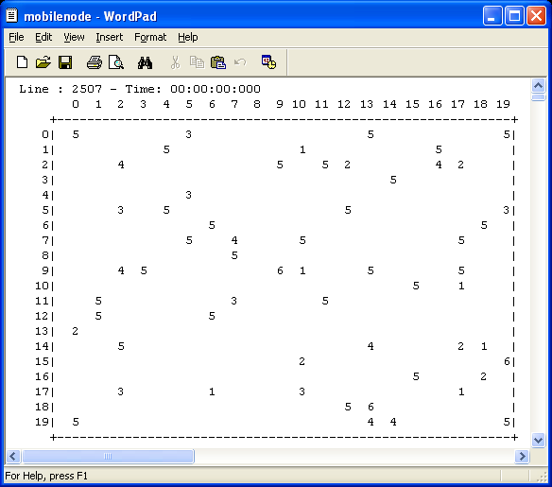
Figure 3: Initial layout of nodes and base stations at mobility plane.
TEST-3: Collision between static and mobile nodes at edge cells: 4 mobile nodes are located at edges (13,0,0), 19,13,0), (5,19,0) and (0,5,0) with directions 2, 4, 3 and 3 respectively. And 4 static nodes are located on their ways at (12,1,0), (18,2,0), (6,18,0) and (1,4,0). These mobile nodes should change their directions right away in order to avoid collision with static nodes.
TEST-4: Collision between static and mobile nodes at inner cells: A static node is located at (5,4,0) which is on the way of mobile node at (4,5,0) with direction 3. Also two additional mobile nodes are located at (1,1,0) and (7,7,0) with direction 1 and 4 respectively, and two static nodes on their ways at (2,11,0) and (6,6,0). Mobile nodes are expected to reverse their directions right away, in order to avoid collision with static nodes.
TEST-5: Collision between two mobile nodes at inner cells: Two mobile nodes located at (4,5,0) and (0,5,0) will face a collision scenario after their second move. Also another scenario is created between nodes located at (15,10,0) and (14,13,0) after their second move.
TEST-6: Collision between mobile nodes and base station at inner cells: Two mobile nodes located at (7,7,0) and (11,7,0) will face a collision scenario with base station located at (9,9,0), after their second move.

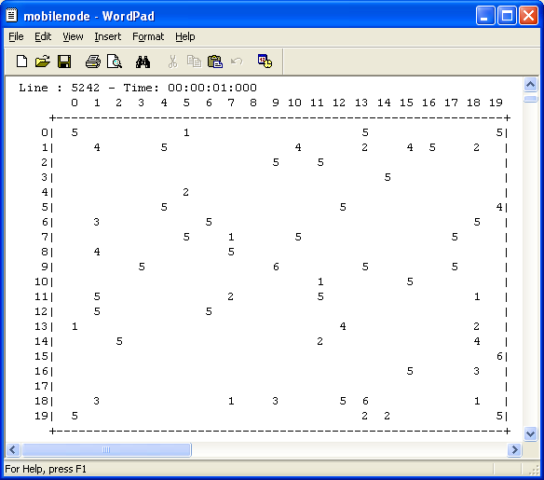
Figure 4: Test results after first move of mobile nodes at Time:00:00:01:000.
TEST-7: Collision between mobile nodes and base stations at edge cells: Two mobile nodes located at (14,18,0) and (16,18,0) with directions 1 and 2 respectively, had to change their directions right away to prevent collision with the base station that is located at (15,19,0). Also another mobile node located at (19,14,0), should change its direction in order to not collide with base station located at (18,13,0).
Figure-4 shows the direction of nodes at Test-3, Test-4 and Test-7 before collision and Figure-5 shows the reversed direction of these nodes in order to prevent collision.

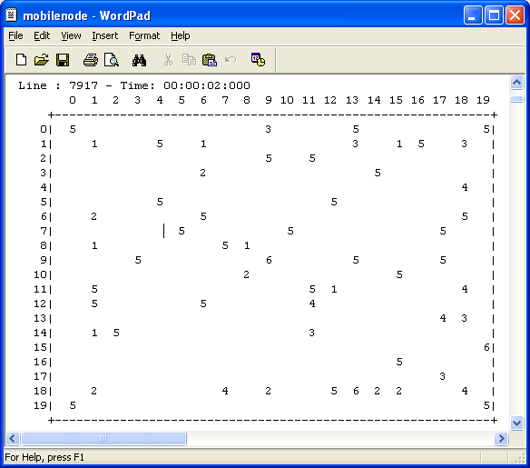
Figure 5: Test results after second move of mobile nodes at Time:00:00:02:000.

Figure-5 shows the direction of nodes at Test-1, Test-2, Test-5 and Test-6 before collision and Figure-6 shows the reversed direction of these nodes in order to prevent collision.

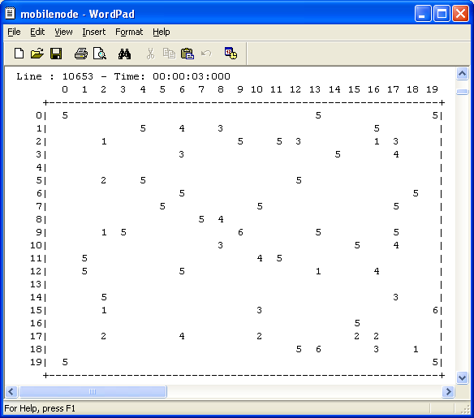
Figure 6: Test results after third move of mobile nodes at Time:00:00:03:000.

TEST-8: Collision between two mobile nodes at corner cells: Different scenarios are prepared initially as shown in Figure-7, by locating mobile nodes at (1,1,0), (3,1,0), (16,1,0), (18,1,0), 18,16,1), (18,18,0), (1,18,0) and (3,18,0) with directions, 4, 4, 3, 3, 1, 1, 2, and 2 respectively.
Figure-8 shows the direction of mobile nodes before the collision. Figure-9 shows the change in direction of these nodes in order to avoid collision.
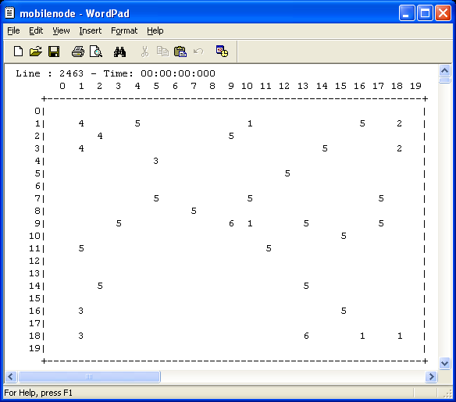
Figure-7: Initial layout for CA of mobile nodes at corner cells at Time:00:00:00:000.
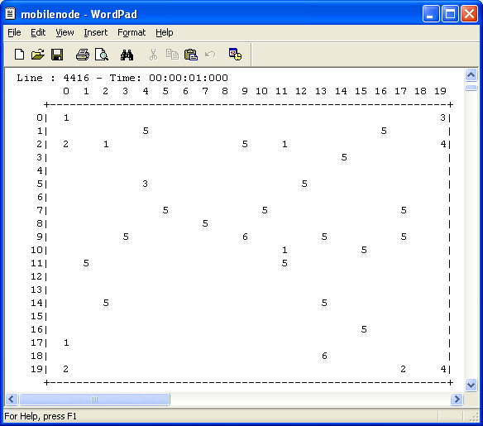
Figure-8 Test results after first move of mobile nodes at Time:00:00:01:000.
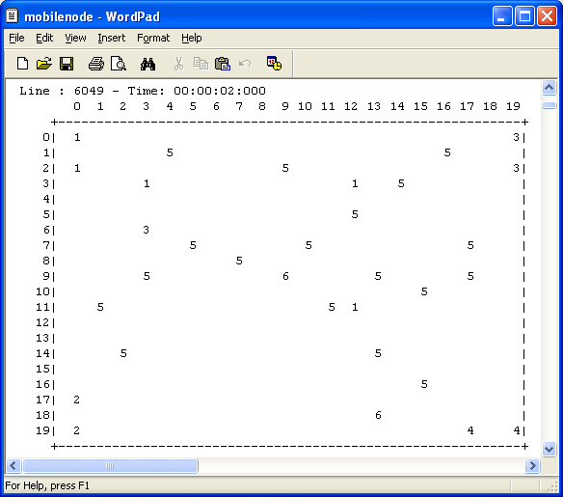

Figure-9: Test results after second move of mobile nodes at Time:00:00:02:000.

When cells are initialized with values that are different than 0,1,2,3,4,5, and 6, the simulator recognized that and gave an error message.

PLANE-1: HOP COUNT PLANE.
Both static and mobile nodes are used. There is no limit on the number of static and mobile nodes or base stations. Also they can be placed anywhere at mobility plane.
It is expected each static or mobile node to find out how many hops away the base station is. So first the nodes in the neighborhood of the base station will update their states to 10 at hop count plane. Then the nodes in the neighborhood of nodes with state 10, will update their states to 20 and so on. As mobile nodes moves especially close to the base station and surrounding static nodes, it is possible to see, how mobile node changes its state.
The initial layout is given in Figure-10. There are:
- 2 base stations with value 6.
- 22 static nodes with value 5.
- 1 mobile node with value 1 (moving in south east direction).
- 1 mobile node with value 2 (moving in north east direction).
- 1 mobile node with value 3 (moving in south west direction).
- 1 mobile node with value 4 (moving in north west direction).
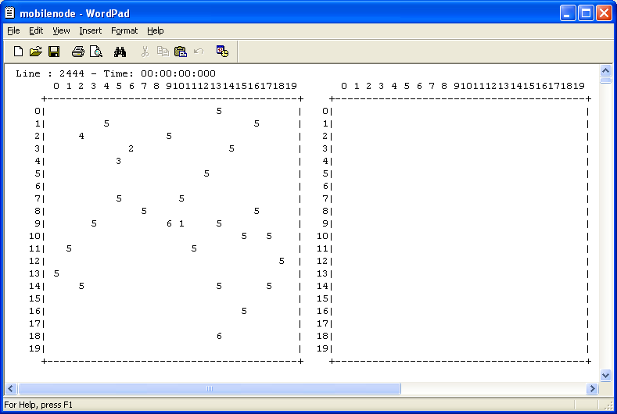
Figure-10: Initial layout of nodes and base stations at mobility plane.

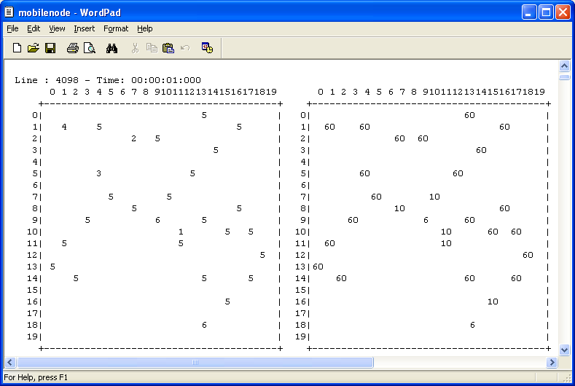
Figure-11: Simulation Output at Time:00:00:01:000.
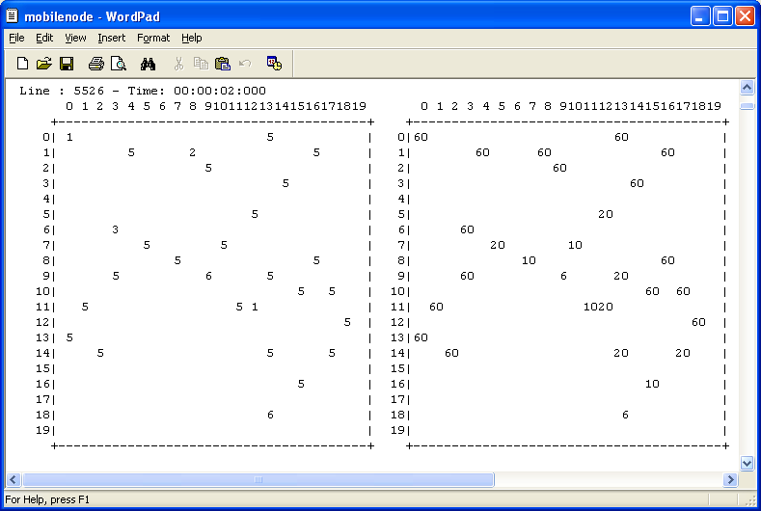
Figure-12: Simulation Outputs at Time:00:00:02:000.
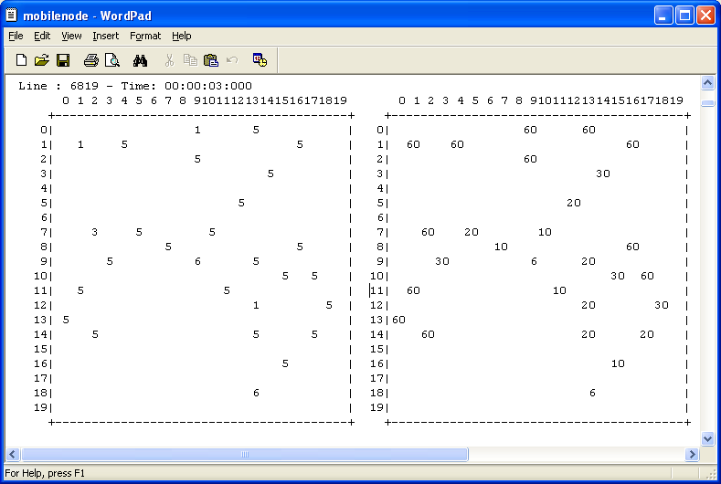
Figure-13: Simulation Outputs at Time:00:00:03:000.
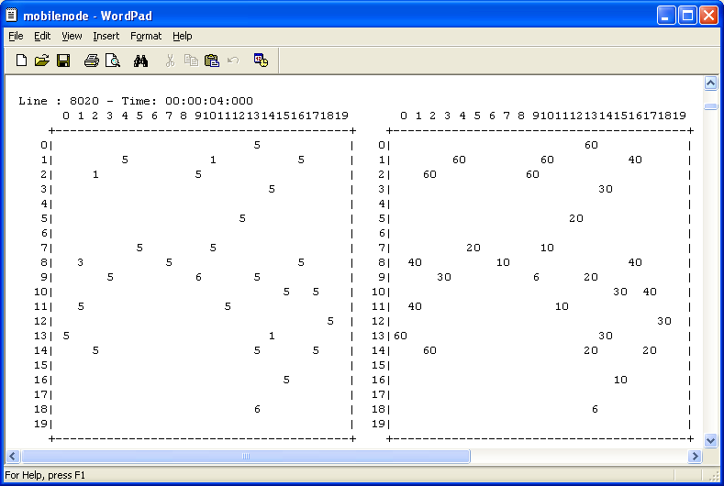
Figure-14: Simulation Outputs at Time:00:00:04:000.
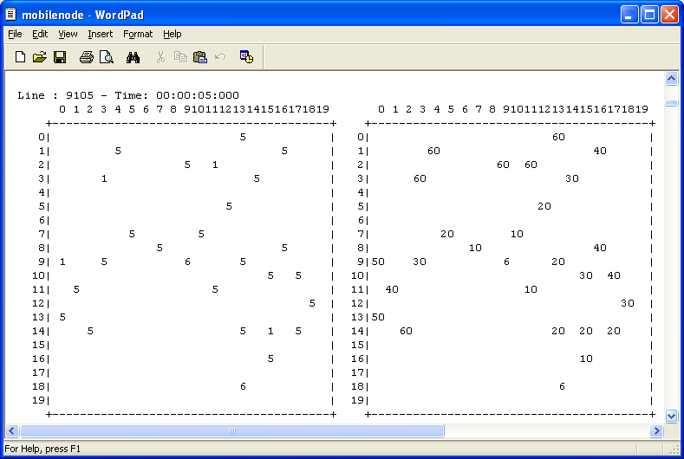
Figure-15: Simulation Outputs at Time:00:00:05:000.
When preparing the initial layout of nodes, loops are created between nodes and base stations, in order to observe if the particular node can choose the path with lowest number of hop counts.
For example at Figure-15, static nodes at (8,16,0) has two paths to base station at (9,9,0). And this node determines its hop count value as 40 by choosing the neighbor with value 30 but not 40.
As another example, node at (12,18,0) has paths to both base stations and choose the one with lowest op count and set its value as 30.
Figure-11, shows that all the nodes in the neighborhood of base stations has value 10, that is 1 hop away from the base station. Figure-12 shows the ones in the neighborhood of nodes with value 10, and their hop count values are 20. Figure-13, Figure-14 and Figure-15 show the ones that are respectively 3, 4 and 5 hops away from the base station.
After the 5’th run all static nodes will determine their distance form the base station and these values will not change after, but only if a mobile node creates a closer hop count path temporarily.

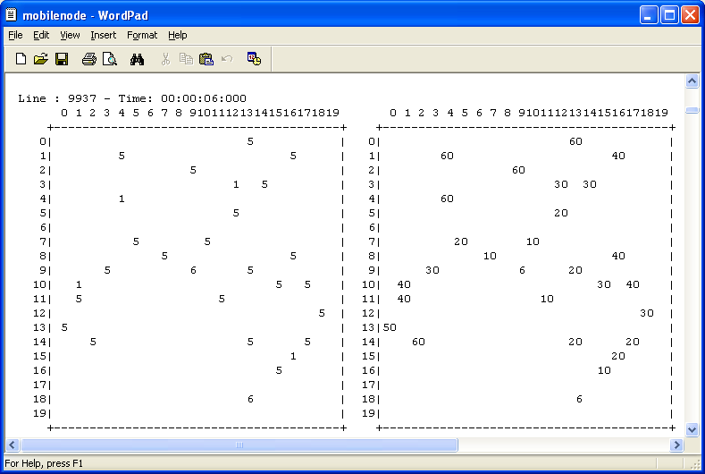
Figure-16: Simulation Outputs at Time:00:00:06:000.
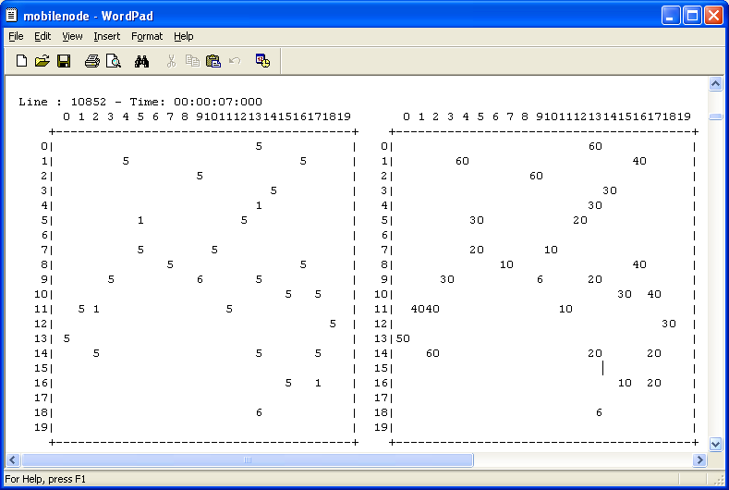
Figure-17: Simulation Outputs at Time:00:00:07:000.
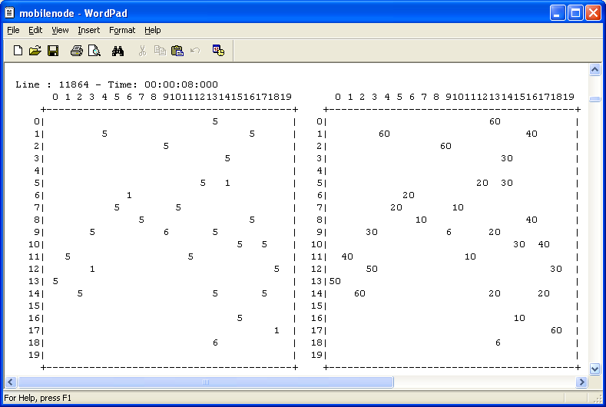
Figure-18: Simulation Outputs at Time:00:00:08:000.
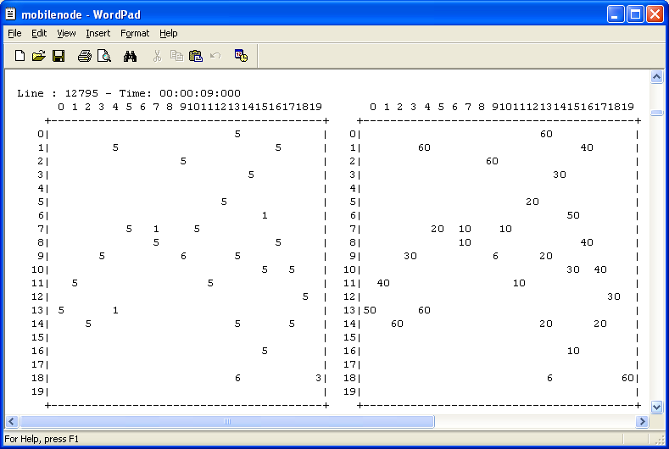
Figure-19: Simulation Outputs at Time:00:00:09:000.
As it is seen from Figure-11 to Figure-19, mobile nodes updates their hop count values correctly as they move around static nodes.
But now let us look at the scenarios in Figure-20 and Figure-21, by looking into mobile nodes at (19,10,0) and (17,12,0).
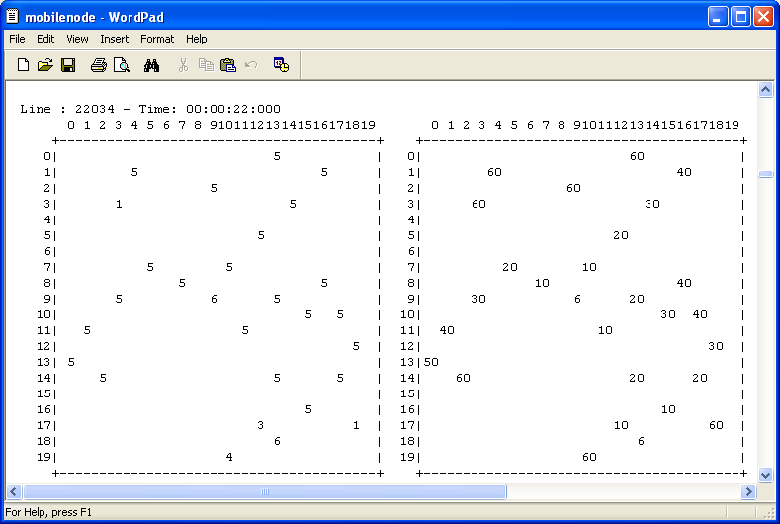
Figure-20: Simulation Outputs at Time:00:00:22:000.
As the one with direction 3 and hop count value 10 comes closer to other mobile node at (19,10,0), it is expected second one to update its hop count value to 20. But as it is seen from Figure-20 and Figure-21, this is not the case.
This is an interesting situation because mobile nodes are not moving closer to each other, but keeping their distance constant. If they had moved closer to each other, they would be able to update their states correctly as far as the cells they are moving in are aware of their existence (that is within each other’s neighborhood). On the other hand, in the above scenario, the one with value 60 moves to a cell, which is not aware of the node with value 10. So, the node could not update its hop count value accordingly.
In real life, this kind of transients when mobile nodes move in or out at the edges of each other’s neighborhood, the same kind of problem will be observed. But, it will be negligible compared the overall system performance.
If hop count plane rules execute much faster than mobility plane rules, as in the case of real life; these transients will be only one delay unit of hop count plane. That means transients will be much shorter and mobile nodes will be able to update their states for the rest of the time (the difference between mobility plane delay and hop count delay).
Another way to make transients negligible is that, increasing the neighborhood size as in the case of real life. In that case, once a mobile node enters into another’s neighborhood, it will stay there for a while, which means that they will have time to update their new states according to each other.
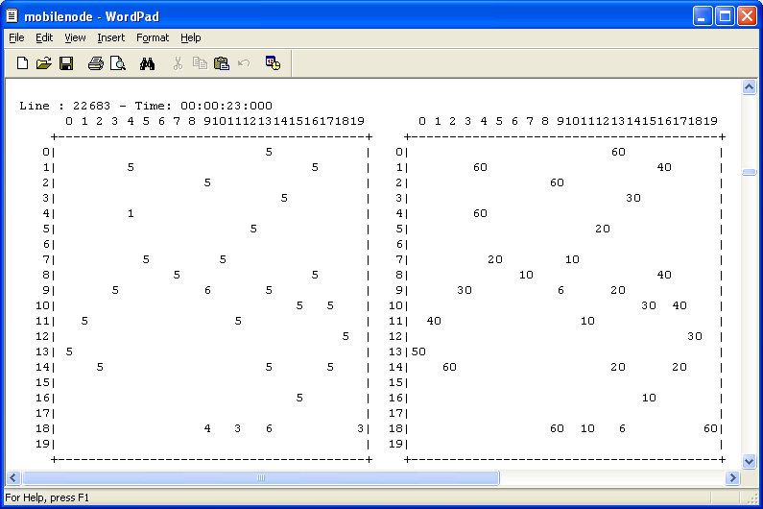
Figure-21: Simulation Outputs at Time:00:00:23:000.
As it will be seen from all figures, once a mobile node moves in mobility plane, the cell at hop count plane, which is just above the cell that mobile node moved in, updates its hop count value accordingly. But, actually the cell at hop count plane, will not be aware of that movement after one delay time unit. But once the cell learns about it after one delay unit, the mobile node will move again and the hop count value will not be valid again. In order to solve this problem, a trick is applied. Hop count plane cells does all job that mobility plane does, in order to predict the next value at mobility plane (without waiting mobility plane cells output the change), to update the hop count plane value immediately as the change occurs. As this trick solves our problem and works properly, it is not considered as a scalable solution in the long run. Because then any change in the mobility plane rules, requires a change in the hop count plane rules.

PLANE-2: COVERAGE PLANE.
The initial layout as in Figure-10 will be used for coverage plane also. As nodes in hop count plane finds out their distance from the base station, coverage plane will update the coverage information. Basically, any cell which is in the neighborhood of base station or another node with hop count value less than 50 will be within the coverage area (can reach to the base station) and will have a value 7.
Graphical 2D Modeler outputs showing 3 plane values are given in Appendix-A for different coverage areas. Here normal simulation outputs for coverage plane and hop count plane will be explained in the following figures.
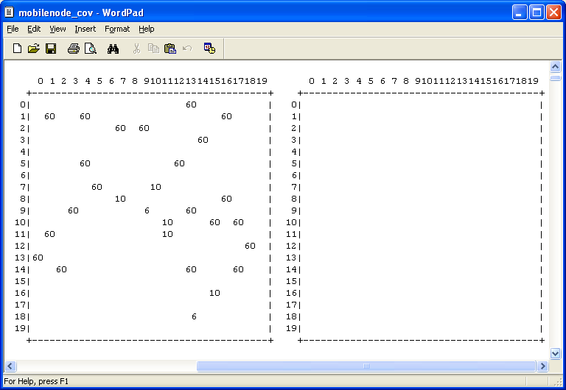
Figure-22: Simulation Outputs at Time:00:00:01:000.
As it can be seen from Figure-22 up to Figure-27, as hop count plane updated the hop count values of the nodes, coverage plane updated itself accordingly. Static nodes determined the main shape of the coverage plane once all determined their hop count values. After then only movement of mobile nodes will cause changes in the coverage plane.
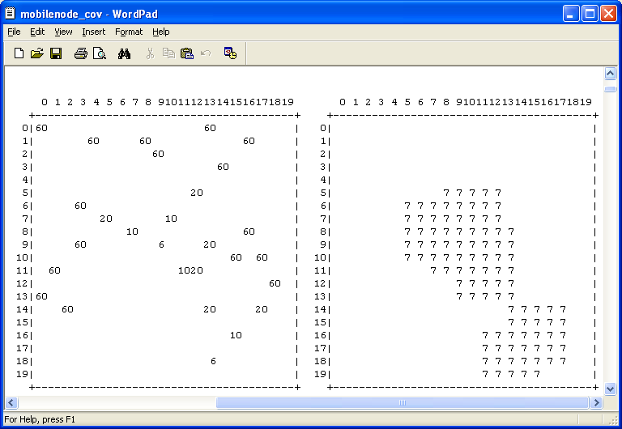
Figure-23: Simulation Outputs at Time:00:00:02:000.
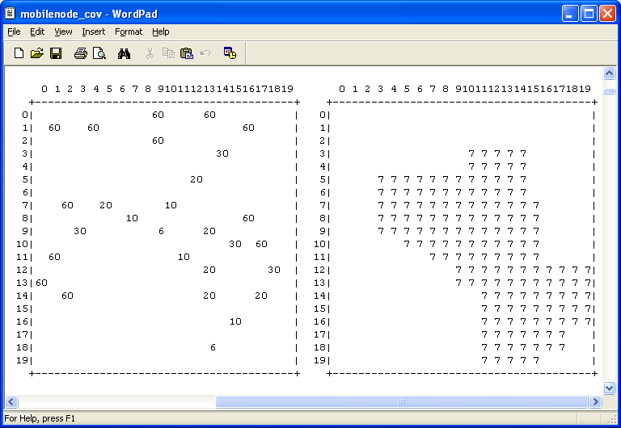
Figure-24: Simulation Outputs at Time:00:00:03:000.
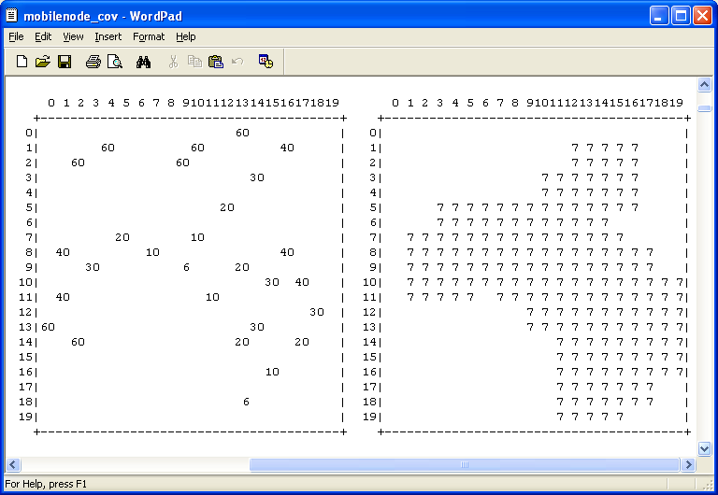
Figure-25: Simulation Outputs at Time:00:00:04:000.
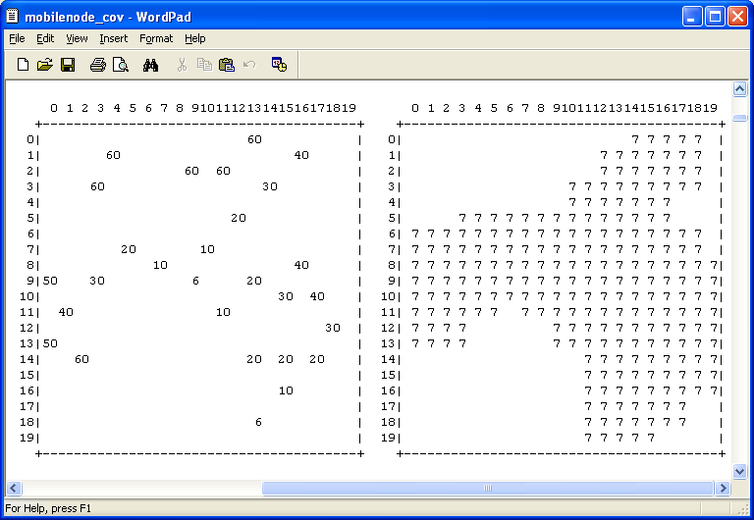
Figure-26: Simulation Outputs at Time:00:00:05:000.
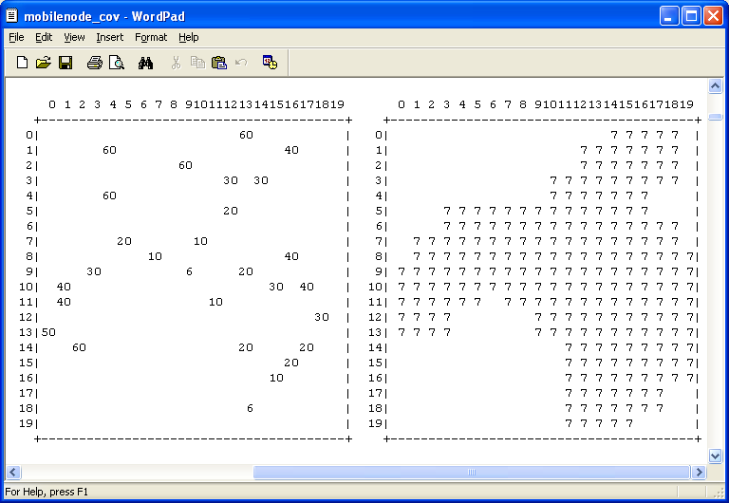
Figure-27: Simulation Outputs at Time:00:00:06:000.
The coverage plane values in these figures are showing the coverage plane values for the hop count plane values of one delay unit ago. For example, coverage plane values at Time:00:00:06:000 are the corresponding values for hop count plane values at Time:00:00:05:000. Mainly because coverage plane cells can update their values after hop count plane cells outputs their values.
Figure-28 and Figure-29 shows, how mobile nodes at (6,6,1) and (18,11,1) make changes in the coverage plane. Coverage plane at Figure-29 is the corresponding one for hop count plane layout as shown in Figure-28.

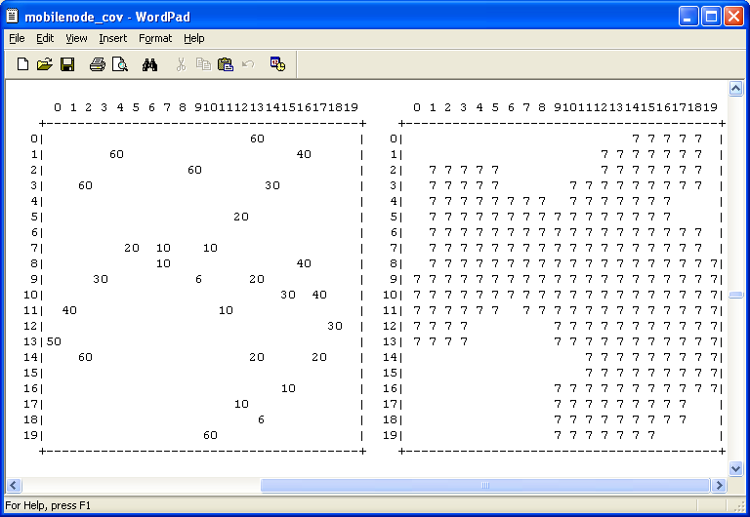
Figure-28: Simulation Outputs at Time:00:00:60:000.
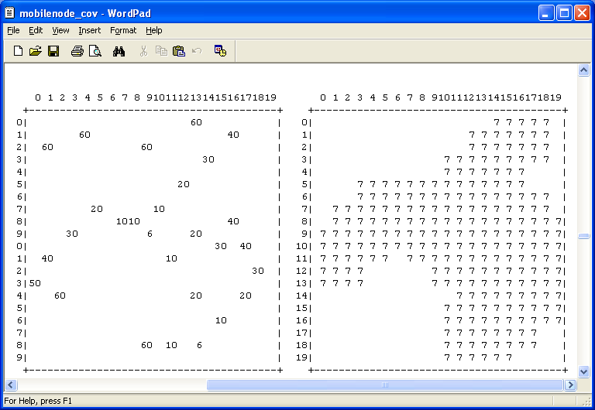
Figure-29: Simulation Outputs at Time:00:00:61:000.

5. ANALYSIS OF TEST RESULTS.
Analysis of test results, are explained in the previous section where tests are results are given for each plane. Here a summary will be made.
Collision avoidance techniques are tested for collision scenarios between static and mobile nodes or between two mobile nodes or between base stations and mobile nodes. Also these tests are repeated at the zones where different mobility rules apply. A mobile node, that is planning to occupy an empty cell, should also check if there are other nodes approaching to the same cell from other directions. According to the test results, it has been seen that, whenever a collision is about to happen, mobile nodes reverse their direction, in order to avoid collision successfully.
It has seen that both mobile nodes and static nodes update their hop count states according to their neighborhood values. Loops are made between nodes and base stations during the initial layout of nodes. And nodes successfully determined the shortest path. When two mobile nodes encounter and update their values according to each other, temporary transients do occur. This is also the case in real networks and by increasing the routing update rate compared with mobility rate, also by increasing the neighborhood size can be minimized. As a mobile node moves forward, the new cell recognizes that it is occupied right away and does not wait for mobility plane, to update its new value. Also the cell that mobile node moved out, knows right away that, it is not occupied any more and returns its hop count state back to 0.
Coverage plane rules are also tested. It has been seen that the static nodes determines the static shape of the coverage plane within 6 time units. On the other hand, mobile nodes are dynamic and as mobile nodes moves around and update their hop count values, coverage plane changes dynamically. Also, from the main shape of the coverage plane, it can be easily seen which parts of the plane are usually out of coverage area. As the node population increases at these areas that is demand increases, network engineers can decide to put extra base stations in these areas.

6. CONCLUSIONS.
An ad-hoc wireless mobile network, which consists of mobile and static nodes and base stations, is implemented using Cell DEVS technique. The model shows each node’s distance form the base station in terms of hop counts and also the total coverage area.
In Cell DEVS, each cell determines its next value according to the outputs of cells, including itself, in its neighborhood. Our model works correctly and transients occur when mobile nodes move in or out of a neighborhood. This is the characteristic of wireless mobile ad-hoc networks and happens in real life also. But in real life, these transients will be negligible, compared with overall network performance, especially when routing update rate is much greater than mobility rate. So our model can be modified in the future by using larger neighborhood and/or assigning greater transport delays to mobility plane (plane#0) than hop count plane (plane#1).
As future work, the model can be improved more by adding extra features. For example, each cell may be assigned an index showing the wireless transmission media rate. As an example, there will be more reflections and consequently attenuation in the wireless signal in urban areas. It is also possible to insert physical objects, such as mountains, high-rise buildings etc. in the model. Altitude is another factor that can be assigned to each cell to determine wireless transmission index.
This ad-hoc model does not consider the user traffic between nodes and base stations. In order to implement traffic, each node should have a Node-ID, which uniquely identifies itself from the others. This feature can be the next step in implementing traffic between nodes.
Cell DEVS is a technique that successfully works for models where each cell behaves with the same rules; such as heat diffusion. Although the model that has been implemented in this project seems to be a very basic one, especially implementing model on mobility concept, ended up with a very complex model with very complicated rules. So there is a need for more functions in Cell DEVS environment to help easier and simpler model development. As an example, statecount() function can be modified to select which plane values to check instead of all neighborhood which may include cells in more than one plane. This will help us to be able to use the same state values for different state variables (assuming that each plane implements a different state variable).
Network engineers can use coverage plane information to decide on where to put extra base stations if there is a demand, that is if node population increases in areas out of coverage and some of the nodes in these areas which are more than 5 hops away from the base station can not reach to the base station.

APPENDIX-A: SAMPLE MODELLER OUTPUTS

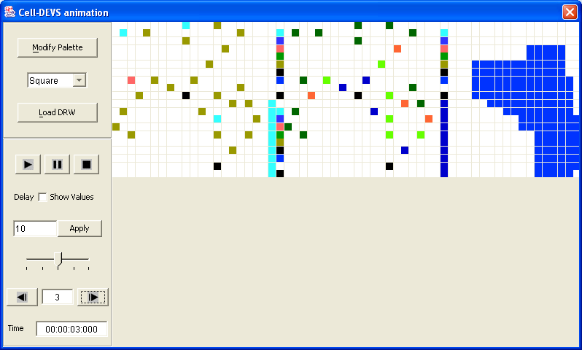
Figure-A1: Modeler Display at Time:00:00:03:000.

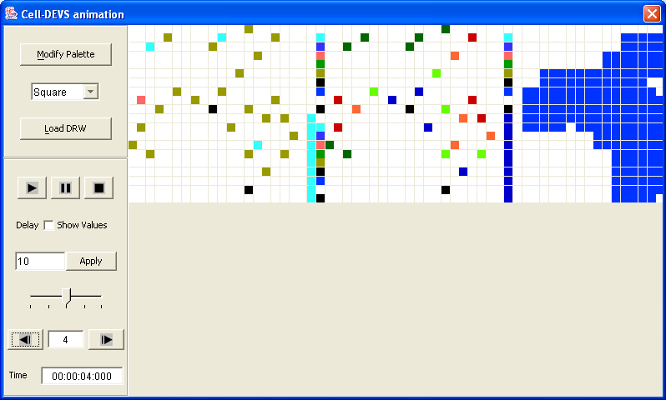
Figure-A2: Modeler Display at Time:00:00:04:000.
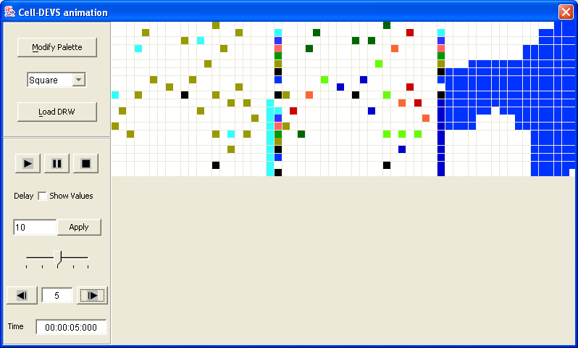
Figure-A3: Modeler Display at Time:00:00:05:000.

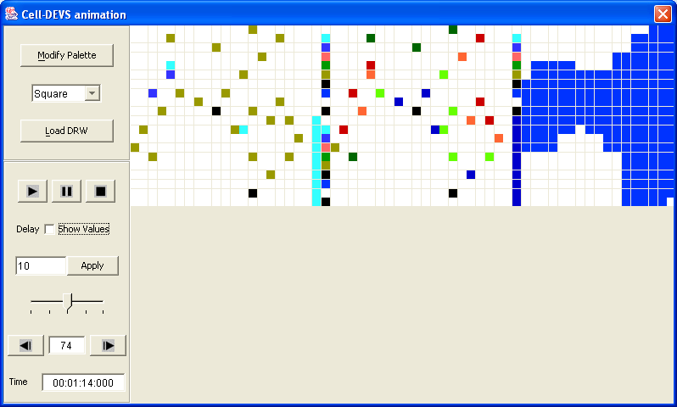
Figure-A4: Modeler Display at Time:00:01:14:000.

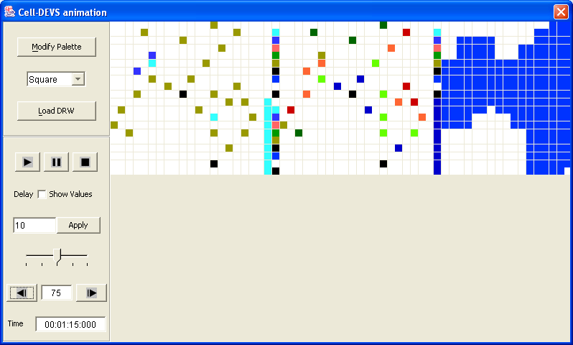
Figure-A5: Modeler Display at Time:00:01:15:000.

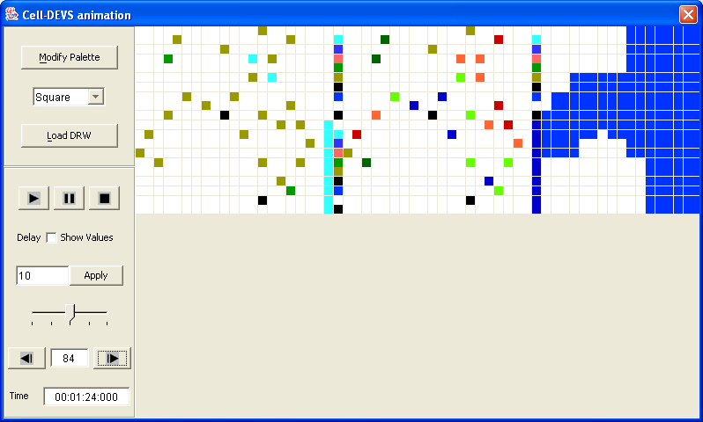
Figure-A6: Modeler Display at Time:00:01:24:000.

