A Cell-DEVS Model Of A Cascade Leading To Vesicle Docking
In A Presynaptic Nerve Terminal

Roderick S. Bain
Carleton University, Ottawa, Canada

Keywords: Discrete event simulation, Cell-DEVS, presynaptic nerve terminal, cell model

Abstract

Transmission of signals at nerve cell (neuron) terminals requires a complex sequence of interactions. One result is the docking of vesicles containing neurotransmitter at a specialized region of the cell membrane called the active zone. In a simple two-dimensional Cell-DEVS model, a fundamental sequence has been modeled which includes (i) opening of calcium ion channels, (ii) activation of calmodulin by calcium ions, (iii) activation of calcium-calmodulin-dependent protein kinase II by activated calmodulin, (iv) phosphorylation of synapsin by activated kinase and (v) release of synaptic vesicles held in a cluster by synapsin. The freed vesicles are then able to drift to the active zone. Though greatly simplified, the model shows the basic effect of a sequence of events leading to vesicle docking at the active zone.

INTRODUCTION
Transmission of signals from neuron to neuron is an extremely complex process (for reviews see Südhof [2004] or Rizzoli and Betz [2005]). There are many types of junctions between neurons. One example is a hippocampal bouton (terminal in a neuron in the hippocampus region of the brain) which is a protrusion from one neuron paired across a synaptic cleft to a postsynaptic density.

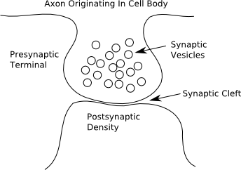

Figure 1 Simplified Illustration Of A Hippocampal Bouton And Postsynaptic Density

These boutons are vanishingly small, i.e., about 1 μm in diameter [Fernández-Alfonso and Ryan 2006]. During transmission, the electrochemical signal arriving at the bouton causes the vesicles to fuse to the cell membrane. After fusing, they release their stored chemical neurotransmitters which are detected by the postsynaptic density of a receiving neuron, and a new signal is generated in the receiving neuron.

The most basic constituents for this type of terminal are shown in Figure 2.

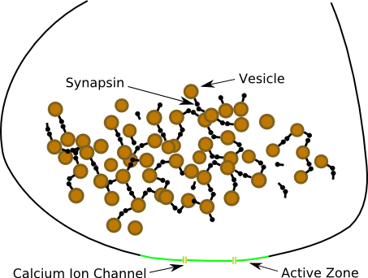

Figure 2 Components Of A Presynaptic Nerve Terminal

The synaptic vesicles (circles) are held in a cluster by a protein called synapsin (ball-and-stick) near a specialized area of the cell membrane called the active zone. Embedded in the membrane, within and near to the active zone, are specialized channels that can allow the passage of calcium ions. The activation of one neuron by another occurs when
1. an electrochemical signal (action potential) reaches the nerve terminal
2. the calcium ion channels are opened
3. calcium ions enter and activate a small protein called calmodulin (CaM)
4. the activated calmodulin interacts with a larger protein called calcium-calmodulin-dependent protein kinase II (CaMKII) and causes a conformational change which allows the CaMKII to phosphorylate (add a phosphate group to) the synapsin
5. the phosphorylated synapsin has a much lower affinity for vesicles than the unphosphorylated form, so vesicles are freed to move to the active zone
6. vesicles dock at the active zone, subsequently fuse with the membrane and consequently release their encapsulated neurotransmitter (a process called exocytosis).

Exocytosis depends directly on the influx of calcium ions as well. For an animation and supporting material see, respectively, http://thierry.galli.free.fr/video.html and Galli and Haucke [2001].

This sequence is illustrated in Figure 3 (see Turner et al. [1999] for a similar diagram).

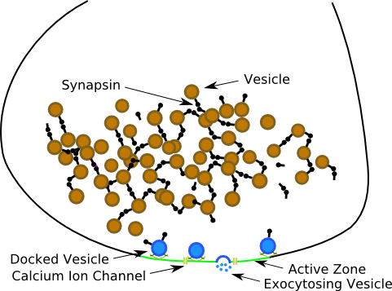

Figure 3 Docking And Exocytosis At A Nerve Terminal

The goal of the Cell-DEVS simulation described here was to model the sequence of events leading up to and including vesicle fusion based on a single action potential. While greatly simplified in terms of components and kinetics (see, for example, Holmes [2000] for more detailed kinetics), the simulation does show a cascade that leads to docking.

2. MODEL DESCRIPTION

The Cell-DEVS framework consists of five layers each with a 30×30 grid of cells.

The main layer (layer 0 in Cell-DEVS terminology) represents the nerve terminal; see Figure 4. The perimeter of the main layer is the cell wall which is composed of three parts: (i) cell membrane, (ii) active zone and (iii) calcium ion channels. Within the perimeter are five kinds of cells: fluid, vesicles, synapsins, CaMKIIs and CaMs. Initially there are synapsins and vesicles joined in a cluster. In addition two vesicles are docked at the active zone. There are 50 CaMs and 50 CaMKIIs placed randomly with no overlapping.

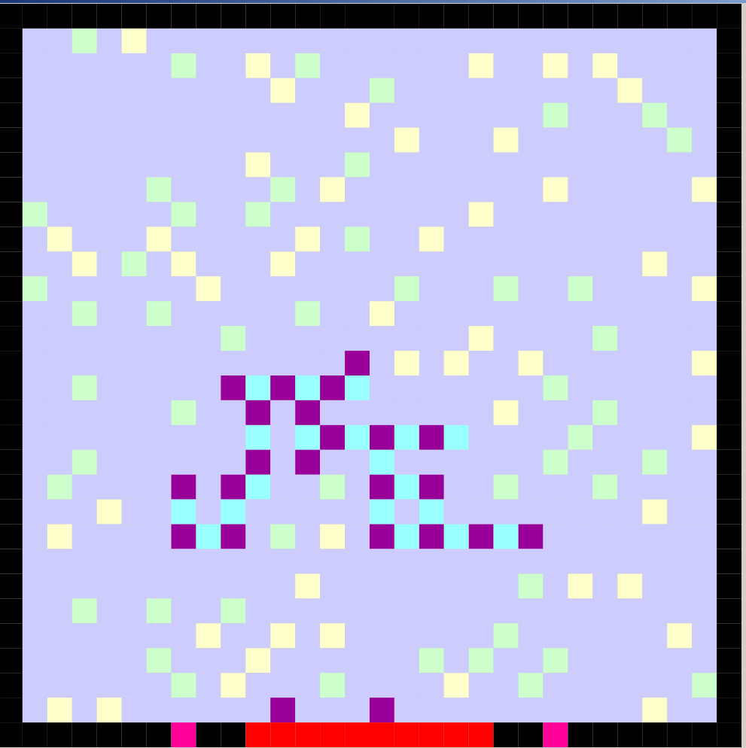

Figure 4 Initial Setup For Simulation
Cell Wall
Active Zone
Calcium Ion Channel
Fluid
Calmodulin (CaM)
Calcium-calmodulin dependent protein kinase II (CaMKII)
Synapsin
Vesicle
An extended von Neumann neighborhood is used. For the main layer it is of a form that allows the cell to see what will happen at the adjacent cell to the east, north, west and south. The cells along diagonals do not affect the central cell directly, i.e., particles only move west, south, east and north, never diagonally. Similarly, particles only interact with other particles that are directly west, south, east or north.

Figure 5 Extended von Neumann Neighborhood Used In Main Layer
The basis of the simulation is particles in motion. Each particle possesses two attributes namely its particle type and its direction of movement. In this scheme 1x is a vesicle, 2x is a synapsin, 3x is a CaM and 4x is a CaMKII. Index x can be 1 (moving west), 2 (moving south), 3 (moving east), 4 (moving north) or 9 (stationary). So, for example, 32 is a south moving CaM and 19 is a stationary vesicle. In addition, when a CaM is activated its value is increased by 0.4, so 33.4 would be an east-moving activated CaM. This seemingly awkward notation reflects the fact that it really takes 4 calcium ions to activate a CaM. Correspondingly, an activated CaMKII would have a value such as 41.4 because an activated CaM has bonded to a CaMKII.

When two or more particles appear to meet a decision must be made as to which one gets precedence in terms of movement over the others (called winning at a cell). For example, consider the central fluid cell in the following scenario.
Before
Possible Configuration After
Figure 6 Example Of A Nonreacting Interaction Where The Cell From East Wins
Fluid
CaM
CaMKII
There is an approaching CaM from the east and an approaching CaMKII from the north. The CaM to the west is not approaching and there is fluid to the south. The central fluid could potentially become a CaM or a CaMKII. If the random number at layer 1 corresponding to the CaM, namely cell(0,1,1), is less than that corresponding to the CaMKII, namely cell(-1,0,1), then the fluid becomes a CaM and the current CaM cell becomes fluid (from east wins over north). The CaMKII cell would continue to be a CaMKII but now with equal probability of heading in one of the four possible directions, which happens to be west here.

The third layer is the calcium ion concentration. Only the non-boundary cells are allowed to have calcium ions. The distribution of calcium depends on source cells and averaging of neighborhoods for dispersion; see Appendix A.

The fourth and fifth layer are grids of U(0,1) values. These are needed for making decisions about reactions between activated CaM and CaMKII, and between activated CaMKII and synapsin. There are two questions: is there a successful interaction and, if so, between which two particles. Consider the possibilities if the cell to the north (CaMKII) is the winner and hence the central fluid becomes a CaMKII.

Possible Configuration After
Before
Figure 7 Example Of A Successful Reaction

Fluid
Activated CaM
CaMKII
Activated CaMKII
Two activated CaMs are approaching. The decisions are whether one of the two approaching activated CaMs will activate the CaMKII, and if so, which one will it be. Say the answers are “Yes” using layer 3, and “the one approaching from the east” using layer 4. Then the CaMKII changes colour, the eastern activated CaM disappears as it is now attached to the CaMKII, and the western activated CaM remains but can be heading in any direction. The southern fluid could have been occupied but is not in this case.

In summary, the layers are

All components except calcium
U(0,1) for particle collision decision
Calcium amount
U(0,1) for whether reaction occurs
U(0,1) which cells react

Figure 8 Summary Of The Function Of Each Layer

3. SIMULATION

Starting the simulation sets the CaMs and CaMKIIs in motion. Motion rules prescribe that any particle will continue in the same direction until it encounters an obstacle. When it encounters another particle and it does not win, its subsequent direction will be chosen randomly from any of the four possibilities. When a particle encounters a wall there is an 85% probability that it will bounce in the opposite direction. This is to avoid having the particles pile up along the walls. This means that each of the three other directions has a 5% probability.

Particles never overlap and, except for vesicles, no type has any precedence. The directions allowed for vesicles are restricted to force the vesicles to migrate to the vicinity of the active zone. On encounter, vesicles have priority over everything else. Once a vesicle docks it cannot move. If a vesicle is docked and the calcium ion content is high, then it will fuse with the active zone and disappear.

When the action potential arrives the cell membrane changes from black to yellow. This is just for display; it is the opening of the calcium ion channels, which occurs after a time lag from the action potential arrival, that is functionally important.

When the calcium ion channels do open, to simulate the influx of ions the cell immediately adjacent to each channel randomly increments its calcium ion content by 0, 1, 2, 3, 4 or 5 per time step, and its immediate neighbors to the east and west are incremented by 0, 1, 2, 3 or 4. The spread of ions is achieved by averaging counts in the neighborhood. Every cell loses 0, 1, 2 or 3 ions each time step as long as the value remains nonnegative. When the channels are open the influx overwhelms the loss and two plumes arise.

One preset docked vesicle exocytoses almost immediately. This too is for effect only, namely to show that exocytosis requires calcium [Galli and Haucke, 2001; Meinrenken et al. 2003]. The other preset docked vesicle is further from the channels so it lingers.

When a CaM reaches a cell in layer 0 corresponding to a cell in layer 2 that has a calcium content greater than four, it becomes activated and its colour changes to a dark orange. When an activated CaM encounters a CaMKII there is a chance that the CaM will bind to and hence activate the CaMKII. If so the CaMKII becomes darker green and the CaM dark orange cell becomes fluid (see Figure 6).

If an activated CaMKII encounters a synapsin there it may phosphorylate the synapsin. The activated CaMKII remains so, but the synapsin changes to darker blue and becomes mobile. The final step in the cascade occurs when a vesicle is not adjacent to any stationary synapsins, then it too becomes mobile.

Arriving vesicles may exocytose if the calcium content is still high, but soon after the calcium ion channels close they merely dock or get trapped near the active zone.

4. RESULTS

Given the starting setup shown in Figure 4, the first change is the arrival of an action potential:

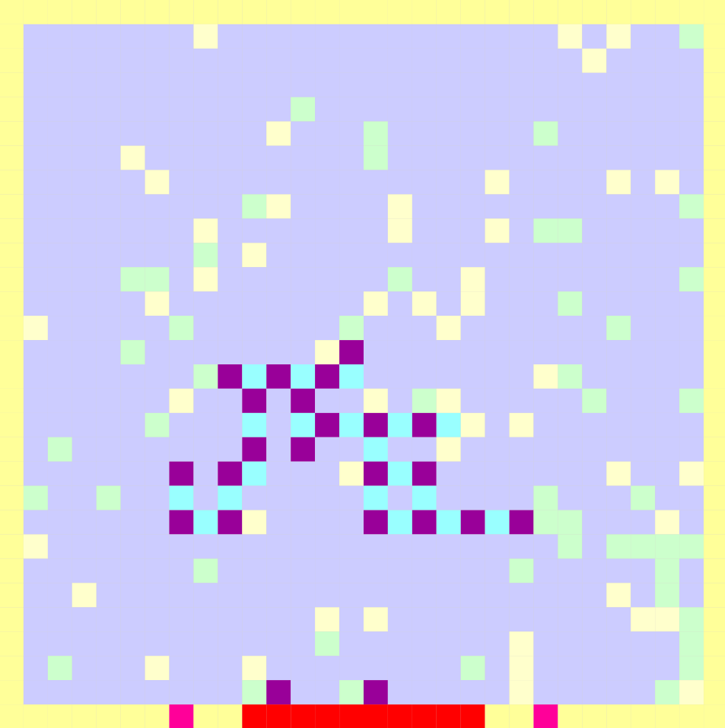

Figure 9 Arrival Of An Action Potential

The effect of the action potential is to turn the cell wall yellow. Nothing else is affected.

The cascade begins when the calcium ion channels open. The causes the influx of calcium ions. Figure 10 shows the calcium ion layer (this figure uses a separate colour scale):

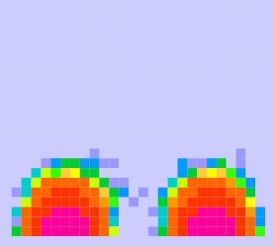

Figure 10 Calcium Ion Layer

Two plumes have arisen but they aren’t symmetric because of the stochastic nature of the creation of ions.
The presence of calcium shows in the main layer because CaMs turn dark orange and some CaMKIIs have been activated (now dark green);

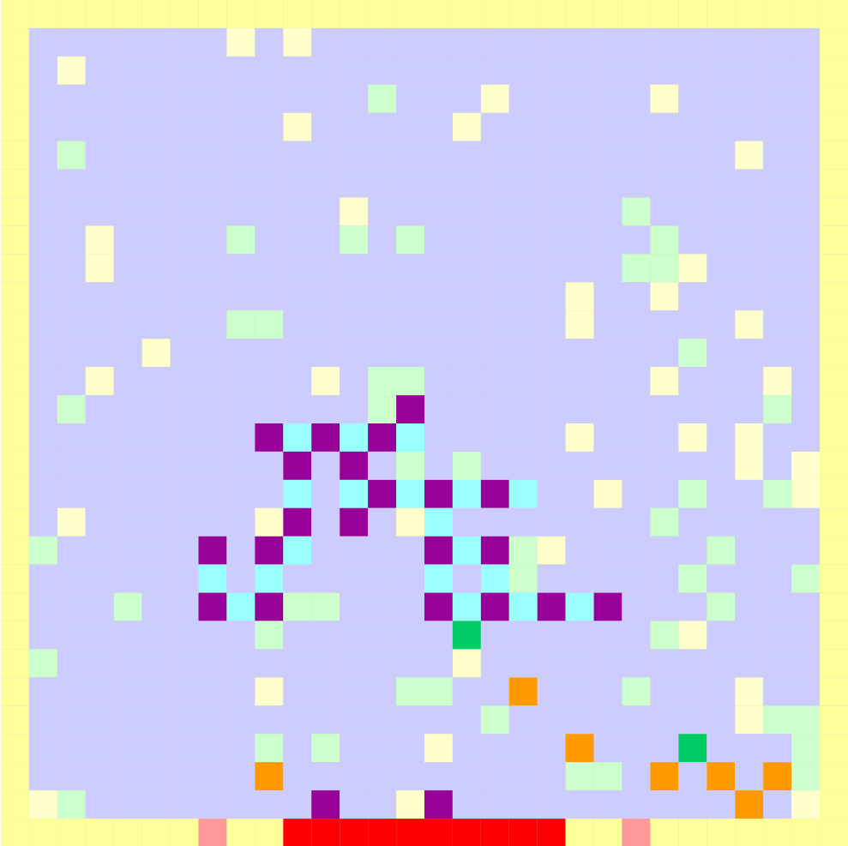

Figure 11 Activation Of CaM and CaMKII

The calcium also causes the leftmost docked vesicle to fuse:

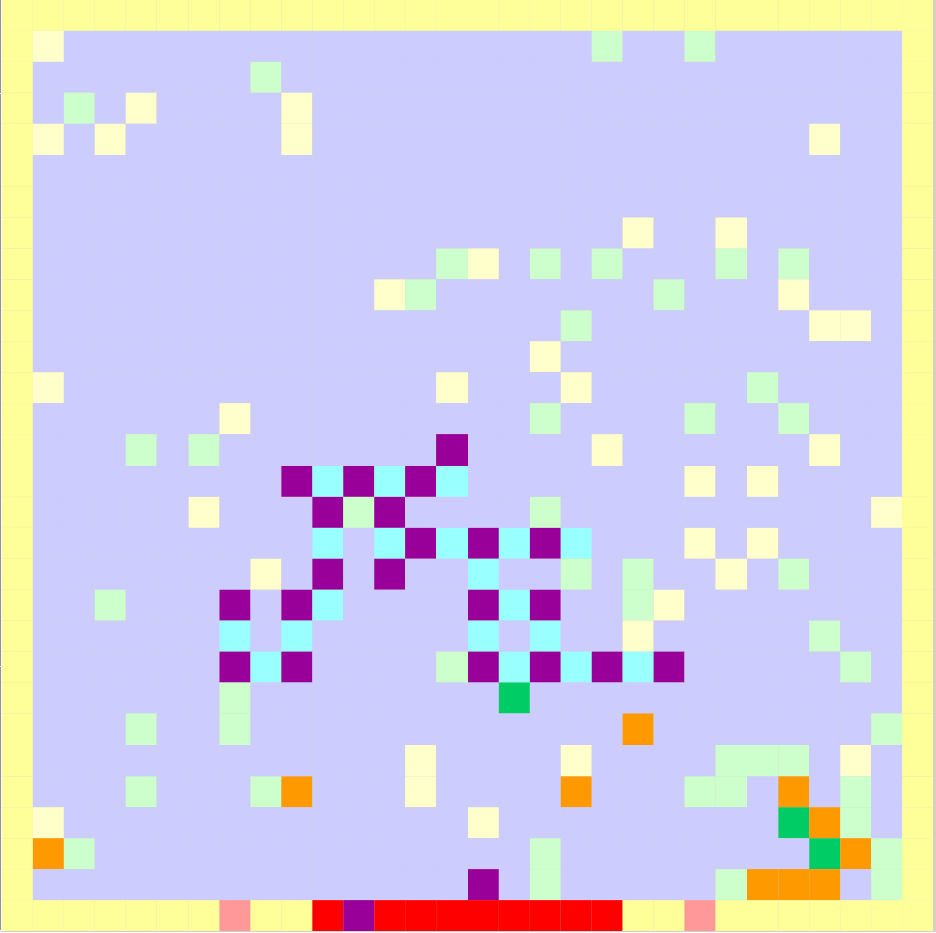

Figure 12 Fusing Of A Docked Vesicle

The activated CaMKIIs subsequently bump into the synapsins and change them to dark blue which represents phosphorylation:

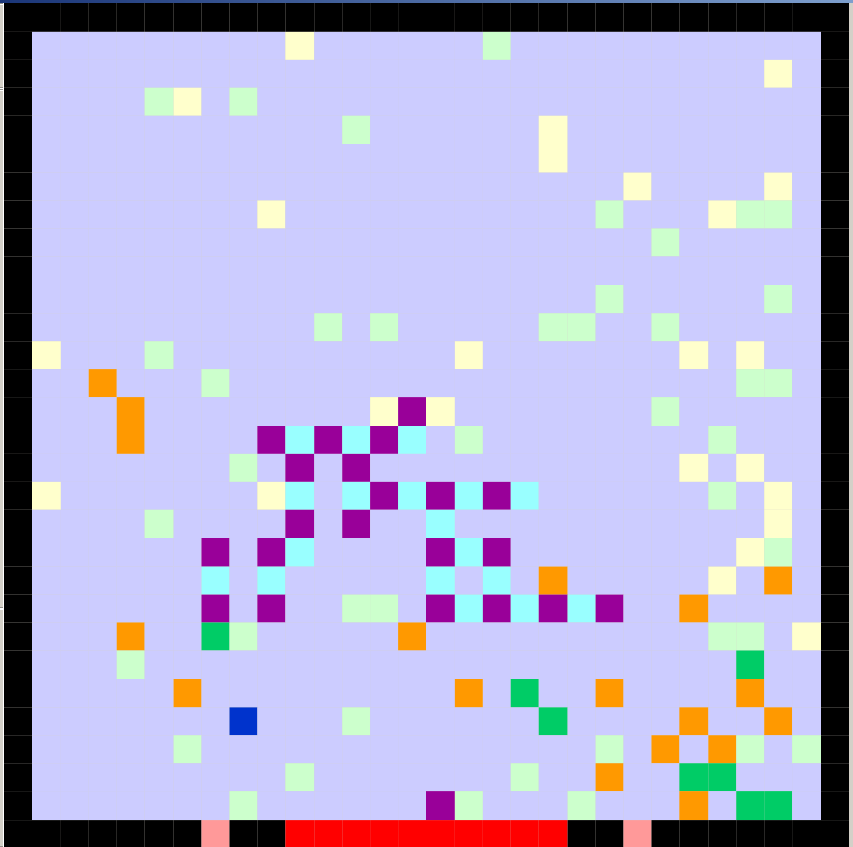

Figure 13 Phosphorylation Of Synapsin (Dark Blue)

Note that the action potential has passed (cell walls are black) but the calcium ion channels are still open as there is a slight time lag after the end of the action potential until they close. The movement of the synapsins frees the vesicles to drift to the active zone:

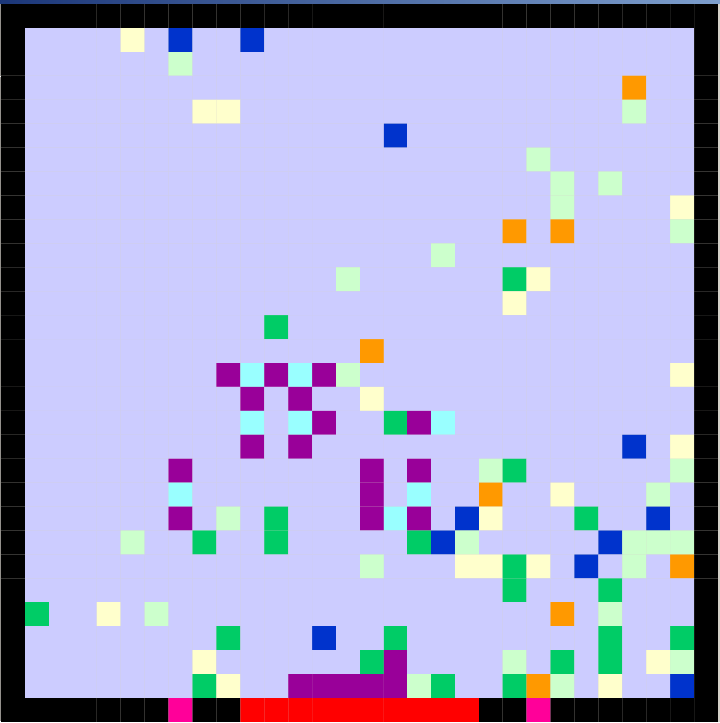

Figure 14 Docking Of Released Vesicles.
5. DISCUSSION

The objective of this simulation was to demonstrate the suitability of Cell-DEVS for modeling biochemical reactions in cells. Validation using experimental results was not attempted. Besides the obvious points that cells are three-dimensional and not square, some points for consideration are listed here:
1. All of the reactions discussed are, in fact, reversible. To implement this based on the current model, one could make several assumptions
(i) the sink for calcium ions is infinite, so activated CaM can spontaneously turn into nonactivated CaM by releasing the bound calcium
(ii) the source and sink for phosphate are both unlimited, so phosphorylated synapsin can spontaneously turn into dephosphorylated synapsin (in reality there are proteins called phosphatases that do this)
(iii) activated CaMKII can break into a CaMKII and an activated calmodulin
2. In the simulation every particle type moves with the same speed. This is not true in cells.
3. The real process is more complex than what is shown. For example, there is another cascade that can lead to phosphorylation of synapsin [Menegon et al. 2006] and there are many steps involved in the activation of CaMKII [Holmes 2000].
4. Reaction rates are governed by probabilities of successful interactions in the simulation. In the literature, rates are expressed as rate constants. Some way to relate probabilities to rate constants is required.
5. New vesicles are created by a process called endocytosis, and they are amalgamated into clusters using unphosphorylated synapsins.

There are some possibilities to address these issues.

Data are available for the exocytosis and endocytosis rates for specified conditions (Fernández-Alfonso and Ryan 2004] for example). This would require a more sophisticated model before validation could be undertaken though.

Values have been published for rate constants for some parts of the cascade [Holmes 2000]. One scenario for tuning the simulation would require

1. eliminating the walls, using wrapped borders, eliminating the synapsin-vesicle cluster and running simulations as if the system were a well-mixed tank
2. writing differential equations describing the system with the rate constants as parameters
3. solve an optimization problem with the success probabilities as the unknowns.

One speculative framework would be: At each step in the optimization, the probabilities are set, the simulation is run and amount of calcium, CaM (normal and activated), CaMKII (normal and activated) versus time are recorded, a nonlinear regression problem is solved to get estimates for the rate constants based on this time series data, and the estimates for the rate constants are compared to published values. The objective function to minimize is based on the discrepancy between the published values and the estimates from the regression. A standard measure would be the sum of squares of the deviations, but this may not be the best idea because the kinetics are controlled by the slow reactions which implies low values for the rate constants. A weighted sum of squares with low values receiving greater weight might be more appropriate.

Once probabilities that best reproduce kinetics for this well-mixed scenario are established, they can be used in the actual simulation, which is not well mixed, with the synapsins and vesicles reintroduced.

In a similar vein, results have been published regarding the calcium influx [Meinrenken et al. 2003 for example]. One could optimize the calcium production rates to mimic the calcium influx reported.

The synchonous nature of the Cell-DEVS simulation allows parallel processing. This would be advantageous as the complexity arises and as a finer grid is employed to allow more types of particle.

6. SUMMARY

The simulation presented here does reflect the nature of vesicle docking at presynaptic nerve terminals. It does incorporate spatial components that are integral to the function of the terminal. Many simplifications compared to the biological system were made to facilitate creation of this demonstration.

References

Fernández-Alfonso, T and Ryan, TA (2004) “The Kinetics of Synaptic Vesicle Pool Depletion at CNS Synaptic Terminals” Neuron 41, 943–953
Fernández-Alfonso, T and Ryan, TA (2006) “The efficiency of the synaptic vesicle cycle at central nervous system synapses” Trends in Cell Biology 16, 413-420
Galli, T and Haucke, V (2001) “Cycling of synaptic vesicles: How far? How fast! Science's STKE 26 June 2001: re1
Holmes, WR (2000) “Models of calmodulin trapping and CaM Kinase II activation in a dendritic spine” Journal of Computational Neuroscience 8, 65-85
Meinrenken, CJ, Borst, JGG and Sakmann, B (2003) “Local routes revisited: the space and time dependence of the Ca2+ signal for phasic transmitter release at the rat calyx of Held” J. Physiology 547, 665-689
Menegon, A, Bonanomi, D, Albertinazzi, C, Lotti, F, Ferrari, G, Kao, H-T, Benfenati, F, Baldelli, P and Valtorta, F “Protein Kinase A-Mediated Synapsin I Phosphorylation Is a Central Modulator of Ca2+-Dependent Synaptic Activity” j. Neuroscience 26, 11670 –11681
Rizzoli, SO and Betz, WJ (2005) “Synaptic vesicle pools” Nature Reviews Neuroscience 6, 57-68
Südhof, TC (2004) “The synaptic vesicle cycle” Annual Reviews in Neuroscence. 27, 509–47
Turner, KM, Burgoyne, RD and Morgan, A (1999) “Protein phosphorylation and the regulation of synaptic membrane traffic” Trends in Neuroscience 22, 459-464

Appendix A Dispersion Of Calcium

When the calcium ion channels are open the two cells immediately north of the channel create between 0 and 5 ions (drawn uniformly) each time step. The cells to the west and east of these generate between 0 and 4 ions (drawn uniformly) each time step. All cells lose between 0 and 3 ions (drawn uniformly) each time step, with the limit that no cell can have less than 0 ions.

Dispersion is effected by averaging over neighborhoods. For fluid cells in the corner this means over three cells

For other cells along the wall, averaging is done over four cells.

For cells in the next row or column inward, averaging is done over five cells.

Cells one row or column further in average over 13 cells.

All cells interior to the ones described average over 25 cells.

