A Demonstration Of In Silico Modelling Of A Presynaptic Nerve Terminal Using Cell-DEVS

Roderick Bain¹, Gabriel Wainer², Michel Dumontier^{1,3,4}
¹Department of Biology, ²Department of Systems and Computer Engineering, ³School of Computer Science, ⁴Institute of Biochemistry,
Carleton University, Ottawa, Canada K1S 5B6

ABSTRACT
Release of synaptic vesicles from clusters in a presynaptic nerve terminal requires a complex cascade of events which is initiated by the arrival of an action potential. A two-dimensional simulation has been created which models this cascade using Cell-DEVS in the software package CD++. The simulation accounts for spatial concentration gradients within the terminal and adjusts particle movement rate according to particle size.
A method to tune parameters in the model was demonstrated by running a simplified version that acted similarly to a well-mixed tank and by tracking the amount of each particle type as a function of time. The recorded amounts were compared to a differential equation model of the same system for which rate constants are available. This would allow a relationship between the model tuning parameters and the rate constants to be established.
The model was able to emulate the processes leading to vesicle docking to the cell membrane.
Keywords
nerve terminal, synapse, cell model, synchronous cellular automata, Cell-DEVS, CD++

MOTIVATION
The objective of this work was to create a numerical model that accounts for the fundamental cascade within a presynaptic nerve terminal that leads to synaptic vesicle release. If the concept version is successful, it could be extended to add other cascades and interactions. The long-term objective is to create a model that is realistic enough that it could be used to investigate possible scenarios within the terminal, and could be incorporated into broader-scope models of neural and neuromuscular systems.

INTRODUCTION
Chemical transmission of signals from neuron to neuron requires the arrival of an action potential, and the subsequent fusion of vesicles containing neurotransmitter with the cell membrane in the nerve terminal. The neurotransmitter is then released into the cleft between neurons where it is detected by receptors in the postsynaptic neuron (Figure 1) (see Südhof ^{[1]} and Rizolli and Betz^{[2]} for reviews).
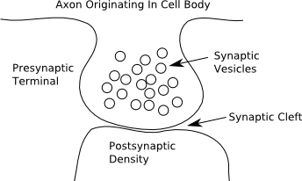
Figure 1 Geometry Of A Neuron To Neuron Pairing
In simplified terms, the fundamental sequence of events that leads to vesicle fusion after an action potential arrives is
1. Influx through channels, and diffusion of calcium ions.
2. Activation of the protein calmodulin (CaM) by calcium.
3. Binding of activated calmodulin to calcium-calmodulin dependent protein kinase II (CaMKII).
4. Transformation by autophosphorylation¹ of CaMKII to other conformations.
5. Phosphorylation by all conformations of CaMKII of the protein synapsin which holds synaptic vesicles in a cluster in the terminal.
6. Release of vesicles by phosphorylated synapsin.
7. Transport of released vesicles to a specialized region of the cell membrane called the active zone.
8. Fusion of vesicles with the active zone and release of neurotransmitter.

Pioneering work in the modelling of presynaptic terminal dynamics was conducted by Benfenati, Valtorta and Greengard^{[3].}. They created simple models that allowed for the combining of vesicles, synapsin and the cytoskeletal scaffold actin into complexes. Their crosslinking model was represented by the following reaction scheme
S + V + A
SV + A
SA + V
SVA
Figure 2 Crosslinking Reaction Scheme From [3]
Here (S) represents synapsin, (V) represents vesicles and (A) represents actin. The model described here does not include actin, but its formulation can be traced back to this concept of the formation and splitting of synapsin-vesicle complexes. A depiction of the cluster is shown in Figure 3.

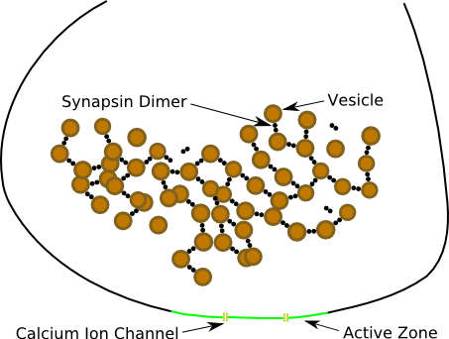
Figure 3 Synapsin-Vesicle Cluster At A Presynaptic Terminal
In Figure 3 the synapsin is represented as a dimer as is often the case (personal communication, James Cheetham).
A more complex model was developed by Holmes^{[4]}, albeit for the postsynaptic density but the reactions are the same, that expresses steps (2) to (4) as a system of ordinary differential equations. Holmes listed values for the rate constants for his system, though some are not well known. A simplified version of the system is shown in Figure 4.
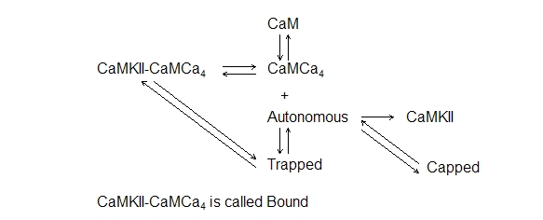
Figure 4 Subset Of Reaction Scheme From Holmes^{[4]}
The key concepts are as follows. The CaM binds to four calcium ions. The CaMCa₄ binds to CaMKII to form the complex CaMKII-CaMCa₄, which is referred to as the Bound state for CaMKII. The Bound CaMKII can autophosphorylate to form what is called the Trapped state. While the term ‘trapped’ is an overstatement, the splitting rate of the CaMKII-CaMCa₄ complex is reduced by a factor of over 1000 after autophosphorylation^{[5]}. If a Trapped CaMKII does split from CaMCa₄, the CaMKII is called Autonomous as it maintains some level of activity without being associated with CaMCa₄. Finally the Autonomous CaMKII can again autophosphorylate at two sites that are in the binding region for CaM^{[6]}. This reduces the probability of a CaMCa₄ binding, effectively ‘capping’ the CaMKII. Bound CaMKII has the greatest synapsin phosphorylation effectiveness, Trapped is slightly less (~85%) and Autonomous and Capped are much less (~38%)^{[7]}.
A restriction in using ordinary differential equations to model such a system is that they do not account for any spatial gradients within the system, i.e., the system is treated as a well-mixed tank. One numerical method that can account for these gradients is cellular automata (CA). In a CA, the system is divided into cells, often squares in two dimensions. At each instant in time each cell is said to be in a specific state. For example, it could be a Trapped CaMKII heading east.
To update the cell states, rules are written following specified protocols. The rules were implemented here in the program Cell-DEVS which is part of the CD++ package developed by Prof. Gabriel Wainer and colleagues. Cell-DEVS is more sophisticated than a straightforward synchronous CA, but in its application here, it can be considered as such.
Rules are checked in top-to-bottom order and the first rule that is satisfied is the one adopted. In the system used here, all cells are effectively updated synchronously. This means that updating rules must be written that account for every possible scenario for each cell, and its future state is determined exactly based on the current state. A typical rule, expressed informally, is of the form
if {Step Number Is Divisible By Two} and {Cell Is Fluid} and {Trapped Approaching From North} and {Step Two Approaching From West} and {Particle In Cell To North Wins Right To Advance Over Particle In Cell To West} and {Trapped To North Splits} and {There Is An Empty Cell For The CaMCa₄ To Land}
then
{Cell Becomes Autonomous}
The rule first checks the step number. CaMKII in all its forms is only allowed to move on even step numbers. Next the status of the current cell is found; here it is Fluid.
The status of particular cells in the so-called neighbourhood is then determined. An extended von Neumann neighbourhood was used here:

Figure 5 Extended von Neumann Neighbourhood
The current (in this case, Fluid) cell is shaded, and the four adjacent cells (cross-hatched) are those for which approaching particles are checked. Particles only move horizontally or vertically. Here, there is an approaching particle from the north and one from the west. The more complicated rules regarding four approaching particles and three approaching particles will have been already checked and will have all failed. Since later on it is specified that the particle to the north wins the right to advance, we don’t care what the kind of particle the one to the west is, except to know that it moves on even steps (Step Two).
Finally, there is a special situation in that the Trapped splits into an Autonomous and a CaMCa₄. This implies that the Fluid cell under consideration becomes an Autonomous. The direction that the Autonomous is heading is set randomly, and the CaMCa₄ that split off the Trapped occupies another cell (where this cell is located is described later).
Probabilities for each type of transformation must be set in Cell-DEVS, e.g., in the example, the probability of the {Trapped To North} splitting. Of course, these probabilities are not provided in the literature, so some way must be found of setting them. For example, for the reactions in Figure 4 the following strategy was employed as a demonstration:
1. Remove all particles except CaM and CaMKII. Have all of the CaM be activated, i.e., in the form CaMCa₄. Do not have any influx of calcium ions, i.e., no action potentials.
2. Remove all walls so that the grid acts as if it were a torus, e.g., particles can seemingly exit the east boundary and appear on the west boundary.
3. Randomly place a set of CaMCa₄ and CaMKII in the grid.
4. Run a simulation and track the number of each particle type as a function of step which corresponds to time.
5. Create a model with a system of ordinary differential equations that describe the interactions; see [4]. The rate constants for the model are the unknown parameters.
6 Estimate the parameter values that provide the best fit of the numerically solved differential equation system to the data; this is a multiresponse nonlinear regression problem for which an objective function to minimize was developed by Box and Draper^{[8]} (see also Box and Tiao^{[9]}).

To properly set the probabilities these steps would be repeated with the probabilities being updated until the estimated rate constants from the regression after the simulation matched (sufficiently) the published values.

METHODS

The grid for the simulation was 30x30, however in the Cell-DEVS format four extra layers were added. The layers are identified in Figure 6.
Main Layer
CaM Layer
Calcium Layer
Random Number Layer
Random Number Layer
Figure 6 Configuration of Cell-DEVS Model

Most of the particles reside in the main layer: vesicles, synapsins, phosphatases and CaMKII. The CaM are all in the second layer. This is because the CaM are considerably smaller than the main layer particles. By isolating them they are allowed to move as if the other particles were not there. The third layer is only for calcium ion influx. The ions are allowed to diffuse freely.
As illustrated in the example, decisions have to be made when the rules are enforced. The random number layers are for this. To decide whether the particles from the north or the one from the west advances, the U(0,1) value in the corresponding cells in layer 4 are compared; low value wins. Layer five is used to make decisions about formation and splitting of complexes.
Referring back to the rule example, if a Trapped splits the resulting free CaMCa₄ gets place into the second layer and hence is not of a concern for the main layer. The split can only occur is there is a place for the CaMCa₄ to ‘land’.
An example initial setup is shown in Figure 7. The vesicle-synapsin cluster is preset, and the positions of the other particle are randomly set.
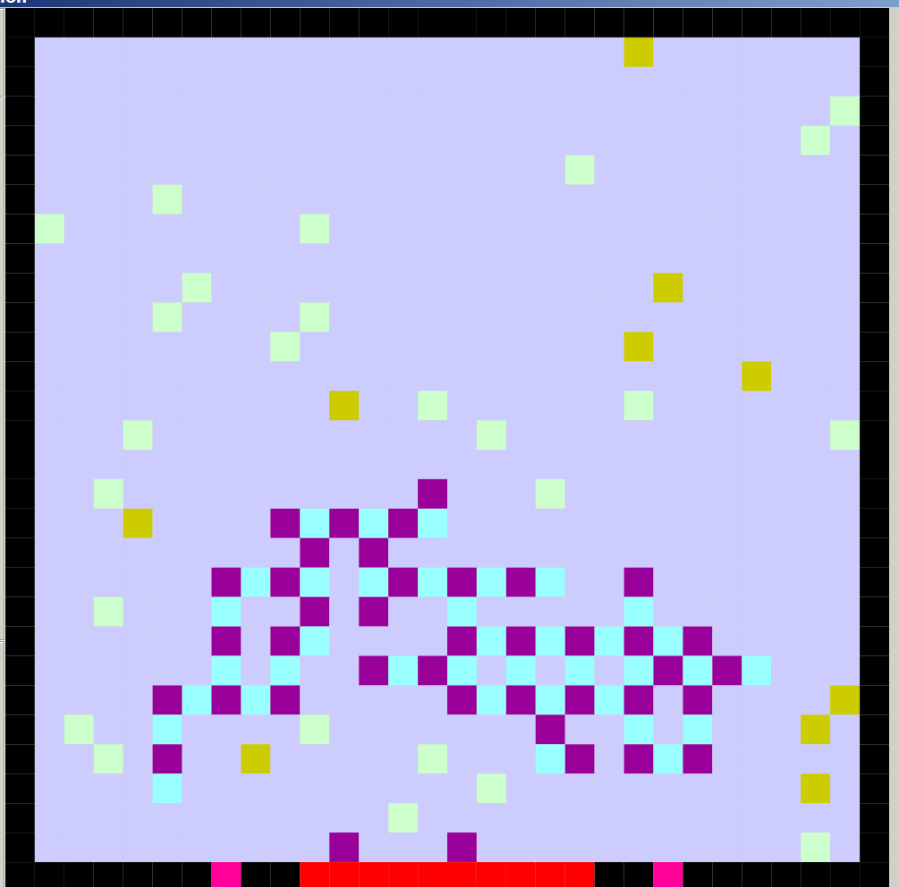
Figure 7 Initial Setup For Simulation
Violet ⇒ Vesicle
Cyan ⇒ Synapsin
Light Green ⇒ CaMKII
Brown ⇒ Phosphatase
Black ⇒ Cell Wall
Red ⇒ Active Zone
Dark Rose ⇒ Calcium Ion Channel In Closed State
Light Blue ⇒ Fluid

RESULTS AND DISCUSSION
Once the simulation is started the particles move randomly to a cell to the east, north, west or south. How often they move is governed by their real-life size: vesicles move every fourth step, synapsins, phosphatases and CaMKII in all its forms move every second step, and CaM moves every step. Vesicles have priority over all other types in competition for an empty cell, e.g., if the applicable rule was started with
if {Step Is Divisible By Four} and {Cell Is Fluid} and {Vesicle Approaching From North} and {CaMKII Approaching From West} and ...
that is all the information that is required. There is no competition: the result is
then
{Cell Becomes Vesicle}
The first event is the arrival of an action potential., as indicated by the cell wall turning yellow. This is for effect only, the first significant event is the opening of the calcium ion channels which follows after a time lag. The lag reflects the actual delay^{[1]}. The influx of calcium ions is created by having the cells adjacent to the channels create a random integer drawn from U(0,6) from the cell immediately north and from U(0,5) for the two adjacent cells.
6
5
5
Figure 7 Cells That Simulate Calcium Ion Influx
Rose ⇒ Open Calcium Ion Channel Yellow ⇒ Cell Wall During Action Potential Values represent maximum amount of calcium generated per step
The diffusion effect is created by averaging calcium ion concentrations over blocks of cells. An example of the state of the calcium ion layer after some diffusion has occurred is shown in Figure 8. The higher concentrations are near the channel as represented by the colored cells, and the grey scale indicates diminishing concentrations as distance from the channels increases.
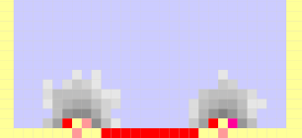
Figure 8 Portion Of Calcium Ion Layer After Diffusion
Colored Cells ⇒ High Calcium Ion Concentration

For every cell in the calcium ion layer, up to three ions disappear at every step reflecting the binding of the ions to buffers. This means that after the channels close, i.e., the cells in Figure 7 stop creating ions, the calcium ion plumes dissipate quickly^{[10]}.
The CaMs in layer 2 become activated when they are below a cell with high calcium content. Material balances for the calcium ions are ignored because there is an abundance of calcium, i.e., there is no compensatory loss in calcium from the calcium layer. Intermediary steps, e.g., CaMCa →CaMCa₂ are not accounted for. This same idea was employed by Sabatini et al.^{[11]} who noted that the first step in the transformation from CaM to CaMCa₄ appeared to be rate limiting in [4]. As the CaM becomes activated, its colour changes as depicted in Figure 9.

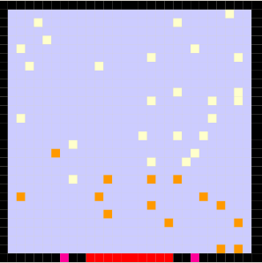
Figure 9 Activation Of CaM By Calcium On Second Layer
Dark Orange ⇒ Activated CaM, i.e., CaMCa₄
Light Orange ⇒ CaM

The activated CaM binds to the CaMKII on the main layer causing the CaMKII to turn darker green. As the transformations from Bound to Trapped to Autonomous to Capped occur, the CaMKII changes shades of green. All forms of CaMKII can phosphorylate synapsin. When phosphorylated the synapsins turn darker blue and they lose their affinity for vesicles and hence become mobile; see Figure 10.
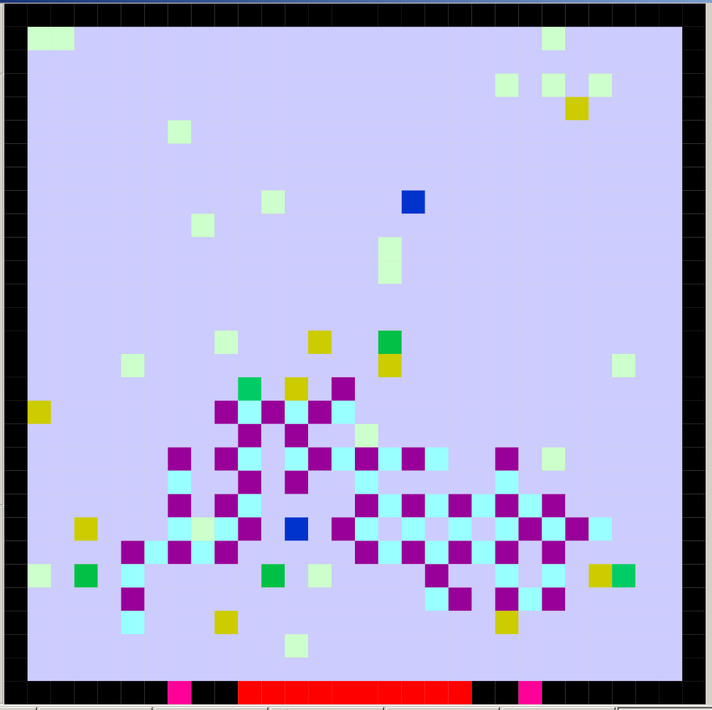
Figure 10 CaMKII Activation And Synapsin Phosphorylation
Dark Green Shades ⇒ Activated Form Of CaMKII Dark Blue ⇒ Phosphorylated Synapsin
When a vesicle is no longer attached to any synapsins it too becomes mobile. Its motion is random, but the cluster impedes its movement so those vesicles between the cluster and the active zone have a greater probability of docking than those on the opposite side of the cluster. Once a vesicle docks it cannot leave. It can fuse and disappear if the calcium concentration is great enough^{[12]}. A released vesicle is shown in Figure 11.
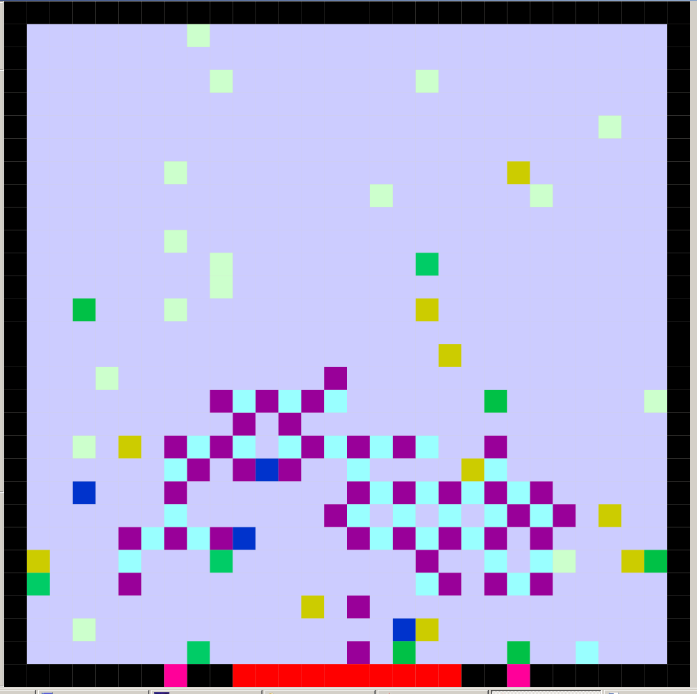
Figure 11 A Docked Vesicle After Release From Cluster

The simulation represented here has the rate of reaction sped up to demonstrate the processes involved. With that in mind, a demonstration of the extraction of rate constants from the simulation results follows. The rate constants given by Holmes^{[4]} are presumably for a well-mixed system. To emulate this, a simulation was run with the walls removed and only activated CaM and CaMKII present to start. A 60×60 grid was used. Amounts of CaM, CaMCa₄, CaMKII, Bound, Trapped, Autonomous and Capped were recorded as a function of time. This set corresponds to the system illustrated in Figure 4. The following differential equation system was used as a model:

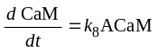
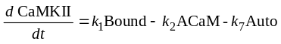
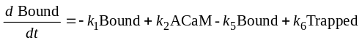
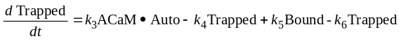
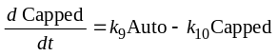
Here ACaM ⇒ CaMCa₄, Auto ⇒ Autonomous and the dot means multiplication. The objective function to minimize for multiresponse nonlinear regression is the determinant of the covariance matrix for the responses^{[8,9]}. However, if one make the assumption that the responses are independent the objective function becomes the sum of the squared residuals taken over all of the responses, i.e., a multiresponse extension of the univariate nonlinear regression criterion. The latter is considerably easier to deal with numerically, and is used here as the covariance matrix is not of interest. An example of the time course of the various species and an optimized fit, in colour, of the differential equation model is given in Figure 12.
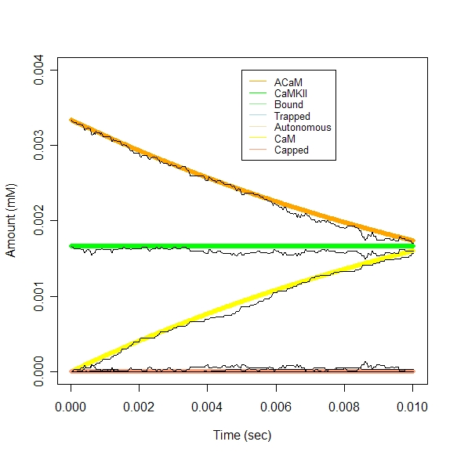
Figure 12 Multiresponse Regression Fit Of Time Series Data

In the simulations, time was arbitrarily set to be 25 μs per step and the volume was set to be 10⁻¹⁶ liters reflecting roughly dimensions for a hippocampal bouton^{[14]} (0.5 μm radius sphere with 20% fluid).
The nonlinear regression does provide an accurate fit to the simulation data. Because the simulation is two-dimensional talking about millimoles per liter is inappropriate; one would require a fully three-dimensional analog to obtain realistic values.

The simulation does account in a reasonable way for the interactions that occur within the terminal with the limited set of species. There are some outstanding difficulties in creating a useful model:
1. The biochemistry of the system is exceedingly complex and is not well understood even qualitatively.
2. Quantitative values for all of the parameters required for the transformation rates are not known.
3. Transformation of quantitative rates, even if they were known, into parameters for the model is computationally expensive. An iterative scheme would be required where values for the transformation probabilities in the Cell-DEVS model are estimated, a simulation is run, the nonlinear regression is run, and the estimated rate constants from the regression are compared to the published values.

ACKNOWLEDGMENTS

We would like to thank James Cheetham for insight regarding the biochemistry of neurotransmission.

REFERENCES

[1] Südhof, T.C. The synaptic vesicle cycle. Annu. Rev. Neurosci., 27 (2004), 509-547
[2] Rizzoli, S.O. and Betz, W.J. Synaptic Vesicle Pools. Nature Reviews Neuroscience, 6 (2005), 57-69
[3] Benfenati, F., Valtorta, F. and Greengard, P. Computer modeling of synapsin I binding to synaptic vesicles and F-actin: implications for regulation of neurotransmitter release. PNAS 88 (1991), 575-579
[4] Holmes, W.R. Models of calmodulin trapping and CaM Kinase II activation in a dendritic spine. J. Computational Neuroscience, 8 (2000), 65-85
[5] Griffith, L.C. Regulation of Calcium/Calmodulin-Dependent Protein Kinase II Activation by Intramolecular and Intermolecular Interactions. J. Neuroscience, 24 (2004) 8394–8398
[6] Hudmon, A. and Schulman, H. Neuronal Ca²⁺/Calmodulin-Dependent Protein Kinase II: The Role of Structure and Autoregulation in Cellular function. Ann. Rev. Biochem., 71 (2002) 473-510
[7] Meyer, T., Hanson, P., Stryer, L. and Schulman, H. Calmodulin trapping by calcium-calmodulin-dependent protein kinase. Science, 256 (1992), 1199-1202
[8] Box, G.E.P. and Draper, N.R. The Bayesian Estimation Of Common Parameters From Several Responses. Biometrika 52 (1965) 355-365
[9] Box, G.E.P. and Tiao, G.C. Bayesian Inference in Statistical Analysis. (1973, 1992) New York: Wiley
[10] Tank, D.W., Regehr, W.G. and Delaney, K.R. A quantitative analysis of presynaptic calcium dynamics that contribute to short-term enhancement. J. Neuroscience 15 (1995), 7940-7952
[11] Sabatini, B.L., Oertner, T.G. and Svoboda, K. The Life Cycle of Ca²⁺ Ions in Dendritic Spines. Neuron, 33 (2002), 439-452
[12] Meinrenken, C.L., Borst, J.G.G. and Sakmann, B. Calcium secretion coupling at calyx of Held governed by nonuniform channel-vesicle topography. J. Neuroscience 22 (2002), 1648-1667
[13] R Development Core Team (2007). R: A language and environment for statistical computing. R Foundation for Statistical Computing, Vienna, Austria. ISBN 3-900051-07-0, URL http://www.R-project.org.
[14] Fernández-Alfonso, T. and Ryan, T.A. The efficiency of the synaptic vesicle cycle at central nervous system synapses. Trends in Cell Biology 16 (2006), 413-420
[15] Horton, H.R., Moran, L.A., Scrimgeour, K.G., Perry, M.D. and Rawn, J.D. Principles of Biochemistry 4th Edn., (2006) Upper Saddle River: Prentice-Hall
[16] Wainer. G. CD++: a toolkit to develop DEVS models. Software: Practice and Experience. 32 (2002), 1261-1306

Phosphorylation involves the addition of phosphoryl groups, PO₃^{[15]}. Kinases are proteins that catalyze phosphorylation. Autophosphorylation implies phosphorylation of a kinase catalyzed by itself^{[7]}.
http://www.sce.carleton.ca/faculty/wainer/wbgraf/index.html See, for example, [16].
Phosphatases act in the opposite way to kinases, i.e., they catalyze the removal of phosphoryl groups^{[15]}.

