NERVE CELL MEMBRANE
DEVS MODEL REPORT

SYSC 5104 - Methodologies for Discrete Event
Modelling and Simulation

Assignment #1

Rhys Goldstein
Carleton University
Student #100747303

2007 October 29
Table of Contents
Conceptual Model 1
Model Specification 3
Ion Generator 3
Ion Gate 4
Potassium Channel 7
Sodium Channel 8
Voltage Regulator 10
Membrane Node 12
Nerve Cell Membrane 13
Model Implementation and Testing 16
Ion Generator Test 16
Ion Gate Test 17
Membrane Node Test 18
Nerve Cell Membrane Test 19

Conceptual Model

The Nerve Cell Membrane DEVS model was designed to facilitate the simulation of action potentials, the biological signals that carry information through the human body.

An important feature of a nerve cell is the transmembrane voltage, the difference in potential measured across the cell's boundary. The transmembrane voltage can be modelled as a function of time and position. As nerve cells are relatively long and narrow in shape, the position is generally described by a single parameter: the distance from one end of the cell.

Action potentials are characterized by a rise and subsequent fall in the transmembrane voltage, a pattern which propagates along a nerve cell from one side to the other. These signals rely on channels in the nerve cell membrane, which open and close to control the flow of ions. Some of these channels, when open, allow sodium ions to enter the cell. This results in the rise in transmembrane voltage. The subsequent fall occurs when the other channels open, allowing potassium ions to escape the cell.

The channels themselves are often modelled as a paths, possibly blocked by voltage sensitive gates. Potassium channels are generally viewed as having a single n-gate. In this model, the n gate begins to open when the transmembrane voltage rises above a threshold level. It then begins to close when the voltage falls below the threshold. Sodium channels are more complicated, allowing ions to pass only when two gates are open. The m-gate is similar n-gate, opening in response to a voltage above threshold. The h-gates, however, begin to open only when the voltage is below the threshold. An import property of each gate is the time it takes to open or close. The n- and h-gates change slowly, while the m-gates are fast.

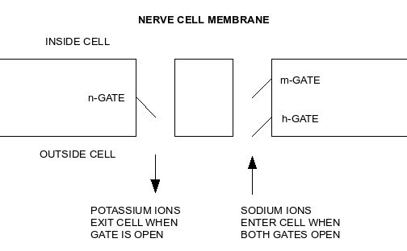

At the rest voltage, which is below the threshold, both channels are closed due to the position of the n- and m-gates. When an external stimulus causes the voltage to increase past the threshold, both of these gates begin to open. Because the m-gates open faster, the sodium ions start traversing the membrane before the potassium ions can pass. This causes the initial rise of an action potential. Eventually, the slow n-gates open and the slow h-gates close. The potassium ions then lower the voltage. When the voltage falls below the threshold, the n-gates start to close. But as these gates close slowly, the voltage overshoots and drops below the rest voltage. Eventually, electric currents restore the rest voltage.

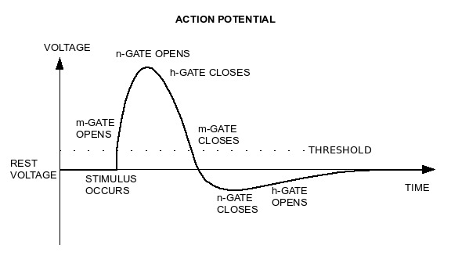

When one particular region of a nerve cell is undergoing an increase in voltage due to an action potential, the movement of ions in that region serves as a stimulus for nearby gates. Those nearby gates then open, stimulating a new set of gates. It is in this way that action potentials propagate along a cell membrane. If a nerve cell is stimulated at one end, the action potential will travel to the other. The behavior of the gates prevents action potentials from being reflected. If a nerve cell is stimulated at both ends simultaneously, the action potentials will meet in the middle and nullify one another.

The model is simplified in many ways. In reality, the ion gates are very complex chemical structures influenced by many factors. They do not change instantaneously from completely open to completely closed after a fixed delay. Another simplification concerns the ions themselves. The channels allow each type of ion to traverse the cell membrane in only one direction. Though neglected by the model, there are mechanisms by which potassium ions can re-enter the cell, and sodium ions can escape. When interpreting the model, one must assume that the concentration of ions on either side of the membrane somehow remains constant.

Model Specification

The DEVS model is a three-level system with four components describing DEVS coupled models, and three components describing DEVS atomic models. The components are specified below, starting with those at the lowest level of abstraction and concluding with the nerve cell membrane itself. This is an appropriate order for implementation and testing.

Ion Generator

In reality, ions in a human body are neither created or destroyed. They move chaotically, at times encountering ion channels with the possibility of passing through them. In the model, ions are generated randomly at the mouthes of these channels. They are modelled by a change in voltage, which reflects the effect they will have on the transmembrane voltage should they pass through the gates. The ion generator component describes atomic models that generate ions.

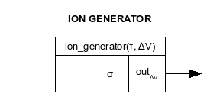

Ion generators are DEVS atomic models parameterized by the average time between outputs τ, and the change in voltage ΔV.

There are no input ports, and hence no external transition function.

There is one output port, out_{ΔV}, through which ΔV is output at exponentially distributed random intervals.

The only state variable is σ, which gives the time remaining until the next output and internal transition.

Triggered after each output, the internal transition function randomizes the time before the next output. This is done by evaluating rand_{exp}(τ), an exponentially distributed random value with mean value τ.

An implementation of this component can be tested independently. When run in a simulation for time T, it will produce n outputs of ΔV, where n is expected to conform to the following approximation.

Ion Gate

Once the ions are generated at the mouth of a channel, they must pass through a series of at least one ion gate before they pass the through the cell membrane. Ion gates allow ions to pass only if they are open. Otherwise, the ions remain on the original side of the membrane, do not affect the transmembrane voltage, and are hence neglected.

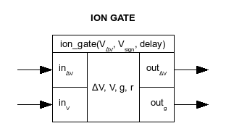

An ion gate atomic model has three parameters: the threshold voltage V_{th}, the direction value V_{sign}, and the delay before the gate's position changes. If a gate is closed and the input voltage reaches the threshold V_{th}, the gate will open after the specified delay. Similarly, the gate will change from open to closed at a time of delay after the voltage passes the threshold in the other direction. The direction value V_{sign} is +1 if the gate opens in response to a voltage of at least the threshold, and -1 if the gate opens for voltages of at most the threshold.

The are four state variables. The net change in voltage, ΔV, is an cumulative sum of the voltage changes introduced by simultaneously incoming ions. The previously-inputted transmembrane voltage, V, is used to determine whether the gate's position needs to change. The gate's position itself is represented by g, with value of true meaning open and false meaning closed. After the voltage V crosses the threshold, the variable r is used to record the time remaining until the position changes.

There are two input ports: in_{ΔV}, on which an incoming ion can deliver a voltage change ΔV_{in}; and in_{V} , which can receive a new transmembrane voltage V_{in}.

The two output ports include out_{ΔV}, on which incoming voltage changes may pass through the gate, and out_{g}, which output the position of the gate each time it changes.

Before specifying the transition functions, it is useful to define two functions γ and ρ. Here γ(V) describes the desired position of the gate based on the voltage parameter, and ρ(V, g) provides a new value for r each time the gate's position has completed a change.

When an input of ΔV_{in} is received on the input port in_{ΔV}, it is added to the state variable ΔV only if the gate is open. If a change in the gate's position is imminent, the elapsed time e must be subtracted from the state variable r.

(where...)

When an input of ΔV is received on the input port in_{V}, it becomes the new value of the state variable V. If the gate was in the process of changing, the elapsed time e must be subtracted from the state variable r. If the gate was not in the process of changing, then the function ρ is used to determine the new value of r.

(where...)

There are two cases to consider with the time advance, output, and internal transition functions. In the first case, ΔV is not zero. This indicates that the gate is open and the transition was triggered by an incoming ion. Because ions take no time to traverse a gate, the time advance function yields zero. The voltage change is thus immediately output on the out_{ΔV} port. In the internal transition function, ΔV is set to zero to prepare for the next incoming ion.

In the second case, where ΔV is zero, the time advance function results in r. If a transition has occurred, it is an indication that the gate's position must change. The new position is output on the out_{g} port. The same value replaces the state variable g in the internal transition function, and r is reset with the function ρ.

Once implemented, the ion gate can be tested by introducing events on both input ports, and observing the results from the two output ports. The gate position output should change in response to voltage inputs above or below the threshold, These changes only take place after the delay, however. The event times for the input and output voltage changes should match, though these outputs will only occur if the gate position last changed to open.

Potassium Channel

The potassium channel delivers voltage changes of -1 to the transmembrane voltage. Although the ions themselves are positive, the fact that they escape the cell accounts for the negative voltage change. These changes occur each time a potassium ion is generated, provided that the n-gate is open.

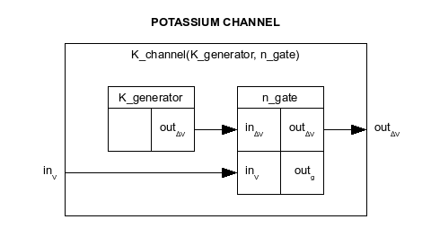

Potassium channels are DEVS coupled models parameterized by the K_generator and the n_gate. The K_generator is an ion generator with a voltage change of -1. The n_gate is an ion gate with a V_{sign} parameter of +1. The voltage threshold should be positive, and the gate's delay should be relatively long.

The formal specification of the potassium channel is below.

The potassium channel can be tested by triggering the n-gate with voltage input events. The output voltage changes will occur at random intervals, but only after the gate is opened by the input.

Sodium Channel

The sodium channel delivers +1 voltage changes to the transmembrane voltage. These changes occur each time a sodium ion is generated, provided that both the h-gate and the m-gate are open.

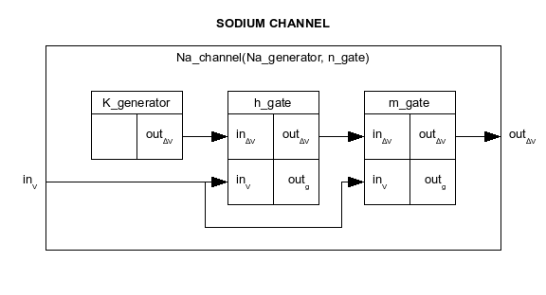

The sodium channel parameters are similar to those of the potassium channel, except that there is an extra gate. The Na_generator is an ion generator with a voltage change of 1, and a time constant somewhat smaller than that of the K_generator. The m_gate is an ion gate with similar parameters to the n_gate. The h_gate is different, in that the V_{sign} parameter is -1, and the delay is zero.

The specification for the sodium channel follows.

Like the potassium channel, the sodium channel should produce voltage change outputs and random intervals, but only after the gates are opened by input events. When testing a case in which the voltage rises above the thresholds, the outputs will start almost immediately but terminate once the h-gate closes.

Voltage Regulator

The voltage regulator does not represent any physical entity. Rather, it is a mathematical model used to regulate the voltage in a particular region of a cell membrane. The regulator has two roles: it must accumulate all voltage changes produced by the sodium and potassium channels, and it must try continuously to restore the transmembrane voltage to zero.

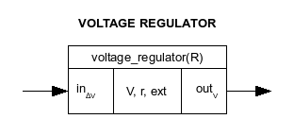

Voltage regulators are DEVS atomic models parameterized by a single value R, which determines the rate at which a voltage of zero is restored. This rate also depends on the transmembrane voltage itself. The greater the voltage in magnitude, the faster it is changed towards zero. It takes a time of R to restore a voltage of +1 or -1 to zero.

The three state variables include the transmembrane voltage V, and two others. The voltage magnitude decreases towards zero by one unit at a time. These decreases occur when the voltage-time integral r is consumed, where r is the second state variable. The third, ext, is a boolean. When truthful, it indicates that the preceding transition was triggered by an external change in voltage.

The sole input port receives voltage changes, while the sole output port sends the current voltage.

The external transition function receives the input voltage change, and adds it to the transmembrane voltage. The variable r is typically reduced by the voltage integral since the preceding transition. If the new voltage is zero, however, then r is given the value R. The state variable ext becomes truthful.

(where...)

Two cases need to be considered for the remaining functions. If the transition was triggered by an external voltage change, then the next output of V is immediate, after which ext is set to false. If the transition was internal, the time advance function predicts the time required to consume the integral r. It is at that point time to output and record the reduced-magnitude voltage.

The voltage regulator can be tested by introducing instantaneous voltage changes as inputs, and observing the voltage magnitude subsequently fall to zero. Though the falls will unfold in series of discrete events, the overall voltage profile will resemble a series of exponential decays.

Membrane Node

The membrane node represents a small part of a nerve cell membrane, containing only a single potassium channel and a single ion channel. It has its own unique voltage regulator. The regulator receives voltage changes as external inputs, and repeatedly tries to restore the accumulated voltage to zero. Upon receiving voltages from the regulator, the two ion gates open and close. When they are open, they produce more voltage changes that affect the regulator, causing a feedback loop. The voltage changes resulting from ions moving through the gates are output from the coupled model. In this way, the ions can affect surrounding nodes in order to propagate an action potential. The voltage from the regulator is also output for monitoring purposes.

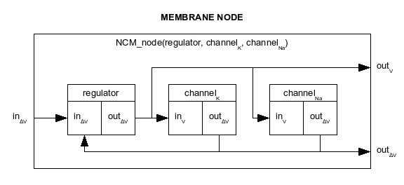

The three parameters of an membrane node (NCM_node) are the voltage regulator (regulator), the potassium channel (channel_{K}), and the sodium channel (channel_{Na}). The voltage regulator parameter R should be chosen such that R/τ, where τ is the time constant of the sodium ion generator, is significantly greater than the threshold voltages on all of the gates.

Below is the specification for the membrane node coupled model.

When tested with an input voltage change smaller than the threshold on the sodium channel, the voltage output of the membrane node will rise sharply, then decay back to zero. If the input voltage change exceeds the threshold, the voltage output should resemble the profile of the action potential illustrated in the conceptual model. The profile may differ, however, as there is only a single pair of gates. In an actual nerve cell membrane, there are many gates, none of which open and close at precisely the same times.

Nerve Cell Membrane

The nerve cell membrane is the uppermost model in the project. It consist of a chain of membrane nodes. Ideally, the number of nodes would be arbitrary, but in this project only four were used. The nodes are linked such that the voltage change outputs of a node go to the inputs of the two adjacent nodes. The voltage changes produced by the outermost nodes are output from the overall model. Inputs are provided on either end to stimulate the nerve cell membrane. With no stimuli, the transmembrane voltages at each node would remain at zero. The voltages at each node are output from the overall model for monitoring.

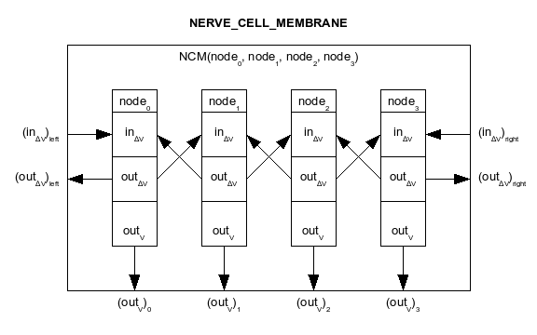

The parameters of the nerve cell membrane are the four membrane nodes it contains. These nodes will generally have identical parameters, though an asymmetry could be introduced to model defects in the membrane.

The formal specification follows.

The nerve cell membrane coupled model should be tested several times. The simplest test it to stimulate an action potential from the left side with a single voltage change input, then observe it propagate to the right. The model is symmetrical, and should perform similarly in a second test when the voltage change is input on the right.

A third test would involve the input of two consecutive stimuli, the second of which would occur near the tail end of the action potential. If the first h-gate has yet to re-open, the first membrane node is in its refractory period. A second action potential will not, in this case, be observed.

A fourth test would involve simultaneous stimulation from both ends of the membrane. The two resulting action potentials will meet in the middle, They should not pass through one another, as the nodes on both sides will be in their refractory periods.

Model Implementation and Testing

All models were implemented and tested using CD++. The three atomic models, the ion generator, the ion gate, and the voltage regulator, were each tested once independently. The three intermediate coupled models, the potassium channel, the sodium channel, and the membrane node, were also tested once each in isolation. Four separate tests were performed on the overall model, the nerve cell membrane. Although there were ten tests in total, only the results of four selected tests are presented here.

Ion Generator Test

A single test was performed on an ion generator with the following parameters.

(where...)

There are no input ports for this model, as all events are generated internally. With a total simulation time of 1000, it was expected that 1000/τ, or 10, outputs would occur. The output below shows 13 outputs, which is a reasonable outcome. The intervals between outputs appear to be roughly exponential in nature, with the majority of the intervals being significantly less than the average.

OUTPUT
00:00:00:004 out_delta_v 1
00:00:00:063 out_delta_v 1
00:00:00:080 out_delta_v 1
00:00:00:082 out_delta_v 1
00:00:00:434 out_delta_v 1
00:00:00:530 out_delta_v 1
00:00:00:603 out_delta_v 1
00:00:00:792 out_delta_v 1
00:00:00:808 out_delta_v 1
00:00:00:856 out_delta_v 1
00:00:00:933 out_delta_v 1
00:00:00:951 out_delta_v 1
00:00:00:999 out_delta_v 1

Ion Gate Test

An ion gate was tested with the parameters below.

(where...)

As shown below, no outputs occur until 100 ms after the first voltage of at least the threshold level is input at time 350. At 450, the gate opens, and the next three voltage change inputs pass through the gate. At 850, the gate closes in response to the input at 750. The gate then re-opens at 950, which is 150 ms after the corresponding input at 800. This increased delay is expected, as the gate had to completely close before it started opening again.

INPUT | OUTPUT
00:00:00:050 in_Delta_V 1  00:00:00:150 in_V 5  00:00:00:300 in_Delta_V 2  00:00:00:350 in_V 10  00:00:00:400 in_Delta_V 3  00:00:00:500 in_Delta_V 4  00:00:00:550 in_V 20  00:00:00:700 in_Delta_V 5  00:00:00:750 in_V -100  00:00:00:800 in_V 100  00:00:00:825 in_Delta_V 6  00:00:00:875 in_Delta_V 7  00:00:00:900 in_Delta_V 8  00:00:00:950 in_Delta_V 9  00:00:00:951 in_Delta_V 10  00:00:01:000 in_Delta_V 22  00:00:01:000 in_V -100  00:00:01:000 in_Delta_V -11  00:00:01:001 in_Delta_V -40  00:00:01:001 in_Delta_V 100  00:00:01:001 in_Delta_V -60 | 00:00:00:450 out_g 1  00:00:00:500 out_delta_v 4  00:00:00:700 out_delta_v 5  00:00:00:825 out_delta_v 6  00:00:00:850 out_g 0  00:00:00:950 out_g 1  00:00:00:951 out_delta_v 10  00:00:01:000 out_delta_v 11  00:00:01:100 out_g 0

The voltage change at 950 did not get through the gate. Though it occurred simultaneously with the opening of the gate, external events occur before internal transitions in the DEVS specification. The voltage change 1 ms later did make it through. Two voltage changes occurred at 1000, which were added together before being output. Three voltage changes occurred at 1001, but were not output because their combined sum was zero.

Membrane Node Test

A membrane node coupled model with the following parameters was tested.

(where...)

(where...)

Below is a plot of the output voltage. At 1000, a voltage increase of 9 was input. As this value was below the threshold, the voltage can be seen to decay as a result of the voltage regulator. At 3000, a voltage increase of 11 was input to stimulate the action potential. The resulting profile features the voltage rise, the subsequent fall, and the restoration. The peaks are sharp, reflecting the fact that only one pair of channels was present.

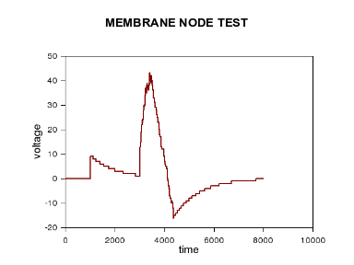

Nerve Cell Membrane Test

A nerve cell membrane model was tested with four membrane nodes. Each had identical parameters to those in the membrane node test, except that all voltage thresholds were changed from 10 to 20. A total of four tests were performed.

In test A, a single voltage change of 25 was input from the left at a time of 1000. As shown below, this triggered an action potential on the first node (NODE 0). The next node (NODE 1) received voltage changes from the sodium ion channel of NODE 0. This triggered an action potential on the second node, which in turn triggered the third, which in turn triggered the fourth. Observing the leading edges of the action potentials, it is evident that the model succeeds in allowing these signals to propagate from one end to the other.

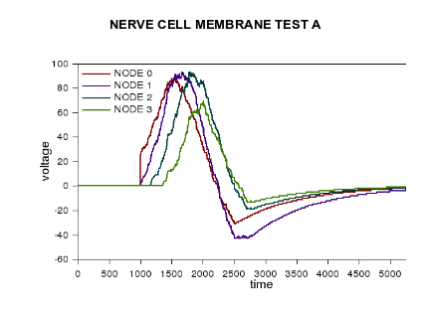

Because in this model the various nodes interact with one another, the peaks are not as sharp as they were in the test of a single membrane node. When a gate closes, for example, the node's voltage still changes in response to the channels of surrounding nodes that have remained open. This effect produces action potentials with more realistic profiles.

In reality, the propagation of an action potential is considered to be a lossless process. The shape of the action potentials should therefore be nearly identical on each node. In the simulation results, it is clear that the profiles are different on each node, particularly at the trailing end. It is difficult to tell whether this asymmetry is an inherent effect of the design of the membrane node models, the result of a poor choice of parameters, or merely the effect of the boundaries of the model. The nodes on the ends can be expected to behave differently, as they have only one adjacent node instead of two. An interesting future experiment would be to test a nerve cell membrane model with ten or more nodes. Perhaps the voltage profiles of the inner nodes would then be nearly identical.

The model behaved as expected on the remaining tests. In test B, the action potential was generated on the right, and propagated to the left. When a second stimulus was input before the first h-gate re-opened in test C, no second action potential occurred. When two action potentials were stimulated from either end in test D, both terminated in the middle.

