94.587 Term Project

Modeling and Simulation of:
Synapsin and Vesicles Interaction in a Nerve Cell
Using Cell-DEVS

Shafagh Jafer
(#100305285)
sjafer@connect.carleton.ca

July, 07, 2006

Table of Contents
Table of Contents 2
1. Introduction 3
2. Modeling Rules 3
3. Formal Specification 4
4. Implementation 5
5. Testing 6
6. Execution Results 7
7. Conclusions 9
Reference 9

- Introduction

This project models the molecular interaction of synapsin (S) with vesicles (V) which occur inside a nerve cell [1]. The model describes the behavior of synapsin movements until reaching a vesicle and binding to it. Once binding has occurred, depending on offrate V and S can again go apart and break their bindings. The onrate and offrate describe how often bindings occur or break then after. The following formula describes the scenario:
S + V ↔ SV
V is modeled stationary (has a fixed position on cell space and does not move), and S is mobile. S can bind to more than one V, and also V can bind to more than one S. Examples of such binding would be:
S-V-S-V
| |
V-S-V-S-V-S-V

- Modeling Rules
In terms of neighboring V and S, they can be adjacent cells or diagonal cells. Figure 1.1 and 1.2 show the possible scanarios. (RedCell = S, BlueCell = V)
1

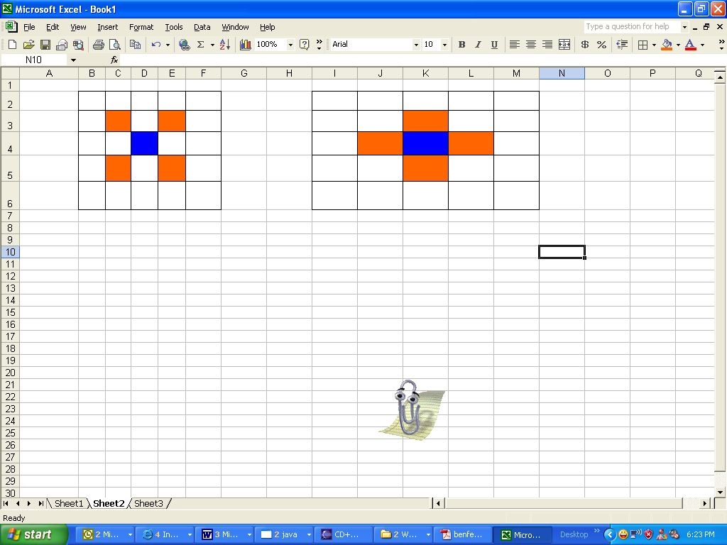  Figure1.1: Diagonal Neighbors | Figure 1.2: Adjacent Neighbors

The model inclues 100 V and 100 S in a (26,22) cell space. As mentioned above, only S cells (red cells) are mobile and they change postion to up, down, left, and right at random. The numbers 1, 2, 3, 4 represent the corrsponding movements which are illustrated by Figure 2.

1

2
4

3

Figure 2: Moving Directions of V Cells
According to the specifications, the onrate was set to 10, and the offrate to 0.1. Therefore, in the model more bindings occur comparing to breaking the bound. This is the reason behind not having all the red cells (S) being mobile and changing their directions. In the file “cell.ma” the offrate can be modified, so the larger it is the more mobile S will be observed. However, the onrate is kept constant which therefore results in having same number of bounds at the end of any execution.

- Formal Specification
The formal specification for the coupled Cell-DEVS model corresponding to the file cell.ma is described as follows.

M=<I,X,Y,Xlist,Ylist,η, N,{m,n}, C, B, Z, select>
Xlist=Φ
Ylist=Φ
η=9
I=<P^{X},P^{y}>,with P^{X}={Φ},P^{y}={Φ};
N={ (-1,-1), (-1,0), (-1,1), (0,-1), (0,0), (0,1), (1,-1), (1,0), (1,1) };
X={0,1,2,11,12,13,14,21,22,23,24,31,32,33,34,41,42,43,44};
Y={0,1,2,11,12,13,14,21,22,23,24,31,32,33,34,41,42,43,44};
m=26; n=22;
B={Φ};
C={Cij/iε[1,26], jε[1,22]}

Z:
Pij Y1 → Pi,j-1 X1  Pij Y2 → Pi+1,j X2  Pij Y3 → Pi,j+1 X3  Pij Y4 → Pi-1,j X4  Pij Y5 → Pij X5 | Pi,j+1 Y1 → Pij X1  Pi-1,j Y2 → Pij X2  Pi,j-1 Y3 → Pij X3  Pi+1,j Y4 → Pij X4  Pij Y5 → Pij X5

select ={ (-1,-1), (-1,0), (-1,1), (0,-1), (0,0), (0,1), (1,-1), (1,0), (1,1) };

- Implementation

As shown in the formal specification, the Nerve Cell model is implemented as a 2D Cell-DEVS. To initialize the cell space, the value 1 was used to represent V, and the value 2 was used to represent S. The number 0 represents an empty cell for which a mobile S can occupy. To give direction to the V (although the model assumes fixed V) or S, a two digit number was used. For example the following represent:
11 “up” moving V  12 “right” moving V  13 “down” moving V  14 “left” moving V | 21 “up” moving S  22 “right” moving S  23 “down” moving S  24 “left” moving S

The following rule was used to assign a direction to each V and S:
rule : {round(uniform(11,14))} 100 { (0,0) = 1 }
rule : {round(uniform(21,24))} 100 { (0,0) = 2 }

Then once V and S are adjacent or diagonal they bind at a rate of onrate=10. Here are the two rules used to define binding, when “random > 0.1” represents the onrate.
rule : {round(uniform(31,34))} 100 {((0,0)=21 or (0,0)=22 or (0,0)=23 or (0,0)=24) and
( ((-1,0)- 10 = 1 or (-1,0)- 10 = 2 or (-1,0)- 10 = 3 or (-1,0)- 10 =4 ) or
((1,0)- 10 = 1 or (1,0)- 10 = 2 or (1,0)- 10 = 3 or (1,0)- 10 = 4) or
((0,-1)- 10 = 1 or (0,-1)- 10 = 2 or (0,-1)- 10 = 3 or (0,-1)- 10 = 4) or
((0,1)- 10 = 1 or (0,1)- 10 = 2 or (0,1)- 10 = 3 or (0,1)- 10 = 4 ) or
((-1,1)- 10 = 1 or (-1,1)- 10 = 2 or (-1,1)- 10 = 3 or (-1,1)- 10 = 4) or
((1,-1)- 10 = 1 or (1,-1)- 10 = 2 or (1,-1)- 10 = 3 or (1,-1)- 10 = 4) or
((1,1)- 10 = 1 or (1,1)- 10 = 2 or (1,1)- 10 = 3 or (1,1)- 10 = 4) or
((-1,-1)- 10 = 1 or (-1,-1)- 10 = 2 or (-1,-1)- 10 = 3 or (-1,-1)- 10 = 4)) and random > 0.10}

rule : {round(uniform(41,44))} 100 {((0,0)=11 or (0,0)=12 or (0,0)=13 or (0,0)=14) and
( ((-1,0)- 30 = 1 or (-1,0)- 30 = 2 or (-1,0)- 30 = 3 or (-1,0)- 30 = 4) or
((1,0)- 30 = 1 or (1,0)- 30 = 2 or (1,0)- 30 = 3 or (1,0)- 30 = 4) or
((0,-1)- 30 = 1 or (0,-1)- 30 = 2 or (0,-1)- 30 = 3 or (0,-1)- 30 = 4) or
((0,1)- 30 = 1 or (0,1)- 30 = 2 or (0,1)- 30 = 3 or (0,1)- 30 = 4 ) or
((-1,1)- 30 = 1 or (-1,1)- 30 = 2 or (-1,1)- 30 = 3 or (-1,1)- 30 = 4) or
((1,-1)- 30 = 1 or (1,-1)- 30 = 2 or (1,-1)- 30 = 3 or (1,-1)- 30 = 4) or
((1,1)- 30 = 1 or (1,1)- 30 = 2 or (1,1)- 30 = 3 or (1,1)- 30 = 4) or
((-1,-1)- 30 = 1 or (-1,-1)- 30 = 2 or (-1,-1)- 30 = 3 or (-1,-1)- 30 = 4)) and random > 0.10}

Once binding has occurred, depending on the offrate the V and S can break their binding and S can move around and find another V to bind to it. This was performed by releasing the V and assigning to it a new direction and letting it move away if there was an empty cell around it.
Since the offrate is too small comparing to onrate, choosing different offrate resulted in having same S-V bound patterns.

- Testing

To test the correctness of the model especially in terms of bounds between adjacent or diagonal S and V, the values printed out on the grid shown in Figure 3 and 4 verify the behavior of the cells. Figure 3 shows the grid at the initial case where S and V have not yet interacted to perform a bound. Then Figure 4 will show how bounds are formed and the corresponding cells change their values to represent the binding.
0 1 2 3 4 5 6 7 8 9 10 11 12 13 14 15 16 17 18 19 20 21
+----------------------------------------------------------------------------------------+
0| 13 24 14 24 23 23 11 13 21 22 12 |
1| 12 23 13 22 14 12 22 12 23 13 |
2| |
3| 12 12 11 23 14 13 21 22 23 22 23 11 |
4| 23 11 14 11 22 22 23 13 14 14 23 |
5| |
6| 12 22 12 23 23 13 22 23 13 13 11 22 |
7| 13 21 24 23 12 12 22 14 24 13 22 |
8| 12 22 13 22 23 23 11 13 14 22 13 24 |
9| |
10| 12 13 12 13 23 23 11 23 24 11 |
11| 12 22 24 22 12 13 13 22 24 22 13 |
12| 13 22 13 24 12 14 24 24 12 22 12 |
13| 24 13 24 12 13 22 12 24 12 21 14 |
14| |
15| 13 22 21 22 12 14 12 13 24 23 13 |
16| 12 23 11 23 21 22 13 21 14 21 12 13 |
17| 12 13 12 12 22 21 12 21 22 12 |
18| |
19| 14 22 13 22 14 11 23 13 24 13 |
20| |
21| 14 23 23 24 11 23 22 23 13 12 13 |
22| 21 12 24 |
23| 22 13 |
24| 12 24 13 22 21 21 12 14 12 22 12 23 |
25| 12 21 22 23 12 14 12 21 22 23 14 |
+----------------------------------------------------------------------------------------+

Figure 3: V and S before binding at Time: 00:00:00:100
0 1 2 3 4 5 6 7 8 9 10 11 12 13 14 15 16 17 18 19 20 21
+----------------------------------------------------------------------------------------+
0| 13 32 41 22 32 34 31 44 42 34 31 12 |
1| 12 32 44 21 42 12 23 42 32 13 |
2| |
3| 41 42 41 32 14 42 32 22 33 33 44 |
4| 32 43 14 41 34 23 13 43 14 32 |
5| 33 |
6| 42 33 44 32 31 43 32 21 44 42 42 34 |
7| 42 31 34 32 41 42 23 42 32 44 31 |
8| 12 31 41 24 34 33 41 13 43 34 42 31 |
9| |
10| 42 44 42 41 23 31 43 32 33 11 |
11| 41 32 32 33 44 44 13 33 33 33 43 |
12| 42 31 41 32 42 43 33 32 12 22 12 |
13| 22 41 32 42 13 34 42 32 44 31 14 |
14| |
15| 41 34 32 33 44 42 42 42 34 32 13 |
16| 44 31 42 31 31 31 42 31 44 33 41 13 |
17| 12 43 43 42 32 31 44 33 12 |
18| 24 |
19| 14 22 13 32 14 42 31 13 33 13 |
20| |
21| 43 33 22 44 31 22 13 44 13 |
22| 23 32 42 32 33 |
23| 33 41 |
24| 12 33 43 31 33 33 42 14 42 23 44 34 |
25| 42 32 34 41 42 42 31 34 21 14 |
+----------------------------------------------------------------------------------------+

Figure 4: V and S after binding at Time: 00:00:00:300
(the red box represents examples of binding structures)

- Execution Results

Several model files have been written in order to see the running process of cell nerve with different offrate.

cell.ma
For this model the offrate is set to 0.1 which was the original value used to develop this model.

cell_06.ma
For this model the offrate is set to 0.6. This is to show the case when large number of S cells are mobile and there for more bounds are broken down and formed again.

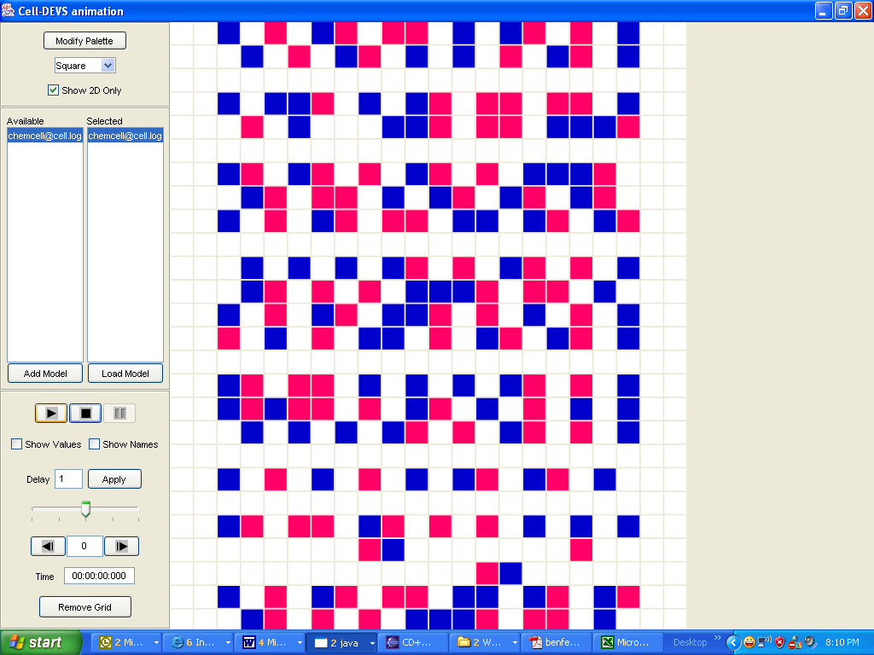
Figure 5: Initial Execution Result of Running cell.ma

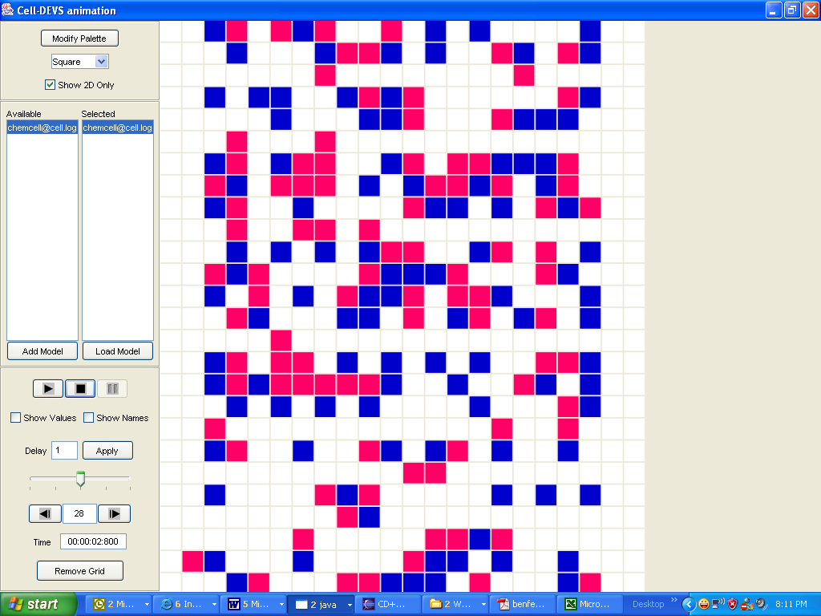
Figure 6: Final Execution Result of Running cell.ma

- Conclusions

For this term project, a model to simulate the process of synapsin-vesicles interactions of a nerve cell with Cell-DEVS has been defined. The model constructed can be further extended to include the movement of both synapsin (S) and vesicles (V) as well as defining different off and on rates. Using Cell-DEVS to build this model was an excellent choice since the randomly moving particles can be easily modeled using this tool.

Reference
[1] Fabio Benfenati, Flavia Valtorta, Paul Greengard; Computer Modelling of Synapsin 1 Binding to Synaptic Vesicles and F-actin: Implications for Regulation of Neurotransmitter Release, October1, 1990

