Ponzi Scheme CD++ Model

Part 1 Problem to be Solved

Overview
Note: This section has been updated from the initial proposal to reflect the model actually built.
The system being simulated is a Ponzi Scheme. In such a scheme the person running it, such as Charles Ponzi, recruits investors by promising them a higher rate of return than is available in the general market, and within a short period of time. In actual fact the money paid to early investors comes from later investors, recruited either by Ponzi himself or by positive word of mouth spread by early investors. Given the nature of the fund, it will be more successful if longer term investors also recruit new investors.
Several assumptions will be made about the behaviour of the fund, the market, and the investors, for the purpose of defining the model. It is assumed that the fund manager, Ponzi, is attempting to reach a target financial goal. Once that financial target is reached, Ponzi will cash out and the scheme will stop. If the fund runs out of money, e.g. a request is made for payment that cannot be met, the scheme stops and Ponzi will flee.
The purpose of this model will be to evaluate the following criteria:
- The number of total investors required for the fun to reach its target monetary value, at which time Ponzi will withdraw all of the money and head to a country without extradition.
- The rate of new investors that must be recruited by long term investors in order for the scheme to succeed.
- The types of runs on the bank that can be withstood by the fund over time.

Model Structure and Behaviour
The model contains the following actors:
- The Fund. It maintains the bank balance of the fund, receiving deposits and responding to requests for withdrawals. Once the target balance is reached it alerts Ponzi and the simulation ends.
- Ponzi - the fund manager. He sets up the fund, recruits investors, makes payouts, and at some point cashes out and runs off with the money.
- Investor Pool, which contains individual investors. The pool must be growing in order for the fund not to go bankrupt. There are two types of investors, depending on the amount of time they have been with the fund.
  - Initial Investors – At the end of their initial investment period they receive their entire principal back plus interest. After this time they become Long Term investors.
  - Long Term Investors – After their initial payout, long term investors re-invest their principal. They receive payouts of interest only. After each payout a percentage of the Long Term Investors recruit new investors.

Part 2 Formal Specification
This section contains the formal specification of the atomic models.

Model Diagram
The diagram of the model is shown below.
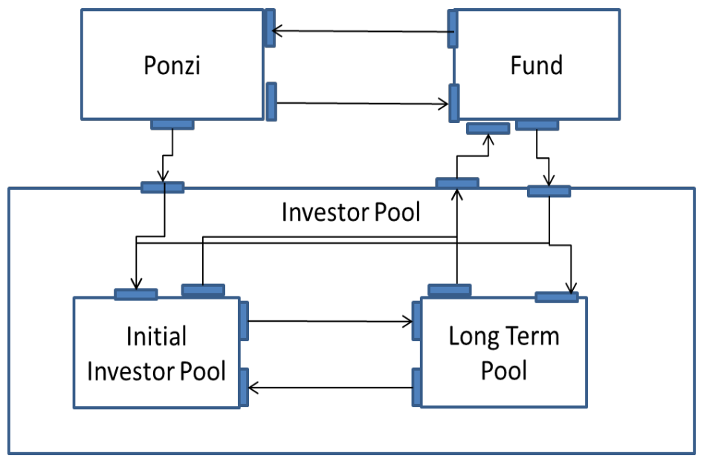

Atomic Models

Overview
All models are presented using the following format:
- External Input Set – List of all input ports and expected inputs on that port.
- External Output Set – List of all output ports and expected outputs on that port.
- Sequential State Set – List of states
- Internal Transition Function – Pseudo code for state changes triggered by internal events.
- External Transition Function – Pseudo code for state changes triggered by external events/inputs
- Output Function – Pseudo code for determining the output from the model.
- Time Function – Indication of how time is managed in the model.
Note: in the model all times are done as multiples of a base time period which are meant to represent weeks. For example, long term investors are paid every four weeks. To simplify the model, a week is represented by five seconds. Therefore, Ponzi recruits a new investor every two weeks (2*5 = 10 seconds) and long term investors are paid every four weeks (4*5 = 20 seconds.)

Fund Type Atomic Model

External Input Event Set
The Fund Type model has the following input ports:
- payment_in – Amount of money to add to the fund balance
- payReq_in – Amount of money to be paid out by the fund.
- Rate_in – Change in interest rate. Was not used.

External Output Set
The Fund Type model has the following output ports:
- Payout_out – Payments made to requestor.
- Alert_out – Used to indicate when status of fund changes based on a deposit or withdrawal.
  - 0 indicates that the fund is empty.
  - 1 indicates that the target value has been reached.
- statsOut_out – Used for debugging.
- Rate_out – Change in interest rate distributed to Investor Pool. Not used.

Sequential State Set
- NoBalance (initial state), Balance, PayoutPending , Empty, TargetReached, Disabled (not used)

Internal Transition Function
No actions are taken in this state.

External Transition Function
- If the Input is a payment, add it to the fund balance. If the balance has gone above the target value, change state to TargetReached.
- If the Input is a payment request, check to see if the fund has enough money to cover the payment. If not, change state to Empty. Otherwise, transition to PaymentPending, which is used to delay payment to make sure that funds are received to cover the payment.

Output Function
- If state is PaymentPending, send payment.
- If state is Empty, send alert.
- If state is TargetReached, send alert.

Time Advance Function
If a payment is required, delay in PaymentPending for two time periods (10 seconds).

Ponzi Atomic Model

External Input Event Set
- Fund_in – status indicator from the Fund. Possible inputs are 0 (Empty) and 1 (Target Reached).

External Output Event Set
- Principal_out – Indicates the amount of money invested by the current investor. Output is provided on this port at the same time as the investorCount_out port.
- investorCount_out – Indicates the count of the number of investors recruited by Ponzi.
- statsOut_out – Used to send a stop message to the Investor Pool when the fund ends, either through success or failure.

Sequential State Set
- Initial, Recruiting, Successful (end state), Flee (end state)

Internal Transition Function
- If state is Recruiting, hold for the next time period.
- If state is Successful or Flee, passivate. This ends the execution of the model.

External Transition Function
- If the fund has reached the target, change internal state to Successful.
- If the fund has been emptied, change internal state to Flee.

Output Function
- If the state is Recruiting, send out the initial payment and count for one new investor.
- If the stat is Successful, send 0 as the principal out as a trigger to cash out the bank account.

Time Advance Function
Every two time periods (2*5 = 10 seconds) recruit one more investor.

Initial Pool Atomic Model
This model represents a ledger of investors who have made their initial contribution.

External Input Event Set
- Count_in – number of new investors. Used to generate the number of total investors to the fund over time.
- initialAmount_in – principal provided by new investors.
- Rate_in – receives inputs from the Fund when the payout rate changes. (Not used.)
- Payout_in – Payment received from the Fund. Inputs are in response to the payout requested by the Investor Pool.
- Control_in – used to disable pool when Ponzi ends the fund (either through Success or Fleeing.)

External Output Event Set
- PayoutReq_out – Request for payment. The amount is the principal of the current initial investors plus interest.
- longCount_out – Number of investors transferring from principal investors to long term investors.
- longAmount_out – Amount of principal contributed to the fund by the investors moving to the long term pool.
- statsOut_out – Used for debugging.

Sequential State Set
- NoBalance (initial state), Counting (at least one investor), PayoutPending (waiting for payout to be returned from fund), Disabled (simulation is complete.)

Internal Transition Function
- If the state is Counting, hold for the time required before next payment is made.

External Transition Function
- If input is new investor (count_in) or new principal (initialAmount_in), add to the running totals. Note: if the state is PayoutPending, add these items to temporary values.
- If the input is a new rate, store it for use in calculating next payout request.
- If the input is payment (payout_in), perform an internal transition.

Output Function
- If the state is Counting, calculate payout request (principal plus interest) and send to fund. Change internal state to PayoutPending.
- If the state is PayoutPending, send the current investor count and amount to the Long Term investor pool. If there are temporary investors and balance (inputs received while payment was pending) transfer them to the main counting variables.

Time Advance Function
- After payout received, wait four weeks (4*5 seconds) before requesting next payment.

Long Term Pool Atomic Model

External Input Event Set
- Count_in – number of investors to add to the long term pool.
- Amount_in – amount of principal contributed by the new long term investors.
- Payout_in – payout received from Fund. Received in response to a payout request.
- Rate_in – rate used to calculate payout requests. Not used.
- Control_in – used to disable pool when Ponzi ends the fund (either through Success or Fleeing.)

External Output Event Set
- newRecruits_out – number of new investors recruited by long term investors.
- newPrincipal_out – amount of money contributed by new investors.
- payoutReq_out – request for payout from Fund.
- statsOut_out – used for debugging.

Sequential State Set
- NoBalance (initial state), Counting, PayoutPending (waiting for payout from fund), Disabled (simulation complete)

Internal Transition Function
- If the state is Counting, hold in state for four weeks (4*5 seconds).

External Transition Function
- If the input is count or principal, add to internal counters. If the state is PayoutPending, add them to temporary values.
- If the input is a new rate, save it for the next payout request calculation.
- If the input is payment, transition immediately.
Output Function
- If the state is Counting, calculate the amount of interest to be paid by the fund and request it.
- If the state is Payout Pending, add the temporary values to the internal count. Calculate a number of new investors and the amount of principal they contribute and send them to the Initial Investor Pool.

Time Advance Function
- After payout is received, wait four weeks (4*5 seconds) before requesting another payout.

Investor Pool Coupled Model

External Input Event Set
- count_in – number of new investors recruited by Ponzi.
- initial_in – principal contributed by the new investors.
- rate_in – rate to be paid to investors. (Not used.)
- payout_in – Payout received from Fund.
- control_in – Indication that Fund is ended.

External Output Event Set
- payoutReq_out – Payout request from fund.
- totalCount_out – Reports status of the fund – all investors recruited to the fund in total.
- longStats_out – Status from the long term pool.
- initialStats_out – Status from the initial investor pool.
- principal_out – Used to monitor amount of principal from new investors generated by Long Term investor pool.

Input Couplings

longCount_out@initialPool count_in@longTermPool

longAmount_out@initialPool amount_in@longTermPool
- newPrincipal_out@longTermPool initialAmount_in@initialPool
- newRecruits_out@longTermPool count_in@initialPool

External Input Couplings
- count_in count_in@initialPool
- initial_in initialAmount_in@initialPool
- rate_in rate_in@initialPool
- payout_in payout_in@initialPool
- rate_in rate_in@longTermPool
- payout_in payout_in@longTermPool
- control_in control_in@longTermPool
- control_in control_in@initialPool

External Output Couplings
- payoutReq_out@initialPool payoutReq_out
- longAmount_out@initialPool principal_out
- statsOut_out@initialPool initialStats_out
- totalCount_out@initialPool totalCount_out
- payoutReq_out@longTermPool payoutReq_out

Test Strategy

Overview
Each of the atomic models is tested on its own. For each model there are the following:
- MA file declaring the model and links on the top model. May also specify input values loaded by the model for the test, e.g. target balance for the Fund.
- EV file with a specific set of input events. Some models have two files to test two specific scenarios.
- Bat file that identifies the MA file, EV file and output files. For models with two EV files, there are two bat files, one for each scenario.
The tests are run by executing the bat files and comparing the output files against the expected results.

Fund Model Testing
There are two testing scenarios for the Fund:
- Fund1.bat / FundTest1.bat – Input balances are contributed. The expected output is an increasing fund balance. One withdrawal is made. The expected output is a payout after the payout period. Another payment is contributed which causes the balance to reach its target. The expected output is a status of 1.
- Fund2.bat / FundTest2.bat – After an initial input, a payout request is made that exceeds the balance in the fund. The expected output is a status of 0 (fund empty).

Ponzi Model Testing
- PonziTest1.bat / PonziTest1.EV - The Ponzi model is started and runs, producing one investor and initial principal output each period (2*5 seconds). After a period of time an input of 1 is sent in, indicating the fund target has been reached. The expected output is 1.
- PonziTest2.bat / PonziTest2.EV - The Ponzi model is started and runs, producing one investor and initial principal output each period (2*5 seconds). After a period of time an input of 0 is sent in, indicating the fund is empty. The expected output is 0.

Initial Investor Pool Model Testing
- InitialPool.bat / InvestorPool.EV - Investor and initial principal values are input to the pool. Expected result is a payout request for the principal and interest. More investors and principal are input prior to the payout being sent in. Once the payout is received the number of investors and amount are sent to the long term investor pool.

Long Term Investor Pool Model Testing
- LongTerm.bat / LongTermTest.EV - Investor and initial principal values are input to the pool. Expected result is a payout request for interest only. More investors and principal are input prior to the payout being sent in. Once the payout is received the number of investors and amount are sent to the long term investor pool.

Investor Pool Coupled Model Testing
- No testing of the coupled model was performed. Such testing would have been similar to the testing of the individual pools since their behaviour is similar, with only the details of the payout request amount and calculation of investors to send to the other model varying. Instead, the overall Ponzi scheme was tested as a whole.

Ponzi Main Testing
- PonziMain.bat / Main.EV / InvestorPool.ma - This represents the execution of the model. No external inputs are provided; however, the initial values (both loaded from the MA file and constants in the code) were modified for the test runs.

Part 3 Testing Results

Testing Results
- Initial testing indicated that if payout from the Fund is returned immediately after the payout request is received, the fund becomes empty. As a result the delay between payout request and payout was introduced to the model.
- Several runs were made varying the multiplier used in the Long Term Investor Pool to calculate the number of new investors generated after each payout. A value of 0.02 (2%) resulted in the fund becoming empty before the target could be reached. A value of .2 (20%) allowed the Ponzi fund to reach its target value after 1402 investors were added to the fund.
- Initial principal for all investors is $100. Interest rate is 5%. Target value is $100,000.

