Advanced Cell-DEVS Models with Defining Multiple State Variables.
Two Plant Species Competition.
Natalia Gorbenko
Department of Systems and Computer Engineering
Carleton University
1125 Colonel By Drive
Ottawa, ON. K1S-5B6 Canada
natalia.gorbenko@carleton.ca

ABSTRACT
Cell-DEVS formalism have shown outstanding results in simulating space-shaped models in various research areas. In this paper, vitality of two plant species with different habitant features was modeled by using Cell-DEVS. CD++ was utilized as a model execution toolkit. In order to obtain more detailed description of model behaviour, definition of multiple variables in each cell was done by the utilization of Extended CD++ Specification Language for Cell-DEVS Model Definition. Various simulations were run in order to obtain balance conditions of two plant species coexistence.

Keywords
Cell-DEVS; CD++; rate of colonization; probability; simulation.

INTRODUCTION
Spatially explicit models gain an increasing interest in ecology. On a large scale they are used to model landscape dynamics and changes in land use or vegetation cover, while on a small scale single or several populations of animal or plant species are of interest. Spatially explicit models allow to increase ability to create basic ecological knowledge and to improve the application of landscape ecology to conservation and land management problems [1].
Competition of Two Plant Species model describes vitality of two plant species with different habitant features. This approach was done by Dytham in 1995 [1]. Dytham researches coexistence of two competing species one of which is dominant (species c) and the other has superior dispersal abilities (species d). According to Dytham’s study, the model has four possible patch states: patch permanently destroyed; patch empty but available for colonisation; patch occupied by species c; patch occupied by species d. Colonisation has a range of only one patch.
Hence, the more patch’s direct neighbours contain the species, the higher its probability of being colonised. On the each time-step an occupied cell can be destroyed with probability 0.1. The rate of colonisation is 0.2 for the superior (species c) and 0.5 for the competitor (species d), and each of the eight adjacent patches can be colonised. Species c can colonise an empty cell as well as the cell occupied by species d, while species d can only colonise empty cells. Extinctions and colonisations occur during the same time-step. For newly colonised patch it is impossible to immediately produce propagules. Simulation is conducted on a grid of 50×50 cells.
This study examines how species’ coexistence depends on the amount of available habitat, destruction pattern and another condition like amount of water in the soil and frequency of rains. The rest of this paper is organized as follows. Section II describes One State Variable Model, with its formal specification and simulation results. More sophisticated version of this model and its simulation results are introduced in Section III – Multiple State Variables Model Description. Finally, Section VI concludes this paper.

One state variable model description

Formal Specification for Cell-DEVS Model
According to Discrete-event modeling and simulation, G.A. Wainer [3], Competition of Two Plant Species model which represents spatial systems can be defined as Cell-DEVS atomic model:
M = < X, Y, S, N, d, δint, δext, τ, λ >
X = Ø
Y = Ø
S = { 0, 1, 2, 3, 4, 5 } is the state set, there:
'0' = empty cell;
'1' = permanently destroyed cell (wall) ;
'2' = cell occupied by c-species (dominant) ;
'3' = cell occupied by d-species (better dispersing);
'4' = freshly occupied by c-species;
'5' = freshly occupied by d-species;
N = neighborhood = {(-1, 1), (-1, 0), (-1, 1), (0, -1), (0, 0) (0, 1), (1, -1), (1, 0), (1, 1)}
d = 100 ms
τ: N→S is defined by the following rules:
- Cell dies with probability 0.1
S = 0 if cell ((0,0) = 2 or (0,0) = 3 or (0,0) = 4 or (0,0) = 5) and (randInt(9) = 0)
- Wall stays wall
S = 1 if cell (0,0) = 1
- Empty or occupied by d cell becomes fresh c with probability 0.2 if there are at list one neighbor c
S = 4 if cell ((0,0) = 0 or (0,0) = 3 or (0,0) = 5) and ( ((-1,-1) = 2 and (randInt(4) = 0)) or ((-1,-0) = 2 and (randInt(4) = 0)) or ((-1,1) = 2 and (randInt(4) = 0)) or ((0,-1) = 2 and (randInt(4) = 0)) or ((0,1) = 2 and (randInt(4) = 0)) or ((1,-1) = 2 and (randInt(4) = 0)) or ((1,0) = 2 and (randInt(4) = 0)) or ((1,1) = 2 and (randInt(4) = 0)))
- Empty cell becomes fresh d with probability 0.5 if there are at list one neighbor d
S = 5 if cell ((0,0) = 0 ) and (( (-1,-1) = 3 and (randInt(1) = 0)) or ((-1,-0) = 3 and (randInt(1) = 0)) or ((-1,1) = 3 and (randInt(1) = 0)) or ((0,-1) = 3 and (randInt(1) = 0)) or ((0,1) = 3 and (randInt(1) = 0)) or ((1,-1) = 3 and (randInt(1) = 0)) or ((1,0) = 3 and (randInt(1) = 0)) or ((1,1) = 3 and (randInt(1) = 0)))
- Fresh c cell becomes c
S =2 if cell (0,0) = 4
- Fresh d cell becomes d
S =3 if cell (0,0) = 5
- If none of the rules below executes cell state doesn’t change.
rule : 0 100 {(0,0) = 0}
rule : 2 100 {(0,0) = 2}
rule : 3 100 {(0,0) = 3}
rule : 4 100 {(0,0) = 4}
rule : 5 100 {(0,0) = 5}

Simulation Results
For better verification purpose three different cases were implemented and tested. Each case was implemented as a separate model file (called plantCompMA1.ma, plantCompMA2.ma, and plantCompMA2.ma).

Random walls, equal amount of c and d
In this scenario 10% of whole space have been occupied by “walls” – permanently destroyed patches that have been distributed randomly. Species c and d also distributed randomly, occupied 10% of whole space each. Figure 1. Represent initial condition and final results of this case.
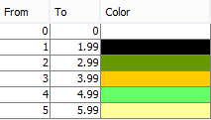
Figure 1 Model Palette

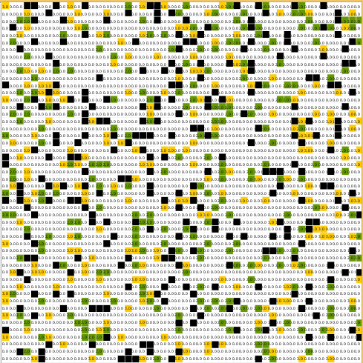
Figure 2 Initial condition of Case 1

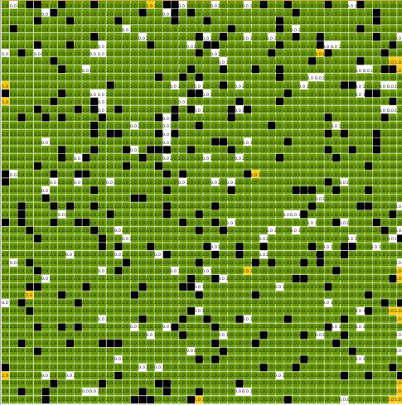
Figure 3 Final results of Case 1

As expected, dominant species c completely ejected d. Even though d can disperse faster and faster occupies empty cells, species c can eject already existing d and wins at the end

Random walls, c 100 times less than d.
In this case c occupied only 0.1% of the space, than d occupied 10%. As in the previous scenario 10% of the space occupied by wall, that distributed randomly. Figures 2, 3 and 4 illustrate initial condition, 10 seconds after and end of simulation.
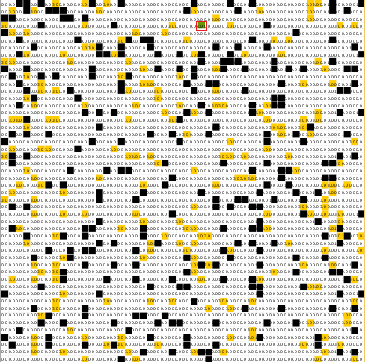
Figure 4 Case 2 Initial state

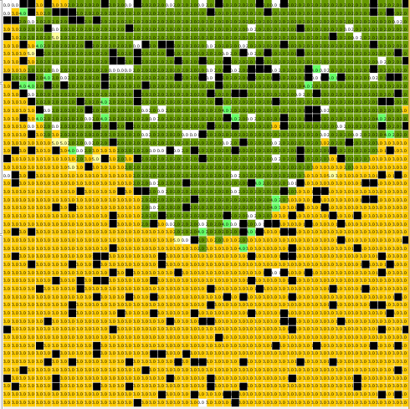
Figure 5 Model state after 10 sec. of simulation
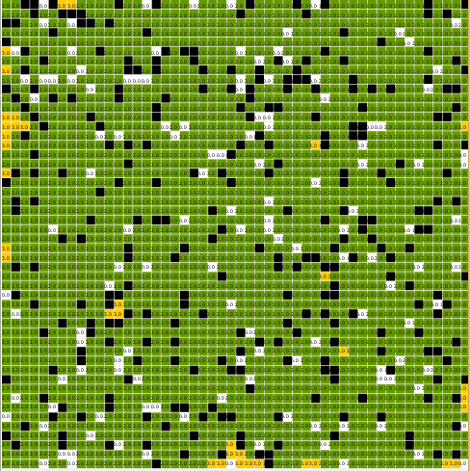
Figure 6 Case 2 – end of simulation
As simulation results shown, increasing quantity of d by 100 times doesn’t show much difference. Species c still win at the end

Custom walls, c 100 times less than d.
In this case we still defined c as occupant only 0.1% of the space, than d occupied 10%. However, unlike previous scenario, in this case we defined custom walls in order to make species obstruction for species c. Figures 5 illustrates initial condition and end of simulation.
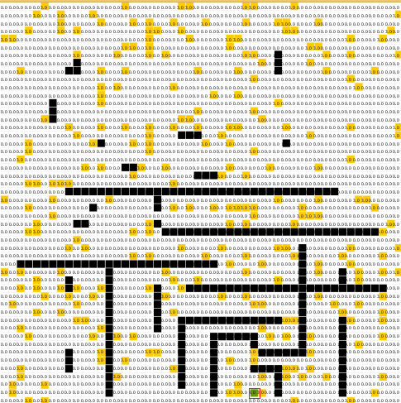
Figure 7 Case 3 - Initial state.
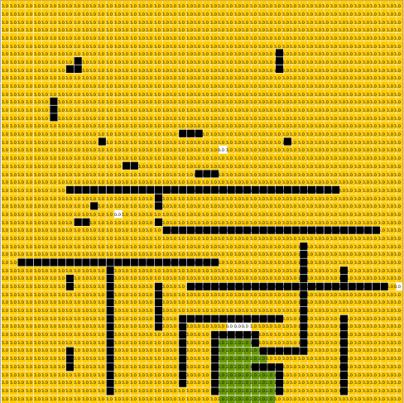
Figure 8 Case 3 - End of simulation.
Hypothetically species c should have had won again because obstacles does not block it completely. Therefore inconsistency in the model behavior with the real system have been detected. This failure can be explained by the CD++ feature to execute the global transition function only on a group of non-quiescent cells called imminent [3]. The global transition function defined as probability function, hence if on particular step probabilities of all neighbours “doesn’t work” the cell goes to quiescent state and its state variable will not compute on the next step.

Multiple state variables model description
One state variable simulations show some limitation in model behavior:
- Species coexistence conditions can be defined only by amount of available habitats and obstacles pattern.
- Asynchronous cell state definition leads to probable model behaviour inconsistency with the real system.
In order to overcome these limitations next modifications have been done:
- Utilization of Extended CD++ Specification Language for Cell-DEVS Model Definition allowed to define new state variables:
  - Level of soil watering;
  - Rain frequency;
  - Time to next rain.
- New rules were assigned in order to define changes of new variables and cell state.
- In order to force cell state computation on each step, variable delta was defined. The purpose of this definition is to change cell state value on 0.00001 only if it is stayed unchangeable after all rules execution.
Hence state value of each cell will be changed on each step. Consequently, more precise results of model execution can be achieved. However, this desired accuracy leads to higher processing time. Another problem raised by this modification is need of rewriting of all previous rules. Now, for the proper rule execution, the conditions cannot be assigned as an explicit value, instead rages of values should be assigned. All set of defined rules presented in the next section.

Formal Specification for Cell-DEVS Model with Multiple state variables.
Cell-DEVS formalism is similar to the one state variable model; however some changes are presented.
M = < X, Y, S, N, θ, d, δint, δext, τ, λ >
X = Ø
Y = Ø
S = { 0, 1, 2, 3, 4, 5 } is the state set, there:
N = neighborhood = {(-1, 1), (-1, 0), (-1, 1), (0, -1), (0, 0) (0, 1), (1, -1), (1, 0), (1, 1)}
d = 100 ms
θ - is the set of the cell’s state variables;
θ = { water, rain_freq, time_till_rain, delta }, there
water - the level of soil watering, can vary in the range
[1-100];
rain_freq - rain frequency, shows how often the rain occurs: 1-every step, 100 one in 100 steps, can vary [1-100]. This variable is assigned as an initial value and does not change during the simulation. Next simplification has been made: All rains have a same intensity and raise the amount of water in each cell to 100.
time_till_rain - Time to next rain [0-99]. There 0 shows that rain goes now, and 99 – rain will occur in 99 steps.
Delta =0.00001 - is used to change cell state value if it is stayed unchangeable after all rules execution.
In order to simplify the rules and avoid code duplication, rules for variables, which values changes on each step (water, time_till_rain) were moved to an external file and declared as macros‏.
New set of rules have been defined.
τ: N→S is defined by the following rules:
Cell cannot be occupied by Species c if level of soil watering < 60
Cell cannot be occupied by Species d if level of soil watering < 20
Species c will die if level of soil watering < 20
Species d will die if level of soil watering < 5
If a cell is occupied by c, the rate of losing water in soil is 5
If a cell is occupied by d, the rate of losing water in soil is 2
If a cell is empty, the rate of losing water in soil is 10.

Model implementation
In order to avoid complicated installation of simulation software the RISE API were used for uploading model files and running simulation online with standard HTTP requests [4]. Simulation results were retrieved from website and then run locally by using DrawLog and CD++ Modeler.
For this particular model API Lopez - an extended version of CD++ for allowing the cells to use multiple state variables, was used. Next steps were done for each simulation:
- Step 1 Creation of workspace, DCD++ service and a framework.
- Step 2 Submission of the model files to the created framework URI.
- Step 3 Run/Re-run Simulation.
- Step 4 Retrieve Simulation results.

Simulation results.
Multitude of simulations were run in order to find conditions for three different scenario of model behavior: Species c wins, Species d wins, and two species coexist in balance. Case 1 Random walls, equal amount of c and d have been chosen as a test bed for all simulations. Each scenario was implemented as a separate model file (called plantcompma_1c_x_1d_c_wins.ma, plantcompma_1c_x_1d_d_wins.ma, and plantcompma_1c_x_1d_balance.ma).
Simulation time was limited to 30 sec for every simulation.

Scenario 1. Species c wins.
In order to achieve this model behavior, next values for state variables were defined:
Water = 60. Each cell will have initial level of water in the soil equal to 60.
Rain_freq = 10. Rain will occur every 10 steps.
Time_till_raine = 10 Time till the first rain is 10 steps.
Figures 6-10 show simulation results:
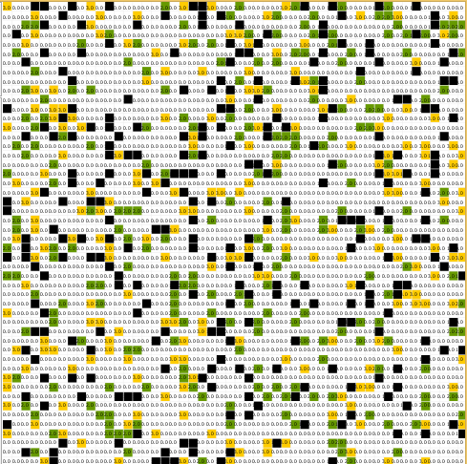
Figure 9 Scenario C wins – Initial state.

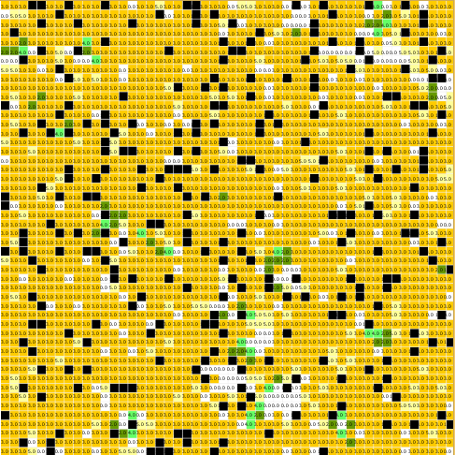
Figure 10 Scenario C wins – 10 sec of simulation.
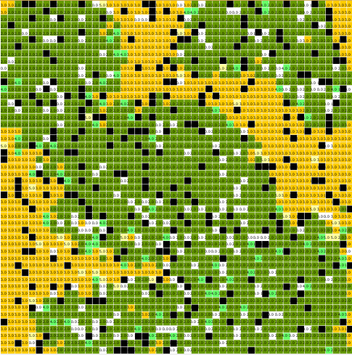
Figure 11 Figure 12 Scenario C wins – 20 sec of simulation.
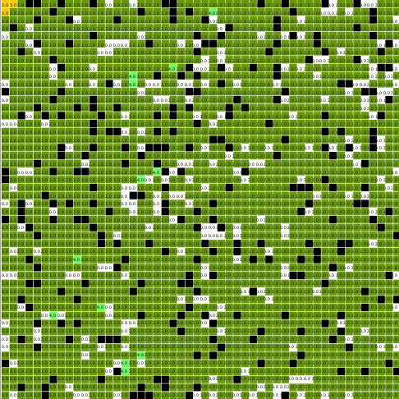
Figure 13 Scenario C wins – End of simulation.
Even though at the beginning of simulation Species c was almost dying, frequent rains and high amount of water in the cells helped it to colonize whole space at the end of simulation.
Scenario 2. Species d wins.
In order to achieve this model behavior, next values for state variables were defined:
Water = 60. Each cell will have initial level of water in the soil equal to 60.
Rain_freq = 40. Rain will occur every 40 steps.
Time_till_raine = 10 Time till the first rain is 10 steps.
Figures 11-13 show simulation results:
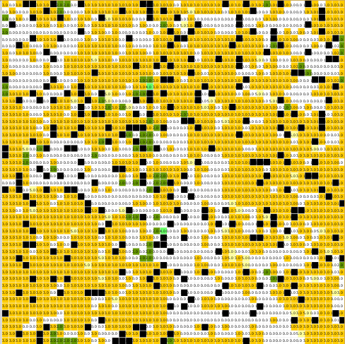
Figure 14 Scenario D wins – 10 sec of simulation.
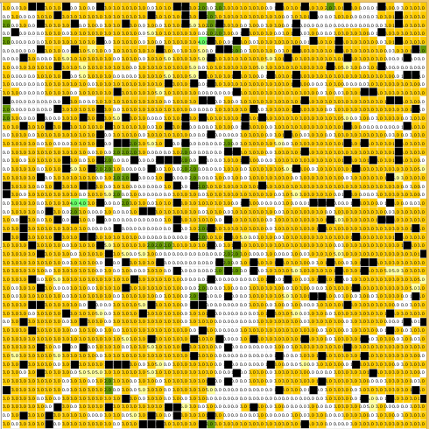
Figure 15 Scenario D wins – 20 sec of simulation.
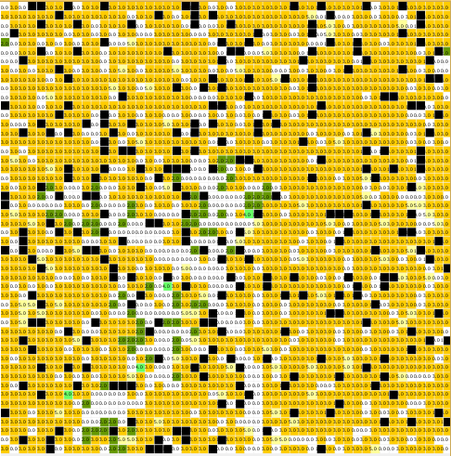
Figure 16 Scenario D wins – End of simulation.
Because the frequency of rains has been decreased, amount of water in the cells quickly drops to the point then both species die. As assigned by the rules, low water level in the cell also prevent species from propagation, hence water evaporation rate increases (water-10 for empty cell). Therefore empty cells stay empty until next rain.
Scenario 3. Two species coexist in balance..
For this scenario, next values for state variables were defined:
Water = 60. Each cell will have initial level of water in the soil equal to 60.
Rain_freq = 25. Rain will occur every 25 steps.
Time_till_raine = 10 Time till the first rain is 10 steps.
Figures 11-13 show simulation results:
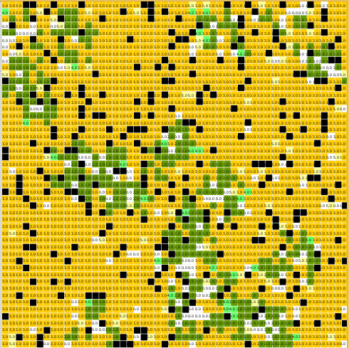
Figure 17 Scenario Two species coexist in balance – 3 sec of simulation.
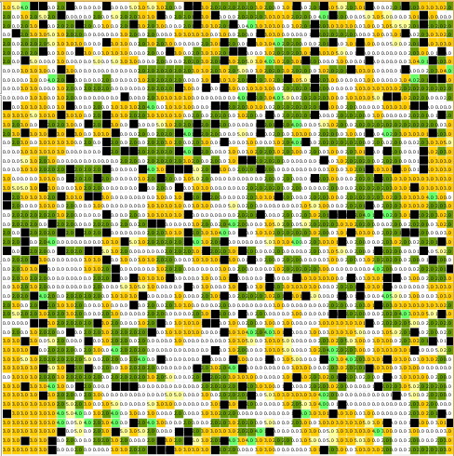
Figure 18 Scenario Two species coexist in balance – 10 sec of simulation.
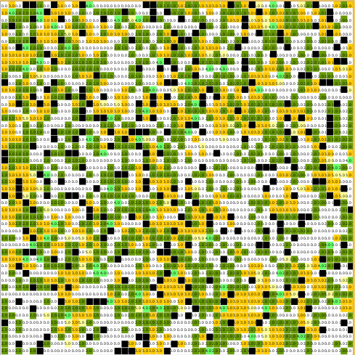
Figure 19 Scenario Two species coexist in balance – 20 sec of simulation.
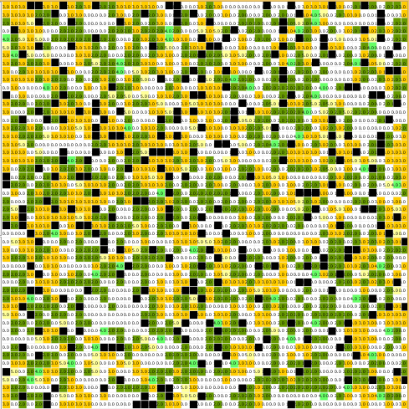
Figure 20 Scenario Two species coexist in balance – end of simulation.
This scenario depict model behavior with moderate frequency of rain, which keeps water level high enough for living and propagation for Species d, and at the same time prevent Species c from excessive colonization. As shown by simulation results, sufficient amount of cells stay empty, because of low level of water. However, further increase of rain frequency will lead to the extensive propagation of Species c.

Conclusions
This study shows how spatially explicit models with different level of nature complexity can be presented by Cell-DEVS and implemented by using CD++ modelling tool-kit. Competition of Two Plant Species model have been chosen as a spatial model example for implementation and its behavior examination under different condition. The goal of this examination was to find conditions under that the balance of two species coexistence will be reached.
In order to obtain more detailed description of model behaviour, definition of multiple variables in each cell was done by the utilization of Extended CD++ Specification Language for Cell-DEVS. In addition, in order to overcome asynchronous cell state definition, variable Delta has been defined with the purpose to force cell state computation on each step. Even though this modification led to the escalation of processing time, it helped to avoid probable model behaviour inconsistency with the real system behaviour. Various simulations were run in order to obtain balance conditions of two plant species coexistence.
This research shows high efficiency of implementation CD++ tool kit for creation sophisticated models, which can be easily adjusted according to different model parameters and external conditions. For instance, the model under the test can be easily modified for any flora and fauna species and variety of geographic areas with different climate conditions. Furthermore, this model can be also used in microbiology for microorganism reproduction simulations.

REFERENCES
- Dytham C. (1995) Competitive coexistence and empty patches in spatially explicit metapopulation models. Journal of Animal Ecology, 64, 145-146.
- Balzter H. et al (1998) Cellular automata models for vegetation dynamics. Ecological Modelling 107 113–125.
- Wainer G. A. (2009). Discrete-event modeling and simulation: A practitioner's approach. Boca Raton: CRC Press
- Wang S., Wainer G. (2014) RISE User Manual (Integrated version) retrieved from:
http://www.sce.carleton.ca

- López A., Wainer G. (2003) Extending CD++ Specification Language for Cell-DEVS Model Definition
retrieved from:
http://www.sce.carleton.ca

