Assignment #1

SYSC 5807

Methodological Aspects of Modeling and Simulation

Peter MacSween

Student # 3067237

DEVS Simulation of the Interception of Multiple Radar Transmitters by a Scanning Radar Receiver

Part I

Problem Description:

The aim of this simulation is to provide a simulation platform that can be used to examine the synchronisation effects between radar receivers and transmitters.

When using a scanning radar receiver, the interception of radar signals can be severely limited when the scan rate of the receiver becomes synchronised with a radar transmitter. Every effort must be made to generate a receiver scan pattern that limits this effect, as it seriously degrades the Probability of Intercept (POI) for the receiver.

Synchronisation occurs when a particular transmitter sends out radar pulses periodically, with the receiver scheduled to scan periodically in such a manner that the receiver is never ‘listening’ when the transmitter is transmitting. This can lead to the transmitter not being detected by the receiver, even though it may be transmitting.

Radar transmitters transmit on a particular frequency, with a particular pulse rate, azimuth, and beam width. Scanning Radar Receivers receive on a tuned frequency (for a specified duration), with a particular azimuth and beam width, and have a ‘tuning time’ associated with the change from one listening frequency to another. The sequential operation of the receiver that defines the tuned-frequency, listening-time, azimuth, and beam width are specified by a ‘scan pattern’.

Receivers can communicate with each other, with each receiver notifying the other receivers about radar transmitters that have been detected. Each receiver is connected to a simple communications bus. Each receiver maintains a tracking table containing all the information about the currently known transmitters.

Allowance must be made for future improvements to incorporate the effects of the transmission path (i.e. local geography).

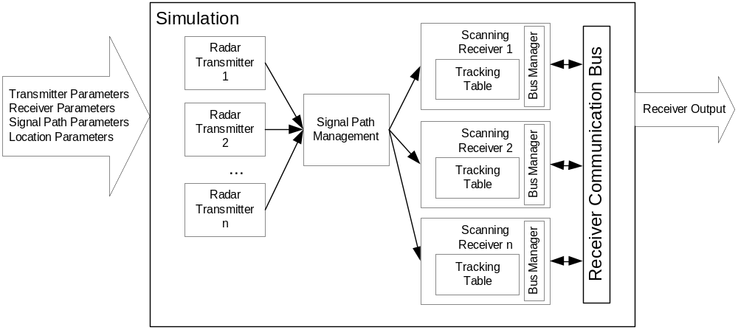Model Structure

Components:

Radar Transmitter
Location (Lat, Long)
Frequency (Hz)
Pulse Rate (pulse/sec)
Azimuth (radians)
Beam Width (radians)

Signal Path Management
Local Geography (Lat, Long, Altitude)

Scanning Receiver
Tracking Table
Bus Management
Tuned Frequency (Hz)
Listening Time (sec)
Azimuth (radians)
Beam Width (radians)
Tuning Time (sec)

Tracking Table
Transmitter ID
Detected by
Frequency
Pulse Rate

Bus Management
Send
Receive

Team Structure: Individual effort

Part II

Formal Specifications

Radar Transmitter = < S, X, Y, δ_{int}, δ_{ext}, ta, λ >
S = {Transmit, Wait}
X = {∅}
Y = { Pulse_Out }
δ_{int} =
{ δ_{int} (Transmit) = Wait;
δ_{int} (Wait) =Transmit;
}
δ_{ext} = {∅}
ta(S) =
{
ta(Transmit) = PULSE_DURATION
ta(Wait) = PULSE.PERIOD - PULSE.DURATION
}
λ(S) =
{ λ(Transmit) = Pulse_Out
}

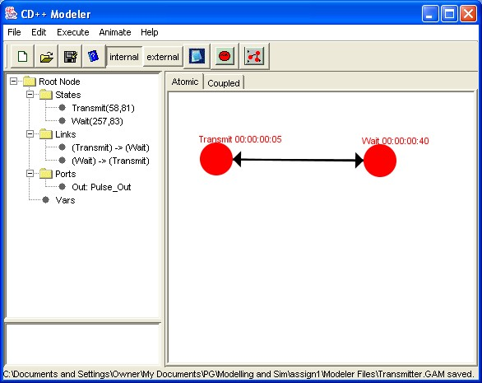
Scanning Receiver = < S, X, Y, δ_{int}, δ_{ext}, ta, λ >
S = {Scan, Signal_Detected, Process_Signal, Notify}
X = { ext_signal }
Y = { notify, detected_signal_properties }
δ_{int} =
{ δ_{int}(Signal_Detected) = Process_Signal,
δ_{int}(Process_Signal) = Notify
δ_{int}(Notify) = Scan
}
δ_{ext} =
{ δ_{ext}(Scan, ext_signal) = Signal_Detected
}
ta =
{
ta(Signal_Detected) = DETECTION_TIME
ta(Process_Signal) = PROCESS_TIME
ta(Notify) = NOTIFY_TIME
}
λ(S) =
{ λ(Signal_Detected) = notify,
λ(Process_Signal) = detected_signal_properties
}

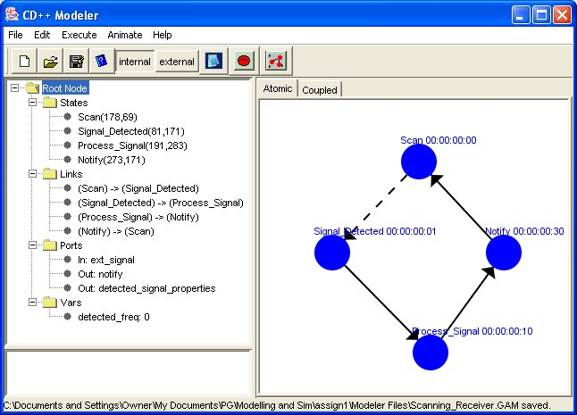
Tracking Table = < S, X, Y, δ_{int}, δ_{ext}, ta, λ >
S = {Receive_Update_From_Bus, Wait, New_Signal_Detected, Send_Update_To_Bus, Notify_New_Freq}
X = { signal_props, bus_receive_freq, bus_receive_id }
Y = { bus_send_freq, bus_send_id, new_freq }
δ_{int} =
{ δ_{int}(Receive_Update_From_Bus) = Notify_New_Freq,
δ_{int}(Notify_New_Freq) = Wait
δ_{int}(New_Signal_Detected) = Send_Update_To_Bus,
δ_{int}(Send_Update_To_Bus) = Wait
}
δ_{ext} =
{ δ_{ext}(Wait, signal_props) = New_Signal_Detected,
δ_{ext}(Wait, bus_receive_freq) = Receive_Update_From_Bus
}
ta =
{
ta(Receive_Update_From_Bus) = UPDATE_TIME,
ta(New_Signal_Detected) = PROCESS_TIME,
ta(Send_Update_To_Bus) = BUS_TIME,
ta(Notify_New_Freq) = NOTIFY_TIME
}
λ(S) =
{ λ(New_Signal_Detected) = ( bus_send_freq, bus_send_id ),
λ(Receive_Update_From_Bus) = new_freq
}

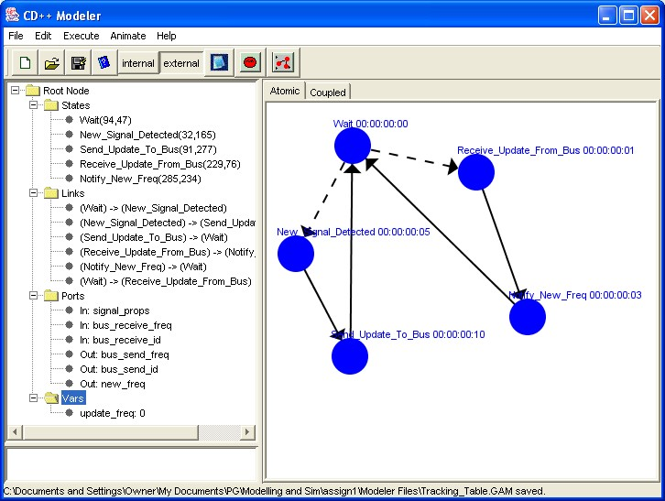
Network_Receiver = < X, Y, {M_{i}}, {I_{i}}, {Z_{ij}}, select >
X = { test_signal, bus_receive_freq, bus_receive_id }
Y = { notify, bus_send_id, bus_send_freq }
M_{i} = { Tracking_Table, Scanning_Receiver }
I_{i} ={ I(Tracking_Table) = Scanning_Receiver,
I(Scanning_Receiver) = Tracking_Table
}
Z_{ij}={ (Scanning_Receiver.detected_signal_properties, Tracking_Table.signal_props),
(Tracking_Table.new_freq, Scanning_Receiver.ext_signal)
}
select = { (Tracking_Table, Scanning_Receiver) = Scanning_Receiver
}

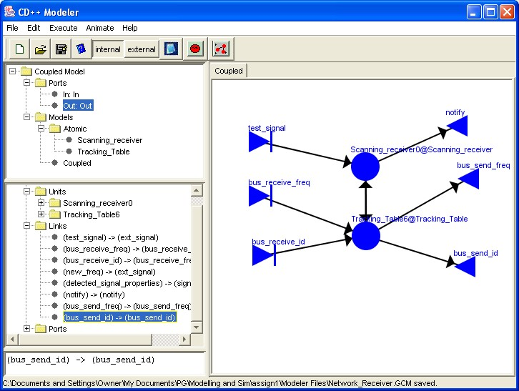
Network_Receiver_With_Transmitter = < X, Y, {M_{i}}, {I_{i}}, {Z_{ij}}, select >
X = { bus_receive_freq, bus_receive_id }
Y = { notify, bus_send_id, bus_send_freq }
M_{i} = { Transmitter, Network_Receiver }
I_{i} ={ I(Transmitter) = Network_Receiver
}
Z_{ij}={ (Transmitter.pulse_out, Network_Receiver.ext_signal),
}
select = { (Transmitter, Network_Receiver) = Network_Receiver
}

Net_Of Network_Receivers_With_Transmitters = < X, Y, {M_{i}}, {I_{i}}, {Z_{ij}}, select >
X = { ∅ }
Y = { notify1, notify2, notify3 }
M_{i} = { Transmitter(1), Transmitter(2), Transmitter(3), Network_Receiver(1), Network_Receiver(2) }

I_{i} ={ I(Transmitter(1)) = Network_Receiver(1),
I(Transmitter(1)) = Network_Receiver(2),
I(Transmitter(2)) = Network_Receiver(1),
I(Transmitter(2)) = Network_Receiver(2),
I(Transmitter(3)) = Network_Receiver(1),
I(Transmitter(3)) = Network_Receiver(2)
}
Z_{ij}={ (Transmitter(1).pulse_out, Network_Receiver(1).ext_signal),
(Transmitter(1).pulse_out, Network_Receiver(2).ext_signal),
(Transmitter(2).pulse_out, Network_Receiver(1).ext_signal),
(Transmitter(2).pulse_out, Network_Receiver(2).ext_signal),
(Transmitter(3).pulse_out, Network_Receiver(1).ext_signal),
(Transmitter(3).pulse_out, Network_Receiver(2).ext_signal)
}
select = { (Transmitter(i), Network_Receiver(j)) = Network_Receiver(j)
}
where:
i = { x  N: 1  x  3 }
j = { x  N: 1  x  2}

Testing Strategy (Atomic):

Transmitter:
Ensure correct state transitions and corresponding outputs
Log state transitions and associated times
Ensure:
λ(Transmit) = Pulse
λ(Wait) = ∅

Scanning_Receiver:
Ensure correct state transitions and corresponding outputs
Log state transitions and associated times
Ensure:
λ(Signal_Detected) = notify
λ(Process_Signal) = detected_signal_properties
λ(Scan) = ∅

Tracking_Table:
Ensure correct state transitions and corresponding outputs
Log state transitions and associated times
Ensure:
λ(New_Signal_Detected) = ( bus_send_freq, bus_send_id )
λ(Receive_Update_From_Bus) = new_freq
λ(Wait) = ∅

Testing Strategy (Coupled):

Network_Receiver:
Log state transitions and associated times
Ensure:
λ(detected_signal_properties)@Scanning_Receiver triggers X(signal_props)@Tracking_Table
λ(new_freq)@Tracking_Table triggers X(ext_signal)@Scanning_Receiver

Network_Receiver_With_Transmitter:
Log state transitions and associated times
Ensure:
λ(Pulse_Out)@Transmitter triggers X(ext_signal)@Scanning_Receiver
λ(detected_signal_properties)@Scanning_Receiver triggers X(signal_props)@Tracking_Table
λ(new_freq)@Tracking_Table triggers X(ext_signal)@Scanning_Receiver

Net_Of_ Network_Receiver_With_Transmitter:
Log state transitions and associated times
Ensure:
λ(Pulse_Out)@Transmitter(i) triggers X(ext_signal)@Scanning_Receiver(1..n)
λ(detected_signal_properties)@Scanning_Receiver(j) triggers (signal_props)@Tracking_Table(j)
λ(new_freq)@Tracking_Table(j) triggers X(ext_signal)@Scanning_Receiver(1..m)
where:
m = number of Transmitters
n = number of Network_Receivers
i = { x  N: 1  x  m }
j = { x  N: 1  x  n}
Test the following scenarios:
Transmitters send on frequencies which are not being scanned
Transmitters send on frequencies which are scanned by Network Receiver #1 only
Transmitters send on frequencies which are scanned by Network Receiver #2 only
Transmitters send on frequencies which are scanned by both Network Receivers

Testing Results (Atomic):

Transmitter:

Scenario: Pulse at 22kHz, Pulse Width = 3 ms, Pulse Interval = 30 ms
Output File | Comments
00:00:00:000 out 22000 | start of a pulse with frequency = 22 kHz
00:00:00:003 out 0 | End of pulse (width = 3 ms)
00:00:00:030 out 22000 | start of a pulse with frequency = 22 kHz (interval = 30 ms)
00:00:00:033 out 0  00:00:00:060 out 22000  00:00:00:063 out 0  00:00:00:090 out 22000  00:00:00:093 out 0  00:00:00:120 out 22000  00:00:00:123 out 0  00:00:00:150 out 22000  00:00:00:153 out 0  00:00:00:180 out 22000  00:00:00:183 out 0  00:00:00:210 out 22000  00:00:00:213 out 0  00:00:00:240 out 22000  00:00:00:243 out 0  00:00:00:270 out 22000  00:00:00:273 out 0  00:00:00:300 out 22000 | The rest of the pulses, with correct PW and PRI
State transitions and corresponding outputs are correct (see .log file for details)
The following was verified:
λ(Transmit) = Pulse
λ(Wait) = ∅

Scanning_Receiver:

Scenario: Receiver set to listen for pulses between 18kHz and 25kHz
Event File | Output File | Comments
00:00:10:00 test_signal 10000 |  | Pulse received, but not in listening range
00:00:30:00 test_signal 11000 |  | Pulse received, but not in listening range
00:01:00:00 test_signal 22000 | 00:01:00:001 notify 1 | Notify that a signal was received
00:01:00:00 test_signal 22000 | 00:01:00:011 props 22000 | Output the detected frequency
00:01:00:00 test_signal 22000 | 00:01:00:041 notify 0  00:01:00:041 props 0 | Reset the outputs
00:02:20:00 test_signal 23000 | 00:02:20:001 notify 1 | Notify that a signal was received
00:02:20:00 test_signal 23000 | 00:02:20:011 props 23000 | Output the detected frequency
00:02:20:00 test_signal 23000 | 00:02:20:041 notify 0  00:02:20:041 props 0 | Reset the outputs

State transitions and corresponding outputs are correct (see .log file for details)

The following was verified:
λ(Signal_Detected) = notify
λ(Process_Signal) = detected_signal_properties
λ(Scan) = ∅

Tracking_Table:

Scenario: Test that a signal is recorded and a bus message is sent (4 times), then test that bus messages are received correctly (2 times)
Event File | Output File | Comments
00:00:10:00 sp 10000 | 00:00:10:005 bs_id 2  00:00:10:005 bs_freq 10000  00:00:10:015 nf 0  00:00:10:015 bs_id 0  00:00:10:015 bs_freq 0 | After 5 ms, message is sent to bus  After 10 ms more, outputs reset
00:00:30:00 sp 11000 | 00:00:30:005 bs_id 2  00:00:30:005 bs_freq 11000  00:00:30:015 nf 0  00:00:30:015 bs_id 0  00:00:30:015 bs_freq 0 | After 5 ms, message is sent to bus  After 10 ms more, outputs reset
00:01:00:00 sp 12000 | 00:01:00:005 bs_id 2  00:01:00:005 bs_freq 12000  00:01:00:015 nf 0  00:01:00:015 bs_id 0  00:01:00:015 bs_freq 0 | After 5 ms, message is sent to bus  After 10 ms more, outputs reset
00:02:20:00 sp 13000 | 00:02:20:005 bs_id 2  00:02:20:005 bs_freq 13000  00:02:20:015 nf 0  00:02:20:015 bs_id 0  00:02:20:015 bs_freq 0 | After 5 ms, message is sent to bus  After 10 ms more, outputs reset
00:03:40:00 brf 21000  00:03:40:00 brid 2 | 00:03:40:001 nf 21000  00:03:40:004 nf 0  00:03:40:004 bs_id 0  00:03:40:004 bs_freq 0 | After 1 ms, message is read and the new freq is available  Outputs reset
00:03:55:00 brf 22000  00:03:55:00 brid 3 | 00:03:55:001 nf 22000  00:03:55:004 nf 0  00:03:55:004 bs_id 0  00:03:55:004 bs_freq 0 | After 1 ms, message is read and the new freq is available  Outputs reset

State transitions and corresponding outputs are correct (see .log file for details)
The following was verified:
λ(New_Signal_Detected) = ( bus_send_freq, bus_send_id )
λ(Receive_Update_From_Bus) = new_freq
λ(Wait) = ∅

Coupled Testing Results:

Network_Receiver:
Scenario: Test the reaction to a signal (once) and to bus messages (once)
Event File | Output File | Comments
00:00:10:00 test_signal 19000 | 00:00:10:001 notify 1 | Notification made after 1 ms
00:00:10:00 test_signal 19000 | 00:00:10:016 bs_id 2  00:00:10:016 bs_freq 19000 | Bus signal sent after 15 ms
00:00:10:00 test_signal 19000 | 00:00:10:026 bs_id 0  00:00:10:026 bs_freq 0 | Reset outputs
00:00:10:00 test_signal 19000 | 00:00:10:041 notify 0 | Reset outputs
00:03:55:00 brf 22000  00:03:55:00 brid 3 | 00:03:55:002 notify 1 | Notification made after 1 ms
00:03:55:00 brf 22000  00:03:55:00 brid 3 | 00:03:55:004 bs_id 0  00:03:55:004 bs_freq 0 | Inputs reset
00:03:55:00 brf 22000  00:03:55:00 brid 3 | 00:03:55:017 bs_id 2  00:03:55:017 bs_freq 22000 | Second bus message sent (see notes on spec problem)
00:03:55:00 brf 22000  00:03:55:00 brid 3 | 00:03:55:027 bs_id 0  00:03:55:027 bs_freq 0 | Reset outputs
00:03:55:00 brf 22000  00:03:55:00 brid 3 | 00:03:55:042 notify 0 | Reset outputs

State transitions and corresponding outputs are correct (see .log file for details)
There is a problem with the specification of the network receiver – currently, signal information that is received by the bus is sent to the scanning receiver, which treats it like an external signal, thus causing a second bus transmission. The specification should be corrected so that signal information is not re-sent over the bus.
The following was verified:
λ(detected_signal_properties)@Scanning_Receiver triggers X(signal_props)@Tracking_Table
λ(new_freq)@Tracking_Table triggers X(ext_signal)@Scanning_Receiver

Network_Receiver_With_Transmitter:

Scenario: Transmitter sends out pulses at 24kHz, Pulse width of 5 ms, Pulse interval of 40 ms. Bus Message at t=20 ms. Receiver listening between 22kHz and 25kHz.
Event File | Output File | Comments
00:00:00:20 brf 19000  00:00:00:20 brid 3 | 00:00:00:001 notify 1  00:00:00:016 bs_id 1  00:00:00:016 bs_freq 24000  00:00:00:026 bs_id 0  00:00:00:026 bs_freq 0  00:00:00:041 notify 0  00:00:00:081 notify 1  00:00:00:096 bs_id 1  00:00:00:096 bs_freq 24000  00:00:00:106 bs_id 0  00:00:00:106 bs_freq 0  00:00:00:121 notify 0  00:00:00:161 notify 1  00:00:00:176 bs_id 1  00:00:00:176 bs_freq 24000  00:00:00:186 bs_id 0  00:00:00:186 bs_freq 0  00:00:00:201 notify 0  00:00:00:241 notify 1  00:00:00:256 bs_id 1  00:00:00:256 bs_freq 24000  00:00:00:266 bs_id 0  00:00:00:266 bs_freq 0  00:00:00:281 notify 0 | Notifications and associated bus messages sent  Input bus message is ignored by receiver because it is outside the listening range.

State transitions and corresponding outputs are correct (see .log file for details)
The following was verified:
λ(Pulse_Out)@Transmitter triggers X(ext_signal)@Scanning_Receiver
λ(detected_signal_properties)@Scanning_Receiver triggers X(signal_props)@Tracking_Table
λ(new_freq)@Tracking_Table triggers X(ext_signal)@Scanning_Receiver

Net_Of_ Network_Receiver_With_Transmitter:

Scenario: Transmitters send on frequencies which are not being scanned:
Output File | Comments
 | No output – no frequency in the scanning range

Scenario: Transmitters send on frequencies which are scanned by Network Receiver #1 only
Output File | Comments
00:00:00:001 notify1 1  00:00:00:041 notify1 0  00:00:00:081 notify1 1  00:00:00:121 notify1 0  00:00:00:161 notify1 1  00:00:00:201 notify1 0  00:00:00:241 notify1 1  00:00:00:281 notify1 0 | Receiver #1 only generated results.

Scenario: Transmitters send on frequencies which are scanned by Network Receiver #2 only
Output File | Comments
00:00:00:001 notify2 1  00:00:00:041 notify2 0  00:00:00:051 notify2 1  00:00:00:091 notify2 0  00:00:00:101 notify2 1  00:00:00:141 notify2 0  00:00:00:151 notify2 1  00:00:00:191 notify2 0  00:00:00:201 notify2 1  00:00:00:241 notify2 0  00:00:00:251 notify2 1  00:00:00:291 notify2 0 | Receiver #2 only generated results

Scenario: Transmitters send on frequencies which are scanned by both Network Receivers
Output File | Comments
00:00:00:001 notify1 1  00:00:00:001 notify2 1  00:00:00:041 notify1 0  00:00:00:041 notify2 0  00:00:00:051 notify2 1  00:00:00:081 notify1 1  00:00:00:091 notify2 0  00:00:00:101 notify2 1  00:00:00:121 notify1 0  00:00:00:141 notify2 0  00:00:00:151 notify2 1  00:00:00:161 notify1 1  00:00:00:191 notify2 0  00:00:00:201 notify1 0  00:00:00:201 notify2 1  00:00:00:241 notify1 1  00:00:00:241 notify2 0  00:00:00:251 notify2 1  00:00:00:281 notify1 0  00:00:00:291 notify2 0 | Both receivers generate results (note differing periods for transmitted signals)

State transitions and corresponding outputs are correct (see .log file for details)
The following was verified (for each scenario):
λ(Pulse_Out)@Transmitter(i) triggers X(ext_signal)@Scanning_Receiver(1..n)
λ(detected_signal_properties)@Scanning_Receiver(j) triggers (signal_props)@Tracking_Table(j)
λ(new_freq)@Tracking_Table(j) triggers X(ext_signal)@Scanning_Receiver(1..m)
where:
m = number of Transmitters
n = number of Network_Receivers
i = { x  N: 1  x  m }
j = { x  N: 1  x  n}

.
Analysis of Results:

The models performed as desired by the specifications. A problem with the specification of the network receiver was revealed while testing and needs to be fixed. The tracing of the signals that are received by the network receivers becomes very difficult when numerous signals are transmitted and the receivers start to share information.

The use of the formal specification defining the atomic and coupled model behaviour was very useful in debugging the models when they were implemented. The iterative procedure of updating the formal spec, then updating the implementation was quite efficient – with problems mostly occurring when this procedure was not followed. Following these iterations resulted in the models matching the specifications.

Several changes were made to the original specification. The Signal Path Management and Bus Manager functions were found to be redundant within the scope of the assignment. Signal Path Management was originally intended to provide an upgrade path for the model, but it was found that the connection and addition of extra models (components) was relatively simple, and will easily allow for the Signal Path Management model in the future. The Bus Manager was removed to reduce the complexity of tracking the information shared between the Network Receivers. Since no target bus was simulated, the Bus Manager would simply act as a large interconnect (with no value added). Instead, the various bus outputs and inputs were directly connected together (which reduced the amount of redundant information sent to the .log files).

The final model was as follows:

