Track Analysis of Radar Targets using Cell-DEVS
Elizabeth Hosang
SYSC, Carleton University
Ottawa, Canada
eahosang@carleton.ca

Abstract— Cellular Automation is a technique for performing analysis by breaking down a problem into smaller pieces and processing the smaller pieces. This technique has been used in image processing to reduce noise and identify edges. This paper attempts to apply Cellular Automata to the problem of track identification in a simulated radar system. The technique is implemented using the Cell-DEVS tool, which models Cellular Automata. Track IDs are assigned by defining rules that make assumptions about the behaviour of the targets. Simple targets are used to evaluate and test the rules for track identification. Some problems were encountered with the implementation. Once the problems were addressed, the simulation was successful. The results show promise for simple targets.

Keywords— Radar, Cellular Automata, Track Identification, Cell-DEVS
- Introduction
In Science and Engineering there are a number of real-world problems that need to be studied and analysed using intensive processing. Some of these problems can be represented by defining the problem as a cell space, and performing analysis or simulation on the individual cells. This technique, Cellular Automation, can be used to break the processing down into smaller, more manageable tasks. This can allow the problem to be simplified, as the processing can be done by analysing only a small portion of the overall cell space. It also allows the problem to be analysed using parallel processing. Among other areas, Cellular Automation has been applied to the problems of image processing and computer vision. It has been applied to noise reduction and border detection [1], medical image processing [3] and greyscale image processing [4].

In radar systems, sensors produce a sequence of images showing the location of objects within an area of interest. From one image to the next, the location of a given object must be tracked by assigning it a unique Track ID so that the human operator can identify where the object has been and where it is moving to. The problem of track identification has been dealt with using a number of techniques in which current possible locations of an already identified object are evaluated [6]. This paper proposes that the problem of track identification could be handled by considering the area of interest as an image and applying cellular automation techniques to analyse the positions of the targets. The problem is investigated using the Cell-DEVS tool.

- Background
- Cellular Automata
The fundamental premise of cellular automata is to approach solving a problem by breaking it down into smaller components that can be solved individually. Each of the smaller components, or cells, can be represented as a model with a distinct state value. Over a number of iterations, the value of the state of a particular cell C is re-evaluated by examining the value of the cells in the neighbourhood around C. In turn the state value of the cell C at the start of the iteration is an input to the state calculation of other cells, where C is part of their neighbourhood. In this way the state of each cell is calculated based on the current state of its neighbouring cells. The new cell values come into effect on the next iteration through the cell space. The definition of the cell space therefore includes the rules that determine how the input of neighbouring cell states affect the next value of a given cell’s state, and the set of cells that make up the neighbourhood of a cell.

The rules governing the change of state, as well as the set of cells around a given cell that constitute the set of input values, or neighbourhood, depend on the nature of the problem being studied. By varying the rules and the neighbourhood definitions, a variety of problems can be studied using simulations made up using cellular automata.

The Cell-DEVS tool is used to define cellular automata and simulate the execution of the resulting model. It is based on the Discrete Event System Specifications (DEVS) technique for simulating systems as a set of atomic models. Each atomic model has its own state value, input and output functions, and input and output ports. Multiple atomic models can be coupled together to form more complex systems.

The DEVS tool provides a framework for creating and coupling atomic models. The Cell-DEVS tool builds on the DEVS tool. It models each cell as a separate atomic model. The tool allows the definition of a cellular automata model by specifying the following values:
- the size of the cell space
- the neighbourhood of a cell
- the rules for evaluating the value of a cell
- the initial values of the cells
- zones within the cell space. The cells within this zone may use a different set of rules
- the treatment of cells on a border, which may not have the same size and shape neighbourhood as those on the interior of the cell space.
- coupling of cells to exterior atomic models which may provide input or receive output from cells within the cell space.

The size of a 2 dimensional cell space is a rectangle. More complex cell spaces may be 3 dimensional, with each layer in the cell space representing a different value.

The neighbourhood of a cell is defined in relation to the position of the cell being evaluated. The cell being evaluated is at position (0,0). Typical models include Von Neumann, where the neighbourhood is all of the cells in a straight line from a cell, e.g. (-1,0), (1,0), (0,-1), (0,1).

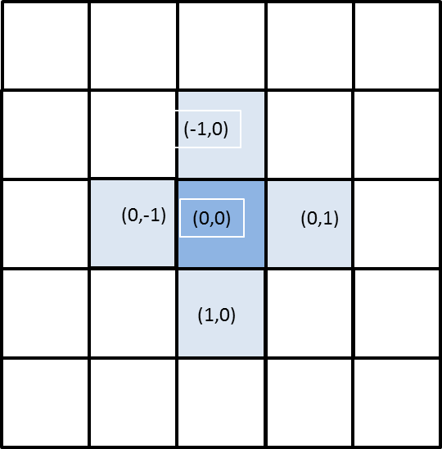
Figure 1 Von Neuman Neighbourhood
Each cell is an individual atomic model. Each cell has an output port for its own state value, and one input port for each cell in the neighbourhood. If the current value of the cell is to be included in the calculation of the next value of the cell, the cell itself must be included in the neighbourhood definition so that an input port will be defined for the cell’s own value.

The rules for evaluating the next state of a cell are defined as
POSTCONDITION DELAY { PRECONDITION }

The expression in the PRECONDITION is evaluated to determine whether it is true. If it is true, the expression in the POSTCONDITION is evaluated and the result is used as the new state value of the cell after the DELAY. The expressions in the pre- and post-conditions may include any of the values from the cells in the neighbourhood. The rules are evaluated from the first listed to the last until one of them is found to be true. Once a rule is found with a PRECONDITION that is true, no other rules are evaluated. This means that the order in which the rules are defined assigns an order of priority to the rules. One of the rules must always evaluate to be true. For this reason the final rule is usually defined with a PRECONDITION of true.

Each group of rules is preceded by a label. This label is used to identify which set of rules is used by which cells.

The initial values of the cells may be specified in a number of ways. A single default value may be specified that is assigned to all cells. A range of cells may be identified and their initial values explicitly set. Alternately the name of a file may be given, where the file contains the initial values for all of the cells. This technique allows the same model to be run with different initial values.

A zone may be defined by specifying a range of cells. The rules used by the cells in this zone may be different from those used by default by the rest of the cells in the cell space. The definition of the zone includes the label on the rules to be used in that zone.

The cells on the border of the cell space are not surrounded by cells on all sides. Their neighbourhood will likely not be the same as those on the interior of the cell space. For this reason the definition of the cell space includes an indication of how the cells on the border are to be treated. Wrapped borders are handled by treating the cells on the opposite side of the cell space as if they are adjacent to the border cells. If the borders are not wrapped, the cells are considered to have no neighbours on that side. In the case of a simulated entity moving across a cell space, the entity is considered to have left the space when it moves off the edge of the grid.

In addition to the input ports connecting to the outputs of the neighbour cells, a cell may have an input port that connects to the output port of another model, either atomic or coupled. This model is said to be coupled to the cell space. For example, in a model of the spread of the temperature in a room, an input port may be defined for the heating vent. Whenever the other model puts an output on its port, the value is included in the evaluation of the pre-conditions for the rule set.
- Use in Image Processing
Cellular Automata have been used in a variety of problems, including image processing [1], [2], [3], [4], and [5]. Among the problems solved by cellular automata is noise reduction. Individual pixels of an image may be evaluated by comparing them to the neighbouring pixels. If the pixel does not match the states of its neighbours, it may be determined to be noise, that is, a random bit of static, and cleaned up to improve the image.

Similarly, cellular automata may be used to detect a contour where physical aspects of the image change. Such a contour may represent a border or boundary between two objects in the image.

This ability to break a region down into discrete portions that can be compared to each other for differences suggests that cellular automata can be used to identify the tracks of objects as they move across an area of interest.
- Radar Analysis and Track Identification Assignment
One problem in the field of engineering involves identifying targets in a radar’s area of interest. The position of all of the targets is determined by a sensor emitting an electro-magnetic pulse. When the pulse encounters a target, it bounces back to antennas that are co-located with the emitting portion of the sensor. The time between the pulse being emitted and the signal bouncing back is used to calculate the distance to the target. The direction of the returning signal is used to determine the direction of the target relative to the sensor. This information is presented as a static image on the operator’s view screen. The sensor emits another pulse and the view screen is updated with the location of the targets at the time of the next pulse. The time between pulses must be calibrated so that it is appropriate to the anticipated speed of the targets, i.e. so that the distance travelled between the two pulses is not excessive. For example, the pulse interval of a radar designed to detect aircraft will be shorter than the time interval of radar used to detect weather patterns.

To simplify the job of the radar operator, radar systems assign Track Identifiers to each of the targets in the area of interest. To do this the software must match the target locations in one radar image with the locations of the target locations shown in the next sweep. This involves the calculation of smooth curves based on a number of factors, including the time between pulses of the sensor as discussed in [6].

- Ants Behaviour Modelling
Cellular Automata have also been used to simulate the behaviour of entities in a natural system. These models include ants moving across a field [7] and people evacuating a ship [8]. In these models, the rules define where an entity may move to next based on assumptions about its behaviour. The models may include rules about the territory across which the entities move, enticements such as food or a pheromone trail, or encounters with other entities, such as when two entities attempt to occupy the same space.

- Track Identification Model
- Migrating Track ID Assignment to a Cell Space Model
This paper proposes that by dividing the radar area of interest into a grid, the entire area can be made into a cell space. Two layers are used, one for the targets that are being tracked, and one for the track ids. Each layer has its own rules. The rules in the Target layer govern the movement of targets. For the sake of this paper simple targets with simple rules of movement are used. The rules in the Track ID layer are used to identify the targets based on their movement. In a twist on the modelling of entities moving in a natural system, the rules in the Track ID layer derive the identity of a target based on where the target may have come from, rather than determining where the target is moving to.

- Target Behaviour Rules
In order to develop the rules for track identification, a controlled set of targets was required. The behaviour of the targets was kept simple to facilitate the development of the model.

The following rules were used for target movement:
- Targets move in straight lines only: top to bottom or left to right across the cell space. There is no diagonal movement across the cell space.
- The time it takes for a target to cross one grid square is equal to the time period between sensor sweeps. That is, the radar measures the movement of the targets across one grid square.
- The speed of the targets is constant.
- The terrain across which the targets move does not affect their movement, e.g. does not slow them down or make them turn.
- At regular intervals, the targets make right-angled turns.
- If two targets want to move into the same cell, only one target moves into the cell. The other target remains stationary. This rule was added based on the results obtained during execution of the model. See the section K Problems encountered

The cell state on the target layer is a number representing the direction in which the target is moving. When the target changes direction, the cell value changes to represent the new direction of movement. The directions are shown in the figure below.

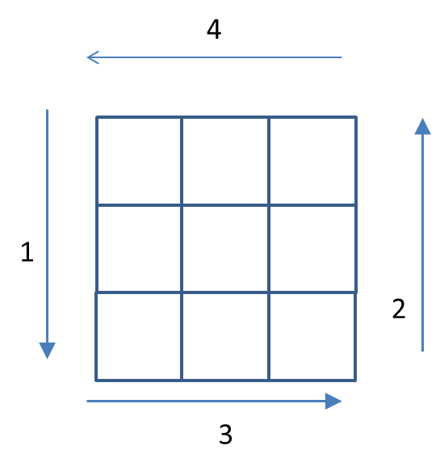
Figure 2 Target Direction of Movement

Movements of the targets are shown in Figure 3 Typical Target Motion.

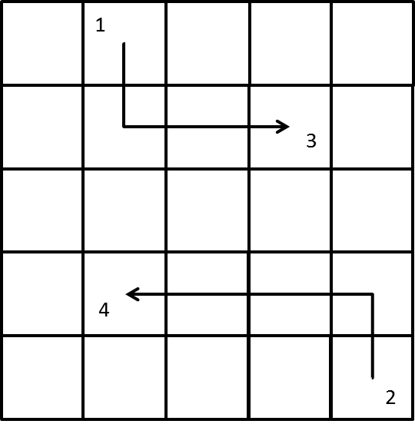
Figure 3 Typical Target Motion

Targets are created by attaching generators to cells on each edge of the cell space. At regular intervals each generator creates a target by providing an exterior input to the cell. The value of the cell is set so that the target proceeds in a direction perpendicular to the edge of the cell, moving across the cell space.

Modelling cellular automata using the Cell-DEVS tool is done by defining rules that govern the setting of the cell state value. The rules are executed on each cell, checking the values of the neighbouring cells to determine what the next state of the cell should be. In the case of the target layer, the rules determine whether a cell should be occupied or not. The rules are defined to check the value of the neighbouring cells. The neighbourhood of the target cells is the same as the neighbourhood of the Track ID cells: a Von Neumann neighbourhood, as shown in Figure 4 Target Layer Neighbourhood.

Figure 4 Target Layer Neighbourhood
Each neighbour is checked for its direction to determine whether its target would move into this cell. The rules check the following conditions:
- whether (-1,0) is moving from top to bottom (value 1)
- whether (1,0) is moving from bottom to top (value 2)
- whether (0,-1) is moving from left to right (value 3)
- whether (0,1) is moving from right to left (value 4)

This order implies a priority of the direction of movement. This is not a significant component of the model, but rather an artefact of the way the tool is implemented.

- Track Identification Rules
Layer 1 contains the track identifiers. The rules are defined based on assumptions about the behaviour of the targets. They were written based on the likely movement of targets based on the rules for the target layer, but are not tied to the rules of the target layer. The intent is to create rules which are independent of the details of the behaviour of the target layer, so that different sets of rules could be used for the target layer.

While the simple targets used initially do not back up, other potential target systems may involve this type of motion, either backing up or performing a tight U-turn. The targets may also remain in the same cell for one or more sensor sweeps.

Despite the attempt to keep the track ID rules as generic as possible, two assumptions are made about the movements of the targets:

- Targets move across one cell per sensor sweep.
- Targets do not move diagonally.

Because of these assumptions, the neighbourhood used on the target layer is a Von Neumann neighbourhood, as shown in Figure 5 Track Id Layer Neighbourhood.

The most important condition in the Track ID layer is that the corresponding cell in the Target layer is occupied by a target. This condition is included in the pre-conditions for all of the rules in the Track ID layer. For this reason the cell below the track layer cell is included in the neighbourhood.

Figure 5 Track Id Layer Neighbourhood

As mentioned previously, the rules in a Cell-DEVS model are evaluated in the order in which they are defined in the implementation of the cell model. As soon as the conditions of a rule are met, the value in the output for the rule is used to set the cell’s value. No further rules are evaluated. This processing of rules gives a priority to possible cell values. While this order was not significant in the Target layer, it becomes important in the Track ID layer. Rules that map to more likely behaviour of a target are automatically evaluated first. For different types of targets, the ordering may need to be changed. Targets in an urban environment such as cars or pedestrians are most likely to continue in a straight line, or make a single ninety degree turn. Targets in a simulation of insects may be more likely to hold still or make erratic turns.

The test for the presence of a target does not check the planned direction of the target. Instead, the Track ID rules test for previous locations of targets by checking the state values of the neighbouring cells on the Track ID layer. The state values contain both the unique Track ID and an indication of the direction in which the target last moved. The current state of the cells represents the previous locations of the targets.

On each pass through the cell space, which corresponds to a sensor sweep, the values of the cells in the Track ID layer are evaluated to determine where the targets have moved. For each cell which has a target in the corresponding target layer, the neighbouring cells on the Track ID layer are tested for an existing Target ID.

For the radar simulation, the assumed rules of behaviour are:

1. Continue in a straight line
2. Make a ninety degree turn and continue in a straight line
3. Stop moving

The most common direction of movement is assumed to be a figure continuing to move ahead in a straight line, as shown in the figure below.

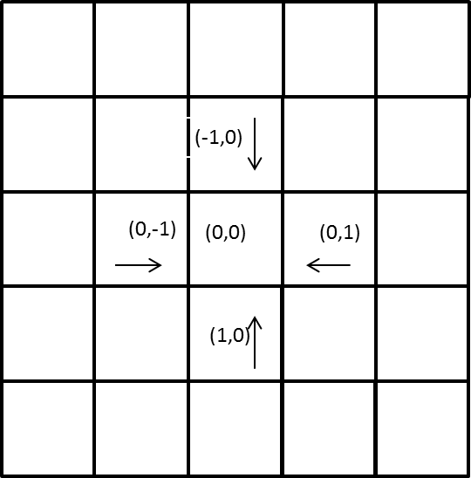

Figure 6 Tests for target moving straight ahead

The test for moving straight ahead examines the cells from which the current target might have come. If the cell contains a track id, the direction of movement of that Track ID is checked.

- The target in cell (-1,0) is checked to see if it was moving from top to bottom (value 1)
- The target in cell (1,0) is checked to see if it was moving from bottom to top (value 2)
- The target in cell (-1,0) is checked to see if it was moving from left to right (value 3)
- The target in cell (1,0) is checked to see if it was moving from right to left (value 4)

If no Track IDs meet any of the previous criteria, the next test is for Track IDs of a target that may have made a ninety degree turn. The tests for this case consider Track IDs of targets that were moving in a perpendicular direction to the current location of the target. The tests are shown in Figure 7 below.

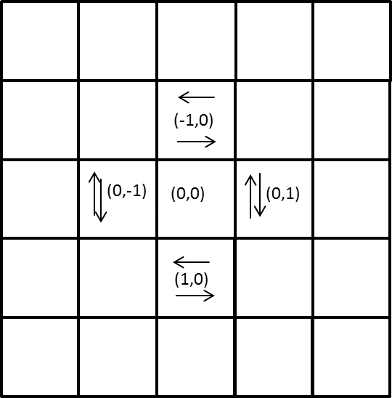
Figure 7 Tests for 90 degree turn

If none of the pre-conditions for these rules are satisfied, the rules check to see if the current cell was previously occupied, i.e. if the cell’s own state was non-zero in the previous iteration. If so, the state value remains unchanged.

If there are no Track IDs in any of the cells in the neighbourhood, this target is assumed to be new, and a new Track ID is allocated to it.

- Track Model Implementation- Cell-DEVS model
The value of a cell in the Track ID layer represents two values: the unique identifier for the track, and the direction in which the target moved on the last sensor sweep. The Cell-DEVS model only allows for each cell to have a single value. The implemented model uses a double. The Track ID is the integer part of the number. The decimal part of the number represents the direction in which the target last moved.

The unique track identifier is generated when a target is identified that cannot be linked to an existing Target ID. The Track ID is generated using a random integer between 10 and 50.

The test for the presence of a target is implemented as a macro in a separate file. This allows the test to be modified if a new set of target rules is defined. The implemented test is a check for a cell value greater than zero. A cell with a zero state space is empty. The actual value of the cell is not considered by the Track ID rules.

The rules are defined in groups that make up the tests for the rules of similar assumed behaviour. The first four rules are the tests for targets continuing in straight lines. Within the group, there is not a single rule for straight line travel, but rather a separate rule for each direction in which a target may travel, declared one after another. This means that there is an implied priority in the directions of travel. However, this is not intentional, but rather an artefact of the implementation of the Cell-DEVS model.

Since the model is simulating calculations performed for each sweep of a sensor, the timing across the model is constant. That is, the delay for each of the rules is the same. 100 ms was selected for convenience. The simulation is run for a total of ten seconds, not in anticipation of an expected outcome at a particular time, but to allow time for the behaviour of the system to be evaluated.

The borders of the cell space are not wrapped: targets come and go across the area of interest represented by the cell space.

- Advanced CD++ Implementation
Problems were encountered with the execution of the CD++ tool. As a result the rules were not evaluated using this tool.

The CD++ tool allows the specification of multiple values in each cell space. This would allow the Track ID and the Direction to be stored as two separate integers instead of using double values. This would reduce the complexity of the rules, as the Track ID and direction indicator would not need to be separated in the pre-condition and then re-combined in the post-condition.

- Analysis
- Execution Behaviour
The simulation is run for ten seconds. The simulation time is arbitrary, since running for longer time does not provide more information: the targets move across the grid space and exit when they reach another edge.

The results of execution of the model were validated by using the Cell Animation tool to watch the values of the cells change at each step of the simulation. The Animation tool displays the cell space as a grid. The numeric cell values can be displayed during the simulation, or the numbers can be turned off. Cell values in the target layer are either 0, representing an empty cell, or one of the values {1, 2, 3, 4} indicating the direction in which the target is currently travelling. The values of the cells in the Track ID layer cover a wider range of values, from 10.0 to 50.0.

The Cell Animation tool provides the ability to define a colour palette to shade each cell according to its numeric value. For this test a distinct colour was assigned to each of the values 0, 1, 2, 3, and 4. This allowed the direction of travel to be identified by colour on the target layer. Their behaviour could have been observed with the number display turned off. However, the same colour palette is used across both layers of the cell space. The Track ID values in layer 1 were greater than 4. Given their range, it was easier to leave the numbers on and track the movement of the Track IDs across the grid. The cells with no Track ID on the Track ID layer had a value of 0.0 and were coloured. The cells on the Track ID layer with ID values were shown as white, making it easier to identify them and watch the values move across the grid.

The Animation tool displays the two layers side by side. This display was used to show the target layer on the left and the Target IDs on the right, as shown in the figure below.

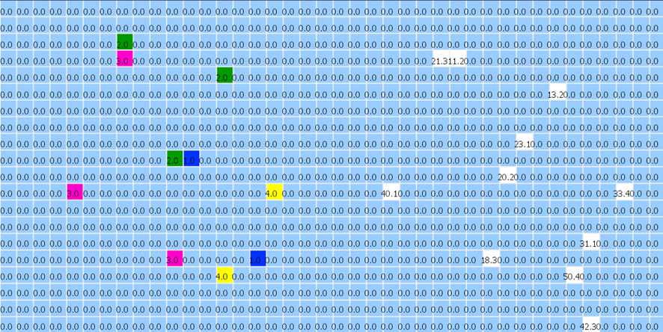
Figure 8 Cell Animation Tool cell display
Layer 0, the Target layer, is on the left, and the Track ID layer is on the right.

The Animation tool can be run from start to finish, or stepped through one simulated sensor sweep at a time.

- Problems encountered
A number of problems were encountered during the development of the model.

- Target Generator

The initial implementation of the model used the Generator included with the Cell-DEVS tool, using a normal deviation. However, the generator created new targets at times other than the regular 100 ms time cycles used to simulate sensor sweeps. This effect could be seen when stepping through the model. Instead of each step being a multiple of 100 ms, there were steps at irregular intervals, e.g. 379, 415, etc. Since the cells used an inertial timer, instead of having single cells moving across the target layer, the three or four cells that the target had moved through previously all contained non-zero values. The size of this trail of cells lengthened and shortened as the simulation proceeded. This lead to the impression of an inchworm moving across the target space rather than a distinct target moving across the grid. The images in Figure 9 show the progress of a single target across the grid space. There should be no changes between times 100 and 200. The changes should show only a single green cell moving across the grid.
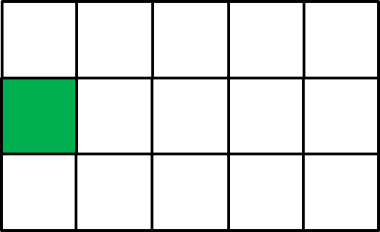
- Time 100

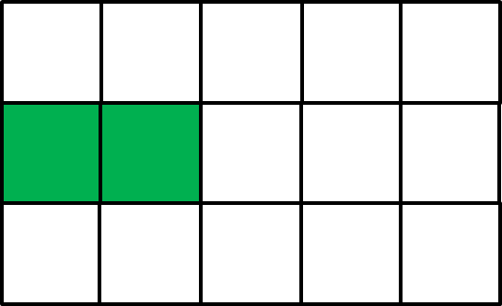

b) Time 127

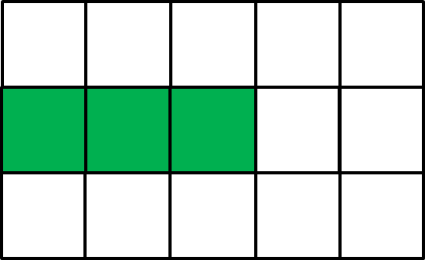
- Time 135

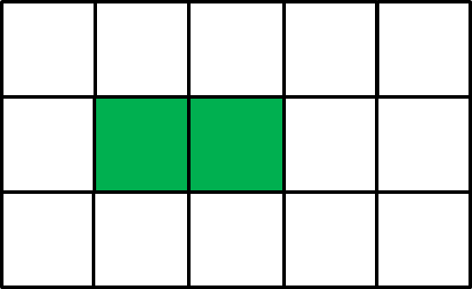
d) Time 178

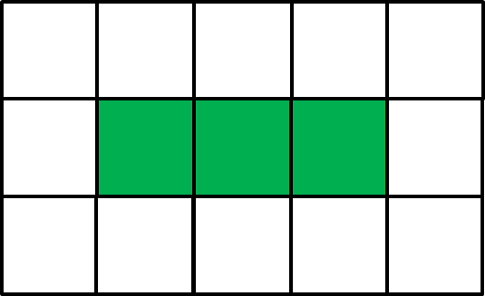
e) Time 197
Figure 9 Targets generated by the default generator

This problem was solved by writing a custom generator. The generator created a new target every 100 ms, the same time interval as the sensor sweep function.

- Target Collisions

The initial definition of the target layer had problems when two targets attempted to occupy the same cell. Each cell selected its new value based on the value of one of the surrounding cells. Since it could only select one value, if there were multiple neighbour cells that had values that could move into that cell, the cells with values that were not selected were lost.
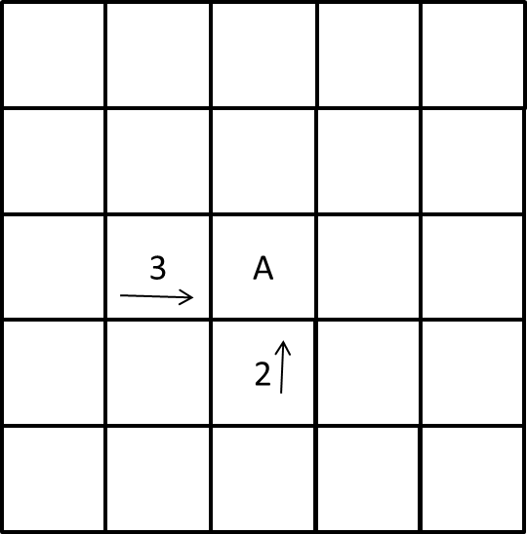
Figure 10 Potential Collision on the Target Layer

In Figure 10 Potential Collision on the Target Layer, targets 2 and 3 should both move into cell A on the next time step in the simulation. Since the rule for target 2 will be evaluated before the rule for target 3, target 3 will disappear. Only target 2 will continue after the next time step.

This problem was corrected by adding rules to the target layer. Each cell checks whether there are other targets that might move into the cell where the current cell’s target may move. In this case the cell maintains the value it currently has; that is, the target does not move. An example is shown in the figure below.

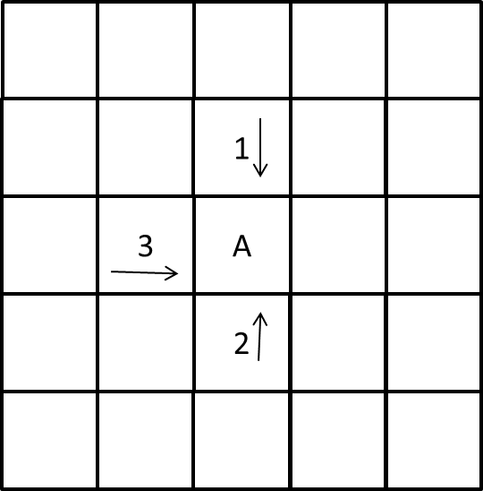
Figure 11 Test for Collision

Applying the tests in Figure 11 to the scenario in Figure 10 results in the following behaviour. The cell with target 3 identifies its potential destination cell A. It checks for a target with direction 2 below cell A, and a target with a direction of 1 above cell A. Since there is a target with direction 2 poised to move into cell A, the target with direction 3 does not move: that is, the cell maintains its value on the next sensor sweep. With this change targets stopped disappearing during the execution of the model.

- Disappearing Track IDs

The original intent of the project was to model a sensor that was two sensor sweeps behind the motion of the targets. The Track ID rules were originally implemented to test cells two rows behind the target cell, that is, testing cell (-2,0,0) instead of (-1,0,0). However, with this implementation, Track IDs were never created. Additional rules were added to the model so that the cells immediately next to the target cells were tested. This test enabled the Track ID rules to work. However, it led to problems when two targets passed next to each other. When the two targets passed next to each other, the Target ID of the one passing with the highest priority became the Target ID of both targets. Removing the tests for cells two spaces away corrected this error.

- Problems with the CD++ tool

The CD++ tool provides an advanced model that allows the declaration of multiple values in each cell. However, it only runs on Linux. Attempts to install and run the tool on a Linux 11 Virtual Machine were unsuccessful.

VMware Player was installed on a Windows 7 machine. An appliance for Mint Linux 11 was installed. The CD++ tool was installed into the /usr/local/bin directory. When the CD++ tool was run, it generated the following error:

error while loading shared libraries: libstdc++-libc6.2-2.so.3: cannot open shared object file: No such file or directory

All attempts to locate information on this problem resulted in the same solution: To download libstdc++2.10-glibc2.2, since the library stopped being included in linux as of Linux 8 Hardy Heron.

All of the web pages that referenced a solution pointed to a web site that no longer had the library available. An email to the Linux support group that maintain the web site indicated that the older versions of Linux are no longer supported.

The archive was located at http://archive.debian.org/debian/pool/main/g/gcc-2.95/. The file that was downloaded was libstdc++2.10-glibc2.2_2.95.4-27_i386.deb. It was installed in the VM.

With this library installed, the CD++ tool was run again. However, this resulted in the following message: The network loader is not currently supported.

At this point the attempt to make CD++ run was abandoned. A simpler solution may be to rebuild the CD++ executable using a more recent version of Linux and the standard C++ library.
- Execution Results
Once the described problems had been addressed, the simulation was run again. The results were checked by running the simulation and viewing the results in the Animation tool. The simulation was run start to finish for general viewing, to verify that targets and Track IDs were generated and moved across the cell space. The Animation was then stepped through to verify the progress of specific Track IDs. Once the problems of target collision and disappearing Track IDs were addressed, the Track IDs were observed to behave as expected. They moved across the cell space in the same direction at the same time as the targets. When new targets entered the grid space they were assigned a unique Track ID. These IDs then followed the targets they represented across the cell space, changing direction as their targets changed directions.

A sample image of the target layer is shown below.

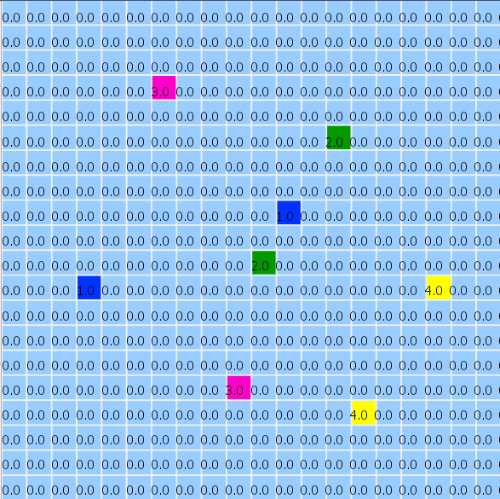
Figure 12Targets
The colours indicate the direction in which the targets are moving.

The Track ID layer at the same time is shown in Figure 13 below.

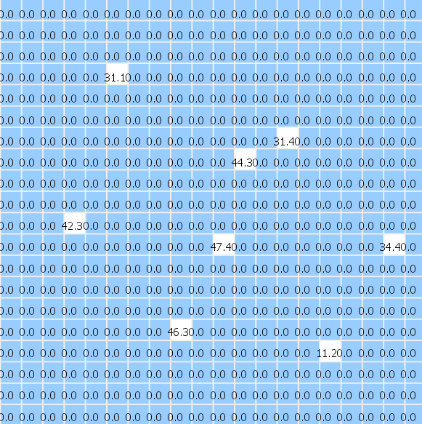
Figure 13 Track IDs

The Track IDs were one always one cell behind the targets. This most likely occurred because of the way the rules were evaluated. A target needed to already be present in a cell for one time step in order for it to be detected by the cells in the Track ID layer. However, at the same time the Track ID layer was determining which ID to display, the cells in the target layer were determining where the target would move to next.

- Possible Model Changes

- Simultaneous Tracking

In order for the Track ID layer to show the Track ID at the same time that the target is in the cell, the Track ID layer should update its cell values with a time step value of half the time step of the Target layer. In this case, every other time step the Track ID layer would find that the target had not moved. The rules of the Track ID layer would have to preserve the direction in which the target had moved two steps earlier to prevent all of the Track IDs from being assigned the same direction value, Unknown.

Another way to handle this scenario would be to offset the time at which the Track ID layer updates its cell values. For example, if the Target layer updates at times 100 ms, 200 ms, 300 ms, etc., the Track ID layer should update at times 120 ms, 220 ms, 320 ms, etc.

- Denser Target Layer
The rules as developed worked well for the simple target model. However, this may have been because of the sparsely populated nature of the target layer. It is unknown how well the rules would work if there were more targets moving across the cell space at the same time. For example, what would happen if multiple target generators were attached to each side of the grid, and the rules of direction changed so that targets may change direction either way. Currently a target moving from top to bottom, will occasionally change direction to move to the left. The rules could be modified so that the target could change direction to move either left or right. This would have the effect of creating more targets crossing each other’s path, and would introduce targets moving in parallel.

- Use of Target IDs

Visually inspecting the execution of the model was possible because of the sparsely-populated target space, and because by viewing the animation one time step at a time. However, the process of verifying that the correct Track ID was assigned to the same target all the way across the cell space could be simplified by adding a Target ID to the Target layer. This would be easier to achieve with the CD++ tool, which allows the definition of more than one variable in for the cell state. The alternative would be to use the same scheme as is used on the Track ID layer, and combine the ID with the direction indicator.

- Complex Target Behaviour
The targets implemented for this model demonstrated fairly simple behaviour. They moved in straight lines, only making ninety degree turns.

One possible change to the model is to use more complex behaviour for the targets. Cellular models of ants moving around their terrain searching for food display non-linear movement. Models of people moving around each other in a mall also display non-linear movement. The rules for motion in the Track ID model could be tested against the movement of these types of targets.

- Ground Truth Tracking
The Cell-DEVS tool is written using C++. Additional C++ code could be written and invoked from the model. This technique could be used to record the ground truth to store the unique ID and the position of the targets in one file, and the cell positions and unique ids of the Track IDs. After a simulation these two sets of values could be compared to determine how well the Track ID rules work.
- Conclusions
The technique of using Cellular Automata for analysing visual data has been demonstrated in a number of fields, including image processing. For this reason it was applied to the problem of tracking targets moving across an area of interest, such as would be found on a radar display. The model worked well with the simple targets that were implemented for the purpose of this project. The techniques could be applied to more complex targets.

References

- Adrianna Popovici, Dan Popovici, “Cellular Automata in Image Processing,”, Departments of Computer Science and Mathematics, Iniversity of the West Timisoara, Bd. Vasile Parvan no. 4, 1900 Timisoara, Romania
- Reichenbach, M.; Schmidt, M.; Fey, D.; , "Analytical Model for the Optimization of Self-Organizing Image Processing Systems Utilizing Cellular Automata," Object/Component/Service-Oriented Real-Time Distributed Computing Workshops (ISORCW), 2011 14th IEEE International Symposium on , vol., no., pp.162-171, 28-31 March 2011
- Hong Wang; Junna Jiang; Lihui Zhou; Liping Du; , "Image Processing Based on Fuzzy Cellular Automata Model," Innovative Computing, Information and Control (ICICIC), 2009 Fourth International Conference on , vol., no., pp.954-957, 7-9 Dec. 2009
- Rosin, P.L.; , "Training cellular automata for image processing," Image Processing, IEEE Transactions on , vol.15, no.7, pp.2076-2087, July 2006
- Dyer, Charles R.; Rosenfeld, Azriel; , "Parallel Image Processing by Memory-Augmented Cellular Automata," Pattern Analysis and Machine Intelligence, IEEE Transactions on , vol.PAMI-3, no.1, pp.29-41, Jan. 1981
- Li Hongbo; Lu Yadong; Zhang Yun; , "A method of target tracking based on spatial trace matching principle," Systems and Control in Aeronautics and Astronautics (ISSCAA), 2010 3rd International Symposium on , vol., no., pp.110-114, 8-10 June 2010
- Langton, C. 1986. Studying artificial life with cellular automata. Physica 22D:120-149.
- Meyer-Konig, T., H. Klupfel, and M. Schreckenberg. A microscopic model for simulating mustering and evacuation processes onboard passenger ships. Proceedings of TIEMS, the International Emergency Management Society’s Eighth Annual Conference, Oslo, Norway.

