SYSC5104 (ELG6187B)
Methodologies for Discrete-Event Modeling and Simulation

Reaction Diffusion Systems Simulation Using Cell-DEVS Formalism

Laurentiu Checiu

#3515592

University of Ottawa

Introduction

I use the following paper “Three-dimensional Cellular Automata in Reaction-Diffusion Systems” by Jorg R. Weimar as a starting point for my second assignment using Cell DEVS.

Examples of reaction diffusion systems can be – according to this paper – “spreading of infectious diseases, propagation of neural signals … chemical reactions”.

Reaction-Diffusion Systems

Reaction diffusion systems can be described by a set of partial differential equations as follows:

x_{i}’ = D_{i} ∇²x_{i} + f_{i}(x₁,x₂,…x_{n}), i=1..n (1)
diffusion reaction

The first term represents the diffusion equation and the second term is the reaction equation where functions f_{i} are always non-linear. (x_{i}’ is dx_{i}/dt)

To simulate reaction diffusion systems we apply first diffusion and then we apply the reaction. We can implement diffusion in cellular automata as follows: the current cell state would be the average of the neighboring cells states:
N is the set of neighbors
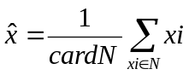 (2)
Then, we apply reaction on this new value. Reaction differential equation is:
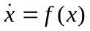 (3)
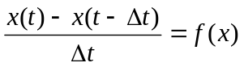 (3’)
For relatively small time intervals we can use (3’) to approximate reaction. In this case we need to know the previous state of the cell so we will use a second plane (“hyper” plane in 3D) as a memory of previous state.

Cell-DEVS formalism

An atomic cell can be formally described as:

CD = < X, Y, I, S, θ, N, d, δint, δext, τ, λ, D > (4)

X ⊆ R is the set of input external events;

Y ⊆ R is the set of output external events;

I = < η, μ, Px, Py > is the model’s modular interface, with
η ∈ N, η < ¥ the neighborhood size,
μ ∈ N, μ < ¥ the number of other ports, and ∀ j ∈ [1, η], i ∈ {X, Y},
Pji = { (Nji, Tji) / ∀ j ∈ [1, η+μ], Nji ∈ [i1, iη+μ] (port name), and Tji ∈ Ιi (port type)}, Ιi = { x / x ∈ X if i = X } or Ιi = { x / x ∈ Y si i = Y } ;

S ⊆ R is the set of possible states for a given cell;

θ is the definition of the cell’s state variables, defined by

θ = { (s, phase, σqueue, σ) /
s ∈ S is the state value for a cell,
phase ∈ {active, passive},
σqueue = { ((v1,σ1),...,(vm,σm)) / m ∈ N ∧ m <∞) ∧ ∀ (i ∈ N, i ∈ [1,m]),
vi ∈ S ∧ σi ∈ R0+∪ ∞}; and
σ ∈ R0+ ∪ ∞
} ; for cells with transport delays, and

θ = { (s, phase, f, σ) / s ∈ S, phase ∈ {active, passive}, f ∈ T, and σ ∈ R0+ ∪ ∞ } for cells with inertial delays;

N ∈ Sη+μ, is the set of the input events;
d ∈ R0+, d < ¥ is the delay of the cells;

δint: θ → θ is the internal transition function;

δext: QxX → θ is the external transition function, with Q = { (s, e) / s ∈ θ x N x d; e ∈ [0, D(s)]};

τ: N → S is the local computing function;

λ: S →Y is the output function, and

D: θ x N x d → R0+ ∪ ∞, is the duration function.

TDC = < X, Y, I, V, q, E, delay, d, dint, dext, t, l, D >

where for #Τ < ∞ ∧ T ∈ {N, Z, R, {0,1} } ∪ {φ}

X ⊆ T is the set of external input events;
Y ⊆ T is the set of external output events;
I = < η, μx, μy, Px, Py >. Here, η ∈ N, η < ∞ is the neighborhood's size,
μx, μy ∈ N, μx, μy < ∞ is the number of other input/output ports, and
∀ j ∈ [1, η], i ∈ {X, Y}, Pj
i is a definition of a port
(input or output respectively), with
Pj i = { (Nji, Tj i) / ∀ j ∈ [1, η+μi], Nj
i ∈ [i1, iη+μ] (port name), y Tj
i ∈ Ιi
(port type)}, where Ιi = { x / x ∈ X if X } or Ιi = { x / x ∈ Y if i = Y } ;
V ⊆ T is the set of values that can be used as state variables for the cell;
θ is the definition of the state variables used in each cell, defined as
θ = { (s, phase, σqueue, σ) / s ∈ V is the status value for the cell,
phase ∈ {active, passive}, σqueue = { ((v1,σ1),...,(vm,σm)) / m ∈ N ∧
m < ∞) ∧ ∀ (i ∈ N, i ∈ [1,m]), vi ∈ V ∧ σi ∈ R0
+∪ ∞};
and σ ∈ R0
+ ∪ ∞ } ; for transport delays, or
θ = { (s, phase, f, σ) / s ∈ V, phase ∈ {active, passive}, f ∈ T,
and σ ∈ R0
+ ∪ ∞ }; for inertial delays;
E ∈ Vη+μ is the set of values of input events;

delay ∈ {transport, inertial};
d ∈ R0⁺, d < ∞ is the transport delay for the cell;
δint: θ → θ is the internal transition function;
δext: QxX → θ is the external transition function, where Q is the state values
defined as:
Q = { (s, e) / s ∈ θ x E x d; e ∈ [0, D(s)]};
τ: E → V is the local computation function;
λ: θ → Y is the output function; and
D: θ x E x d → R0⁺ ∪ ∞, is the state's duration function.

Cell-DEVS model for 3D reaction-diffusion systems

According to [1] we can choose one of the following structures for neighboring cells:

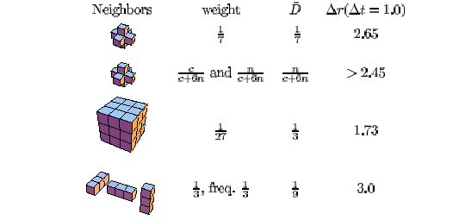
Also, we have to keep in mind that we need the previous state of the cell, so we need 4 dimensions in our representation:

dim : (5,5,5,2)
and two zones:

zone : rd-rule { (0,0,0,0)..(4,4,4,0) } – reaction diffusion zone
zone : memory-rule { (0,0,0,1)..(4,4,4,1) }- previous state of all cells from reaction diffusion zone

I have chosen the first neighboring structure, so the definition of the neighbors in my model file are:

neighbors : rd(0,0,-1,0) rd(-1,0,0,0) rd(0,0,1,0)
neighbors : rd(0,-1,0,0) rd(0,0,0,0) rd(0,1,0,0)
neighbors : rd(1,0,0,0)
neighbors : rd(0,0,0,-1)
neighbors : rd(0,0,-1,1) rd(-1,0,0,1) rd(0,0,1,1)
neighbors : rd(0,-1,0,1) rd(0,0,0,1) rd(0,1,0,1)
neighbors : rd(1,0,0,1)

The whole model file for three dimensional reaction-diffusion systems follows:

#include(rd.inc)

[top]
components : rd

[rd]
type : cell
dim : (5,5,5,2)
delay : transport
defaultDelayTime : 100

border : nowrapped

neighbors : rd(0,0,-1,0) rd(-1,0,0,0) rd(0,0,1,0)
neighbors : rd(0,-1,0,0) rd(0,0,0,0) rd(0,1,0,0)
neighbors : rd(1,0,0,0)
neighbors : rd(0,0,0,-1)
neighbors : rd(0,0,-1,1) rd(-1,0,0,1) rd(0,0,1,1)
neighbors : rd(0,-1,0,1) rd(0,0,0,1) rd(0,1,0,1)
neighbors : rd(1,0,0,1)

initialvalue : 100.0
initialCellsValue : rd.val
localtransition : rd-rule

zone : rd-rule { (0,0,0,0)..(4,4,4,0) }
zone : memory-rule { (0,0,0,1)..(4,4,4,1) }

[memory-rule]
rule : {(0,0,0,-1)} 70 { t }

[rd-rule]
rule : {(#macro(diffusion) - (0,0,0,1)) / 100 } 100 { t }

In the memory rule we save the value from the cell “below” and in the rd-rule we calculate first the diffusion as follows:

#BeginMacro(diffusion)
( ( (0,0,0,0) + (-1,0,0,0) + (1,0,0,0) + (0,-1,0,0) + (0,1,0,0) + (0,0,1,0) + (0,0,-1,0) ) / 7 )
#EndMacro

and then we substract the previous value of the cell stored in the “above” cell.

Simulation

Let’s take two substances that are going to react:

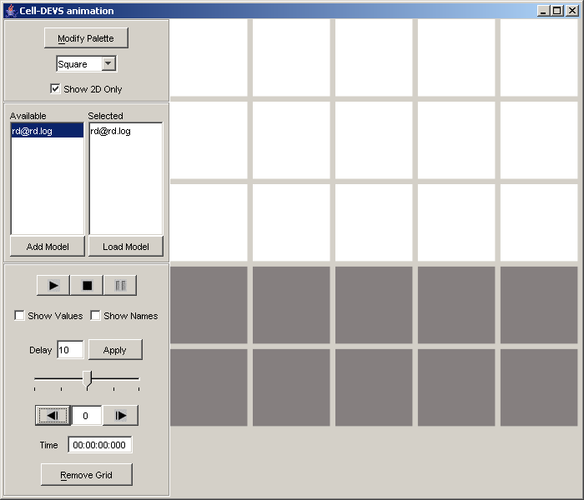

We get following configuration on the second step:
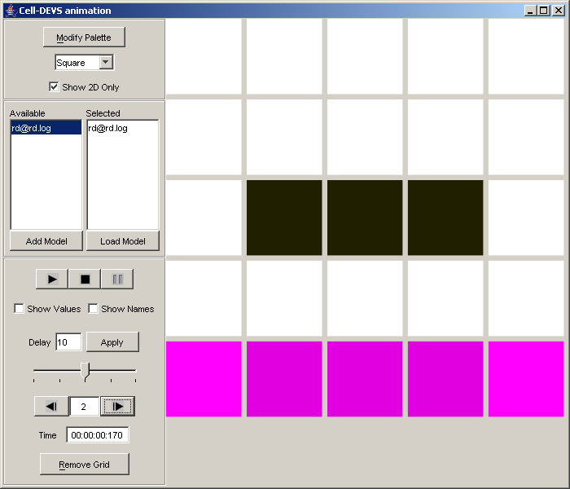

in 3D step 1 would be:

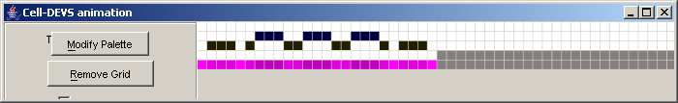

and step 2:

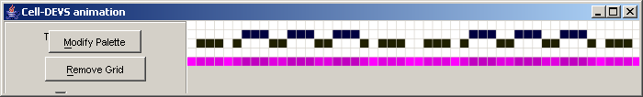

Later on we get something like this:

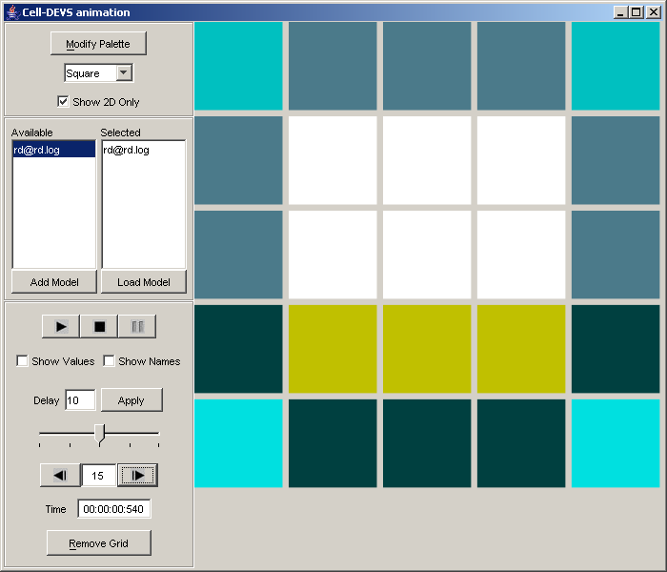
and in 3D:
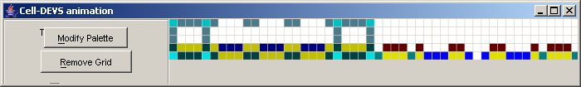

On the 20th step:
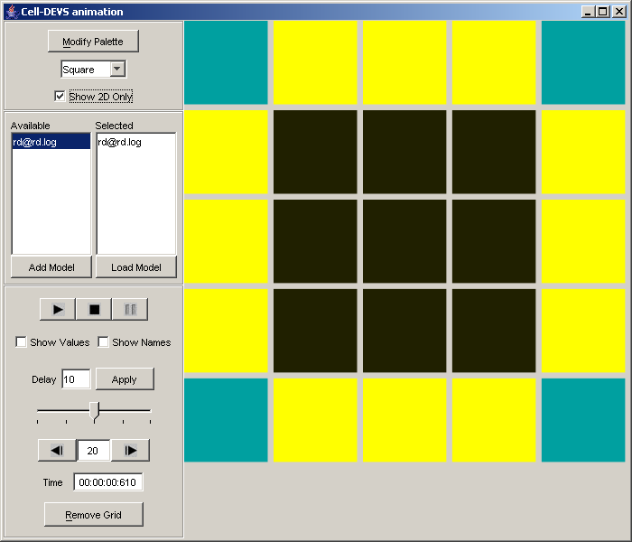

In 3D the image would be:

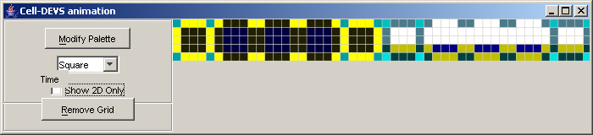

The first 5 layers of 5x5 squares represent our rd simulation hyperspace.
After 34 steps the system is going to be stabile in the following structure:

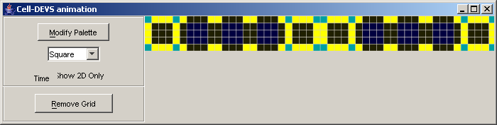

In conclusion, the system reaches a stability point where nothing happens anymore.

Bonus part

Our simulation space has 4 dimensions – because we need previous value – so it will be difficult, actually impossible, to represent 4 spatial dimensions. In this case I will create a simulation for 2 dimension + memory dimension.

2D module is like this:

#include(rd_bonus.inc)

[top]
components : rd

[rd]
type : cell
dim : (5,5,2)
delay : transport
defaultDelayTime : 100

border : nowrapped

neighbors : rd(-1,-1,0) rd(-1,0,0) rd(-1,1,0)
neighbors : rd(0,-1,0) rd(0,0,0) rd(0,1,0)
neighbors : rd(1,-1,0) rd(1,0,0) rd(1,1,0)
neighbors : rd(0,0,-1)
neighbors : rd(-1,-1,1) rd(-1,0,1) rd(-1,1,1)
neighbors : rd(0,-1,1) rd(0,0,1) rd(0,1,1)
neighbors : rd(1,-1,1) rd(1,0,1) rd(1,1,1)

initialvalue : 100.0
initialCellsValue : rd_bonus.val
localtransition : rd-rule

zone : rd-rule { (0,0,0)..(4,4,0) }
zone : memory-rule { (0,0,1)..(4,4,1) }

[memory-rule]
rule : {(0,0,-1)} 100 { t }

[rd-rule]
rule : {(#macro(diffusion) - (0,0,1)) / 100.0 } 100 { t }

and

#BeginMacro(diffusion)
(((0,0,0) + (-1,0,0) + (0,-1,0) + (0,1,0) + (1,0,0) + (-1,-1,0) + (1,1,0) + (-1,1,0) + (1,-1,0)) / 9)
#EndMacro

First step:
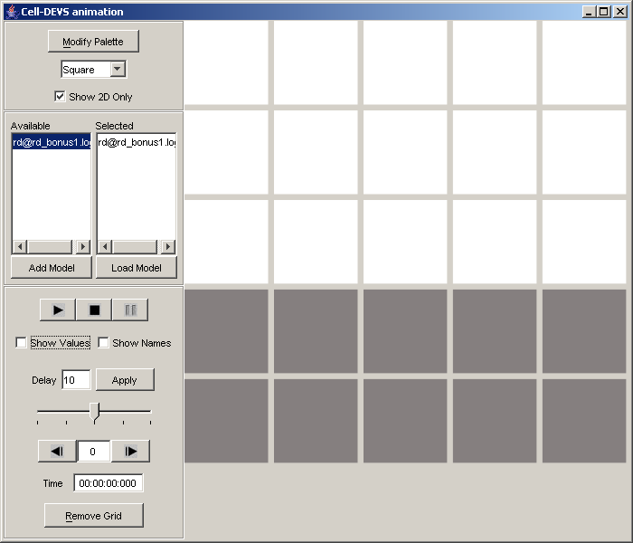

and
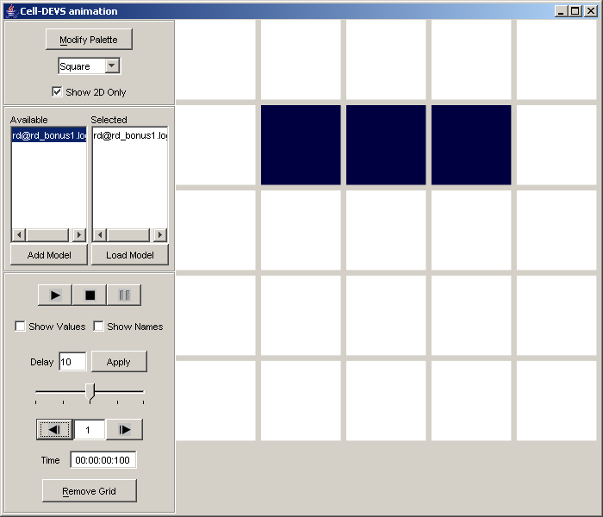

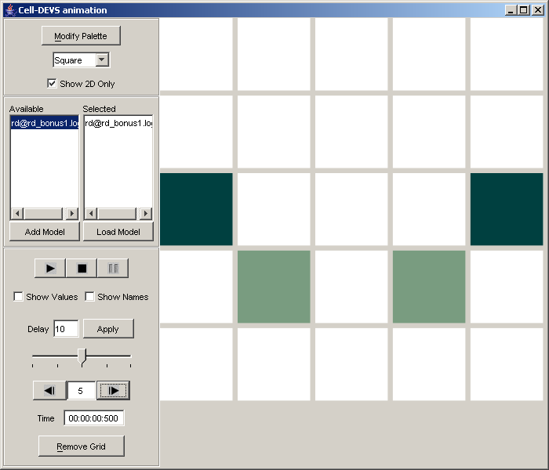

and the equilibrium is reached:
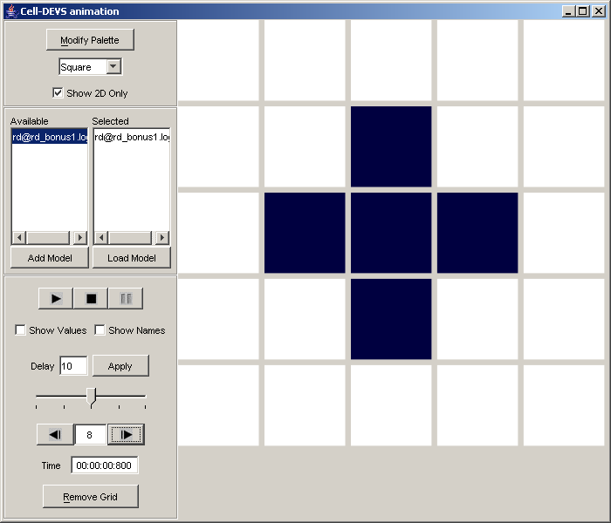

Using VRML GUI we obtain following (5x5, easier to assign colours and hiding the memory level):

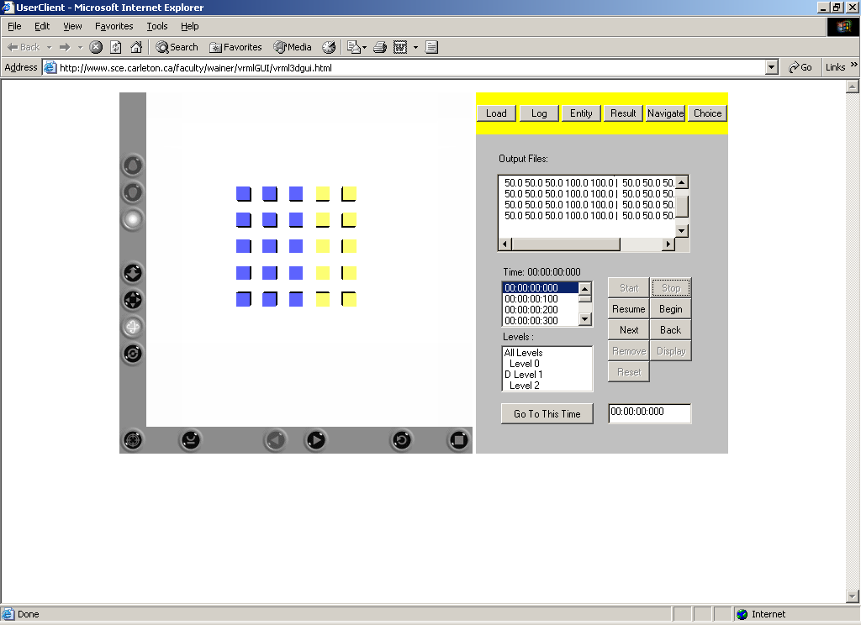

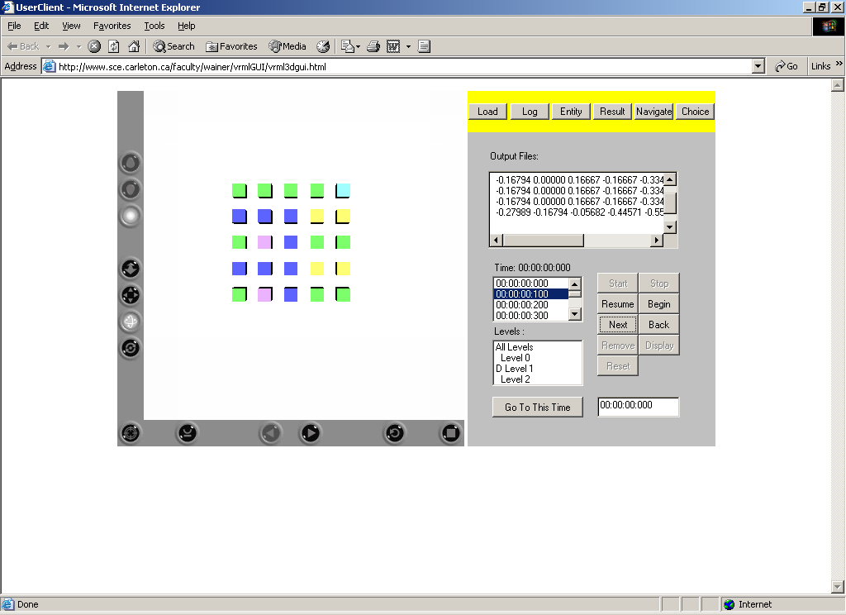
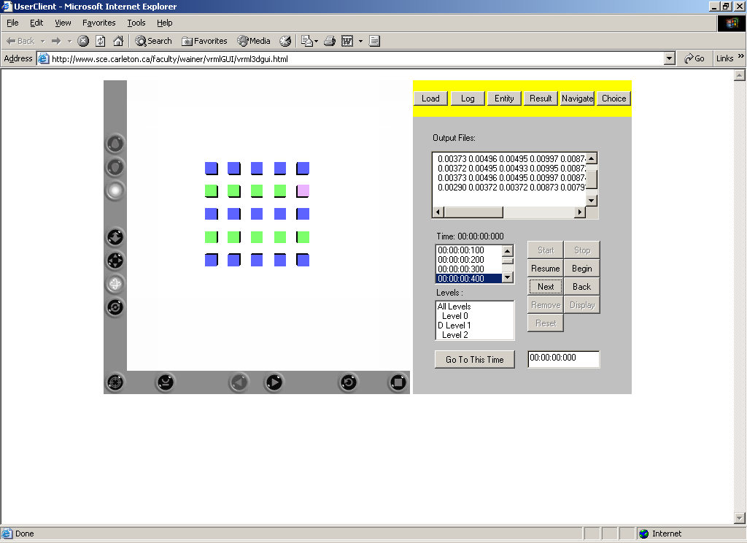
Stability point:
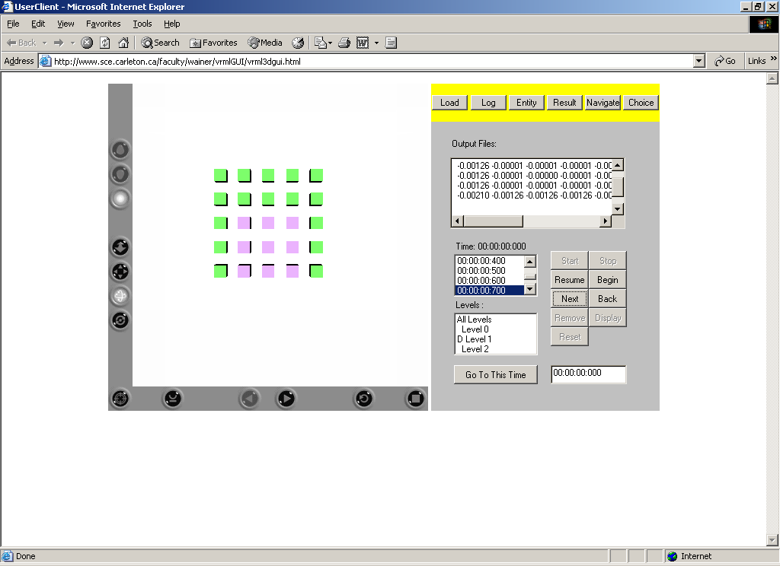
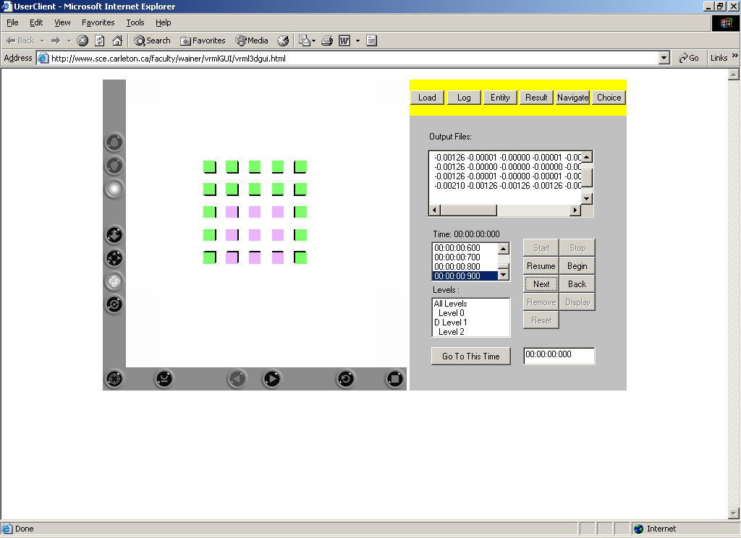
References:
[1] Jorg R. Weimar “Three-dimensional Cellular Automata for Reaction Diffusion Systems”
[2] Gabriel Wainer and Norbert Giambasi “Timed Cell-DEVS: modeling and simulation of cell spaces”
[3] Prof. Gabriel Wainer “Methodologies for Discrete-Event Modeling and Simulation” - course slides.

