CARLETON UNIVERSITY
Department of Systems and Computer Engineering

COURSE 94.587

Advanced Topics in Computer Systems: Methodological aspects of modeling and simulations.

Report for assignment 2:

Repair Robots

Prepared by
Christian Jacques
Student Number: 313216

7 November 2001

Table of Contents

Table of Contents 1
1. Introduction 2
2. Conceptual Model Description 2
2.1. The Cellular Space 2
2.2. Damage Definition 3
2.3. Robot Behaviour 3
3. Model Validation 4
4. Atomic Cell-DEVS Specification 4
4.1. Non-border Cell 4
4.2. Border Cell 6
5. Coupled Cell-DEVS Specification 7
6. Model Implementation 8
6.1. Acknowledgments 8
6.2. Introduction 8
6.3. Collision Detection and Avoidance 8
6.4. Inertial or Transport Delays 10
6.5. Multiplexing of State Variables 11
6.6. Effecting Repairs 12
6.7. Known problems 13
7. Bonus Section 14
8. Conclusion 14

Introduction

After spending much time researching various Cellular Automata (CA) applications on the internet I found that none that were particularly attractive for this assignment. Some, like simulation of a power distribution grid and pattern recognition of a video image seemed interesting but far too complex to be tackled in the context of this assignment. Others were either quite theoretical in nature or seemed to mainly be concerned with how cool the resulting patterns looked on the cellular space. For these reasons I decided to model an application for which I did not specifically find literature: Repair Robots. The idea is to have robots scan a field, looking for damaged areas, and fix the damage.

Conceptual Model Description

The Cellular Space

Figure 1 illustrates the 16 x 24 cellular space the model is to use. Black squares indicate damage while grey ones, whether or not they have diagonal lines in them, represent the repair robots. The borders are not wrapped.

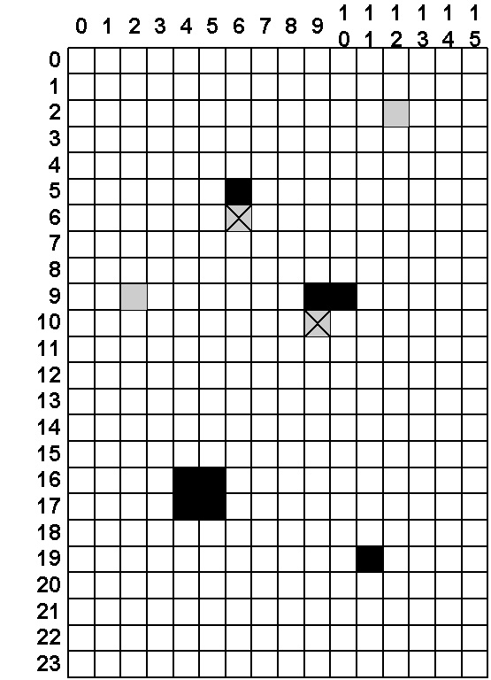
Figure 1. Damaged field and repair robots

Damage Definition

As mentioned before, the black squares indicate damage to the field. The amount and location are set at random the beginning of the simulation. The amount of damage is represented by touching black squares. For example, the damage at (4,16)(5,16)(4,17)(5,17) represents four units of damage while the single square at (11,19) represents a single unit of damage. Instances of damage cannot be larger than four units. The relation between the amount of damage and the time it takes to fix it is not directly proportional as shown in Table 1. For example, a single robot would take 20 time periods to fix two single units of damage while it would take another robot twice as much (40 time periods) to fix a two-unit large damage. Robots can team up to reduce repair time as show in Table 1 but the number of robots effecting repairs cannot be larger than the number of units of damage. When a damage area is under repair, it should be marked as such so other robots finding the damage are aware of the situation.

Damage Size | Repair Time
Damage Size | 1 robot | 2 robots | 3 robots | 4 robots
1 unit | 10 | not allowed | not allowed | not allowed
2 units | 40 | 10 | not allowed | not allowed
3 units | 80 | 40 | 10 | not allowed
4 units | 160 | 80 | 40 | 10
Table 1. Damage size and repair time relationship

Robot Behaviour

The robot behaviour is the important aspect of this model. The goal is to refine the basic model described below and run simulations to see how effective the robots can become. The basic model is:

- There are always four robots. Each one of them enters the cellular space from a corner at the beginning of the simulation. The one entering at cell (0,0) initially travels in a South-East direction, the one at (0,23) travels in a North-East direction and so on such that all four initially travel towards the center of the cellular space.
- The robots travel one square for every time period.
- The robots use Moore’s neighbourhood to stay aware of their surroundings.
- When scanning the cellular space, robots are in scanning mode. This is shown in Figure 1 as a grey square. Refer to cells (12,2) and (2,9).
- If two or more scanning robots come in collision, their traveling direction after the collision is chosen at random.
- When a robot hits the border of the cellular space, it bounces off it at a 90 degree angle.
- When a robot finds a damage area that is not under repair, it stops moving, puts the area under repair and switches its state to repair mode.
- When a robot finds a damage area that is under repair, it simply continues its travel or bounces off of it at a 90 degree angle depending on its traveling direction. This is illustrated in Figure 2 which shows an example of a robot traveling North-East encountering a damage area that is under repair. Note that when under repair, an immobilized robot, in repair mode, marked with an X, is always present beside the damage area.

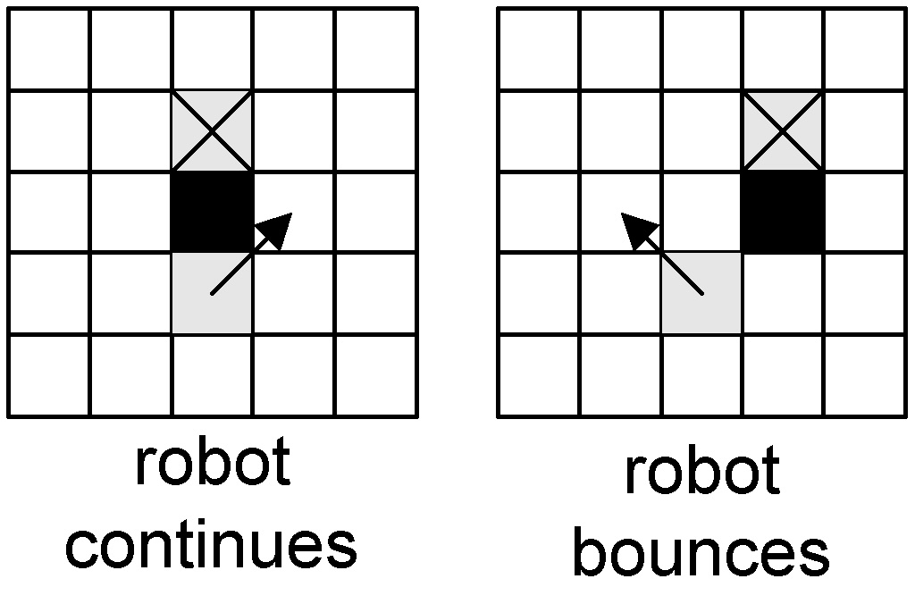
Figure 2. Robot bouncing off a damage area

- To fix damage, a robot simply needs to stay beside the damage for a period of time equal to that shown in Table 1.

The robot behaviour described above is the basic one. One of the goals of the model is to investigate various enhancements such as:

- Better scanning behaviour so the entire cellular space is scanned faster,
- Better repair behaviour so robots collaborate more when effecting repairs.

Model Validation

The model will be validated against the description and requirements found in section 2 and the results of the refinements will be analyzed.

Atomic Cell-DEVS Specification

This section defines the atomic Cell-DEVS specification for the repair robot model. There are two specifications. One for a border cells and one for a non-border cell.

Non-border Cell

CD = <X, Y, I, S, θ, N, d, δ_{int}, δ_{ext}, τ, λ, D>

where:

X = {∅}, Y = {∅} hence δ_{ext} and λ need not be specified.

δ_{int} and D need not be specified either since they are not under the modeler’s control.

I = <η, μ, P^{X}, P^{Y}> where η = 9, μ = 0 and where the ports are defined as:

Input ports: P_{i}^{X} ∀ i ∈ N, i ∈ [1,η]
Output ports: P_{i}^{Y} ∀ i ∈ N, i ∈ [1,η]

S = {0, 1, 2, 3, 4, 81, 82, 83, 84, 5.0, 5.1, 6.0, 6.1, 6.2, 7.0, 7.1, 7.2, 7.3, 8.0, 8.1, 8.2, 8.3, 8.4}
where:
0: Default state value. Cell does not contain a robot and is not damaged.
1: Robot is present and travelling North-East.
2: Robot is present and travelling North-West.
3: Robot is present and travelling South-East.
4: Robot is present and travelling South-West.
81: Robot is present, effecting repairs (i.e. immobile) and was travelling North-East before starting the repairs.
82: Robot is present, effecting repairs (i.e. immobile) and was travelling North-West before starting the repairs.
83: Robot is present, effecting repairs (i.e. immobile) and was travelling South-East before starting the repairs.
84: Robot is present, effecting repairs (i.e. immobile) and was travelling South-West before starting the repairs.
5.0: Cell is damaged. Size of damage = one unit.
5.1: Cell is damaged but being repaired by a single robot.
6.0: Cell is damaged. Size of damage = two units.
6.1: Cell is damaged but being repaired by a single robot.
6.2: Cell is damaged but being repaired by two robots.
7.0: Cell is damaged. Size of damage = three units.
7.1: Cell is damaged but being repaired by a single robot.
7.2: Cell is damaged but being repaired by two robots.
7.3: Cell is damaged but being repaired by three robots.
8.0: Cell is damaged. Size of damage = four units.
8.1: Cell is damaged but being repaired by a single robot.
8.2: Cell is damaged but being repaired by two robots.
8.3: Cell is damaged but being repaired by three robots.
8.4: Cell is damaged but being repaired by four robots.

θ = {s, phase, σqueue, σ) where s ∈ S, phase ∈ {active, passive}and σ ∈ R₀⁺ ∪ ∞
σqueue = {((v₁, σ₁),…,(v_{m,}, σ_{m}) | m ∈ N ∧ m < ∞) ∧ ∀ (i ∈ N, i ∈ [1,m]),
v_{i} ∈ S and σ_{i} ∈ R₀⁺ ∪ ∞}

N ∈ S

d ∈ R₀⁺, d ≤ 16000 msec. More specifically:

d = 100 msec when a robot travels from one cell to the next.
d = 0 when a robot changes its state from scanning (s ∈ {1, 2, 3, 4}) to repairing (s ∈ {81, 82, 83, 84}). I.e. a robot goes in repair mode immediately when it detects there is damage to be repaired in its neighbourhood. the inverse is also true. When a robot completes repairs, it immediately goes back to scanning mode.
d ∈ [1000,16000] msec is the delay necessary for a damaged cell to become repaired after the repairs have commenced.

τ

if robot is scanning (state = {1,2,3,4}) and detects damage (state = {5, 6, 6.1, 7, 7.1, 7.2, 8, 8.1, 8.2, 8.3}), go to repair mode (state = {81, 82, 83, 84}).

if damage sees a robot going to repair mode, go to damage-under-repair state (state = {5.1, 6.1, 6.2, 7.1, 7.2, 7.3, 8.1, 8.2, 8.3, 8.4) and then go to repaired state (state = 0) after a delay according to that shown in Table 1.

if robot is repairing (state = {81, 82, 83, 84}) and detects that damage is repaired (state = 0), go back to scanning mode (state = {1, 2, 3, 4})

if robot is scanning and detects a potential collision with another robot or a damage area that is under repair (5.1, 6.2, 7.3, 8.4), bounce off the obstacle.

Border Cell

CD = <X, Y, I, S, θ, N, d, δ_{int}, δ_{ext}, τ, λ, D> where:

X = {∅}, Y = {∅} hence δ_{ext} and λ need not be specified.

δ_{int} and D need not be specified either since they are not under the modeler’s control.

I = <η, μ, P^{X}, P^{Y}> where η = 6, μ = 0 and where the prost are defined as:

Input ports: P_{i}^{X} ∀ i ∈ N, i ∈ [1,η]
Output ports: P_{i}^{Y} ∀ i ∈ N, i ∈ [1,η]

S = {0, 1, 2, 3, 4} where:

0: Default state value. Cell does not contain a robot and is not damaged.
1: Robot is present and travelling North-East.
2: Robot is present and travelling North-West.
3: Robot is present and travelling South-East.
4: Robot is present and travelling South-West.

θ = {s, phase, σqueue, σ) where s ∈ S, phase ∈ {active, passive}and σ ∈ R₀⁺ ∪ ∞
σqueue = {((v₁, σ₁),…,(v_{m,}, σ_{m}) | m ∈ N ∧ m < ∞) ∧ ∀ (i ∈ N, i ∈ [1,m]),
v_{i} ∈ S and σ_{i} ∈ R₀⁺ ∪ ∞}

N ∈ S ∪ {81, 82, 83, 84, 5.0, 5.1, 6.0, 6.1, 6.2, 7.0, 7.1, 7.2, 7.3, 8.0, 8.1, 8.2, 8.3, 8.4}

d ∈ R₀⁺, d ≤ 100 msec. More specifically:

d = 100 msec when a robot travels from one cell to the next.
τ

if robot is scanning (state = {1,2,3,4}) and going in a direction where it will enter a border cell, simply alter its course once in the border cell so it loos as if it bounced off.

Coupled Cell-DEVS Specification

This section defines the coupled Cell-DEVS specification for the repair robot model.

GCC = <Xlist, Ylist, I, X, Y, η, N, {f,c}, C, B, Z, select> where:

Xlist = {∅}, Ylist = {∅}, X = {∅}, Y = {∅}

I = <P^{X}, P^{Y}> where
P^{X} = {∅}, P^{Y} = {∅}

η = 9, f = 24, c = 16

N = {(-1,-1), (-1,0), (-1,1), (0,-1), (0,0), (0,1), (1,-1), (1,0), (1,1)}

C = {C_{ij} | i ∈ [1, 24], j ∈ [1,16]} where C_{ij} is an atomic component as defined in section 4 of this report.

B = {C_{ij} | (i ∈ {1, 24} ∀ j ∈ [1,16]) ∨ (j ∈ {1, 16} ∀ i ∈ [1,24])} where C_{ij} is an atomic component as defined in section 4 of this report.

Z defined by the following internal couplings:

Neighbourhood Inverse Neighbourhood
P_{ij}^{Y}₁ → P_{i-1,j-1}^{X}₁ P_{i+1,j+1}^{Y}₁ → P_{ij}^{X}₁
P_{ij}^{Y}₂ → P_{i-1,j}^{X}₂ P_{i+1,j}^{Y}₁ → P_{ij}^{X}₁
P_{ij}^{Y}₃ → P_{i-1,j+1}^{X}₃ P_{i+1,j-1}^{Y}₁ → P_{ij}^{X}₁
P_{ij}^{Y}₄ → P_{i,j-1}^{X}₄ P_{i,j+1}^{Y}₁ → P_{ij}^{X}₁
P_{ij}^{Y}₅ → P_{ij}^{X}₅ P_{ij}^{Y}₁ → P_{ij}^{X}₁
P_{ij}^{Y}₆ → P_{i,j+1}^{X}₆ P_{i,j-1}^{Y}₁ → P_{ij}^{X}₁
P_{ij}^{Y}₇ → P_{i+1,j-1}^{X}₇ P_{i-1,j+1}^{Y}₁ → P_{ij}^{X}₁
P_{ij}^{Y}₈ → P_{i+1,j}^{X}₈ P_{i-1,j}^{Y}₁ → P_{ij}^{X}₁
P_{ij}^{Y}₉ → P_{i+1,j+1}^{X}₉ P_{i-1,j-1}^{Y}₁ → P_{ij}^{X}₁

select = {(-1,-1), (-1,0), (-1,1), (0,-1), (0,0), (0,1), (1,-1), (1,0), (1,1)}

Model Implementation

This section describes the important aspects of the repair robot Cell-DEVS model.

Acknowledgments

The rebota model sample found on the Cell Based Discrete Event Simulation web site was used as the starting point for the repair robot cell-DEVS model presented here.

Introduction

The final implementation of the repair robots model (found in file repair_robot.ma) meets the requirements as stated in section 2 except for some aspects of damage repair. The model cannot handle damage areas which have a size of three or four units (cells). The decision to not implement this part of the specification was because the handling of such sizes of damage is just an extension to the model being able to handle two-unit damage sizes. Section 6.5 explains why it is so. Furthermore, it was felt the study of collision detection and avoidance was more important since it is the stepping stone that allows robots to refine their scanning algorithm. For example, if we want a robot capable of accepting operator input to tell it where to go, we must ensure the robot is capable of avoiding obstable on its way to that location. Otherwise it may simply bounce off objects and never get to the desired location. Another aspect of the requirements that was not met was the random distribution of damage in the dimensional space. This is because it is not possible to control the makerand tool to create various damage sizes according to the damage definition. Finally, the repair robot model is a three dimensional one as opposed to the two dimensional space specified. The reasons explaining why the addition of this third dimension was necessary can be found in section 6.6.

Please also note that the specification for τ found in the previous sections is really simplistic compared to what ended up being implemented. Actually, what was implemented is a super set of the defined τ. The main reason for this is that the formal specification was created based on the conceptual model specification which later prooved to be missing many details on how various situation should be handled. My lack of experience with CA and CD++ also played a role because I did not realized all the intricacies associated with creating a local computing function.

Collision Detection and Avoidance

As previously mentioned, much time was spent on studying collisions which resulted in the repair robots having collision detection and avoidance capabilities which are more complex than simply bouncing off a damage area or another robot as specified in section 2.3. Given the definition of a collision was not mentioned in the specification, this is perhaps the proper location for it: A collision occurs when two robots attempt to occupy the same cell or when a robot attempts to occupy a cell where there is damage.

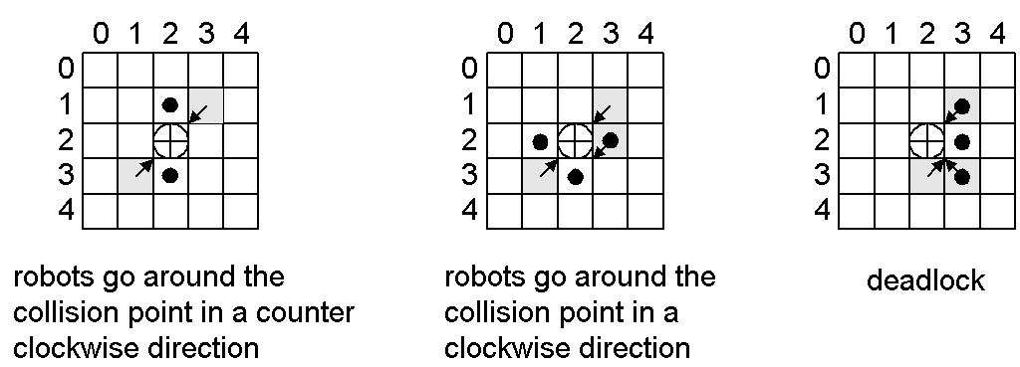
Figure 3. Collision detection and avoidance

Figure 3 show three typical collision situations the model can handle. A grey square represents a robot with the arrow pointing in the direction of travel. The circle with the cross inside represents the cell where the collision would occur. The black dots represent where the robots will be at the next time interval assuming they all travel at the same speed.

The figure on the left shows robots at (3,1) and (1,3) travelling towards each other. The situation is detected by cell (2,2) which changes state to indicate to its neighbourhood that a collision is imminent. The cells the von Neumann neighbourhood of (2,2) respond by checking if they could help avoid the collision by accepting a robot. I.e. allow the robot to move around the collision cell. In the example shown, the robot at (3,1) would move to (3,2) and the one at (1,3) would move to (1,2). On the next time period they would both resume travel in the direction they were travelling before avoiding the collision. The default behaviour of the model is to have the robots go around a collision point in a clockwise manner. Executing batch file collision_test1.bat will generate a collision_test1.drw which can be viewed using the graflog applet and files repair_robot.pal and xxx.ma. The latter file is used with the Graflog applet instead of the real .ma file (repair_robot.ma) so one can work around a bug in the applet. That is, the applet considers the .drw invalid because the real .ma defines three dimensions. File xxx.ma fakes the model as having only two dimensions.

The middle figure shows another scenario which can be handled by the model. In this case, if the (1,3) and (3,1) robots were to go around in a counter-clockwise manner, a collision would occur at position (3,2) because of the robot at (2,3) travelling South-West. So the model handles it by having (2,2) signal that a collision is imminent but the robots are to go around in a clockwise manner. This results in robots (1,3) and (3,1) go to (2,1) and (3,2) respectively while the (2,3) robot simply continues on its course to cell (3,2). Executing batch file collision_test2.bat will generate a collision_test2.drw which can be viewed using the graflog applet and files repair_robot.pal and xxx.ma. The drw file shows six scenarios where robots go around the collision point in a clockwise manner. Robots are in blue, collision cells are in red.

The rightmost figure shows a typical deadlock situation. Robots (1,3) and (3,3) are on a collision course. However, going around the collision cell in a clockwise or counter-clockwise manner would cause one of them to go to (2,2) which is the cell robot (3,2) is also going to. The model handles this situation by having the collision cell signal the deadlock which will cause the robots in its von Neumann neighbourhood to continue their course while the other robots stay immobile for one time period. The end result is that (1,3) and (3,3) won’t move and (3,2) will move to (2,3). The next time interval the (1,3) and (3,3) robots will then go around the collision cell in a counter-clockwise manner. Executing batch file collision_test3.bat will generate a collision_test3.drw which can be viewed using the graflog applet and files repair_robot.pal and xxx.ma. The drw file shows three scenarios where a deadlock is signalled causing robots to behave as previously above. Robots are in blue, collision cells are in red.

There are a few advantages to having robots go around a collision cell in a clockwise or counter-clockwise manner as opposed to using another algorithm. Like giving right of way to one of the robots:

- The algorithm is the same and works whether two, three or four robots are on a collision course.
- The algorithm does not assume the collision cell is empty. So if cell (2,2) contains a robot or contains damage, the robots still behave properly.

One drawback however is the fact the collision cell only looks at its Moore’s neighbourhood to signal whether robots should go around in a clockwise or counter-clockwise manner. Hence it is not guaranteed a robot outside of the neighbourhood could come in an actually cause a collision. Using the leftmost figure for example, if a third robot was travelling North-West at (4,3), it would collide with the (3,1) robot at position (3,2) on the next time frame. One possible solution would be to increase the neighbourhood of the model so cells can “see” farther and take the appropriate collision avoidance decision. That being said, the problem was never seen with only four robots roaming the dimensional space. Only during collision testing, where 20 or so robots were let loose in the space, did the problem ever occur.

Inertial or Transport Delays

The model was originally specified and implemented using transport delays. There was no significant reason for doing so. However, this proved to be a probem: Assume the scenario as illustrated in Figure 4 occurs at time t₀. The cells of interest are (1,2) and (2,2).

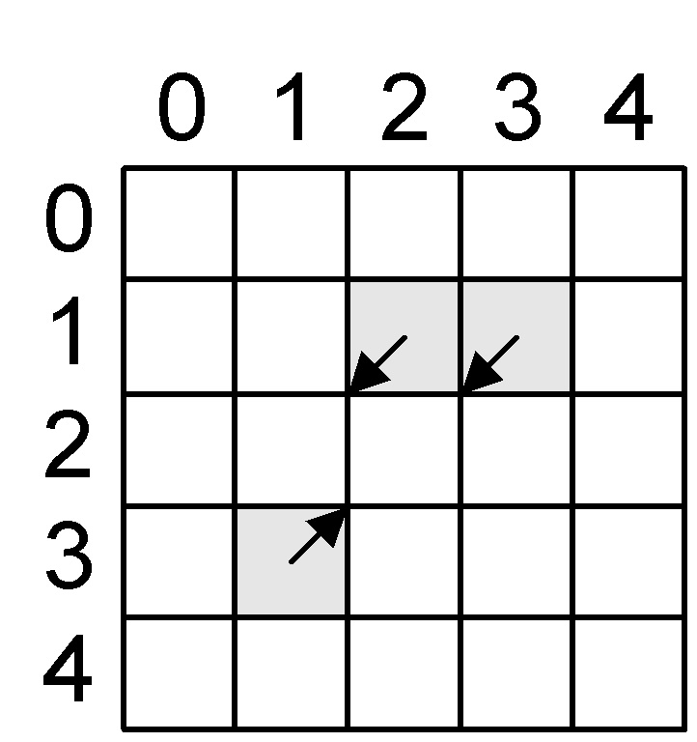
Figure 4. Transport Delay Scenario

t₀: Activate the local computing function of the cells in the neighbourhood of cells (1,2), (1,3) and (3,1). Given the implementation of the model used, this will cause (1,2) to go to 0 at time t₀ + 100 msec. I.e. the robot will leave the cell in 100 msec. This transition is stored in the σqueue of the model. For cell (2,2), the local computing function will cause it to go to 60 at time t₁ = t₀ + 0. I.e. the cell immediately detects the potential collision between (1,3) and (3,1).

t₁: Because cell (2,2) changed state (0→60), activate the local computing functions of the cells in its neighbourhood. This will cause (1,2) to accept the robot presently located in (1,3). Therefore (1,2) will stay in state 4 (robot travelling South-West) at t₁ + 100. This transition is stored in the σqueue of the model.

However, given t₀ = t₁, the two entries in the σqueue of cell (1,2) are scheduled to be output at the same time. The simulator’s reaction at t₂ = t₁ + 100 was to simply output the first entry which caused the robot at (1,3) to disappear instead of moving to (1,2).

The logical solution was to change the model to use an inertial delay so the second state change of cell (1,2) preempted the first state change (4→0). This is why the model now uses an inertial delay.

Multiplexing of State Variables

One of the challenges presented by this assignment was to overcome the inherent lack of state variables with CA. That is, the cell only has one state variable so it must be multiplexed if one needs to store more than one state inside the variable. Two approaches were used to do so. The first one was to make use of the fractional part of the state variable as if it was a variable all in itself. This technique was briefly discussed in class. For the repair robot model it was used to store the number of robots presently effecting repairs on a damaged area. For example, the state 6.0 is used to represent a two-unit damage. When a robot arrives and starts repairing the damage, the fractional part is incremented by .1 causing the state of the damage to go to 6.1. When a second robot arrives, the state goes to 6.2.

The second technique used was to use the tens independantly of the units. For example, state 4 represent a robot travelling South-West. To represent the same robot effecting repairs, the state would be 84. This allows the model to know what state to return the robot to after the repairs are completed. Similarly, a state of 52, 62 or 72 indicates a robot is travelling North-East but at the same time it indicates the cell in which the robot resides is going to be a collision cell. I.e. the 5 in 52, the 6 in 62 and the 7 in 72 are manipulated independantly from the 2.

Effecting Repairs

When a robot finds damage, it stops and changes its state to repair mode. When a damage cell detects this change of state in a robot, it automatically assumes it is being repaired by the robot and changes its state to “damage under repair” and schedules itself to be completely repaired according to the time values described in Table 1. When the damage cell becomes repaired, the repairing robot sense the change in state and returns to scanning mode. For one-unit sized damage, the implementation was straightforward since only one robot is allowed to fix such a size of damage. Executing batch file damage_repair_test1.bat will generate a damage_repair_test1.drw which can be viewed using the Graflog applet and files repair_robot.pal and xxx.ma. The .drw file shows four robots scanning the space for damages. All damage areas are one-unit large. Scanning robots are in royal blue, repairing robots are in light blue, damage areas are in black and collisions are in red. Note how each robot takes 1000 msec to fix a single damage area. Furthermore, when an area is already under repair, a scanning robot will simply ignore it as seen in cell (8,6) of frame 21, cell (11,11) of frame 25 and cell (10,3) of frame 26.

For damage areas larger than one-unit in size, the implementation was more complexed and it actually required the introduction of a third dimension for the model. The main differences between a one-unit damage area and a multi-unit damage area are:

- As mentioned above, when a damage cell detects that a robot has just started repairs, it switches its state to “damage under repair”. Unlike single cell damage areas, this information needs to be propagated to all cells (2, 3 or 4) of the damage area. As mentioned earlier, the repair robot model cannot handle damage which is more than two cells in size but the same algorithm applies to larger damage areas.
- Another difference between single and multiple cell sized damage areas is the fact a robot can receive help from another robot after it has already started repairing a damage area. When this happens, the damage cells need to re-compute when they will be repaired because two robots will do the work faster than one. Assuming a two-cell damage area, we would have the following scenario:
  - Robot 1 arrives at damage area. Changes state to repair mode. E.g. 4→84.
  - Cells in damage area change from damage state to damage under repair state. I.e. 6.0→6.1. Furthermore they schedule to go to repaired state (0) in 4000 msec.
  - Robot 2 arrives at damage area. Changes state to repair mode. E.g. 2→82.
  - Cells in damage area change state to indicate that an additional robot is effecting repairs. I.e. 6.1→6.2. Furthermore they recompute the delay before going to repaired state.

This last bullet implies that the cells know how long they have been under repair already which in turn implies the cells saved that time somewhere. Unfortunately, this is not so easy to do for the same reasons explained in section 6.5. Therefore, a third dimension was added to the original repair_robot model. This new dimension is used as a two dimensional plane sitting on top of the original two dimensional space. Its function is to serve as an extension to store state variable information of the cells in the bottom plane of the model. This means robots only move in the bottom plane and damage is only present in the bottom plane. However, when a damage cell go in “damage under repair” state, it can save the estimated time for repairs in the cell located right above. Similarly, when a an additional robot joins a repair party, the damage cell can retrieve the the previous estimated time from the cell above, recompute a new estimated time and resave the value.

Executing batch file damage_repair_test2.bat will generate a damage_repair_test2.drw which can be viewed using the Graflog applet and files repair_robot.pal and xxx.ma. The .drw file shows four robots scanning the space for damages. All damage areas are two-unit large. Scanning robots are in royal blue, repairing robots are in light blue, damage areas are in black and collisions are in red. Note how each robot takes 4000 msec to fix the first damage areas they find. However, at time frame 11, the robot at location (8,8) joins the robot at location (8,7) causing the damage at cells (8,9) and (9,9) to go from 6.1 to 6.2. It was verified that the cells recomputed they expected repaired time properly.

Known problems

The repair robot model proposed has some problems which should be fixed to make it more robust. They are:

- There is no collision detection being performed by border cells. Moving around the collision cell in a clockwise or counter-clockwise manner is not an option here because the collision cell is on the border. The proposed solution would be to have one of the robots move aside giving the right of way to the other robot. The right of way approach seems like a valid one here because border collisions can only involve two robots as opposed to three or four for open field collisions.
- The algorithm which causes robots to move around a collision cell needs to be refined because it does not checks if damage exists in the cell where the robot will be moving to.
- The algorithm which causes a repairing robot to return to scanning mode needs to be refined because a robot may be returred to scanning mode too early if a potential collision is detected in the damaged cell. This situation is actually demonstrated in cell (2,9) of frame 44 of damage_repair_test1.drw.
- The algorithm that controls when damage switches to damage-under-repair needs to be refined because it is possible for a single robot to fix two non-touching damage cells at the same time. Furthermore, when two robots arrive at the location of damages simultaneously, in some circumstances they may both be repairing the damage as if they were working alone. This is shown in cells (16,7) and (16,8) which fail to go to state 6.2 because the robots at (17,6) and (17,9) arrived at the damage area simultaneously.

Bonus Section

I tried animating my various .drw files using the DEVS-GUI tool . Unfortunately I was not successful. I got Java related errors in my command window but the DEVS-GUI tool did not actually complain. Therefore I don’t believe I was misusing the tool. Just to make sure I was using it properly I successfully animated the rebota.drw. it did not make sense that the Graflog applet was capable of animating my .drw but the DEVS-GUI could not. I investigated the problem and noticed something peculiar which may explain why my model would not work: The x parameter in the “cell animate” pop up window does not seem to get stored. For example, if I specify a value other than 20, then set another parameter, for example y, and return to x, the value dispayed is not what I entered previously. I think this may affect my model since it uses 24 rows as opposed to 20.

Conclusion

From the point of view of model validation, the repair robot model does not meet 100% of the requirements listed in section 2. The shortcomings included the inability of the model to handle damage areas larger than 2 cells in size and the known problems. However, collision detection and avoidance capabilities of the model greatly surpass what was initially specified and I feel that my focusing in this area probably allowed me to learn more about CA and the CD++ tool.

