Carleton University
Department of Systems and Computer Engineering

SYSC 5807

Advanced topics on Computer Systems: Methodological Aspects of Modeling and Simulation

Assignment 2 Report

Shannon Borho
Student No. 280901
Professor G. Wainer
The system that I chose to model using Cellular DEVS (Discrete EVent System specifications) is clouds in a satellite image. This assignment mainly deals with the application of Cell-DEVS to the simulation of Satellite Remote Sensing Images, which is a typical real-life image analysis problem. Cellular Automata is applied to solve a diffusion equation, to simulate cloud behavior such that the simulation results can be compared to actual images.

The simulation space, which will represent the sky around the world or the sky above a specific region on earth, will be divided into discrete square areas. The border of the space will be wrapped since the world is a sphere and is continuous.

Inside each of the cell spaces, there can be many particles of cloud but has to be less than a maximum value. Originally, I decided that each cell will have one of three states, either cloudy, cloud free or cloud edge. However, creating a cell space that moved a whole cloud around was rather difficult. The rules to generate this would become complex and I didn’t have time to come up with specific rules that generated a “realistic simulation” based on the initial specifications. In the proposal, I stated that the cell would be in the cloudy state if the number of particles in the cell were greater than 50% of the maximum allowed. It will be in the cloud free state if there is less than 25% of the maximum allowed. Lastly, the cells with 25% to 50% of the maximum particles will be considered a clouds edge. I have decided to change this into ranges of cloud density. I kept the specifications the same for having a cloud free zone, less than 25% of the maximum. However from there, I decided to increment the density of the clouds by 10%. So from 25-35%, I had being a light density of cloud, from 35-45% a little more dense and so on until it got to the maximum 100% as the most dense. These values will be reflected in the Graflog tool as different increments in the palette.

Each cell has a neighborhood that will influence the cell’s state; each cell will influence its neighborhood’s cells as well. Each cell’s neighborhood will be defined to be a Moore neighborhood, which consists of the eight surrounding cells. The particles will move to a neighbor cell with a given probability and will depend on a certain well-defined rule depending on the wind value and direction. These rules were not given in the paper on which I am basing my assignment but I came up with a specific rule that would seem to be realistic to how a cloud would move around the sky.

Originally, I had planned on using just a two-dimensional cell space. As can be seen in the clouds.ma file, I have changed that to a three-dimensional cell space with a total of three layers that makes up the third dimension. The ‘x’ and ‘y’ dimensions can be as large as necessary, my examples were simply 10-by-10, but the third dimension must remain a constant three layers. The three layers will represent different cell variables in the system. The first layer represents the percentage of the maximum number of particles of cloud that each cell contains. Each cell in (x, y, 0) will contain a discrete value from 0 to 100 and the level of density of cloud in each cell is described above. The second layer describes the speed of the wind. The values for this layer (x, y, 1) will be a real number from 0 to 1 and will represent the percentage of particles that will move out of the corresponding cell to a neighboring cell. So if cell (2,5,0) contains 40 particles, and cell (2,5,1) contains the value 0.60, 40*0.6 = 24 particles will leave that cell and move to a neighboring cell. The other 40*(1-0.6) = 16 particles will remain in the cell. There will however possibly be more than the 16 particles in the cell since the neighbors could be giving particles to this cell. If a value of 1.0 is in this cell, then all the current particles are going to move to neighboring cells. To determine which neighbors the particles are going to move to, I introduced a third layer, (x, y, 2). This layer represents the direction of the wind. It will contain a discrete value in the set {0,1…7}. Each value will represent wind going in one of eight directions. They are mapped as follows:
West → 0
North-West → 1
North → 2
North-East → 3
East → 4
South-East → 5
South → 6
South-West → 7

I made the rule as such if the wind is going in one of the distinct directions (value is even) either N, S, E, or W, then all the particles that are to move out of the cell will move to the cell in that direction. So continuing from the previous example, if the value in the cell (2,5,2) is 6, the wind is traveling south. Therefore, the 24 particles that are leaving this cell will go to the neighboring cell directly south (3,5,0). However, if the direction is an odd direction (NW, NE, SW, or SE), the particles will move to three different neighboring cells. 50% of the particles leaving will move to the cell diagonally and 25% will move to two of the adjacent cells. So if the value of the cell (2,5,2) is 3, the wind is traveling northeast. This will 50% of the traveling particles to move to the cell in the northeast direction, and 25% to move to both the north and east direction. Therefore, in the example, 40*0.6*0.5 = 12 particles will move to the cell (2,6,0), 40*0.6*0.25 = 6 particles will move to both (3,6,0) and (2,5,0).

In order to determine exactly how many particles will be in a cell after a local transition, I had to look at all three layers for each of the neighboring cells. This caused the neighborhood to be considerably larger that the original neighborhood. I just took each neighbor’s cell and included all three of the layers of the cell. This made the neighborhood to be three times as large. Technically, the layer 3 (0,0,2) cell for the current cell (0,0,0) is not necessary to be part of the neighborhood since it was not used in the local transition rule but the current layer 1 (0,0,0) and 2 cell (0,0,1) is. The fact that the inverse neighborhood is the same as the regular neighborhood for a Moore neighborhood, made the rule a bit simpler. The rule to calculate the new number of particles in the current cell is that you take the number of particles in the cell and multiply it by one minus the number of particles that are leaving the current cell, and then add the particles that are entering the cell from neighboring cells. Each of the neighboring cell’s wind direction (layer 3) had to be checked to determine if any of their particles would be moving into the current cell. So for example, if I first check neighboring cell (1,0,0) to the south, I would look at cell (1,0,2) and see what the direction of the wind was. If it was in the north at all, i.e. a 1, 2, or 3, then some particles will be moving to the current cell. If the direction of the wind was to the northwest (1), then the number of particles moving to the current cell is 0.25 * (1,0,1) * (1,0,0). Here is a table of third layer wind directions that affect the current cell:

5 | 5, 6, 7 | 7
3, 4, 5 | All | 7, 0, 1
3 | 1, 2, 3 | 1

This means that there are 16 different ways that particles of cloud could move to the center cell. The final rule looks like this:
{(0,0,0)*(1-(0,0,1)) +
if( (1,0,2)=2 , (1,0,0)*(1,0,1) , 0) +
if( (1,0,2)=3 , 0.25*(1,0,0)*(1,0,1) , 0) +
if( (1,0,2)=1 , 0.25*(1,0,0)*(1,0,1) , 0) +
if( (1,-1,2)=3 , 0.5*(1,-1,0)*(1,-1,1) , 0) +
if( (0,-1,2)=4 , (0,-1,0)*(0,-1,1) , 0) +
if( (0,-1,2)=3 , 0.25*(0,-1,0)*(0,-1,1) , 0) +
if( (0,-1,2)=5 , 0.25*(0,-1,0)*(0,-1,1) , 0) +
if( (-1,-1,2)=5 , 0.5*(-1,-1,0)*(-1,-1,1) , 0) +
if( (-1,0,2)=6 , (-1,0,0)*(-1,0,,1) , 0) +
if( (-1,0,2)=5 , 0.25*(-1,0,0)*(-1,0,1) , 0) +
if( (-1,0,2)=7 , 0.25*(-1,0,0)*(-1,0,1) , 0) +
if( (-1,1,2)=7 , 0.5*(-1,1,0)*(-1,1,1) , 0) +
if( (0,1,2)=0 , (0,1,0)*(0,1,1) , 0) +
if( (0,1,2)=1 , 0.25*(0,1,0)*(0,1,1) , 0) +
if( (0,1,2)=7 , 0.25*(0,1,0)*(0,1,1) , 0) +
if( (1,1,2)=1 , 0.5*(1,1,0)*(1,1,1) , 0) } 1000 { cellpos(2)=0
}

The ‘if’ statement if(a=b, c, d) just evaluates the first parameter a=b and checks if it is true. If so, then it returns c, if not then d is returned. I do this for the 16 different possibilities and add them together, then add the number of particles that are staying in the current cell. This could however return a value greater than 100 which is not allowed according to the specification so I added an ‘if’ statement the will return 100 if the new value is greater than 100, otherwise just returned the correct value. I assume that it takes one second for these particles to move to the neighboring cells hence the 1000ms. The condition cellpos(2) just checks the z dimension and evaluates the rule only if it is 0. This is because I only want to change the first layer, the number of cloud particles but want the wind strength and direction to remain the same. I included the second local transition rule for the other two layers:
rule : {(0,0,0)} 1000 { t }
This means that if we are dealing with a layer 2 or 3 cell, they just remain the same so the strength and direction of the wind remain unchanged on a local transition.

The formal definition of my cell-DEVS model is as such:
M = < I, X, Y, Z, Xlist, Ylist, , N, {m, n, o}, C, B, Z, select>

I = defined by cell-DEVS model

X = Y = {0,1…9}
Xlist = {}
Ylist = {(3,3,0), (8,8,0)}
 = 27
N = (-1,-1,0), (-1,0,0), (-1,1,0), (0,-1,0), (0,0,0), (0,1,0), (1,-1,0), (1,0,0), (1,1,0), (-1,-1,1), (-1,0,1), (-1,1,1), (0,-1,1), (0,0,1), (0,1,1), (1,-1,1), (1,0,1), (1,1,1), (-1,-1,-1), (-1,0,-1),
(-1,1,-1), (0,-1,-1), (0,0,-1), (0,1,-1), (1,-1,-1), (1,0,-1), (1,1,-1)
m = n = 10
o = 3
C = {C_{ijk} / i  [0,9], j  [0,9], k  [0,2]}
B = {}
Z =
P_{ijk}Y₁ → P_{i,j,k}X₁ P_{ijk}X₁ ← P_{i,j,k}Y₁
P_{ijk}Y₂ → P_{i,j,k+1}X₂ P_{ijk}X₂ ← P_{i,j,k+1}Y₂
P_{ijk}Y₃ → P_{i,j+1,k}X₃ P_{ijk}X₃ ← P_{i,j+1,k}Y₃
P_{ijk}Y₄ → P_{i,j+1,k+1}X₄ P_{ijk}X₄ ← P_{i,j+1,k+1}Y₄
P_{ijk}Y₅ → P_{i+1,j,k}X₅ P_{ijk}X₅ ← P_{i+1,j,k}Y₅
P_{ijk}Y₆ → P_{i+1,j,k+1}X₆ P_{ijk}X₆ ← P_{i+1,j,k+1}Y₆
P_{ijk}Y₇ → P_{i+1,j+1,k}X₇ P_{ijk}X₇ ← P_{i+1,j+1,k}Y₇
P_{ijk}Y₈ → P_{i+1,j+1,k+1}X₈ P_{ijk}X₈ ← P_{i+1,j+1,k+1}Y₈
P_{ijk}Y₉ → P_{i,j,k-1}X₉ P_{ijk}X₉ ← P_{i,j,k-1}Y₉
P_{ijk}Y₁₀ → P_{i,j-1,k}X₁₀ P_{ijk}X₁₀ ← P_{i,j-1,k}Y₁₀
P_{ijk}Y₁₁ → P_{i,j+1,k-1}X₁₁ P_{ijk}X₁₁ ← P_{i,j+1,k-1}Y₁₁
P_{ijk}Y₁₂ → P_{i-1,j,k}X₁₂ P_{ijk}X₁₂ ← P_{i-1,j,k}Y₁₂
P_{ijk}Y₁₃ → P_{i+1,j,k-1}X₁₃ P_{ijk}X₁₃ ← P_{i+1,j,k-1}Y₁₃
P_{ijk}Y₁₄ → P_{i+1,j-1,k}X₁₄ P_{ijk}X₁₄ ← P_{i+1,j-1,k}Y₁₄
P_{ijk}Y₁₅ → P_{i-1,j+1,k+1}X₁₅ P_{ijk}X₁₅ ← P_{i-1,j+1,k+1}Y₁₅
P_{ijk}Y₁₆ → P_{i+1,j-1,k+1}X₁₆ P_{ijk}X₁₆ ← P_{i+1,j-1,k+1}Y₁₆
P_{ijk}Y₁₇ → P_{i,j-1,k+1}X₁₇ P_{ijk}X₁₇ ← P_{i,j-1,k+1}Y₁₇
P_{ijk}Y₁₈ → P_{i-1,j,k+1}X₁₈ P_{ijk}X₁₈ ← P_{i-1,j,k+1}Y₁₈
P_{ijk}Y₁₉ → P_{i-1,j+1,k}X₁₉ P_{ijk}X₁₉ ← P_{i-1,j+1,k}Y₁₉
P_{ijk}Y₂₀ → P_{i-1,j-1,k+1}X₂₀ P_{ijk}X₂₀ ← P_{i-1,j-1,k+1}Y₂₀
P_{ijk}Y₂₁ → P_{i+1,j+1,k-1}X₂₁ P_{ijk}X₂₁ ← P_{i+1,j+1,k-1}Y₂₁
P_{ijk}Y₂₂ → P_{i,j-1,k-1}X₂₂ P_{ijk}X₂₂ ← P_{i,j-1,k-1}Y₂₂
P_{ijk}Y₂₃ → P_{i-1,j,k-1}X₂₃ P_{ijk}X₂₃ ← P_{i-1,j,k-1}Y₂₃
P_{ijk}Y₂₄ → P_{i-1,j-1,k}X₂₄ P_{ijk}X₂₄ ← P_{i-1,j-1,k}Y₂₄
P_{ijk}Y₂₅ → P_{i-1,j+1,k-1}X₂₅ P_{ijk}X₂₅ ← P_{i-1,j+1,k-1}Y₂₅
P_{ijk}Y₂₆ → P_{i+1,j-1,k-1}X₂₆ P_{ijk}X₂₆ ← P_{i+1,j-1,k-1}Y₂₆
P_{ijk}Y₂₇ → P_{i-1,j-1,k-1}X₂₇ P_{ijk}X₂₇ ← P_{i-1,j-1,k-1}Y₂₇

select = order they are specified in the neighborhood above.

I was originally going to have inputs for the system for the wind and this would show the wind direction and speed changing but have run short of time and was unable to fully implement and test this. It would not be difficult to implement this though as I could simply have an input port and then would have to connect the input to a specific cell or cells. I could even go as far as to have generators that would automatically generate wind and direction and could have a generator for each cell and have them accurately represent the real wind values of the specific region. I would then have to specify rules for the inputs coming in and have them reflect whether it was a speed or direction change. I did add two output ports for testing purposes, so I could zone in on a couple of cells to ensure that the rule is changing the particles of cloud as I expect.

Since I didn’t have any generators and didn’t want every cell to start with the same value, I had to come up with an initial values file that described the initial value of each cell which was a tedious job. To make things simple, I set the wind speed to 0.8 for each cell so for every local transition, 80% of the cloud particles will leave the cell. I had a pattern for the wind directions where the cell space was split into 9 sections, each having the same wind value. The initial state of the cloud particles was chose to reflect two clouds in the sky.

At this point, I simulated and came up with a *.drw file and a *.log file. I simulated for 30 seconds which will correspond to 30 internal transitions since I had the local transitions informing their neighborhood every second. Here is a portion of the text-based results:

Initially the system looked like this:
Layer 1:
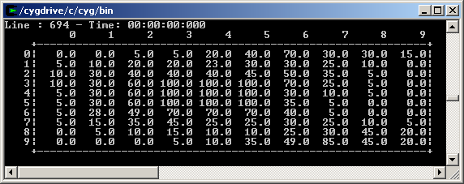

Layer 2:
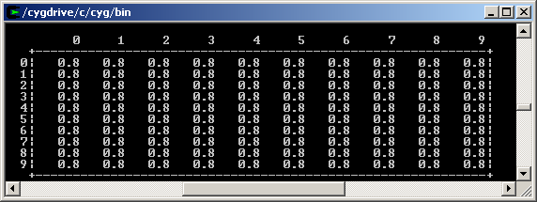

Layer 3:
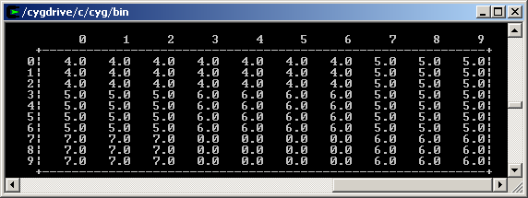

The second and third layers remained consistent throughout the entire simulation. In order to test the results, I performed some simple calculations on specified cells (3,3,0) and (8,8,0) which were the cells that were producing outputs. The output file that was generated looked like this:
00:00:01:000 cell330 32
00:00:01:000 cell880 17
00:00:02:000 cell330 10
00:00:02:000 cell880 7
00:00:03:000 cell880 3
00:00:03:000 cell330 3
00:00:04:000 cell880 1
00:00:04:000 cell330 1
00:00:05:000 cell330 0
00:00:15:000 cell880 0
Initially cell (3,3,0) had the value 100 and cell (8,8,0) had contained 45. After a local transition their values changed according to the output file in the lines at the time 1 second to 32 and 17 respectively. When I calculated manually the values of these cells, it went as follows for cell (3,3,0):
Old value: 100
Wind in current cell: 0.8
Neighbors that pass particles to this cell: (0,-1,0)
Wind direction in the neighbor: 5 (SW)
Wind in the neighbor: 0.8
Number of particles in neighbor: 60
New value = 100*(1-0.8) + 0.25*0.8*60 = 32

And for cell (8,8,0):

Old value: 45
Wind in current cell: 0.8
Neighbors that pass particles to this cell: (-1,0,0)
Wind direction in the neighbor: 6 (S)
Wind in the neighbor: 0.8
Number of particles in neighbor: 10
New value = 45*(1-0.8) + 0.8*10 = 17.

This calculation can be done for any cell to show that the rule is correct according to the specifications. To test more thoroughly, the initValues.txt file was changed to indicate different initial values and the new values were calculated to ensure accuracy. If the new value doesn’t come out evenly then the new value is rounded according to the round function given by CD++ where the value is rounded up or down to the nearest whole number.

Lastly, I used the graphical output on the course web page to view the results in a graphical way. I first had to create the palette to define how the intervals were to map to the specific colors. If there were less than 25 particles in a cell, it was considered free of cloud. From there I went up in intervals of 10 where the higher the interval, the darker the color of the cell became. Here is the initial state using the graphical applet:
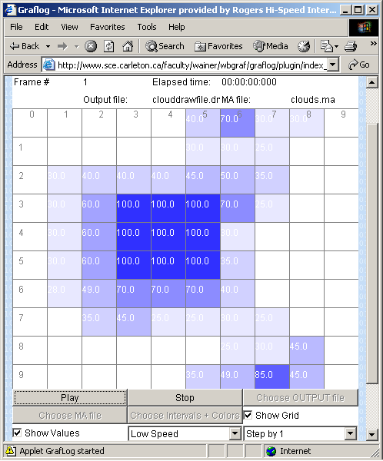

Here is the state after 10 seconds:
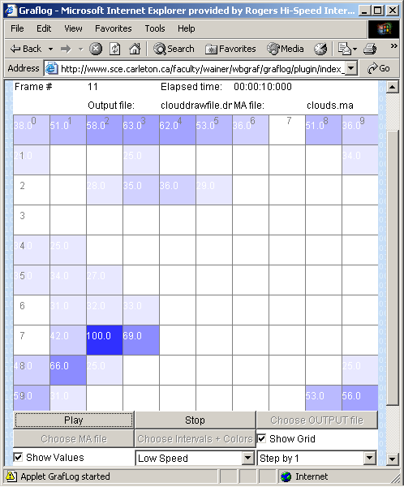

After 20 seconds:
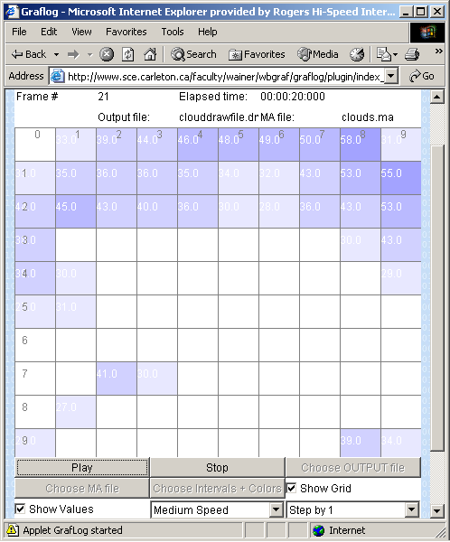
And at 30 seconds:
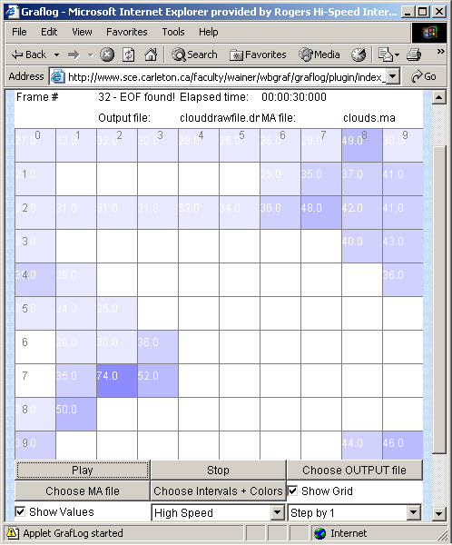

It can be seen easily from the graphical results, that the cloud that was in the middle of the cell-space, has moved to the southwest. This is correct since the wind is going south in the middle of the space, then west in the bottom-middle zone, which pushes the cloud southwest. The output still isn’t very realistic since there are clouds that don’t have edges but every cloud should have an edge. For example, the cell (7,2,0) at the end of the simulation (30 seconds) has a 74 but realistically, every cloud should have an edge in the cells around it. The rules would have to be created so it takes this into consideration and ensures that each cloud has proper edges. Also the wind values have to be set to a realistic value and direction to make the simulation look like what would happen in real life. Overall, the simulation didn’t adequately represent the real-world problem but did show how cellular-DEVS has the potential to characterize and simplify complex problems.

