Snowflake Growth Simulation

SYSC5104: Methodologies for Discrete-Event Modeling and Simulation

Assignment #2

WEI DING
ID:100664296

Part 1. SnowFlake Growth Conceptual Model
The system that I chose to model using Cell-DEVS is Snowflake Growth. This model is based on the Local Cellular Model for Snow Crystal Growth that is described on the Internet at [1]. This assignment mainly deals with the application of Cell-DEVS to the simulation of Snowflake crystals growth, which has a rich diversity of forms with striking hexagonal symmetry structure. Although the real dendrite growth of snowflake is very complicated and influenced by many factors in natural environment, My aim is that try to build a simple, two-dimensional cell-DEVS model that has just a few parameters influence the desired diversity, and use this model to investigate the impact of varying conditions of growth. Somebody already found that the form of snow crystals depended heavily upon the saturation and temperature during growth. The forms observed include dendrites, stellar forms, sectors, plates, needles, spatial, columns, scrolls, and cups and many others [2]. Because I just try to build a simple, two-dimensional model, we cannot hope to model the forms of snow crystals that have substantial 3-dimensional components. For example, the capped column form shown in the lower Figure [2] is beyond the scope of our model. Nonetheless, I still expect to see that we can easily exhibit simulations of the growth of crystals with sector, stellar, dendrite, and plate forms.
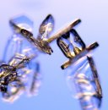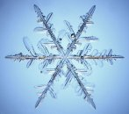
Capped Columns Sectored Plates Stellar Dendrites
Wolfram has popularized a Boolean model for snowflake growth [3][4] that evolves on a hexagonal lattice by the following rule. At each time step, each cell is either ice or not. On the subsequent step, cells that were ice, remain ice, while cells that were not ice, become ice if and only if exactly one of the neighboring cells is ice. This model is offered in the spirit that Boolean hexagonal automata can have behavior surprisingly similar to a kind of snowflake growth. I will try to present a far more realistic model, but the transition rules of my model will mostly work in a similar spirit with Wolfram’s since I sought a very simple model.
In detail, the model space will be divided into discrete hexagonal arrangement of cells areas. The border of the space will be no wrapped.
Reference:
[1] http://www.lafayette.edu/~reiterc/mvp/sfn/
[2] http://www.snowcrystals.com/
[3] Packard NH. Lattice models for solidification and aggregation. Theory and
Applications of Cellular Automata. Wolfram S, ed; Singapore: World Scientific
Publishing; 1986. p. 305-310.
[4] Wolfram S. A new kind of science. Champaign: Wolfram Media; 2002.

Part 2.Formal Specification

The formal specification <X, Y, I, S, θ, N, d, τ, δint, δext, λ, ta> for the atomic Cell-DEVS snowflake growth model is defined as follows:
X = {∅
} // Input external event
Y = {∅
} // Output external event
I = <25, 0, {∅}, {∅}> // Model’s modular interface
with the neighborhood η
= 25, there are no part in this model
S = {s | s ∈ [0, infinity)} //[0,1]: non-ice, [1, infinity): ice
θ = { (s, phase, σqueue, σ)}.
where s∈ [0,infinity), phase∈{passive, active},
σqueue = {(v_{i}, σ_{i}) / i ∈ N, v_{i} ∈[0, infinity), σ_{i} ∈ R₀⁺]
and σ ∈ R₀⁺ //user transport delay
d = 10ms //fixed for the cell in the model
τ = will be discussed in part2.2

δint://internal transition function that is defined by CD++ automatically
δext://external transition function that is defined by CD++ automatically
λ: //output function that is defined by CD++ automatically
ta(passive) = INFINITY
ta(active) = d

2.1 Neighborhood List

(-2,2) | (-1,2) | (0,2) | (1,2) | (2,2)
(-2,1) | UL (-1, 1) | U (0,1) | UR (1, 1) | (2,1)
(-2,0) | L (-1,0) | (0,0) | R (1,0) | (2,0)
(-2,-1) | DL (-1, -1) | D (0,-1) | DR (1, -1) | (2,-1)
(-2,-2) | (-1,-2) | (0,-2) | (1,-2) | (2,-2)

As the above figure shows, the neighborhood consists of 25 cells, include 8 immediate neighbors and 16 outer neighbors. UL is the upper’s left cell, U is the upper cell, UR is the upper’s right cell, L is the left cell, R is the right cell, RR is the right’s right cell, DL is the down’s left cell, D is the down cell and DR is the down’s right cell.
Although our model is built theoretically at the base of hexagonal lattices space, due to the time restriction and in order to simplify the rules, we still use 8 immediate neighbors instead of 6. And the reason why we introduced the outer neighbors will be discussed in the part 2.3

2.2 Detail Description and Implementation
The model we investigate uses a arrangement of cells and each cell contains a real value. We assume the value of any cell as measuring the amount of water at that cellular location in air. Values of one or higher are taken to correspond to ice, while lower values are taken to represent water in a form that may possibly move to neighboring cells. Then classify each cell at each step as either receptive or non-receptive. The first stage is to determine the receptive sites. These are the sites that are ice or that have an immediate neighbor that is ice. At the next stage, the values of the cells are given by the values at the receptive sites plus a constant γ plus a diffusion term. The diffusion term is a local average of a modified cellular field obtained by setting the receptive sites to zero. The averaging algorithm as below

Vu =0.5*Vo +0.5*∑Vn /8
Vu: Update value of Cell
Vo: Original value of cell
Vn: Value of 8 immediate neighbors

It means the center cell has weight 1/2 while the 8 neighboring cells each have weight 1/16. The motivation for the model is that receptive sites are viewed as permanently storing any mass that arrives at that point. The mass in the unreceptive sites is free to move, and hence moves toward an average value. Lastly, the constant γ added to receptive sites corresponds to the idea that not only is "add a constant" an especially simple generalization to the model, but it very informally captures the idea that some water may be available from outside the plane of growth. The constant to be added to the receptive sites is one of the parameters that we vary. The second parameter that we vary is the background level β. We will ordinarily begin with a single cell of value one (an ice seed) in a sea of a constant background. We will usually denote the added constant by γ and the background level by β. The boundary conditions are fixed at the background level at a fixed (Euclidean) distance from the initial cell. These boundary conditions attempt to make the boundary conditions as isotropic as possible.

2.3 Rules Specifications & Implementation
All cells can be divided into three types. The cell is ice; the cell is not ice but it has at least one neighbor that is ice; the cell is not ice and it has no ice neighbor. And the definition of ice cell and non-ice cell we talked before. So, there have three rules independently to each cell group mentioned above.
a. For the ice cell

Rule : {(0,0)+ 0.001} 10 {(0,0) >= 1}

It means for ice cell, it will absorb more and more water in the air continually.

b. For the cell that is not the ice and has no ice neighbor

rule : {(0,0)*0.5 +
(
if((
if((-2,2) >=1,1,0)
+ if((-1,2) >=1,1,0)
+ if((0,2) >=1,1,0)
+ if((-2,1) >=1,1,0)
+ if((0,1) >=1,1,0)
+ if((-2,0) >=1,1,0)
+ if((-1,0) >=1,1,0)
) = 0,(-1,1),0)
+
if((
if((-1,2) >=1,1,0)
+ if((0,2) >=1,1,0)
+ if((1,2) >=1,1,0)
+ if((-1,1) >=1,1,0)
+ if((1,1) >=1,1,0)
+ if((-1,0) >=1,1,0)
+ if((1,0) >=1,1,0)
) = 0,(0,1),0)
+
if((
if((0,2) >=1,1,0)
+ if((1,2) >=1,1,0)
+ if((2,2) >=1,1,0)
+ if((0,1) >=1,1,0)
+ if((2,1) >=1,1,0)
+ if((1,0) >=1,1,0)
+ if((2,0) >=1,1,0)
) = 0,(1,1),0)
+
if((
if((-2,1) >=1,1,0)
+ if((-1,1) >=1,1,0)
+ if((0,1) >=1,1,0)
+ if((-2,0) >=1,1,0)
+ if((-2,-1) >=1,1,0)
+ if((-1,-1) >=1,1,0)
+ if((0,-1) >=1,1,0)
) = 0,(-1,0),0)
+
if((
if((0,1) >=1,1,0)
+ if((1,1) >=1,1,0)
+ if((2,1) >=1,1,0)
+ if((2,0) >=1,1,0)
+ if((0,-1) >=1,1,0)
+ if((1,-1) >=1,1,0)
+ if((2,-1) >=1,1,0)
) = 0,(1,0),0)
+
if((
if((-2,0) >=1,1,0)
+ if((-1,0) >=1,1,0)
+ if((-2,-1) >=1,1,0)
+ if((0,-1) >=1,1,0)
+ if((-2,-2) >=1,1,0)
+ if((-1,-2) >=1,1,0)
+ if((0,-2) >=1,1,0)
) = 0,(-1,-1),0)
+
if((
if((-1,0) >=1,1,0)
+ if((1,0) >=1,1,0)
+ if((-1,-1) >=1,1,0)
+ if((1,-1) >=1,1,0)
+ if((-1,-2) >=1,1,0)
+ if((0,-2) >=1,1,0)
+ if((1,-2) >=1,1,0)
) = 0,(0,-1),0)
+
if((
if((1,0) >=1,1,0)
+ if((2,0) >=1,1,0)
+ if((0,-1) >=1,1,0)
+ if((2,-1) >=1,1,0)
+ if((0,-2) >=1,1,0)
+ if((1,-2) >=1,1,0)
+ if((2,-2) >=1,1,0)
) = 0,(1,-1),0)
)/16}
10
{(0,0) < 1 and
(if((-1,1) >=1,1,0)
+ if((0,1) >=1,1,0)
+ if((1,1) >=1,1,0)
+ if((-1,0) >=1,1,0)
+ if((1 ,0) >=1,1,0)
+ if((-1,-1) >=1,1,0)
+ if((0,-1) >=1,1,0)
+ if((1,-1) >=1,1,0))=0
}
c. For the cell that is not the ice but has ice neighbors

rule : {(0,0)*0.5 + 0.001 +
(
if((
if((-2,2) >=1,1,0)
+ if((-1,2) >=1,1,0)
+ if((0,2) >=1,1,0)
+ if((-2,1) >=1,1,0)
+ if((0,1) >=1,1,0)
+ if((-2,0) >=1,1,0)
+ if((-1,0) >=1,1,0)
) = 0,(-1,1),0)
+
if((
if((-1,2) >=1,1,0)
+ if((0,2) >=1,1,0)
+ if((1,2) >=1,1,0)
+ if((-1,1) >=1,1,0)
+ if((1,1) >=1,1,0)
+ if((-1,0) >=1,1,0)
+ if((1,0) >=1,1,0)
) = 0,(0,1),0)
+
if((
if((0,2) >=1,1,0)
+ if((1,2) >=1,1,0)
+ if((2,2) >=1,1,0)
+ if((0,1) >=1,1,0)
+ if((2,1) >=1,1,0)
+ if((1,0) >=1,1,0)
+ if((2,0) >=1,1,0)
) = 0,(1,1),0)
+
if((
if((-2,1) >=1,1,0)
+ if((-1,1) >=1,1,0)
+ if((0,1) >=1,1,0)
+ if((-2,0) >=1,1,0)
+ if((-2,-1) >=1,1,0)
+ if((-1,-1) >=1,1,0)
+ if((0,-1) >=1,1,0)
) = 0,(-1,0),0)
+
if((
if((0,1) >=1,1,0)
+ if((1,1) >=1,1,0)
+ if((2,1) >=1,1,0)
+ if((2,0) >=1,1,0)
+ if((0,-1) >=1,1,0)
+ if((1,-1) >=1,1,0)
+ if((2,-1) >=1,1,0)
) = 0,(1,0),0)
+
if((
if((-2,0) >=1,1,0)
+ if((-1,0) >=1,1,0)
+ if((-2,-1) >=1,1,0)
+ if((0,-1) >=1,1,0)
+ if((-2,-2) >=1,1,0)
+ if((-1,-2) >=1,1,0)
+ if((0,-2) >=1,1,0)
) = 0,(-1,-1),0)
+
if((
if((-1,0) >=1,1,0)
+ if((1,0) >=1,1,0)
+ if((-1,-1) >=1,1,0)
+ if((1,-1) >=1,1,0)
+ if((-1,-2) >=1,1,0)
+ if((0,-2) >=1,1,0)
+ if((1,-2) >=1,1,0)
) = 0,(0,-1),0)
+
if((
if((1,0) >=1,1,0)
+ if((2,0) >=1,1,0)
+ if((0,-1) >=1,1,0)
+ if((2,-1) >=1,1,0)
+ if((0,-2) >=1,1,0)
+ if((1,-2) >=1,1,0)
+ if((2,-2) >=1,1,0)
) = 0,(1,-1),0)
)/16}
10
{(0,0) < 1 and
(if((-1,1) >=1,1,0)
+ if((0,1) >=1,1,0)
+ if((1,1) >=1,1,0)
+ if((-1,0) >=1,1,0)
+ if((1 ,0) >=1,1,0)
+ if((-1,-1) >=1,1,0)
+ if((0,-1) >=1,1,0)
+ if((1,-1) >=1,1,0))=0
}

Base on the detail description of rules list above, we can find when we calculated the updated value of the particular non-ice cell whatever it has ice neighbor or not, we need to know the value of immediate neighbor’s neighbors. So we introduced the extra outer neighbor other than 8 immediate neighbors for each cell.
Furthermore, the one special rule defines the boundary conditions of the cell space will be executed at first. We assume the boundary conditions of cell space will be fixed at the whole process of simulation.
Testing
In order to investigate the different result from the model by using different variables I set three different group variable vectors (γ ,β) and cell space = (30,30) = 900,
This model was tested using CD++ Modeler by checking the new state for each cell after each iteration and verify if it is the expected state.

β | γ
0.3 | 0.001
0.4 | 0.01
0.5 | 0.0035

Part 3.Simulation Results & Discussion
The following examples show the growth forms that appear as γ and β vary.

β = 0.3, γ = 0.001, 10000 iterations cell space =(200 * 200) 10000 iterations
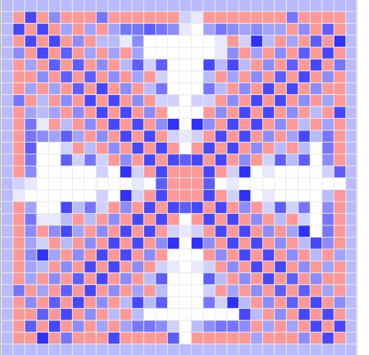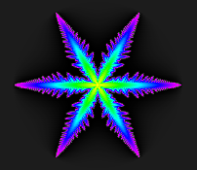

β = 0.4, γ = 0.01, 1000 iterations cell space =(200 * 200) 10000 iterations
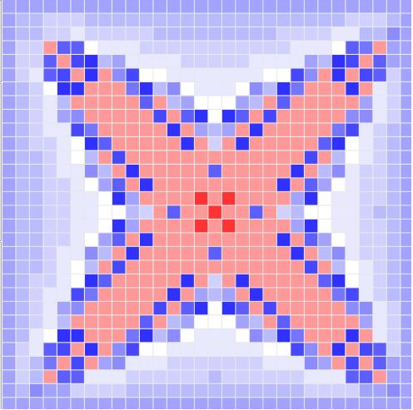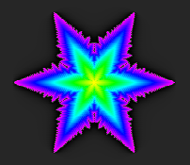

β = 0.05, γ = 0.0035, 1000 iterations cell space =(200 * 200) 10000 iterations
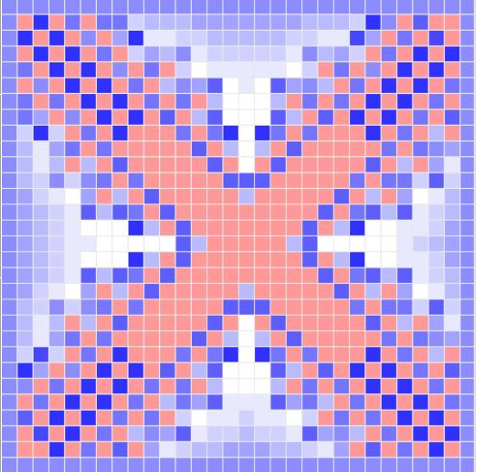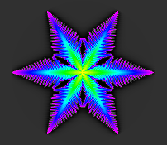
The left list of pictures showed the result got from the Cell-DEVS animation provided by CD++ modeler. Due to we use the rules based on the square lattice instead of the hexagonal lattices, we found there only have 4 dendrite branches instead of 6 that the real snowflake should have. But we still can find some similar features between two lists.
The right list pictures are actual snowflake generated from another source. The rules to generate this would become complex and I didn’t have time to come up with specific rules that generated a “realistic simulation” based on the initial specifications. If we want get this perfect result directly from CD++, it will be take so long time and need a extra bigger cell space and more techniques provided by CD++, so I want to extend this model using a newer version of CD++ in the future.

