SYSC 5807 Assignment #1 Kevin Lam
October 18, 2002 215552

Part I: Original Conceptual Model

The original proposed model for this assignment was the state of a game of soccer.

“The Official Soccer Site – Laws of the Game” (http://www.drblank.com/slaws.htm) describes the various rules of the game. Some of these rules describe distinct play modes (ball in play, ball out of play, penalty kicks, etc.) which can be modeled as states with transitions between them.

A system model representing the soccer game states could have three sub-models: Ball_In_Play, Ball_Out_Of_Play, and Special_Cases. These models are detailed below.

Ball_In_Play: model representing times when the ball is in regular play. This model contains atomic submodels representing specific actions to be taken: Kick_Off, and Play_Game. State variables include ScoreHome and ScoreVisitor counters, as well as a Period counter to track which half of the game is being played. An internal transition function will be defined to track the time remaining in each half, and when fired will cause either a move from the first game half to the second, or will cause the game to end.

Ball_Out_Of_Play: this is an atomic model representing a situation in which the ball is out of play, i.e. due to an out-of-bounds pass.

Special_Cases: this model represents special situations in the game including Corner_Kick, Penalty_Kick, and Goal_Kick. Transitions between Ball_In_Play and Special_Cases are made according to referee calls, which will be modeled as an external input to the overall soccer model.

Modeling an entire soccer game system with players and the interactions between the players and the game system itself would be very complex. This model uses external inputs for events such as “kick out of bounds” or “penalty”. In implementation, these events could come from a Referee model, or a set of models representing Teams, or even individual Players. For testing purposes, a simple Referee model will be used which will generate events, either in a pre-programmed sequence or at random.

The following diagram shows the basic components of the Soccer system model.

Soccer_Game_System
Ball_Out_Of_Play
Ball_In_Play
Special_Cases
Referee (Player, Team events)
Kick_Off
Play_Game
ScoreHome
ScoreVisitor
Period
Corner_Kick
Penalty_Kick
Goal_Kick
Part II: Model Definitions

The complete implementation of the conceptual model was not possible due to the amount of time available. In addition, some design changes were made since some of the proposed models would have been impractical to implement. This section and those that follow describe the work that was actually completed. Appendix A describes more work that would have been done if time was available.

a. The Complete Model

The completed simulation model contains one coupled model (the Top model) which consists of two atomic modules, as shown in the following figure:

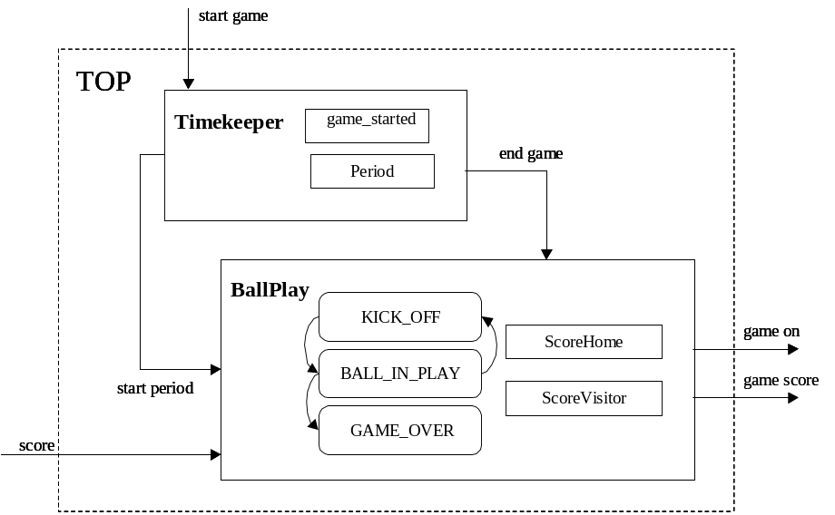

The two atomic modules are:
- Timekeeper is a simple model which performs all the timing operations including period changes and the end of the game. A regulation soccer game consists of two periods of 45 minutes each. Timekeeper keeps track of when periods start and when the game ends.
- BallPlay tracks the status of the game and indicates whether the ball is in play or if a kick-off is occurring. This model also tracks the score for each team and reports it at the end of the game.

Timekeeper and BallPlay, together form the coupled model. This coupled model could interact with another model such as a Referee, or even Players, but in this case they interact as the Top model with the simulator itself. The original plans were to couple these models with another set of models which would add behaviour for other situations such as goal kicks, ball out of bounds, player penalties, etc.

b. The atomic models

The Timekeeper Model

The following figure shows the Timekeeper model in detail. Timekeeper contains one input and two outputs, as well as a state variable Period. The input <start_game> indicates that the Timekeeper should begin a game. The output <start_period> is sent whenever it is time to start a new period (typically twice) and <end_game> is output when the two periods are over and the game should end.

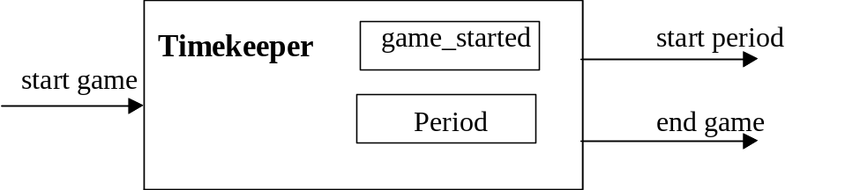

The formal specification of the Timekeeper model is as follows:

Timekeeper = <S, X, Y, δ_{int,} δ_{ext,} λ, ta>
S = { Period, game_started }
X = {start_game}
Y = {start_period, end_game}
δ_{int} ( Period < 3 ) = Period++
δ_{ext} (start_game, !game_started) = game_started
ta( Period < 3 ) = { period_interval (45 minutes) }
λ ( Period < 3) = start_period
λ ( Period ≥ 3) = end_game

The internal and external transition functions and the output function are further detailed in the following pseudocode:

δ_{ext} (game_started, e, x){
if game_started = false
game_started = true;
Period = 0;
schedule execution of δ_{int} immediately
else
do nothing
}

δ_{int} (Period){
if Period < 3
Period++
set next δ_{int} to occur period_interval from now (45 minutes)
else
do nothing
}

λ (Period){
if Period < 3
send start_period
else
send end_game
}

When Timekeeper receives a <start_game> input, it immediately executes the output function and outputs <start_period>. An internal transition is scheduled for period_interval minutes in the future. When this transition occurs, it increments the Period counter, and outputs another <start_period> if the Period count is less than 3, or <end_game> if there have already been two periods. A flag game_started is set when <start_game> is received to ensure the game only starts once.

Unit Testing the Timekeeper atomic model
Because there is only one input, testing the Timekeeper model was straightforward. Two test cases are proposed, one to confirm correct execution of the model and another to confirm that the model can handle incorrect operation (in this case if <start_game> is received more than once.) The event files corresponding to these two test cases are shown below:

Case 1: Typical Operation  00:03:00:000 start_game 1 | Case 2: Incorrect Operation  00:03:00:000 start_game 1  00:13:00:000 start_game 1

In either case the first instance of the <start_game> input occurs at time 00:03:00:000, so the expected output of the model is the following:

00:03:00:000 start_period 0
00:48:00:000 start_period 1
01:33:00:000 end_game 1

The BallPlay Model

The following figure shows the BallPlay model in detail. BallPlay contains three inputs, two outputs, state variables to contain the scores for Home and Visitor teams, and three internal states (represented by a single state variable): Kick Off, Ball In Play, and Game Over. The input <start_period> indicates the start of each new period. Likewise, the input <end_game> signals the end of the game (once in this state, the BallPlay model no longer reacts to inputs.) An input <score> is used to indicate that a team has scored. The output <game_on> is sent whenever a kick-off has occurred and the ball is in play, and the <game_score> output provides the final score at the end of the game.

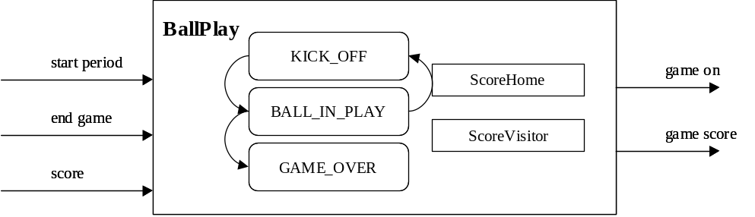

The formal specification of the BallPlay model is as follows:

BallPlay = <S, X, Y, δ_{int,} δ_{ext,} λ, ta>
S = { ScoreHome, ScoreVisitor, Kick_Off, Ball_In_Play, Game_Over }
X = {start_period, end_game, score}
Y = {game_on, game_score}
δ_{int} ( Kick_Off ) = Ball_In_Play
δ_{ext} ( Ball_In_Play, start_period) = Kick_Off
δ_{ext} ( Ball_In_Play, score) = Kick_Off
δ_{ext} ( Ball_In_Play, end_game) = Game_Over
ta( Kick_Off ) = one minute
ta( Ball_In_Play ) = infinity
ta( Game_Over ) = infinity
λ ( Ball_In_Play ) = game_on
λ ( Game_Over ) = game_score

The internal and external transition functions and the output function are further detailed in the following pseudocode:

δ_{ext} (S, e, x){
case port:
start_period:
if state != Game_Over
state = Kick_Off;
activate δ_{int} in one minute;
score:
if state = Ball_In_Play
if score.value = 0
ScoreHome++;
else
ScoreVisitor++;
end_game:
state = Game_Over;
activate δ_{int} immediately;
}

δ_{int} (S){
if state = Kick_Off
state = Ball_In_Play
else
do nothing
}

λ (S){
if state = Ball_In_Play
send game_on
else if state = Game_Over
send game_score ( ScoreHome);
send game_score ( ScoreVisitor);
}

BallPlay begins executing when a <start_period> input is received. Prior to receiving a <start_period>, it is not possible to score, so <score> inputs are ignored. (It is possible to receive a <game_over> at any time.) When a period begins, the internal state of BallPlay stays in Kick_Off for one minute and then transitions to Ball_In_Play. A <game_on> output is sent at this time. BallPlay stays in this state until either another input is received. It then either goes back to Kick_Off state (if the input was a <score> or <start_period>, or to a Game_Over state. If a <score> input is received, the value of the Score state variables are adjusted. Once a <game_over> is received, the game score is sent using two consecutive <game_score> outputs.

Unit Testing the BallPlay atomic model
Several test cases can be used to confirm the correct operation of BallPlay as an atomic model. One test case fully exercises the expected operation of the model and confirms correctness. The second test case, and variations of it, confirms the model handles error cases. The event files corresponding to the proposed test cases are shown below:

Case 1: Typical Operation  00:05:30:000 start_period ?  00:08:00:000 score 1  00:09:05:000 score 1  00:15:00:000 score 1  00:22:00:000 start_period ?  00:48:00:000 score 1  00:57:00:000 score 0  01:00:00:000 end_game ? | Case 2: Some Incorrect Operations  00:03:00:000 score 1  00:05:30:000 start_period ?  00:08:00:000 score 1  00:09:05:000 score 1  00:15:00:000 score 1  00:22:00:000 start_period ?  00:48:00:000 score 1  00:57:00:000 score 0  01:00:00:000 end_game ?  01:22:00:000 start_period ?

The expected outputs of both test cases shown above is the same. In Case 1, the model should respond to each of the inputs with a Kick_Off and, one minute later, a transition to Ball_In_Play. When the <end_game> signal is received, the model should output the game score, which according to the <score> inputs is Home 1, Visitor 4.

In Case 2, the model should ignore the first <score> input (since the period has not yet started) and it should also ignore the <start_period> input which occurs after <end_game> is received.

c. The Coupled Model

The two atomic models combine to form a coupled model (which in this instance is equivalent to the Top model, i.e. the Top model is the coupled model). The coupled model contains two inputs and four outputs:

c_start_game: this input signals the beginning of a new game
c_score: this input signals a score by a team (true = Visitors, false = Home)

c_end_game: this output signals the end of the game
c_start_period: this output signals the beginning of each period
c_game_on: this output signals that the ball is in play
c_game_score: this output indicates the final score

The coupling scheme for the coupled Top model is shown in the following diagram:

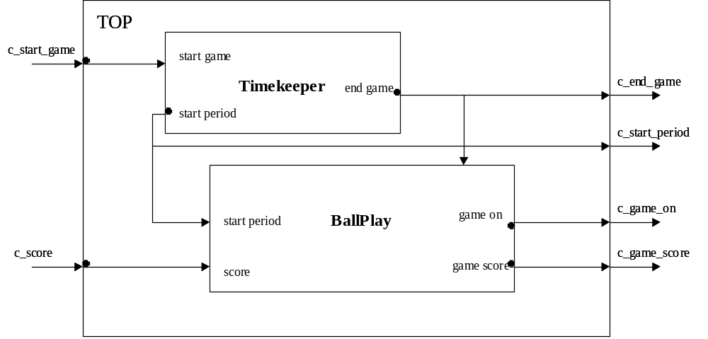

The CD++ model specification is shown below:

[top]
components : tk@Timekeeper bp@BallPlay
in : c_start_game c_score
out : c_start_period c_game_score c_game_on c_end_game

Link : c_score score@bp
Link : end_game@tk end_game@bp
Link : game_on@bp c_game_on
Link : game_score@bp c_game_score
Link : c_start_game start_game@tk
Link : end_game@tk c_end_game
Link : start_period@tk c_start_period
Link : start_period@tk start_period@bp

The formal specification for this model is as follows:

TIMEKEEPER-BALLPLAY model:

EQUIPMENT-OPERATION =<X, Y, {TIMEKEEPER, BALLPLAY}, {Ii}, {Zij}, SELECT>

X = { c_start_game, c_score };
Y = { c_end_game, c_start_period, c_game_on, c_game_score };
I(TIMEKEEPER) = BALLPLAY;
Z(BALLPLAY) = TIMEKEEPER;
Z(TIMEKEEPER) = BALLPLAY;

Testing the Timekeeper-BallPlay coupled model
Several test cases can be used to confirm the correct operation of BallPlay as an atomic model. One test case fully exercises the expected operation of the model and confirms correctness. The second test case confirms the model correctly handles error cases. The event files corresponding to the proposed test cases are shown below:

Case 1: Typical Operation  00:03:00:000 c_start_game 1  00:05:00:000 c_score 1  00:08:00:000 c_score 1  00:09:05:000 c_score 0  00:15:00:000 c_score 1  00:52:00:000 c_score 1  00:59:00:000 c_score 0 | Case 2: Some Incorrect Operations  00:05:00:000 c_score 1  00:08:00:000 c_score 1  00:09:05:000 c_start_game 1  02:59:00:000 c_score 0  03:09:05:000 c_start_game 1  01:22:00:000 start_period ?

Case 1 is a typical operation in which a game starts and several scores are made throughout. It is expected that the outputs should reflect a typical game with 2 periods, and the score will be 4-2 (Visitors). Because scores were made 6 times, and there were two kick-offs to begin periods, there should be a total of eight <game_on> outputs.

Case 2 represents several error cases. First, a score is attempted before a game has been started. This input should be completely ignored by the model. Second, a game is started at 00:09:05:000 and thus should end approximately 90 minutes later around 1:39:05:000. The <score> and <start_game> inputs made around the 03:00:00:000 mark should be ignored.

Part III: Model Implementation and Testing

The models defined in Part II were developed in CD++ according to the specifications given. Tests were run to confirm the correct operation of each atomic model, and also to confirm that they were resistant to errors in inputs. The two models were then coupled into a single model for integration testing.

The coupled model, shown, below, operates as expected. The following sections describe the test cases that were run and the outputs given from each case.

a. The Timekeeper Model

The Timekeeper model was tested with two test cases, one to prove correct operation and another, superset of the first test case, which included an extra input which the model should ignore. The contents of the .ev file and results of the testing are shown in the following table:

Timertest.ev Event File  00:03:00:000 c_start_game 1  00:13:00:000 c_start_game 1 | TimeKeeper.out Execution results  00:03:00:000 c_start_period 0  00:48:00:000 c_start_period 1  01:33:00:000 c_end_game 1  01:22:00:000 start_period ?

The game starts, two <start_period> outputs are sent, with 45 minutes between them, and finally <end_game> is output. After the game is started once, further <start_game> inputs are ignored. This test proves correct operation as well as demonstrates that the Timekeeper atomic model is resistant to error inputs.

b. The BallPlay Model

As with the Timekeeper model, the BallPlay model was tested with two test cases. The first contains all inputs as expected, to prove correct operation. In the second test case, extra inputs were added to try to “confuse” the model into operating incorrectly. Because the second test case includes all the functionality of the first test case, only the second test case is shown here. If the model is resistant to error inputs, the outputs from both the “correct” and “incorrect” test files are identical.

The contents of the .ev file and results of the testing are shown in the following table:

BallPlayTest.ev Event File  00:03:00:000 c_score 1  00:05:30:000 c_start_period ?  00:08:00:000 c_score 1  00:09:05:000 c_score 1  00:15:00:000 c_score 1  00:22:00:000 c_start_period ?  00:48:00:000 c_score 1  00:57:00:000 c_score 0  01:00:00:000 c_end_game ?  01:22:00:000 c_start_period ? | BallPlay.out Execution results  00:06:30:000 c_game_on 1  00:09:00:000 c_game_on 1  00:10:05:000 c_game_on 1  00:16:00:000 c_game_on 1  00:23:00:000 c_game_on 1  00:49:00:000 c_game_on 1  00:58:00:000 c_game_on 1  01:00:00:000 c_game_score 1  01:00:00:000 c_game_score 4  01:22:00:000 start_period ?

The <score> input at 00:03:00:000 is ignored. When the game (and the first period) starts at 00:05:30:000, the BallPlay model enters the Kick_Off state. One minute later, at 00:06:30:000, the model transitions to Ball_In_Play and a <game_on> output is sent. Several <score> inputs are processed, each with a new kick off and the <game_on> output is sent one minute after each. The game ends at 01:00:00:000, upon which the model outputs the correct score, 4-1, and no longer reacts to inputs such as the extraneous <start_period> input at 01:22:00:000.

Variations on the <score> inputs were tested to confirm that the model correctly interprets scores for Home and Visitor teams and outputs the correct total in the <game_score> outputs.

c. The Coupled Model

The coupled model was first tested with an event file corresponding to typical inputs. The contents of the .ev file and results of the testing are shown in the following table:

ModelTest.ev Event File  00:03:00:000 c_start_game 1  00:05:00:000 c_score 1  00:08:00:000 c_score 1  00:09:05:000 c_score 0  00:15:00:000 c_score 1  00:52:00:000 c_score 1  00:59:00:000 c_score 0 | ModelTest.out Execution results  00:03:00:000 c_start_period 0  00:04:00:000 c_game_on 1  00:06:00:000 c_game_on 1  00:09:00:000 c_game_on 1  00:10:05:000 c_game_on 1  00:16:00:000 c_game_on 1  00:48:00:000 c_start_period 1  00:49:00:000 c_game_on 1  00:53:00:000 c_game_on 1  01:00:00:000 c_game_on 1  01:33:00:000 c_end_game 1  01:33:00:000 c_game_score 2  01:33:00:000 c_game_score 4 01:22:00:000 start_period ?

As before, this test demonstrates that the model operates correctly. The soccer game begins, two periods are played, and the game ends with the correct score. A new <game_on> output is sent whenever a kick off occurs, which is once for each period and once after each score. The time stamps indicate that the <game_on> output is sent one minute following BallPlay’s transition into the Kick_Off state.

Finally, an event file was created which contained a number of errors. The contents of the .ev file and results of the testing are shown in the following table:

ModelTestErrors.ev Event File  00:03:00:000 c_score 1  00:05:00:000 c_score 1  00:08:00:000 c_start_game 1  00:09:05:000 c_score 0  00:15:00:000 c_score 1  01:57:00:000 c_score 1  01:57:30:000 c_start_game 1 | ModelTestErrors.out Execution results  00:08:00:000 c_start_period 0  00:09:00:000 c_game_on 1  00:10:05:000 c_game_on 1  00:16:00:000 c_game_on 1  00:53:00:000 c_start_period 1  00:54:00:000 c_game_on 1  01:38:00:000 c_end_game 1  01:38:00:000 c_game_score 1  01:38:00:000 c_game_score 1

In this test, attempts to <score> were made prior to the <start_game> input, and attempts to <score> and <start_game> were made well after the game had already ended at 01:57:00:000. The model ignores all of these erroneous inputs, as expected.

It was also noted in testing that any <score> inputs which occurred at times when the BallPlay model was in Kick_Off state, (i.e. any <score> inputs time-stamped within one minute of another <score> input or a <start_period> input). This is correct operation (it makes sense that one cannot score a goal while both teams are lined up for a kick-off) which was not specified in the original design but both the operation of the model and “common sense” dictate that this condition is correct.

Appendix A: Executing the Models, and Further Work

a. Executing and Testing the Models

The contents of the .ZIP file should be placed “on top” of a CD++ distribution. The standard “make” tool should then compile a simulation executable containing the Timekeeper and BallPlay models. Once compiled, the following batch files can be run to test the models:

TestTimekeeper.bat - executes the Timekeeper model using input file TimerTest.ev and produces Timekeeper.out
TestBallPlay.bat - executes the BallPlay model using input file BallPlayTest.ev and produces BallPlay.out
TestModel.bat - executes the coupled model using input file ModelTest.ev and produces ModelTest.out
TestModelErrors.bat - executes the coupled model as above but with error inputs specified in ModelTestErrors.ev and outputs to ModelTestErrors.out

a. Potential Further Work

Had more time been available, there would have been a number of additional steps to produce a completed model as specified in Part I of this document. Some of the steps to follow would have been:

- Produce a Referee atomic model which would interface with the Timekeeper-BallPlay coupled model. The Referee would input <start_game> and the <score> inputs to the Timekeeper-BallPlay model, and would receive as input the final scores at the end of the game.
- Produce an additional atomic model BallOutOfPlay, which would represent instances when the ball came out of play such as when the ball is sent out of bounds. Inputs to BallPlay such as <penalty> or <ball_out_of_bounds> would cause it to send a message to this state, and wait for a <kick_in> message from BallOutOfPlay before resuming regular game play.
- Produce an additional atomic model SpecialCases, which would contain internal states for GoalKick, CornerKick, and PenaltyKick. Each kick would take one minute in duration, much like the Kick_Off state within BallPlay. Inputs to BallPlay such as <ball_crossed_goal_line> would cause it to send an input to SpecialCases, and BallPlay would then expect a <kick_completed> message from SpecialCases before resuming regular game play.
- Re-couple the models so that BallPlay, BallOutOfPlay, and SpecialCases form one coupled model. Timekeeper would then couple with this combined model instead of directly with BallPlay. The combined coupled model would interface with a Referee model and describe fully the soccer game conceptualized in Part I. The following diagram illustrates:

