Overview:

The cellular automaton called “Togetherness” is based on a random initial system where the cells try to move to empty locations or to swap positions among themselves. By moving to an empty location or swapping positions, the cell will maximize the number of neighbours which are in the same state as that cell (states in this model are colours). The ultimate goal is for all cells of the same state to be together in a single cluster. Rarely can a single cluster of the each state can be achieve. Generally, clusters of same states are formed.

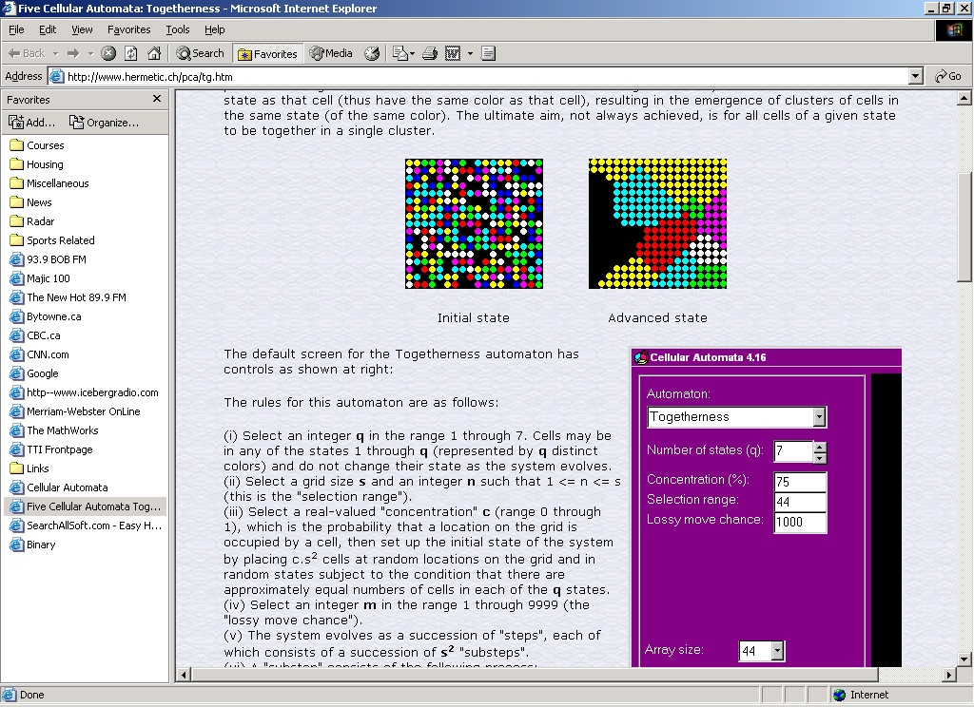

Initial State Final State

Specifications:

- cell state, q=4
- grid size, s=7
- selection range, n=1 (1<=n<=s)
- concentration, c=0.75 (0<=c<=1) (probability that location on grid is occupied by cell)
- lossy move chance, m=9999

Togetherness Process:

- select a random cell which is not surrounded by 8 neighbours all in the same state ‘cell 1’
- within grid size and within n units distance from cell 1, select a ‘cell location’ at random.
- if ‘cell location’ is occupied by a cell and if it has the same state as ‘cell 1’ or it is surrounded by 8 neighbours all in same state as ‘cell location’ then continue to step 4.
- if there is no cell at ‘cell location’, then calculate “gain”, g. Gain is the increase or decrease in the number of neighbours of cell that would result from moving ‘cell 1’ to that location. If (g>=0,) then move cell to new location. If (g=-1), then make the move with probability of 1 in m.
- if there is a cell at that location then calculate the net gain g. Net gain = (gain if no cell swap) – (gain if cell swap). If (g>=0), the swap cells. If (g=-1) or (g=-2), then perform swap with probability of 1 in m

