The Simulation of an interconnected Local Traffic Control System
By:
Ardeshir Golshani, St. #: 100631620
Ismaeel Al Ridhawi, St. #: 3385278

Part I The Conceptual Model
In this assignment we will consider a local traffic light system. The Local Traffic Control System is composed of four traffic lights at each intersection, each of which controls the traffic in one direction. Given the model of an intersection, we will duplicate this model to create a small city area. We will replace the current Cell-DEVS model of the connection between the intersections with a DEVS model. Then, we will use CD++ to simulate this model. The purpose of this simulation is to study the time that it will take a vehicle to drive from one intersection to the next.
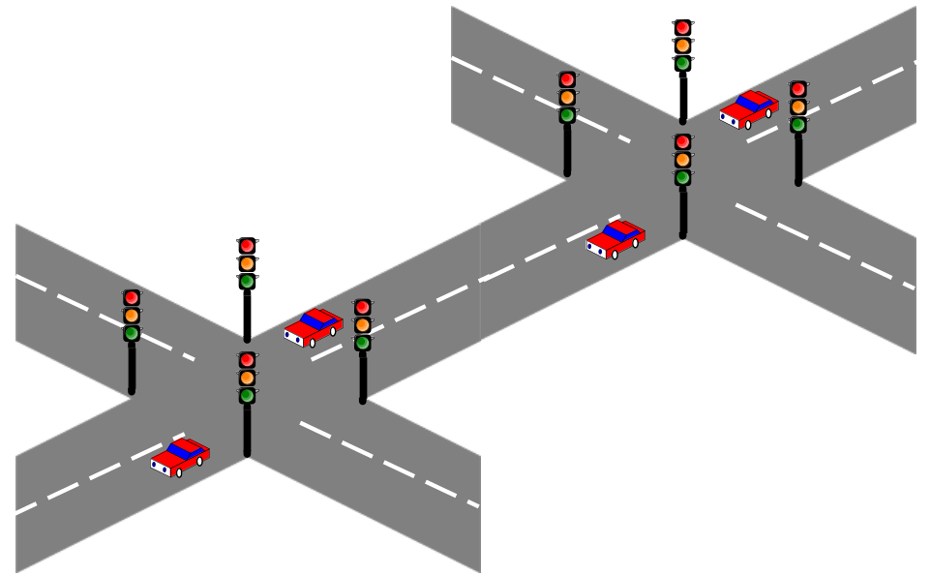
Figure 1: Interconnected Traffic Light System

The model will have the same assumptions as described in, “The Simulation of Local Traffic Control System” [1], only it will be done using CD++ DEVS:
- Only one lane per direction is considered at this time.
- The speed of a vehicle can be divided into 4 levels: stop, low, middle and high. The speed of the vehicle determines how long it takes to move from one cell to the next. The faster the speed, the shorter the time. However, a stopped vehicle is not necessarily completely still; it can move very slowly, which is the actual behaviour for a car waiting for the traffic light.

- Lane composites of limited cells, each cell can only be occupied by one vehicle at a time. When all cells are occupied, no more vehicles are allowed to move into the lane from the intersection. So if a lane is full, no vehicles are allowed to enter the intersection area ahead and no vehicles can enter into the lane, either.

- A vehicle can only travel from one cell to its adjacent cell ahead, with speed variation not exceeding one level.

- As a rule, each vehicle is responsible for keeping safe space between the vehicle in front of it and itself; the safe space size is in proportion to its speed, that means there is at least 3 spaces ahead of a high speed car, 2 space for middle speed; 1 space for low speed, and 0(zero) space for a stopped car etc.

- Within intersection area, vehicle can change its speed to a lower or a higher level, and the total intersection passing time is determined by speed of vehicle.

- When traffic light is yellow, if a vehicle can stop safely, it must stop; otherwise, it should pass the intersection

Model Structure
The following are the models included in the top model of this project:
Intersection Connector
This component is the main part, where it receives signals from intersection 1, and outputs the result to intersection 2. The reason behind this component is to connect two traffic light intersection together to calculate the average time of a car to travel from one intersection to the next.
Connector generator
Once a car has crossed the first traffic light intersection, it will be an input to the connector generator, which will provide a time for a specific car to travel, indicating its velocity. The output will be provided to the connector queue.
Connector Queue
This component stores all cars in the specified lane, waiting to pass through the second intersection, it can contain zero or more cars, and the number of cars in it specifies its state.
Connector Controller
This component is responsible to control each car waiting to be passed through the second intersection, it has state of IDLE and BUSY. If its busy that means that the light is red on intersection 2 and the lane will not move, the opposite of that is true.

Intersection 1

This component is mostly defined in [1] with minor changes in the intersection controller model. This component is responsible to control each car passing through the intersection, it has state of IDLE and BUSY.

Intersection 2

This component is mostly defined in [1] with minor changes, where the generator were removed and inputs were connected to the outputs of the intersection connector. This component is responsible to control each car passing through the intersection, it has state of IDLE and BUSY.
Figure 1 visualizes the top model, where the intersection connector is the component providing the connection between one traffic intersection to another. When a car has left the first intersection it will enter the intersection connector component. From there the input will be delivered to the connector generator. The purpose of the connector generator is to generate a random time to each incoming car. The random time is used to assign the time that it takes for a car to travel from one intersection to another, meaning its velocity. Once this is done, the connector generator will output the result and store it on a queue which is the lane connecting the two traffic light intersections. If the queue is full it will notify intersection 1 to not output anymore cars using the block output. If the queue has space and an input has been received from the connector generator it will notify intersection 1 that you can send more cars out if the traffic light is green. Once the cars are waiting in the queue, if the traffic light is green in intersection 2, a next signal is received from intersection 2, and cars are outputted to that component. A block signal indicates that it is red, and cars must wait in the queue.

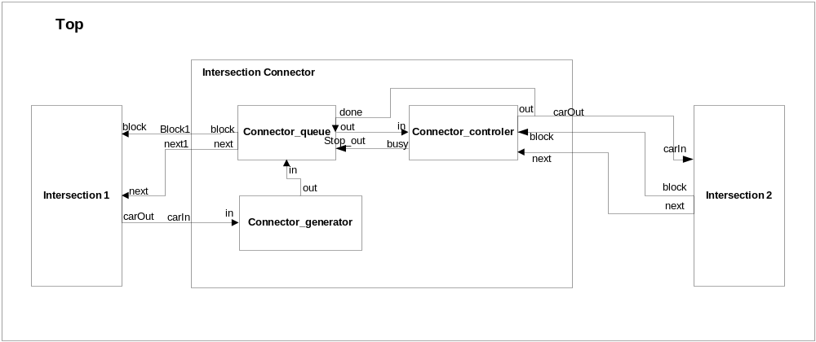
Figure 2: Top Model

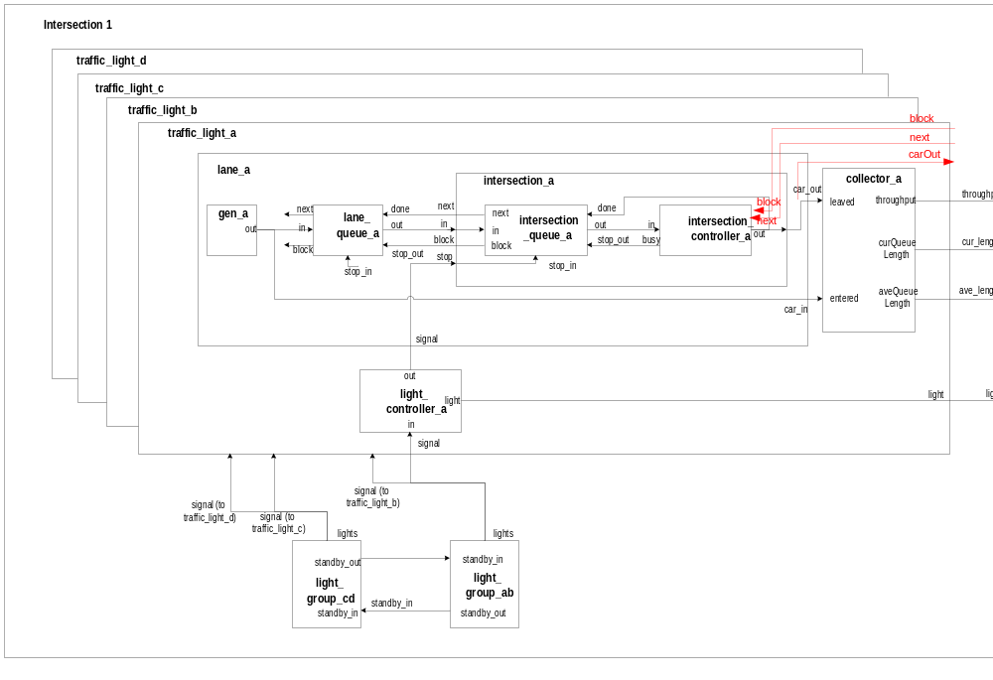
Figure 3: Intersection 1 Model
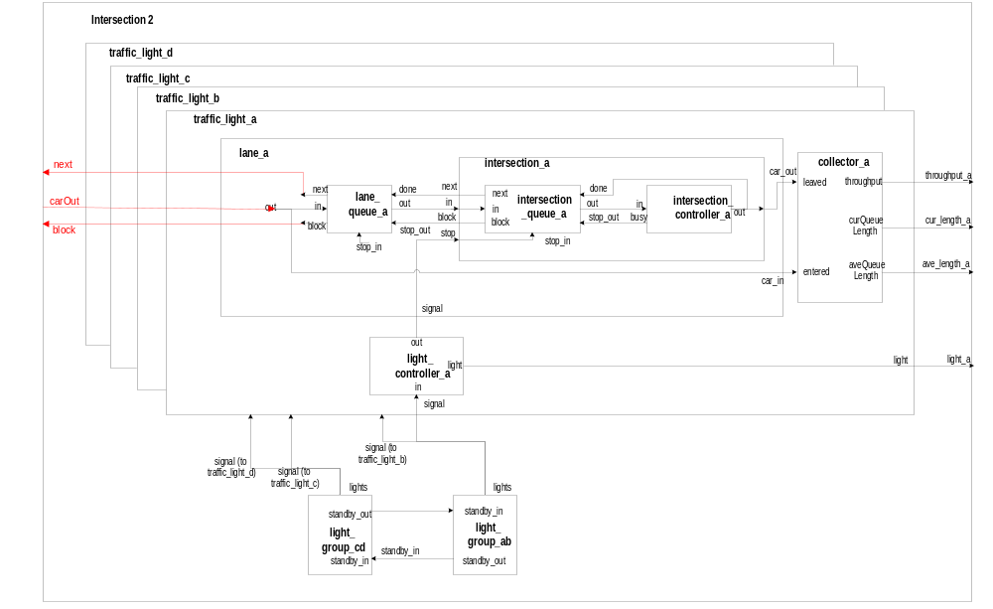
Figure 4: Intersection 2 Model

Part II: Formal Specifications for Models

The component structure of the traffic and intersection connector model is shown in Figures 2-4. We describe the specifications of the new models created and the ones modifies. First, the top model is represented; then, the intersection controller model, after that we will discuss the connector queue model, then the connector generator model, and finaly the connector controller model.

Top Model

Top=<S, X, Y, 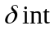, 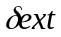, , ta>
- X=
- Y= {throughput_A, cur_length_A, ave_length_A, light_A,Average_Time}
- S={{phase, sigma, }}
- EIC=
- EOC= {( Traffic_Light_A.throughput, throughput_A),connector_controller.average_time}

Intersection Controller Model

Intersection_Controller=<S, X, Y, , , , ta>
- X= {traffic_in}
- Y={busy(the intersection is full),traffic_out}
- S={{phase, sigma, action{busy, outputing}}}
- ( action, e )
{
// pseudo code
if(the controller is BUSYING)
{
clear BUSYING state;
set the state as OUTPUTING; // we gonna output the input vehicle.
Hold In active state for a period of time; // now it is 0
}
else if(the controller is OUTPUTING)
{
clear the state;
passivate();
}
else
{
report error;
passivate();
}
}
- (e, x(type: traffic_in , next, block))
{
// pseudo code
if(the state is passive)
{
// we gonna be busy
action |= BUSYING;
hold in the state for responseTime time;
set the serviceTime;
}
If (block = 1)
{
Discard any input; //lane queue is now blocked
}
else
{
// now busy
discard any input; // for the lane queue is supposed to be blocked.
}
}
- (s)
{
// pseudo code
if(action & BUSYING)
{
Output busy info at busy_port;
}
else if(action & OUTPUTING)
{
Output an out at out_port.
}
else
{
report error;
}
}

Connector Queue Model

ConnectorQueue=<S, X, Y, , , , ta>
- X= { vehicle_in <vehicle_id>, block(stop_out), done, stop_in}
- Y={next, block, vehicle_out}
- S={{phase, sigma, vehicle_queue, vehicle}}
- ( vehicle_queue, vehicle, e )
- ( vehicle_queue, vehicle, e, x(type:vehicle, stop_out))
- ( action, e )
{
// pseudo code
if(the controller is BUSYING)
{
clear BUSYING state;
set the state as OUTPUTING; // we gonna output the input vehicle.
Hold In active state for a period of time; // now it is 0
}
else if(the controller is OUTPUTING)
{
clear the state;
passivate();
}
else
{
report error;
passivate();
}
}

- (e, x(type: traffic_in , done, stop_out))
{
// pseudo code
if(the state is passive)
{
Activate the state;
Check input:
If (input = stop_out)
{
Discard any input; //lane queue is now blocked
Out = null;
Block = 1;
Next = 0
}
Else if (input = done)
{
out = 1;
Queue_size = Queue -1;
Next = 1;
Block = 0;
}
}

- (s)
{
// pseudo code
if(action & BUSYING)
{
Output block;
}
else if(action & OUTPUTING)
{
Output carOut
Next = 1;
}
else
{
report error;
}
}

Connector Generator Model

Intersection_Controller=<S, X, Y, , , , ta>
- X= {in (car input) }
- Y={out (car output) }
- S={{phase, sigma, action{busy, outputing}}}
- ( action, e )
{
if(state()==active)
{
holdIn( passive , timeOut );
}
else
passivate();

- (e, x(type: in))
{
If an input “in” is received
Then {
Index++
Output index and the random tiem;
}
}
- (s)
{
If state = passive
Then send out the output;
}

Connector Controller Model

Similar to intersection controller with some changes, described below:
Intersection_Ctrller=<S, X, Y, , , , ta>
- X= {traffic_in}
- Y={busy(the intersection is full),traffic_out}
- S={{phase, sigma, action{busy, outputing}}}
- ( action, e )
{
// pseudo code
if(the controller is BUSYING)
{
clear BUSYING state;
set the state as OUTPUTING; // we gonna output the input vehicle.
Hold In active state for a period of time; // now it is 0
}
else if(the controller is OUTPUTING)
{
clear the state;
passivate();
}
else
{
report error;
passivate();
}
}
- (e, x(type: traffic_in ))
{
// pseudo code
if(the state is passive)
{
// we gonna be busy
action |= BUSYING;
hold in the state for responseTime time;
set the serviceTime;
}
else
{
// now busy
discard any input; // for the lane queue is supposed to be blocked.
}
}
- (s)
{
// pseudo code
if(action & BUSYING)
{
Output busy info at busy_port;
}
else if(action & OUTPUTING)
{
Output an out at out_port.
}
else
{
report error;
}
}

Testing and Results

Testing of Queue:
The .ma file created for testing the Queue can be seen below:
[top]
components : queue@Queue
in : in done
out : out
Link : in in@queue
Link : out@queue out
Link : done done@queue
[queue]
preparation : 0:0:3:000
capacity : 10
input : enable
output : enable
To test the Queue, we fed it the following inputs through an event file:
0:0:0:0 in 11
0:0:33:0 in 2
0:1:0:0 in 3
0:1:45:0 in 4
0:3:0:0 in 5
0:3:10:0 in 6
0:8:10:0 done 3
0:10:10:0 done 3
The corresponding outputs, saved in a .out file, are as shown next:
00:00:03:000 out 11
00:08:13:000 out 2
00:10:13:000 out 3

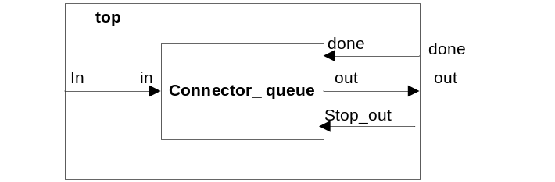

The way that this works is that upon receiving its first job (or car in our case), the queue forwards that job to the controller through its output port (i.e. 11 is being outputted through port out). Every subsequent job is stored into the queue until the queue receives a done signal from the controller, telling it that the controller is “done” with the old job, and can now accept a new job. When the done signal is received, the queue outputs the next job. This queue works in FIFO manner.
Testing of ConnectionGenerator:
The .ma file created for testing the ConnectionGenerator can be seen below:
[top]
components : connection_generator@ConnectionGenerator
out : out
in : in
in : reset
Link : out@connection_generator out
Link : in in@connection_generator
Link : reset reset@connection_generator
[connection_generator]
distribution : normal
mean : 30
deviation : 8
timeOut : 00:00:0:001
zero : 00:00:00:00

To test the ConnectionGenerator, we fed it the following inputs through an event file:
00:00:10:00 in 2
00:00:35:00 reset 1
00:00:45:00 in 2
00:01:00:00 in 2
00:02:10:00 in 2
00:02:20:00 in 2
00:02:25:00 in 2
00:04:10:00 in 2
00:06:10:00 in 2

The corresponding outputs, save in a .out file, are as shown next:
00:00:10:001 out 29.9024
00:00:10:002 out 0
00:00:45:001 out 20.3688
00:00:45:002 out 0
00:01:00:001 out 21.6624
00:01:00:002 out 0
00:02:10:001 out 30.2834
00:02:10:002 out 0
00:02:20:001 out 23.4604
00:02:20:002 out 0
00:02:25:001 out 31.2854
00:02:25:002 out 0
00:04:10:001 out 36.7991
00:04:10:002 out 0
00:06:10:001 out 35.2418
00:06:10:002 out 0
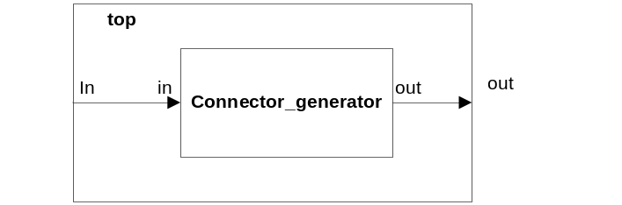

As can be seen in the .ma file, for the randomly generated processing times the mean that we requested is 30 and the deviation is 8. What this refers to is the amount of time it takes a vehicle to get from one intersection to the next. In other words, it is the amount of time it takes for a job to be processed. ConnectionGenerator has one input port and one output port. The way it works is that when the input port receives a signal, the atomic model creates a job, and sends it out through the output port, which goes directly into the queue.
Testing of Top File of Past Assignment 1:

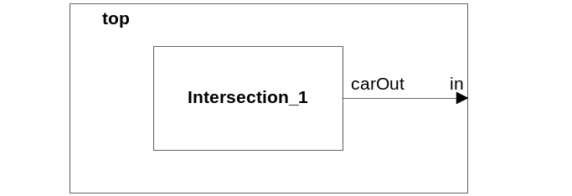
We took the top.ma file of the people who started this assignment, and tested their work. To test the top file, an event file was not required as the data was randomly generated through a generator. The outputs were stored in a .out file. The following is a sample of the resulting output of our test.
00:00:02:010 light_a 2
00:00:02:010 light_b 2
00:00:06:010 carout 1
00:00:07:010 carout 1
00:00:10:836 carout 1
00:00:14:523 carout 1
00:00:17:607 carout 1
00:00:20:026 carout 1
00:00:24:648 carout 1
00:00:27:876 carout 1
00:00:30:000 kharchang 16
00:00:30:000 throughput_a 16
00:00:30:000 curlen_a 1
00:00:30:000 avelen_a 1
00:00:30:000 throughput_b 20
00:00:30:000 curlen_b 1

Additionally, we added a carOut output port to their top file. Whenever a car leaves the intersection, a signal is sent through carOut. As we can see in the above output results, a car leaves the intersection at 6.01 seconds, 7.01 seconds, and so on. The rest of their output ports (such as throughput_a and curlen_a) are irrelevant for our purposes.

Testing of intersection_1 Coupled with connection_generator:

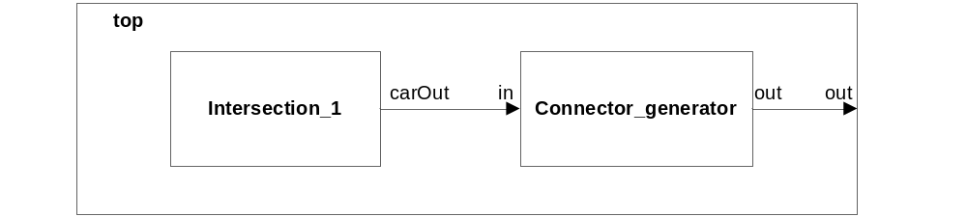
To perform this test, we coupled intersection_1 and connection_generator together in a top file. Intersection_1 contains a generator which generates the jobs (or cars), so an event file was not needed. For every car that left the intersection, a signal was sent from intersection_1 to connection_generator, telling connection_generator to generate a processing time for that job. What we mean by processing time is the time that it takes for a car to traverse the connecting street and finally reach the second intersection. We assumed a normal distribution with mean of 30 and standard deviation of 8. A sample of the resulting output file is shown below.
00:00:30:001 out 32.229
00:00:30:002 out 0
00:01:00:001 out 42.7614
00:01:00:002 out 0
00:02:00:001 out 38.4435
00:02:00:002 out 0
00:02:30:001 out 18.7303
00:02:30:002 out 0
00:03:00:001 out 34.0697
00:03:00:002 out 0
00:03:30:001 out 48.9467
00:03:30:002 out 0
00:04:30:001 out 30.4557
00:04:30:002 out 0
00:05:00:001 out 33.1012

Testing of intersection_1 and connection_generator and connector_queue Coupled Together:
To test the coupled model, we fed it the following inputs through an event file:
0:0:0:0 done 1
0:0:33:0 done 1
0:1:0:0 stop 1
0:1:45:0 done 1
0:3:0:0 done 1
The following results were obtained in the output file:
00:00:03:000 out 2
00:00:36:000 out 4
00:01:48:000 out 5
00:03:03:000 out 6
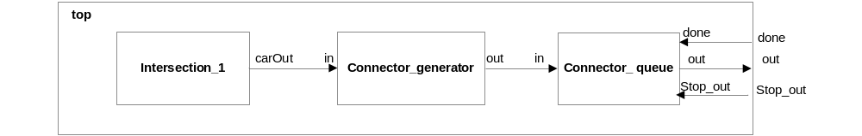

What this coupled model does is that intersection_1 sends a signal to connection_generator every time a car leaves the intersection. Then, connection_generator creates a random traversing time that the car will take to drive to the next intersection (normal distribution, mean 30, standard deviation 8) and send it to the connector_queue. The connector_queue will send out the job (or car) when it receives a done signal.

