Course: 94587 Assignment 1

The Simulation of Simple Local Traffic Control System
by
Jidong Cao (student #: 350637 ) and
Xuebing Qing (student #: 3037225)

Part I The Conceptual Model

A simple local traffic control system is simulated in this assignment. As shown in Figure 1, only the traffic control at one intersection, or a Unit Local Traffic Control System, is observed at this time. Physically, the Unit Local Traffic Control System is composed of four traffic lights, each of which controls the traffic in one direction respectively. The purpose of this simulation is to use CD++ to reproduce the behaviors of a local traffic control system, and to identify the factors that affect the throughput of the local traffic system as well as the potential defects of it that may cause vehicle collisions.

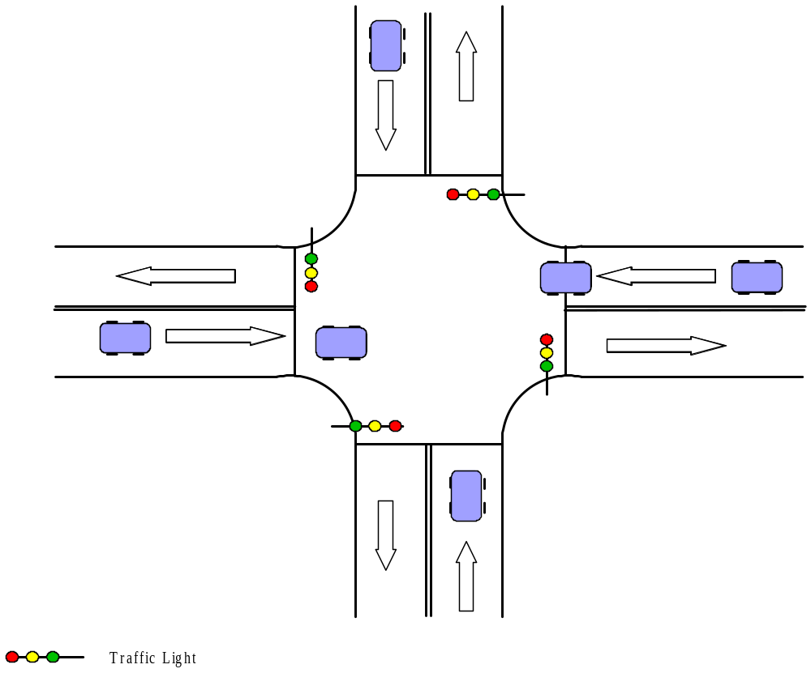
Figure 1 Simple Local Traffic Control System (One Intersection)
As part of the conceptual definition of the system, we make the following assumptions that can serve as the boundary conditions of the system, which further form the so-called experimental frame of the Unit Local Traffic Control System:
- Only traffic in four directions is considered; right-turn and left-turn traffic is not observed at this time.
- The traffic in each direction has at least one lane respectively.
- The length of each lane is unlimited, i.e. each lane is capable of accommodating unlimited number of vehicles at a given time.
- On the contrary, the capacity of the intersection area is limited; the maximum number of vehicles it accommodates is constant and defined when the system is built.
- Red-light-overlapping for any two intersectant directions is considered. The red-light-overlapping happens when the traffic light in one of the intersectant directions becomes red from yellow while the one in the other of the intersectant directions is red and turning into green. We call the time period in which the both lights are red as Red-light-overlapping time.
- Each vehicle in traffic does not change lane at any given time.
- A vehicle moving to a given direction never enters the intersection area if the traffic light for that direction is red.
- A vehicle moving to a given direction enters the intersection area if and only if the traffic light for that direction is red or yellow.
- No vehicle stops in the intersection area at any given time.
- Each vehicle in traffic uses the same amount of time to pass through the intersection area. The time for one vehicle to pass can be obtained by observing the average passing time of all vehicles.
- Except traffic lights, there are no other traffic control methods considered in the system.
- No pedestrian and pedestrian control are involved in the system at this time.

The Model Structure

According to the place where functions are achieved, we have system structure as depicted in Figure 2.

Lights Group Controller
This component is responsible to control one-group lights, each for every direction.
It communicates with another group controller to synchronize them, and outputs same signals to the two lights belonging to this group. Its state includes RED, YELLOW and GREEN.

Traffic Light
This component represents the physical traffic light for a unidirectional traffic, which controls one or more lanes. Its state is controlled by “Traffic Light Controller” component.

2.1 Traffic Light Controller
This component receives signals from group controller, turns on only one of its three lights according to the signal, and output enable/disable signal to all lanes controlled by this light. Its state includes RED, YELLOW and GREEN.

2.2 Lights
This component represents the red, yellow and green lights belong to one traffic light, each light has ON and OFF state.

2.3 Lane
This component represents one lane and the area of intersection through which the traffic of that lane pass. It’s stateless.

2.3.1 Lane Queue
This component stores all cars in the specified lane, waiting to pass through the intersection, it can contain zero or more cars, and the number of cars in it specifies its state.

2.3.2 Intersection
This component represents the intersection area where car traffic passed through. It has status of ENABLED, DISABLED.

2.3.2.1 Intersection Queue
This component contains the cars passing the intersection; it has limited capacity, usually 1-2, which is specified by the length of the real intersection. Its state is the number of cars within it.

2.3.2.2 Intersection Controller
This component is responsible to control each car passing through the intersection, it has state of IDLE and BUSY. At this time, this component does very simple work – just for go straight traffic. If left turn, right turn or pedestrian are supported in the future, this component will check status of some other controller components before passing through the intersection.

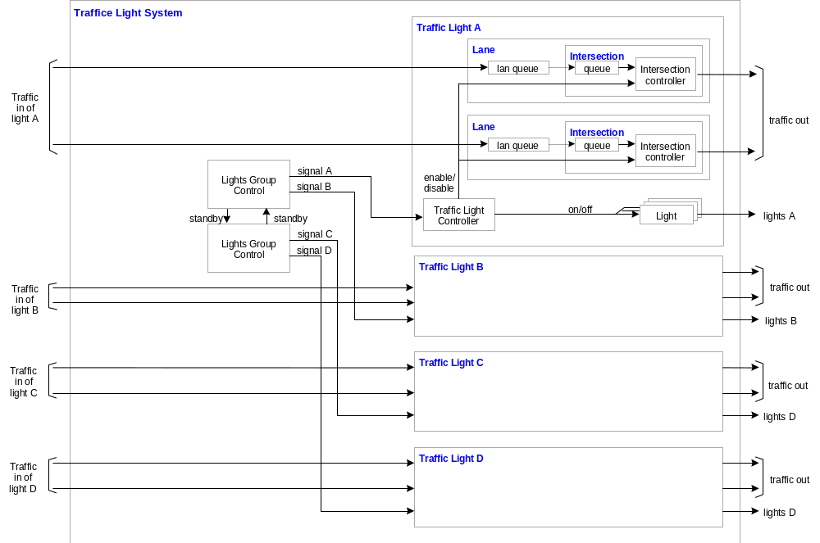
Figure 2 Traffic Light System Structure
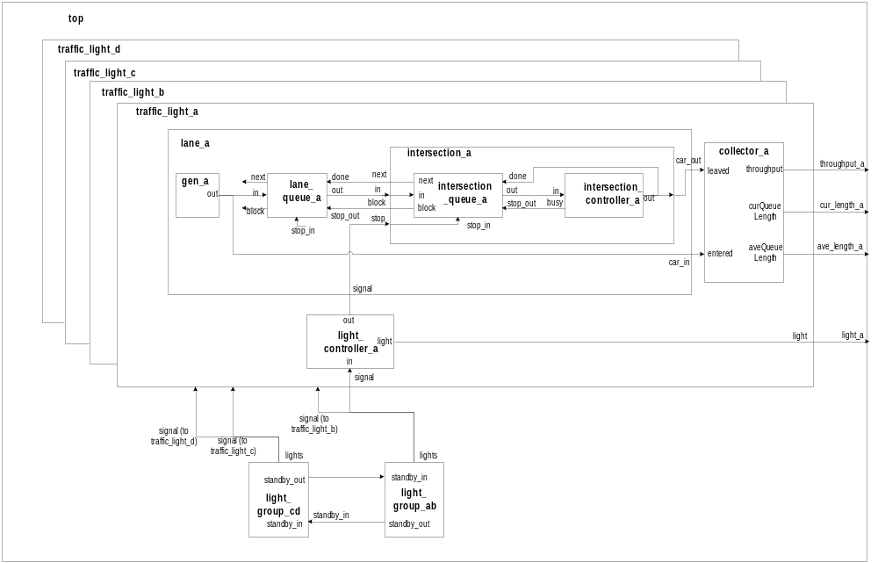
Figure 3 Component Structure

Part II The Formal Specifications for Models

2.1 Model Specifications

The component structure of Unit Local Traffic Control System is shown in Figure 3. We describe the specifications of models here one by one. First, the top model, or the specifications of local traffic control is represented; then, the specifications of secondary models are depicted. Finally, atomic models are described.

2.1.1 Local Traffic Control Model

This is the top coupled model and its formal specification is:
Local_Traffic_Control_Model = <X, Y, {Light_Group_ AB, Light_Group_ CD, Traffic_Light_A, Traffic_Light_B, Traffic_Light_C, Traffic_Light_D}, EIC, EOC, IC, SELECT>
- X=
- Y={throughput_A, cur_length_A, ave_length_A, light_A, throughput_B, cur_length_B, ave_length_B,light_B, throughput_C, cur_length_C, ave_length_C,light_C, throughput_D, cur_length_D, ave_length_D, light_D}, where throughput_X is the throughput of all lanes in the direction X, cur_length_X is the current length in the direction X and ave_length_X is the average length of the traffic in the direction X.
- EIC=
- EOC={(Traffic_Light_A.throughput, throughput_A),(Traffic_Light_A.curqueuelength, cur_length_A),(Traffic_Light_A.avequeuelength,ave_length_A),(Traffic_Light_A.light, light_A), (Traffic_Light_B.throughput, throughput_B),(Traffic_Light_B.curqueuelength, cur_length_B),(Traffic_Light_B.avequeuelength,ave_length_B), (Traffic_Light_B.light, light_B), (Traffic_Light_C.throughput, throughput_C),(Traffic_Light_C.curqueuelength, cur_length_C),(Traffic_Light_A.avequeuelength,ave_length_C), (Traffic_Light_C.light, light_C), (Traffic_Light_D.throughput, throughput_D),(Traffic_Light_D.curqueuelength, cur_length_D),(Traffic_Light_D.avequeuelength,ave_length_D), (Traffic_Light_D.light, light_D) }
- IC={(Light_Group_ AB.lights, Traffic_Light_A.signal), (Light_Group_ AB.lights, Traffic_Light_B.signal), (Light_Group_ CD.lights, Traffic_Ligh _C.signal), (Light_Group_ CD.lights, Traffic_Light _D.signal),
(Light_Group_ AB.standby_out, Light_Group_ CD.standby_in),
(Light_Group_ CD.standby_out, Light_Group_ AB.standby_in)}

- SELECT:
({Light_Group_ AB, Traffic_Light_A})= Light_Group_ AB
({Light_Group_ AB, Traffic_Light_B})= Light_Group_ AB
({Light_Group_ CD, Traffic_Light_C})= Light_Group_ CD
({Light_Group_ CD, Traffic_Light_D})= Light_Group_ CD

2.1.2 Traffic Light Model

We have totally four instances of Traffic Light Model, namely, Traffic_Light_A, Traffic_Light_B, Traffic_Light_C and Traffic_Light_D. We give the formal specifications of Traffic Light Model as following:

Traffic_Light = <X,Y, {{LANEi},Traffic_Collector, Light_Ctrller}, EIC, EOC, IC, SELECT>, where {LANEi} represents a collection of LANE, and 1 i num_Lanes
- X={signal}
- Y={throughput, cur_length, ave_length, light}
- EIC={(signal,Light_Ctrller.in)}
- EOC={(Traffic_Collector.throughput,throughput), (Traffic_Collector.curqueuelength.cur_lengh), (Traffic_Collector.avequeuelength,ave_length), (Light_Ctrller.light, light)}
- IC={ (Light_Ctrller.out, LANE₁. signal),…, (Light_Ctrller.out, LANE_{i}.signal), …,( Light_Ctrller.out, LANE_{n}.signal),( LANE₁.car_out,Traffic_Collector.leaved),…, ( LANE_{i}.car_out,Traffic_Collector.leaved),…,( LANE_{n}.car_out,Traffic_Collector.leaved), ( LANE₁.car_in,Traffic_Collector.entered),…, ( LANE_{i}.car_in,Traffic_Collector.entered),…,( LANE_{n}.car_in,Traffic_Collector.entered), (Traffic_Light_Ctrller.out,Light.in) }, where 1 i num_Lanes and n is the number of lanes.
- SELECT:
({LANE_{i}, Traffic_Collector})= LANE_{i}
({Light_Ctrller,LANE_{i}, Traffic_Collector})= Light_Ctrller

2.1.3 Lane Model

Lane is also a coupled model and represented as following:

Lane= <X, Y, {Gen, Lane_queue, Intersection}, EIC, EOC, IC, SELECT>
- X={in_signal}
- Y={car_out, car_in}
- EIC={(signal,Intersection.stop)}
- EOC={(Intersection.out, car_out), (Gen.out,car_in)}
- IC={(Gen.out,Lane_queue.in),(Lane_queue.out,Intersection.in),(Intersection.next,Lane_queue.done),(Intersection.block,Lane_queue.stop_out)}
- SELECT=:
({Gen, Lane_queue, Intersection})=Gen
({Lane_queue, Intersection})=Intersection

2.1.4 Intersection Model

The specifications of Intersection model is:

Intersection = <X, Y, {Intersection_queue, Intersection_Ctrller}, EIC, EOC, IC, SELECT>
- X={in, stop}
- Y={next, block,car_out}
- EIC={(in, Intersection_queue.in), (stop, Intersection_queue.stop_in)}
- EOC={(Intersection_queue.next, next), (Intersection_queue.block, block),(Intersection_Ctrller.out, car_out)}
- IC={(Intersection_queue.out,Intersection_Ctrller.in),(Intersection_Ctrller.busy,Intersection_queue.stop_out),(Intersection_Ctrller.out, Intersection_queue.done)}
- SELECT:
({Intersection_queue,Intersection_Ctrller)}= Intersection_queue

Starting from the next sub-section, we give the specifications for each of the atomic models.

2.1.5 Lights Group Control Model

The specifications of Light Group or Light Group Control is:

Lights_Group_Ctrl=<S,X,Y, 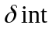, 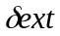, , ta>
- X={standby_in}, where standby_in means red_overlapping
- Y={standby_out,lights{Green, Yellow, Red}}
- S={light_state{Green, Yellow, Red_Overlapping(stand_by), Red}}
- Ta(Red)=INFINITY
- Ta(Green)=green_light_ time
- Ta(Yellow)=yellow_light_time
- Ta(Red_Overlapping) = red_overlapping_time
- (light_state,e)
{
// pseudo code
switch(light_state)
{
case GREEN:
set current_state as YELLOW;
phase = active;
sigma = yellow_time;
break;
case YELLOW:
set current_state as RED;
phase = passive;
break;
case STANDBY:
set current_state as GREEN;
phase = active;
sigma = green_time;
break;
case RED:
throw an exception;
break; }
}
- (light_state,e, x(type: activate))
{
//pseudo code
if(current_state is not RED)
{
// the states of two set of lights are not synchronized correctly.
Throw an exception;
return;
}

set current_state as STANDBY(red overlapping);
Hold in “active” for standby_time time;
}
- (light_state)
{
// pseudo code:
switch(current_state)
{
case GREEN:
output YELLOW at lights port;
break;
case YELLOW:
output RED at lights port;
output RED at standby_out port;
break;
case STANDBY:
output GREEN at lights port;
break;
case RED:
throw an exception;
break;
}
}

2.1.6 Traffic Generator Model

The model Gen from CD++ package is reused.

2.1.7 Traffic Collector Model

Collector=<S, X, Y, , , , ta>
- X= {leaving_vehicle, entering vehicle}
- Y={throughput, curqueuelength, avequeuelength}
- S={{phase, sigma}}
- Ta(PASSIVE)=INFINITY
- Ta(ACTIVE)=sample_frequency
- ( e)
{
// pseudo code
hold in active state for frequency time.
}
- (e)
{
// pseudo code
if(the state is passive)
{
hold In active for frequence time;
}
else // if(the state is active)
{
if(the event is from entered port)
{
enterCount++;
}
else // if(the event is from leaved port)
{
leaveCount++;
}
hold In the active state for the rest of the period (sigma);
}
}
- (s)

2.1.8 Traffic Light Controller Model

Light_Ctrller=<S,X,Y, , , , ta>
- X= { signal{Red, Green, Yellow}}
- Y={out{enable, disable}, light{Red, Green, Yellow}}
- S={light_ctrller_state{red, green, yellow}, sigma, phase}
- Ta(red)=INFINITY (passive)
- Ta(green)=INFINITY (passive)
- Ta(yellow)=INFINITY (passive)
- Ta(active) = 0;
- (e)
{
if (current_state is RED and requested state is GREEN)
{
set current_state with requested state;
passivate();
}
else if(current_state is GREEN and requested state is YELLOW)
{
set current_state with requested state;
passivate();
}
else if(current_state is YELLOW and requested state is RED)
{
set current_state with requested state;
passivate();
}
else
{
exception;
}}
- (e)
{
//pseudo code
get the requested state;
hold in the active state for a short preparing time;
}
- (s)
{
//pseudo code
if (current_state is RED && the requested state is GREEN)
{
Output GREEN at light port;
Output 0 at out port; // non-stop
}
else if(current_state is GREEN && the requested state is YELLOW)
{
Output YELLOW at light port;
}
else if(current_state is YELLOW && the requested state is RED)
{
Output RED at light port;
Output 1 at out port; // stop the traffic!
}
else
{
exception;
}
}

2.1.9 Lane Queue Model

Lane_Queue=<S, X, Y, , , , ta>
- X= { vehicle_in <vehicle_id>, block(stop_out), done, stop_in}
- Y={next, block, vehicle_out}
- S={{phase, sigma, vehicle_queue, vehicle}}
- ( vehicle_queue, vehicle, e )
- ( vehicle_queue, vehicle, e, x(type:vehicle, stop_out))
The simplified and non-completed description of the internal the external functions is shown in Figure 4.
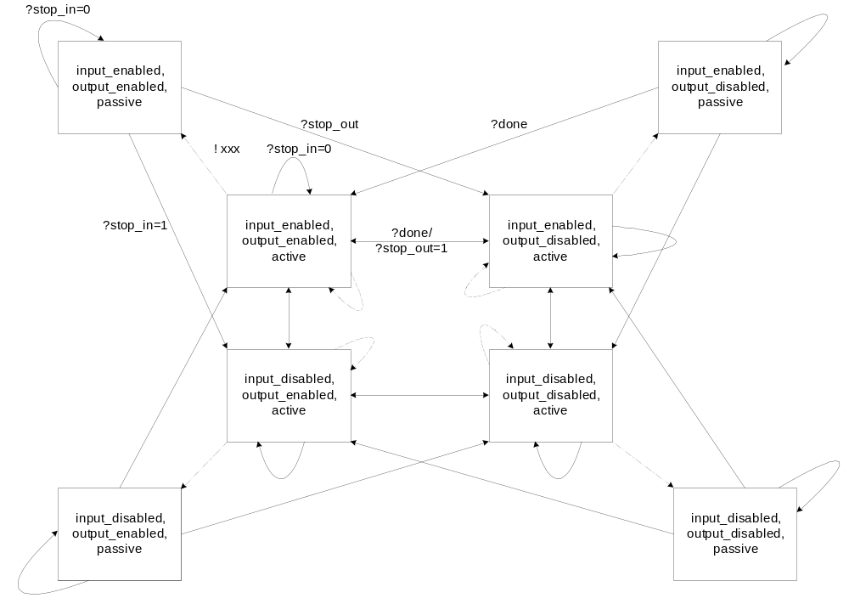
Figure 4 State-based Diagram for Lane Queue and Intersection Queue

2.1.10 Intersection Queue Model

Queue=<S, X, Y, , , , ta>
- X= { vehicle_in <vehicle_id>, block(stop_out), done, stop_in}
- Y={next, block, vehicle_out}
- S={{phase, sigma, vehicle_queue, vehicle}}
- ( vehicle_queue, vehicle, e )
- ( vehicle_queue, vehicle, e, x(type:vehicle, stop_out))
The description of the internal the external functions is shown in Figure 4.

2.1.11 Intersection Controller Model

Intersection_Ctrller=<S, X, Y, , , , ta>
- X= {traffic_in}
- Y={busy(the intersection is full),traffic_out}
- S={{phase, sigma, action{busy, outputing}}}
- ( action, e )
{
// pseudo code
if(the controller is BUSYING)
{
clear BUSYING state;
set the state as OUTPUTING; // we gonna output the input vehicle.
Hold In active state for a period of time; // now it is 0
}
else if(the controller is OUTPUTING)
{
clear the state;
passivate();
}
else
{
report error;
passivate();
}
}
- (e, x(type: traffic_in ))
{
// pseudo code
if(the state is passive)
{
// we gonna be busy
action |= BUSYING;
hold in the state for responseTime time;
set the serviceTime;
}
else
{
// now busy
discard any input; // for the lane queue is supposed to be blocked.
}
}
- (s)
{
// pseudo code
if(action & BUSYING)
{
Output busy info at busy_port;
}
else if(action & OUTPUTING)
{
Output an out at out_port.
}
else
{
report error;
}
}

2.2 Testing Strategies

Three-stage-testing strategy is used: unit test for atomic models, unit test for simple coupled model and the integration test for the system.

For each atomic model, we perform unit test to check its correctness and robustness. The test cases for correctness or conformance testing are created in accordance with the experimental frames that are derived from the stated assumptions in Part I. Obviously, the test cases for robustness testing are created so as to feed invalid data for a specific unit (atomic model) and make sure this unit can still run without any uncaught exceptions. However, because some atomic models’ features depends on other models’ output data, the testing for these features is deferred and performed in the coupled model testing.

The conformance and robustness test cases for atomic models are expanded and reused in coupled model, as well as integration testing. All of them cover the conformance and robustness testing in the coupled and integration level, respectively.

2.2.1 Traffic Generator Model

The generator model in CD++ is reused in our system and hence it is not necessary to perform any unit test with it.

2.2.2 Light Group Control Model

Test Case #: 1
Top
light_cd
light_ab
groupAB
groupCD
standby_in
standby_in
standby_in
standby_in
lights
lights

The purpose of this model is to output correct, at least non-harmful signals to the traffic that it controls all the time. For example, outputting green light signal when the model is in the passive state is obviously harmful and unacceptable for the local traffic control system.

The following has been tested:
- The model outputs the green light signal when there is a standby signal input with the value of 1.
- The model outputs the green, yellow, red signal based on the predefined time schedule when it is active.
- The model outputs the standby control signal to its counterpart when it changes from the state of Red_overlapping to Red.

2.2.3 Lights Group A-B and C-D

Test Case #: 1

Because of the importance of the two models, and the likelihood of deadlock between them, we put them together and do the unit test for a certain period of time. The expected output signals produced from them are:
- Either of the model performs correctly in accordance with the predefined time schedule for Green, Yellow, red overlapping and red.
- When one of the two models is in the state of either green or yellow, another must be red.

The test cases stated in 2.2.2 are reused here.

2.2.4 Traffic Collector Model
Top
traffic collector
gen1
out
entered
throughput
gen2
out
leaved
curQueueLength
aveQueueLength
throughput
curlength
avelength

Test Case #: 7

We have tested:
- The model receives one vehicle at the entered port and increases the current length counter by 1.
- The model receives one vehicle at the leaved port and decreases the current length counter by 1.
- The model outputs throughput, current length and average length correctly.

Please note that in this test case, we use two generators to feed the entered and leaved port of the collector model respectively, because two generator’s rate is different and Poisson function is used, for a certain period of time, the feed rate for the leaved port is great then the one for the entered port, the current length is negative for that time period. Actually, this is how the generic collector works.

2.2.5 Traffic Light Controller Model

Test Case #: 2
Top
in
signal
light_controller
out
in
light
light

For the conformance testing, we need test:
- The model receives a light signal and output a proper control signal to Lane model (either enabled (non-stop) or disabled (stop)).
- The model receives a light signal and output a proper light control signal to Light model timely (red, green and yellow).

For the robustness testing, we need test:
- The model receives invalid light signals and ignores it; it prints an error message too.

2.2.6 Lane Queue Model

Test Case #: 3,4
Top
in
out
lane_queue
out
in
block
next
next
block
stop_in
stop_out
stop_in
stop_out
done
done

We have tested:
- The model stop outputting vehicles whenever the traffic control signal is disabled (the intersection may be full or not).
- The model stop outputting vehicles when the traffic control signal is enabled while the intersection is full.
- The model can accommodate any number of vehicles without outputting vehicles, when either the traffic control signal is disable or the intersection is full.
- The model output vehicles based on the proper time schedule, i.e. each vehicle stays the same amount of time before leaving the lane queue.
- Test the above against unlimited-length queue and limited-length queue respectively.

2.2.7 Intersection Queue Model
Top
in
out
intersection_queue
out
in
block
next
next
block
stop_in
stop_out
stop_in
stop_out
done
done

Test Case #: 5

We have tested:
- The model stop inputting vehicles when the traffic control signal is disabled.
- The model keeps outputting vehicles no matter what the traffic control signal is(enabled or disabled) until the queue becomes empty.
- The model can only accommodate a predefined number of vehicles (e.g. 2), which indicates the capacity of the intersection.
- The model output vehicles based on the proper time schedule, i.e. each vehicle stays the same amount of time before leaving the queue.

2.2.8 Intersection Controller Model

Test Case #: 6
Top
out
timeout
server@
Intersection
Controller
out
in
busy
gen
queue
out
in
busy
done
value
We have tested:
- The model outputs vehicles immediately.

2.2.9 Intersection Model
Top [Intersection]
out
out
intersection
controller
out
in
intersection
queue
in
in
next
out
busy
stop_out
done
block
next
block
stop
stop_in

Test Case #: 5,6,8

This is a coupled model, which is composed of the intersection queue model and the intersection controller model. The test cases for the intersection queue and controller model are combined and reused, i.e. the test cases (conformance and robustness) concerning about in_traffic (vehicles), “intersection full feedback” signal in the intersection queue model, and those about control signal in the intersection controller model. Please refer to 2.2.7 and 2.2.8 for detail.

2.2.10 Lane Model

Test Case #: 9
Top [ Lane]
intersection
out
in
next
block
stop_in
intersection
controller
out
in
busy
out
intersection
queue
in
next
out
stop_out
done
block
stop_in
gen
lane queue
stop_in
block
next
out
in
out
done
stop_out
stop
car_in
car_out
The lane model is composed of the lance queue, the intersection queue and the intersection controller model. The test cases are mainly combined from the test cases of the lane queue model and the intersection model. That is to say, the test cases for the lane queue model which are concerning about the in_traffic(vehicles) and the test cases for the intersection controller which are concerning about the traffic control signal are put together.

2.2.11 Traffic Light Model

Test Case #: 10
Top [ TrafficLight]
traffic light controller
lane
collector
out
stop
signal
in
light
car_in
car_out
entered
leaved
throughput
curQueueLength
aveQueueLength
throughput
curlength
avelength
light

The traffic generator model, traffic light controller and several instances of lane models are combined to perform the testing. Hence, it can be considered as a small integration test.

We have tested:
- The model stops the traffic when the traffic control signal is red; the light output should be red.
- The model moves the traffic when traffic control signal is green or yellow; the light output should be green or yellow, respectively.
- The model discards the duplicated control signal automatically.
- The model works decently and display proper error messages.

2.2.12 Integration Test and Analysis

Test Case #: 0
Top
light_group_controller_ab
light_group_controller_cd
standby_in
standby_in
standby_in
standby_in
lights
lights
traffic_light_a
traffic_light_b
traffic_light_c
traffic_light_d
signal
signal
signal
signal
light_a
throughput_a
curlength_a
avelength_a
light
throughput
curlength
avelength
light_b
throughput_b
curlength_b
avelength_b
light
throughput
curlength
avelength
light_c
throughput_c
curlength_c
avelength_c
light
throughput
curlength
avelength
light_d
throughput_d
curlength_d
avelength_d
light
throughput
curlength
avelength
The whole system is integrated and run for a normal case for a certain period of time, i.e. a regular traffic control scheme is used, e.g. on A-B direction, G: 30 seconds, Y:3 seconds, R_over_lap(stand_by): 2 seconds; while in C-D direction: G:45 seconds, Y:3 seconds, R_over_lap(stand_by): 2 seconds.

In part III, we conduct a result analysis on this test case.

Part III Execution Result Analysis Report

The result of Test case 0 is analyzed here.

First, we analyze whether the Unit Local Traffic Control model works properly by checking 1). The green, yellow, standby time for AB, CD respectively; 2). The throughput at red light time and green light time.

The following is a segment from the output file:

00:00:02:010 light_a 2
00:00:02:010 light_b 2
00:00:30:000 throughput_a 16
00:00:30:000 curlen_a 1
00:00:30:000 avelen_a 1
00:00:30:000 throughput_b 20
00:00:30:000 curlen_b 1
00:00:30:000 avelen_b 1
00:00:30:000 throughput_c 0
00:00:30:000 curlen_c 10
00:00:30:000 avelen_c 10
00:00:30:000 throughput_d 0
00:00:30:000 curlen_d 9
00:00:30:000 avelen_d 9
00:00:32:010 light_a 3
00:00:32:010 light_b 3
00:00:35:010 light_a 1
00:00:35:010 light_b 1
00:00:37:010 light_c 2
00:00:37:010 light_d 2
00:01:00:000 throughput_a 6
00:01:00:000 curlen_a 7
00:01:00:000 avelen_a 4
00:01:00:000 throughput_b 6
00:01:00:000 curlen_b 8
00:01:00:000 avelen_b 4.5
00:01:00:000 throughput_c 20
00:01:00:000 curlen_c 10
00:01:00:000 avelen_c 10
00:01:00:000 throughput_d 20
00:01:00:000 curlen_d 11
00:01:00:000 avelen_d 10
00:01:22:010 light_c 3
00:01:22:010 light_d 3
00:01:25:010 light_c 1
00:01:25:010 light_d 1
00:01:27:010 light_a 2
00:01:27:010 light_b 2

We can see, at the time “00:00:02:010”, both of light_a and light_b are 2, i.e. green. At the time “00:00:32:010”, they turn into yellow(i.e. 3), so G_{AB} = 30 seconds. At the time “00:00:35:010”, light_a and light_b turn into red (i.e. 1), so Y_{AB} = 3 seconds. Please not that at the same time, light_c and light_d starts the standby period; at the time “00:00:37:010”, light_c and light_d turn green, so STANDBY_{CD} = 2 seconds. Similarly, we calculate G_{CD} = 1:22:010 – 00:37:010 = 45 seconds, Y_{CD}=01:25:010 - 01:22:010 = 3 seconds and STANDBY_{AB} = 01:27:010 - 01:25:010 = 2 seconds. The results match with the parameters set in the *.ma file completely.

We also notice that when light C and D are red (from 00:00:02:010 to 00:00:37:010), the throughput in CD direction is 0; while after lights C and D become green, the throughputs in C and in D become 20.

Secondly, we analyze how the traffic light time schedule for one direction is affecting its average queue length. In Test Case 0, we know G_{AB} = 30, Y_{AB} = 3, STANDBY_{AB} = 2 and G_{CD} = 45, Y_{CD} = 3, STANDBY_{CD} = 2, then we can guess in the direction CD, the average length is likely shorter then in the direction AB over a certain period of time. We can verify this by analyzing the output data.

We extract the following data from the output file:

00:14:30:000 avelen_a 62.6552
00:14:30:000 avelen_b 56.7931
00:14:30:000 avelen_c 31.1724
00:14:30:000 avelen_d 27
:
:
00:28:00:000 avelen_a 119.304
00:28:00:000 avelen_b 105.732
00:28:00:000 avelen_c 54.1964
00:28:00:000 avelen_d 45.6071
:
:
00:36:00:000 avelen_a 151.597
00:36:00:000 avelen_b 135.861
00:36:00:000 avelen_c 68.6944
00:36:00:000 avelen_d 56.4306
:
:
00:48:30:000 avelen_a 202.454
00:48:30:000 avelen_b 183.773
00:48:30:000 avelen_c 91.3608
00:48:30:000 avelen_d 75.3814
:
:
00:53:00:000 avelen_a 221.038
00:53:00:000 avelen_b 200.953
00:53:00:000 avelen_c 98.5094
00:53:00:000 avelen_d 82.2075
:
:
00:57:00:000 avelen_a 237.333
00:57:00:000 avelen_b 216.518
00:57:00:000 avelen_c 104.684

We observe that the average length of traffic queue in AB direction is always longer than in CD direction. More interesting, the lengths of all of the queues are increasing with time. This means either there are too many vehicles for the observed intersection or the traffic capacity of the intersection needs improvement.

