Carleton University
Department of Systems and Computer Engineering

94.587 Assignment 1

Shannon Borho
Student No. 280901

Identifying the system
I have decided to do a traffic light system as the system that can be represented using the DEVS formalism. The system is comprised of two one-way streets that intersect with a traffic light controlling the flow. Pedestrians also use this intersection to cross the street. The pedestrians have a light indicating if it is okay to cross the street. In this system, the top model is the Intersection System. It can be decomposed into 5 simple sub models:
- Lights
- Queues
- Generators
- A Sensor
- A Button

The Lights can be further broken down to two sub models:
- Traffic Control
- Walk Control

The Traffic Control can once again break down to two atomic models:
- East-West Light
- North-South Light

The Walk Control can also be broken down to two atomic models:
- East-West Walk Signal
- North-South Walk Signal

The lights are responsible for informing the cars and pedestrians whether it is safe to cross the intersection in their direction.

The generator system has four different generators, two producing cars, and the other two producing pedestrians.

The queue system also has four atomic models, four queues representing the cars and pedestrians waiting to cross the street if they are informed not to go.

The button is responsible for informing the light system that there is a pedestrian waiting to cross the intersection in the east-west direction. Once this happens, the light will turn red in the north-south direction and inform the pedestrian that it is safe to cross.

Here is a visual description of the system with the sub models and atomic models with their links.
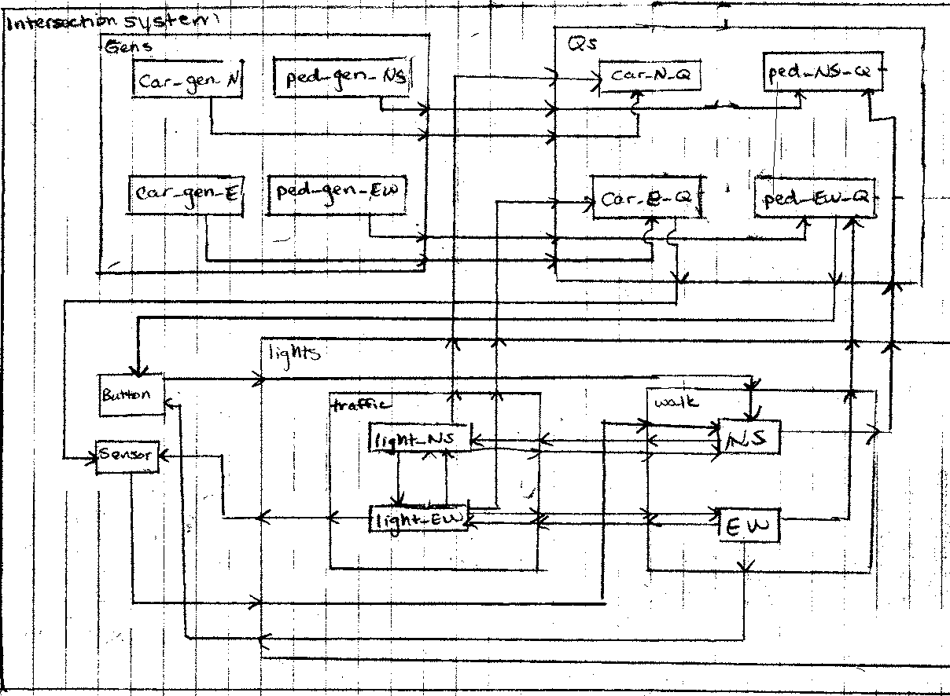

Similarly, the sensor is responsible for informing the light system that a car wants to cross the intersection in the east-west direction.

Coupled Model specification

Below is the coupled model specification taken from my intersection.ma file. Following that is the specification as shown in class using ports.
[top]
components : Gens Qs Lights button@Button sensor@Sensor
Link : car_E@Gens car_E@Qs
Link : car_N@Gens car_N@Qs
Link : ped_NS@Gens ped_NS@Qs
Link : ped_EW@Gens ped_EW@Qs
Link : EW_car_Q@Qs car_in_Q@sensor
Link : EW_ped_Q@Qs ped_in_Q@button
Link : button_on@button button_on@Lights
Link : sensor_set@sensor sensor_set@Lights
Link : walk_stop_EW@Lights walk_stop@button
Link : light_red_EW@Lights light_red@sensor
Link : light_red_EW@Lights fill_Q_car_EW@Qs
Link : light_red_NS@Lights fill_Q_car_NS@Qs
Link : walk_stop_EW@Lights fill_Q_ped_EW@Qs
Link : walk_stop_NS@Lights fill_Q_ped_NS@Qs
Link : light_green_EW@Lights empty_Q_car_EW@Qs
Link : light_green_NS@Lights empty_Q_car_NS@Qs
Link : walk_EW@Lights empty_Q_ped_EW@Qs
Link : walk_NS@Lights empty_Q_ped_NS@Qs

[Qs]
components : car_E_Q@Queue car_N_Q@Queue ped_EW_Q@Queue ped_NS_Q@Queue
in : car_N car_E ped_NS ped_EW fill_Q_car_EW fill_Q_car_NS fill_Q_ped_EW
in : fill_Q_ped_NS empty_Q_car_EW empty_Q_car_NS empty_Q_ped_EW empty_Q_ped_NS
out : EW_car_Q EW_ped_Q
Link : car_N enqueue@car_N_Q
Link : car_E enqueue@car_E_Q
Link : ped_EW enqueue@ped_EW_Q
Link : ped_NS enqueue@ped_NS_Q
Link : add@ped_EW_Q EW_ped_Q
Link : add@car_E_Q EW_car_Q
Link : fill_Q_car_EW fill_Q@car_E_Q
Link : fill_Q_car_NS fill_Q@car_N_Q
Link : fill_Q_ped_EW fill_Q@ped_EW_Q
Link : fill_Q_ped_NS fill_Q@ped_NS_Q
Link : empty_Q_car_EW empty_Q@car_E_Q
Link : empty_Q_car_NS empty_Q@car_N_Q
Link : empty_Q_ped_EW empty_Q@ped_EW_Q
Link : empty_Q_ped_NS empty_Q@ped_NS_Q

[Gens]
components : car_gen_N@Generator car_gen_E@Generator ped_gen_NS@Generator
components : ped_get_EW@Generator
out : car_N car_E ped_EW ped_NS
Link : out@car_gen_N car_N
Link : out@car_gen_E car_E
Link : out@ped_gen_NS ped_NS
Link : out@ped_gen_EW ped_EW

[Lights]
components : Traffic Walk
in : sensor_set button_on
out : light_green_NS light_red_NS light_green_EW light_red_EW walk_EW walk_NS
out : walk_stop_EW walk_stop_NS
Link : sensor_set sensor_set@Traffic
Link : button_on button_on@Walk
Link : light_green_NS@Traffic light_green_NS
Link : light_green_EW@Traffic light_green_EW
Link : light_red_NS@Traffic light_red_NS
Link : light_red_EW@Traffic light_red_EW
Link : walk_NS@Walk walk_NS
Link : walk_EW@Walk walk_EW
Link : walk_stop_NS@Walk walk_stop_NS
Link : walk_stop_EW@Walk walk_stop_EW
Link : walk_stop_NS@Walk walk_stop_NS@Traffic
Link : walk_stop_EW@Walk walk_stop_EW@Traffic
Link : light_green_NS@Traffic light_green_NS@Walk
Link : light_green_EW@Traffic light_green_EW@Walk

[Traffic]
components : light_NS@Light light_EW@Light
in : walk_stop_NS walk_stop_EW
out : light_green_NS light_green_EW light_red_NS light_red_EW
Link : walk_stop_NS walk_stop@light_NS
Link : walk_stop_EW walk_stop@light_EW
Link : light_green@light_NS light_green_NS
Link : light_green@light_EW light_green_EW
Link : light_red@light_NS light_red_NS
Link : light_red@light_EW light_red_EW
Link : light_red@light_NS opp_light_red@light_EW
Link : light_red@light_EW opp_light_red@light_NS

[Walk]
components : EW@Walk_No_But_Sen NS@Walk_But_Sen
in : sensor_set button_on light_green_NS light_green_EW
out : walk_EW walk_stop_EW walk_NS walk_stop_NS
Link : button_on button_on@NS
Link : sensor_set sensor_set@NS
Link : light_green_NS light_green@NS
Link : light_green_EW light_green@EW
Link : walk@EW walk_EW
Link : walk_stop@EW walk_stop_EW
Link : walk@NS walk_NS
Link : walk_stop@NS walk_stop_NS

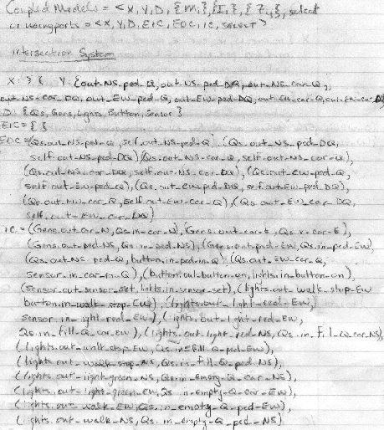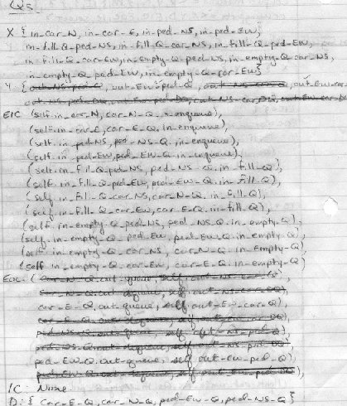

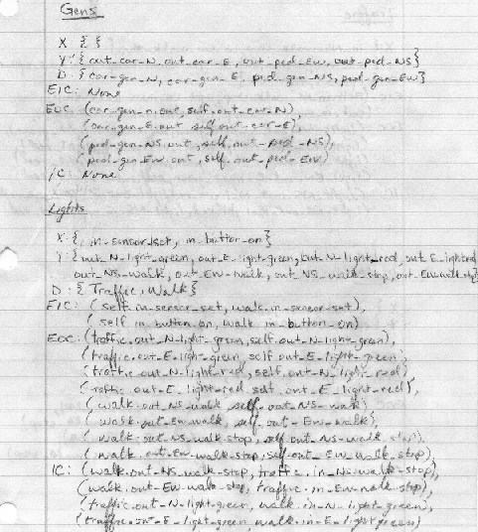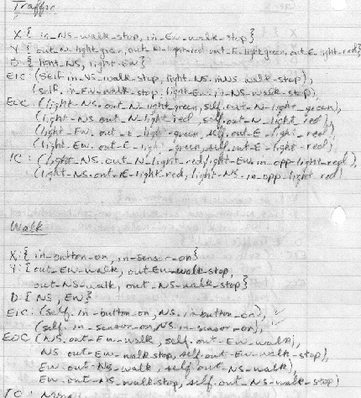

Atomic Model Specifications
The following is my specifications for my atomic models, followed by the pseudo code for each atomic model focusing on the output function, internal and external transitions.

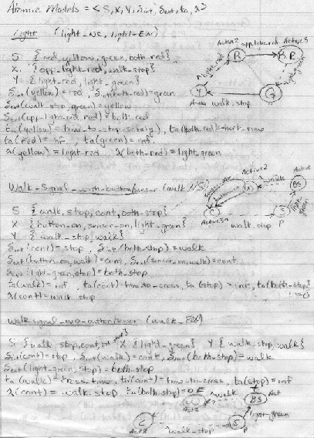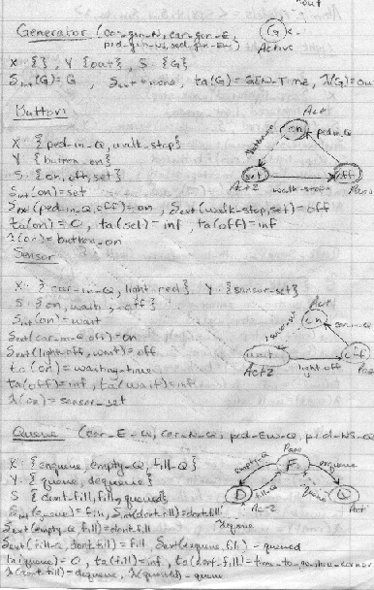

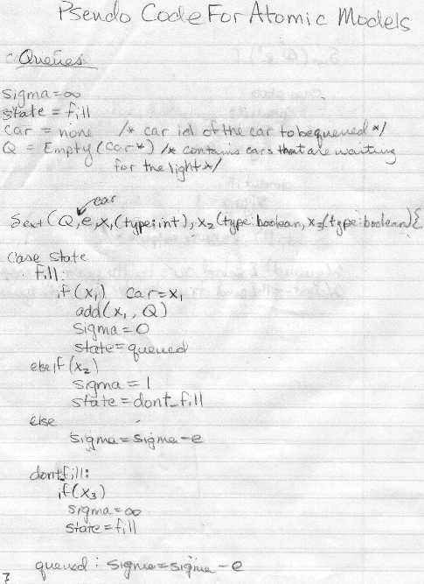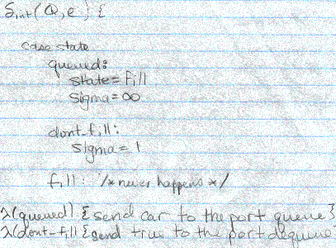
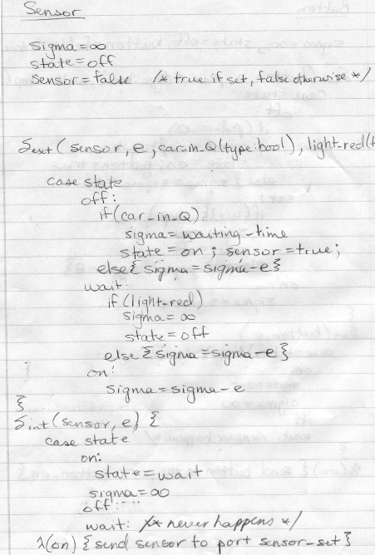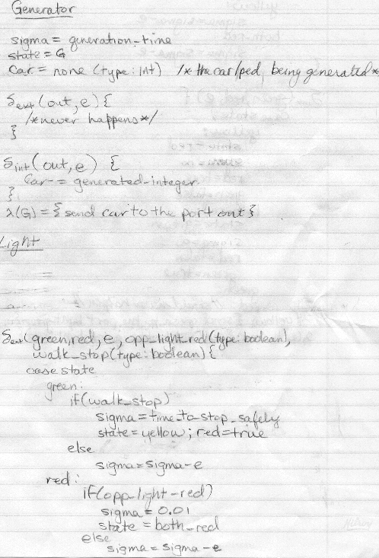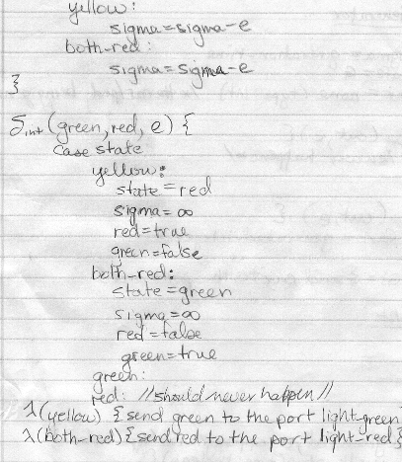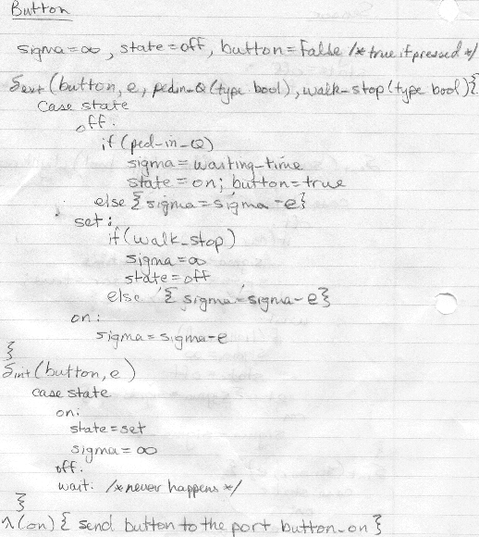

Testing strategies for each one of the models.

Each atomic model needs to be tested to ensure proper functionality. This can be done using an ev file that specifies events sent to different ports of the model. The atomic and coupled models should both be tested, and then the overall integration testing should be performed. I created event files for each of my atomic models. Unfortunately, I was unable to test the actual system or models as I ran into problems after successfully compiling my system. Here is the event file that I was going to test walk signal atomic model with.

00:00:05:00 button_on true
00:00:25:00 light_green true
00:00:30:00 sensor_on true
00:00:50:00 light_green true
00:00:59:00 button_on true
00:01:08:00 light_green true
00:01:10:00 sensor_on true
00:01:18:00 light_green true
00:01:30:00 button_on true
00:01:40:00 light_green true
00:01:50:00 sensor_on true
00:02:10:00 light_green true
00:02:15:00 button_on true
00:02:25:00 light_green true
00:02:40:00 sensor_on true
00:02:55:00 light_green true

There are three inputs to the model, light_green indicating that the light has turned green and it is safe to allow pedestrians to cross the intersection in that direction, button_on indicating that a pedestrian going the opposite direction wants to cross the street so in this direction pedestrians should stop crossing, and similarly sensor_on which tells the walk signal that a car is waiting to cross the intersection in the opposite direction so we should halt pedestrians crossing in this direction.

There are two output ports, walk_stop and walk. They indicate to the light in the same direction what the pedestrians are to do in this direction. So when a button_on message is received, we should stop pedestrians from crossing and when all of them have had enough time to safely cross the street, we have to send an output to the light that it is okay to stop the cars in this direction. From there, the other light can turn green and the pedestrian who pressed the button in the other direction can cross the intersection safely. An input from the sensor works the same way. When a message is received in the light_green port, this tell us that the light in this direction is green and it is safe to change the walk signal from don’t walk to walk. The output file that would be generated if I were able to simulate the system should reflect this situation.

I wrote similar event testing files for each of the other atomic models. The generator model didn’t need an event file because there are no input ports; they generate events on their own. I set it up so they generated events via a normal distribution with a specific mean and standard deviation depending on the rate that cars and pedestrians approach the intersection. These ev files are included in the package.

Building the Atomic Models using CD++

The final stage was to actually build the atomic models using CD++. With the pseudo code created, the backbone of all the atomic models were already there; all that was left was putting it all together. Once again, I was unable to determine if my atomic models are correct. I know they are put together correctly since they compile without errors but I’m not positive that functionality is right. I made a few minor modifications from the original specifications. Originally, I had every queue sending an output to the whole system so it can keep statistics on how big the queues are getting and so it can determine if the cars are lining up for to long. I made the model a bit easier by just assuming that the queues themselves can keep track of the information despite I didn’t include this in my implementation. The actual code for the models are included in the package. Everything else in the system was built to the original specifications except I wasn’t quite sure at the beginning how the light system was going to interact with the sensors or buttons but quickly saw how the links go. I feel that I chose a slightly complex system since it had too many messages coming and going to one another. The number of models was okay but keeping track of the links was time-consuming.

