Modeling Particles Transport Using Cell-DEVS

Lianhua Li
Department of Systems and Computer Engineering
Carleton University
1125 Colonel By Drive
Ottawa, ON. K1S-5B6 Canada
lianhua@sce.carleton.ca

ABSTRACT
In this paper, the transport models of snow particles and volcanic particles are defined and simulated using Cell-DEVS formalism. Form these modeling activities, the general modeling process to model particles transports using Cell-DEVS is generalized and proposed, some guidelines are presented.
Categories and Subject Descriptors
I.6 [SIMULATION AND MODELING]:
I.6.5 [Model Development] Modeling methodologies
General Terms
Measurement, Experimentation.
Keywords
Discrete Event System Specification (DEVS), Cell-DEVS, Particles transport, Modeling, Simulation, CD++.

INTRODUCTION
Particle transport [3,4,9] is a kind of complex nature system. Many research related to particles focus on the physics features and motion laws. Simulation is a common method to perform research works and verify the theory or results which are obtained from research works. In general, simulations of particles transport need massive computation. The dynamics of solid-particles erosion, transport and deposition due to the action of a steaming fluid plays a crucial role in sand dune formation, sedimentation problems and snow transport [9].
Snow particles travelling by wind is a typical problem. The Predicting the location of snow deposit after a wind period is a crucial question to protect roads against snow drift or control the formation of wind-slab (responsible for about 80% of accidently caused avalanches). Furthermore, placing snow fences at appropriate locations can substantially modify the shape of the deposit, by screening out the wind [3]. Meanwhile, snow fences are also used to store snow on some ski trails. Snow transport by wind is a phenomenon involving many complex processes, which hard to simulate the whole process accurately. [3] presented a simulation process by applying Cellular Automata and a lattice gas model to simulate snow transport. [9] described snow particles transport in terms of creeping, saltation and suspension, which are three phases in the process of erosion and deposition. And proposed a lattice Boltzmann model for snow particles transport and deposition compare to the Cellular Automata method. The snow particles transport model described as follows is based [3].
Volcanic eruptions are one of the most dramatic natural phenomena and can significantly affect the life of people living close to active volcanoes. Properly forecasting the volcanic particle dispersal is important for studies of risk assessment [4].
Cellular Automata (CA) is a well-known formalism. It was originally introduced by von Neumann to study self-reproducing systems. All the models [3,4,9] I referenced in this project apply CA as a basic methods. In CA, states in the lattice are updated according to a local rule in a simultaneous, synchronous way, and cell states change in discrete time steps [1].
Cell-DEVS [1,6,10] is another formalism which is used to capture the behaviour of systems that can be represented as cell spaces. Cell-DEVS has explicit time delay, which is different form CA. CD++ [1,8] is a toolkit designed to perform the simulations which specified by DEVS or Cell-DEVS formalisms.
This project is about using Cell-DEVS formalism to model particles transport systems, and proposing a general modeling process for simulating particle transportation problems using Cell-Devs.

BACKGROUND
Conference’10.
Copyright 2010 ACM 1-58113-000-0/00/0010…$10.00.

Permission to make digital or hard copies of all or part of this work for personal or classroom use is granted without fee provided that copies are not made or distributed for profit or commercial advantage and that copies bear this notice and the full citation on the first page. To copy otherwise, or republish, to post on servers or to redistribute to lists, requires prior specific permission and/or a fee.

Discrete Event System Specification (DEVS)
DEVS is formalism for modeling and analysis of discrete event systems, which was invented by Dr. Bernard P. Zeigler in 1976. DEVS provides a formal model and simulation framework, which separates modeling from simulation and provides mechanisms of defined coupling of components. DEVS Framework for M&S supports dynamic system representation and hierarchical, modular model development, which is able to model both continuous and discrete time systems [Zeigler, 1976/84/90/00]. Since Dr. Zeigler proposed a hierarchical simulation algorithm for DEVS model simulation in 1984, DEVS formalism had been widely used, and many extended formalisms from DEVS have been developed. Cell-DEVS formalism is one of them, which combines DEVS and CA.
DEVS Formalism consists of two models, DEVS Atomic models and DEVS coupled models. Therefore, Basic DEVS atomic models that can be coupled into some DEVS coupled models hierarchically to build complex simulations.

2.1.1 DEVS Atomic models [1, 10]:
DEVS Atomic models semantics are shown in Figure 1.
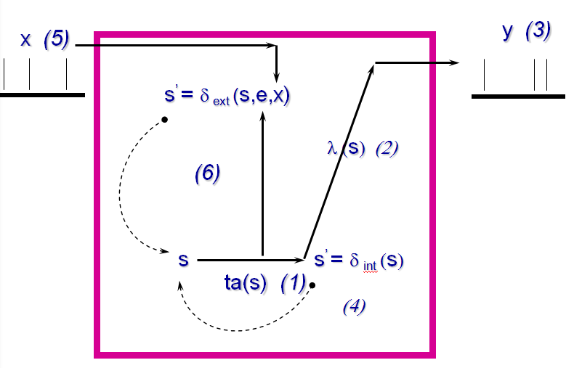
Figure 1. DEVS Atomic models semantics[1]

Atomic DEVS = < S, X, Y, δ_{int} , δ_{ext} , λ, ta >
X : external input event set
Y : external output event set
S : sequential state set
δint: internal transition function
δext :external transition function
λ : output function
ta : time advance function. S → R+0,∞

In which, δint, δext , λ , ta specify discrete event dynamics of an atomic model.
Internal event transition function (δ_{int}) is used to transform internal states form one state into another state after a time period has elapsed. External event transition function (δ_{ext}) is used to transform internal states from one state into another state as an input event occurs. Output function (λ) is used to generate an output after the internal function has been executed. At last, Time advance function (ta) is used to map a state into duration [10].

2.1.2 DEVS Coupled models [1, 10]:
CM = < X, Y, D, {M_{i}}, {I_{i}}, {Z_{ij}}, select >
X is the set of input events;
Y is the set of output events;
D is an index for the components of the coupled model, and
M_{i} is a basic DEVS model (either an atomic or coupled model), defined by M_{i} = < I_{i}, X_{i}, S_{i}, Y_{i}, δint_{i} , δext_{i} , ta_{i} >. It is the set of models that can be influenced by outputs of model i;
Z_{ij} is the translation function from i to j;
select is the tie-breaking selector.
For example, Figure 2 shows a coupled DEVS model for ‘PREEMPTABLE_SCHEDULER’. Black boxes are atomic models, and red boxes represent hierarchical coupled models.

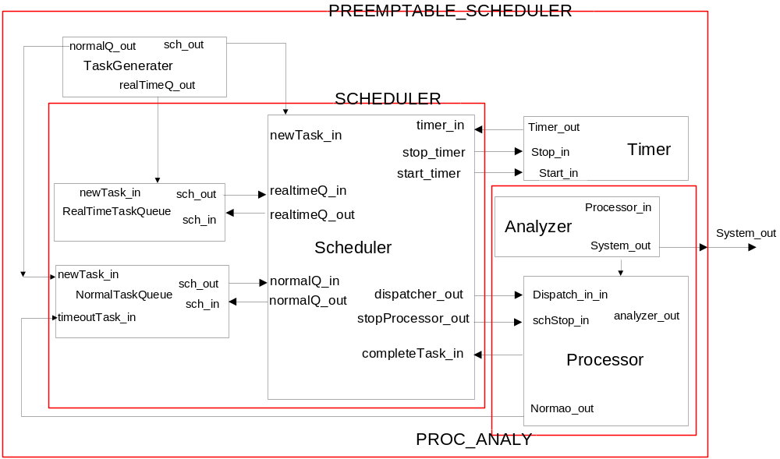
Figure 2. Coupled DEVS model for PREEMPTABLE_SCHEDULER

Cell-DEVS:
Cell-DEVS is an extension of DEVS by adopting the concept of cell space. The concept of cell Spaces is shown by Figure 3. Cell space can be specified by the following formalism.
CCA = < S, n, C, η, N, T, t >
C cell’s state variables;
S finite alphabet to represent each cell’s state;
n dimensional space;
N neighboring cells;
T global transition function;
t local computing function.
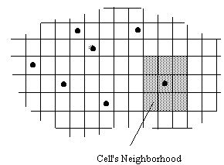.

Figure 3. Cell Spaces and Neighborhood

Each cell has N inputs form N neighbors. When an external event occurs, the local computing function is activated and executed, and the inputs are consumed by the cell.
Commonly used rectangular neighborhoods are von Neumann Neighbors and Moore Neighbors. Certainly, regular or irregular neighborhood can be specified as need.
Cell-DEVS has explicit timing delays which can be either transport delays or inertial delays. Transport delay is shown in the Figure 4.
In Cell-DEVS, an individual cell is considered as an atomic model, and its corresponding cell space is defined as a coupled model. The basic model of Cell-DEVS is atomic cell model, which automatically couple between the cells.
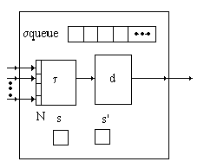

Figure 4. Informal description of an atomic cell
with a transport delay
Atomic Cell-DEVS model can be defined as:
CD = < X, Y, I, S, q, N, d, δ_{inti} , δ_{exti} , t, λ, D >
X is the set of input external events;
Y is the set of output external events;
I = < η, μ, P^{x}, P^{y} > is the model’s modular interface,
With: η :the neighborhood size;
μ: the number of other ports;
P_{j}^{i} = { (N_{j}^{i}, T_{j}^{i}) , N_{j}^{i} (port name), and T_{j}^{i} (port type)} ;
S is the set of possible states for a given cell;
q is the definition of the cell’s state variables, defined by
q= { (s, phase, squeue, σ) }; for cells with transport delays, and q = { (s, phase, f, s) } for cells with inertial delays;
N ϵ S^{η+μ}, is the set of the input events;

A coupled Cell-DEVS model might be decomposed into several cell atomic models and some other DEVS atomic models or coupled models. Figure 5 shows a coupled Cell-DEVS model informally.
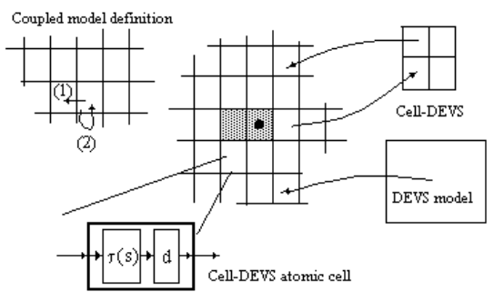
Figure 5. Informal description of a coupled Cell_DVES
model [7]

CD++
CD++ tool [1,7,8] has been developed following the specifications of DEVS and Cell-DEVS. In the toolkit, it includes many extensions to support integrations with other simulation environments, and provide services to build models based on DEVS or Cell-DEVS formalism, to execute simulations, and to visualize the results obtained in the simulation. The simulation engine of CD++ tool is built as a class hierarchy.
There two versions of CD++ were developed for simulating Cell-DEVS models. One is commonly used to simulate general Cell-DEVS models. However, a huge number of neighbors are required, if a Cell-DEVS model has multiple state variables for each cell. The execution time increase significantly. Another version of CD++ was developed for this purpose in [7]. Manipulations of multiple state variables are done within each cell in each time step. It also supports multiple inter-cell ports to communicate with the neighbours, and improves the definition of complex models. Another significant advantage of second version is the execution time of simulations reduced dramatically.
Because of configuration problems, I have to use the first version of CD++ in the project.

MODEL DEFINITION

Model 1: Snow particles transport with wind

Conceptual model
This model is about snow transport, collision, deposition and erosion of snow particles by wind. This model contains two kinds of basic particles, snow particles and wind particles. Using Cell- DEVS formalism, and each cell contains one particle only.
According to [3], wind particle can move to six directions, and each cell has hexagonal neighbors. Although, using CD++ is able to define models with hexagonal or triangular neighbors, time steps need to be distinguished even steps or odd steps. For the reason of simplifying, I change the model to rectangular shape. Each cell has eight neighbors in its plane. Space is discretized as a regular lattice and particles move synchronously according to discrete time steps with a finite set of possible velocities [3].
Wind particles can move up to 8 directions. Wind particles enter one cell and collide with other wind particles if they are move into the same cell from different directions. After the collision, wind particles change the moving direction and leave the cell at next time step.
Snow particles can move up to 8 directions as well. If there is no wind in the cell, a snow particle falls down by the effect of the gravity. Otherwise, the snow particle moves to the direction by the combination of the gravity and wind average.
Also, wind and snow particles may hit a fence, during their transport; their moving direction will be changed.
Snow particles are generated by the cells represented sky boundary area, and deposit on the ground and become snow deposit.
In summary, the interactions of wind-wind, wind-snow, wind-fence, snow-fence, wind-ground, snow-ground and snow-snow deposits are need to be considered in this simulation. Both wind and snow particles have multiple variables and some intermediate results, which need some additional planes to store.

Cell-DEVS models

Wind particle model
In each cell, there are up to 8 wind particles moving to 8 different directions and leaving the cell at one moment. Figure 6 shows the 8 directions and their indexes. Therefore, each time step is made of two phases: Collision: when several particles meet at the same cell, they interact with each other to modify their directions of motion. Propagation: the particles move to a nearest neighbor site, according to their new direction of motion
At next time step, all wind particles will leave this cell. Meanwhile, there will be up to 8 wind particles enter this cell from 8 different neighbors, then they collide with each other if there are more than one particles move into the same cell. After the collision, wind particles change the motion direction and ready to leave the cell at next time step. Each wind particle has 10 state variables, which include 8 binary wind vectors, wind value and wind average.

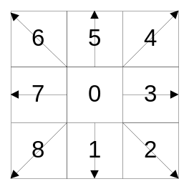
Figure 6. Wind direction and index

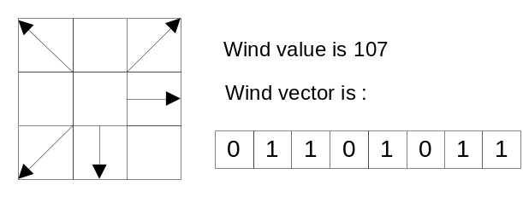
Figure 7. The relationship between wind vector and wind value

Wind vector planes
Windvector_i = < X, Y, S, N, d, δint, δext, τ, λ, D >
where: X = Y = ø;
S = { 0, 1 };
d = 0 ms (transport);
τ: S = 1 If the ith bit corresponding to value of the cell (0,0,x) in plane windvalue= 1;
S = 0 Otherwise;
For neighbors: ‘windvector_1’: N = {0, 0, 4}
‘windvector_2’: N = {0, 0, 3}
‘windvector_3’: N = {0, 0, 2}
‘windvector_4’: N = {0, 0, 1}
‘windvector_5’: N = {0, 0, -1}
‘windvector_6’: N = {0, 0, -2}
‘windvector_7’: N = {0, 0, -3}
‘windvector_8’: N = {0, 0, -4}

I arranged the plane in this order to reduce the number of neighbors of the entire model. I pre-computed the look-up table, and assigned to a macro variable.

Plane ‘windvalue’
Parameter ‘windvalue’ represents the value of an 8-bit wind vector after wind particles collide to each other, and its value should be in the range (0,255). The relationship between windvalue and windvectors is shown in Figure 7. The calculation of the wind value is from the wind vectors of their neighbors. The windvalue follows the collision rule of the wind particles.

Windvalue = < X, Y, S, N, d, δint, δext, τ, λ, D >
where: X = Y = ø;
S = { 0, 1,2, ..., 255 };
d = 0 ms (transport);
τ: Collision rules of wind particles.
S= (0,1,1)*16+(-1,1,2)*32+(-1,0,3)*64+(-1,-1,4)*128
+(0,-1,-4)+(1,-1,-3)*2+(1,0,-2)*4+(1,1,-1)*8

N={0,1,3}{-1,1,4}{-1,0,5}{-1,-1,6}{0,-1,-6}
{1,-1,-5}{1,0,-4}{1,1,-3}
Collision rules of wind particles:
If only one wind particle enter the cell, it moves in that direction. If several wind particles come from different directions, they collide each other and bounce back in the opposite direction. For example:
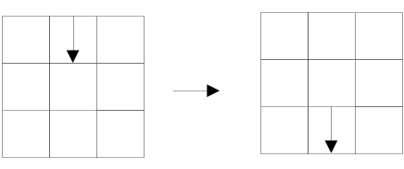
Figure 8a. Examples of Collision rules

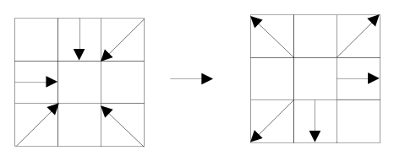
Figure 8b. Examples of Collision rules
As [3] did not provide the detail transition rules and the hexagonal neighborhood was used in [3], I programmed and pre-computed the all transition rules using Moore neighborhood.

Plane ‘windavg’
Parameter ‘windavg’ is another intermediate calculation result which represents an average direction of wind vectors in each cell. It is an integer number from 0 to 8. It is used by snow particles. It is computed by the value of windvalue. The formal specification of plane ‘windavg’ is:
windavg = < X, Y, S, N, d, δint, δext, τ, λ, D >
where: X = Y = ø;
S = { 0, 1,2, ..., 8 };
d = 0 ms (transport);
N = {0,0,5}
τ: based on the value of cell (0,0, 5) in the plane windvalue. The wind average is pre-computed and generated a look-up table.
The following list shows the definition of planes.

Snow particles model
Snow particles can move up to 8 directions. If there is no wind in the cell, a snow particle falls down by the effect of the gravity. Otherwise, the snow particle moves to the direction by the
List 1. Definition of planes
zone : windvector_1 {(0,0,3)..(4,9,3)}
zone : windvector_2 {(0,0,4)..(4,9,4)}
zone : windvector_3 {(0,0,5)..(4,9,5)}
zone : windvector_4 {(0,0,6)..(4,9,6)}
zone : windvector_5 {(0,0,8)..(4,9,8)}
zone : windvector_6 {(0,0,9)..(4,9,9)}
zone : windvector_7 {(0,0,10)..(4,9,10)}
zone : windvector_8 {(0,0,11)..(4,9,11)}
zone : windavg {(0,0,2)..(4,9,2)}
zone : windvalue {(0,0,7)..(4,9,7) }
zone : snowgeneration{(0,0,5)..(0,9,0)}
zone : snowmoving {(0,0,1)..(4,9,1)}
zone : snow {(1,0,0)..(4,9,0)}

combination of the gravity and wind average. Each wind particle has 2 state variables, which are motion directions. Therefore, 2 planes are required for the Cell_DEVS model of snow particles.

Plane ‘snow’
Plane ‘snow’ is used to store the motion direction of snow particles travelling in the air. It also indicates the locations of ground, sky, snow deposit and fence cells. Each cell stores an integer to represent whether there is a snow particle in the cell and which direction it is facing if there is one.
snow = < X, Y, S, N, d, δint, δext, τ, λ, D >
where: X = Y = ø;
S = { 0, 1,2, ..., 8, 401,..., 410, 500, 600 };
Which: 0 : no snow particle in the cell;
1-8: A snow particle is facing one of directions shown in Figure 6 .
401~410: Snow deposit;
500: Ground.
600: Fence
d = 1 ms (transport);
N={0,0,5} which is the cell in the plane of ‘snowmoving’.
τ: follow the Snow Transport rules and based on the value of cell (0,0, 5) in the plane‘snowmoving’. The wind average is pre-computed and generated a look-up table.
Snow particles transport rules:
a. If there is no snow particle in the cell, and the corresponding cell in plane ‘snowmoving’ has a value in between 1 and 8. This cell will become occupied. Meanwhile, the combination of the wind average in this cell and gravity will become new direction of the snow particle.
b. If there is a snow particle in the cell, and the neighbor in its moving direction is empty and its value in plane ‘snowmoving’ is same with the moving direction of the snow particle, the cell becomes empty.
c. If there is a snow particle in the cell, and the neighbor in its moving direction is ground, this cell becomes snow deposit.
d. If there is a snow particle in the cell, and the neighbor in its moving direction is snow deposit, this cell becomes snow deposit or zero, depends on the state value of the neighbor. Snow deposit cell can accumulate at most 10 snow particles. If the value is 410, this cell cannot accept snow particle any more.
e. If there is a snow particle in the cell, and the neighbor in its moving direction is occupied, this snow particle will change direction, which is the opposite direction.
f. Snow particles are generated by the cells represented sky boundary area, and their initial direction is the direction of the gravity.
g. If Snow particles hit the hence, will change direction or become a snow deposit. I add new rules for wind-fence and snow fence interactions.

Plane ‘snowmoving’
Each cell stores an integer to represent the average direction of the neighbours in ‘snow’ plane, if a neighbour is going to move toward this cell. Actually, this direction is also the one which next snow particle comes from.
snowmoving = < X, Y, S, N, d, δint, δext, τ, λ, D >
where: X = Y = ø;
S = { -1, 0, 1, ..., 8, };
Which: -1 : there is a snow particle in the same cell of ‘snow’ plane.
1-8: represent 8 directions which next snow particle comes from one of them.
0: there is no snow particle will come to this cell in next time step.
d = 1 ms (transport);
N = {0,0,4} which is the cell in the plane of ‘windavg’.
τ: compute the direction of combination of gravity and wind average based on the value of cell (0,0, 4) in the plane‘windavg’. The direction is pre-computed and generated a look-up table.
Rule: After a snow particle enters into a cell in ‘snow’ plane, if the average of wind in that cell 0, this snow particle will fall down by the gravity. Otherwise, it flies in a direction combined by the average of the wind and the gravity.

Model 2: Volcanic particle transport.
The basic model of volcanic particles transport is based on the work done by K. Tsunematsu et al. [4], in which Cellular Automata Method is applied to Study of Transport and Deposition of Volcanic Particles .

Conceptual model:
When a volcano eruption occurs, fragments of magma are emitted from the crater within a mixture of gas, and formed an eruption column above the crater, called plume. Fragments of magma and gas called tephra. Fragments of magma compose particles with a range of size. These particles or fragments travel in the air and form eventually deposit on the ground.
In general, a well-developed plume consists of a gas thrust region, a convective region and an umbrella region (Figure 9).
In the Figure 9, Ht is the total height of the eruption column. Hb is the neutral buoyancy level. Hcb is the base of spreading current.

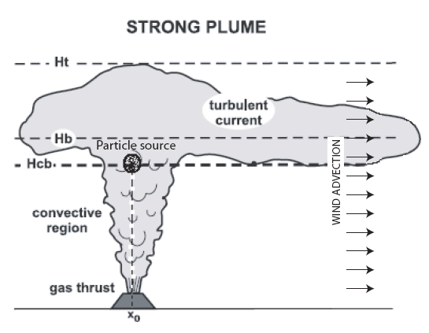
Figure 9. Sketch of plume features. [4]

In the gas thrust region, the eruption column rises against gravity, while buoyancy forces dominate in the convective region. In the umbrella cloud region, the ascending plume has the same density as the surrounding atmosphere (Hb), and is characterized with the level of neutral buoyancy [4].
This simulation is about tephra particles transport in the atmosphere by wind and finally deposit on the ground. All particles are dispersed from the point (x0, Hcb).
Here, only the tephra particles, which reach the plume, are considered; the particles which fall out during the acceding are not considered into the simulation.
The simulation includes modelling tephra transport by wind and diffusion. According to the Ballistic calculation (BA) model, particles with same size and the same density typically deposit with the same distance to the crater. The finer particles are, the further the distance is. However, diffusion occurs during the transport.

Tephra Transport Model
Tephra is transported horizontally in the air by the wind, and travelled vertically with the terminal velocity u_{t}. For each particle, u_{t} represents the speed when it reaches the balance of gravity, buoyancy and friction forces. u_{t} depends on particle and atmospheric characteristics, and computation of the terminal velocity is based on the formula which presented in [5]. The velocity of wind u_{x} is a constant in the simulation domain.
According to [4], the transport of tephra can be modeled by probability.
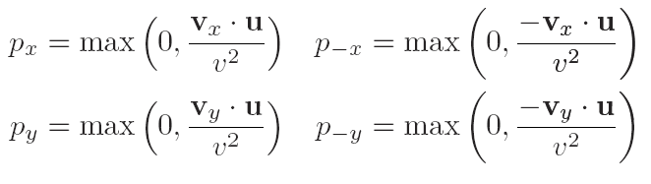
where, p_{x} , p_{-x}, p_{y} p_{-y} are the probability p_{i} of four directions i = ±x and i = ±y, which are proportional to the projection of u onto the velocity vectors vi of norm v = Δx/Δt, and it is shown by Figure 10. Δx is the distance between two cells and Δt is the discrete time unit.
Note that if p_{x} > 0 then p_{-x} = 0 and vice versa. The same holds for p_{y} and p_{-y}. Therefore, positive p_{x} and p_{y} are used in the simulation [4].
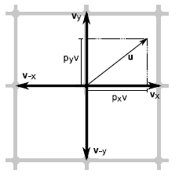
Figure 10. Probabilistic rule of particle transport

However, when the diffusion happen, the diffusion is calculated by another probability rules described as follows. Two independent random numbers q_{x}, q_{y} ∈ [0, 1] are generated in each time step. If q_{x} < p_{x} then the particle moves along the (Δx,0) direction. Similarly, if q_{y} < p_{y}, the particle moves along (0, Δx). Thus,
Table 1. Probability table
A particle will move to a direction. | with probability
(Δx, 0) | p = q_{x} *(1 − q_{y}),
(0,Δx) | p = (1 − q_{x})* q_{y}
(Δx,Δx) | p = q_{x} * q_{y}
Stay at cell | p = (1 − q_{x})*(1 − q_{y}).

Volcanic_particle= < X, Y, S, N, d, δint, δext, τ, λ, D >
where: X = Y = ø;
S = { -∞,…, -1, 0, 1, …, ∞};
Which: -∞ ~-1 : ground cell with tephra deposit;
-1 : ground cell without tephra deposit;
0: no particles in a cell.
1~ ∞: number of particles travelling in the air in this cell;
d = 1 time unit (transport delay);
N = {0,1,1}{0,-1,1} {0,0,1}
{1,0,2} {-1,0,2} {0,0,1}
{-1,-1,3}{-1,1,3} {1,-1,3 } {1,1,3} {0,0,1}
which are the cells in the planes move_x, move_y, move_xy.
τ: compute the direction of combination of gravity and wind average based on the value of cell (0,0, 4) in the plane‘windavg’. The direction is pre-computed and generated a look-up table.

At each cell, There is a population of particles subject to a velocity vector u. To have pi ≤ 1, the lattice must be chosen so that u < v at every site. The moore neighbourhood is used.
The velocity of wind ux and v are constants in the simulation domain.
Therefore, at each cell, the state variables are particle population Ni, terminate velocity ut, velocity vector u, and four directions probabilities, p_{x},p_{y}. p_{-x},p_{-y} , and two diffusion possibilities q_{x} and q_{y}.
The formula from [5] indicates the terminal velocity differs mainly by height and diameter of particles. Therefore, in the simulation, I pre-compute the value of terminal velocity for each size particles, as well as the four directions probabilities, p_{x}, p_{y}.p_{-x}, p_{-y} .
In order to model the multiple state variables of each cell, I used several planes to store the multiple state variables, which are shown by Table2.
Table 2. Multiple state variables
Plane | State variable | Value ranges of state variables
0 | Ni | >0: particle population  =-1: ground without tephra deposit  <-1: ground with tephra deposit
1 | Move_x | Number of particles:  >0: move to ((Δx, 0)  <0: move to ((-Δx, 0)  =0: no particle moves to either directions.
2 | Move_y | Number of particles:  >0: move to ((Δx, 0)  <0: move to ((-Δx, 0)  =0: no particle moves to either directions.
3 | Move_xy | Number of particles:  >0: move to (Δx, Δx) or(-Δx,-Δx)  <0: move to (-Δx, Δx) or (Δx, -Δx)  =0: no particle moves to any of four directions.
4 | q_{x} | q_{x}∈ [0, 1]
5 | q_{y} | q_{y} ∈ [0, 1]
6 | p_{x}, p_{y} ∈ [0, 1] | p_{x}, p_{y}∈ [0, 1]

Plane 1,2 and 3 are used to store the intermediate calculation results, the number of particles which will move to one of directions in next time step. The probability formulas in Table 1 are used in calculations. They used zero delay for each cell. The formal specifications for each plane are omitted, because they are defined using similar process to the snow model.
Plane 4 and 5 are used to store the probability of qx and qy , which are random numbers with uniform distribution and within the range of 0 and 1.
Plane 6 store px and py at same time. They differ for different size particles.
Transition rules:
Rule 1: Regular cells
A. Ni=Ni- Ni.move_x-Ni.move_y- Ni.move_xy AND
B. If (0,-1).move_x >0 then Ni +(0,-1).move_x
If (0,1).move_x <0 then Ni -(0,-1).move_x
If (-1,0).move_y >0 then Ni +(-1,0).move_y
If (1,0).move_y <0 then Ni -(1,0).move_y
If (-1,-1).move_xy >0 AND (-1,-1).move_x >0
then Ni +(-1,-1).move_x
If (1,-1).move_xy <0 AND (1,-1).move_x >0
then Ni -(10,-1).move_x
If (-1,1).move_xy <0 AND (-1,1).move_x <0
then Ni -(-1,1).move_x
If (1,1).move_xy >0 AND (1,1).move_x <0
then Ni +(1,1).move_x

Rule 2: If cell (0,0) is sky boundary, then
A. Ni=Ni- Ni.move_x-Ni.move_y- Ni.move_xy
B. If (0,-1).move_x >0 then Ni +(0,-1).move_x
If (0,1).move_x <0 then Ni -(0,-1).move_x
If (1,0).move_y <0 then Ni -(1,0).move_y
If (1,-1).move_xy <0 AND (1,-1).move_x >0
then Ni-(10,-1).move_x
If (1,1).move_xy >0 AND (1,1).move_x <0
then Ni +(1,1).move_x

Rule 3: if (0,0) is the cell above the ground, then:
A. Ni(Δx+1)1=Ni- Ni.move_x-Ni.move_y- Ni.move_xy
B :
If (0,-1).move_x >0 then Ni +(0,-1).move_x
If (0,1).move_x <0 then Ni -(0,-1).move_x
If (-1,0).move_y >0 then Ni +(-1,0).move_y
If (-1,-1).move_xy >0 AND (-1,-1).move_x >0
then Ni +(-1,-1).move_x
If (-1,1).move_xy <0 AND (-1,1).move_x <0
then Ni -(-1,1).move_x

Rule 4 : if cell (0,0) is a ground.
A. If (-1,0).move_y >0 then Ni +(-1,0).move_y
If (-1,-1).move_xy >0 AND (-1,-1).move_x >0
then Ni +(-1,-1).move_x
If (-1,1).move_xy <0 AND (-1,1).move_x <0
then Ni-(-1,1).move_x

Particle aggregation which happens in plumes dominated by fine particles is not considered into the simulation.

Parameters:
The simulation used the data of 1875 eruption of Askja, volcano, Iceland[4], which is a case without aggregation. I choose tephra particles with three different sizes, which are d=8mm(Φ =-3), d=0.354mm(Φ =1.5), and d=0.125mm(Φ =3). Particles with d=8mm, are the largest size particles; particles with d=0.354mm, are the medium size particles; particles with d=0.125mm, are the particles smaller than medium size, but not the smallest size;

Table 3. Particle parameters
particle size  Φ = −log2 d | -3 | 1.5 | 3
Diameter: d (mm) | 23 =8 | 2-1.5=0.354 | 2-3=0.125
Particle volume (mm3) | 268 | 0.0232 | 0.0001
Total volume(m3) | 1*10⁶
Percentage | 0.5 | 0.05 | 0.0001
Total Particle volume | 5*10⁵ | 5*10⁴ | 1*10²
Number of particles | 1.866*10¹² | 2.155*10¹⁵ | 1*10¹³
Number in simulation( 10⁶) | 1.8668*10⁶ | 2.155*10⁹ | 1*10⁷

Other parameters used in the model are shown in the following table.
Table 4. Simulation Parameters
Type of sedimentation | No aggregation
Ht [km] | 26
Hcb [km] | 14.6
Wind velocity [m/s] | 25
Particle size (Φ) | -3 to 6
Median of grain size | 1.5
Δx [m] | 500
Δt [s] | 16.6
Duration [s] | 10⁵

Simulation result and discussion
In volcanic particles transport simulation, particles with 3 difference size is simulated separately. According to [4], all particles deposit within 500 km form the crater. For the largest size (8 mm) particles, the distance of the thickest deposit is around 140 km. If the cell size is 500m X 500m, the dimension of model should be (50, 100, 7). However, the execution time of this model with so huge dimension lasted more than 30 hours. For this reason, I scaled the model size from (50, 100, 7) to (12, 20, 7) for the particles with 8mm diameter, and (10, 20, 7) for the particles with 0.354 and 0.125 diameters. The cell size becomes 2km×2km and 2.5km×2.5km responsively. During the scaling, the value of velocity kept same. Since smaller size particles travel horizontally much more than vertically.
Because the purpose of the project, it is important to indicate that Cell-DEVS model are capable of modeling particles transport problem efficiently. This is another reason I scale the model dimension. But this dimension can not cover the entire area of tephra deposit.
Figure 12 show the result of transport of particles with diameter 8mm, 0.354mm, and 0.125 mm.
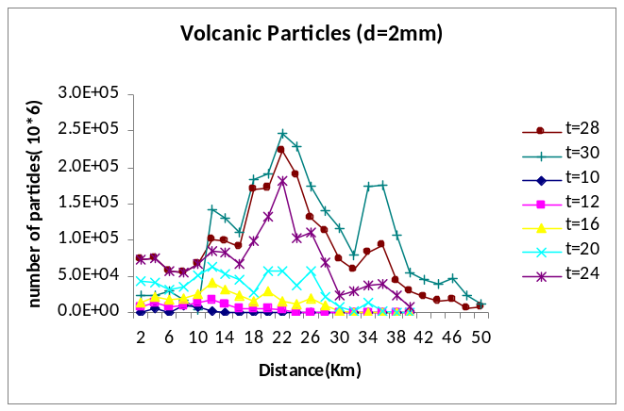
Figure 12. Simulation result for volcanic particles (d=8mm)

From the figure, the larger size particles fall out faster than smaller ones. However, the locations with large numbers are not the real location with thickest tephra deposit. Because at this time step, the simulation is not complete, and there is a huge number of particles are travelling in the atmosphere.

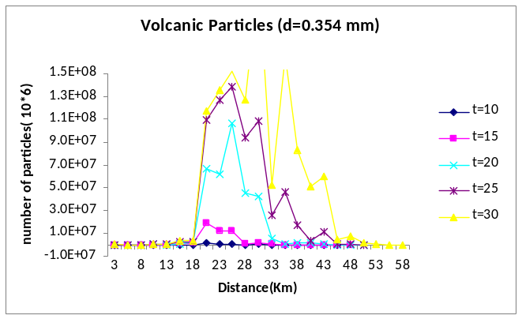
Figure 13. Simulation result for volcanic particles (d=0.354 mm)

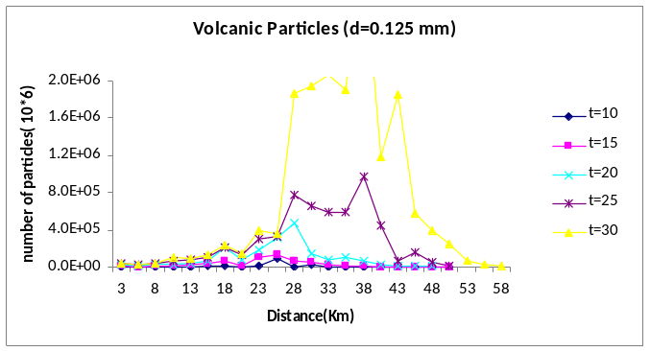
Figure 12. Simulation result for volcanic particles (d=0.125mm)

In the simulation for the particles with 8mm diameter, 50 time steps are executed. Therefore, the total time elapsed is around 33000s (50×4 ×166s). For the others small particles, simulation is stopped in 100 time steps, which the total time elapsed is 830000s (1000×5×166s).
Another thing need to mention is, in the model, wrapped border is used. So the simulation can run until all particles deposit on the ground. However, the locations do not represent the final distance from the crater. But the locations in the three figures above represent the real distance, because at these time steps in the three simulations, the tephra deposits have not been overlapped yet.
In the simulation, because the wind velocity u_{x} is much larger than terminal velocity u_{t}, it results the probability of moving to (Δx,0) direction is much larger than the probability of moving to(0, Δx) direction. That means, tephra take longer time to deposit on the ground, and the number of time step require much larger. So, I reduce values of the two probability state varibles q_{x}, q_{y}. in order to reduce the simulation execution time.
In this model, the particle diffusion is affected by its terminal velocity, which depends on the particle diameter. So the particle diffusion varies considerably.

Modeling process generalization
A goal of this project is generalizing the modeling process for particles transport simulation using Cell-DEVS. From the two models defined in previous section, the general modeling process can be derived. The general process is described as follows.
1. Real problem analyzing phase
In this phase, through studying the real problem, to understand the topic and it relative environment, to decide the purpose or goals of simulation, to collect the enough background information, and to present the requirements of the simulation. The big picture is obtained in the phase. For example, we should decide what kind of particles are involved; how to calculation the velocities of particles; which features of particles need to be considered; which kind of transitions or interactions are need to simulate, such as deposition, erosion, fine particles aggregation, etc; the existence of other environment factors which might be affect the transport. In this phase, some professionals form a certain area can provide some insights.
2. Model defining phase.
In this phase, first, we should clear which kind of particles need to be considered as individual model, and which kind of particles can be regarded as state variables or constants instead. For example, in the snow particles model, wind particles modeled as a separate particle model, while in the volcanic particles model, wind particles are not single out, because the velocity of wind is assumed as a constant in the entire simulation.
Then, we should decide which kind and how many state variables are necessary for each type of particles. In order to get enough and correct state variables, we need the analysis result of phase one. Parameters of particles and all kinds of intermediate calculation results are considered as state variables. For example, in snow particles model, wind vectors and moving direction of snow particles are state variables, and the windvalue, windavg and snowmoving are intermediate calculation results.
Another important thing is whether a single particle or a population of particles occupy each cell, and whether it is necessary to track individual particle in the case of multi-particles cell and how to track.
Next, define the shape and number of neighborhood. Rectangular neighborhood is the most common one. However, hexagonal neighborhood is needed in some special cases, because hexagonal neighborhood can provide higher isotropy.
Last, recognize all the necessary transitions need to be considered. Using snow particles model example again, typical transitions include snow-wind, wind-wind, snow-ground, snow-deposit, and wind-ground transitions. If erosion is concerned, snow-snow transitions must be specified. Or if a fence is placed in some cells, wind-fence, snow-fence, snow-fence-ground, and wind-fence-ground must be defined properly.
3. Defining Cell-DEVS model in CD++:
In CD++, there are two versions to model particles with multiple state variables. First, use the additional planes to store multiple state variables. This method requires a huge number neighbors, this is the biggest disadvantage. Meanwhile, manipulating neighbors among planes is error-prone and time consuming process. If we arrange planes carefully enough, it might reduce the number of neighbors significantly. Consequently, the execution time of simulation is reduced as well.
Each plane can be specified as a special zone following special rules. There might be several zones in one plane according to a specific case. In general, the planes which store intermediate results and zones which manipulate intermediate results use zero delay.
The particle transport problem is usually complex in computation, and need a big size of cell space to simulate. Therefore, pre-compute the values of some state variables as much as you can and generate some look-up lists, these pre-simulation steps can reduce the complexity of computations in each cell. Developing some simple programs to generate initial cell values and pre-compute some rules is a good approach to improve the efficiency of simulation, and generating different repeatable experiments becomes much easier. Meanwhile, if a look-up list has lots of data records, some searching techniques might become necessary. For example, the volcanic particles model became much simpler after all the pre-computations are done.
The second version of CD++ can manipulate and store multiple state variables directly inside each cell. This version release lots of burden on simulation designers. Huge number of neighbours is not necessary any more. Consequently, the execution time is reduced remarkably and coding and debugging are much easier. Therefore, the preference is place to this method.
In summary, modeling and simulating the particles transport themselves are not really difficult. However, because of the nature and instinctive complexity of this kind of problem, how to modeling properly to real systems, how to improve the efficiency and accuracy, and how to simulate massive systems are the concerns.

CONCLUSIONS
In this project, two kinds of particles transports are modeled and simulated using Cell-DEVS specification. Snow particles transport model was modified by adding fence into the model, based on the previous work. However, there are still some bugs in the part of the modified code; I didn’t present the simulation result after modification.
Volcanic particles transport model is completed and simulated. The parameters come from [4]. The results are reasonable. Finer the particle is, further it travels.
The general modeling process for modeling particles transport is described and explained. It is consists of three phases, real problem analyzing phase, model defining phase, and defining Cell-DEVS model in CD++. Real problem analysis phase is really important to the later activities of modeling and simulation. A successful simulation strongly depends on the proper analysis.
In addition, I explained the how to model the multiple state variables in CD++. Using extra planes requires a large number of neighbors, and is difficult to code and debug, and time consuming. The execution time is unaccepted in some cases, especially in simulating complex nature systems. As the project carries on, I deeply understand what I explained for the modeling. The second version supports manipulating and storing multiple state variables in each cell, but is only running on Linux.
Future studies for the project might make extensions to the window version CD++ tools to support multiple state variables facilities.

ACKNOWLEDGMENTS
I would like to express my thanks to Professor G. Wainer.

REFERENCES
- Wainer, Gabriel, A. and Mosterman, P. J. Discrete-Event Modeling and Simulation: Theory and Applications. Boca Raton: CRC Press.
- Zeigler, B., Kim, T., and Praehofer H.: Theory of Modeling and Simulation: Integrating Discrete Event and Continuous Complex Dynamic Systems, Academic
- Masselot, A and Chopard, B. 1996. Cellular automata modeling of snow transport by wind’, Applied Parallel Computing Computations in Physics, Chemistry and Engineering Science, Lecture Notes in Computer Science, Volume 1041/1996, 429-435. DOI= http://doi.acm.org/0.1007/3-540-60902-4_45
- Tsunematsu, K, Falcone, J.L, Bonadonna, C, and Chopard, B. 2008. Applying a Cellular Automata Method for the Study of Transport and Deposition of Volcanic Particles. Cellular Automata. Lecture Notes in Computer Science, 2008, Volume 5191, 393-400. DOI= http://doi.acm.org/10.1007/978-3-540-79992-4_51
- Bonadonna, C., and J. C. Phillips (2003), Sedimentation from strong volcanic plumes, J. Geophys. Res., 108(B7), 2340, DOI=://doi.acm.org/10.1029/2002JB002034.
- Wainer, G., Giambiasi, N. 2001, Application of the Cell-DEVS Paradigm for Cell Spaces Modeling and Simulation, Simulation, Vol. 71, No. 1, pp. 22-39.
- López, A., Wainer G. 2004. Improved Cell-DEVS model definition in CD++. ACRI 2004, LNCS 3305. Springer-Verlag.
- Wainer, G. 2002. CD++: a Toolkit to Define Discrete-Event Models, Software, Practice and Experience, Wiley, Vol. 32, No 3. pp. 1261-1306.
- Masselot, A and Chopard, B. 1998. A lattice Boltzmann model for particle transport and deposition. Europhys. Lett. 42 259 DOI= 10.1209/epl/i1998-00239-3
- Wainer, G. 2010. Lecture Note. http://www.sce.carleton.ca/courses/sysc-5104/ doku.php?id= materials. Accessed Dec, 2010.

