Barber Shop Simulation
Course: SYSC5104

Name: Shyam Bhuptani
Student number: 101166611

1. Barber Shop Model 3
Brief Description 4
2. Components 5
Atomic 5
CutHair 5
CheckHair 6
Reception 7
Coupled Models 8
Barber 8
BarberShop 8
3. Testing 9
Atomic Model Testing 9
Cuthair 9
Checkhair 9
Reception 9
Coupled Model Testing 10
Barber 10
Barbershop 10
4 Simulation Results 10
Atomic Testing 10
Cuthair, Checkhair, Reception 10
Coupled Testing 13
Barber and Barbershop 13
Summary . . . 15
Appendix 15
Readme.txt 15
Typical .Outputs.txt file 19

1. Barber Shop Conceptual Model
A Barber Shop model has been created which can be tested and compiled using cadmium tool. It is a simple representation and hierarchical implementation of a numeric Atomic Models which have been defined for the Cadmium Simulation tool. The model diagram is as follows:
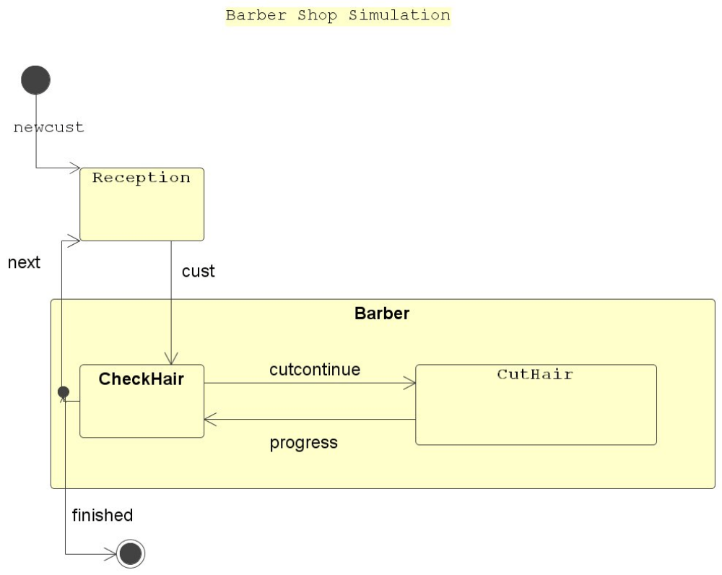

Brief Description
The main Model is BarberShop, which represents a simple retail Barber Shop.

The sub-models are as below:
1) the Atomic Reception, which is a set of chairs for the customers to wait for their haircut in.

Customers arrive and are lined up in queue to wait for the Barber.
There are all chairs empty until the first customer comes which will be directed to the Barber, and the Barber tells the receptionist when he does the haircut or he is ready for a new customer. The opening hours has nor constraints, and the receptionist gets a call when haircut is done, and customer is served so he can send a new customer.

2) the sub-model Barber, which represents the Barber.
Barber is comprised of two Atomic models:
CheckHair and CutHair.
The Barber receives a customer from reception and starts working on. Cuthair simply represents his arms, hands and scissors. Cuthair reports progress back to checkhair which counts if customer is prepared or not. When the haircut is complete, the barber signals the receptionist to send new customer and Cuthair also sends this message back to reception.

2. Components
Atomic
The following are the Atomic Component Model Definitions for BarberShop.
CutHair

Atomic CutHair = {X, S, Y, iTfn, xTfn, ta, lamda}
X = Input Set = {cutcontinue}
S = State = {cutting , passive}
Y=Output ={progress}
iTfn=Internal Transition Function
iTfn(ta) {cutting} -> {passive}
xTfn=External Transition Function
xTfn(cutcontinue) {passive) -> {cutting}
ta=time advance
lamda=output function -> {progress@checkhair}

Devs State Variables :

sigma is (transition time (passive= infinity , active = predetermined))
phase <element of> {passive, cutting} (initial= passive)
xTfn(e){
assert port = cutcontinue
sigma = cutting-time;
phase = cutting;
lamda = progress@checkhair
}
iTfn(e, sigma){ assert active
phase = passive ;
sigma = inf ;
}

CheckHair

Atomic CheckHair = {X, S, Y, iTfn, xTfn, ta, lamda}
X = Input Set = {CutHair.progress, cust}
S = State = {Checking , passive}
Y=Output ={cutcontinue, finished}
iTfn=Internal Transition Function
iTfn(e) {Sending} ->passive
xTfn=External Transition Function
xTfn(Customer, passive) ->Sending
xTfn(cuthair.progress, Sending) -> Sending
ta=time advance
lamda=output function -> {continue@cuthair, next@reception}

Devs State Variables

sigma (transition time(passive= oo, active = predetermined)
phase (initial= passive) phase <element of> {passive, Checking}
xTfn(Customer, CutHair.progress){
case port
reception.cust { sigma = checktime
phase = checking
lamda=cutcontinue@cuthair
}
cuthair.progress{
sigma = sending time;
phase = Checking;
lamda = finished,next@reception
end-case
}
iTfn(e,){
// assert active
sigma = oo;
phase = passive ;
}
Reception

Atomic Reception = {X, S, Y, iTfn, xTfn, ta, lamda}
X = Input Set = {newcust, finished@checkhair}
S = State = {seating customer , passive}
Y=Output ={cust@checkhair}
iTfn=Internal Transition Function
iTfn(e) {serving customer} ->passive
xTfn=External Transition Function
xTfn ( passive) ->serving customer
ta=time advance
lamda=output function -> {continue@cuthair, next@reception}

Devs State Variables

sigma (transition time(passive= oo, active = predetermined)
phase (initial= passive) phase <element of> {passive, servingCustomer}
xTfn(Customer, CutHair.progress){
case port
newcust { sigma = servingtime
phase = servingCustomer
lamda=internal queue, cust@checkhair
}
checkhair.finished{
sigma = servingtime;
phase = servingCustomer;
lambda= cust@checkhair
}
end-case
}
iTfn(e,){
// assert active
sigma = oo;
phase = passive ;
}
Coupled Models
Barber

Coupled Barber CM= <I,X,Y,D,{Mi},{Ii},{Zij}>
I = interfaces = {in,out,cust,progress,finished,cutcontinue}
X = Input Set = {in}
Y = Output Set = {out}
D = index to components Mi
M1 = {checkhair}
M2 = {cuthair}
I1 = {reception}

Zij = mapping between components
cust@reception -> in@Barber
out@Barber ->next@reception

in@Barber ->cust@checkhair
finished@checkhair -> out@barber

cutcontinue@checkhair cutcontinue@cuthair
progress@cuthair progress@checkhair
finished@checkhair finished

BarberShop

Coupled BarberShop CM= <I,X,Y,D,{Mi},{Ii},{Zij}>
I = interfaces = {in,out }
X = Input Set = {in}
Y = Output Set = {out}
D = index to components Mi
M1 = {reception}
M2 = {Barber}
I1 = {}

Zij = mapping between components
in -> in@Barbershop
out@BarberShop -> out

in@BarberShop ->newcust@reception
out@barber ->out@BarberShop

barber -> mapped as in Barber above
3. Testing Strategy
We have test cases for all 3 models, and this are going to be tested individually as well as in coupled mode.

Atomic Model Testing
Cuthair

Cuthair is a server whicn receives cutcontinue messages, taking the defined time to cut the desired hair. When the cut is finished, it outputs progress to checkhair model

Checkhair

Checkhair is a having 2 main process.

- cust arrived messages from reception, and progress messages from cuthair.
- progress from cuthair

Checkhair is required to be able to process both concurrently. On cust messages from reception, Checkhair will be tested that it correctly starts cutting hair.

Reception

Reception is simply a queue.
Queue size is number of chairs and it has main 2 inputs.
- New customer
- Finished message from checkhair
So once customer is in queue, it should be sent to checkhair and one checkhair sends output as finished , it sends new customer to checkhair if any.
Coupled Model Testing
Barber

Barber is the coupled of below
- Checkhair
- Cuthair
It receives customers, sends customer back to checkhair once it is finsiehd
It is coupled model and will be tested in all conditions

Barbershop

Barbershop is the complete hierarchically coupled system,
- Reception,
- Checkhair and Cuthair/ Barber

It receives customers in queue.If barber is not working it sends one customer from the queue to the barber and the output is barber to send finished message. It must be able to start when it receives a customer in a FIFO manner.

4. Simulation Result
Atomic Testing
Cuthair, Checkhair, Reception

These 3 are individually tested for below testcase and the procedure is described down in readme.txt file. Here reception atomic model is described (ip/op) and checkhair and cuthair also works in the same fashion

Test input for reception atomic model:
08:01:00:00 newcust
09:10:00:00 newcust
09:10:10:00 newcust
09:10:20:00 newcust
10:01:00:00 newcust
11:10:00:00 newcust
12:10:10:00 newcust
13:10:20:00 newcust
14:10:20:00 newcust
15:10:20:00 newcust
16:20:40:00 next
17:20:40:00 next

Output file :

00:00:00:000
State for model input_reader_con is next time: 00:00:00:000
State for model reception1 is total Customers: 0
00:00:00:000
State for model input_reader_con is next time: 08:01:00:000
State for model reception1 is total Customers: 0
08:01:00:000
State for model input_reader_con is next time: 01:09:00:000
State for model reception1 is total Customers: 1
08:01:05:000
State for model input_reader_con is next time: 01:09:00:000
State for model reception1 is total Customers: 1
09:10:00:000
State for model input_reader_con is next time: 00:00:10:000
State for model reception1 is total Customers: 2
09:10:05:000
State for model input_reader_con is next time: 00:00:10:000
State for model reception1 is total Customers: 2
09:10:10:000
State for model input_reader_con is next time: 00:00:10:000
State for model reception1 is total Customers: 3
09:10:15:000
State for model input_reader_con is next time: 00:00:10:000
State for model reception1 is total Customers: 3
09:10:20:000
State for model input_reader_con is next time: 00:50:40:000
State for model reception1 is total Customers: 4
09:10:25:000
State for model input_reader_con is next time: 00:50:40:000
State for model reception1 is total Customers: 4
10:01:00:000
State for model input_reader_con is next time: 01:09:00:000
State for model reception1 is total Customers: 5
10:01:05:000
State for model input_reader_con is next time: 01:09:00:000
State for model reception1 is total Customers: 5
11:10:00:000
State for model input_reader_con is next time: 01:00:10:000
State for model reception1 is total Customers: 6
11:10:05:000
State for model input_reader_con is next time: 01:00:10:000
State for model reception1 is total Customers: 6
12:10:10:000
State for model input_reader_con is next time: 01:00:10:000
State for model reception1 is total Customers: 7
12:10:15:000
State for model input_reader_con is next time: 01:00:10:000
State for model reception1 is total Customers: 7
13:10:20:000
State for model input_reader_con is next time: 01:00:00:000
State for model reception1 is total Customers: 8
13:10:25:000
State for model input_reader_con is next time: 01:00:00:000
State for model reception1 is total Customers: 8
14:10:20:000
State for model input_reader_con is next time: 01:00:00:000
State for model reception1 is total Customers: 8
15:10:20:000
State for model input_reader_con is next time: 01:10:20:000
State for model reception1 is total Customers: 8
16:20:40:000
State for model input_reader_con is next time: 01:00:00:000
State for model reception1 is total Customers: 7
17:20:40:000
State for model input_reader_con is next time: inf
State for model reception1 is total Customers: 6

Explanation: here as count increased from 8, the number of chairs were full, so customer didn’t increased even if they were new. Once next call is received from checkhair component, count decreased by 1 as new customer fone for cutting process.
Coupled Testing
Barber and Barbershop

The barbershop is coupling of barber and reception model. This model provides end to end journey of barber shop from the customer enters till the exit.
Below is the test case used and output received.

Input file for top model:
08:08:15:00 newcust
08:10:00:00 newcust
10:15:00:00 newcust

Output file:

00:00:00:000
State for model input_reader is next time: 08:08:10:000
State for model reception1 is total Customers: 0
State for model cuthair1 is Hair Cut done of
State for model checkhair1 is Customer:
08:08:10:000
State for model input_reader is next time: 00:01:50:000
State for model reception1 is total Customers: 1
State for model cuthair1 is Hair Cut done of
State for model checkhair1 is Customer:
08:08:15:000
State for model input_reader is next time: 00:01:50:000
State for model reception1 is total Customers: 1
State for model cuthair1 is Hair Cut done of
State for model checkhair1 is Customer: newcust
08:08:22:000
State for model input_reader is next time: 00:01:50:000
State for model reception1 is total Customers: 1
State for model cuthair1 is Hair Cut done of newcust
State for model checkhair1 is Customer: newcust
08:08:42:000
State for model input_reader is next time: 00:01:50:000
State for model reception1 is total Customers: 1
State for model cuthair1 is Hair Cut done of newcust
State for model checkhair1 is Customer: finished
08:08:45:000
State for model input_reader is next time: 00:01:50:000
State for model reception1 is total Customers: 0
State for model cuthair1 is Hair Cut done of newcust
State for model checkhair1 is Customer: finished
08:10:00:000
State for model input_reader is next time: 02:05:00:000
State for model reception1 is total Customers: 1
State for model cuthair1 is Hair Cut done of newcust
State for model checkhair1 is Customer: finished
08:10:05:000
State for model input_reader is next time: 02:05:00:000
State for model reception1 is total Customers: 1
State for model cuthair1 is Hair Cut done of newcust
State for model checkhair1 is Customer: newcust
08:10:12:000
State for model input_reader is next time: 02:05:00:000
State for model reception1 is total Customers: 1
State for model cuthair1 is Hair Cut done of newcust
State for model checkhair1 is Customer: newcust
08:10:32:000
State for model input_reader is next time: 02:05:00:000
State for model reception1 is total Customers: 1
State for model cuthair1 is Hair Cut done of newcust
State for model checkhair1 is Customer: finished
08:10:35:000
State for model input_reader is next time: 02:05:00:000
State for model reception1 is total Customers: 0
State for model cuthair1 is Hair Cut done of newcust
State for model checkhair1 is Customer: finished
10:15:00:000
State for model input_reader is next time: inf
State for model reception1 is total Customers: 1
State for model cuthair1 is Hair Cut done of newcust
State for model checkhair1 is Customer: finished
10:15:05:000
State for model input_reader is next time: inf
State for model reception1 is total Customers: 1
State for model cuthair1 is Hair Cut done of newcust
State for model checkhair1 is Customer: newcust
10:15:12:000
State for model input_reader is next time: inf
State for model reception1 is total Customers: 1
State for model cuthair1 is Hair Cut done of newcust
State for model checkhair1 is Customer: newcust
10:15:32:000
State for model input_reader is next time: inf
State for model reception1 is total Customers: 1
State for model cuthair1 is Hair Cut done of newcust
State for model checkhair1 is Customer: finished
10:15:35:000
State for model input_reader is next time: inf
State for model reception1 is total Customers: 0
State for model cuthair1 is Hair Cut done of newcust
State for model checkhair1 is Customer: finished

Explanation: Once customer comes to reception, it takes around 00:00:05:00 to transfer the same to checkhair which will take 00:00:09:00 time to send them to cuthair. Cutting time is fixed irrespective of anything and once received output from cuthair, checkhair takes 00:00:03:00 time to produce final output as FINISHED.

summarizing . . .

This is a great learning of how to simulate an entire model using cadmium.
Knowing the end to end transition components and functions revealed the all-important edges and states at each atomic model.

Thank you for the cadmium which is such a user-friendly tool and which showcased the errors while compiling.

Shyam

Appendix

Readme.txt

This folder contains the Barber Shop DEVS model implemented in Cadmium

/**************************/
/****FILES ORGANIZATION****/
/**************************/

README.txt
BarberShop.doc
makefile

atomics [This folder contains atomic models implemented in Cadmium]
checkhair.hpp
cuthair.hpp
reception.hpp
bin [This folder will be created automatically the first time you compile the poject.
It will contain all the executables]
build [This folder will be created automatically the first time you compile the poject.
It will contain all the build files (.o) generated during compilation]
data_structures [This folder contains message data structure used in the model]
message.hpp
message.cpp
input_data [This folder contains all the input data to run the model and the tests]
input_barber_0_1st.txt
cuthair_input_test.txt
checkhair_input_test_cuthair.txt
checkhair_input_test_reception.txt
reception_input_test.txt
simulation_results [This folder will be created automatically the first time you compile the poject.
It will store the outputs from your simulations and tests]
test [This folder the unit test of the atomic models]
main_reception_test.cpp
main_cuthair_test.cpp
main_checkhair_test.cpp
top_model [This folder contains the barber shop top model]
barber.cpp

/*************/
/****STEPS****/
/*************/

0 - BarberShop.doc contains the explanation of this model

1 - Update include path in the makefile in this folder and subfolders. You need to update the following lines:
INCLUDECADMIUM=-I ../../cadmium/include
INCLUDEDESTIMES=-I ../../DESTimes/include
Update the relative path to cadmium/include from the folder where the makefile is. You need to take into account where you copied the folder during the installation process
Example: INCLUDECADMIUM=-I ../../cadmium/include
Do the same for the DESTimes library
NOTE: if you follow the step by step installation guide you will not need to update these paths.
2 - Compile the project and the tests
1 - Open the terminal (Ubuntu terminal for Linux and Cygwin for Windows) in the BarberShop folder
3 - To compile the project and the tests, type in the terminal:
make clean; make all
3 - Run checkhair test
1 - Open the terminal in the bin folder.
2 - To run the test, type in the terminal "./CHECKHAIR.exe " .
3 - To check the output of the test, go to the folder simulation_results and open "checkhair_test_output_state.txt" and "checkhair_test_output_messages.txt"
4 - To run reception and cuthair tests you just need to select the proper executable name in step 3.2

5 - Run the top model
1 - Open the terminal (Ubuntu terminal for Linux and Cygwin for Windows) in the bin folder.
3 - To run the model, type in the terminal "./NAME_OF_THE_COMPILED_FILE NAME_OF_THE_INPUT_FILE". For this test you need to type:
./BARBER ../input_data/input_barber_0_1st.txt (for Windows: ./BARBER.exe ../input_data/input_barber_0_1st.txt)
4 - To check the output of the model, go to the folder simulation_results and open "barber_couple_model_state.txt" and "barber_couple_model_message.txt"
5 - To run the model with different inputs
5.1. Create new .txt files with the same structure as input_barber_0_1st.txt in the folder input_data
5.2. Run the model using the instructions in step 3
5.3. If you want to keep the output, rename a"barber_couple_model_state.txt" and "barber_couple_model_message.txt". Otherwise it will be overwritten when you run the next simulation.
Typical .Outputs.txt file
00:00:00:000
State for model input_reader is next time: 00:00:00:000
State for model reception1 is total Customers: 0
State for model cuthair1 is Hair Cut done of
State for model checkhair1 is Customer:
00:00:00:000
State for model input_reader is next time: 08:08:10:000
State for model reception1 is total Customers: 0
State for model cuthair1 is Hair Cut done of
State for model checkhair1 is Customer:
08:08:10:000
State for model input_reader is next time: 00:01:50:000
State for model reception1 is total Customers: 1
State for model cuthair1 is Hair Cut done of
State for model checkhair1 is Customer:
08:08:15:000
State for model input_reader is next time: 00:01:50:000
State for model reception1 is total Customers: 1
State for model cuthair1 is Hair Cut done of
State for model checkhair1 is Customer: newcust
08:08:22:000
State for model input_reader is next time: 00:01:50:000
State for model reception1 is total Customers: 1
State for model cuthair1 is Hair Cut done of newcust
State for model checkhair1 is Customer: newcust
08:08:42:000
State for model input_reader is next time: 00:01:50:000
State for model reception1 is total Customers: 1
State for model cuthair1 is Hair Cut done of newcust
State for model checkhair1 is Customer: finished
08:08:45:000
State for model input_reader is next time: 00:01:50:000
State for model reception1 is total Customers: 0
State for model cuthair1 is Hair Cut done of newcust
State for model checkhair1 is Customer: finished

