**Cell-DEVS-Based Modelling**

**for**

**Solid Propellant Combustion**

by

Françoise Blanc

Student ID: 101209287

Submitted to: Professor Gabriel A. Wainer

Assignment 2 – Final Report  
SYSC 5104 – Methodologies for Discrete Event Modelling and Simulation

Department of Systems and Computer Engineering

Faculty of Engineering

Carleton University

November 9, 2020

**CONTENTS**

1 PART I – CONCEPTUAL MODEL DESCRIPTION 3

1.1 Background 3

1.2 Model Overview 3

2 PART II – IMPLEMENTATION 4

2.1 Formal Specification 4

2.2 Creation of initial cell value files 5

2.3 Testing Strategy 5

2.3.1 Test Case #1 5

2.3.2 Test Case #2 6

2.3.3 Test Case #3 9

2.4 Experimentation 11

2.4.1 Creation of propellant grain cross-sections 11

2.4.2 Simulation execution and analysis 11

3 CONCLUSION 16

4 REFERENCES 17

# PART I – CONCEPTUAL MODEL DESCRIPTION

## Background

Solid propellants are most commonly known for their use in rockets and missiles. In recent years, solid propellants also found various commercial applications in different safety devices, such as airbags. These applications require very different solid propellant performance. One of the two main factors determining the solid propellant mass consumption rate is the solid propellant geometry. The solid propellant shape determines the exposed surfaces from which the combustion starts and progresses throughout the growing surface. Various shapes can lead to very different burning profiles, as shown in Figure 1.

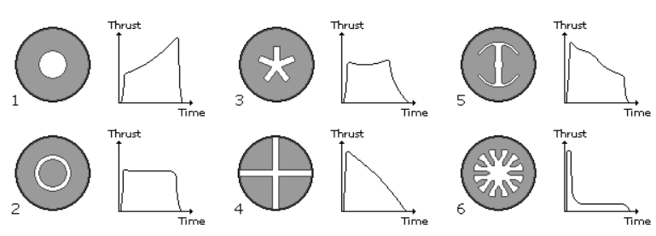

Figure : Variation of the thrust profile for different geometries [1]

Sebastien Wurster and Thomas S. Fisher from the Fraunhofer Institute for Chemical Technology in Germany have done considerable work exploring and documenting new methods to characterize complex-shaped propellants. Their work [2] includes an algorithm based on cellular automata to simulate the propellant geometry changes during combustion.

## Model Overview

The work presented by Wurster and Fisher [2] will be represented into a Cell-DEVS model and then implemented in CD++.

The implemented model will represent the combustion behaviour of a propellant grain cross-section. The cross-section is reproduced into a 2D array of cells, as shown in Figure 2. Each cell has three possible states:

* 0: empty (white cells)
* 1: filled with solid propellant (black cells)
* 2: outside of the propellant grain cross-section (grey cells)

The cell's state is influenced by the cell itself and all 8 neighbours. A cell becomes empty when at least one of the neighbouring cells is burning (i.e., empty). The simulation ends once all cells filled with solid propellant are emptied (i.e., no more propellant left). The model simply reproduces the mass loss at every step of the simulation. It simulates a geometry change and is not coupled to physical quantity such as pressure or heat loss that would affect the burn rate. Different propellant grain shapes will be used to test the model.

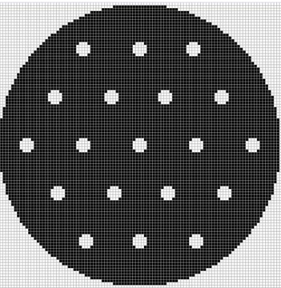

Figure : Example of a cellular space representing a 19-hole propellant grain cross-section [2]

# PART II – IMPLEMENTATION

## Formal Specification

Table 1 provides the formal specification for the solid propellant combustion atomic Cell‑DEVS model.

|  |  |
| --- | --- |
| **Solid Propellant Combustion Atomic Cell Model <*X*, *Y*, S, N, d, τ, δint, δext, λ, ta>** | |
| X  Y  S  N  d  τ | = Ø  = Ø  = {0, 1, 2} where:  0 = *empty* (white)  1 = *filled* with propellant (black)  *2 = outside* of propellant grain cross-section (grey)  = {(-1,-1), (-1,0), (-1,1),  (0,-1), (0,0), (0,1), Moore’s neighborhood  (1,-1), (1,0), (1,1)}  = 1 time unit  : N → S is defined by the following rules:  S = *empty* (0) if cell is *filled* (1)and number of wall neighbors  *empty* (0) is > 0;  S =remains constant for all other cases |
| δint,δext,λ and ta are defined using Cell-DEVS specifications. | |

Table : Solid propellant combustion atomic Cell-DEVS model

## Creation of initial cell value files

Prior to run any test cases and experiments, initial cell value files (i.e., .val files) were created to represent various propellant grain cross-sections. These .val files are required to define the initial values of the solid propellant combustion model's cells.

First, propellant grain cross-sections were drawn using Microsoft Paint, where each pixel represents a cell of the cellular model. The shapes were drawn using only three colours:

* white pixels: empty (i.e., no propellant);
* black pixels: filled with propellant; and
* grey pixels: outside of the cross-section.

Each drawing was then saved into a 24-bit Bitmap file format in order to use the CD++ tool (bmptoval.exe), allowing to convert a Bitmap file into a .val files. Once a Bitmap file is converted into a .val files, the values of the .val files were then replaced only to contain the following values:

* 0 (empty);
* 1 (filled); and
* 2 (outside).

The 24-bit Bitmap files were prepared using various pixel resolutions varying from 20 pixels by 20 pixels up to 500 pixels to 500 pixels.

## Testing Strategy

### Test Case #1

**Description:** The first test case uses a basic pattern verifying that the model rules are well implemented.

**Script:** [combustion_test_20px.bat](../scripts/)

**Results:** [video link](../videos/solid_propellant_combustion_20px.webm)

|  |  |  |  |
| --- | --- | --- | --- |
|  |  |  |  |
|  |  |  |  |
|  |  |  |  |

Figure : Results of test case #1

**Discussions:**

The simulation results, shown in the video and Figure 3, correspond to the expected behaviour: the black cells become *emptied* (i.e., white) once at least one neighbour is *empty* (i.e., white). The results also show that the grey cells, which represent the outside of the grain cross-section, remain unchanged.

### Test Case #2

**Description:** The second test case uses increasing pixel resolutions, from 100 x 100 pixels to 500 x 500 pixels, to represent the propellant grain cross-section. This test serves to examine the influence of pixel resolution on the simulation results.

The cross-section geometry used for this test case is a 19-hole propellant grain similar to the one presented in Figure 2. This shape was chosen as it contains circular shapes which are the most affected by pixel resolution.

**Scripts:** The following five scripts were used for test case #2:

1. [combustion_grain_19hole_100px.bat](../scripts/)
2. [combustion_grain_19hole_200px.bat](../scripts/)
3. [combustion_grain_19hole_300px.bat](../scripts/)
4. [combustion_grain_19hole_400px.bat](../scripts/)
5. [combustion_grain_19hole_500px.bat](../scripts/)

**Results:** The graphical outputs of the above scripts can be found at the following links:

1. 19-hole / 100 x 100 pixels: [video link](../videos/solid_propellant_combustion_19hole_100px.webm)
2. 19-hole / 200 x 200 pixels: [video link](../videos/solid_propellant_combustion_19hole_200px.webm)
3. 19-hole / 300 x 300 pixels: [video link](../videos/solid_propellant_combustion_19hole_300px.webm)
4. 19-hole / 400 x 400 pixels: [video link](../videos/solid_propellant_combustion_19hole_400px.webm)
5. 19-hole / 500 x 500pixels: see remarks in the “discussion” section

Figure 4 and Figure 5 provide a few snapshots at different time units of the 19‑hole propellant grain's combustion evolution for a pixel resolution of 100 x 100 pixels and 400 x 400 pixels.

|  |  |  |
| --- | --- | --- |
|  |  |  |
| 00:00:00:000 | 00:00:00:004 | 00:00:00:017 |

Figure : Snapshots of a 19-hole propellant grain's combustion – 100 x 100 pixels

|  |  |  |
| --- | --- | --- |
|  |  |  |
| 00:00:00:000 | 00:00:00:014 | 00:00:00:017 |

Figure : Snapshots of a 19-hole propellant grain's combustion – 400 x 400 pixels

Figure 6 provides the 2D form function as a function of the burned area fraction for each tested pixel resolution. The 2D form function represents the burning cells (i.e., cells that have been switched from filled to empty during one iteration) over the initial burning cells. The burned area fraction represents the remaining solid propellant (i.e., number of black cells after each iteration) over the original number of cells filled with propellant (i.e., number of black cells at the beginning of the simulation). The 2D form function and burned area fraction were calculated using the simulation result .log files and the .val file.

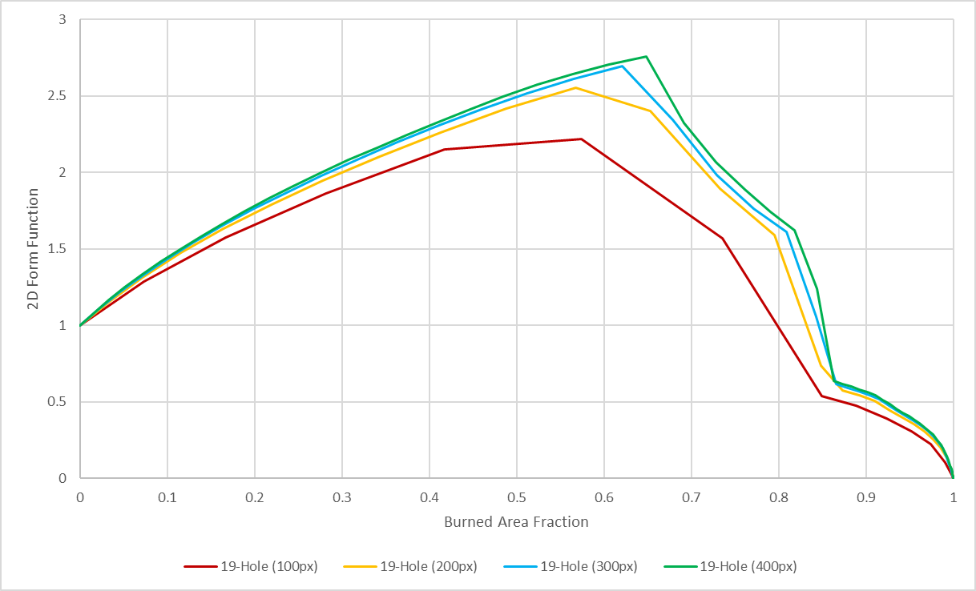

Figure : Resulting 2D form functions for a 19-hole propellant grain geometry at a pixel resolution of 100 x 100, 200 x 200, 300 x 300, and 400 x 400

**Discussions:**

The script for the pixel resolution of 500 x 500 pixels could not be run due to high computation time. For high pixel resolutions, the model should be run in parallel mode (i.e., using more than one processor-core). Ideally, it would have been desired to test the model with a pixel resolution of 2000 x 2000 pixels to compare the simulation results with the ones provided by Wurster and Fisher [2].

Figure 4 and Figure 5 show that a pixel resolution of 400 x 400 better represents the grain's combustion compared to the pixel resolution of 100 x 100. However, it also clearly indicates that a pixel resolution of 400 x 400 is not sufficient to accurately simulate complex-shaped propellants, such as the 19-hole configuration.

Figure 6 shows that any increase in pixel resolution above 200 x 200 pixel does not considerably change the 2D form function. Again, it would have been interesting to compare these results with simulation results at a significantly higher pixel resolution, such as 2000 x 2000.

### Test Case #3

**Description:** Due to high computation time for higher pixel resolutions, changes to the model were considered (i.e., changes to the rules or the neighbourhood) to improve the correct evolution of complex-shaped propellant cross-sections at lower pixel resolutions.

A potential solution that was not covered in the literature is the use of a hexagonal mesh instead of the typical square mesh to represent the cell spaces. A hexagonal mesh can be more suitable than a square mesh for physical systems showing isotropic behaviour, such as solid propellant combustion.

LTRANS (Lattice Translator) is a CD++ tool translating hexagonal rules into square rules. Using LTRANS, the following new rules were obtained:

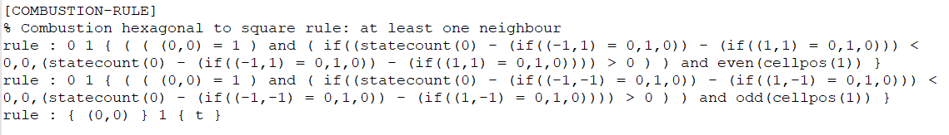

Figure : Combustion hexagonal rules translated into square rules

The third test case is similar to the second test case; however, the models now use hexagonal rules translated into square rules, as shown in Figure 7.

**Scripts:** The following scripts were used for test case #3:

1. [combustion_grain_19hole_100px_hexa.bat](../scripts/)
2. [combustion_grain_19hole_200px_hexa.bat](../scripts/)
3. [combustion_grain_19hole_300px_hexa.bat](../scripts/)
4. [combustion_grain_19hole_400px_hexa.bat](../scripts/)

**Results:** The graphical outputs of the above scripts can be found at the following links:

1. 19-hole / 100 x 100 pixels / hexagonal rules: [video link](../videos/solid_propellant_combustion_19hole_100px_hexa_to_square.webm)
2. 19-hole / 200 x 200 pixels / hexagonal rules: [video link](../videos/solid_propellant_combustion_19hole_200px_hexa_to_square.webm)
3. 19-hole / 300 x 300 pixels / hexagonal rules: [video link](../videos/solid_propellant_combustion_19hole_300px_hexa_to_square.webm)
4. 19-hole / 400 x 400 pixels / hexagonal rules: [video link](../videos/solid_propellant_combustion_19hole_400px_hexa_to_square.webm)

Figure 8 provides the 2D form function as a function of the burned area fraction for each tested pixel resolution using the hexagonal rules. This graph also provides the simulation results of test case #2 (dotted lines) as a measure of comparison.

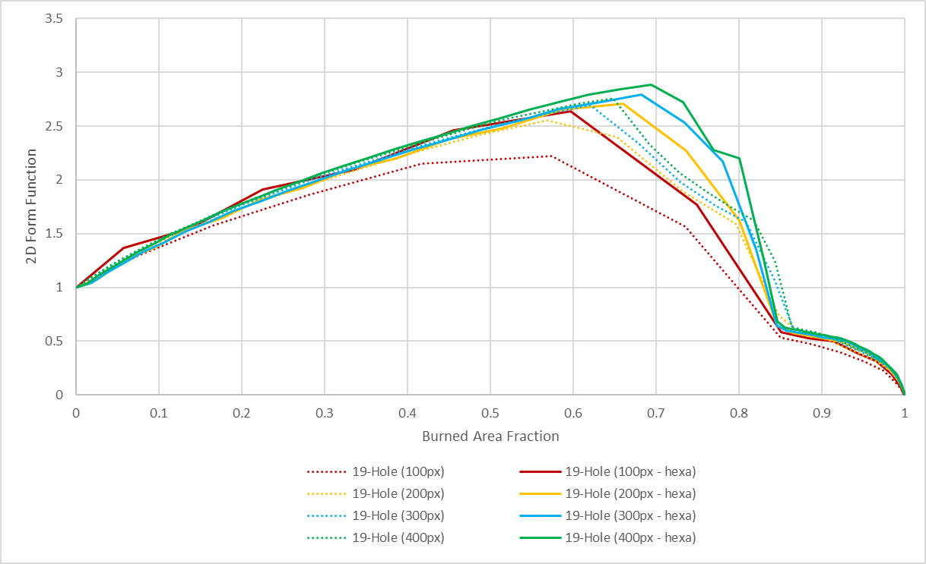

Figure : Resulting 2D form functions comparing hexagonal rules versus square rules for a 19-hole propellant grain geometry at a pixel resolution of 100 x 100, 200 x 200, 300 x 300, and 400 x 400

**Discussions:**

Figure 8 shows that the hexagonal rules improve the form function for the pixel resolution of 100 x 100. As for the other tested pixel resolutions, it is unknown if the hexagonal rules provide a more accurate form function. As for the previous test case, these results should be compared to the results of a higher pixel resolution, such as 2000 x 2000 pixels. This comparison would determine if the use of hexagonal rules provides a better approximation of the form function than square rules at lower pixel resolutions.

## Experimentation

This section presents the simulation results of commonly known shapes of propellant grain. Based on the test case results and required computation time, it was decided to run the simulations for a pixel resolution of 200 x 200 with squares rules and hexagonal rules.

### Creation of propellant grain cross-sections

Before running the simulations, the first step was developing Bitmap files and the associated initial cell value files (i.e., .val files) of commonly known shapes of propellant grain. Section 2.2 briefly explains how the .val files were created. The tested shapes are presented in Figure 9.

|  |  |  |  |
| --- | --- | --- | --- |
| **19-hole** | **Cross** | **Tubular** | **Outside Tubular** |
|  |  |  |  |
| **Large Dendrite** | **Small Dendrite** | **Star** | **Tubular & Rod** |
|  |  |  |  |

Figure : Tested propellant grain shapes

### Simulation execution and analysis

**Scripts:** The following scripts were used to test the above propellant grain shapes:

Square rules:

1. 19-hole: [combustion_grain_19hole_200px.bat](../scripts/)
2. Cross: [combustion_grain_cross_200px.bat](../scripts/)
3. Inside Tubular: [combustion_grain_inside_tubular_200px.bat](../scripts/)
4. Large Dendrite: [combustion_grain_large_dendrite_200px.bat](../scripts/)
5. Outside Tubular: [combustion_grain_outside_tubular_200px.bat](../scripts/)
6. Small Dendrite: [combustion_grain_small_dendrite_200px.bat](../scripts/)
7. Star: [combustion_grain_star_200px.bat](../scripts/)
8. Tubular & Rod: [combustion_grain_tubular_rod_200px.bat](../scripts/)

Hexagonal rules:

1. 19-hole: [combustion_grain_19hole_200px_hexa.bat](../scripts/)
2. Cross: [combustion_grain_cross_200px_hexa.bat](../scripts/)
3. Inside Tubular: [combustion_grain_inside_tubular_200px_hexa.bat](../scripts/)
4. Large Dendrite: [combustion_grain_large_dendrite_200px_hexa.bat](../scripts/)
5. Outside Tubular: [combustion_grain_outside_tubular_200px_hexa.bat](../scripts/)
6. Small Dendrite: [combustion_grain_small_dendrite_200px_hexa.bat](../scripts/)
7. Star: [combustion_grain_star_200px_hexa.bat](../scripts/)
8. Tubular & Rod: [combustion_grain_tubular_rod_200px_hexa.bat](../scripts/)

**Results:** The graphical outputs of the above scripts can be found at the following links:

Square rules:

1. 19-hole: [video link](../videos/solid_propellant_combustion_19hole_200px.webm)
2. Cross: video link
3. Inside Tubular: video link
4. Large Dendrite: video link
5. Outside Tubular: video link
6. Small Dendrite: video link
7. Star: video link
8. Tubular & Rod: video link

Hexagonal rules:

1. 19-hole: [video link](../videos/solid_propellant_combustion_19hole_200px_hexa_to_square.webm)
2. Cross: [video link](../videos/solid_propellant_combustion_cross_200px_hexa_to_square.webm)
3. Inside Tubular: [video link](../videos/solid_propellant_combustion_inside_tubular_200px_hexa_to_square.webm)
4. Large Dendrite: [video link](../videos/solid_propellant_combustion_large_dendrite_200px_hexa_to_square.webm)
5. Outside Tubular: [video link](../videos/solid_propellant_combustion_outside_tubular_200px_hexa_to_square.webm)
6. Small Dendrite: [video link](../videos/solid_propellant_combustion_small_dendrite_200px_hexa_to_square.webm)
7. Star: [video link](../videos/solid_propellant_combustion_star_200px_hexa_to_square.webm)
8. Tubular & Rod: [video link](../videos/solid_propellant_combustion_tubular_rod_200px_hexa_to_square.webm)

Figure 10 to Figure 15 present a few snapshots at different time units of the combustion evolution for three propellant grain shapes: inside tubular, 19-hole, and large dendrite. The simulation results are for a pixel resolution of 200 x 200 using square and hexagonal rules.

|  |  |  |  |
| --- | --- | --- | --- |
|  |  |  |  |
| 00:00:00:000 | 00:00:00:012 | 00:00:00:030 | 00:00:00:049 |

Figure : Snapshots of an "inside tubular" propellant grain's combustion  
200 x 200 pixels – square rules

|  |  |  |  |
| --- | --- | --- | --- |
|  |  |  |  |
| 00:00:00:000 | 00:00:00:012 | 00:00:00:030 | 00:00:00:049 |

Figure : Snapshots of an "inside tubular" propellant grain's combustion  
200 x 200 pixels – hexagonal rules

|  |  |  |
| --- | --- | --- |
|  |  |  |
| 00:00:00:000 | 00:00:00:010 | 00:00:00:017 |

Figure : Snapshots of a "19-hole" propellant grain's combustion  
200 x 200 pixels – square rules

|  |  |  |
| --- | --- | --- |
|  |  |  |
| 00:00:00:000 | 00:00:00:010 | 00:00:00:017 |

Figure : Snapshots of a "19-hole" propellant grain's combustion  
200 x 200 pixels – hexagonal rules

|  |  |  |
| --- | --- | --- |
|  |  |  |
| 00:00:00:000 | 00:00:00:004 | 00:00:00:013 |

Figure : Snapshots of a "large dendrite" propellant grain's combustion  
200 x 200 pixels – square rules

|  |  |  |
| --- | --- | --- |
|  |  |  |
| 00:00:00:000 | 00:00:00:004 | 00:00:00:013 |

Figure : Snapshots of a "large dendrite" propellant grain's combustion  
200 x 200 pixels – hexagonal rules

Using the simulation result .log files, the evolution of the burn area per time unit for each simulation using square rules was obtained and depicted in Figure 16.

The 2D form function as a function of the burn area fraction was also obtained for each simulation using square and hexagonal rules. The resulting form function for each propellant grain shape is shown in Figure 17.

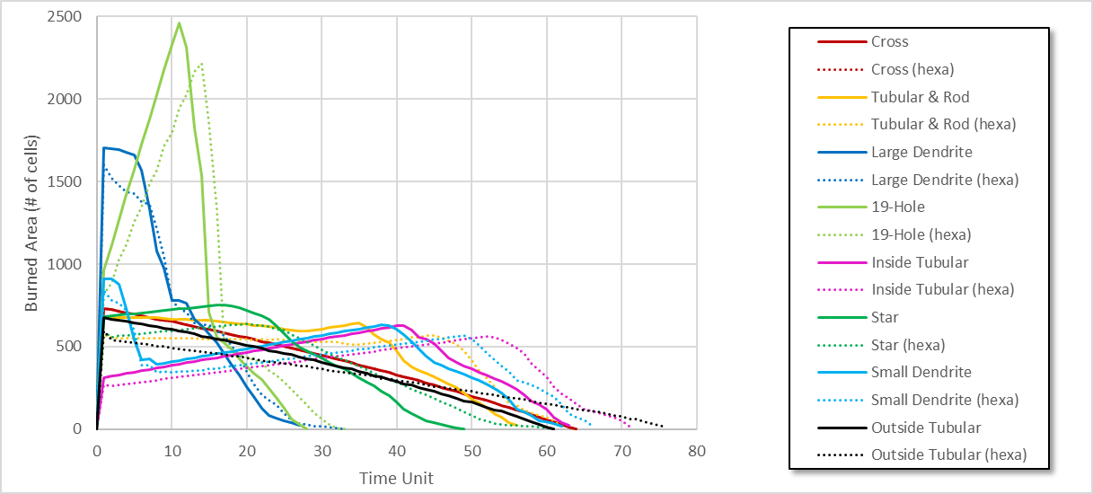

Figure : Burning profile for each tested propellant grain shapes comparing square rules (continuous lines) versus hexagonal rules (dotted lines) at a pixel resolution of 200 x 200

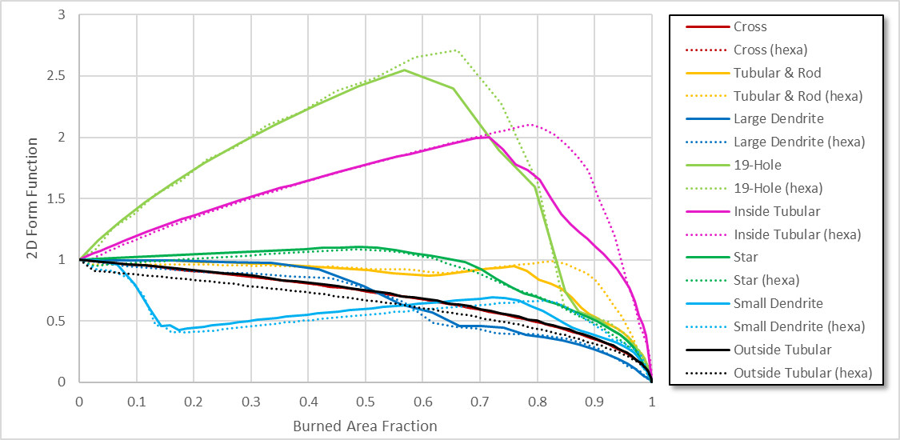

Figure : Resulting 2D form functions of the tested propellant shapes comparing square rules (continuous lines) versus square rules (dotted lines) at a pixel resolution of 200 x 200

**Discussion:**

The visual representation of the simulation results shown in Figure 10 to Figure 15 indicates that the chosen pixel resolution of 200 x 200 is insufficient to provide an accurate evolution of the global geometry, particularly for the inside tubular and 19-hole shape. However, as predicted, the simulation results using the hexagonal rules provide better isometric behaviour than the square rules, which seems to provide a more accurate evolution of the global geometry.

These snapshots are useful for quickly assessing the burn area evolution; however, the graphs presented in Figure 16 and Figure 17 provide a better indication of the propellant grain performance. The burn profiles presented in Figure 16, which are proportional to thrust profiles, provides valuable information about the propellant grain performance by displaying if the propellant grain is progressive (i.e., growing thrust), regressive (i.e., diminishing thrust), neutral (i.e., constant thrust), or showing more complex burning profiles. The burning profiles obtained through simulation are comparable to the ones provided in Figure 1.

In Figure 17, the resulting 2D form functions of the tested propellant shapes also offer a good indication of the propellant grain performance. This figure shows that the hexagonal rules provide similar results except for the shapes mainly characterized by circular lines such as the 19-hole, inside tubular and tubular & rod shapes. As previously mentioned, simulation results at greater pixel resolutions would determine if the simulation results using hexagonal rules better represent the actual burning profile.

# CONCLUSION

The solid propellant combustion model, represented into a Cell-DEVS model and then implemented in CD++, successfully provided the evolution of the burn area for various propellant grain shapes.

The simulation results show that the chosen pixel resolution directly impacts the quality of the results, particularly for propellant grain shapes characterized by circular shapes. The more pixels are used to represent a geometry, the better the simulation will be. It would be interesting to use the CD++ parallel mode to run the model over a network of machines in order to test higher pixel resolutions, such as 2000 x 2000, and then compare these results to the hexagonal results obtained at lower resolutions. It seems that the use of hexagonal rules at lower pixel resolutions could provide a better estimation than square rules. Even though high pixel resolutions could not be tested due to high computation time, the implementation of this model into CD++ does provide a quick and efficient way to estimate and visualize the combustion of any complex-shaped propellant grains, which can be difficult to assess using analytic and numerical approaches.

# REFERENCES

[1] R. Michele, "Aerospace Engineering - Solid Rocket Motors," November 21, 2013. [Online]. Available: <http://www.aerospacengineering.net/1255/>. [Accessed: Oct. 26, 2020].

[2] S. Wurster, T. Fisher, "ICT-Cellular-Combustion-Algorithm (ICCA) Application to the Combustion of Complex Shaped Propellants," In Proceedings of the 45th International Annual Conference of ICT, 2014, pp. 32.1-32.12.