

**SYSC 5104 – Methodologies for Discrete Event Modelling and Simulation**

**Assignment 1**

**Conceptual Model Document**

**Package Monitoring**

Mahsa Layeghi

Ghida Dandan

**Course Instructor:** Gabriel Wainer

Sunday, October 25, 2020

Table of Contents

Part I 2

1.1 Problem Statement 2

1.2 Conceptual Model 2

1.3 Components Outline 3

Part II 4

2.1 DEVS Formal Specification 4

2.1.1 Excessive Heat Detection Atomic Model 4

2.1.2 Excessive Humidity Detection Atomic Model 4

2.1.3 Excessive Tilting Detection Atomic Model 5

2.1.4 Box Opening and Tampering Detection Coupled Model 5

2.1.5 Light Detection Atomic Model 6

2.1.6 Tampering Detection Atomic Model 6

Part III 7

3.1 Test Cases 7

# Part I

## 1.1 Problem Statement

Packages are often exposed to harsh conditions throughout their shipping process, which may lead to irreversible damage to said package. Such damages may result from certain weather conditions (i.e. high temperatures or humidity, rain), an opening or tampering with the package as in the case in customs for safety purposes, or involuntary shaking/excessive tilting during transport. These different events may be monitored and logged for later analysis by the receiver or sender through the use of different components outlined by the team members, as will be discussed in later on sections. Since such product does not exist in the market, a lot of creative liberty was taken in terms of setting assumptions for these different components.

## 1.2 Conceptual Model

This project's conceptual model can be seen as per figure 1. This is the finalized version of the model and it contains five atomic models and one coupled model.

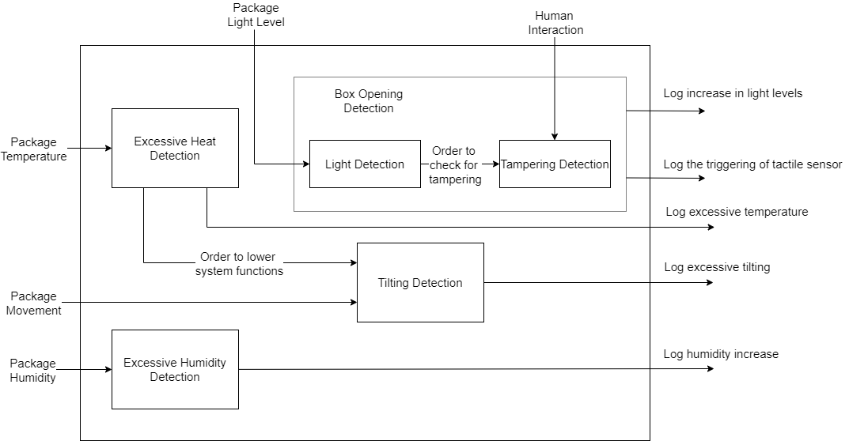

**Figure 1 –** Model Structure for Package Status Monitoring

## 1.3 Components Outline

The different atomic models and the coupled model referenced in figure 1 each serve a different purpose in monitoring the events through which the package encounter. All events would be logged onto an SD card for later use. The different models' behavior can be described as follows:

* **Excessive Heat Detection:** Monitored using a temperature sensor. It records temperature data, and when the temperature reaches a certain threshold, this event is logged. Moreover, an order to put excessive tilting detection to sleep is sent out as an additional output. The temperature threshold is assumed to be 50°C or 120°F.
* **Excessive Tilting Detection:** An accelerometer would be in charge of recording coordinate data and logging onto the SD file whenever excessive tilting or shaking occurs. Its inputs are twofold: the movement of the device itself, and the potential lowering of its functions due to excessive heat coming from the heat detection unit. The need to put this function to sleep in case of overheating is because coordinate data collection, as well as the necessary calculations performed on this data, consumes a lot of power. For the sake of simplicity, the computationally intensive aspect of this atomic model is overlooked and the input to the model is taken as either 1 (for tilt) or 0 (no tilt).
* **Ambient Humidity Detection:** A hygrometer can be used to record ambient humidity values, and logs the event of excessive humidity. The humidity threshold is taken as roughly 52%.
* **Box Opening and Tampering Detection:** This is a coupled model consisting of two atomic models: the light detection and the tampering detection model. The light detection model uses a light sensor and it records light level values, while the tampering detection model would consist of a touch sensor that would only be triggered if the light sensor was triggered first. As a result, the package opening only triggers the light detection event; however, this wouldn't log the event as the tampering detection event must also occur. The threshold is assumed to be 150 lux for the light sensor, and touch sensors typically only return a value when they're triggered.



# Part II

## 2.1 DEVS Formal Specification

### 2.1.1 Excessive Heat Detection Atomic Model

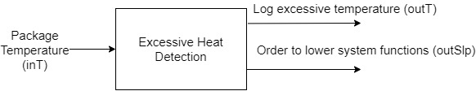

**Figure 2 –** Excessive Heat Detection Atomic Model

Heat Model = <X, Y, S, δint, δext, λ, ta>

X = {inT}

Y = {outL, outO}

S = {A, E} //A for acceptable, E for excessive

δint(A) -> A

δext (X, A) -> E

λ: E -> Y

ta: processing time

### 2.1.2 Excessive Humidity Detection Atomic Model

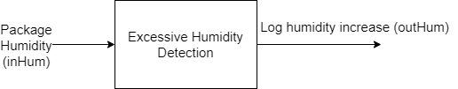

**Figure 3 –** Excessive Humidity Detection Atomic Model

Humidity Model = <X, Y, S, δint, δext, λ, ta>

X = {inHum}

Y = {outHum}

S = {A, E} //A for acceptable, E for excessive

δint(A) -> A

δext (X, A) -> E

λ: E -> Y

ta: processing time

### 2.1.3 Excessive Tilting Detection Atomic Model

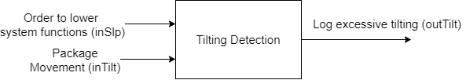

**Figure 4** **–** Tilting Detection Atomic Model

Tilting Model = <X, Y, S, δint, δext, λ, ta>

X = {inTilt, inSlp}

Y = {outTilt}

S = {A, E} //A for no tilt, E for tilt

δint(A) -> A

δext (X, A) -> E

λ: E -> Y

ta: processing time

### 2.1.4 Box Opening and Tampering Detection Coupled Model

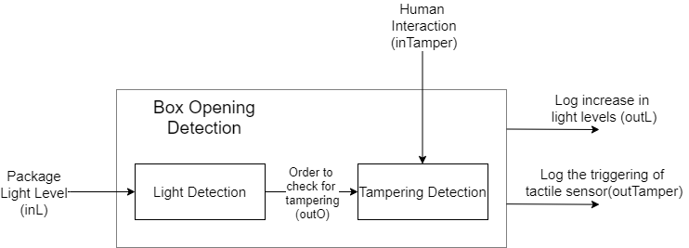

**Figure 5** **–** Box Opening and Tampering Detection Coupled Model

BOD Model = <X, Y, D, EIC, EOC, IC, select>

X = {inL, inTamper}

Y = {outL, outTamper}

D = {Light Detection, Tampering Detection}

EIC = {(BOD.inL, LD.inL), (BOD.inTamper, TD.inTamper)}

EOC = {(LD.out, BOD.out) (TD.out, BOD.out)}

select: (LD, TD) = LD

### 2.1.5 Light Detection Atomic Model

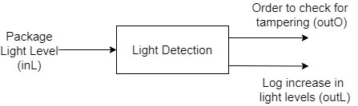

**Figure 6** **–** Light Detection Atomic Model

LD Model = <X, Y, S, δint, δext, λ, ta>

X = {inL}

Y = {outL, outO}

S = {D, B} // D for dim, B for bright

δint(D) -> D

δext (X, D) -> B

λ: B -> Y

ta: processing time

### 2.1.6 Tampering Detection Atomic Model

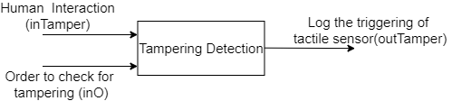

**Figure 7** **–** Tampering Detection Atomic Model

TD Model = <X, Y, S, δint, δext, λ, ta>

X = {inTamper, inO}

Y = {outTamper}

S = {A, E} // E is for sensor triggering, A is for none

δint(A) -> A

δext (X, A) -> E

λ: E -> Y

ta: processing time

# Part III

## 3.1 Test Cases

Three of the five atomic models’ inputs are analogous in nature, as they represent a physical quantity (temperature, humidity, light). These three atomic models await their respective thresholds to be crossed before triggering an event.

Each of the other two atomic models (tampering detection and tilting detection) expects a Boolean input, i.e. either a 1 or a 0. Additionally, each of those two expect not only one, but two inputs from other atomic models. This means that a failure in a previous model may hinder the output of these two due to the existing dependencies.

Furthermore, a provided value may be considered erroneous if this value is of the wrong type, as each of them expects a certain variable type as inputs.