Table of Content

Conceptual Model Description(Part 1): 2
Problem/Solution 3
Conceptual model 3
State Variables 3
Model Specification(Part 2): 5
Terminology Acronym: 5
Coupled Model(s): 5
Top level Coupled Model is the “Internet Online Banking“: 5
Authentication Engine (AE): 6
Atomic Models: 8
Account Access Manager (AAM) 8
Account Number Verifier (ANV) 11
Password Verifier (PV) 13
Bill Payment Manager (BPM) 15
Transaction Processing Manager (TPM) 18
Model Testing and Verification(Part 3): 20
Atomic Models: 20
Account Access Manager (AAM): 20
Account Number Verifier (ANV): 21
Password Verifier (PV): 22
Bill Payment Manager (BPM): 22
Transaction Processing Manager (TPM): 23
Coupled Models: 24
Top level Coupled Model is the “Internet Online Banking“ 24
Authentication Engine (AE) 26

Conceptual Model Description(Part 1):
Following is what initialized planned and submitted as a proposal:
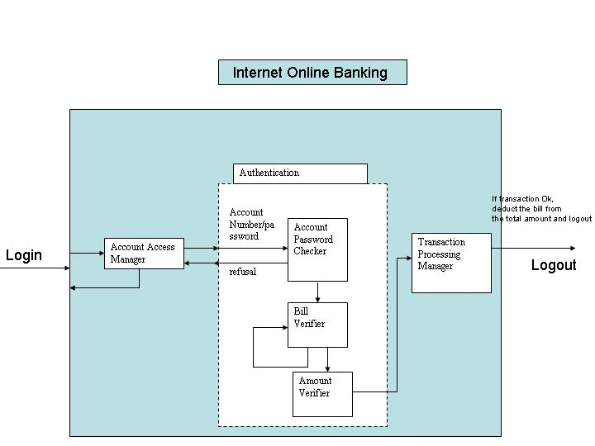

Problem/Solution:

An internet online banking system is modeled. This is a simplified version of a real commercial online banking system. Modeling is done on the account number and password verification,

The purpose of the simulation is to get a rough idea of how much internet access time is usually needed for a “normal” online banking, which includes the time on password verification (maybe failed few times before successfully login), and time spent on the bill payment.

Conceptual model:

This model conceives three sub models; one coupled model has three atomic models
Following components are involved in this modeling.

- Account Access Manager: is to manage taking the input of online banking account and password, (which is passed to the Authentication Manager), and take the result from Authentication Manger to make further decision. If it fails, it will keep asking for input of account number and password
- Authentication Manager: get the input from Account Access Manager and do the verification and it has the following atomic models
  - Account number/PIN verifier Manager : for simplicity, we are not going to predefine a database which store the matching account number and PIN number. A random function will return Yes or No, to simulate the PIN is acceptable or not
  - Bill Verifier Manager: checks the bill (the associated institute) has already listed in the account. If not, will ask to pay another bill. (for simplicity, adding to bill payment is not implemented), and random function is implemented to simulate the bill is existing
  - Amount Verifier Manager: check the amount in your amount with the bill amount about to pay, if enough to cover, function will return TRUE.
- Transaction Processing Manager: In real life, the input of this block is to ask user to confirm and click “Do you really want to pay this bill”. Here, I am just use the output of Bill Verifer and Amount Verifier. If both validation are passed, then it will perform the transaction and output to logout the session

State Variables:

Account Access Manager: sigma, account number, phase.
Amount Verifier Manager: sigma, amount, Number_of_trials.
Bill Verifier: sigma, bill number, Number_of_trials
PIN Verifier: sigma, PIN, Number_of_trials, accountNumber
Transaction Processing:

And after a fine tuning up, a slight modification has been made, and the updated model looks like the following.

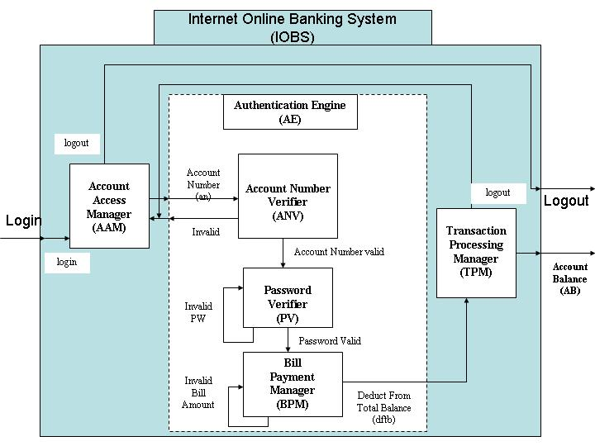

Model Specification(Part 2):

Terminology Acronym:

IOBS: Internet Online Banking System
AAM: Account Access Manager
AE: Authentication Engine
ANV: Account Number Verifier
PV: Password Verifier
BPM: Bill Payment Manager
TPM: Transaction Processing Manager

Coupled Model(s):

Top level Coupled Model is the “Internet Online Banking“:
It models the online web bank account access, and bill payment transaction operation in a simpler version vs. real-life’s.

Internet Online
Banking System
(IOBS)
INPUT
OUTPUT
Account Balance Update (ABU)
Port definitions:

IN PORTS: LOGIN
OUT PORTS: LOGOUT

IOBS = <X,Y,D,EIC,EOC,IC,SELECT>

Where:
X = {LOGIN}

Y = {LOGOUT, ABU}

D = {AAM, TPM, AE}

EIC = {IOBS.login, AAM.login}

EOC = {(AAM.logout, IOBS.logout),
(TPM.logout, IOBS.logout)}

IC = { (AAM.an_out, AE.an_in),
(AE.ian, AAM.ian_in),
(AE.dftb_out, TPM.in) }

SELECT: { AAM, TPM} = TPM
{AE, TPM} = TPM

To test this top level modeling, input data can be feed into the system, and output data will be generated by CD++, therefore data can be viewed and interpreted.

Input can be: (where time is specified and in put “1” means login event happens)

01:00:08:00 in 1
01:00:18:00 in 1
01:00:28:00 in 1

Output:
As mentioned, this is the generated data, and output should be “1”, which indicates the online banking session has been closed.
If the bill payment transaction is processed successful, output will also update the account balance.

Authentication Engine (AE):
This is a submodel of Internet Online Banking System(IBOS). It gets input from the Account Access Manager (AAM), the input is an account number which is randomly generated by the AAM,. The account number then pass to Account Number Verifier (ANV), for simplicity, ANV has a random generator, generates a value of TRUE or FALSE. If TRUE, meaning the inputted Account number is a valid account number, and ANV will use another random generator to generates a Password word. If it is FALSE, then it will send a logout signal back to AAM to end the login session. The Password Verifier gets the Password Number (pn) as input, and it has a random generator to generates TRUE or FALSE. TRUE means password matches the valid account number that has just been inputted, and then it will random generates a value representing the Bill payment amount. If FALSE, it will send an Invalid PW (ipn) signal back to ANV to generate another password number. The Bill payment Manager (BPM) gets an numeric bill amount number as an input, and compares the current amount balance (Initially, we assume the account has a balance of $3000), it verifies the bill payment amount with the balance, if it is smaller or equal, then it send the bill amount to TPM as an output. If is bigger than the balance, it send an Over Limit (ol) signal back to PV to generate another bill amount.

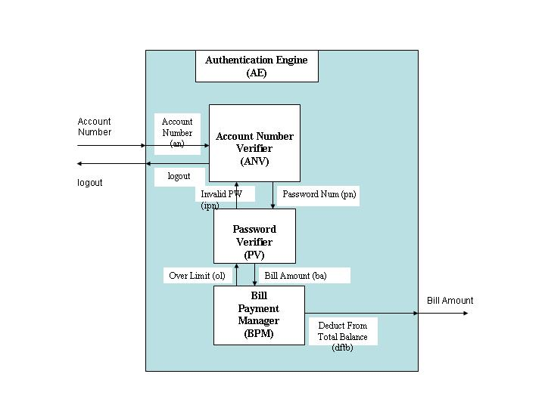

Input Port: Amount Number (an)
Output Ports: Bill Amount(ba), logout

Formal specifications:
AE = <X,Y,D,EIC,EOC,IC,SELECT>
Where:
X = {AccountNumber}
Y = { BillAmount, logout}
D = { ANV, PV, BPM}
EIC = { (AE.in, ANV.an) }
EOC = { (BPM.ba, AE.ba),
(ANV.logout, AE.logout)}
IC = { (PV.pn_in, ANV.pn_out),
(BPM.ba_in, PV.ba_out),
(ANV.ipn_in, PV.ipn_out),
(PV.ol_in, BPM.ol_out) }

SELECT: Priority order (Descending) : ANV, PV, BPM

To test this model, we can apply the input (account number), and let CD++ generate it corresponding output and have the data result interpreted.

Input:
01:00:08:00 in 20030000
01:00:18:00 in 20022222
01:00:28:00 in 23450000

Output:
Logout signal will be sent out if the account number is not valid.
Else, a valid bill payment amount will be sent out

Atomic Models:
A random processing time with its corresponding distribution function specified in *.MA file is associated with each of the atomic models list as following.

Account Access Manager (AAM)
This model gets a user login signal as its input; it will then generate a random online bank Account Number, and pass it to Authentication Engine (AE). This model can also receive the Invalid Account Number (ian) as an input, and then will send an output signal out.

Account Access Manager
(AAM)
login

Invalid Amount Number (ian),
Valid Amount Number
(van)
logout

Definition of Ports:
Input Ports: login, ian
Output Ports: logout, van

Formal specification:
AAM = <X, Y, S, δ_{int}, δ_{ext}, λ, ta>
Where:

X = {
login | default is value of 0 or 1. 0 means that user has not logged in, a 1 means user just enters to the system ,

ian | default value is a value of 0 or 1. 0 means it is either, user enters the valid account number, or system is expecting to be logged in; value of 1 means the user entered an invalid account number, and AAM is expected to logout. }

Y = { logout, van}

S = { Phase, sigma, out_of_session, randAccountNumber, login_status, ian_status,}

δ_{ext} (S,e,X) {
Case port
login:
Case Phase
Passive:
Sigma = generate random Processing Time;
Phase = busy;
randAccountNumber= Generate random number of a six digital integer number
login_status = 1;
ian_status = 0;
busy:
// Ignore the request;

ian:
Case Phase
busy:
Sigma = generate random Processing Time;
login_status = 0;
ian_status = 1;
Passive:
// Ignore the request;

}

λ (S) {
case phase
busy:
If login_status ( is equal to 1)
// send randAccountNumber to out
Send (van_port, AAM. randAccountNumber);
Else (ian_status = = 1)
// a logout request
Send (logout_port, logout);

Passive: // Should not happen.
}

δ_{int} (S) {
case phase
busy:
sigma = infinity;
If ian_status = = 1 and no login_status
phase = passive;
passive: //never happens
}

The logic and functionality of this model block can be tested by inputting event of login and Invalid_Account_Number(ian), output can be generated and used to interpreted.

Input:
00:00:30:000 LOGIN 1
00:00:40:000 IAN 1

Output: (respective to input)
An account number of any six digit integer number is sent out to Account Number output port
Value of 1 at logout output port

Account Number Verifier (ANV)
This model get the input (Account Number), and then triggers a random generated to randomly verifies it is a valid number or not , if it is invalid Account Number, it sends the logout_request to logout_output port. Else if it is a valid Account Number, it then sends the ValidAccountNumber signal to the ValidAccountNumber output port.

Account Number Verifier
(ANV)
Account Number (an)
Logout

Valid Account Number

Definition of Ports:
Input Ports: AccountNumber_IN
Output Ports: logout_OUT, ValidAccountNumber_OUT

Formal specification:
ANV= <X, Y, S, δ_{int}, δ_{ext}, λ, ta>
Where:

X = {
AccountNumber | any six digit integer number }

Y = { logout_OUT, ValidAccountNumber_OUT }

S = { Phase, sigma, randAccountNumberValid, }

δ_{ext} (S,e,X) {
Case port
AccountNumber:
Case Phase
Passive:
Sigma = generate random Processing Time;
Phase = busy;
randAccountNumberValid = Generate random number between 0 and 1;
busy:
// Ignore the request;
}

λ (S) {
case phase
busy:
If randAccountNumberValid
//send out to its port
Send (ValidAccountNumber_OUT port, 1);
Else
// logout signal
Send (logout_OUT, logout);

Passive: // Should not happen.
}

δ_{int} (S) {
case phase
busy:
phase = passive;
sigma = infinity;
passive: //never happens
}

The logic and functionality of this model block can be tested by inputting event of Login and Account Number(the randomly generated six digit number), output is generated by CD++ builder and used to interpreted.

Input:
00:00:30:000 AN 100001

Output:
Value of 1 at ValidAccountNumber_OUT port
Value of 1 at logout_OUT port

Password Verifier (PV)
The model has two inputs (VAN_IN and IVPN_IN), In the initial state, both input signals are “0”.
When receiving a VAN_IN, the model has a random generator, simulating user’s password has been accepted or not. A randomly generated number of “1” or “0” where “1” means, user password number is valid and a signal VPN_OUT is sent out to output port, and “0” means invalid password number, and a IVPN_OUT signal is sent to IVPN_output port.
When IVPN output port is sent out, it also enable the IVPN_input port. When receiving IVPN_IN signal, this model will regenerate another value to indicate password number is acceptable. The model will loop till an VPN signal is sent out.

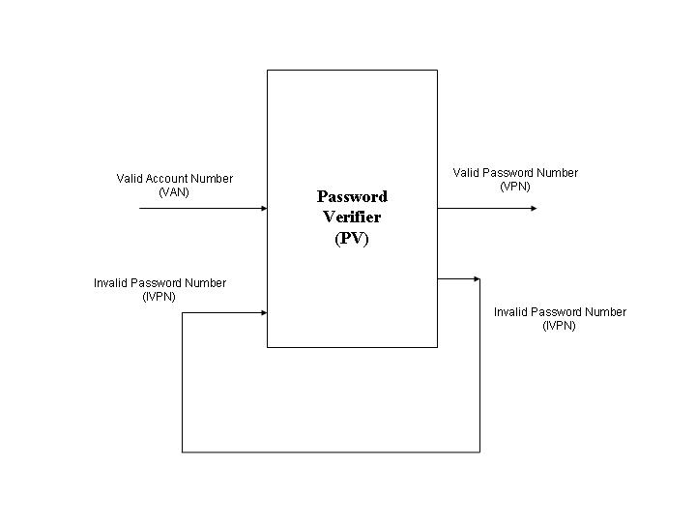
Definition of Ports:
Input Ports: VAN_IN, IVPN_IN
Output Ports: VPN_OUT, IVPN_OUT

Formal specification:
PV= <X, Y, S, δ_{int}, δ_{ext}, λ, ta>
Where:

X = {
VAN_IN | a value of either “0” or “1”, where 0 means that no Valid account number has been enter, and “1” means account number has been validated. And “1” will trigger the generator to generate a Password validation result number.
IVPN_IN | a value of either “0” or “1”, where 1 will trigger the generator to regenerate a number }

Y = { VPN_OUT , IVPN_OUT }

S = { Phase, sigma, randPasswordNumber}

δ_{ext} (S,e,X) {
Case port
VAN_IN:
Case Phase
Passive:
Sigma = generate random Processing Time;
Phase = busy;
randPasswordNumber = Generate random number (0 or 1); busy:
// Ignore the request;

IVPN_IN:
Case Phase
busy:
Sigma = generate random Processing Time;
randPasswordNumber = Generate random number (0 or 1);
Passive:
// Ignore the request;

}

λ (S) {
case phase
busy:
If randPasswordNumber (is equal to 1)
//send out to its port
Send (VPN_OUT, 1);
Else
//send out to its port
Send (IVPN_OUT, 1);

Passive: // Should not happen.
}

δ_{int} (S) {
case phase
busy:
phase = passive;
sigma = infinity;
passive: //never happens
}

The logic and functionality of this model block can be tested by inputting event of VAN ( 0 or 1), output is generated by CD++ builder and used to interpreted.

Input:
00:00:30:000 VAN_IN 1
00:00:40:000 IVPN_IN 1

Output:
Value of 1 at VPN output port
Value of 1 at IVPN output port and looping till Value of 1 at VPN output port

Bill Payment Manager (BPM)
Similar to the previous model, this model has two inputs, In the initial state, both input signals are initialized to be “0”.
When receiving a Valid Password Number(VPN_IN) signal from the input port, it triggers the model’s internal random generator, sends out a randomly generated number between “1” to “4000” (initially the account balance is $3000). It then compared the account balance, if it is equal or smaller than a signal Valid Bill Amount (VBA_OUT) to VBA_OUT port, and if the compared result is larger, then it sends a IBA_out signal is sent to IBA_out port.
When IBA_Out is sent out, it also enable the IBA_IN port. When receiving IBA_IN signal, this model will regenerate another bill amount value to check if it is valid amount or not. The model will loop till a VBA_OUT signal is sent out.

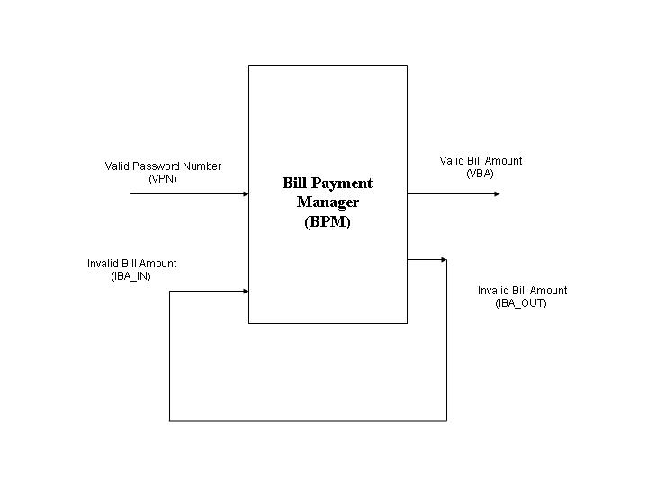
Definition of Ports:
Input Ports: VPN_IN, IBA_IN
Output Ports: VBA_OUT, IBA_OUT

Formal specification:
BPM = <X, Y, S, δ_{int}, δ_{ext}, λ, ta>
Where:

X = {
VPN_IN | a value of either “0” or “1”, where 0 means that no Valid Password number has been enter, and “1” means Password number has been validated. And “1” will trigger the generator to generate a numeric bill payment amount, it and compares it with current account balance.
IBA_IN | a value of either “0” or “1”, where 1 will trigger the generator to regenerate a bill payment amount number }

Y = { VBA_OUT , IBA_OUT }

S = { Phase, sigma, randBilAmount, current_account_balance}

δ_{ext} (S,e,X) {
Case port
VPN_IN:
Case Phase
Passive:
Sigma = generate random Processing Time;
Phase = busy;
randBilAmount = Generate random number (1 to 4000);
busy:
// Ignore the request;

IBA_IN:
Case Phase
busy:
Sigma = generate random Processing Time;
randBilAmount = Generate random number (1 to 4000);
Passive:
// Ignore the request;

}

λ (S) {
case phase
busy:
If randBilAmount (is equal or smaller to current_account_balance)
//send out to its port
Send (VBA_port, randBilAmount);
Else
//send out to its port
Send (IBA_OUT, 1);

Passive: // Should not happen.
}

δ_{int} (S) {
case phase
busy:
phase = passive;
sigma = infinity;
passive: //never happens
}

The logic and functionality of this model block can be tested by inputting event of VPN_IN ( 0 or 1), output is generated by CD++ builder and used to interpreted.

Input:
00:00:40:000 VPN_IN 1
00:00:50:000 IBA_IN 1

Output:
Value of “Valid_Bill_Amount” at VBA output port
Or
Value of 1 at IBA output port and looping till value of randBilAmount at VBA_OUT output port

Transaction Processing Manager (TPM)
This models detects the signal from the input port of Valid Bill Amount(VBA_IN), and deduct the amount from the current and amount balance, and sent the updated balance to the Updated Account Balance (UAB_OUT) port, and it also sends the logout signal to the LOGOUT port.

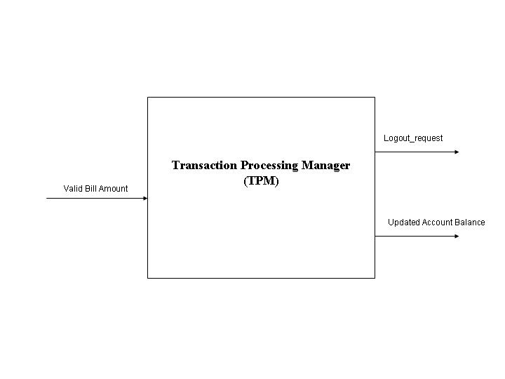
Definition of Ports:
Input Ports: VBA_IN
Output Ports: UAB_OUT, LOGOUT

Formal specification:
TPM = <X, Y, S, δ_{int}, δ_{ext}, λ, ta>
Where:
X = { VBA_IN | VBA is a value smaller to the current balance 0- 3000 }
Y = { UAB_OUT | the new amount cash balance (0-3000),
LOGOUT | a signal to logout}
S = { Phase, sigma, current_account_balance, billAmount }

δ_{ext} (S,e,X) {
Case port
VBA_IN:

Case Phase
Passive:
Sigma = generate random Processing Time;
Phase = busy;
current_account_balance = current_account_balance – billAmount;
busy:
// Ignore the request;

}

λ (S) {
case phase
busy:
// print the account balance
Send (UAB_OUT, current_account_balance)
Send (LOGOUT_Port, LOGOUT)

Passive: // Should not happen.
}

δ_{int} (S) {
case phase
busy:
phase = passive;
sigma = infinity;
passive: //never happens
}

Testing can be done by inputting one or more events at the input port and observing the output:

Input:
00:00:33:000 IN 200

Output:
2800 at UAB_OUT port
1 at LOGOUT port

Model Testing and Verification(Part 3):
Testing has been done on each of the following five Atomic Models as well as the two coupled Models:

Atomic Models:

Account Access Manager (AAM):
AccountAccessManager.MA:
[top]
components : aam@AccountAccessManager
out : logout_OUT
out : van_OUT
in : login_IN
in : ian_IN

Link : ian_IN ian@aam
Link : login_IN login@aam
Link : van@aam van_OUT
Link : logout@aam logout_OUT

[aam]
distribution : normal
mean : 4
deviation : 2

AccountAccessManager.EV
00:00:10:00 login_IN 1
00:00:20:00 login_IN 1
00:00:30:00 login_IN 1
00:00:40:00 login_IN 1
00:00:50:00 login_IN 1
00:00:60:00 ian_IN 1
00:00:70:00 login_IN 1
00:00:80:00 ian_IN 1
00:00:90:00 ian_IN 1

And results are generated in the *.out files:
00:00:13:975 van_out 470632
00:01:01:592 logout_out 1
00:01:11:915 van_out 221397
00:01:24:070 logout_out 1

Account Number Verifier (ANV):
AccountNumberVerifier.MA
[top]
components : anv@AccountNumberVerifier
out : ValidAccountNumber
out : logout
in : AccountNumber

Link : AccountNumber AccountNumber_IN@anv
Link : ValidAccountNumber_OUT@anv ValidAccountNumber
Link : logout_OUT@anv logout

[anv]
distribution : normal
mean : 4
deviation : 2

AccountNumberVerifier.EV
00:00:10:00 AccountNumber 100000
00:00:20:00 AccountNumber 22323
00:00:30:00 AccountNumber 33333
00:00:40:00 AccountNumber 55555
00:00:50:00 AccountNumber 23456
00:00:60:00 AccountNumber 123455
00:00:70:00 AccountNumber 133455
00:00:80:00 AccountNumber 34335
00:00:90:00 AccountNumber 75432

And results are generated in the *.out files:
00:00:13:975 logout 1
00:00:21:592 validaccountnumber 1
00:00:31:915 logout 1
00:00:44:070 logout 1
00:00:52:365 logout 1
00:01:04:321 validaccountnumber 1
00:01:15:699 logout 1
00:01:25:310 validaccountnumber 1
00:01:34:892 validaccountnumber 1

Password Verifier (PV):
PasswordVerifier.MA
[top]
components : pv@PasswordVerifier
out : VPN
out : IVPN
in : VAN
in : IVPN

Link : VAN VAN_IN@pv
Link : IVPN IVPN_IN@pv
Link : VPN_OUT@pv VPN
Link : IVPN_OUT@pv IVPN

[pv]
distribution : normal
mean : 4
deviation : 2

PasswordVerifier.EV
00:00:10:00 VAN 1
00:00:20:00 VAN 1
00:00:30:00 VAN 1
00:00:40:00 IVPN 1
00:00:50:00 VAN 1
00:00:60:00 VAN 1
00:00:70:00 IVPN 1
00:00:80:00 VAN 1
00:00:90:00 VAN 1

And results are generated in the *.out files:
00:00:13:975 vpn 1

Bill Payment Manager (BPM):
BillPaymentManager.MA
[top]
components : bpm@BillPaymentManager
out : VBA
out : IBA
in : VPN
in : IBA

Link : VPN VPN_IN@bpm
Link : IBA IBA_IN@bpm
Link : VBA_OUT@bpm VBA
Link : IBA_OUT@bpm IBA

[bpm]
distribution : normal
mean : 4
deviation : 2

BillPaymentManager.EV
00:00:10:00 VPN 1
00:00:20:00 IBA 1
00:00:30:00 VPN 1
00:00:40:00 VPN 1
00:00:50:00 VPN 1
00:00:60:00 IBA 1
00:00:70:00 VPN 1
00:00:80:00 VPN 1
00:00:90:00 IBA 1

And results are generated in the *.out files:
00:00:13:975 vba 374
00:00:21:592 vba 1522
00:00:31:915 vba 1324

Transaction Processing Manager (TPM):
TransactionProcessManager.MA
[top]
components : tpm@TransactionProcessManager
out : UAB
out : LOGOUT_OUT
in : VBA
Link : VBA VBA_IN@tpm
Link : UAB_OUT@tpm UAB
Link : LOGOUT@tpm LOGOUT_OUT

[tpm]
distribution : normal
mean : 4
deviation : 2

TransactionProcessManager.EV
00:00:10:00 VBA 200
00:00:20:00 VBA 30
00:00:30:00 VBA 45
00:00:40:00 VBA 100
00:00:50:00 VBA 133
00:00:60:00 VBA 150
00:00:70:00 VBA 500
00:00:80:00 VBA 100
00:00:90:00 VBA 34

And results are generated in the *.out files:
00:00:13:975 uab 2800
00:00:13:975 logout_out 1
00:00:21:592 uab 2770
00:00:21:592 logout_out 1
00:00:31:915 uab 2725
00:00:31:915 logout_out 1
00:00:44:070 uab 2625
00:00:44:070 logout_out 1
00:00:52:365 uab 2492
00:00:52:365 logout_out 1
00:01:04:321 uab 2342
00:01:04:321 logout_out 1
00:01:15:699 uab 1842
00:01:15:699 logout_out 1
00:01:25:310 uab 1742
00:01:25:310 logout_out 1
00:01:34:892 uab 1708
00:01:34:892 logout_out 1

Coupled Models:

Top level Coupled Model is the “Internet Online Banking“
ONLINEBANK.MA
[top]
components : AE aam@AccountAccessManager tpm@TransactionProcessManager
out : ab
out : logout
in : login

Link : login login@aam

Link : logout@aam logout

Link : UAB_OUT@tpm ab

Link : LOGOUT@tpm ian@aam

Link : logout@AE ian@aam

Link : van@aam an@AE

Link : ba@AE VBA_IN@tpm

[AE]
components : bpm@BillPaymentManager pv@PasswordVerifier anv@AccountNumberVerifier
out : ba
out : logout
in : an

Link : an AccountNumber_IN@anv
Link : logout_OUT@anv logout
Link : ValidAccountNumber_OUT@anv VAN_IN@pv
Link : IVPN_OUT@pv IVPN_IN@pv
Link : VPN_OUT@pv VPN_IN@bpm
Link : IBA_OUT@bpm IBA_IN@bpm
Link : VBA_OUT@bpm ba

[bpm]
distribution : normal
mean : 4
deviation : 2

[pv]
distribution : normal
mean : 4
deviation : 2

[anv]
distribution : normal
mean : 4
deviation : 2

[aam]
distribution : normal
mean : 2
deviation : 1

[tpm]
distribution : normal
mean : 2
deviation : 1

ONLINEBANK.EV
01:00:30:00 login 1
01:00:50:00 login 1
03:00:10:00 login 1
05:00:20:00 login 1

And results are generated in the *.out files:
01:00:40:746 ab 2360
01:00:42:906 logout 1
01:01:00:605 logout 1
03:00:28:150 ab 309
03:00:31:909 logout 1
05:00:25:854 logout 1

Authentication Engine (AE)
AuthenticationEngine.MA
[top]

components : bpm@BillPaymentManager pv@PasswordVerifier anv@AccountNumberVerifier
out : ba
out : logout
in : an

Link : an AccountNumber_IN@anv
Link : logout_OUT@anv logout
Link : ValidAccountNumber_OUT@anv VAN_IN@pv
Link : IVPN_OUT@pv IVPN_IN@pv
Link : VPN_OUT@pv VPN_IN@bpm
Link : IBA_OUT@bpm IBA_IN@bpm
Link : VBA_OUT@bpm ba

[bpm]
distribution : normal
mean : 4
deviation : 2

[pv]
distribution : normal
mean : 4
deviation : 2

[anv]
distribution : normal
mean : 4
deviation : 2

AuthenticationEngine.EV
00:00:10:00 an 100001
00:00:20:00 an 12345
00:00:30:00 an 23434
00:00:40:00 an 343434
00:00:50:00 an 243434
00:00:60:00 an 111333
00:00:70:00 an 22224
00:00:80:00 an 76543
00:00:90:00 an 85432
00:00:100:00 an 88932
00:00:110:00 an 111123
00:00:120:00 an 54545

And results are generated in the *.out files:
00:00:13:975 logout 1
00:00:29:942 ba 1700
00:00:34:321 logout 1
00:00:45:699 logout 1
00:01:03:661 logout 1
00:01:15:359 logout 1
00:01:24:168 logout 1
00:01:24:428 ba 1109
00:01:31:408 logout 1
00:01:55:027 ba 1726
00:02:13:225 ba 635

