SYSC5104 Modelling Discrete-Event Systems Using DEVS (October 2007)

Assignment1: Optical Networks on Chip (ONoC)

Shafagh Jafer 100305285

Carleton University

IMPLAMANTATION OF ONoC IN CD++

The Transmitter (top component) is decomposed of two atomic components: Driver and Laser.

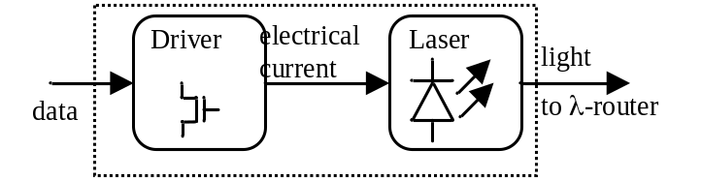
Figure 1. Transmitter Block diagram
The following figures represent the MA files associated with each of these atomic components and the corresponding unit testing results. The unit testing is performed by running each atomic model individually and watching the output form the out ports.
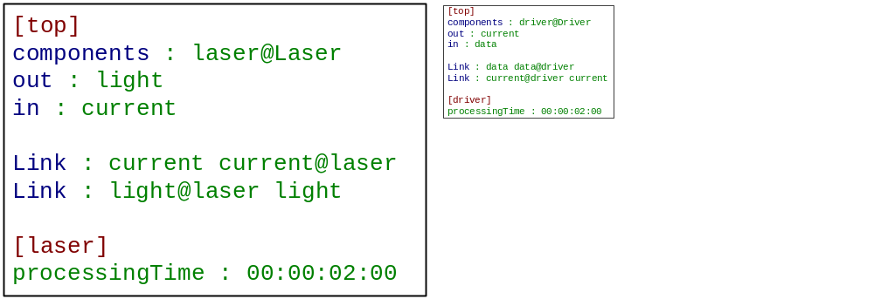
(a) (b)
Figure 2. Driver MA file (a), Laser MA file (b)
The following are the unit testing results for each atomic model:
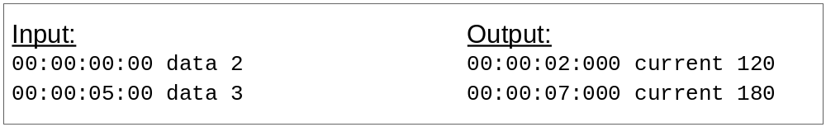
Figure 3. Driver model unit testing results
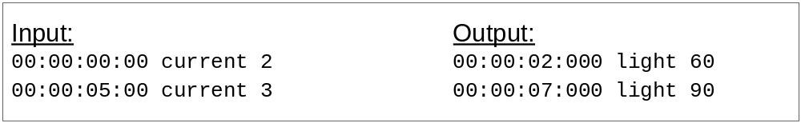
Figure 4. Laser model unit testing results

The coupled model Transmitter is modeled as follows:
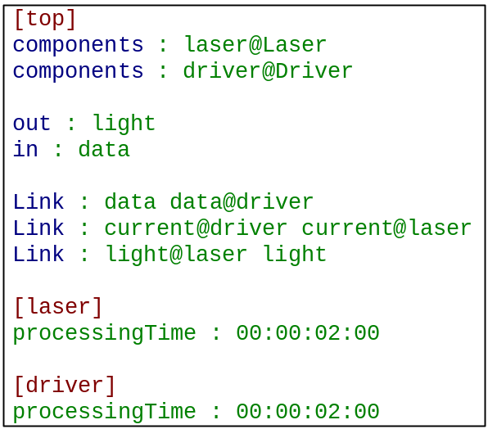
Figure 5. Transmitter coupled component MA file
Testing the Transmitter coupled model results the following:
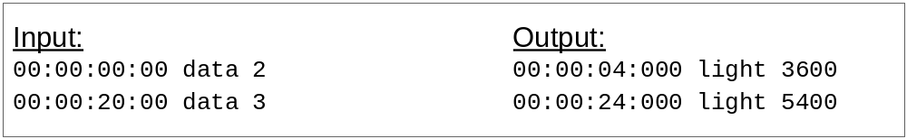
Figure 6. Transmitter integrated testing results

The Receiver (top component) is decomposed of two atomic components: Photodiode and TIAComparator.

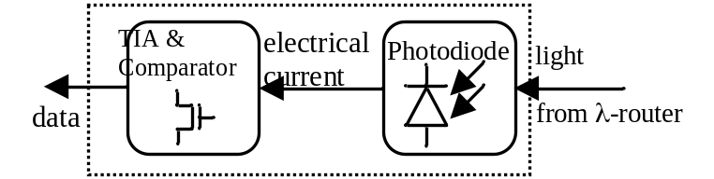
Figure 7. Receiver Block diagram
The following figures represent the MA files associated with each of these atomic components and the corresponding unit testing results. The unit testing is performed by running each atomic model individually and watching the output form the out ports.
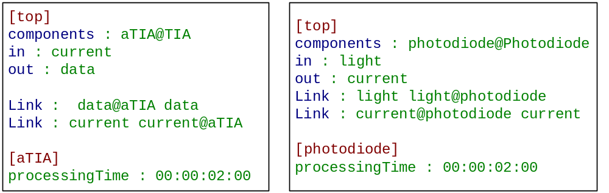
(a) (b)
Figure 8. TIA MA file (a), Photodiode MA file (b)
The following are the unit testing results for each atomic model:
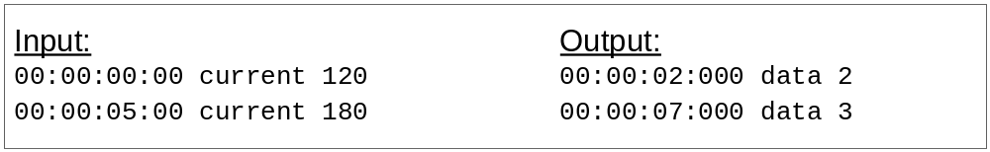
Figure 9. TIA model unit testing results
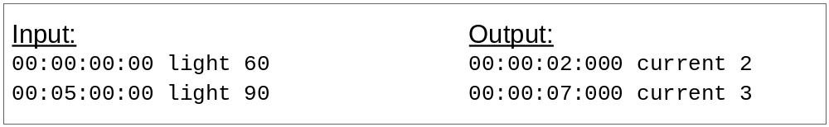
Figure 10. Photodiode model unit testing results

The coupled model Receiver is modeled as follows:
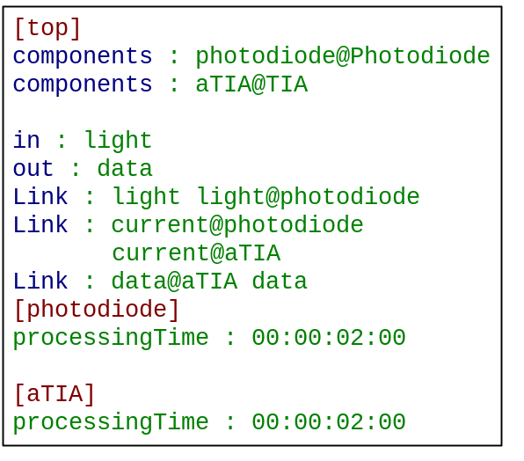
Figure 11. Receiver coupled component MA file
Testing the Receiver coupled model results the following:
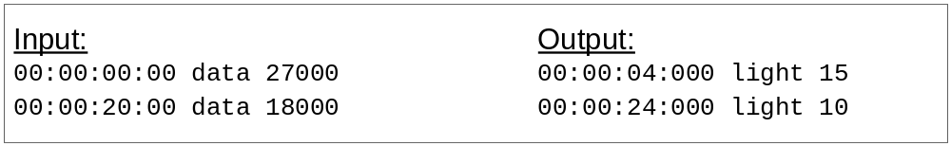
Figure 12. Receiver integrated testing results

IMPLAMANTATION OF DEVS OPTICAL TRANSMITTER IN CD++

The OpticalTransmitter (top component) is decomposed of three atomic components: CommandModulation, EmissionLaser, and PolarizationCommand.
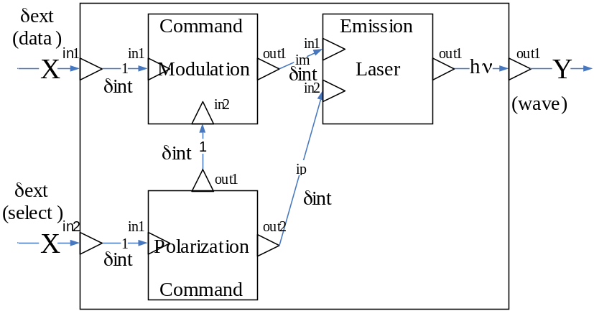
Figure 13. DEVS optical transmitter architecture view
The following figures represent the MA files associated with each of these atomic components and the corresponding unit testing results. The unit testing is performed by running each atomic model individually and watching the output form the out ports.
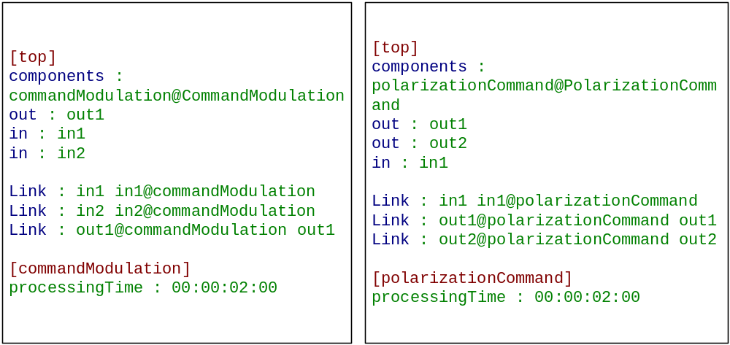
(a) (b)
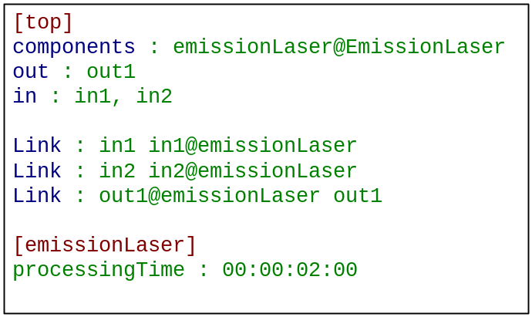
(c)
Figure 14. Command Modulation MA file (a), Polarization Command MA file (b), c) Emission Laser MA file
The coupled model Transmitter is modeled as follows:
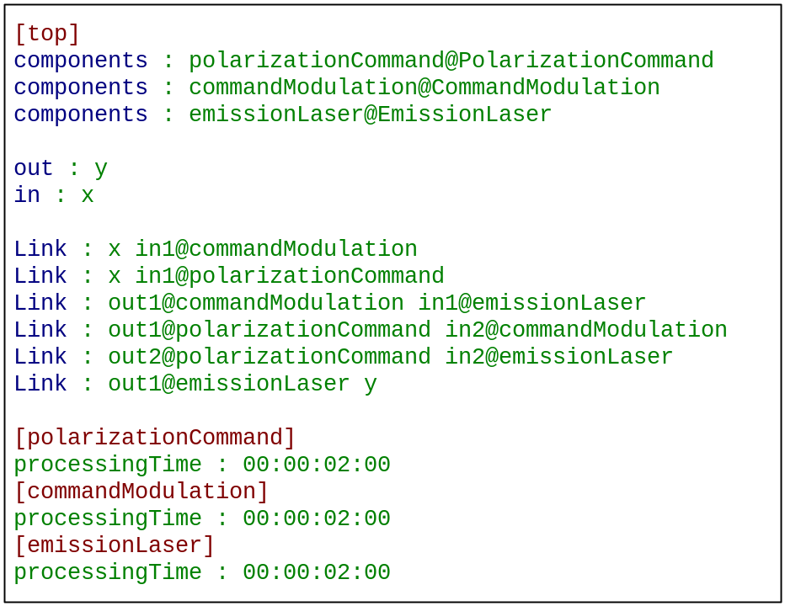
Figure 15. Optical Transmitter coupled component MA file
Testing the Optical Transmitter coupled model results the following:
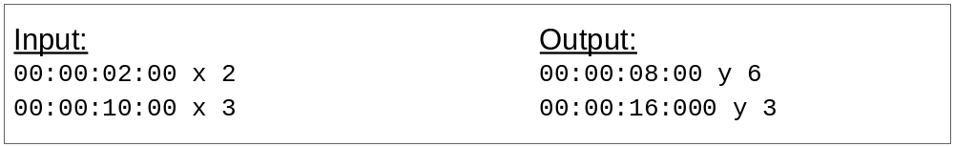
Figure 16. Optical Transmitter integrated testing results

